SCPID#6944
Test Title: |  | Server Under Maintenance
Test Description: |  | Issue: Mobile display “Server Under Maintenance” screen for all scenarios.  Solution: Restructure the sentence for each scenario.
Test Functionality:
Test Procedure:
Response Message:
Test Result: | Pass: Fail: |  | Tested by: | Fadhly, Jun Yang
Reason for Failure:
Remarks: |  | 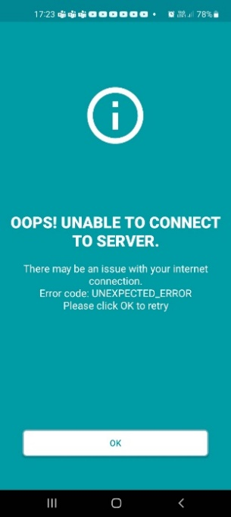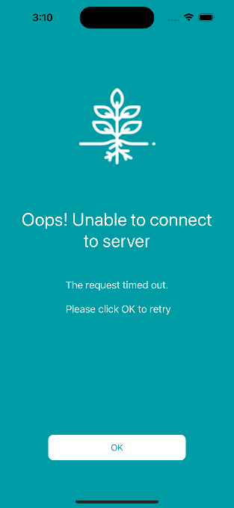  Figure 1: Wrong host name (VPN not connected)  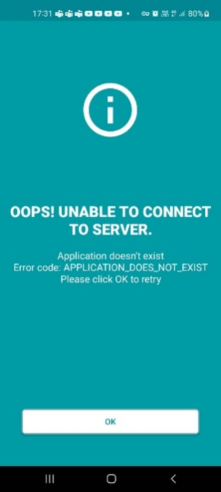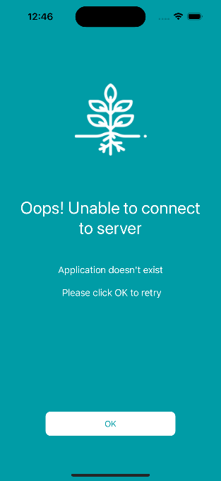  Figure 2: Version number doesn't exist (If dev build wrong)  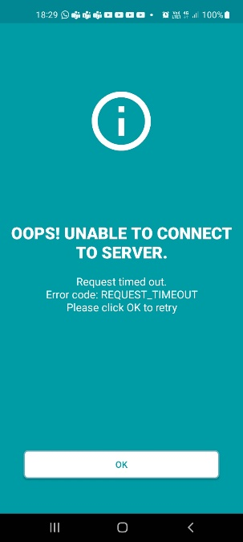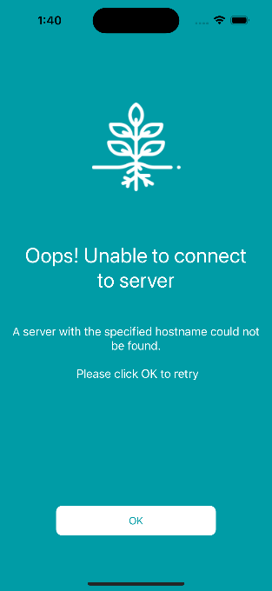  Figure 3: Wrong pointing (If dev build wrong)  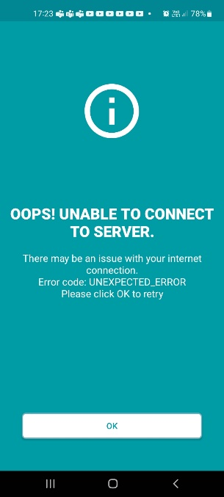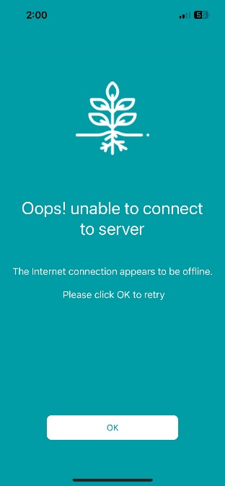  Figure 4: Internet off (user’s side)  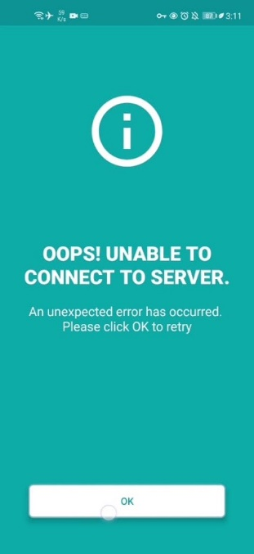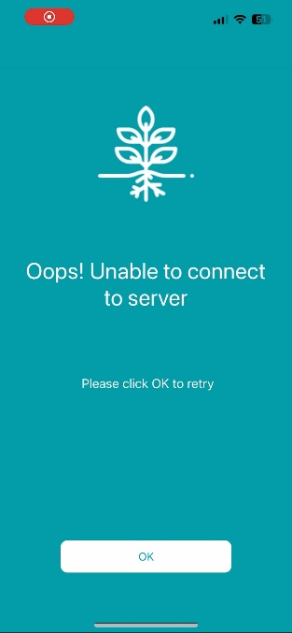  Figure 5: Restful down (Server is down, should not happen)

