SCPID#6907
Test Title: |  | Mobile - DuitNow Favorite
Test Description: |  | Root cause:  Mobile - DuitNow Favorite error.  Missing parameter when mobile send to services.  Solutions:  Fix Favorite DuitNow in iOS.
Test Functionality: |  | 1. Add nadType to request body  2. Change the existence of Check Beneficiary ID
Test Procedure: |  | Performing DuitNow Favorite  - To perform DuitNow Favorite with positive test  - To perform DuitNow Favorite with negative test
Response Message:
Test Result: | Pass: Fail: |  | Tested by: | Amir Hakim Mior (13/03/2024-14/03/2024)
Reason for Failure:
Remarks: |  | iOS  Pre-prod (3.3.6 Build 28): https://testflight.apple.com/join/hf4SeRaH  Credentials UAT:  - username: umaiinit  - password: Bbbb@111  Add nadType to request body  To perform add nadType to request body with positive testing.  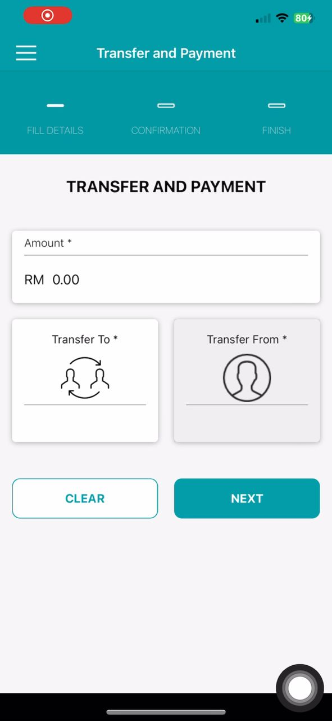  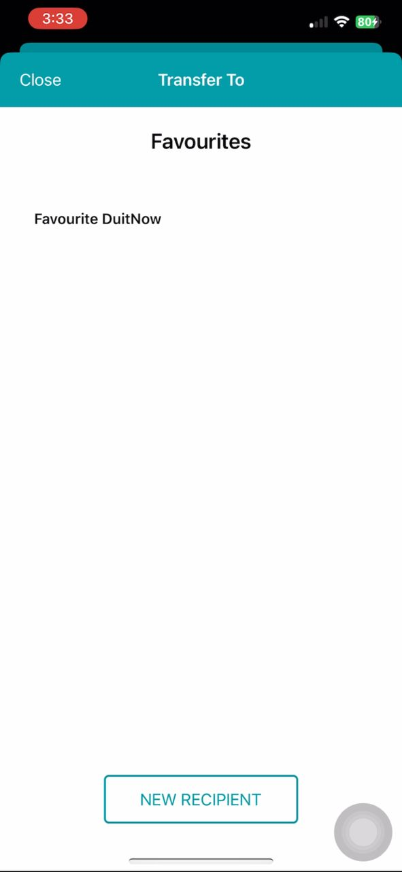  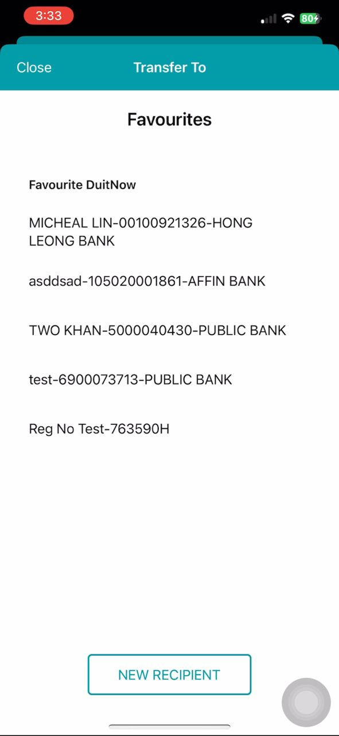  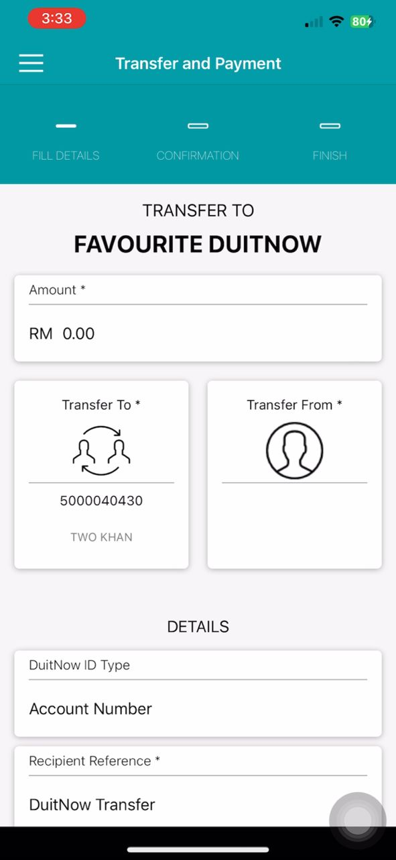  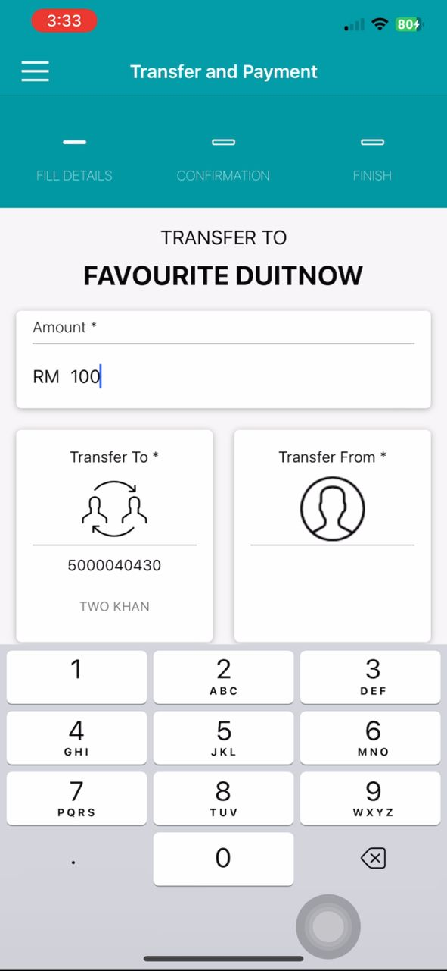  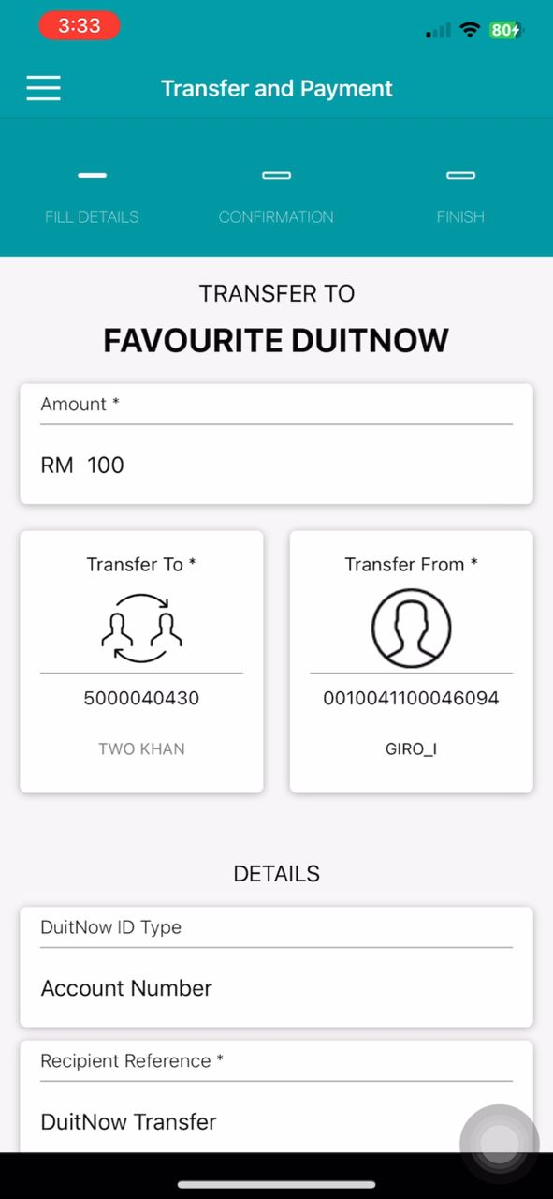  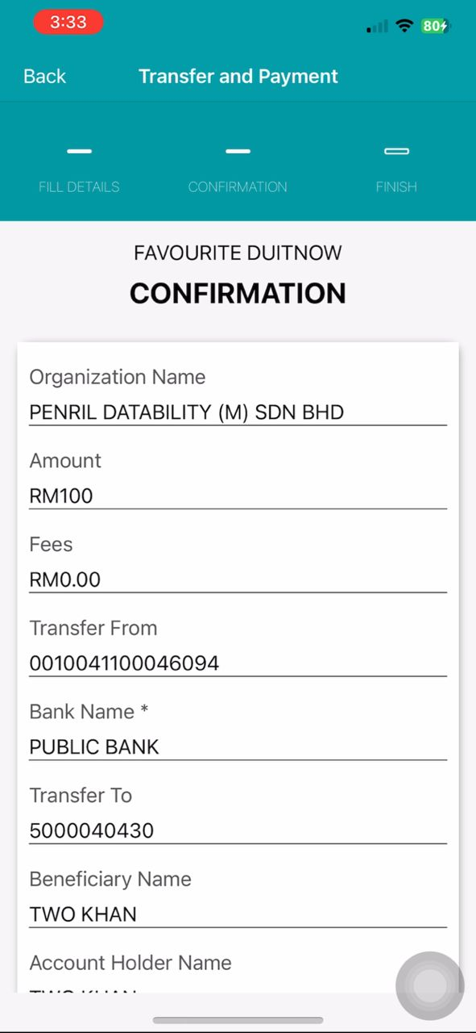  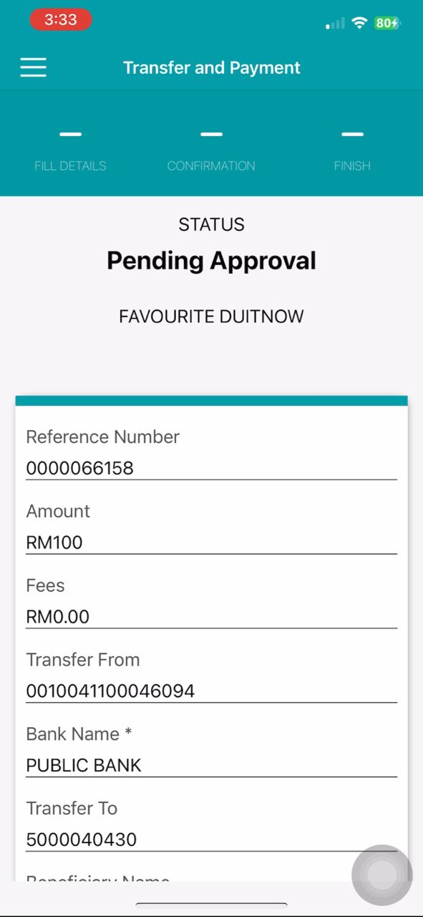  To perform add nadType to request body with negative testing.  Error message if ‘Amount’ is empty and ‘Transfer from’ is empty.  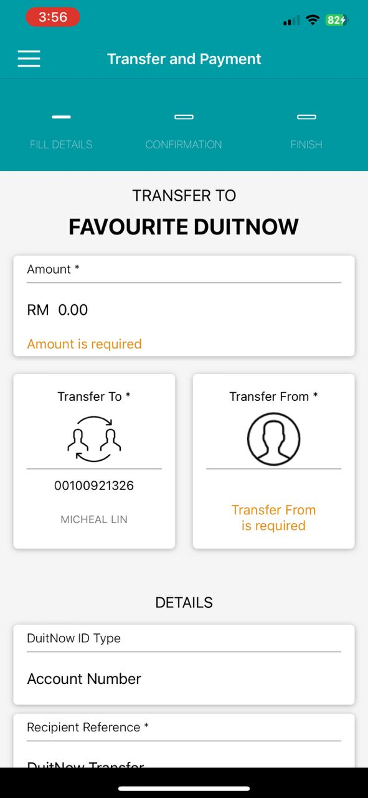  Error message if ‘Amount’ is more than limit.  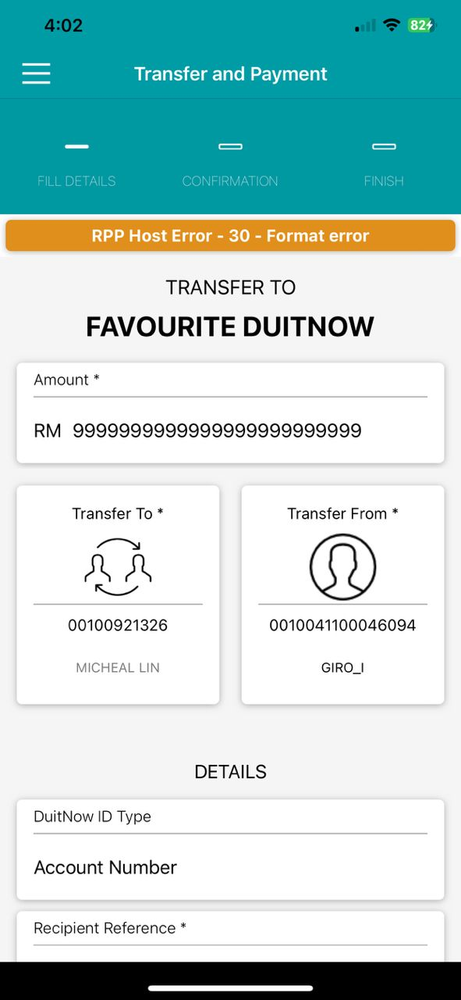  SIT (3.3.6 Build 29): https://testflight.apple.com/join/D2HQqZxx  Change the existence of Check Beneficiary ID  To perform change the existence of Check Beneficiary ID with positive testing.  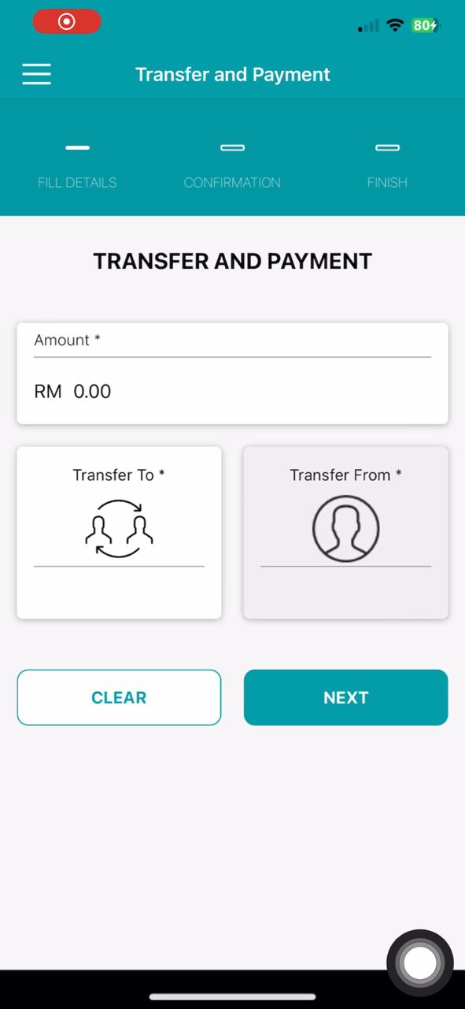  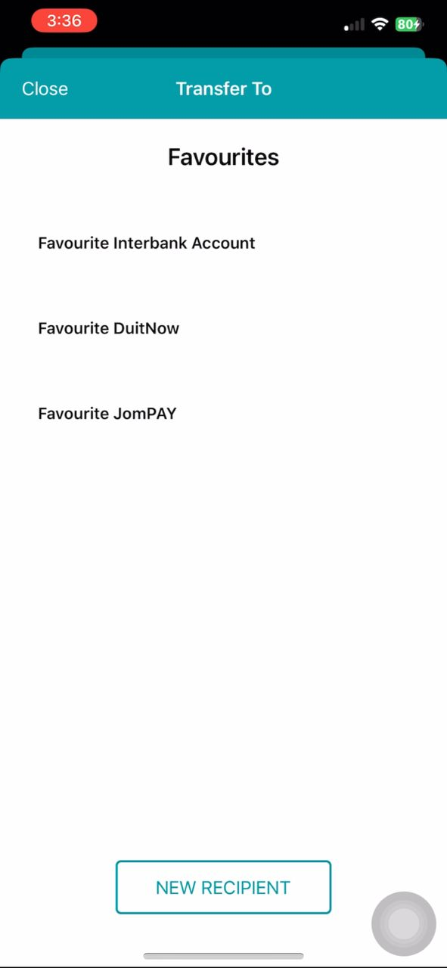  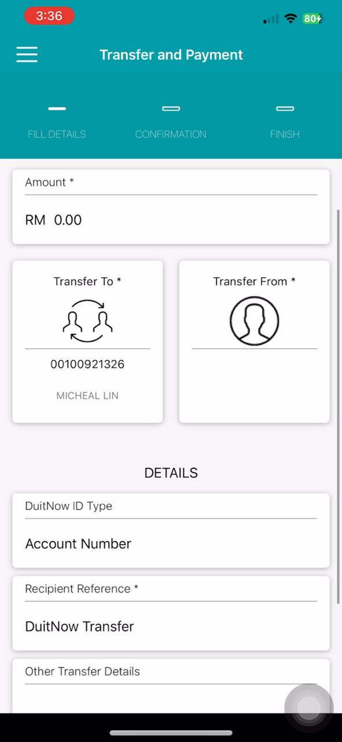  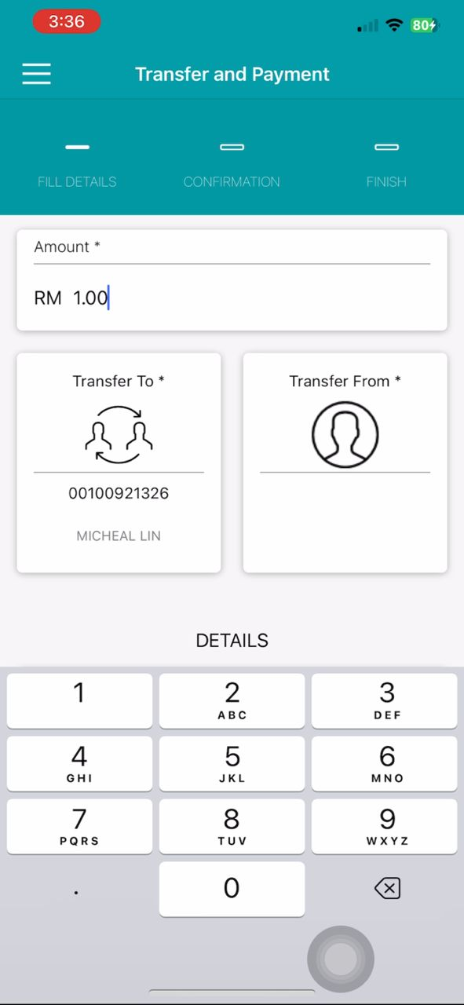  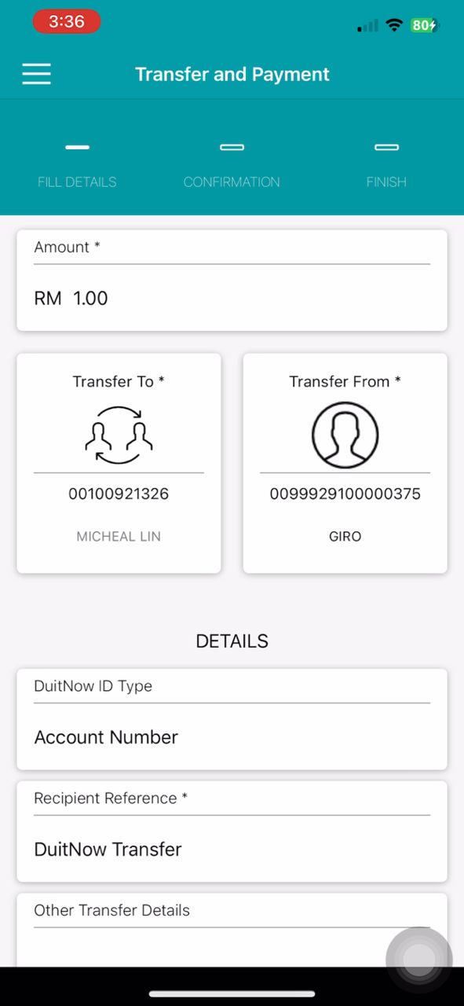  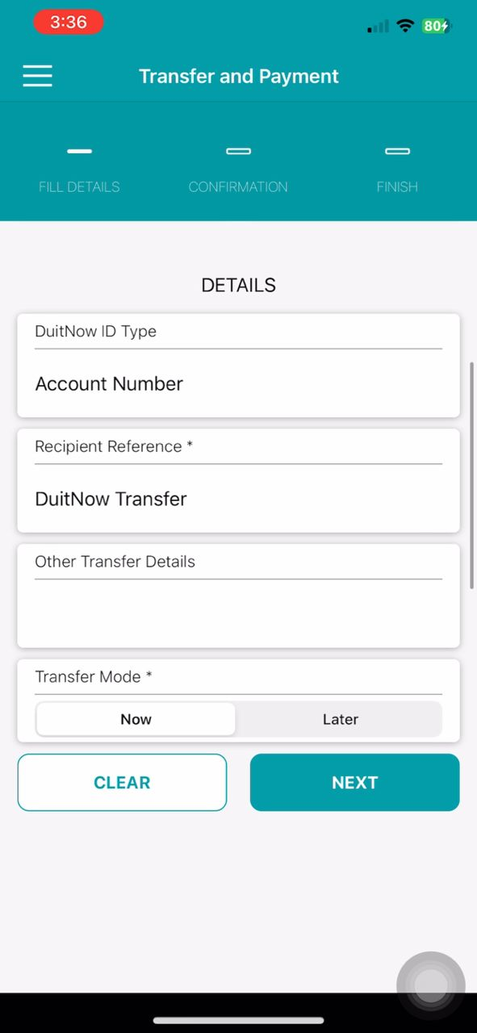  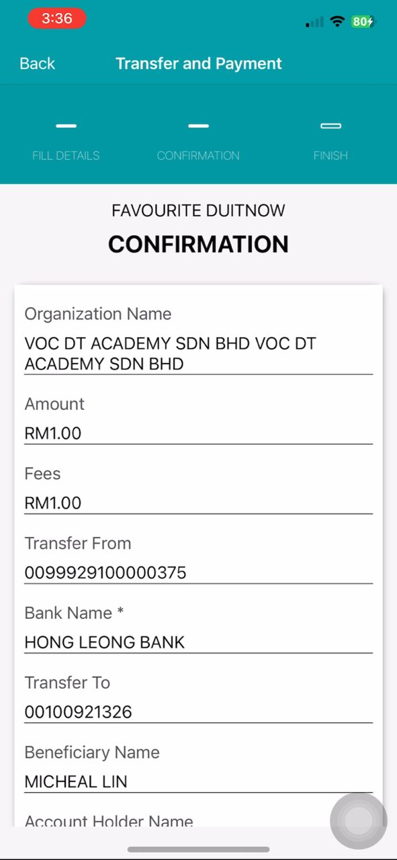  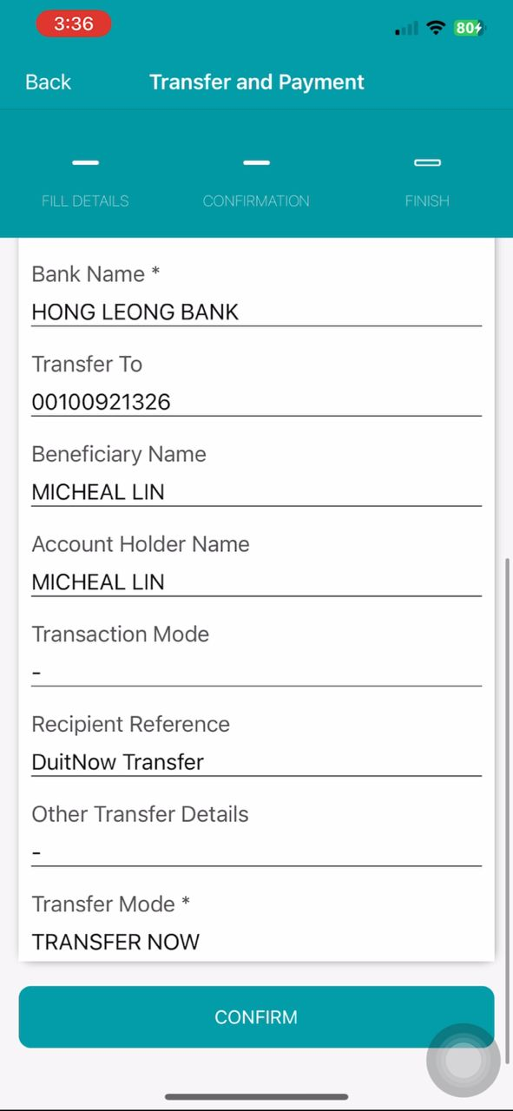  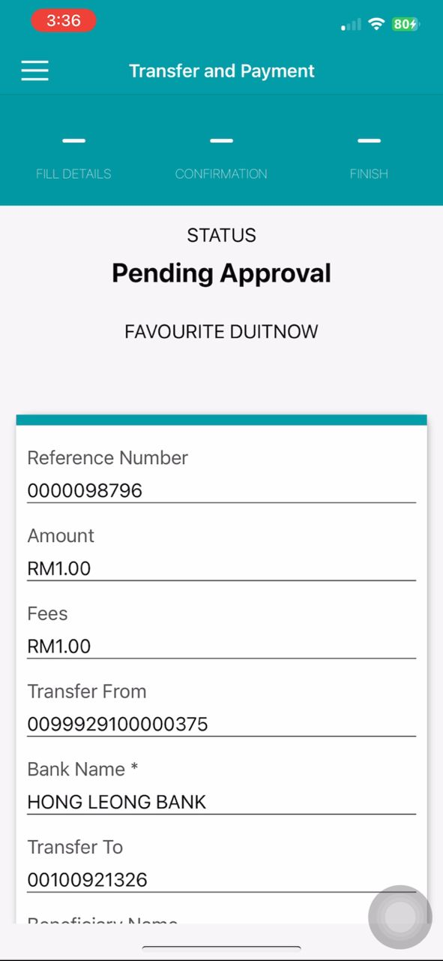  To perform change the existence of Check Beneficiary ID with negative testing.  Error message if ‘Amount’ is empty and ‘Transfer from’ is empty.  Error message if ‘Amount’ is more than limit.

