|  |
| --- |
|  |
| **Corporate Digital Banking**  **BSNeBIZ – New API to OCMS Project Server**  **CR24003** |
| Business Requirement and Functional Document |
|  |
| ***(PENRIL/BSN/BRFD_BSNEBIZ(P2)037)***  ***Revision: 00*** |
| **14th March 2024**  Prepared By: **Penril Datability (M) Sdn Bhd (816792-X)**  Suite A-07-07 Plaza Mon’t Kiara  No. 2, Jalan Kiara, Mon’t Kiara  50480 Kuala Lumpur, Malaysia  Tel: (603) 6201 2622Fax: (603) 6201 7622 |

# Document Amendment Log

| **Rev. No** | **Date Update** | **Description of Change** | **Update By**  **<Name, Dept>** | **Review By**  **<Name, dept>** | **Approved By**  **<Name, Dept>** |
| --- | --- | --- | --- | --- | --- |
| 00 | 18/12/2023 | Initial Release | Aziana Jaafar  Quality Engineer | Nurul Athirah  Quality Engineer | Norhaidah Dasuki  Senior Manager |
|  |  |  |  |  |  |

# Table of Content

Document Amendment Log 1

Table of Content 3

Business Requirement & Functional Acceptance 4

**Section A: Introduction** 5

1 Introduction 5

1.1 Objective 5

1.2 Assumptions 6

1.3 Impact Modules 7

2 Secure Verification for Monetary Transaction at BSNeBiz 8

2.1 Hardware Token (Vasco) 8

2.1.1 Process Flow 8

2.1.2 Screen Flow 9

2.2 Mobile Token 10

2.2.1 Process Flow 11

2.2.2 Screen Flow 11

**Section B: BSNeBiz – New API to OCMS Project Server** 14

3 SOW01.0: Integration with OCMS Project Server 14

3.1 SOW01.1 New Registration – with or without CIS 14

3.1.1 Process Flow 14

3.1.2 Screen Flow 14

3.2 SOW01.2 Authentication 14

3.2.1 Process Flow 14

# Business Requirement & Functional Acceptance

I/We hereby verify that this Business Requirement & Functional consist of all the requirements requested by BANK SIMPANAN NASIONAL. The implemented system will fulfill ONLY this requirement.

I/We also hereby AGREE that this satisfies our entire requirement for **Enhancement of Expired Password Flow, Email Content And Eye Icon To Password Field.** Any future changes to this agreed scope would be treated as an enhancement to the system. Any future changes to the project timeline will be subjected to the final approval of the project steering committee.

**BANK SIMPANAN NASIONAL:**

|  |  |  |  |
| --- | --- | --- | --- |
| **Approved by** | **Role** | **Signature** | **Date** |
|  |  |  |  |
|  |  |  |  |
|  |  |  |  |
|  |  |  |  |
|  |  |  |  |
|  |  |  |  |
|  |  |  |  |

**Penril Datability (M) Sdn. Bhd.:**

|  |  |  |  |
| --- | --- | --- | --- |
| **Approved by** | **Role** | **Signature** | **Date** |
| Norhaidah Bt Md Dasuki | Senior Manager, Profesional Service |  |  |
|  |  |  |  |
|  |  |  |  |

**Section A: Introduction**

# Introduction

This document served as the business requirement and system specification of implementing **BSNeBiz - New API to OCMS Project Server.**

This document shall explain all the features and functionalities, which is elaborating with screen captures, process flow, descriptions, input fields specifications and error messages. All screen designs provided in this document are samples and only illustration purpose for easy understanding. The screen designs are not final.

## Objective

The objective of this document is to capture user requirements of transactional and administration modules of implementing **BSNeBiz - New API to OCMS Project Server.** This document will facilitate development and implementation of the mentioned modules of Internet Banking System for BSNeBiz.

The base line features description and screen designs will become a reference blueprint for the development team to develop the transactional and administration module. Hence, it is crucial that all stakeholders need to ensure the correctness and adequacy of the requirements captured in this document.

All stakeholders involved are expected to review and sign off this document before the development starts. By signing off the document, the stakeholder has endorsed the correctness and accuracy and adequacy of the requirements documented in this document.

## Assumptions

**BSNeBiz - New API to OCMS Project Server**

This module will enhance the New Registration with or without CIS.

1. **New Registration with or without CIS**

New Registration with CIS (Customer Information System): Assuming that the OCMS Project Server may need to integrate with an external system for user registration, such as a CRM or customer database.

New Registration without CIS: Assuming that there's an option for users to register directly within the OCMS Project Server without needing integration with an external system.

1. **Authentication**

Username and Passphrase Authentication: Assuming that users may have the option to log in using a combination of a username and passphrase, where the passphrase could be a more secure form of authentication such as a one-time password or a token generated through another system.

Usernames and Password Authentication: Assuming that users can also log in using the traditional username and password combination.

## Impact Modules

To update impact module section



|  |  |  |  |
| --- | --- | --- | --- |
| System | Modules | Features | Description |
| BSNeBiz | Registration | Field | Integration (API) |
| Login Page | Field | Integration (API) |
|  |  |  |
|  |  |  |  |
|  |  |  |  |

Table 1: BSNeBiz - New API to OCMS Project Server Impact Module

# Secure Verification for Monetary Transaction at BSNeBiz

PIN is required as the second level security authentication for BSNeBiz Role’s Single User and Approver when perform any monetary transactions via online. PIN is a six random digits temporary security code, which is generated and verified by the authentication server.

**There are two types of Secure Verification assign to the user by Corporate Admin:**

1. Hardware Token (Vasco)
2. Mobile Token

## Hardware Token (Vasco)

Hardware token from VASCO is physical device that will be used by Single User and Approver to authorize a monetary transaction using the “Transaction Singing” function; also known as Challenge Response (CR).

### Process Flow



Diagram 1: Hardware Token Flow Diagram

### Screen Flow

***Step 1:***

1. When user in Transaction Confirmation page, BSNeBiz system will required Challenge Response code to proceed the transaction
2. User needs to use Hardware Token to generate the Challenge Response code.

Figure 1: Hardware Token

***Step 2:***

1. Users press OK button for 2 seconds to turn on the Token.
2. User key in the 6 digits login PIN (User Password) and press OK.
3. BSN logo will be displayed on the token screen.

Figure 2: Turn on Token Flow

***Step 3:***

1. User press button 2 to change to Challenge Response program.
2. User key in the last 8 digits of recipient account number for Challenge Response.
3. Press OK and Challenge Response code will be displayed.

Figure 3: Get Challenge Response Code Flow

***Step 4:***

1. User use generated Challenge Response from the Token and input to the Challenge Response field in BSNeBiz – Transaction Confirmation pages.

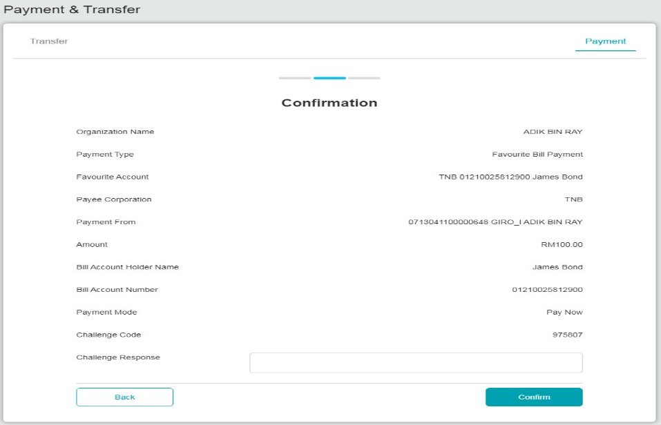

Figure 4: Confirmation page for Hardware Token verification

## Mobile Token

Mobile Token is a mobile application that has the same functionalities as the VASCO Hardware Token using mobile phone features and serves the same usage purpose.

### Process Flow



Diagram 2: Mobile Token Flow Diagram

### Screen Flow

***Step 1:***

1. When user in Transaction Confirmation page with QR code.
2. User needs to use Mobile Apps to scan the QR code to generate the Challenge Response code.

Figure 5: Mobile Apps screen

***Step 2:***

1. User Login to the Mobile apps and Click on Challenge Respond icon.
2. User scans the QR code generated at IBS confirmation screen.

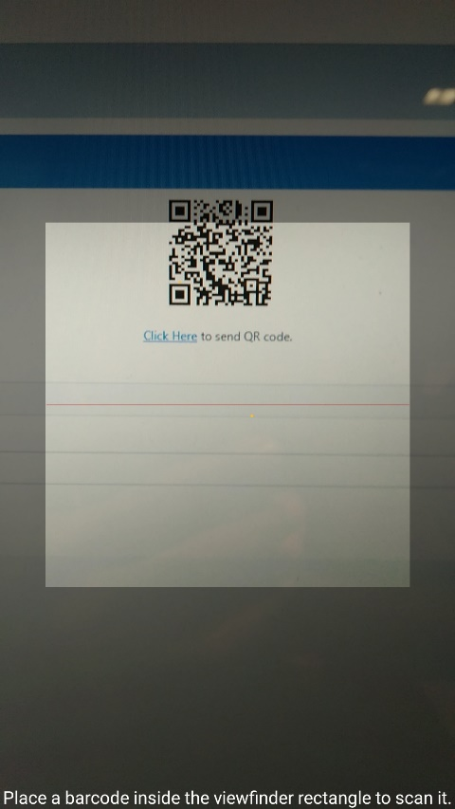

Figure 6: Mobile Apps QR Scan screen

***Step 3:***

1. BSN Application generate and display the Challenge Response code to be used.

Figure 7: Challenge Response Code display Screen

***Step 4:***

1. User use generated Challenge Response from the Mobile Token App and input to the Challenge Response field in BSNeBiz – Transaction Confirmation pages.

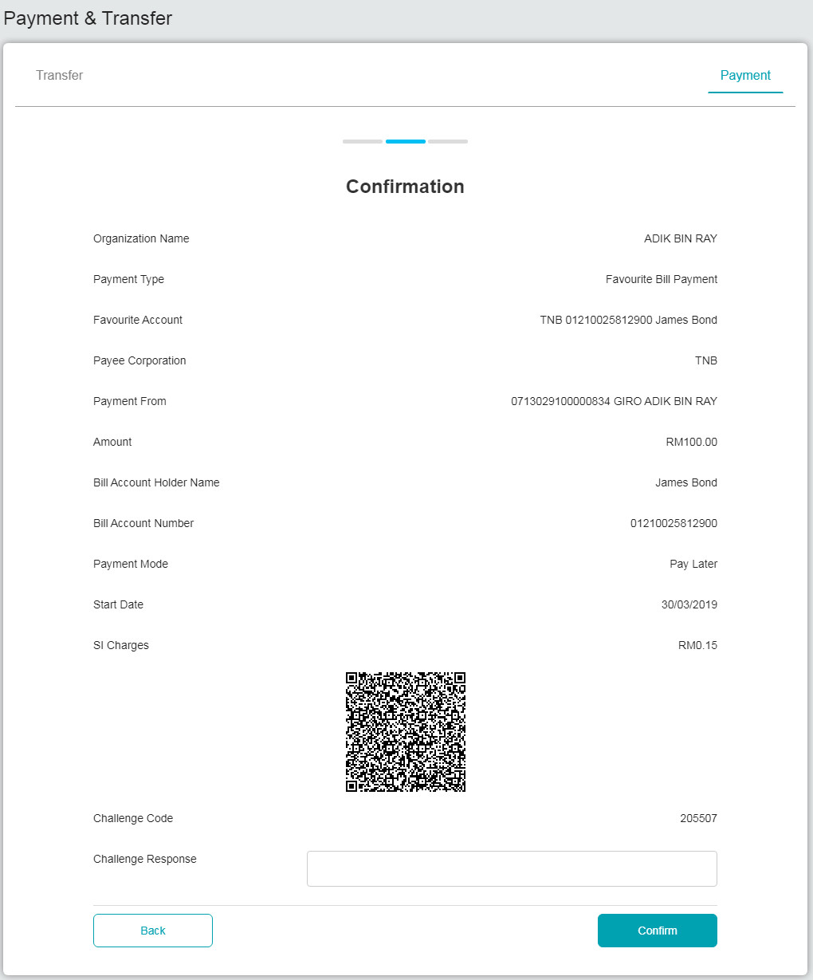

Figure 8: Confirmation page for Mobile Token verification

**Section B:** **BSNeBiz – New API to OCMS Project Server**

# 3 SOW01.0: Integration with OCMS Project Server



## SOW01.1 New Registration

OCMS will be sent the command as per BSNeBiz registration. CIS will be sent by OCMS.

### Process Flow

Diagram 3:

### Screen Flow

## SOW01.2 Authentication

To key in username and return passphrase and key in username and password to login.

### Process Flow