|  |
| --- |
|  |
| **Corporate Digital Banking**  **BSNeBIZ – New API to OCMS Project Server**  **CR24003** |
| Business Requirement and Functional Document |
|  |
| ***(PENRIL/BSN/BRFD_BSNEBIZ(P2)037)***  ***Revision: 00*** |
| **14th March 2024**  Prepared By: **Penril Datability (M) Sdn Bhd (816792-X)**  Suite A-07-07 Plaza Mon’t Kiara  No. 2, Jalan Kiara, Mon’t Kiara  50480 Kuala Lumpur, Malaysia  Tel: (603) 6201 2622Fax: (603) 6201 7622 |

# Document Amendment Log

| **Rev. No** | **Date Update** | **Description of Change** | **Update By**  **<Name, Dept>** | **Review By**  **<Name, dept>** | **Approved By**  **<Name, Dept>** |
| --- | --- | --- | --- | --- | --- |
| 00 | 02/04/2024 | Initial Release | Aziana Jaafar  Quality Engineer | Nurul Athirah  Quality Engineer | Norhaidah Dasuki  Senior Manager |
|  |  |  |  |  |  |

# Table of Content

Document Amendment Log 1

Table of Content 3

Business Requirement & Functional Acceptance 4

**Section A: Introduction** 5

1 Introduction 5

1.1 Objective 5

1.2 Assumptions 6

1.3 Impact Modules 7

2 Secure Verification for Monetary Transaction at BSNeBiz 8

2.1 Hardware Token (Vasco) 8

2.1.1 Process Flow 8

2.1.2 Screen Flow 9

2.2 Mobile Token 10

2.2.1 Process Flow 11

2.2.2 Screen Flow 11

**Section B: BSNeBiz – New API to OCMS Project Server** 14

3 SOW01.0: Integration with OCMS Project Server 14

3.1 SOW01.1 New Registration – with or without CIS 14

3.1.1 Process Flow 14

3.1.2 Screen Flow 14

3.2 SOW01.2 Authentication 14

3.2.1 Process Flow 14

# Business Requirement & Functional Acceptance

I/We hereby verify that this Business Requirement & Functional consist of all the requirements requested by BANK SIMPANAN NASIONAL. The implemented system will fulfill ONLY this requirement.

I/We also hereby AGREE that this satisfies our entire requirement for New API to OCMS Project Server**.** Any future changes to this agreed scope would be treated as an enhancement to the system. Any future changes to the project timeline will be subject to the final approval of the project steering committee.

**BANK SIMPANAN NASIONAL:**

|  |  |  |  |
| --- | --- | --- | --- |
| **Approved by** | **Role** | **Signature** | **Date** |
|  |  |  |  |
|  |  |  |  |
|  |  |  |  |
|  |  |  |  |
|  |  |  |  |
|  |  |  |  |
|  |  |  |  |

**Penril Datability (M) Sdn. Bhd.:**

|  |  |  |  |
| --- | --- | --- | --- |
| **Approved by** | **Role** | **Signature** | **Date** |
| Norhaidah Bt Md Dasuki | Senior Manager, Profesional Service |  |  |
|  |  |  |  |
|  |  |  |  |

**Section A: Introduction**

# Introduction

This document served as the business requirement and system specification of implementing **BSNeBiz - New API to OCMS Project Server.**

This document shall explain all the features and functionalities, which is elaborating with screen captures, process flow, descriptions, input fields specifications and error messages. All screen designs provided in this document are samples and only illustration purpose for easy understanding. The screen designs are not final.

## Objective

The objective of this document is to capture user requirements of transactional and administration modules of implementing **BSNeBiz - New API to OCMS Project Server.** This document will facilitate development and implementation of the mentioned modules of Internet Banking System for BSNeBiz.

The base line features description and screen designs will become a reference blueprint for the development team to develop the transactional and administration module. Hence, it is crucial that all stakeholders need to ensure the correctness and adequacy of the requirements captured in this document.

All stakeholders involved are expected to review and sign off this document before the development starts. By signing off the document, the stakeholder has endorsed the correctness and accuracy and adequacy of the requirements documented in this document.

## Assumptions

**BSNeBiz - New API to OCMS Project Server**

This module will enhance the New Registration with or without CIS.

1. **New Registration with or without CIS**

New Registration with CIS (Customer Information System): Assuming that the OCMS Project Server may need to integrate with an external system for user registration, such as a CRM or customer database.

New Registration without CIS: Assuming that there's an option for users to register directly within the OCMS Project Server without needing integration with an external system.

1. **Authentication**

Username and Passphrase Authentication: Assuming that users may have the option to log in using a combination of a username and passphrase, where the passphrase could be a more secure form of authentication such as a one-time password or a token generated through another system.

Usernames and Password Authentication: Assuming that users can also log in using the traditional username and password combination.

## Impact Modules

To update impact module section



|  |  |  |  |
| --- | --- | --- | --- |
| System | Modules | Features | Description |
| BSNeBiz | Registration | Field | Integration (API) |
| Login Page | Field | Integration (API) |
|  |  |  |
|  |  |  |  |
|  |  |  |  |

Table 1: BSNeBiz - New API to OCMS Project Server Impact Module

# Secure Verification for Monetary Transaction at BSNeBiz

PIN is required as the second level security authentication for BSNeBiz Role’s Single User and Approver when perform any monetary transactions via online. PIN is a six random digits temporary security code, which is generated and verified by the authentication server.

**There are two types of Secure Verification assign to the user by Corporate Admin:**

1. Hardware Token (Vasco)
2. Mobile Token

## Hardware Token (Vasco)

Hardware token from VASCO is physical device that will be used by Single User and Approver to authorize a monetary transaction using the “Transaction Singing” function; also known as Challenge Response (CR).

### Process Flow



Diagram 1: Hardware Token Flow Diagram

### Screen Flow

***Step 1:***

1. When user in Transaction Confirmation page, BSNeBiz system will required Challenge Response code to proceed the transaction
2. User needs to use Hardware Token to generate the Challenge Response code.

Figure 1: Hardware Token

***Step 2:***

1. Users press OK button for 2 seconds to turn on the Token.
2. User key in the 6 digits login PIN (User Password) and press OK.
3. BSN logo will be displayed on the token screen.

Figure 2: Turn on Token Flow

***Step 3:***

1. User press button 2 to change to Challenge Response program.
2. User key in the last 8 digits of recipient account number for Challenge Response.
3. Press OK and Challenge Response code will be displayed.

Figure 3: Get Challenge Response Code Flow

***Step 4:***

1. User use generated Challenge Response from the Token and input to the Challenge Response field in BSNeBiz – Transaction Confirmation pages.

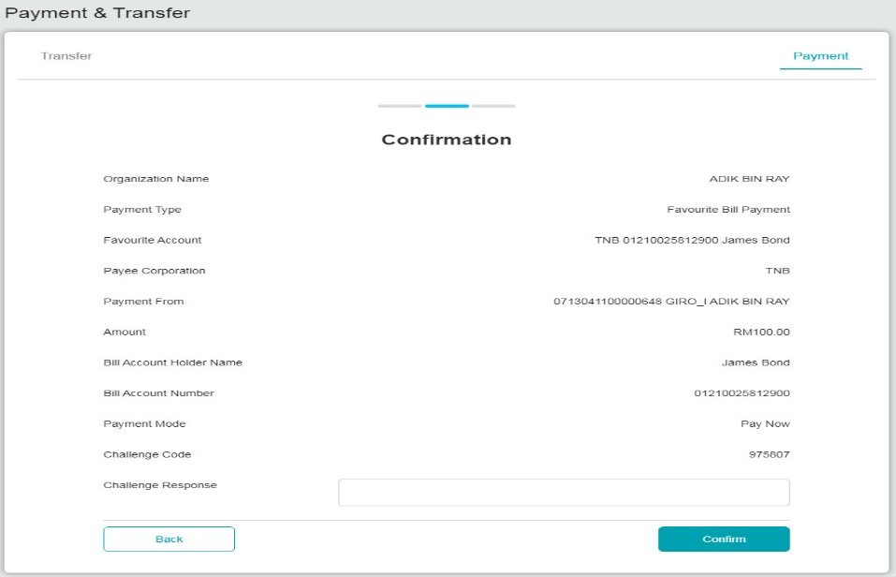

Figure 4: Confirmation page for Hardware Token verification

## Mobile Token

Mobile Token is a mobile application that has the same functionalities as the VASCO Hardware Token using mobile phone features and serves the same usage purpose.

### Process Flow



Diagram 2: Mobile Token Flow Diagram

### Screen Flow

***Step 1:***

1. When user in Transaction Confirmation page with QR code.
2. User needs to use Mobile Apps to scan the QR code to generate the Challenge Response code.

Figure 5: Mobile Apps screen

***Step 2:***

1. User Login to the Mobile apps and Click on Challenge Respond icon.
2. User scans the QR code generated at IBS confirmation screen.

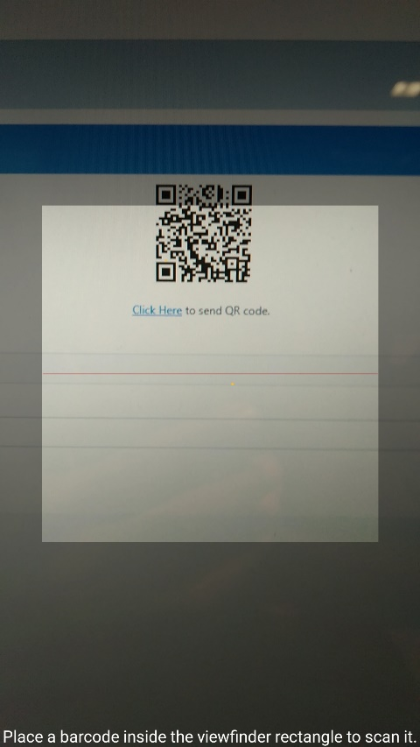

Figure 6: Mobile Apps QR Scan screen

***Step 3:***

1. BSN Application generate and display the Challenge Response code to be used.

Figure 7: Challenge Response Code display Screen

***Step 4:***

1. User use generated Challenge Response from the Mobile Token App and input to the Challenge Response field in BSNeBiz – Transaction Confirmation pages.

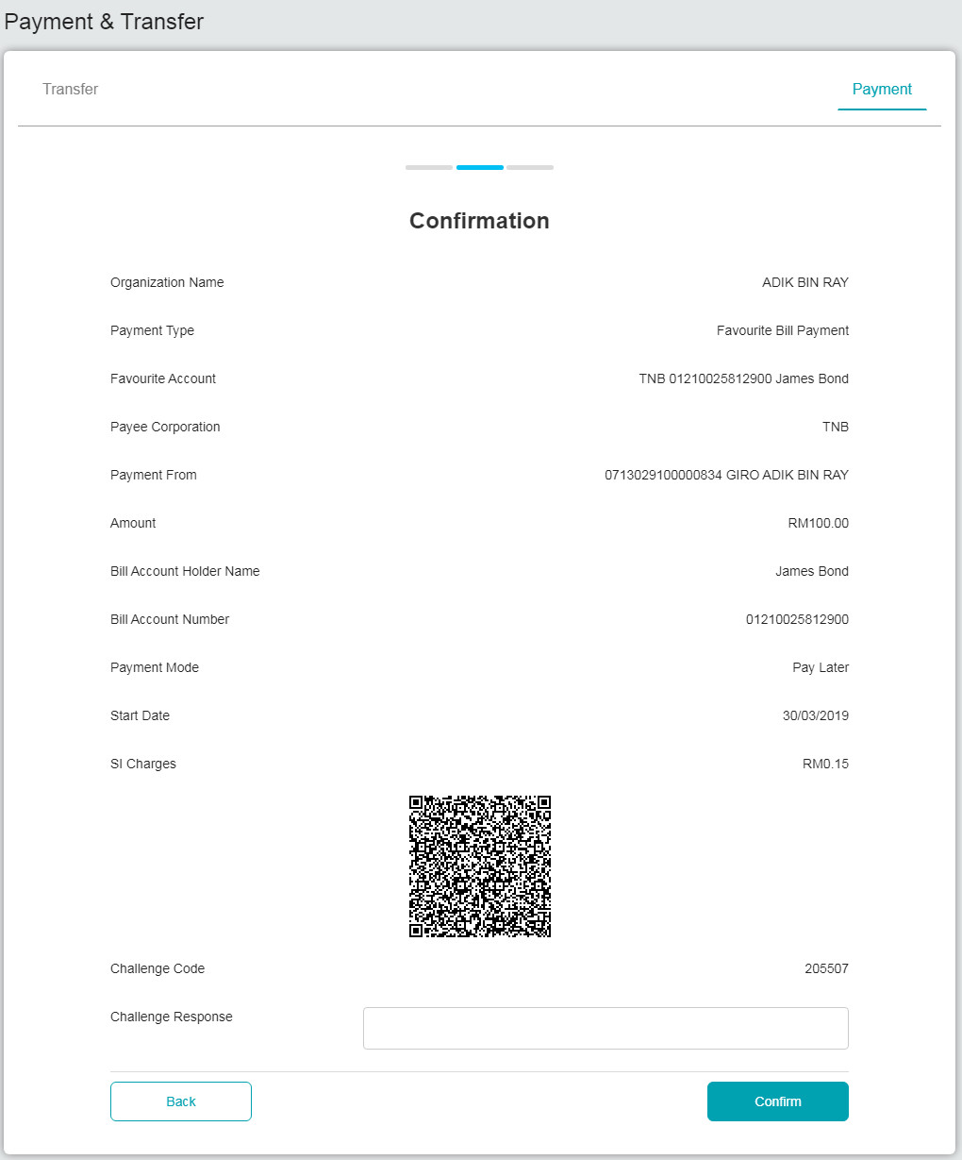

Figure 8: Confirmation page for Mobile Token verification

**Section B:** **BSNeBiz – New API to OCMS Project Server**

# 3 SOW01.0: Integration with OCMS Project Server



## SOW01.1 New Registration

OCMS will be sent the command as per BSNeBiz registration. CIS will be sent by OCMS.

### Process Flow



Diagram 3: Authentication - Register

### Screen Flow

***Step 1:***

1. Customer access to the OCMS login screen.
2. Customer clicks the “Register” button to go to CDB Main Screen.



Figure 9: New Application Form – OCMS Login Screen

**Action:**

| **No** | **Action** | **Type** | **Description** |
| --- | --- | --- | --- |
|  | Register | Button | This action will direct user to CDB main page. |

Table 1: OCMS New Application Form

***Step 2:***

1. Customer access to the Registration form by clicking on the “New Application” hyperlink. CDB system displays the online Registration form.

Figure 10: BSNeBiz Login Screen

**Action:**

| **No** | **Action** | **Type** | **Description** |
| --- | --- | --- | --- |
| 1. 1. | New Application | Link | This action will be used to display New Application Form |

Table 2: New Application Action

***Step 3:***

1. Customer inputs the required organization and information fields, and clicks “Next” button, or click “Back” button to go to previous page.
2. CDB System will save the data input.

Figure 11: New Application Form – Organization and Information Screen

**Input Specification:**

| **No** | **Field** | **Field Type** | **Rule** | **Description** | **Required** |
| --- | --- | --- | --- | --- | --- |
|  | Organization Name | Text Box | Max length:64  Alphanumeric | The name of an organization | Yes |
|  | Business Registration No. | Text Box | Max length:16 Alphanumeric | The organization registration No. | Yes |
|  | Organization Address | Text Box | Max length:64  Alphanumeric | The organization address | Yes |
|  | Postcode | Text Box | Match length:5 Numeric | Display the postcode of the organization city located | Yes |
|  | City | Text Box | Max Length: 64  Alphanumeric | Displays the city that the organization is located | Yes |
|  | State | Drop down | List of State:  Select one only | Display the state of the organization located | Yes |
|  | State | Drop down | List of State:  Select one only | Customer’s registration that defines by state | Yes |
|  | Type of company | Radio button | Select one only | Non-government or government | Yes |
|  | Contact Person’s Full Name | Text Box | Max length:64  Alphanumeric | Organization Contact Person’s full name | Yes |
|  | Contact Person’s ID No. | Text Box | Max Length:12  Alphanumeric | Organization Contact Person’s ID No. | Yes |
|  | Contact Person’s Mobile No. | Text Box | Max Length:14  Numeric | Organization Contact Person’s Mobile No. | Yes |
|  | Contact Person’s Email | Text Box | Max length:40  Alpha, numeric, and/or Text combination as long contain this format: <value>@<value>.<value> | Organization Contact Person’s email | Yes |
|  | Corporate Administrator’s Full Name | Text Box | Max length:64  Alphanumeric | Organization Corporate Administrator’s full name | Yes |
|  | Corporate Administrator’s ID No. | Text Box | Max Length:12  Alphanumeric | Organization Corporate Administrator’s ID No. | Yes |
|  | Corporate Administrator’s Mobile Phone No. | Text Box | Max Length:14  Numeric | Organization Corporate Administrator’s Mobile Phone No. | Yes |
|  | Corporate Administrator’s Email | Text Box | Max length:40  Alpha, numeric, and/or Text combination as long contain this format: <value>@<value>.<value> | Organization Corporate Administrator’s email | Yes |

Table 3: New Application Form – Organization and Information Input Specification

**Action:**

| **No** | **Action** | **Type** | **Description** |
| --- | --- | --- | --- |
|  | Back | Button | Contain the action to forward back to previous page |
|  | Next | Button | * Contains the action to do field validation according to requirement mentioned in specification table, also checks for empty and duplicate fields. * Forward the action to save the input fields to database |

Table 4: New Application Form – Organization and Information Action

**List of available messages for the screen:**

| **No.** | **Event** | **Error Description in English** |
| --- | --- | --- |
|  | Did not fill in the required field. | Organization Name is required  Business Registration No.is required  Organization Address is required  Post code is required  City is required  State is required  State is required  Contact Person’s Full Name is required  Contact Person’s ID No.is required  Contact Person’s Mobile No.is required  Contact Person’s Email is required  Corporate Administrator’s Full Name is required  Corporate Administrator’s ID No.is required  Corporate Administrator’s Mobile No.is required  Corporate Administrator’s Email is required |
|  | Unselect the required field | Type of company is required |
|  | Fill in the below fields with special characters   * Postcode * Contact Person’s ID No. * Contact Person’s Mobile No. * Corporate Administrator’s ID No. * Corporate Administrator’s Mobile Phone No. | Please enter a valid number |
|  | Fill in the below fields with less than 9 digits   * Contact Person’s ID No. * Contact Person’s Mobile No. * Corporate Administrator’s ID No. * Corporate Administrator’s Mobile Phone No. | Contact Person’s ID No. cannot be less than 9 digits  Contact Person’s Mobile No. cannot be less than 9 digits  Corporate Administrator’s No. cannot be less than 9 digits  Corporate Administrator’s Mobile No. cannot be less than 9 digits |

Table 5: New Application Form – Organization and Information Available Error Message

***Step 4:***

1. Customer select the subscribing services, input the BSN Corporate Account No fields, select the type of access and clicks the “Next” button to go to next page, or click the “Back” button to go to the previous page.
2. CDB System will save the data input.

Figure 12: New Application Form – Services & Access Type Screen

**Input Specification:**

| **No** | **Field** | **Field Type** | **Rule** | **Description** | **Required** |
| --- | --- | --- | --- | --- | --- |
|  | Services | Checkbox | N/A | Master Checkbox | No |
|  | Online Transfer | Checkbox | N/A | Service to perform online transfer. Checked by default. | No |
|  | Collection Receivable | Checkbox | N/A | Service to perform collection receivable | No |
|  | Bulk Payment | Checkbox | N/A | Service that involves money transfer to perform salary or supplier payment | No |
|  | Auto Debit | Checkbox | N/A | Service facility that automatically settles outstanding bills by deducting corporate savings/current account on a fixed schedule. Checked by default. | No |
|  | Bulk Payment | Checkbox | N/A | Service that involves money transfer to perform salary or supplier payment. Checked by default. | No |
|  | Corporate Card | Checkbox | N/A | Service that to perform corporate card transaction | No |
|  | Statutory Body | Checkbox | N/A | Service that performs statutory body payments such as EPF, SOCSO and LHDN (PCB) | No |
|  | EPF | Checkbox | N/A | EPF will be enabled once statutory service has been selected. | Yes, if statutory body is enabled |
|  | SOCSO | Checkbox | N/A | SOCSO will be enabled once statutory service has been selected. | Yes, if statutory body is enabled |
|  | LHDN (PCB) | Checkbox | N/A | LHDN will be enabled once statutory service has been selected. | Yes, if statutory body is enabled |
|  | ZAKAT | Checkbox | N/A | Service that performs ZAKAT payment | No |
|  | Type of Access | Radio button | Select one | Type of access for company’s user authorizer | Yes |

Table 6: New Application Form – Services & Access Type Input Specification

**Action:**

| **No** | **Action** | **Type** | **Description** |
| --- | --- | --- | --- |
|  | Back | Button | Contain the action to forward back to previous page |
|  | Next | Button | * Contains the action to do field validation according to requirement mentioned in specification table, also checks for empty and duplicate fields. * Forward the action to save the input fields to database |

Table 7: New Application Form – Services & Access Type Action

**List of available messages for the screen:**

| **No.** | **Event** | **Error Description in English** |
| --- | --- | --- |
|  | Did not fill in the required field. | Service(s) is required |
|  | Fill in the below fields with special characters   * BSN Corporate Account | Please enter a valid account number |
|  | Fill in BSN Corporate Account with less than 9 digits | BSN Corporate Account cannot be less than 9 digits |
|  | Did not select any type of access | Type of access is required |

Table 8: New Application Form – Services & Access Type Error Message

***Step 5:***

1. CDB displays the Application’s Summary screen.
2. Customer confirms the registration by clicking on the “Next” button or clicks on the “Back” button to go back to the previous page.

Figure 13: New Application Form – Summary Screen

**Display Specification:**

| **No** | **Field** | **Field Type** | **Description** |
| --- | --- | --- | --- |
| **Organization Information and Information** | | | |
|  | Organization Name | Text | The name of an organization |
|  | Business Registration No. | Numeric | The organization registration No. |
|  | Organization Address | Text | The organization address |
|  | Postcode | Numeric | Display the postcode of the organization located |
|  | City | Text | Display the city of the organization located |
|  | State | Text | Display the state of the organization located |
|  | State | Text | Customer application that segregate by state |
|  | Type of company | Radio button | Display type of company selected by customer |
| **Contact Person** | | | |
|  | Contact Person’s Full Name | Text | Organization Contact Person’s full name |
|  | Contact Person’s ID No. | Numeric | Organization Contact Person’s ID No. |
|  | Contact Person’s Mobile No. | Numeric | Organization Contact Person’s Mobile No. |
|  | Contact Person’s Email | Text | Organization Contact Person’s email |
| **Corporate Administrator** | | | |
|  | Corporate Administrator’s Full Name | Text | Organization Corporate Administrator’s full name |
|  | Corporate Administrator’s ID No. | Numeric | Organization Corporate Administrator’s 2 ID No. |
|  | Corporate Administrator’s Mobile No. | Numeric | Organization Corporate Administrator’s Mobile No. |
|  | Corporate Administrator’s Email | Text | Organization Corporate Administrator’s email |
| **Services** | | | |
|  | Services | Checkbox | Master Checkbox |
|  | Online Transfer | Checkbox | BSN Account Number for Services |
|  | Collection Receivable | Checkbox | Services that perform collection receivable |
|  | Bulk Payment | Checkbox | Service that involves money transfer to perform salary or supplier payment |
|  | Auto Debit | Checkbox | Service facility that automatically settles outstanding bills by deducting corporate savings/current account on a fixed schedule. |
|  | Corporate Card | Checkbox | Service that to perform corporate card payment |
|  | Statutory Body | Checkbox | Service that performs statutory body payments such as EPF, SOCSO and LHDN |
|  | LHDN | Checkbox | Service that to perform ZAKAT payment |
| **Type of Access** | | | |
|  | Type of Access | Radio button | Type of access that require workflow or not |
| **Date & Time Stamp** | | | |
|  | Date & Time | Text | Date and time of application created |

Table 9: New Application Form – Summary Display field

**Action:**

| **No** | **Action** | **Type** | **Description** |
| --- | --- | --- | --- |
|  | Back | Button | Contain an action to forward back to previous page. |
|  | Next | Button | Contains an action that proceeds to the next course of action. |

Table 10: New Application Form – Summary Action

***Step 6:***

1. CDB display Terms & Conditions screen.

IF NO:

1. If customer tick on “NO, I DO NOT agree…”, system will prompt “Thank You!...”.

IF YES:

1. Customer, tick on “YES, I agree...” to accept the Terms and Conditions of the usage.
2. CDB display Applicant Declaration form. Customer input the details (Name, IC Number, Email) and click on “Save & Print” button.
3. The system will download the completed registration form as PDF file.
4. Customer clicks on “Submit” button to submit the application for processing.

Figure 14: New Application Form – Applicant Declaration Screen

**Input Specification:**

| **No** | **Field** | **Field Type** | **Description** |
| --- | --- | --- | --- |
|  | Yes, I agree with Terms and Conditions | Radio button | Verification of information and consent on terms and conditions |
|  | No, I DO NOT agree with the Terms and Conditions | Radio button | Verification of information and consent on terms and conditions |
|  | Name | Text | Applicant’s name |
|  | IC Number | Numeric | Applicant’s IC number |
|  | Email | Text | Applicant’s email |

Table 11: New Application Form – Applicant Declaration Display field

**Action:**

| **No** | **Action** | **Type** | **Description** |
| --- | --- | --- | --- |
|  | Back | Button | Contain an action to forward back to previous page. |
|  | Save & Download | Button | Contains an action that save the applicant declaration details and download the application’s information in PDF file. |
|  | Submit | Button | Contains an action to submit the application and proceeds to the next course of action. |

Table 12: New Application Form – Applicant Declaration Action

**List of available messages for the screen:**

| **No.** | **Event** | **Error Description in English** |
| --- | --- | --- |
|  | Did not fill in the required field. | Name is required  IC is required  Email is required |

Table 13: New Application Form – Services & Access Type Error Message

***Step 7:***

1. CDB system display Result screen.
2. Customer clicks the “Back to login” button to go to OCMS main screen.

Figure 15: New Application Form – Result Screen

**Display Specification:**

| **No** | **Field** | **Field Type** | **Description** |
| --- | --- | --- | --- |
|  | Email | Hyperlink | A list of state group email and BSNeBiz support for document submission and inquiries. |

Table 14: New Application Form – Result Display Fields

**Action:**

| **No** | **Action** | **Type** | **Description** |
| --- | --- | --- | --- |
|  | Back to Login | Button | This action will direct user to OCMS main page. |
|  | Contact Us | Button | This action will direct user to numbers of BSN departments to contact . |

Table 15: New Application Form – Result Action

***Step 8:***

1. Customer access to the OCMS login screen.



Figure 16: New Application Form – OCMS Login Screen

**Action:**

| **No** | **Action** | **Type** | **Description** |
| --- | --- | --- | --- |
|  | Register | Button | This action will direct user to CDB main page. |

Table 16: New Application Form – Register Action

## SOW01.2 Authentication

To key in username and return passphrase and key in username and password to login.

### Process Flow



Diagram 4: Authentication

### Screen Flow

1. User open OCMS system

2. User click on Registration and will display BSNeBiz page

Figure 17: BSNeBiz Landing Page

**Input Specification:**

| **No** | **Field** | **Field Type** | **Rule** | **Description** | **Required** |
| --- | --- | --- | --- | --- | --- |
| 1. | Username | Textbox | Alphanumeric | Allow user to insert username | Yes |

Table 18: BSNeBIZ Screen Input Specification

**Action:**

| **No** | **Action** | **Type** | **Description** |
| --- | --- | --- | --- |
| 1. | Next | Button | This action will go next Page |
| 2. | Login | Button | This action will go to Detail Screen Page |
| 3. | Eye Icon | Button | This action will view the password |

Table 19: BSNeBIZ Login Screen Actions