SCPID#6995
Test Title: |  | DuitNow Exception
Test Description: |  | Issue:  The indicator Y / N is not accurate because no amount debited from account and no reconciliation need to be done.  Finding:  Error in setting checking debit status. Set before getting response from web service (BSN-to-BSN account).  Solution:  Set the debit status after getting success response from web service.
Test Functionality: |  | To ensure indicator Y / N in DuitNow Exception report is accurate.
Test Procedure: |  | Test steps:  - Perform duitnow get success and failed trnx status (pay to acc, duitnow proxy and duitnow QR)  - IBAM > BSNeBiz Report > check generated Duitnow Exception Report (Staging need to ask developer to run report program batch)  - Check and make sure in the report, Debit and Reversal status display based on the trnx status.
Response Message:
Test Result: | Pass: Fail: |  | Tested by: | Nor Athirah Umairah (04/04/24 - 05/04/24)
Reason for Failure:
Remarks: |  | 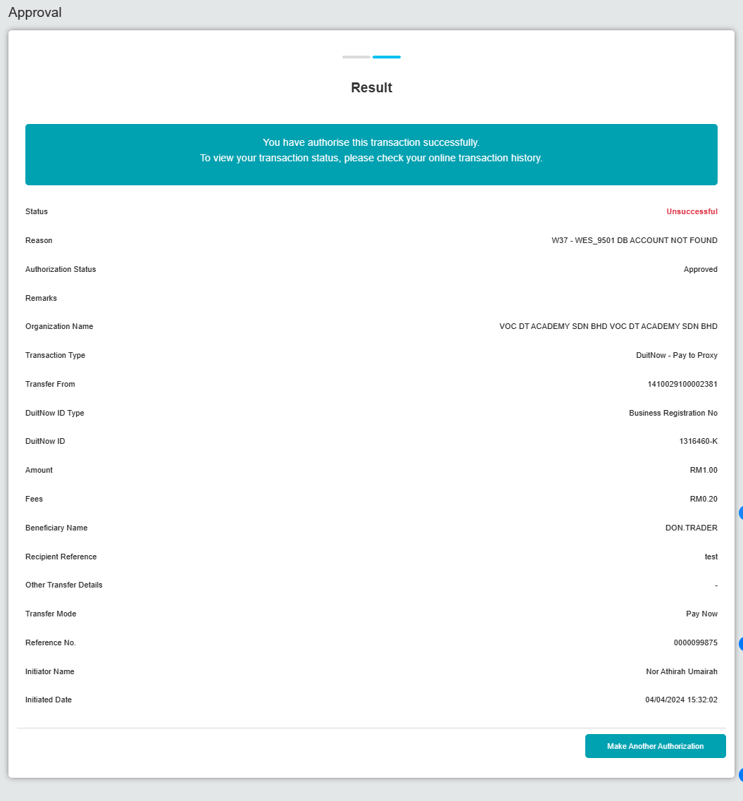  Figure 1: DuitNow Proxy with charges  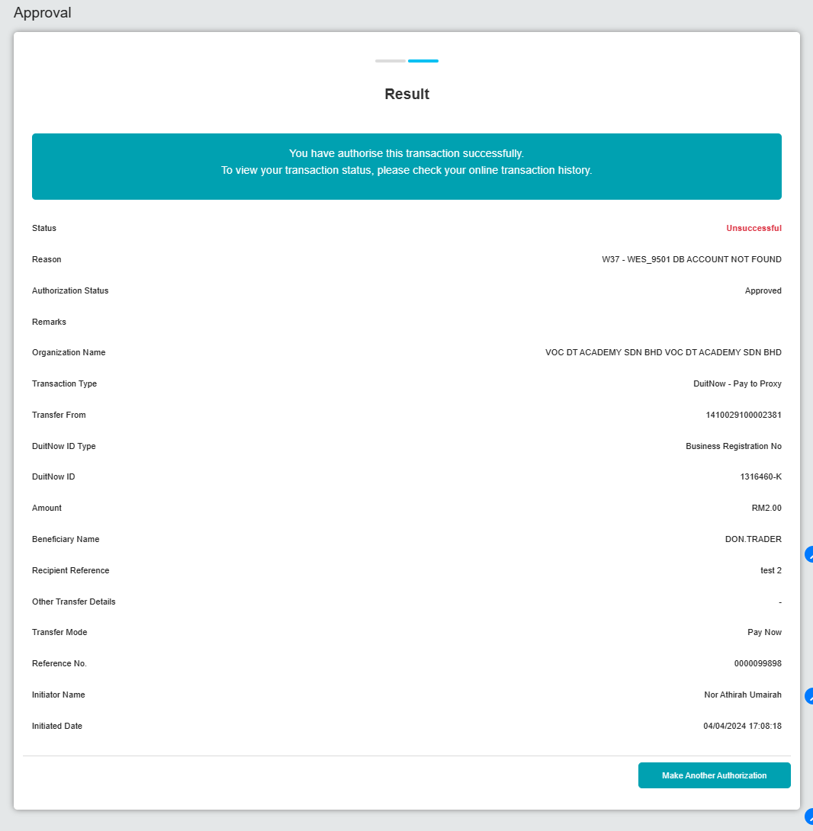  Figure 2: DuitNow Proxy without charges  Figure 3: DuitNow Exception Report  **Reversal for charges in DuitNow Proxy with charges  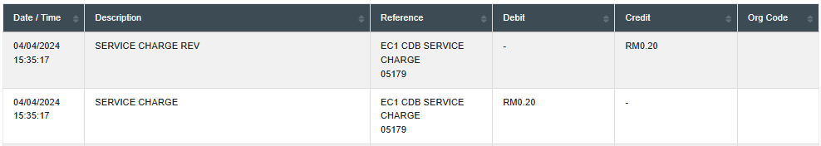  Figure 4: Transaction History

