|  |
| --- |
|  |
| **User Guide – Corporate User**  **for**  **BSNeBiz and BSNeBiz Mobile** |
| ***(PENRIL/BSN/UG_CDB021)***  ***Revision: 00*** |
| **16th April 2024**  Prepared By: **Penril Datability (M) Sdn Bhd (816792-X)**  Suite A-07-07 Plaza Mon’t Kiara  No. 2, Jalan Kiara, Mon’t Kiara  50480 Kuala Lumpur, Malaysia  Tel: (603) 6201 2622Fax: (603) 6201 7622 |

# Document Amendment Log

| **Rev. No** | **Date Update** | **Description of Change** | **Update By**  **<Name, Dept>** | **Review By**  **<Name, dept>** | **Approved By**  **<Name, Dept>** |
| --- | --- | --- | --- | --- | --- |
| 00 | 16/04/2023 | Initial Release | Amir Hakim Mior  Quality Engineer | Athirah Umairah  Quality Engineer | Norhaidah Dasuki  Senior Manager |
|  |  |  |  |  |  |

# Table of Content

Document Amendment Log 2

Table of Content 3

1 Perform First Time Login 4

Step 1 4

Step 2 5

Step 3 6

Step 4 6

Step 5 7

Step 6 8

Step 7 8

Step 8 9

2 Device pairing 10

Step 1 10

Step 2 10

Step 3 11

Step 4 12

Step 5 13

Step 6 14

Step 7 15

Step 8 16

Step 9 17

Step 10 18

Step 11 19

# Perform First Time Login

First Time Login is a function for BSNeBiz Online users to login to their BSNeBiz account for the first time after they have made a New Application. BSNeBiz offers customers almost every service traditionally available through a local branch including deposits, transfers, and online bill payments that you can access through a computer or app.

## Step 1

1. When user enters BSNeBiz, user can access 1st Time Login function by clicking ‘1st Time Login‘ at the bottom left corner of the screen.

Figure 1: BSNeBiz Login Screen

## Step 2

1. User read the Terms & Conditions.
2. User may download and print the Terms & Conditions by clicking the icons located at the top right part of the screen.
3. Click ‘YES, I agree with Terms and Conditions’ radio button and click Continue button to go to the next screen.
4. If user do not wish to proceed, user may click Cancel button.

Figure 2: FTL Terms & Conditions screen.

## Step 3

1. User choose Corporate User as the type of User Type they want to First Time Login.
2. Corporate User is an account that can access BSNeBiz and all related functions on behalf of their business entity.
3. Some Corporate User accounts need to do device pairing in order to perform a transaction. These accounts are :
   1. Single User
   2. Approver

Figure 3: FTL User Type Screen

## Step 4

1. User enters Username.
2. User enters Temporary Password they have received in their assigned email.
3. Click ‘Next’ button to go to the next screen.
4. If user do not wish to proceed, user may click ‘Back’ button.

Figure 4: FTL credential screen.

1. User may refer the Temporary Password they have received in their assigned email as shown below:

Figure 5: FTL temporary password email screen.

## Step 5

1. User enters New Password.
2. User enters Confirm New Password.
3. Click ‘Next’ button to go to the next screen.
4. If user do not wish to proceed, user may click ‘Back’ button.

Figure 6: FTL Register Password screen.

## Step 6

1. User enters Security Phrase.
2. Click ‘Next’ button to go to the next screen.
3. If user do not wish to proceed, user may click ‘Back’ button.

Figure 7: FTL Security Phrase screen.

## Step 7

1. User selects Security Questions for question 1 until 3.
2. User fill in Answer and Confirm Answer for Security Questions for question 1 until 3.
3. Click ‘Next’ button to go to Acknowledgement screen.
4. If user do not wish to proceed, user may click ‘Back’ button to go back to previous screen.

Figure 8: FTL Register Security Question screen.

## Step 8

1. Click ‘Proceed to Login’ button to go to Login screen.

Figure 9: FTL Acknowledgement Screen

# Device pairing

Device pairing is a function that allows BSNeBiz web user to sync Single User / Approver / Corporate Administrator account that could be accessed through their mobile phone to BSNeBiz web . This allows them to access features in the BSNeBiz web. By pairing the device, user acts as an approver to perform a transaction.

## Step 1

1. When a Single User / Approver / Corporate Administrator enters BSNeBiz, they can access Device Pairing by clicking ‘Device Pairing‘ icon under the New Application icon.

Figure 10: BSNeBiz Login Screen

## Step 2

1. User enters Username
2. User enters Password.
3. Click ‘Next’ button to go to the next screen.
4. If user do not wish to proceed, user may click ‘Cancel’ button.

Figure 11: BSNeBiz Username and Password Screen

## Step 3

1. System displays the QR for user to scan using their BsneBiz mobile application.
2. Click ‘Finish’ button after user scanned the QR.
3. If user do not wish to proceed, user may click ‘Cancel’ button to go to the previous screen.

Figure 12: BSNeBiz Token Registration Screen

1. If user haven’t downloaded the BSNeBiz mobile application, user may download & install BSNeBiz mobile application from Play Store / Apple Store with the following logo :

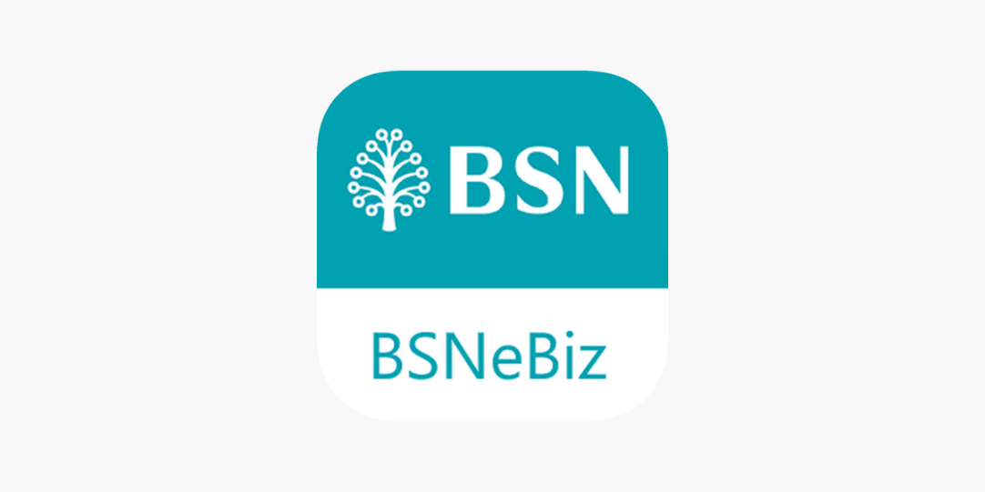

Figure 13: BSNeBiz mobile application logo Screen

## Step 4

1. User opens their BSNeBiz mobile application.
2. User enters Username.
3. User enters Password.
4. Click ‘Submit’ button to login.

Figure 14: BSNeBiz Mobile Login Screen

## Step 5

1. User click the ‘Mobile Token' button.

Figure 15: BSNeBiz Mobile Home Screen

## Step 6

1. User click the ‘Register Device' button located at the bottom part of the screen.

Figure 16: BSNeBiz Mobile Token Screen

## Step 7

1. User scan the QR that appeared at the screen on BSNeBiz web.

Figure 17: BSNeBiz QR scan Screen

## Step 8

1. User enter a new passcode.

Figure 18: BSNeBiz Enter New Passcode Screen

## Step 9

1. User re-enter the new passcode.

Figure 19: BSNeBiz Re-enter New Passcode Screen

## Step 10

1. System will display the result pop-up.

Figure 20: BSNeBiz Device Pairing Result Screen

## Step 11

1. Once Single User / Approver / Corporate Administrator user has done device pairing, user may login to BSNeBiz. Other type of users have a different interface after clicking ‘Next’ button.

Figure 21: BSNeBiz Login Screen