
Corporate Digital Banking
BSNeBiz

(CORPORATE ADMIN)
User Guide
(PENRIL/BSN/BRFD_CDB(SU)006)
Revision: 00

17th April 2024

Prepared By:

Penril Datability (M) Sdn Bhd (816792-X)
Suite A-07-07 Plaza Mon’t Kiara
No. 2, Jalan Kiara, Mon’t Kiara
50480 Kuala Lumpur, Malaysia
Tel: (603) 6201 2622Fax: (603) 6201 7622

Document Amendment Log
Rev. No | Date Update | Description of Change | Update By  <Name, Dept> | Review By  <Name, dept> | Approved By  <Name, Dept>
00 | 17/4/2023s | Initial Release | Nurul Aziana  QA Executive |  | Tan Lee Yong  Project Manager

Table of Content
Document Amendment Log 2
Table of Content 3
1. New Application 4
1.1. Process Flow 4
1.2. Screen Flow 4
2 Login 4
2.1 Process Flow 4
2.2 Screen Flow 4
1. Receiving Email 5
3.1 First Time Login 5
3.1.1 Process Flow 5
3.1.2 Screen Flow 5
3.2 Login 6
3.2.1 Process Flow 6
3.2.2 Screen Flow 6

New Application
  - Process Flow
Diagram 1: New Application
  - Screen Flow
Step 1: User open the BSNeBiz website
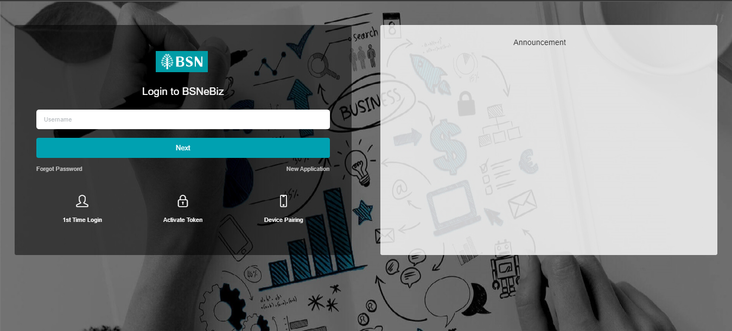
Figure 1: BSNeBiz Homepage

Step 2: User click on New Application and fill in the form.

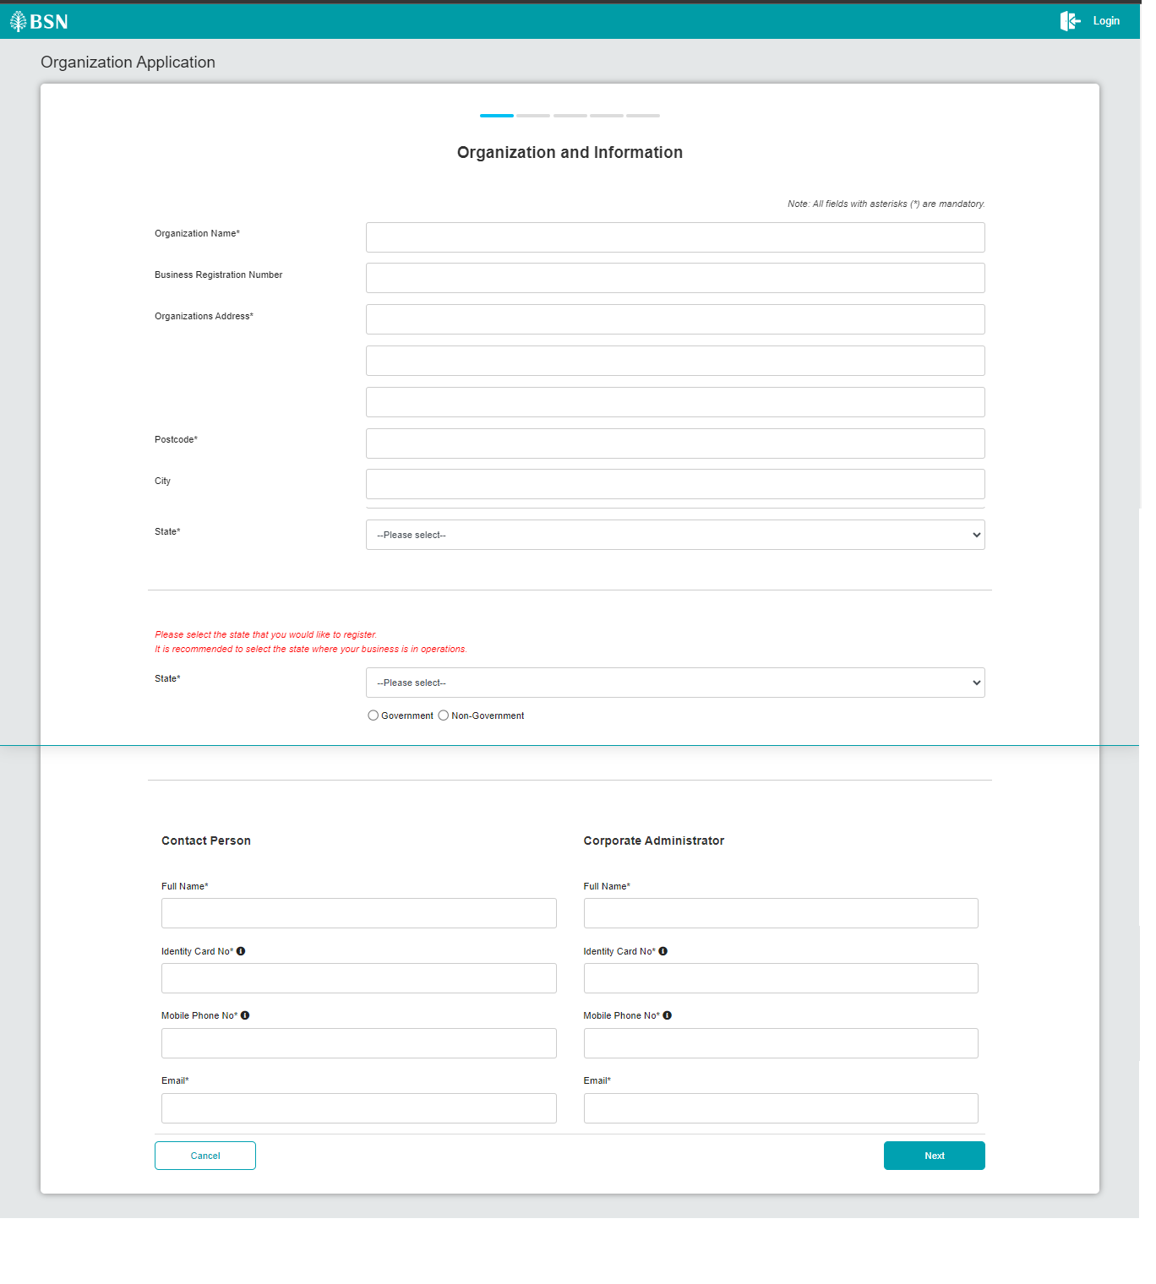 Figure 2: BSNeBiz Homepage
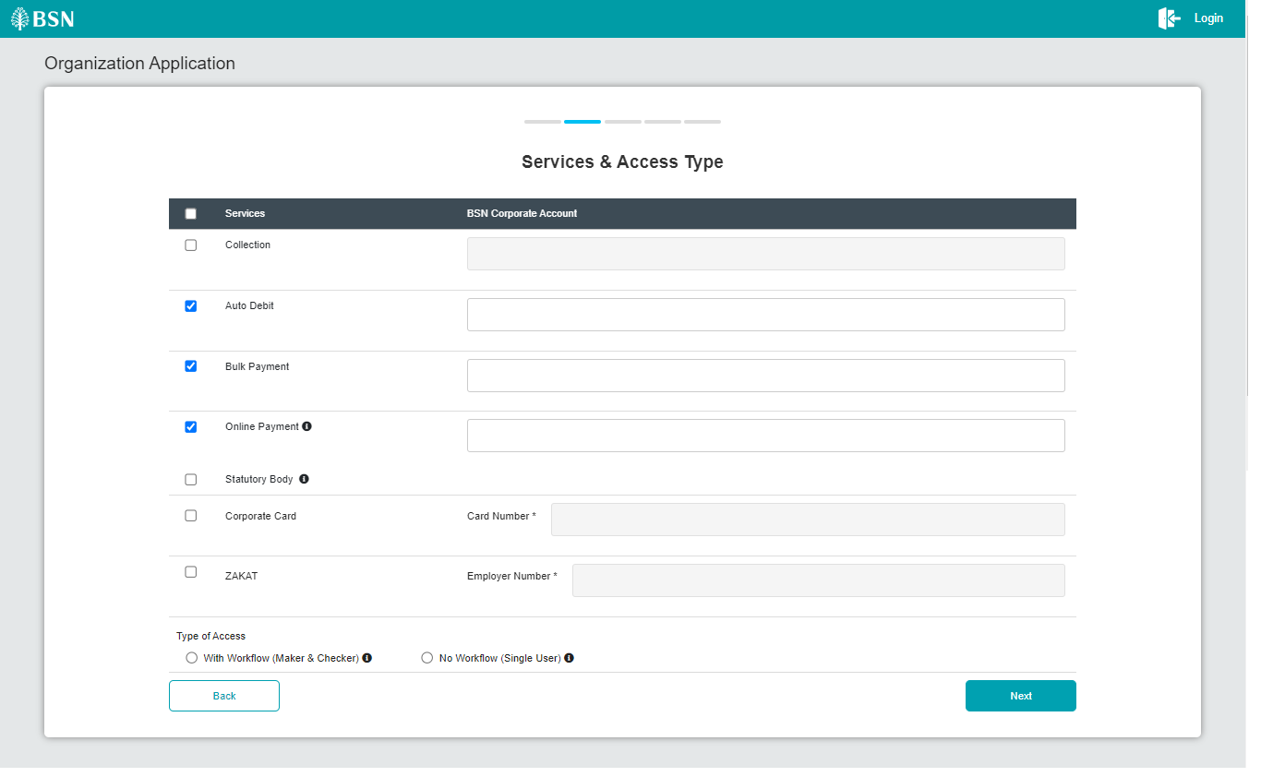
Figure 3: Service & Access Type

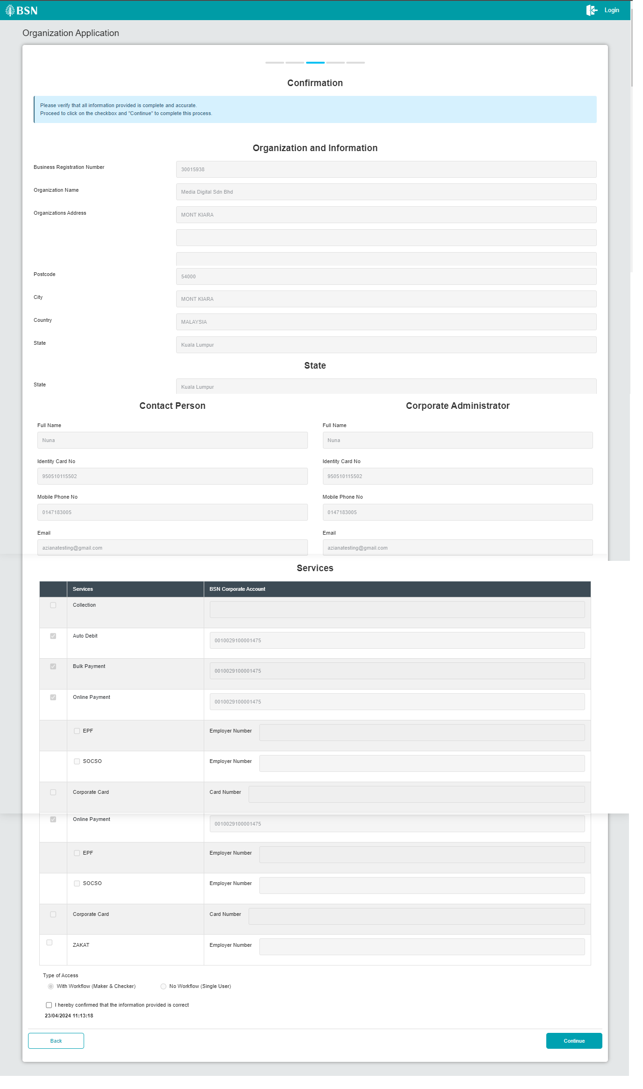
Figure 4: Confirmation

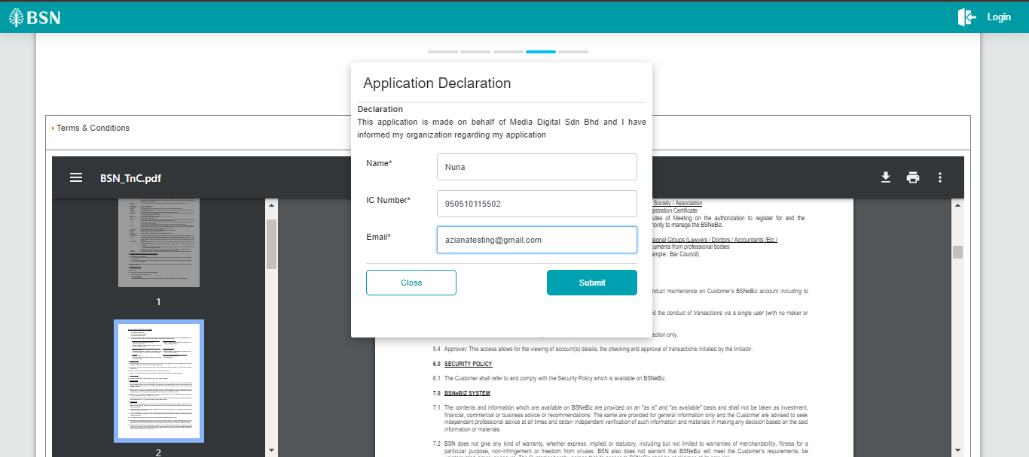
Figure 5: Popup Application Declaration

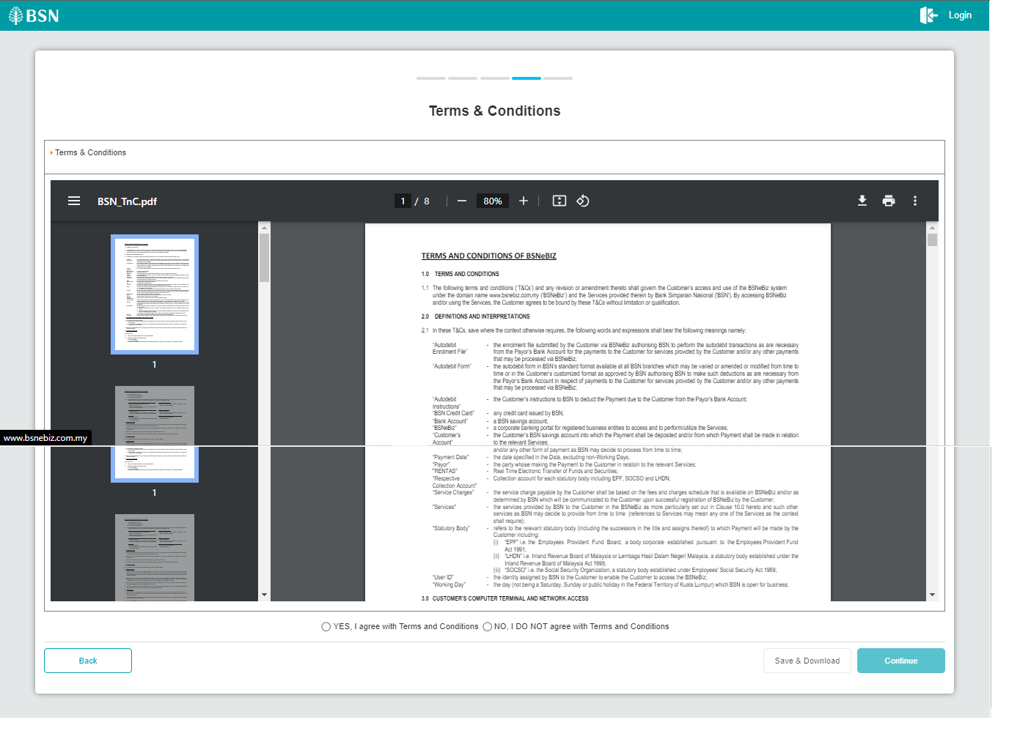

Figure 6: Terms and Conditions
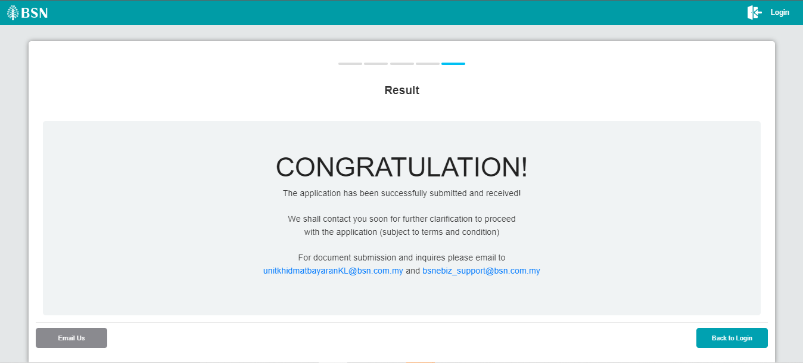
Figure 7: Successful message

Login
  - Process Flow
  - Screen Flow
Step 1:

Receiving Email

First Time Login

Process Flow

Screen Flow

Login

Process Flow

Screen Flow

