
Corporate Digital Banking
BSNeBiz

(CORPORATE ADMIN)
User Guide
(PENRIL/BSN/BRFD_CDB(SU)006)
Revision: 00

25th April 2024

Prepared By:

Penril Datability (M) Sdn Bhd (816792-X)
Suite A-07-07 Plaza Mon’t Kiara
No. 2, Jalan Kiara, Mon’t Kiara
50480 Kuala Lumpur, Malaysia
Tel: (603) 6201 2622Fax: (603) 6201 7622

Document Amendment Log
Rev. No | Date Update | Description of Change | Update By  <Name, Dept> | Review By  <Name, dept> | Approved By  <Name, Dept>
00 | 17/4/2023s | Initial Release | Nurul Aziana  QA Executive |  | Tan Lee Yong  Project Manager

Table of Content
Document Amendment Log 2
Table of Content 3
1. New Application 4
1.1. Process Flow 4
1.2. Screen Flow 4
2 Login 4
2.1 Process Flow 4
2.2 Screen Flow 4
1. Receiving Email 5
3.1 First Time Login 5
3.1.1 Process Flow 5
3.1.2 Screen Flow 5
3.2 Login 6
3.2.1 Process Flow 6
3.2.2 Screen Flow 6

New Application
  - Process Flow
Diagram 1: New Application
  - Screen Flow
Step 1:
- User access to the Registration form by clicking on the “New Application” link. CDB system displays the online Registration form.

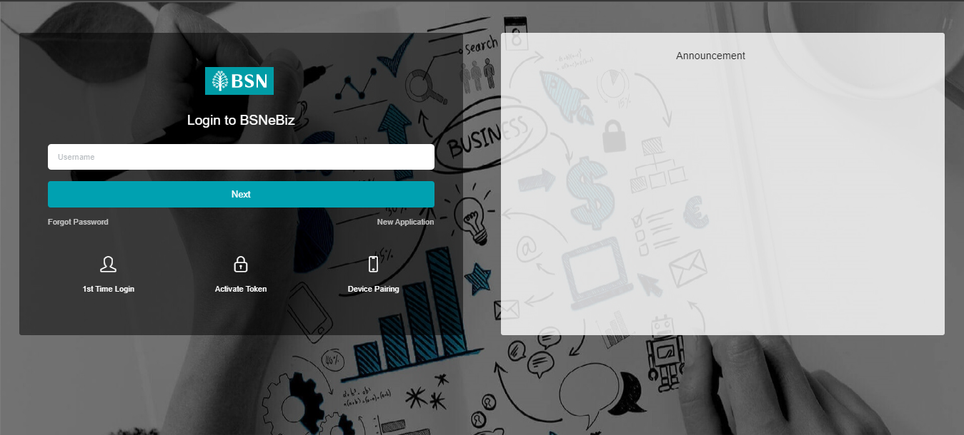
Figure 1: BSNeBiz Login Screen

Step 2:
1. Customer inputs the required organization and information fields, and click “Next” button, or click “Back” button to go previous page.
2. CDB System will save the data input.

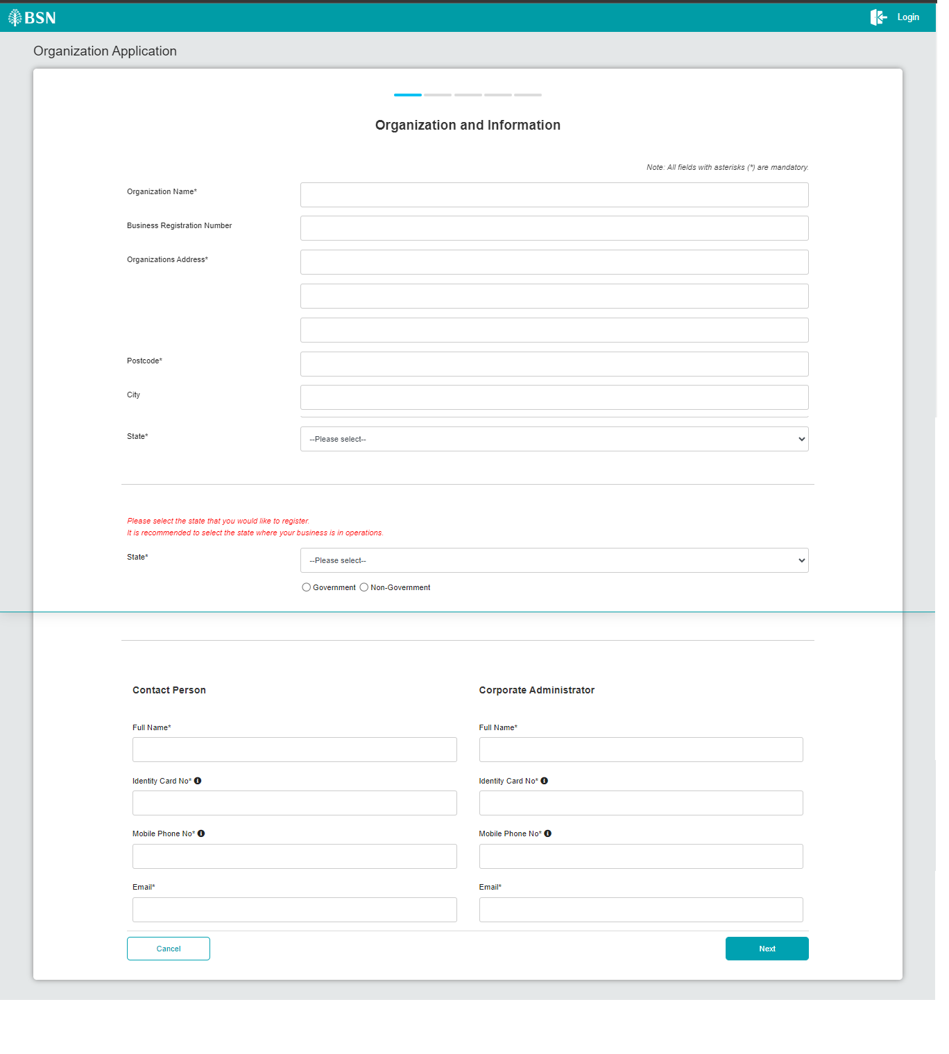
Figure 2: New Application Form – Organization and Information screen

Step 3:
1. User select the subscribing services, input the BSN Corporate Account No fields, select the type of access and clicks the “Next” btton to go to next page, or click the “Back” button to go to the previous page.
2. CDB system will save the data input.

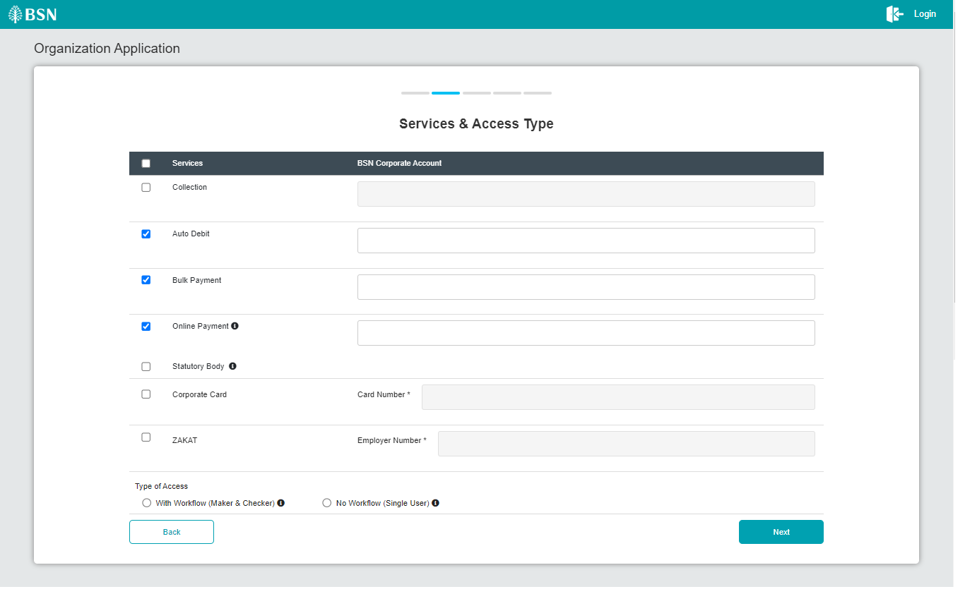
Figure 3: New Application Form – Services & Access Type Screen

Step 4:

1. CDB displays the Application’s summary screen.
2. Customer confirms the registration by clicking on the “Next” button or clicks on the “Back” button to go back to the previous page.
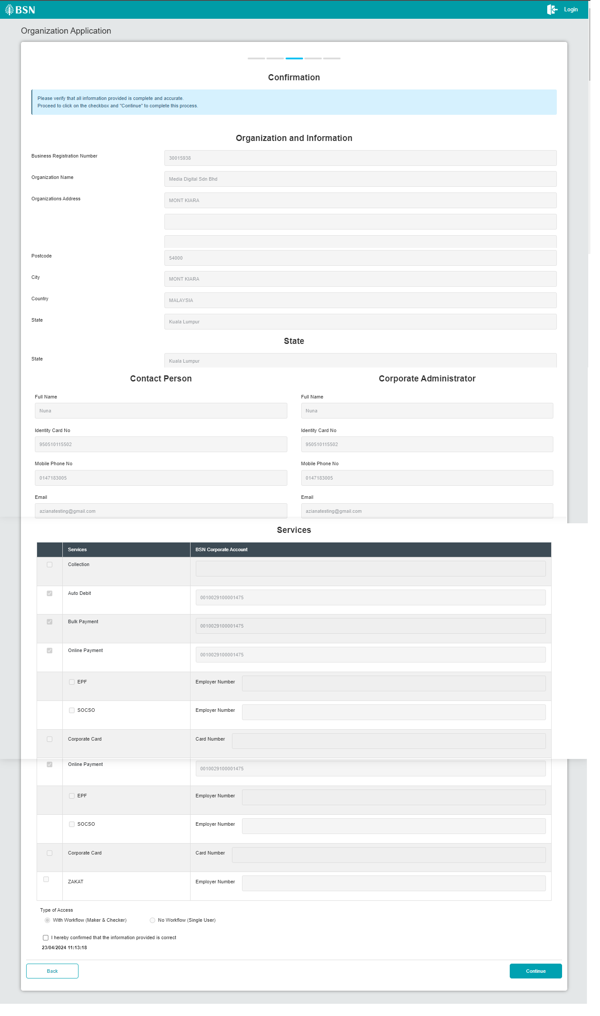
Figure 4: New Application Form – Summary Screen

Step 5:

1. CDB display Terms & Conditions screen.

2. If user tick on “NO, I DO NOT AGREE….”, system will prompt “Thank You!...”.
3. If user tick on “ YES, I agree…” to accept the Terms and Conditions of the usage.
4. CDB display Applicant Declaration form. Customer input the details (Name, IC Number, Email) and click on “Save & Print” button.
5. The system will download the completed registration form as PDF file.
6. Customer clicks on “Submit” button to submit the application for processing.

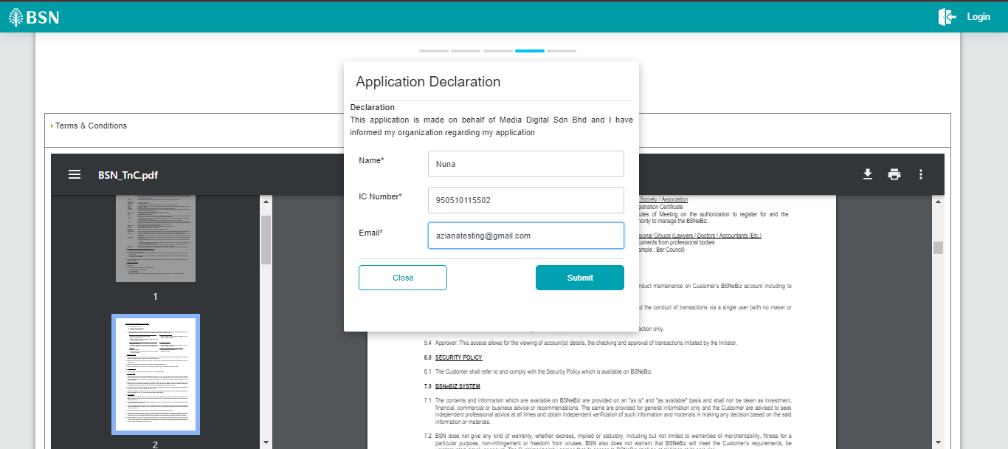
Figure 5: New Application Form – Applicant Declaration Screen

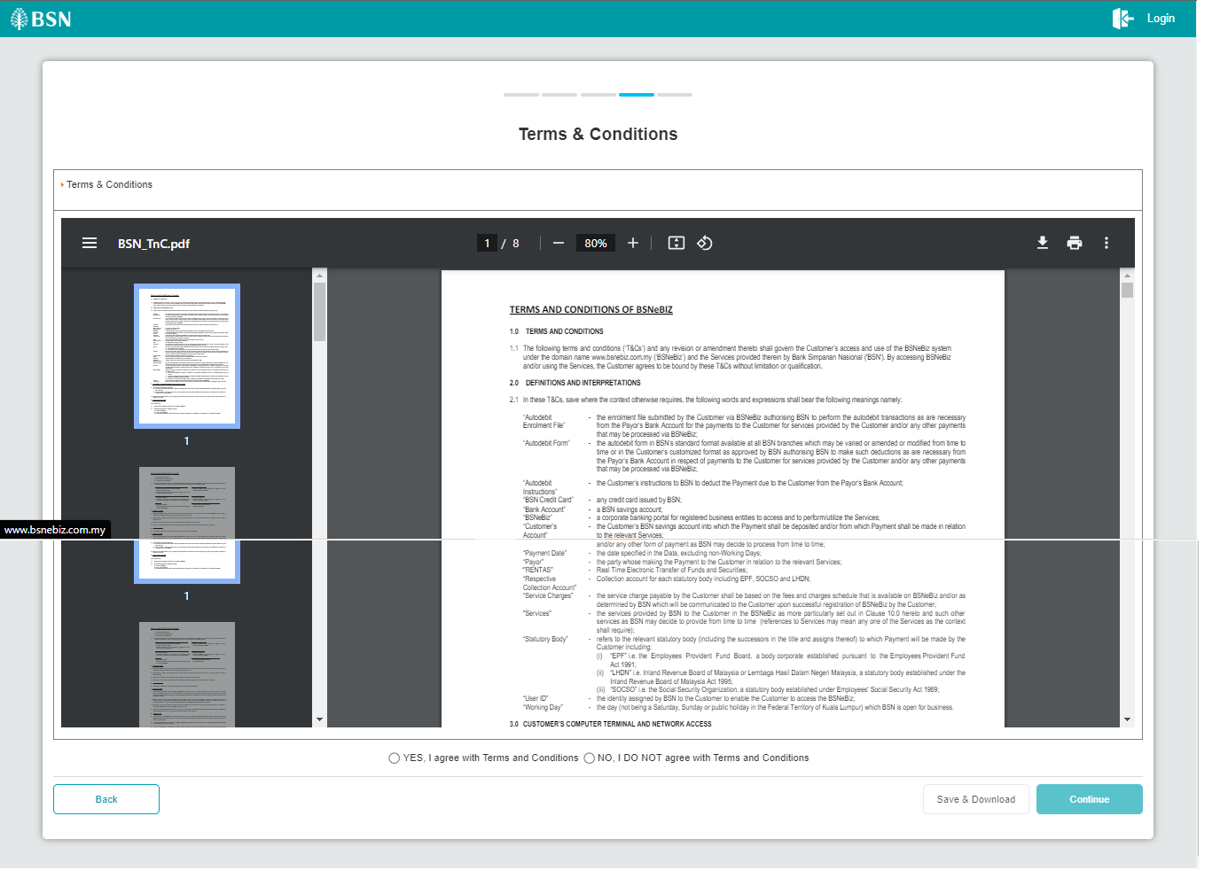

Figure 6: New Application Form - Terms and Conditions

Step 6:

1. CDB system display Result screen.
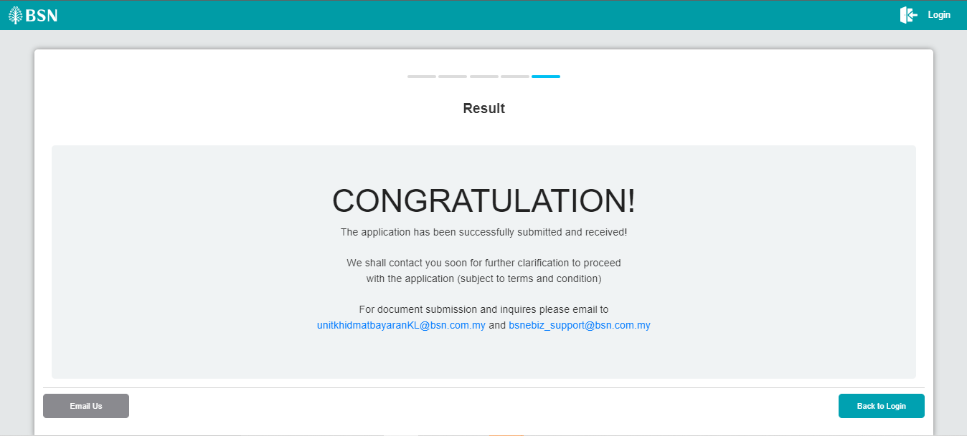
Figure 7: New Application Form – Result Screen

Login
  - Process Flow
  - Screen Flow
Step 1:

Receiving Email

First Time Login

Process Flow

Screen Flow

Login

Process Flow

Screen Flow

