SCPID#7001
Test Title: |  | Finance Entry No Cutoff - To set cutoff timing for finance entry
Test Description: |  | Issue:  Customer/user still able to perform finance entry even after EOD cutoff timing.  Solution:  Set error message if customer/user perform finance entry after EOD cutoff.
Test Functionality: |  | To ensure error message displayed and user unable to perform finance entry after EOD cutoff.
Test Procedure: |  | Test steps:  - Perform the Finance entry after EOD cutoff timing.  - If the result is error ‘Failed to process due to cutoff time or invalid date.’ then it is within expected result.
Response Message:
Test Result: | Pass: Fail: |  | Tested by: | Nor Athirah Umairah (15/04/2024-26/04/2024)
Reason for Failure:
Remarks: |  | Before EOD cutoff After EOD cutoff  Administrator Success (Scenario 1) Unsuccess (Scenario 4)  Maker Success (Scenario 2) Unsuccess (Scenario 5)  Checker (Approve) Success (Scenario 3) Unsuccess (Scenario 6)  Checker (Reject) Success (Scenario 7) Success (Scenario 8)  Scenario 1: Administrator (Before EOD)  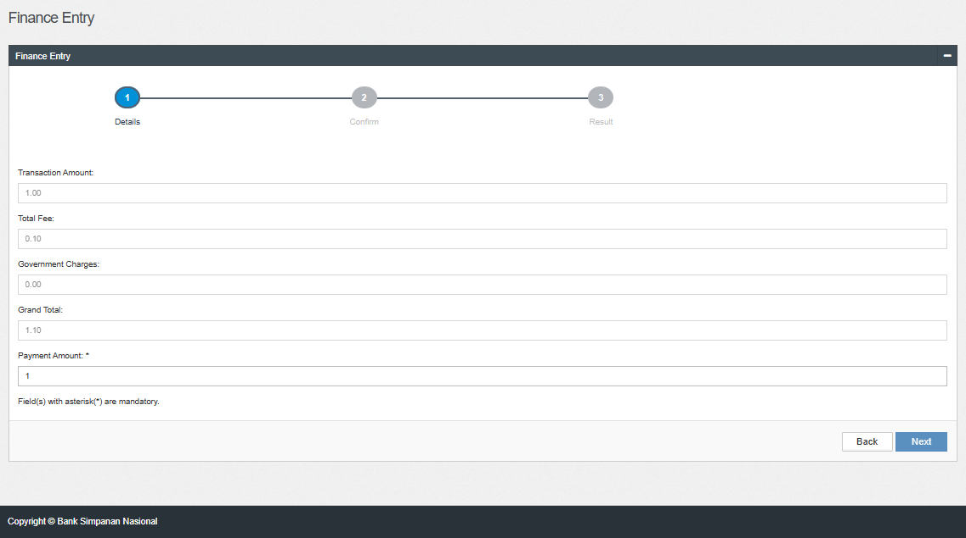  Figure 1: Finance Entry – Details  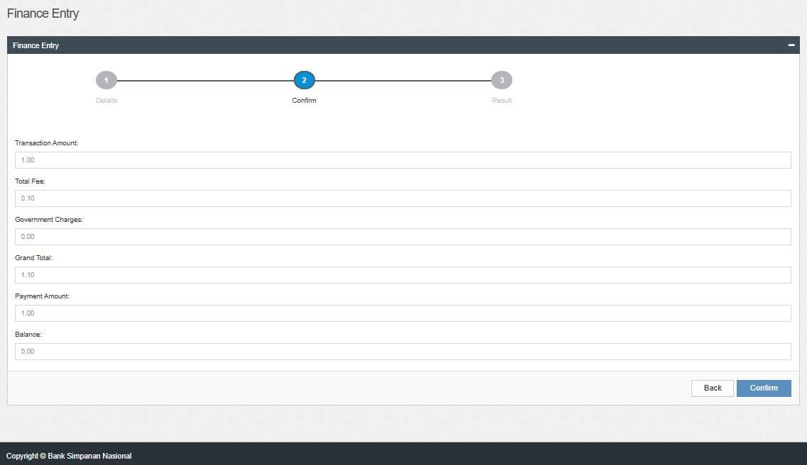  Figure 2: Finance Entry – Confirm  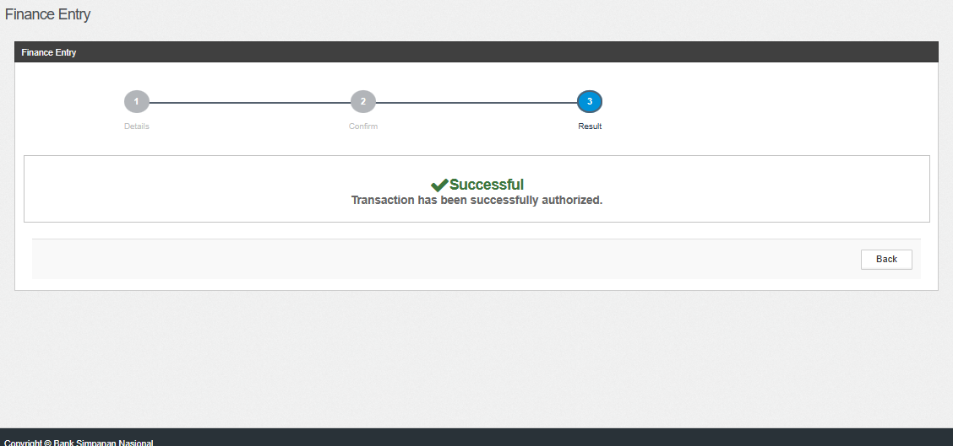  Figure 3: Finance Entry – Result  Scenario 2: Maker (Before EOD)  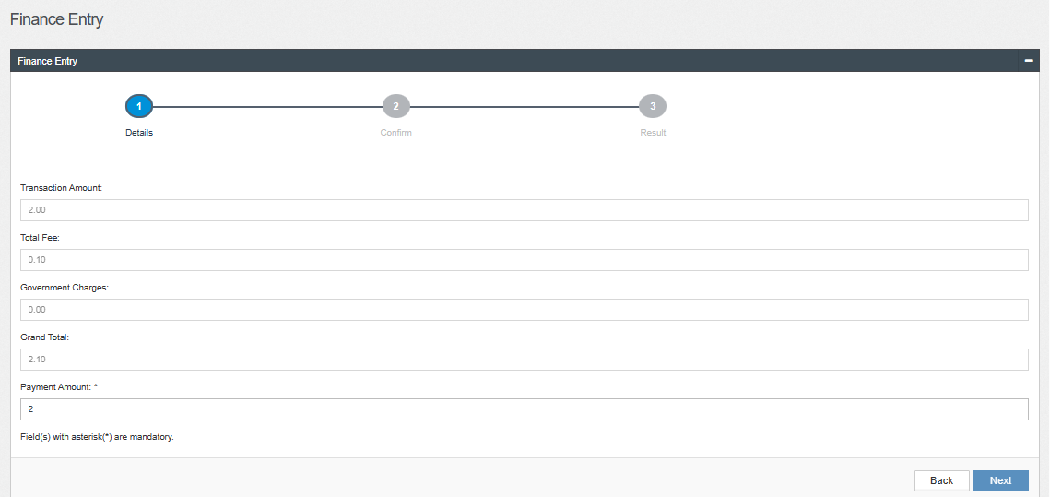  Figure 4: Finance Entry – Details  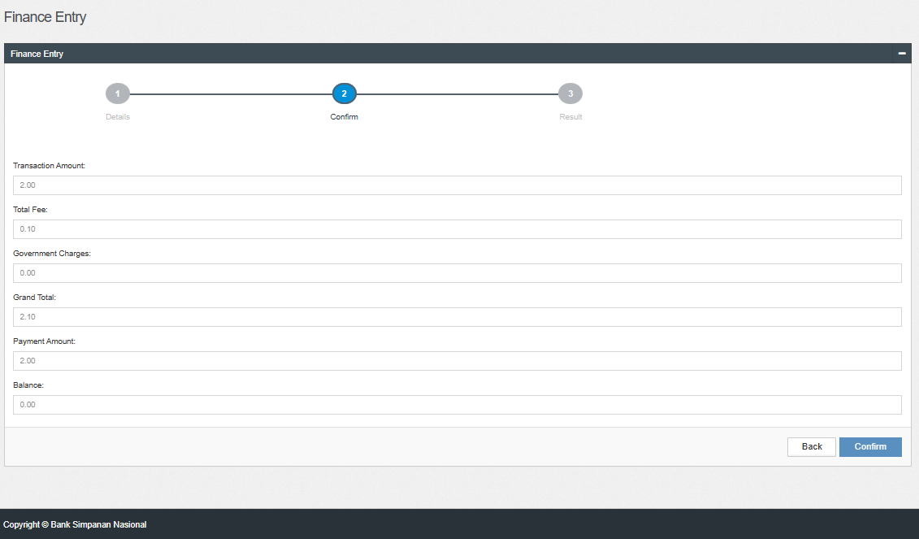  Figure 5: Finance Entry – Confirm  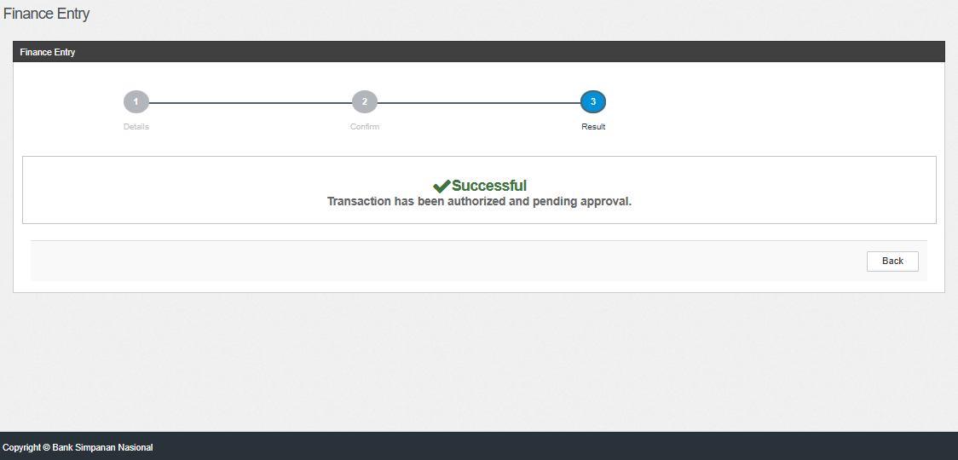  Figure 6: Finance Entry – Result  Scenario 3: Checker - Approve (Before EOD)  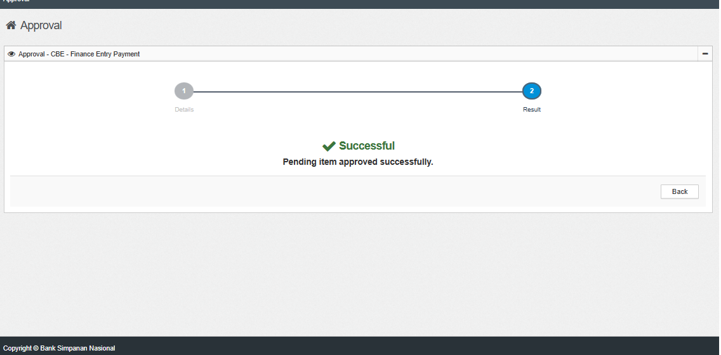  Figure 7: Approval – Result  Scenario 4: Administrator (After EOD)  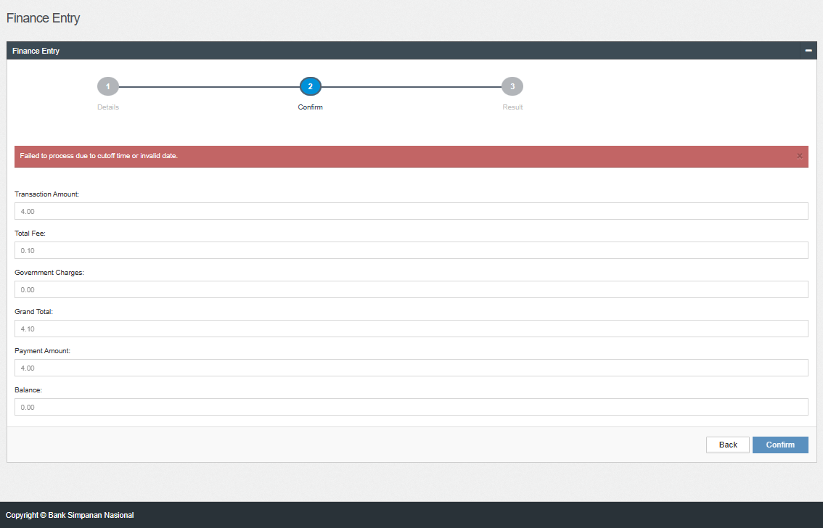  Figure 8: Finance Entry – Confirm  Scenario 5: Maker (After EOD)  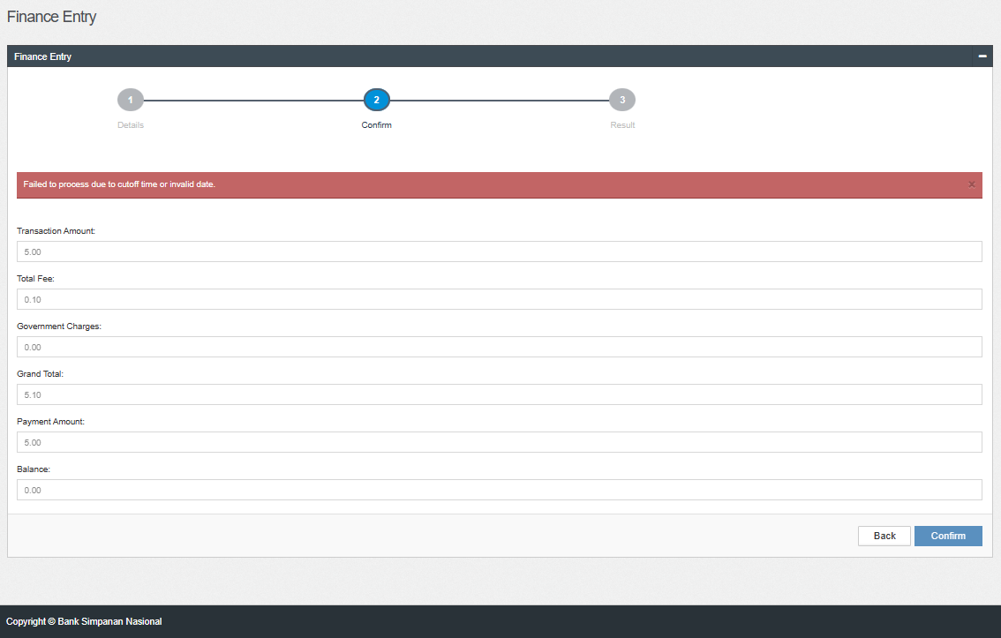  Figure 9: Finance Entry – Confirm  Scenario 6: Checker - Approve (After EOD)  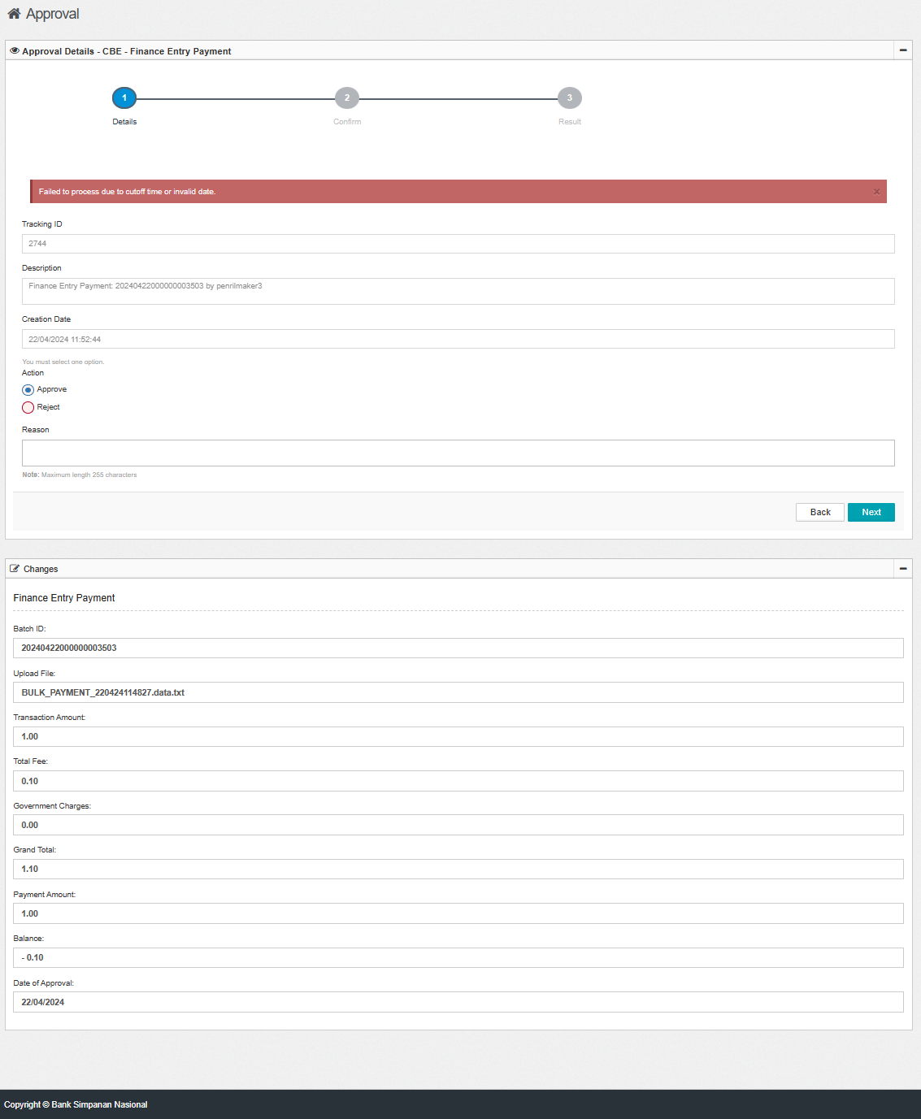  Figure 10: Approval – Result  Scenario 7: Checker - Reject (Before EOD)  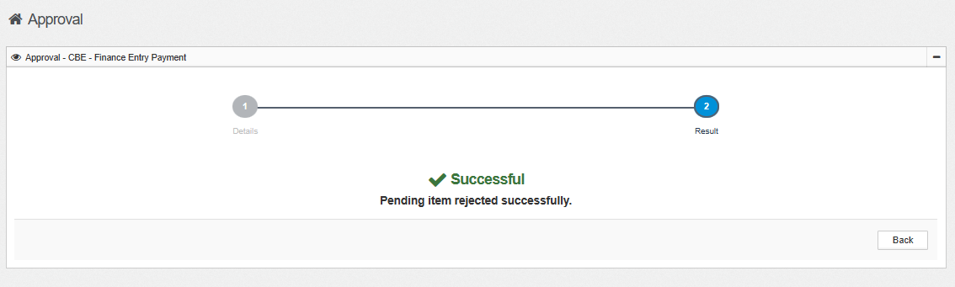  Figure 11: Approval – Result  Scenario 7: Checker - Reject (After EOD)  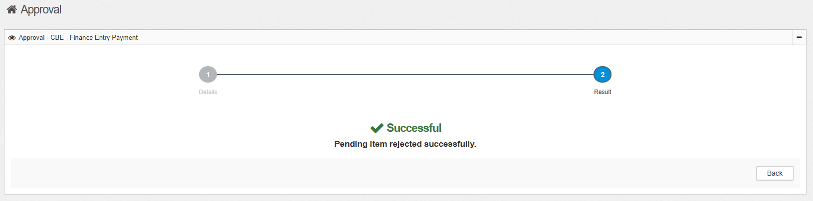  Figure 12: Approval – Result  Figure 13: Approval Log

