
Corporate Digital Banking
BSNeBIZ – Dormant Account
CR24002

Business Requirement and Functional Document
(PENRIL/BSN/BRFD_BSNEBIZ(P2)037)
Revision: 00

22th March 2024

Prepared By:

Penril Datability (M) Sdn Bhd (816792-X)
Suite A-07-07 Plaza Mon’t Kiara
No. 2, Jalan Kiara, Mon’t Kiara
50480 Kuala Lumpur, Malaysia
Tel: (603) 6201 2622Fax: (603) 6201 7622

Document Amendment Log
Rev. No | Date Update | Description of Change | Update By  <Name, Dept> | Review By  <Name, dept> | Approved By  <Name, Dept>
00 | 22/4/2024 | Initial Release | Nurin Sabrina, Nurin Nadia  Quality Engineer

Table of Content
Document Amendment Log 2
Table of Content 3
Business Requirement & Functional Acceptance 5
Section A: Introduction 6
1 Introduction 6
1.1 Objective 6
1.2 Assumptions 7
1.3 Scope of Works 8
Section B: Internet Banking Administration Module (IBAM) 9
2 SOW01: Enhancement at IBAM 9
2.1 SOW01.1: To enhance on existing Account Management 9
2.1.1 SOW01.1: View & Edit Dormant Account at Account Management 9
2.1.2 Process Flow 9
2.1.3 Screen Flow 9
2.2 SOW01.2: To enhance on existing User Maintenance 14
2.2.1 SOW01.2: View & Edit Dormant Account at User Maintenance 14
2.2.2 Process Flow 14
2.2.3 Screen Flow 14
Section C: BSNeBiz 22
3 SOW01: Enhancement at BSNeBiz 22
3.1 SOW01.3: To enhance on existing User Maintenance 22
3.1.1 SOW01.3: View & Edit Dormant Account at User Maintenance 22
3.1.2 Process Flow 22
3.1.3 Screen Flow 22
4.1 SOW02.0: To enhance on existing Account Summary 31
4.1.1 SOW02.0: To enhance on existing Account Summary 31
4.1.2 Process Flow 31
4.1.3 Screen Flow 31
4.2 SOW02.0: To enhance on existing Account Details 33
4.2.1 SOW02.0: To enhance on existing Account Details 33
4.2.2 Process Flow 33
4.2.3 Screen Flow 33
4.3 SOW02.0: To enhance on existing Transaction History 38
4.3.1 SOW02.0: To enhance on existing Transaction History 38
4.3.2 Process Flow 38
4.3.3 Screen Flow 38
4.4 SOW02.0: To enhance on existing BSNeBiz Transaction History 44
4.4.1 SOW02.0: To enhance on existing BSNeBiz Transaction History 44
4.4.2 Process Flow 44
4.4.3 Screen Flow 44
4.5 SOW02.0: To enhance on existing e-Statement 47
4.5.1 SOW02.0: To enhance on existing e-Statement 47
4.5.2 Process Flow 47
4.5.3 Screen Flow 47
4.6 SOW02.0: To enhance on existing Balance Inquiry 51
4.6.1 SOW02.0: To enhance on existing BSNeBiz Account Details 51
4.6.2 Process Flow 51
4.6.3 Screen Flow 51
5.1 SOW03.0: To enhance on existing Transaction Details (Monetary & Non-Monetary) 57
5.1.1 SOW03.0: To enhance on existing Transaction Details (To Account & From Account) 57
5.1.2 Process Flow 57
5.1.3 Screen Flow 57
Section D: BSNeBiz Mobile 63
6 SOW02: Enhancement at BSNeBiz Mobile 63
6.1 SOW02.0: To enhance on existing Account Summary 63
6.1.1 SOW02.0: To enhance on existing BSNeBiz Account Summary 63
6.1.2 Process Flow 63
6.1.3 Screen Flow 63
6.2 SOW02.0: To enhance on existing Account Transaction History 67
6.2.1 SOW02.0: To enhance on existing Account Transaction History 67
6.2.2 Process Flow 67
6.2.3 Screen Flow 67
6.3 SOW02.0: To enhance on existing BSNeBiz History 69
6.3.1 SOW02.0: To enhance on existing BSNeBiz History 69
6.3.2 Process Flow 69
6.3.3 Screen Flow 69
6.4 SOW02.0: To enhance on existing e-Statement 71
6.4.1 SOW02.0: To enhance on existing e-Statement 71
6.4.2 Process Flow 71
6.4.3 Screen Flow 71
7.1 SOW03.0: To enhance on existing Transaction Details (Monetary & Non-Monetary) 74
7.1.1 SOW03.0: To enhance on existing Transaction Details – Transaction Account List (To Account) 74
7.1.2 Process Flow 74
7.1.3 Screen Flow 74

Business Requirement & Functional Acceptance

I/We hereby verify that this Business Requirement & Functional consist of all the requirements requested by BANK SIMPANAN NASIONAL. The implemented system will fulfill ONLY this requirement.

I/We also hereby AGREE that this satisfies our entire requirement for Enhancement IBAM & BSNeBiz Web and Mobile Dormant Account. Any future changes to this agreed scope would be treated as an enhancement to the system. Any future changes to the project timeline will be subjected to the final approval of the project steering committee.

BANK SIMPANAN NASIONAL:
Approved by | Role | Signature | Date

Penril Datability (M) Sdn. Bhd.:
Approved by | Role | Signature | Date

- Section A: Introduction

Introduction
This document served as the business requirement and system specification of implementing BSNeBiz – Dormant Account.

This document shall explain all the features and functionalities, which is elaborating with screen captures, process flow, descriptions, input fields specifications and error messages. All screen designs provided in this document are samples and only illustration purpose for easy understanding. The screen designs are not final.

Objective
The objective of this document is to capture user requirements of transactional and administration modules of implementing BSNeBiz – Dormant Account. This document will facilitate development and implementation of the mentioned modules of Internet Banking System for BSNeBiz.

The base line features description and screen designs will become a reference blueprint for the development team to develop the transactional and administration module. Hence, it is crucial that all stakeholders need to ensure the correctness and adequacy of the requirements captured in this document.

All stakeholders involved are expected to review and sign off this document before the development starts. By signing off the document, the stakeholder has endorsed the correctness and accuracy and adequacy of the requirements documented in this document.

Assumptions
- IBAM – Account Management
- UKB is allows to view and edit Dormant Account in the organization accounts list.

- IBAM – User Maintenance
- UKB is allows to view and edit Dormant Account accessibility for the organization’s user.

- BSNeBiz – User Maintenance
  - CA is allows to view and edit Dormant Account accessibility for the organization’s corporate user.

- BSNeBiz – Account Summary
  - Dormant Account can be view by Corporate User.

- BSNeBiz – Transaction Details
  - Dormant Account can receive any transaction but cannot initiate one.
  - In Transaction Account List – “To Account” will display all accounts available including Dormant Account.
  - In Transaction Account List – “From Account” will exclude Dormant Account to ensure that Dormant Account cannot initiate any transaction.

- BSNeBiz Mobile – Account Summary
  - Dormant Account can be view by Corporate User.

- BSNeBiz Mobile – Transaction Details
  - Dormant Account is allowed to receive any transaction but cannot initiate any transaction.
  - In Transaction Account List – “To Account” will display all accounts available including Dormant Account.
  - In Transaction Account List – “From Account” will exclude Dormant Account to ensure that Dormant Account cannot initiate any transaction.

Scope of Works
System | Modules | Features | Description
IBAM | CBE – Organization Setup  - Account Management  - User Maintenance | Field | - To enhance on existing Account Management for Dormant Account  - To enhance on existing User Maintenance for Dormant Account
BSNeBiz | Account Summary | Field | - To enhance on existing BSNeBiz - Account Summary BSNeBiz for Dormant Account  - Account Summary screen  - Account Details screen  - Transaction History screen  - BSNeBiz History screen  - Balance Inquiry screen  - e-Statement screen
BSNeBiz | Transaction Details  - Monetary  - Non-Monetary | Field | - To enhance on existing Transaction Account List – “To Account” for Dormant Account  - To exclude Dormant Account in Transaction Account List – “From Account”
BSNeBiz (Mobile) | Account Summary | Field | - To enhance on existing BSNeBiz - Account Summary BSNeBiz for Dormant Account  - Account Summary screen  - Account Details screen  - Transaction History screen  - BSNeBiz screen  - Balance Inquiry screen  - e-Statement screen
BSNeBiz (Mobile) | Transaction Details  - Monetary  - Non-Monetary | Field | - To enhance on existing Transaction Account List – “To Account” for Dormant Account  - To exclude Dormant Account in Transaction Account List – “From Account”

Table 1: Enhancement of Dormant Account

- Section B: Internet Banking Administration Module (IBAM)

2 SOW01: Enhancement at IBAM

2.1 SOW01.1: To enhance on existing Account Management
This feature enables IBAM (CBE Admin) to view and edit Organization’s account list with IB inaccessible (Dormant) status.

2.1.1 SOW01.1: View & Edit Dormant Account at Account Management
Function ID | SOW01.1
Module Name | Account Management | Path | IBAM > CBE > Organization Setup > Organization Details > Account Management
Description | This feature allows IBAM (CBE Admin) to view and edit Organization’s accounts list with IB inaccessible (Dormant) status.

2.1.2 Process Flow
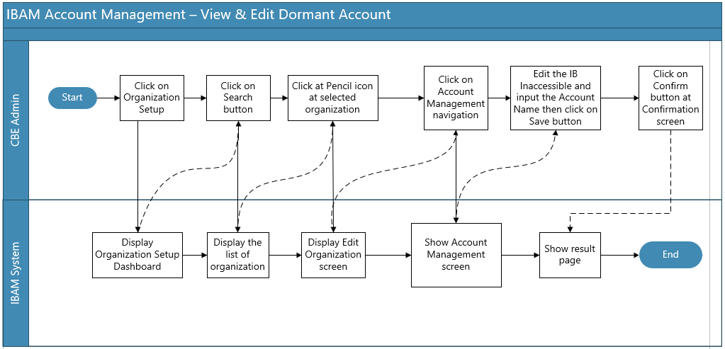
Diagram 1 : Account Management Flow Diagram

2.1.3 Screen Flow
Step 1:
- IBAM (CBE Admin) clicks on Organization Setup navigation at the left side of the screen.
- IBAM (CBE Admin) clicks on the “Pencil” icon button on the selected Organization.

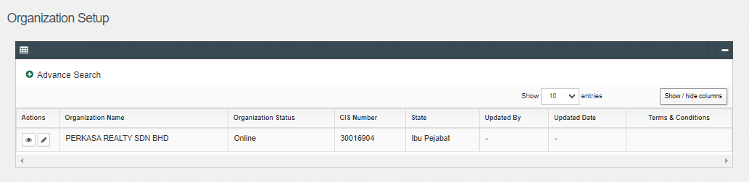
Figure 1 : Organization Setup – Search Result Screen

Display Specification:
No | Field | Field Type | Description
1. | Organization ID | Numeric | ID of an Organization
2. | Organization Name | Text | The name of an organization
3. | Business Registration Number | Alphanumeric | Display the Organization Registration Number
4. | Organization Status | Text | Define the availability of the existing Organization whether it is online or offline.
5. | CIS Number | Numeric | Common ID Number. The unique personal identifier for an organization.
6. | State | Text | Define the State of the organization.
7. | Updated By | Text | Show who updated the Organization
8. | Updated Date | DD/MM/YYYY HH:MM:SS | Shows the date and time when a particular IBAM (CBE Admin) was updated.
Table 2 : Organization Setup - Display Specification
Action:
No | Action | Type | Description
1. | “Pencil” icon | Button | Contain the action to display the selected Organization details
2. | “Eye” icon | Button | Contain the action to display the selected Organization details
3. | “Download” icon | Button | Contain the action to display the selected Organization terms & condition details
Table 3 : Organization Setup - Action

Step 2:
- IBAM (CBE Admin) go to “Account Management” screen.
- System displays Account Management screen.
- IBAM (CBE Admin) is allowed to edit the IB Inaccessible account and input the Account Name.
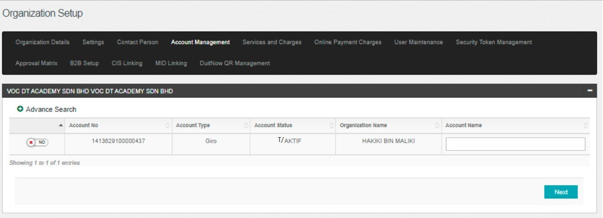
Figure 2 : Account Management screen
Display Specification:
No | Field | Field Type | Description
1. | Account No | Text | Displays the account number
2. | Account Type | Text | Displays the type of account.
3. | Account Status | Text | Displays the account status.
4. | Organization Name | Text | Displays the Organization name.
Table 4 : Account Management - Display Specification
Input Specification:
No | Field | Field Type | Validation Rule | Description | Required
1. | Account Name | Text | Max length: 64 | Display the account name | YES
Table 5 : Account Management - Input Specification
Action:
No | Action | Type | Description
1. | IB Inaccessible | Slide Checkbox | To enable or disable IB Inaccessible
2. | Next | Button | Contain action to service editor
Table 6 : Account Management - Action

Step 3:
- IBAM system displays the confirmation screen.
- IBAM (CBE Admin) click on “Confirm” button to proceed on changes or click on “Back” button to cancel the action.
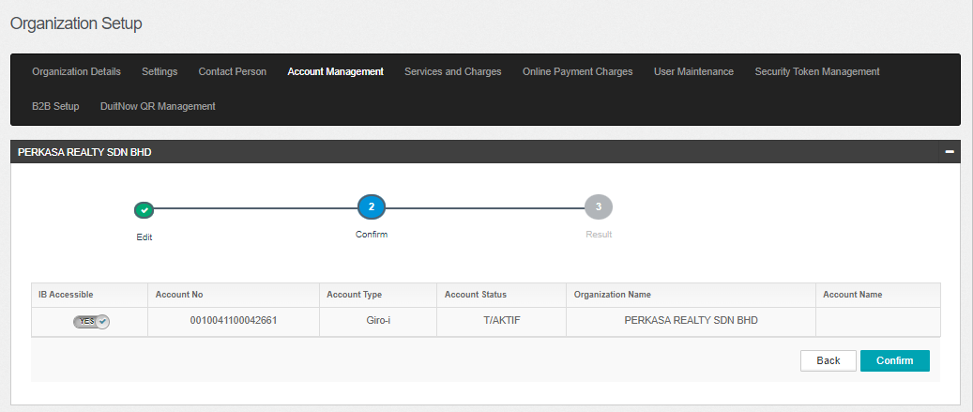
Figure 3 : Account Management Confirmation screen
Action:
No | Action | Type | Description
1. | Confirm | Button | Contain an action to save the changes made and display the result page
2. | Back | Button | Contain an action to cancel the changes made and display back on previous page.
Table 7 : Account Management Confirmation – Action

Step 4:
- IBAM System validates and save the changes to IB Database and displays result page.
- IBAM shows Successful message and pending for Authorization approval process.
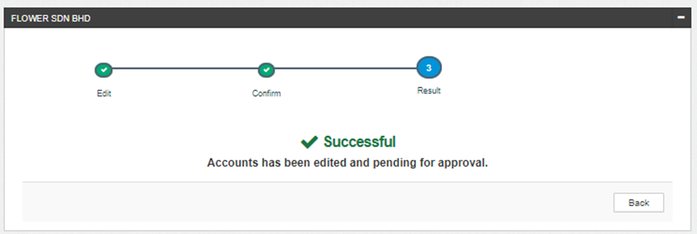
Figure 4 : Account Management – Edit Result screen

If Account Management Module Maker Checker Permission set as ‘Disable’
- IBAM saves the update information and displays the successful result page.
- IBAM shows Successful message and will shows update information without any approval process.

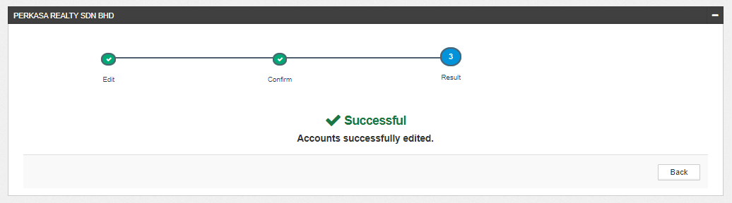
Figure 5 : Account Management - Edit Result with disable Checker Maker Permission Screen

Display Fields:
No | Field | Format | Description
1. | Result Step | Alphanumeric | To display result step
2. | Status | Alpha numeric | To display result status.
3. | Result Message | Alpha numeric | To display result message.
Table 8 : Account Management - Edit Result Display Field
Action:
No | Action | Type | Description
1. | Back | Button | Contains an action to Account Management main page
Table 9 : Account Management - Edit Result Action

2.2 SOW01.2: To enhance on existing User Maintenance
This feature enables IBAM (CBE Admin) to view and edit Organization’s account with inaccessible (Dormant) status for Corporate User role.

2.2.1 SOW01.2: View & Edit Dormant Account at User Maintenance
Function ID | SOW01.2
Module Name | User Maintenance | Path | IBAM > CBE > Organization Setup > Organization Details > User Maintenance
Description | This feature allows IBAM (CBE Admin) to view and edit Organization’s accounts list with IB inaccessible (Dormant) status.

2.2.2 Process Flow
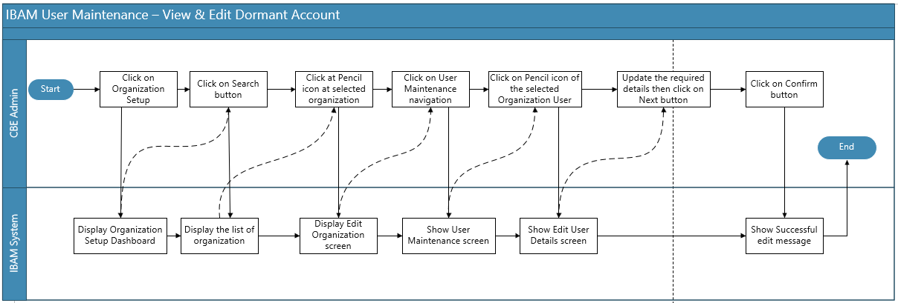
Diagram 2 : User Maintenance Flow Diagram

2.2.3 Screen Flow
Step 1:
- IBAM (CBE Admin) clicks on Organization Setup navigation at the left side of the screen.
- IBAM (CBE Admin) clicks on “Pencil” icon button on the selected Organization.
Figure 6 : Organization Setup - Search Result screen

Action:
No | Action | Type | Description
1. | “Pencil” icon | Button | Contain the action to edit the selected Organization details
2. | “Eye” icon | Button | Contain the action to display the selected Organization details
Table 10 : Organization Setup - Action

Step 2:
- IBAM (CBE Admin) clicks on the User Maintenance tab.
- IBAM shows the list of registered users under that Organization
- IBAM (CBE Admin) clicks on the “pencil’ icon button.
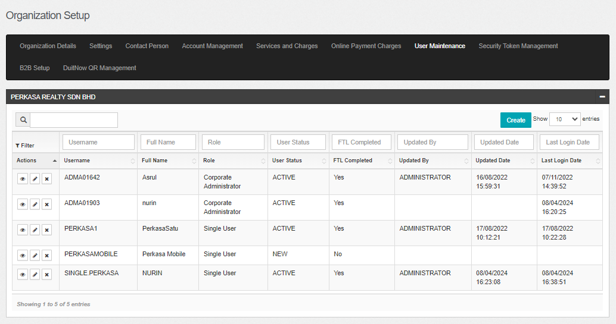
Figure 7 : User Maintenance screen

Action:
No | Action | Type | Description
1. | “Pencil” icon | Button | Contain the action to display Edit User Details page
Table 11 : User Maintenance - Action
Step 3:
- IBAM display the Edit User Detail screen.
- For Corporate User role, UKB User can choose either to edit in User Information, Allow Service or Accessible Account.
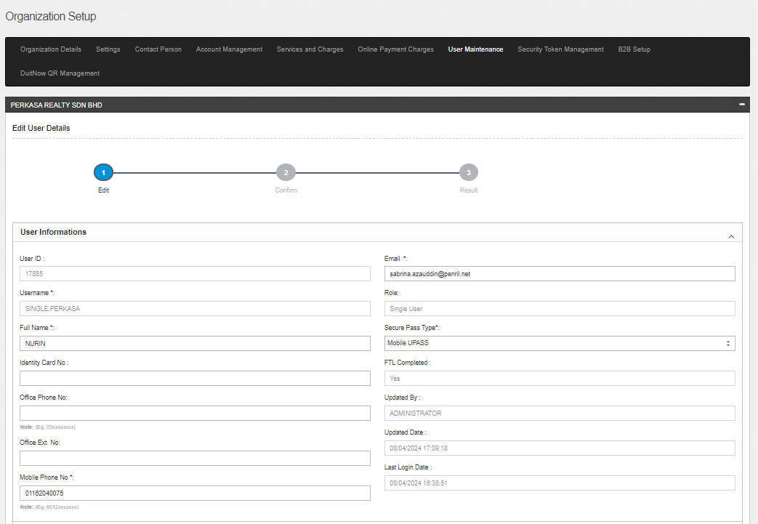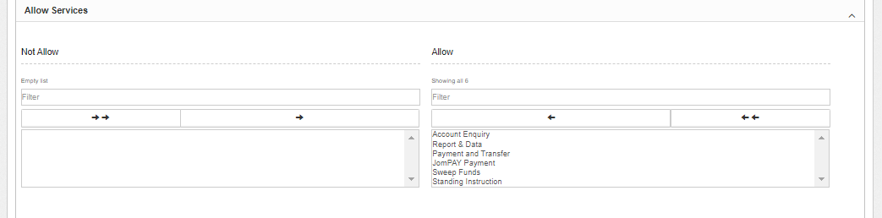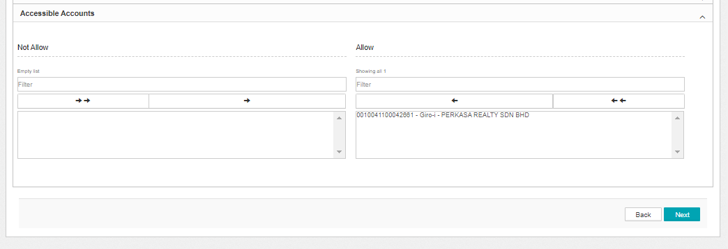
Figure 8 : User Maintenance - Edit Details screen

Display Fields:
No | Field | Format | Description
1. | User ID | Text | Display the User ID for the selected user.
2. | Username | Text | Display the Username for the selected user.
3. | Role | Text | Display the role for the selected user.
4. | FTL Completed | Text | Display the FTL status for the selected user.
5. | Updated By | Text | Display the Username that updated the selected user.
6. | Updated Date | Text | Display the Updated Date for the selected user.
7. | Last Login Date | Text | Display the Last Login Date for the selected user.
Table 12 : User Maintenance - Edit Details Display Field
Input Specifications:
No | Field | Field Type | Rule | Description | REQUIRED
1. | Full Name | Text | Max length: 64  Alphanumeric with Space | User’s Full name | M
2. | Identity Card No | Text | Max length: 20 | User’s ID number | M
3. | Office Phone No. | Text | Match length: 13  Numeric | The user’s office phone number | O
4. | Office Ext. No | Text | Max length: 6  Numeric | The user’s phone extension no | O
5. | Mobile Phone No. | Text | Match length: 13  Numeric | The user’s mobile number | M
6. | Email Address | Text | Max length: 50  Alpha, numeric, and/or Text combination as long contain this format: <value>@<value>. <value> | The user’s email address | M
Table 13 : User Maintenance - Edit Details Input Specifications
Input Specifications:
No | Field | Field Type | Rule | Description | REQUIRED
1. | Allow Services | Checkbox | N/A | Services that user will have in CDB | M
2. | Accessible Account | Checkbox | N/A | Accounts that is accessible for the user in CDB | M
3. | Allow Org Code | Checkbox | N/A | Organization ID that user will have in CDB | M
Table 14 : User Maintenance - Edit Details Input Specifications
Action:
No | Action | Type | Description
1. | Next | Button | Contain the action to display Edit User - Confirm page
2. | Back | Button | Contain the action to display back on previous screen.
Table 15 : User Maintenance - Edit Details Action
Step 4:
- IBAM display the Edit User – Confirm page.
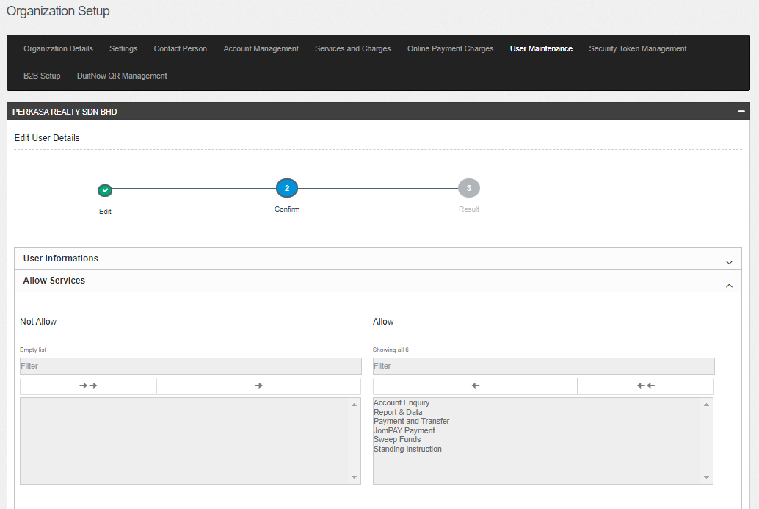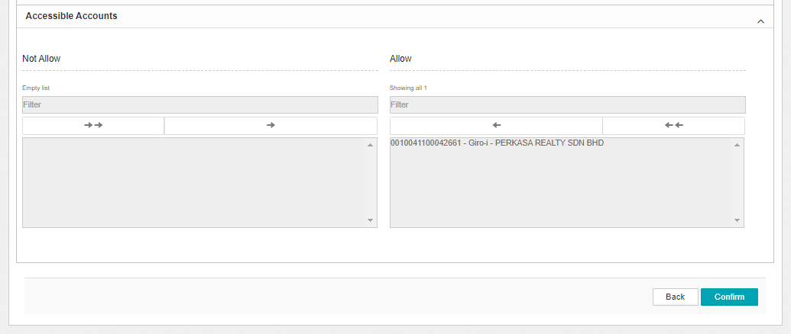
Figure 9 : User Maintenance - Edit Details Confirmation screen

Action:
No | Action | Type | Description
1. | Next | Button | Contain the action to display Edit User – Result page
2. | Back | Button | Contain the action to display back on previous screen.
Table 16 : User Maintenance - Edit Details Confirmation Action
Step 5:
- IBAM System validates and saves the changes to IB Database and displays result page.
- IBAM shows Successful message and pending for Authorization approval process.

Figure 10 : User Maintenance - Edit Details Result screen

If User Maintenance Module Maker Checker Permission set as ‘Disable’
- IBAM saves the update information and displays the successful result page.
- IBAM shows Successful message and will shows update information without any approval process.

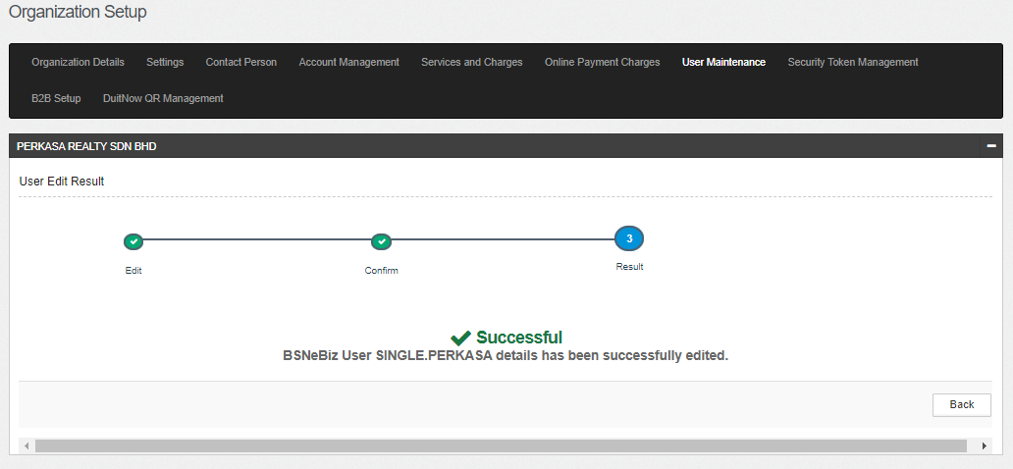
Figure 11 : User Maintenance - Edit Details Results screen with disable Checker Maker Permission screen

Display Fields:
No | Field | Format | Description
1. | Result Step | Alphanumeric | To display result step
2. | Status | Alpha numeric | To display result status.
3. | Result Message | Alpha numeric | To display result message.
Table 17 : User Maintenance - Edit Details Result Display Fields
Action:
No | Action | Type | Description
1. | Back | Button | Contains an action to User Maintenance main page
Table 18 : User Maintenance - Edit Details Result Action

- Section C: BSNeBiz

3 SOW01: Enhancement at BSNeBiz

3.1 SOW01.3: To enhance on existing User Maintenance
This feature allows Corporate Admin (CA) to view and edit user details with Organization’s list of Dormant status for the Organization without workflow and multiple users with workflow.

3.1.1 SOW01.3: View & Edit Dormant Account at User Maintenance
Function ID | SOW01.3
Module Name | User Maintenance | Path | BSNeBiz > Maintenance > User Maintenance
Description | This feature allows Corporate Admin (CA) to view and edit user details with Organization’s account list of Dormant status.

3.1.2 Process Flow
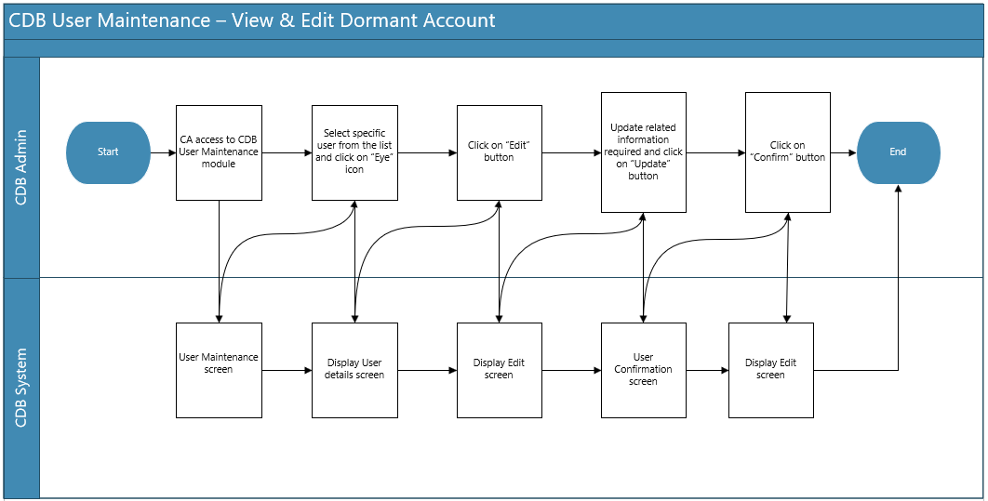
Diagram 3 : User Maintenance Flow Diagram

3.1.3 Screen Flow
Step 1:
- CA access to CDB User Maintenance screen by clicking on Maintenance menu at the left navigation followed by clicking User Maintenance navigation.
- At User Maintenance List screen, CA select specific user from the list by click on eye icon.

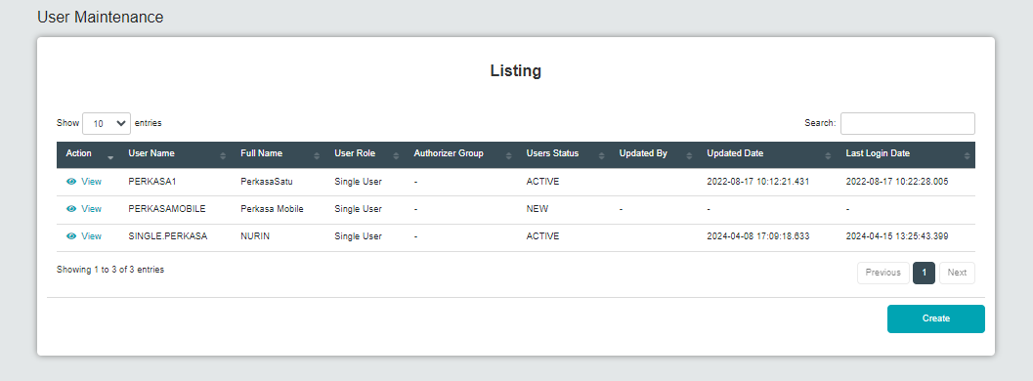
Figure 12 : User Maintenance Listing screen
Display Fields:
No | Field | Format | Description
1. | User Name | Text | Display the User Name for the selected user.
2. | Full Name | Text | Display the Full Name for the selected user.
3. | User Role | Text | Display the role for the selected user.
4. | Authorizer Group | Text | Display the authorization group for the selected user.
5. | User Status | Text | Display the status that updated the selected user.
6. | Updated By | Text | Display the Updated By for the selected user.
7. | Updated Date | Text | Display the Updated Date for the selected user.
8. | Last Login Date | Text | Display the Last Login Date for the selected user.
Table 19 : User Maintenance Listing - Display Field
Action:
No | Action | Type | Description
1. | Eye icon | Button | Contain the action to display the selected Organization details
2. | Create | Button | Contain the action to create user for the Organization
Table 20 : User Maintenance Listing - Action
Step 2:
- CDB System display CDB User Maintenance – Details screen.
- CA edits the details and click on Edit button.

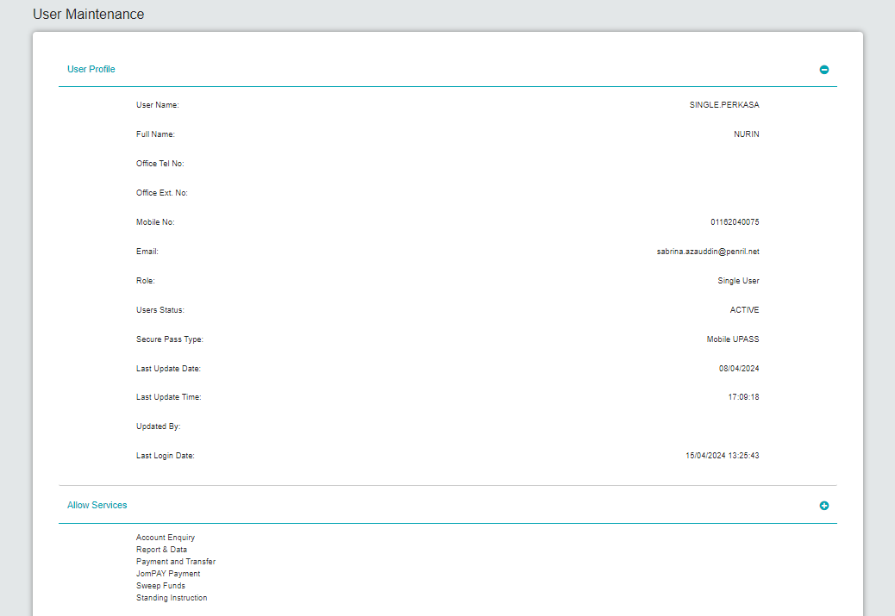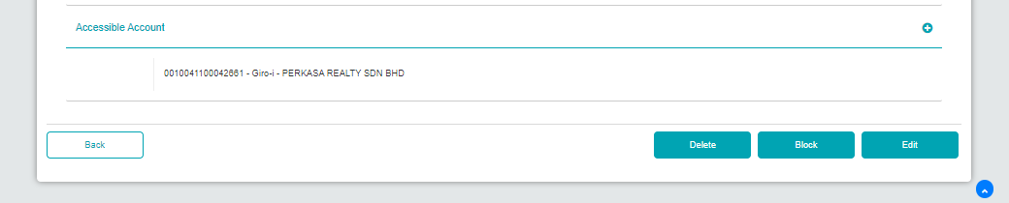
Figure 13 : User Maintenance Details screen
Display Fields:
No | Field | Format | Description
 | User Information:
1. | User Name | Text | Display the User Name for the selected user.
2. | Full Name | Text | Display the Full Name for the selected user.
3. | Office Tel No. | Text | Display the Office telephone number for the selected user.
4. | Office Ext. No. | Text | Display the Office extension number for the selected user.
5. | Mobile No. | Text | Display the Mobile number for the selected user.
6. | Email | Text | Display the Email address for the selected user.
7. | Role | Text | Display the role for the selected user.
8. | User Status | Text | Display the status that updated the selected user.
9. | Last Update Date | Text | Display the Last Update Date for the selected user.
10. | Last Update Time | Text | Display the Last Update Time for the selected user.
11. | Updated By | Text | Display the Updated By for the selected user.
12. | Last Login Date | Text | Display the Last Login Date for the selected user.
 | Allow Services:
13. | Services | Text | Selection of navigation that able CDB user to access
 | Accessible Account:
14. | Account Number | Text | Display the Organization’s account number
 | Allow Org Code:
15. | Org Code | Text | Display the Organization Code
Table 21 : User Maintenance Details - Display Field
Actions:
No | Action | Type | Description
1. | Back | Button | Contain the action to go back to User Maintenance list screen
2. | Edit | Button | Contain the action to edit the user details
3. | Block | Button | Contain the action to block the selected user
4. | Delete | Button | Contain the action to delete the selected user
Table 22 : User Maintenance Details - Action

Step 3:
- CDB system display CDB User Maintenance – Edit screen
- CA edits the details and click on Update button.

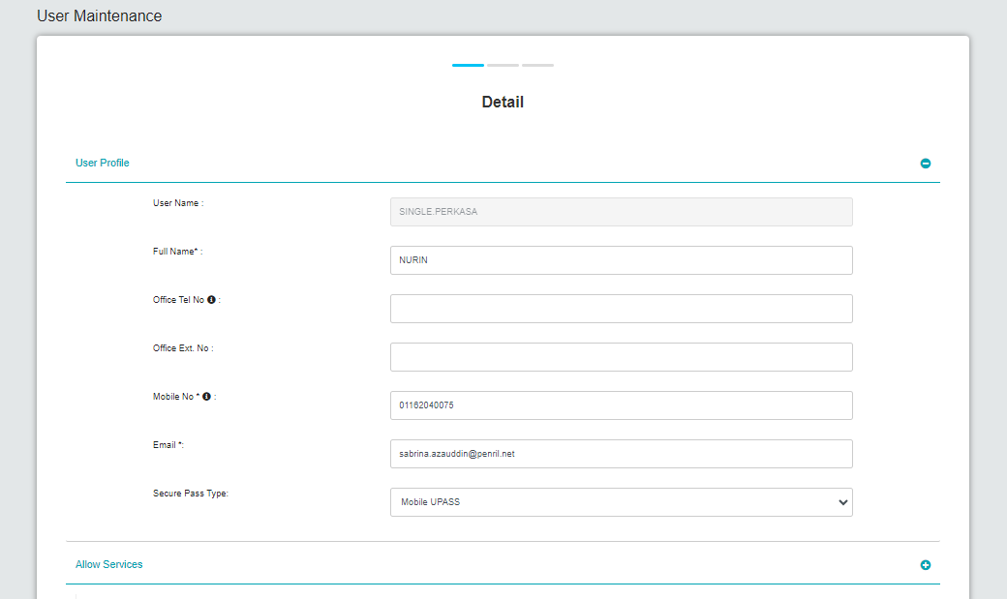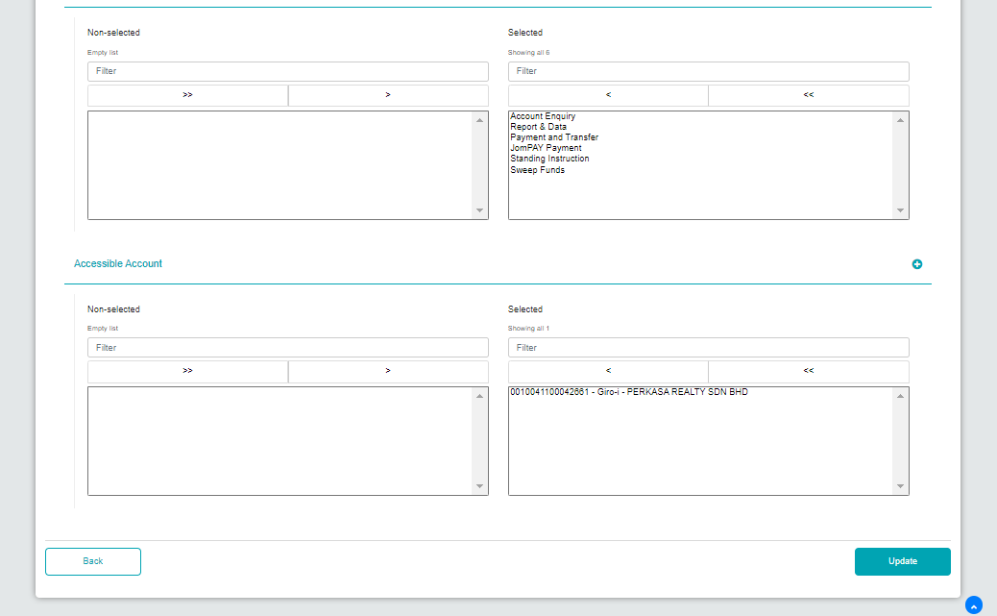
Figure 14 : User Maintenance - Edit Details screen

Input Specifications:
No | Field | Field Type | Rule | Description | Required
1. | Full Name | Text Box | Alphabet, naming special characters | User’s full name | Yes
2. | Office Tel No. | Text Box | Min Length:  Max Length:  Numeric | User’s office telephone no | Yes
3. | Office Ext. No. | Text Box | Min Length:  Max Length:  Numeric | User’s office extension no | Yes
4. | Mobile No. | Text Box | Min Length:  Max Length:  Numeric | User’s mobile no | Yes
5. | Email | Text Box | Alpha, numeric, and/or Text combination as long contain this format: <value>@<value>.<value> | User’s email address | Yes
6. | Services | Selection | N/A | Service that user will have in CDB | Yes, at least one
7. | Account Number | Selection | N/A | Account Number for CDB user to use/view | Yes, at least one
8. | Org Code | Selection | N/A | Organization Code of the organization | Yes, at least one
Table 23 : User Maintenance - Edit Details Input Specification
Display Fields:
No | Field | Format | Description
 | User Information:
1. | User Name | Text | Display the User Name for the selected user.
Table 24 : User Maintenance Edit Details - Display Field
Action:
No | Action | Type | Description
1. | Back | Button | Contain the action to go back to CDB Maintenance - Details screen
2. | Update | Button | Contain the action to CDB Maintenance Confirmation screen
Table 25 : User Maintenance Edit Details - Action Field

Step 4:
- CDB system display CDB User Maintenance – Confirmation screen.
- CA click on Confirm button to proceed with the changes.

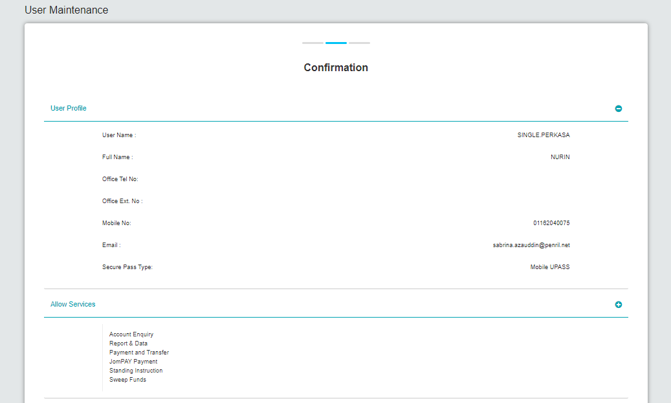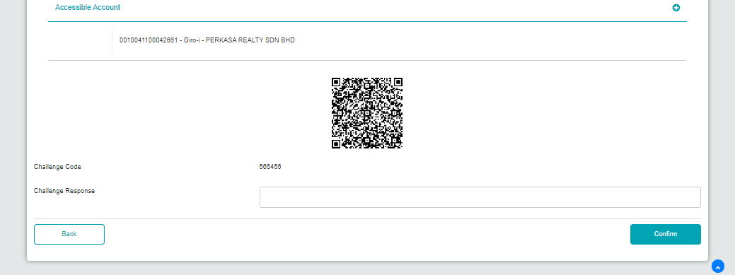
Figure 15 : User Maintenance Confirmation screen

Display Fields:
No | Field | Format | Description
 | User Information:
1. | User Name | Text | Display the User Name for the selected user.
2. | Full Name | Text | Display the Full Name for the selected user.
3. | Office Tel No. | Text | Display the Office telephone number for the selected user.
4. | Office Ext. No. | Text | Display the Office extension number for the selected user.
5. | Mobile No. | Text | Display the Mobile number for the selected user.
6. | Email | Text | Display the Email address for the selected user.
 | Allow Services:
7. | Services | Text | Selection of navigation that able CDB user to access
 | Accessible Account:
8. | Account Number | Text | Display the Organization’s account number
 | Allow Org Code:
9. | Org Code | Text | Display the Organization Code
Table 26 : User Maintenance Confirmation - Display Field
Input Specifications:
No | Field | Field Type | Rule | Description | Required
1. | Challenge Response | Text Box | Numeric | Challenge Response Token | Yes
Table 27 : User Maintenance Confirmation - Input Specification
Action:
No | Action | Type | Description
1. | Back | Button | Contain the action to go back to CDB Maintenance - Details screen
2. | Confirm | Button | Contain the action to CDB Maintenance Result screen
Table 28 : User Maintenance Confirmation - Action
Step 5:
- CDB system save the edited details to database.
- CDB system display the CDB Maintenance – Result screen.

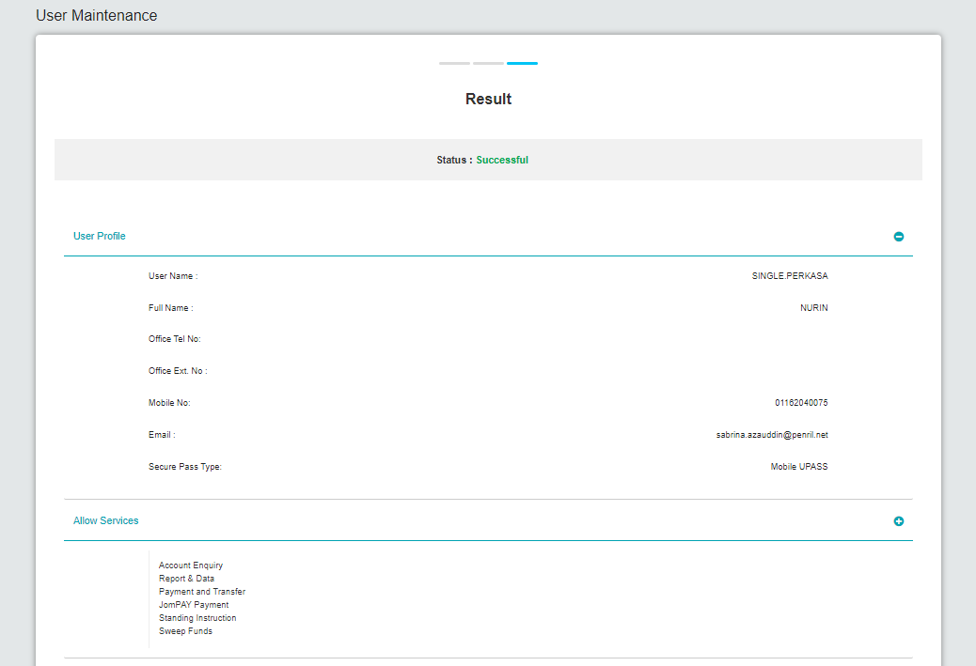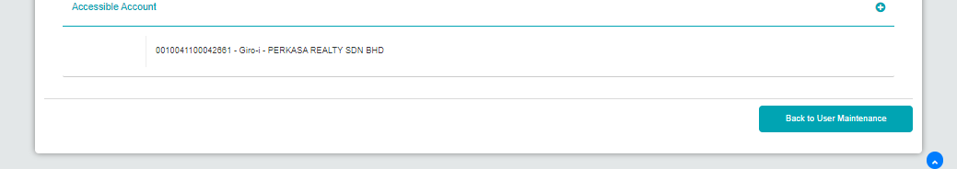
Figure 16 : User Maintenance Result screen

Action:
No | Action | Type | Description
1. | Back to User Maintenance | Button | Contain the action to go back to CDB User Maintenance list screen
Table 29 : User Maintenance Result - Action

4.1 SOW02.0: To enhance on existing Account Summary
This feature enables BSNeBiz User (CDB User) to view Account Details, Transaction History, BSNeBiz History, E-statement, Balance Inquiry. Account Summary feature shall provide a list of accounts which can be retrieved from the ICBS, such as Giro account, Giro-i Current account, Fixed Deposit. Account Summary is available to the user if the access right is given by the Corporate Administrator (CA).

4.1.1 SOW02.0: To enhance on existing Account Summary
Function ID | SOW02.0
Module Name | Account Summary | Path | BSNeBiz > Account Summary > All Accounts
Description | This feature allows BSNeBiz User (CDB User) to view Account Summary with Dormant Account status.  BSNeBiz : Account with status Dormant  - To retrieve form ICBS, such as Giro account, Giro-i Current account, Fixed Deposit related to Corporate Admin, Initiator, Approver, Viewer.

4.1.2 Process Flow

Diagram 4 : Account Summary Flow Diagram

4.1.3 Screen Flow
Step 1:
- CDB User access to CDB Landing page and clicks “Account Summary” continued with “All Accounts”.
- CDB System retrieves Account Summary Details from Host System by CIS No. and displays Account Summary for Holding Company & subsidiary company if any.
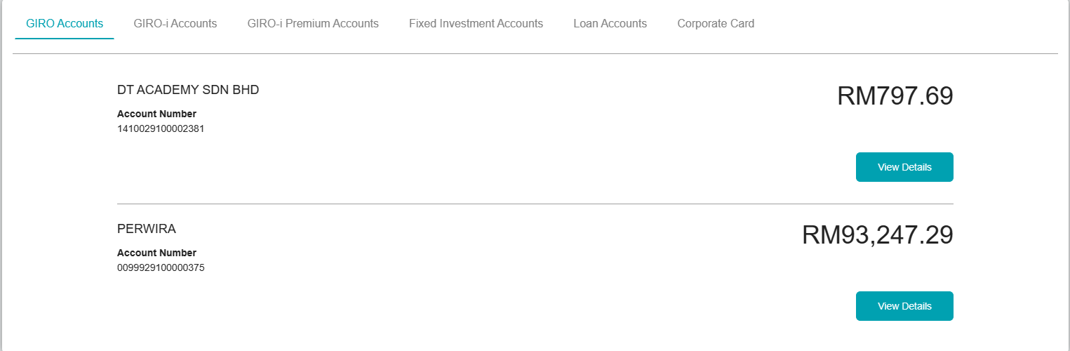
Figure 17 : Account Summary All Accounts screen
Display Fields:
No | Field | Format | Description
1. | Account Type | Text | Account Type  Possible Values:  - GIRO  - GIRO-i  - Fixed Investment Accounts
2. | Account Number | Numeric | Allowing user to display the Account number details
3. | Balance | Numeric | Show the current balance of the particular account number
Table 30 : Account Summary - Display Field

Action:
No | Action | Type | Description
1. | View Details | Button | Contains an action to show the account details
Table 31 : Account Summary - Action

4.2 SOW02.0: To enhance on existing Account Details
To retrieve account balance and transaction information for a specific account from anywhere in the online banking service.

4.2.1 SOW02.0: To enhance on existing Account Details
Function ID | SOW02.0
Module Name | Account Details | Path | BSNeBiz > Account Summary > All Accounts > Account Details
Description | This feature allows BSNeBiz User (CDB User) to view Account Details with Dormant Account status.  BSNeBiz : Account with status Dormant  - To retrieve form ICBS, such as details about the specific account of an organization with dormant status.

4.2.2 Process Flow

Diagram 5 : Account Details Flow Diagram

4.2.3 Screen Flow
Step 1:
- CDB User access to Account Summary screen and clicks on the “All Accounts” button on selected account type.
- User clicks on “View Details” button to view account details page.

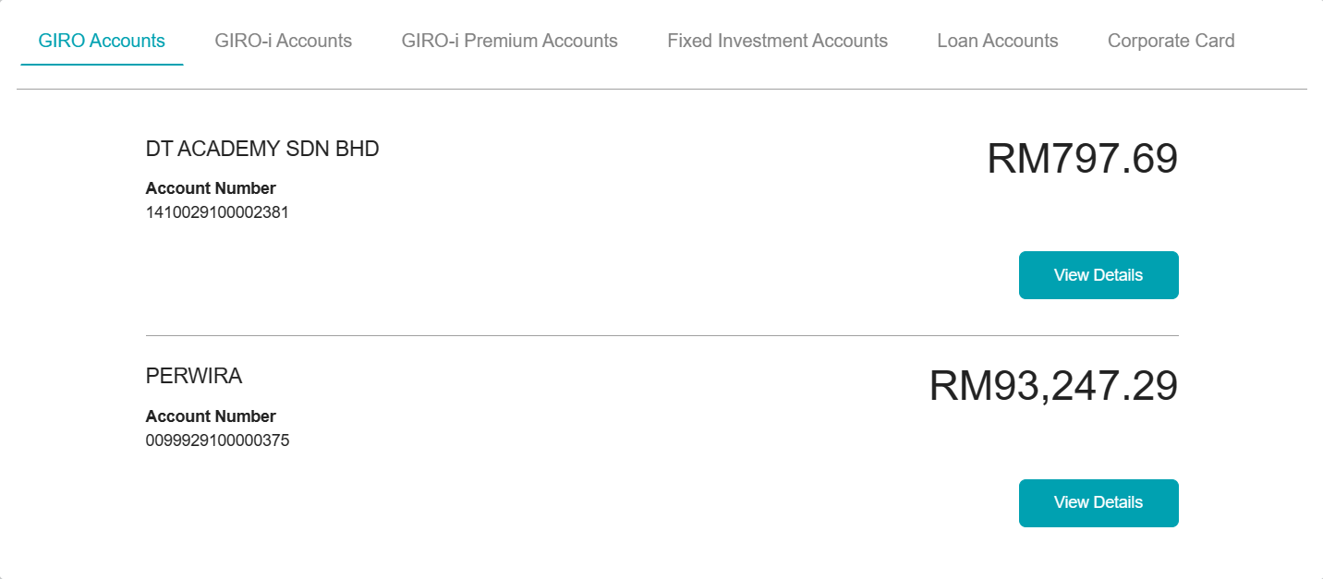
Figure 18 : Account Summary screen
Display Fields:
No | Field | Format | Description
1. | Holding Account | Text | Parent company for subsidiary.
2. | Account Type | Text | Type of account available that consists of Conventional account and Islamic account
3. | Account Number | Text | Allowing user to display the Account number details
4. | Balance | Numeric | Show the current balance of the particular account number
Table 32 : Account Summary - Display Field
Action:
No | Action | Type | Description
 | Account Details | Button | Contains an action to show the account detail.
Table 33 : Account Summary - Action

Step 2:
- CDB System retrieve the information from Host and display the Account details screen.
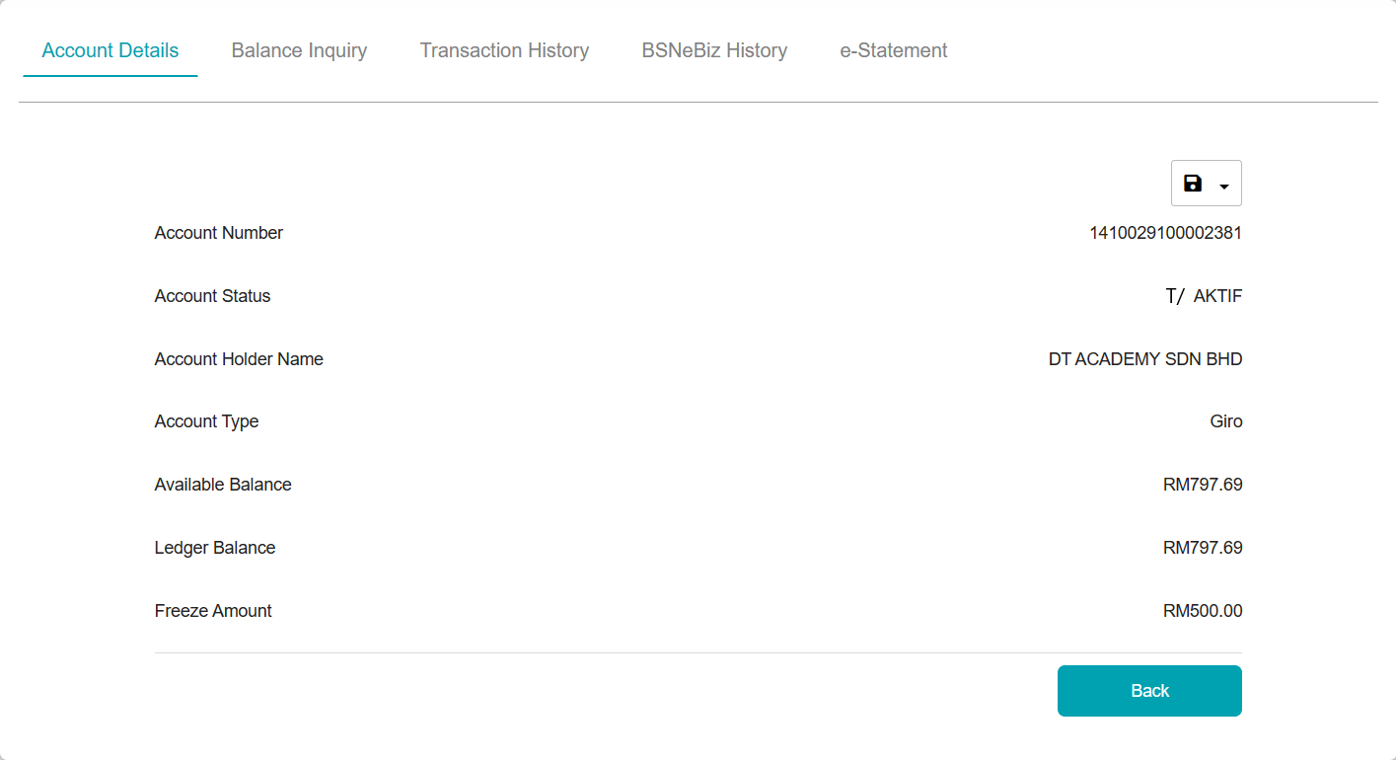
Figure 19 : Account Details screen
Display Fields:
No | Field | Format | Description
1. | Account Number | Text | Shows the corporate account number
2. | Account Status | Text | Shows the Status of selected account
3. | Account Holder Name | Text | Shows the Account Holder Name
4. | Account Type | Text | Shows Account type details
5. | Available Balance | Text | Shows Amount of current balance as of the beginning of the day minus any checks deposited but not yet made available for the use of the account holder
6. | Ledger Balance | Text | Shows Amount in bank account at the beginning of the day include funds that aren't available for withdrawal, such as check deposits that are on hold for verification and freeze amount.
7. | Freeze Amount | Text | Shows the freeze amount
Table 34 : Account Details - Display Field
Action:
No | Action | Type | Description
1. | Balance Inquiry | Tab | Contains an action to show the account Balance Inquiry
2. | Transaction History | Tab | Contains an action to show the account Transaction History
3. | BSNeBiz History | Tab | Contains an action to show the account Online Transaction History
4. | e-Statement | Tab | Contains an action to show the account e-Statement
5. | Back | Button | Contain an action to back screen
Table 35 : Account Details – Action

Step 3:
- CDB User can Download as PDF and Excel the account details by clicking on the Save Sub Menu.

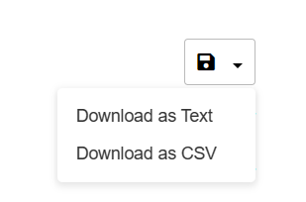
Figure 20 : Account Details Download Option
Action:
No | Action | Type | Description
 | Download as Text | Button | Contains an action to download the Transaction History details in Text format
 | Download as CSV | Button | Contains an action to download the Transaction History details in spreadsheet format
 | Download as PDF | Button | Contains an action to download the Transaction History details in PDF format
Table 36 : Account Details Download Option - Action

Step 3a:
- CDB User also can download the account detail in Text file type by clicking “Download as Text” button. Furthermore, IB User can open the downloaded Excel file by using supported software (Common software: Notepad).
- CDB system display the download pop-up screen. User can choose Open With or Save File and clicks the “OK” button to download the file.

Figure 21 : Account Details Download Option


Figure 22 : Account Details “Download as Text” dialog box

Step 3b:
- CDB User also can download the account details in CSV file type by clicking “Download as CSV” button. Furthermore, IB User can open the downloaded Excel file by using supported software (Common software: Microsoft Excel).
- CDB system display the download pop-up screen. User can choose Open With or Save File and clicks the “OK” button to download the file.

Figure 23 : Account Details Download Option


Figure 24 : Account Details "Download as CSV" dialog box

4.3 SOW02.0: To enhance on existing Transaction History
Transaction History is important in understanding the CDB User account transactions. User can always view the screen to verify the payments received or made, as well as to check for fees charged to the user. Transaction History is retrieved directly from Bank Core Banking.

4.3.1 SOW02.0: To enhance on existing Transaction History
Function ID | SOW02.0
Module Name | Transaction History | Path | BSNeBiz > Account Summary > All Accounts > Account Details > Transaction History
Description | This feature allows BSNeBiz User (CDB User) to view Transaction History with Dormant Account status.  BSNeBiz : Account with status Dormant  - To retrieve form ICBS, such as details about CDB User account transaction of an account with Dormant status.

4.3.2 Process Flow

Diagram 6 : Transaction History Flow Diagram

4.3.3 Screen Flow
Step 1:
- CDB accesses the selected Account Detail screen and clicks on “Transaction History” tab.
- System displays the Transaction history details.
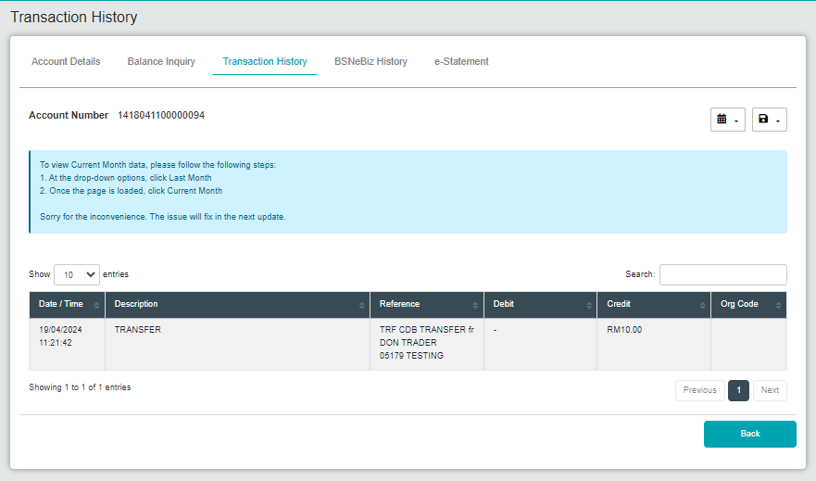
Figure 25 : Transaction History screen
Display Fields:
No | Field | Format | Description
1. | Account Number | Text | Shows the Account number
2. | Date / Time | Text | Show the date and time when the transaction occurs
3. | Description | Text | Description of the Transaction that has been made.
4. | Reference | Text | Show reference of the transaction
5. | Debit | Text | Show Amount of Debit of particular transaction.
6. | Credit | Text | Show Amount of Credit of particular transaction.
7. | Organization Code | Text | Show the organization code as a reference.
Table 37 : Transaction History - Display Field

Notes: Information at Description field on below item depends to Host Respond Data
- Payer or Payee Name / Delivery Channel / Branch Code
- Transaction Type
- Ref 1 & Ref 2 / Payment Description (as required by IBG)
- Inward chq number (if possible)

Action:
No | Action | Type | Description
1. | Back | Button | Contains an action to Back to previous screen
Table 38 : Transaction History - Action

Step 2:
- CDB user can choose to view Transaction History with selected option by choosing Current Date, Current Month, Last Month and Last Two Month by clicking on Calendar Sub Menu.
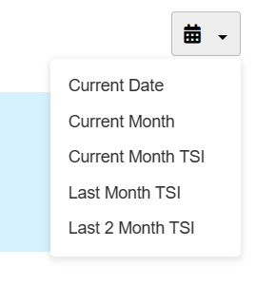
Figure 26 : Transaction History Calendar Selection Sub Menu screen
Action:
No | Action | Type | Description
1. | Current Date | Button | Contains an action to view Current Date history
2. | Current Month | Button | Contains an action to view Current Month history
3. | Current Month TSI | Button | Contains an action to view Current Month Transaction history
3. | Last Month TSI | Button | Contains an action to view Last Month Transaction history
4. | Last 2 Month TSI | Button | Contains an action to view Last 2 Month Transaction history
Table 39 : Transaction History Calendar Selection Sub Menu - Action

Step 3:
- CDB User can print, Download as Text and Download as CSV the transaction history by clicking on the Save Sub Menu.

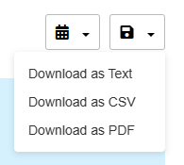
Figure 27 : Transaction History Download Option screen
Action:
No | Action | Type | Description
1. | Download as Text | Button | Contains an action to download the Transaction History details in Text format.
2. | Download as CSV | Button | Contains an action to download the Transaction History details in CSV format.
3. | Download as PDF | Button | Contains an action to download the Transaction History details in PDF format.
Table 40 : Transaction History Download Option - Action
Step 3a:
- CDB User can download the transaction history in Text file type by clicking “Download as Text” button. Furthermore, IB User can open the downloaded Text file by using supported software (Common software: Notepad).
- CDB system display the download pop-up screen. User can choose to Open with or Save File and clicks the “OK” button to download the file.

Figure 28 : Download as Text option

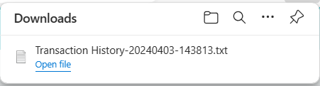
Figure 29 : "Download as Text" dialog box
Step 3b:
- CDB User also can download the transaction history in Excel file type by clicking “Download as CSV” button. Furthermore, IB User can open the downloaded Excel file by using supported software (Common software: Microsoft Excel).
- CDB system display the download pop-up screen. User can choose to Open With or Save File and clicks the “OK” button to download the file.

Figure 30 : Download as CSV option


Figure 31 : "Download as CSV" dialog text
Step 3c:
- CDB User also can download the transaction history in PDF file type by clicking “Download as PDF” button. Furthermore, IB User can open the downloaded Excel file by using supported software (Common software: Adobe Reader).
- CDB system display the download pop-up screen. User can choose Open with or Save File and clicks the “OK” button to download the file.

Figure 32 : Download as PDF option


Figure 33 : "Download as PDF" dialog box

4.4 SOW02.0: To enhance on existing BSNeBiz Transaction History
BSNeBiz Transaction History is a record of every transaction performed by CDB User via CDB System within a certain period of time.

4.4.1 SOW02.0: To enhance on existing BSNeBiz Transaction History
Function ID | SOW02.0
Module Name | BSNeBiz Transaction History | Path | BSNeBiz > Account Summary > All Accounts > Account Details > BSNeBiz Transaction History
Description | This feature allows BSNeBiz User (CDB User) to view BSNeBiz Transaction History with Dormant Account status.  BSNeBiz : Account with status Dormant  - To retrieve form ICBS, such as details about CDB User account transaction of an account via BSNeBiz system with Dormant status.

4.4.2 Process Flow

Diagram 7 : BSNeBiz Transaction History Flow Diagram

4.4.3 Screen Flow
Step 1:
- CDB User accesses to the selected Account Detail screen and click on “BSNeBiz Transaction History” tab.
- System displays the BSNeBiz Transaction history details screen.

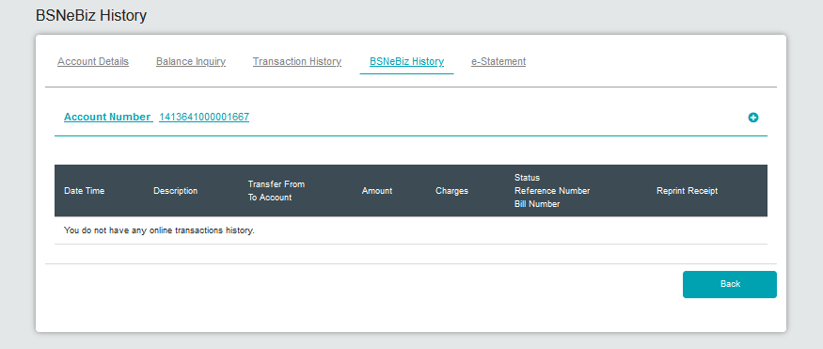
Figure 34 : BSNeBiz Transaction History screen
Display Fields:
No | Field | Format | Description
1. | Account Number | Text | Show Account Number
2. | Date Time | Text | Shows the date and time of the occurring transaction
3. | Description | Text | Shows the Transaction Details
4. | From account to account | Text | Shows From account and to account number in particular transaction.
5. | Amount | Text | Shows Amount of funds in particular transaction
6. | Government Charges | Text | Show all type of Charges as below  - Government Charges/Tax
7. | Transaction Charges | Text | Show all type of Charges as below  - IBG/IBFT Charges  - Payment Charges
8. | Status Reference No.  Bill Number | Text | Show Status and Bill Number
9. | Reprint Receipt | Text | Show Action to Reprint Receipt
Table 41 : BSNeBiz Transaction History - Display Field
Action:
No | Action | Type | Description
1. | Back | Button | Contain an option to go to back to previous page
Table 42 : BSNeBiz Transaction History – Action

Step 2:
- CDB User also may use the Advance Search function based on criteria of From Date, To Date, Transaction Type, From Account, To Account, Status, Reference and/or any combination of filters.
- CDB System lists out the search result in the table format below the Advance Search function.

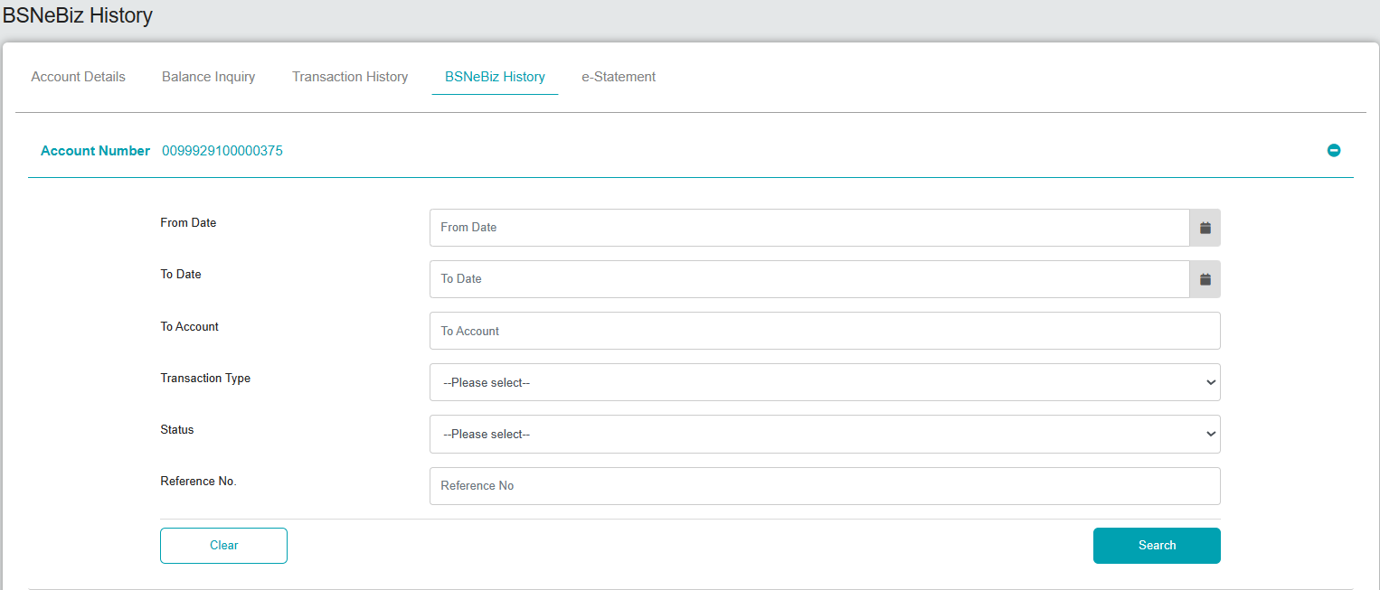
Figure 35 : BSNeBiz Transaction History Advance Search screen
Input Specification:
No | Field | Field Type | Rule | Description | Required
1. | From Date | Date Picker | DD/MM/YYYY | Search application based on Transaction From Date | No
2. | To Date | Date Picker | DD/MM/YYYY | Search application based on Transaction To Date | No
3. | To Account | Text Box | Numeric | Search based on Transaction To Account | No
4. | Transaction Type | Dropdown | List of Transaction Type  Select one only | Search based on Transaction Type | No
5. | Status | Dropdown | List of Status  Select one only | Search based on Transaction Status. | No
6. | Reference No. | Text Box | Alphanumeric | Search based on Transaction Reference Number | No
Table 43 : BSNeBiz Transaction History Advance Search - Input Specification
Action:
No | Action | Type | Description
1. | Search | Button | Contains an action to display the search result screen.
2 | Clear | Button | Contains an action to clear up the entered fields.
Table 44 : BSNeBiz Transaction History Advance Search - Action

4.5 SOW02.0: To enhance on existing e-Statement
e-Statement is the online form / soft copy of your Conventional and/or Islamic Banking Statement of Account.

4.5.1 SOW02.0: To enhance on existing e-Statement
Function ID | SOW02.0
Module Name | e-Statement | Path | BSNeBiz > Account Summary > All Accounts > Account Details > e-Statement
Description | This feature allows BSNeBiz User (CDB User) to view and download the soft copy of conventional or Islamic Banking Statement of Account

4.5.2 Process Flow
Diagram 8 : e-Statement Flow Diagram

4.5.3 Screen Flow
Step 1:
- CDB User accesses the selected Account Detail screen and click on “e-Statement” tab.
- System display the CDB e-Statement screen.
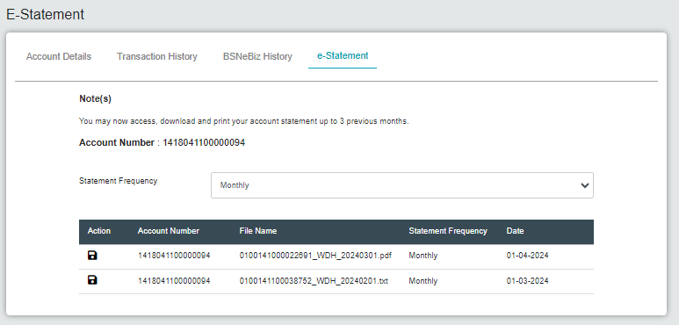
Figure 36 : e-Statement Period Selection screen

Display Fields:
No | Field | Format | Description
1. | Account Number | Text | Show Account Number
2. | Statement Frequency | Text | Shows the frequency of the account statement up to previous 3 months
3. | Action | Button | Contain process to download and print statement up to previous 3 months
4. | Date | Numeric | Shows the date and time of the occurring transaction
Table 45 : e-Statement Period Selection - Display Field
Input Specification:
No | Field | Field Type | Rule | Description | Required
 | Statement Frequency | Drop down list | Daily  Weekly  Monthly | Contain an option for Frequency Statement | No
Table 46 : e-Statement Period Selection - Input Specification
Step 2:
- CDB User select the statement period from the dropdown list.
- CDB User click Statement Frequency option to download Statement up.
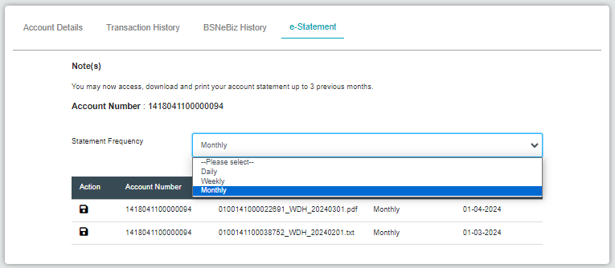
Figure 37 : Sample option for e-Statement screen
Action:
No | Action | Type | Description
1. | Daily | Button | Contains an action to view Current Date history
2. | Weekly | Button | Contains an action to view Current Week history
3. | Monthly | Button | Contains an action to view Last Month history
Table 47 : e-Statement Frequency Selection - Action

Step 2a:
1. CDB User can choose the option by clicking the “Statement Frequency” drop down and CDB system display the option for Daily, Weekly and Monthly.
2. CDB User may choose Daily Statement and choose to save and download the statement by clicking the action button.
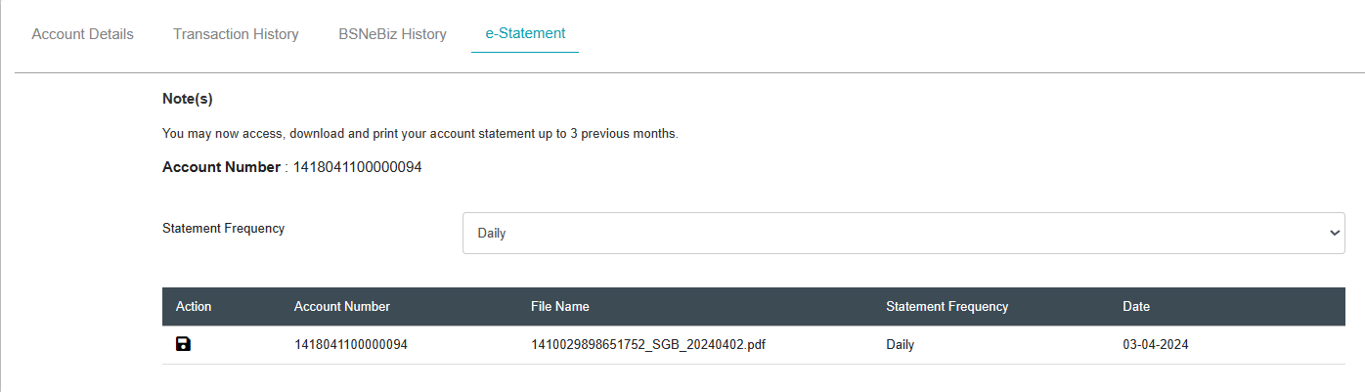
Figure 38 : Select as Daily e-Statement


Figure 39 : "Download Daily e-Statement" dialog box
Step 2b:
1. CDB User can choose the option by clicking the “Statement Frequency” drop down and CDB system display the option for Daily, Weekly and Monthly.
2. CDB User may choose “Weekly” Statement and choose to save and download the statement by clicking the action button.
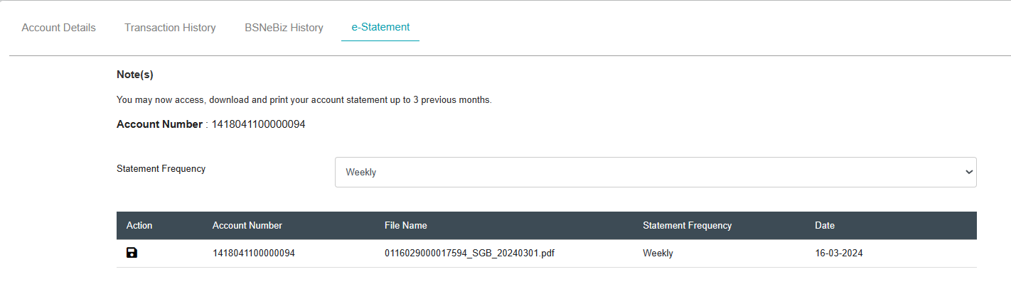
Figure 40 : Select as Weekly e-Statement


Figure 41 : "Download Weekly e-Statement" dialog box
Step 2c:
1. CDB User can choose the option by clicking the “Statement Frequency” drop down and CDB system display the option for Daily, Weekly and Monthly.
2. CDB User may choose “Monthly” Statement and choose to save and download the statement by clicking the action button.
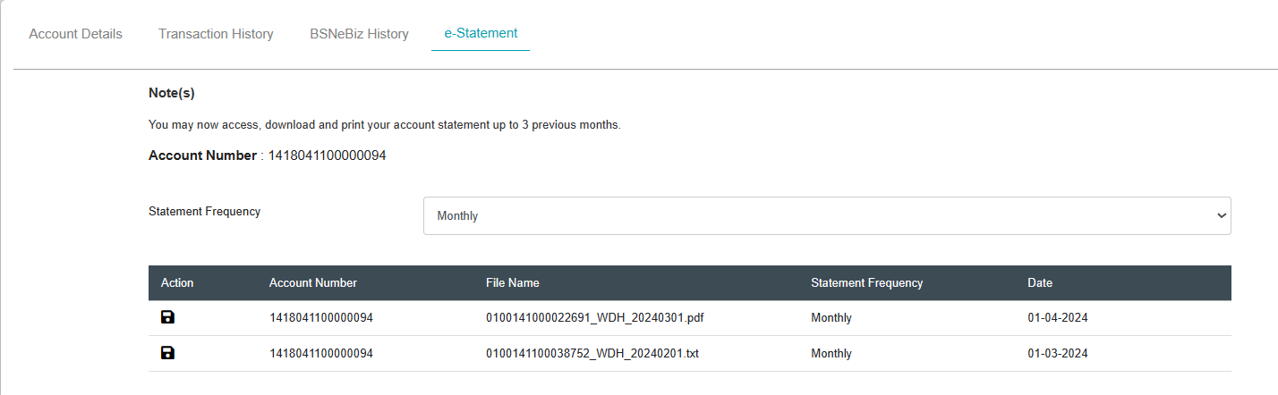
Figure 42 : Select as Monthly e-Statement

Figure 43 : "Download Monthly e-Statement" dialog box

4.6 SOW02.0: To enhance on existing Balance Inquiry
Balance inquiry is a process used to check the current balance of an account, typically a bank account or a financial account. It allows account holders to verify the amount of money in the account at a given moment.

4.6.1 SOW02.0: To enhance on existing BSNeBiz Account Details
Function ID | SOW02.0
Module Name | Balance Inquiry | Path | BSNeBiz > Account Summary > Balance Inquiry
Description | This feature allows BSNeBiz User (CDB User) to view the current balance of an account.

4.6.2 Process Flow
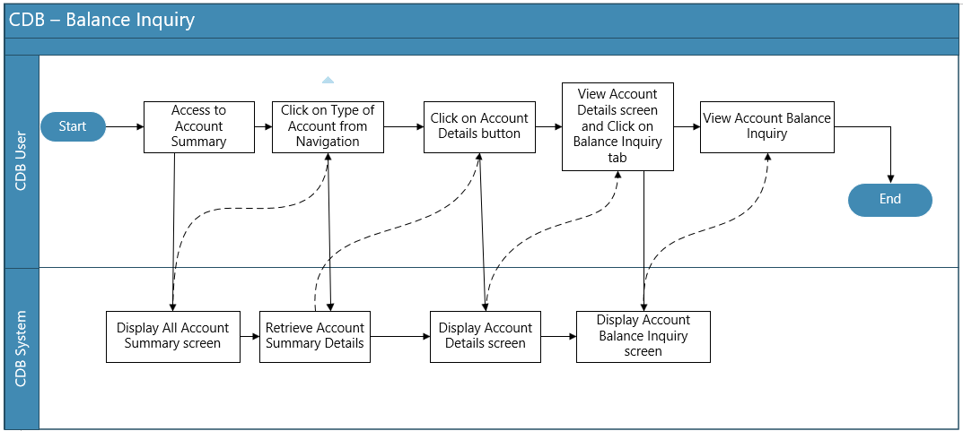
Diagram 9 : Balance Inquiry Flow Diagram

4.6.3 Screen Flow
Step 1:
- CDB User accesses the selected Balance Inquiry screen.
- System display the CDB Balance Inquiry screen.
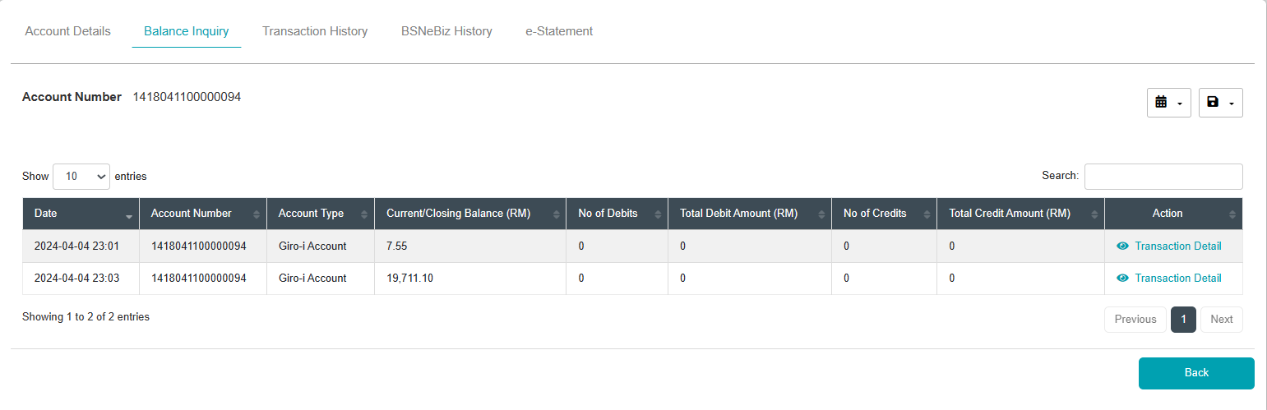
Figure 44 : Balance Inquiry Period Selection screen
Display Fields:
No | Field | Format | Description
1. | Account Number | Text | Allowing user to display the Account number details
2. | Date | Text | Type of account available that consists of Conventional account and Islamic account
3. | Account Type | Text | Allowing user to display the Account number details
4. | Current/Closing Balance (RM) | Numeric | Show the current balance of the particular account number
5. | No of Debits | Numeric | Count of debit transactions that have occurred within certain context
6. | Total Debit Amount (RM) | Numeric | Sum of all debit transactions made in particular account within specific time period
7. | No of Credits | Numeric | Count of credit transactions that have occurred within certain context
8. | Total Credit Amount (RM) | Numeric | Sum of all credit transactions made in particular account within specific time period
9. | Action | Text | Show the transaction Details of the balance inquiry
Table 48 : Balance Inquiry Period Selection - Display Field
Action:
No | Action | Type | Description
1. | Back | Button | Contain function to go back to previous page
2. | Download | Button | Contain an action to download selected e-Statement
3. | Transaction History | Button | Contain function to view Transaction History
Table 49 : Balance Inquiry Period Selection – Action

Step 2:
1. CDB user can choose to view Transaction History with selected option by choosing Previous Date, Last 7 Days and Last 30 days by clicking on Calendar Sub Menu.

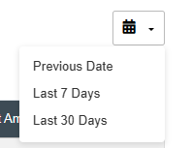
Figure 45 : Balance Inquiry Calendar Selection Sub Menu screen
Action:
No | Action | Type | Description
1. | Previous Date | Button | Contains an action to view Previous Date history
2. | Last 7 Days | Button | Contains an action to view Last 7 Days history
3. | Last 30 Days | Button | Contains an action to view Last 30 Days history
Table 50 : Balance Inquiry - Action
Step 3:
1. CDB User can print, Download as Text, Download as CSV and Download as PDF the transaction history by clicking on the Save Sub Menu.
Figure 46 : Balance Inquiry Download Option screen
Action:
No | Action | Type | Description
1. | Download as Text | Button | Contains an action to download the Transaction History details in Text format.
2. | Download as CSV | Button | Contains an action to download the Transaction History details in CSV format.
3. | Download as PDF | Button | Contains an action to download the Transaction History details in PDF format.
Table 51 : Balance Inquiry Download Option - Action
Step 3a:
1. CDB User can download the transaction history in Text file type by clicking “Download as Text” button. Furthermore, IB User can open the downloaded Text file by using supported software (Common software: Notepad).
2. CDB system display the download pop-up screen. User can choose to Open with or Save File and clicks the “OK” button to download the file.

Figure 47 : Download as Text Option screen

Balance Inquiry-20230403-143813.txt

Figure 48 : "Download as Text" dialog box

Step 3b:
1. CDB User also can download the account detail in CSV file type by clicking “Download as CSV” button. Furthermore, IB User can open the downloaded Excel file by using supported software (Common software: Microsoft Excel).
2. CDB system display the download pop-up screen. User can choose Open With or Save File and clicks the “OK” button to download the file.

Figure 49 : Download as CSV Option screen

Balance Inquiry-20230403-143813.csv

Figure 50 : "D Download as CSV” dialog box

Step 3c:
1. CDB User also can download the account details in PDF file type by clicking “Download as PDF” button. Furthermore, IB User can open the downloaded Excel file by using supported software (Common software: Adobe Reader).
2. CDB system display the download pop-up screen. User can choose Open With or Save File and clicks the “OK” button to download the file.

Figure 51 : Download as PDF Option screen

Balance Inquiry-20230403-143813.pdf

Figure 52 : "Download as PDF" dialog box

5.1 SOW03.0: To enhance on existing Transaction Details (Monetary & Non-Monetary)
Transaction Details provides a comprehensive view of all the specifics of individual transactions. This includes information such as the transaction amount, date, parties involved (from and to accounts), transaction type (e.g., transfer, payment), and any applicable notes or descriptions. This module is essential for tracking and verifying all transaction activities within an account, helping users and financial institutions ensure accuracy and accountability in financial management.

5.1.1 SOW03.0: To enhance on existing Transaction Details (To Account & From Account)
Function ID | SOW03.0
Module Name | Transaction Details | Path | BSNeBiz > Transfer & Payment > Transfer & Payment > Transfer
Description | This feature allows Corporate User to view and select dormant accounts at “To Account” to receive any transaction and exclude dormant account in the “From Account” list

5.1.2 Process Flow
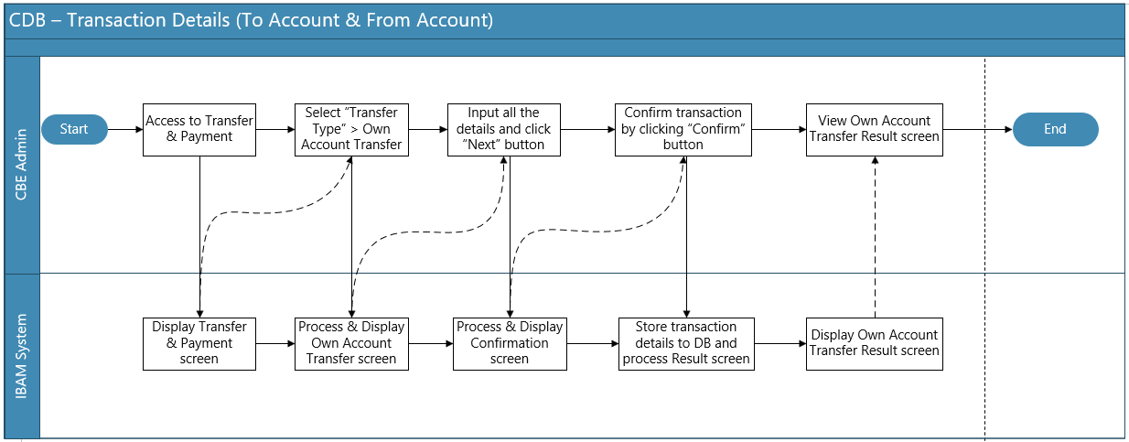
Diagram 10 : Transaction Details Flow Diagram

5.1.3 Screen Flow
Step 1:
- CDB User access to Transfer & Payment screen and clicks on the Transfer & Payment button.
- User clicks on “Transfer” button to view transfer details page.
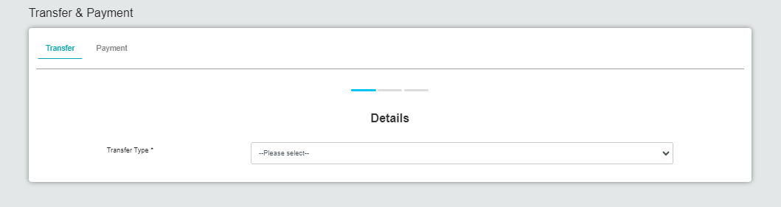
Figure 53 : Transfer Details screen

Input Specification:
No | Field | Field Type | Validation Rule | Description | Required
1. | Transfer Type | Dropdown List | Must be selected | Contains an action to show the transfer type | Yes
Table 52 : Transfer Details - Input Specification

Step 2:
- CDB User click on “Transfer Type” button to select transfer type choices.
- CDB system will show Transfer Details screen.
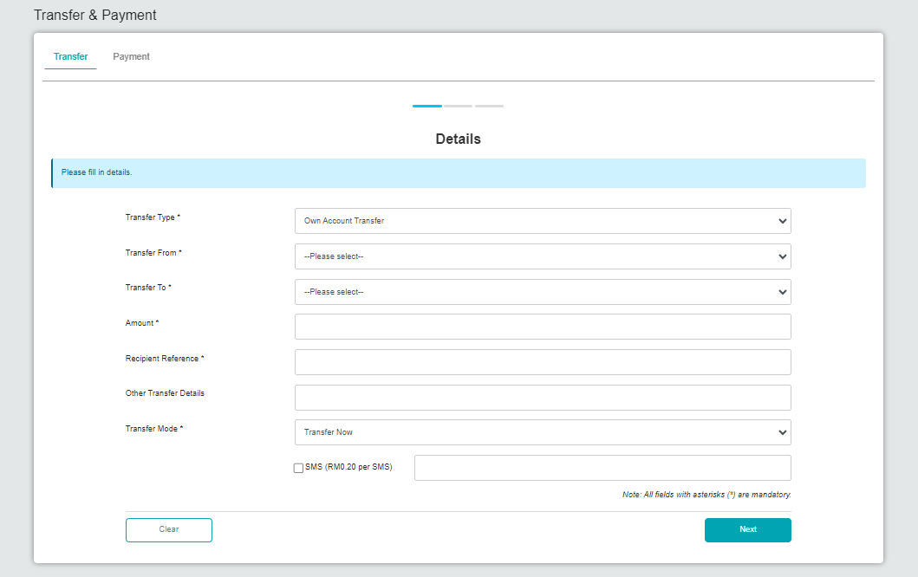
Figure 54 : Transfer Details screen
Step 3:
- CDB User filled in all the details and click on “Transfer To”
- “Transfer To” list will show available Dormant Accounts in the list.
- Click Next button to proceed to confirmation screen.
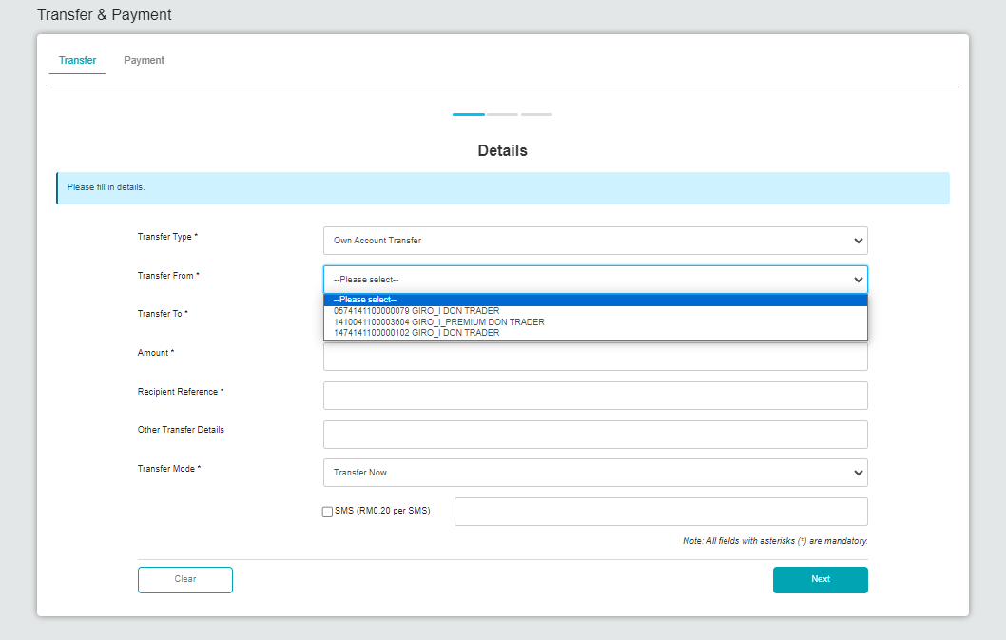
Figure 55 : Transfer Details "From Account" list screen

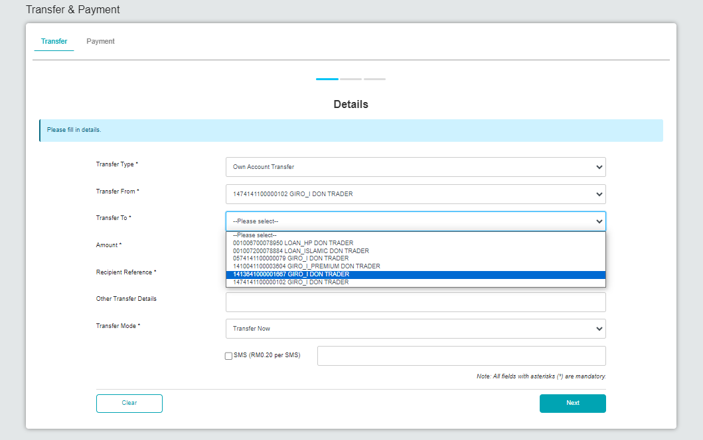
Figure 56 : Transfer Details "To Account" list screen

Input Specifications:
No | Field | Field Type | Validation Rule | Description | Required
1. | Transfer Type | Dropdown List | Must be selected | List of transaction type | Yes
2. | Transfer From | Dropdown List | Must be selected | List of eligible account numbers | Yes
3. | Transfer To | Dropdown List | Must be selected | List of existing own account | Yes
4. | Amount | Text | 15,2 decimals | Transfer amount | Yes
5. | Recipient Reference | Text | Alphanumeric | The transaction references, which can be the receipt, invoice, bills, etc. | Yes
6. | Other Transfer Details | Text | Alphanumeric | The description of the transaction | No
7. | Transfer Mode | Dropdown List | Must be selected | The mode of transaction | Yes
Table 53 : Transfer Details - Input Specification

Action:
No | Action | Type | Description
1. | Next | Button | Contain an action to proceed transaction and go to confirmation page
2. | Clear | Button | Contain an action to clear all filled in details
Table 54 : Transfer Details - Action
Step 4:
- CDB system display the Own Account Transfer confirmation screen.
- Click on Next button to proceed Result screen.
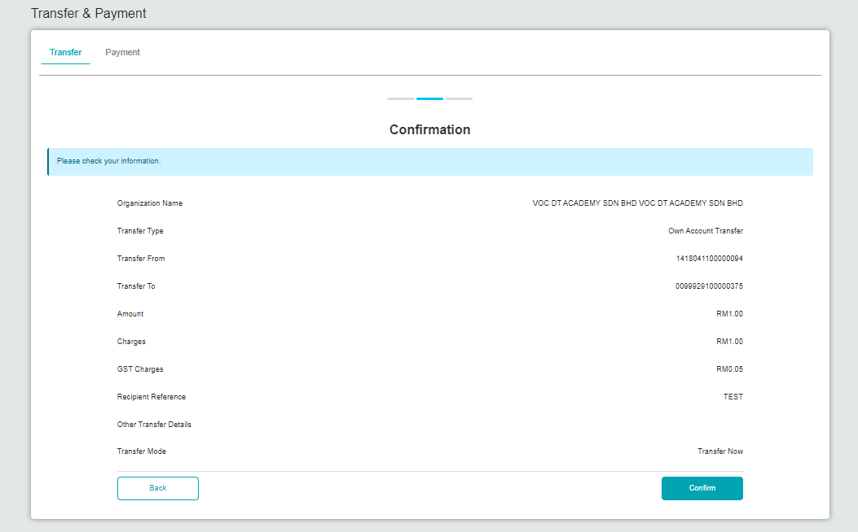
Figure 57 : Transfer Confirmation screen

Action:
No | Action | Type | Description
1. | Next | Button | Contain an action to proceed transaction and go to result page
2. | Back | Button | Contain an action to go to previous page which is Transfer Details page
Table 55 : Transfer Confirmation - Action
Step 5:
- CDB system will show result screen with pending for Authorization approval process.
- Dormant Account will only be able to receive transaction and cannot initiates any transaction.

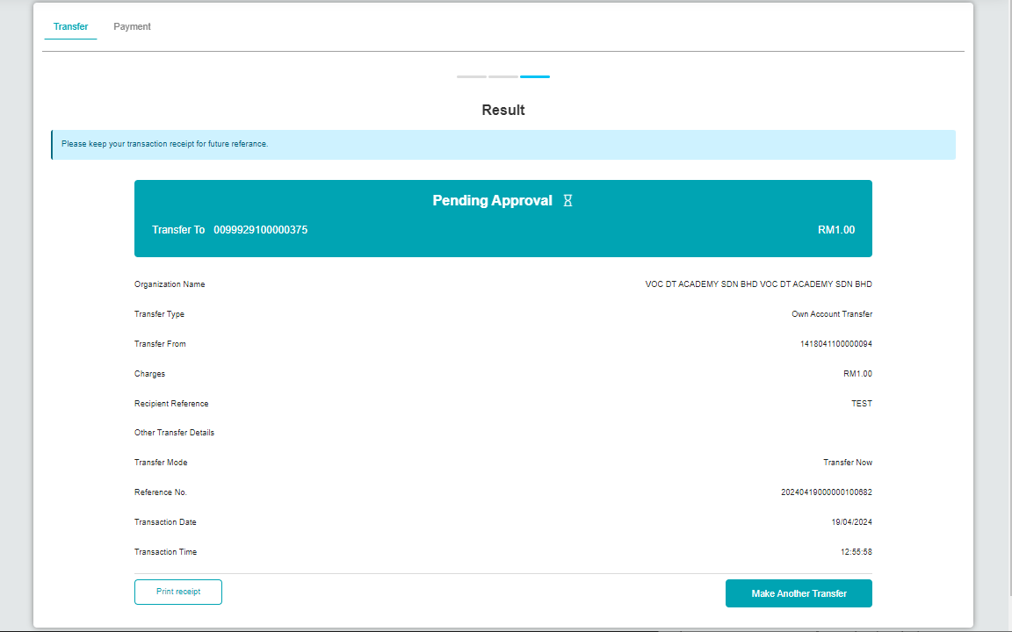
Figure 58 : Transfer Result screen
Action:
No | Action | Type | Description
1. | Make Another Transaction | Button | Contain an action to proceed
2. | Print receipt | Button | Contain an action to download transaction receipt in pdf
Table 56 : Transfer Result - Action

- Section D: BSNeBiz Mobile

6 SOW02: Enhancement at BSNeBiz Mobile

6.1 SOW02.0: To enhance on existing Account Summary
This feature enables BSNeBiz User (CDB User) to view Transaction History, BSNeBiz History, E-statement. Account Summary feature shall provide a list of accounts which can be retrieved from the ICBS, such as Giro account, Giro-i Current account, Fixed Deposit. Account Summary is available to the user if the access right is given by the Corporate Administrator (CA).

6.1.1 SOW02.0: To enhance on existing BSNeBiz Account Summary
Function ID | SOW02.0
Module Name | Account Summary | Path | BSNeBiz Mobile > Quick Balance > Account Summary
Description | This feature allows BSNeBiz User (CDB User) to view Account Summary with Dormant Account status.  BSNeBiz : Account with status Dormant  - To retrieve form ICBS, such as Giro account, Giro-i Current account, Fixed Deposit related to Corporate Admin, Initiator, Approver, Viewer.

6.1.2 Process Flow
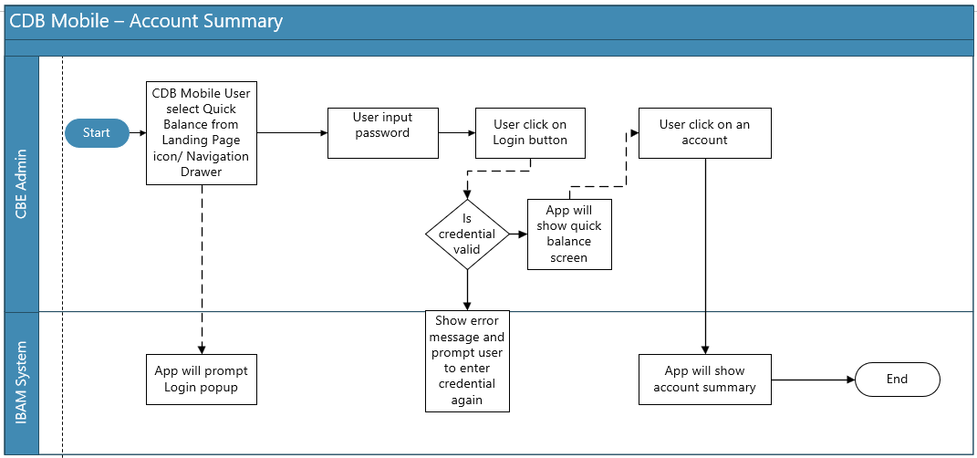
Diagram 11 : Account Summary Flow Diagram

6.1.3 Screen Flow
Step 1:
      - CDB Mobile User successfully login, CDB Mobile user will be on CDB Mobile landing page.
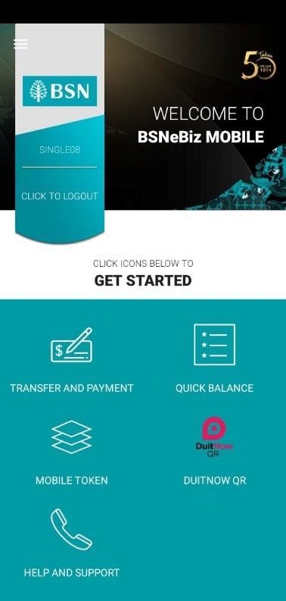
Figure 59 : CDB Mobile App Landing Page

Step 2:
- Click on Quick Balance button, CDB MOBILE APPS will show Quick Balance screen
- User will be able to switch account type by tapping on Tab Bar
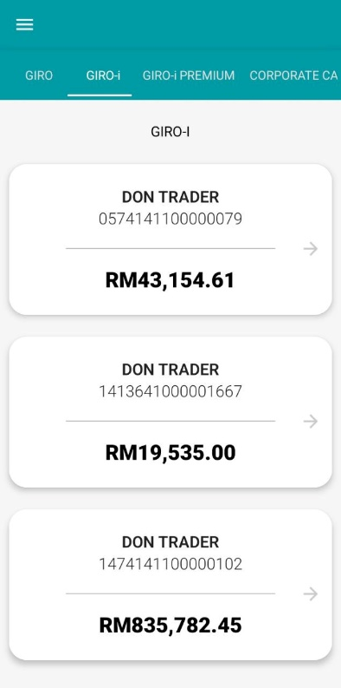
Figure 60 : Quick Balance screen
Display Fields:
No | Field | Format | Description
1. | Title | Text | Quick Balance
2. | Sub Title | Text | Giro-i
3. | Account List | List | List of Account  - Display Account Name  - Account Number  - Current Balance
Table 57 : Quick Balance - Display Field
Step 3:
      - Click on any selected Account List, CDB Mobile Apps will show Account Summary.
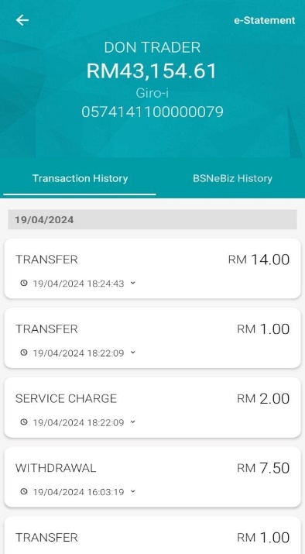
Figure 61 : Account Summary screen

Display Fields:
No | Field | Format | Description
1. | Account Name | Text | Display account name
2. | Current Balance | Text | Display account current balance
3. | Account Type | Text | Display account type
4. | Account Number | Text | Display account number
5. | History List | List | On History Detail List Item Show  - Transaction Date  - Transaction Time  - Transaction Description  - Transaction Amount
Table 58 : Account Summary - Display Field
Action:
No | Action | Type | Description
1. | Back | Button | This action will go back and show Account List
2. | History List Item | List Item | This action will expand List item with more detail
3. | Option Menu | Button | This action will show e-Statement menu
Table 59 : Account Summary – Action

6.2 SOW02.0: To enhance on existing Account Transaction History
Transaction History is important in understanding the CDB User account transactions. User can always view the screen to verify the payments received or made, as well as to check for fees charged to the user. Transaction History is retrieved directly from Bank Core Banking.

6.2.1 SOW02.0: To enhance on existing Account Transaction History
Function ID | SOW02.0
Module Name | Account Transaction History | Path | BSNeBiz Mobile > Quick Balance > Account Summary > Transaction History
Description | This feature allows BSNeBiz User (CDB User) to view Transaction History with Dormant Account status.  BSNeBiz : Account with status Dormant  - To retrieve form ICBS, such as details about CDB User account transaction of an account with Dormant status.

6.2.2 Process Flow
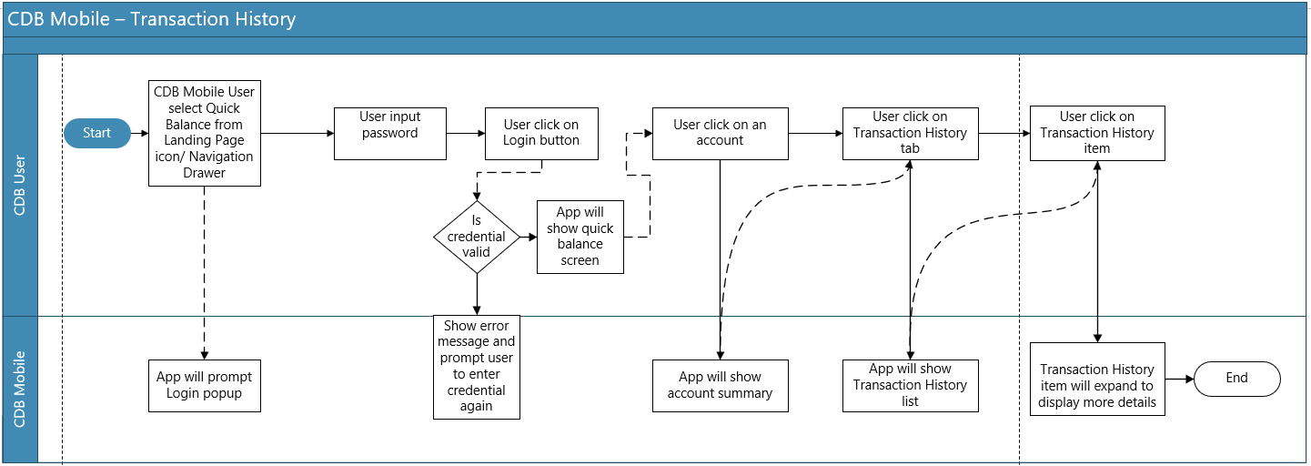
Diagram 12 : Transaction History Flow Diagram

6.2.3 Screen Flow
Step 1:
      - CDB User tap Transaction History tab on Account Summary, CDB Mobile will show Transaction History. Transaction History will list out transactions which executed outside CDB system or CDB Mobile application
      - Tap on History List item to see more details about selected transaction.
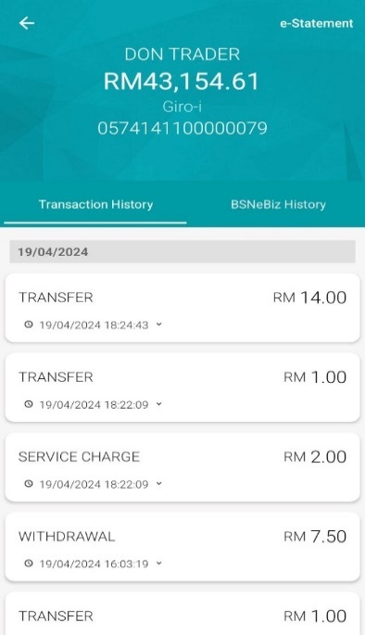
Figure 62 : Transaction History screen

Display Fields:
No | Field | Format | Description
1. | Account Name | Text | Display account name
2. | Current Balance | Text | Display account current balance
3. | Account Type | Text | Display account type
4. | Account Number | Text | Display account number
5. | History List | List | On History Detail List Item Show  - Transaction Date  - Transaction Time  - Transaction Description  - Transaction Amount
Table 60 : Transaction History – Display Field
Action:
No | Action | Type | Description
1. | Back | Button | This action will go back and show Account List
2. | History List Item | List Item | This action will expand List item with more detail
3. | Option Menu | Button | This action will show e-Statement menu
Table 61 : Transaction History – Action

6.3 SOW02.0: To enhance on existing BSNeBiz History
BSNeBiz History is a record of every transaction performed by CDB User via CDB Mobile within a certain period of time.

6.3.1 SOW02.0: To enhance on existing BSNeBiz History
Function ID | SOW02.0
Module Name | BSNeBiz History | Path | BSNeBiz Mobile > Quick Balance > Account Summary > BSNeBiz History
Description | This feature allows BSNeBiz User (CDB User) to view BSNeBiz History with Dormant Account status.  BSNeBiz : Account with status Dormant  - To retrieve form ICBS, such as details about CDB User account transaction of an account via BSNeBiz system with Dormant status.

6.3.2 Process Flow
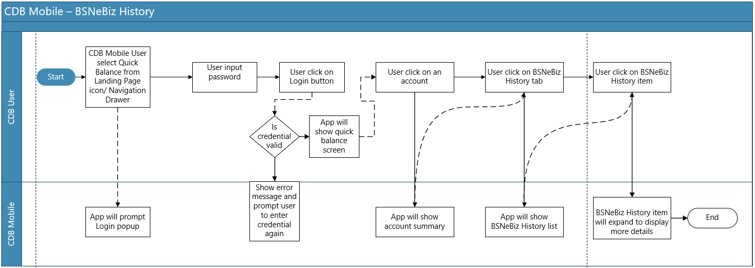
Diagram 13 : BSNeBiz History Flow Diagram

6.3.3 Screen Flow
Step 1:
            - CDB User tap BSNeBiz History tab on Account Summary, CDB Mobile will show BSNeBiz History. BSNeBiz History will list out transactions which executed on CDB system or CDB Mobile application
            - Tap on History List item to see more details about selected transaction.
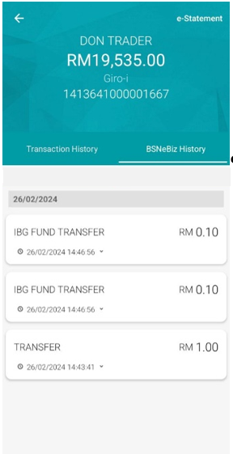
Figure 63 : BSNeBiz History page

Display Fields:
No | Field | Format | Description
1. | Account Name | Text | Display account name
2. | Current Balance | Text | Display account current balance
3. | Account Type | Text | Display account type
4. | Account Number | Text | Display account number
5. | History List | List | On History Detail List Item Show  - Transaction Date  - Transaction Time  - Transaction Description  - Transaction Amount
Table 62 : BSNeBiz History – Display Field
Action:
No | Action | Type | Description
1. | Back | Button | This action will go back and show Account List
2. | History List Item | List Item | This action will expand List item with more detail
3. | Option Menu | Button | This action will show e-Statement menu
Table 63 : BSNeBiz History – Action

6.4 SOW02.0: To enhance on existing e-Statement
e-Statement is the online form / soft copy of your Conventional and/or Islamic Banking Statement of Account.

6.4.1 SOW02.0: To enhance on existing e-Statement
Function ID | SOW02.0
Module Name | e-Statement | Path | BSNeBiz Mobile > Quick Balance > Account Summary > e-Statement
Description | This feature allows BSNeBiz User (CDB User) to view and download the soft copy of conventional or Islamic Banking Statement of Account

6.4.2 Process Flow
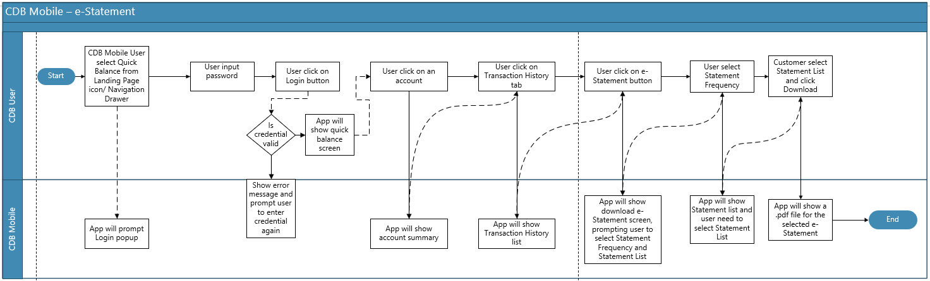
Diagram 14 : e-Statement Flow Diagram

6.4.3 Screen Flow
Step 1:
      - User can access the e-Statement screen through the Account Summary screen.
      - Select any account and tab on Transaction History.
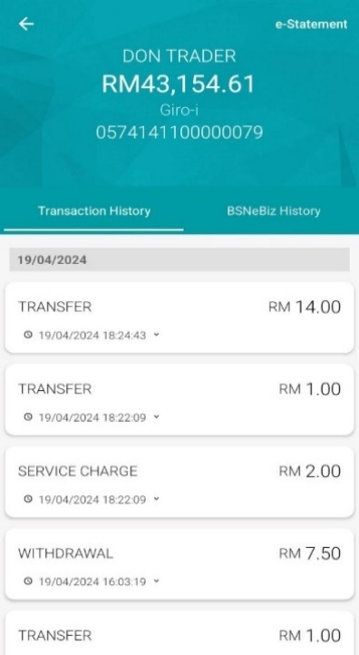
Figure 64 : e-Statement screen
Display Fields:
No | Field | Format | Description
1. | Account Name | Text | Display account name
2. | Current Balance | Text | Display account current balance
3. | Account Type | Text | Display account type
4. | Account Number | Text | Display account number
5. | History List | List | On History Detail List Item Show  - Transaction Date  - Transaction Time  - Transaction Description  - Transaction Amount
Table 64 : e-Statement – Display Field
Action:
No | Action | Type | Description
1. | Back | Button | This action will go back and show Account List
2. | History List Item | List Item | This action will expand List item with more detail
3. | Option Menu | Button | This action will show e-Statement menu
Table 65 : e-Statement – Action

Step 2:
            - Tap on e-Statement button on the right top of the Account Summary screen, e-Statement page will be prompted.
            - Select Statement Frequency with 3 choices which are Daily, Weekly and Monthly.
            - Select available Statement List and click on Download button.
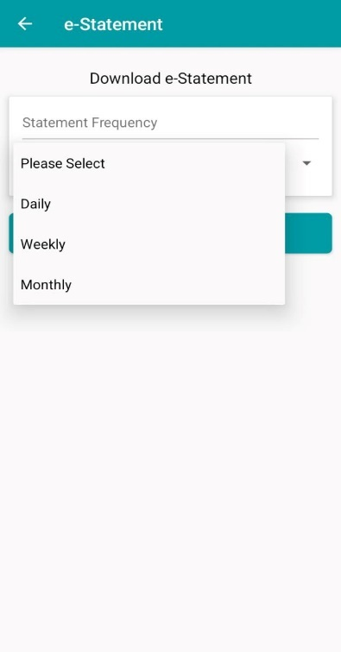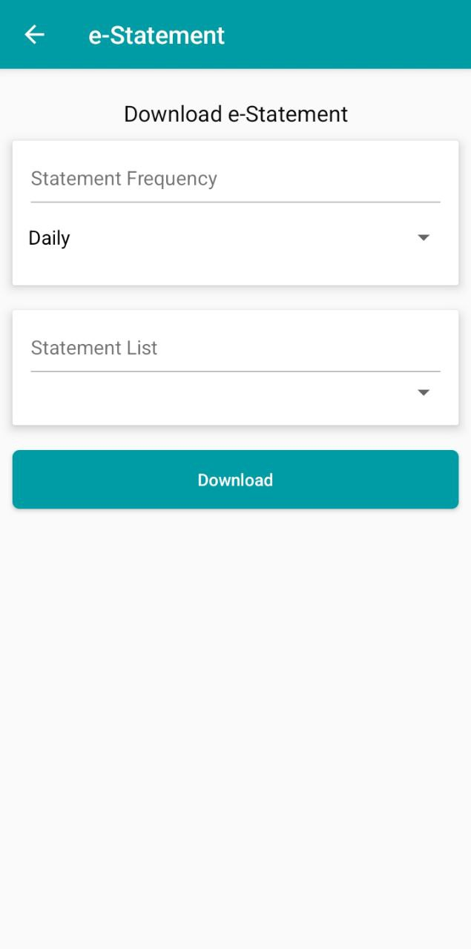
Figure 65 : e-Statement Download screen

Display Fields:
No | Field | Format | Description
1. | e-Statement | Text | Display the page title
2. | Download e-Statement | Text | Display the page sub title
3. | Statement Frequency | Text | Display the action title
4. | Statement List | Text | Display the action title
Table 66 : e-Statement Download – Display Field
Action:
No | Action | Type | Description
1. | Statement Frequency | Dropdown List | This action will display all available frequency to download e-Statement
2. | Statement List | Dropdown List | This action will display all available e-Statement based on selected frequency
3. | Download | Button | This action will prompt a download for the selected e-Statement
Table 67 : e-Statement Download – Action

7.1 SOW03.0: To enhance on existing Transaction Details (Monetary & Non-Monetary)
Transaction Details provides a comprehensive view of all the specifics of individual transactions. This includes information such as the transaction amount, date, parties involved (from and to accounts), transaction type (e.g., transfer, payment), and any applicable notes or descriptions. This module is essential for tracking and verifying all transaction activities within an account, helping users and financial institutions ensure accuracy and accountability in financial management.

7.1.1 SOW03.0: To enhance on existing Transaction Details – Transaction Account List (To Account)
Function ID | SOW03.0
Module Name | Transaction Details | Path | BSNeBiz Mobile > Transfer and Payment
Description | This feature allows Corporate User to view and select dormant accounts at “To Account” to receive any transaction.

7.1.2 Process Flow
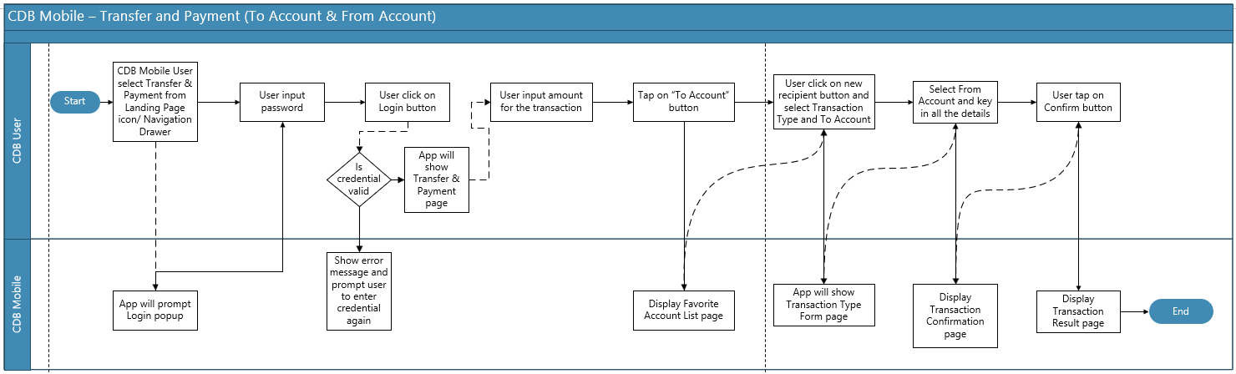
Diagram 15 : Transaction Detail Flow Diagram

7.1.3 Screen Flow
Step 1:
      - CDB Mobile User tap on Transfer and Payment icon on the landing page screen.
      - CDB Mobile will show Transfer and Payment form.
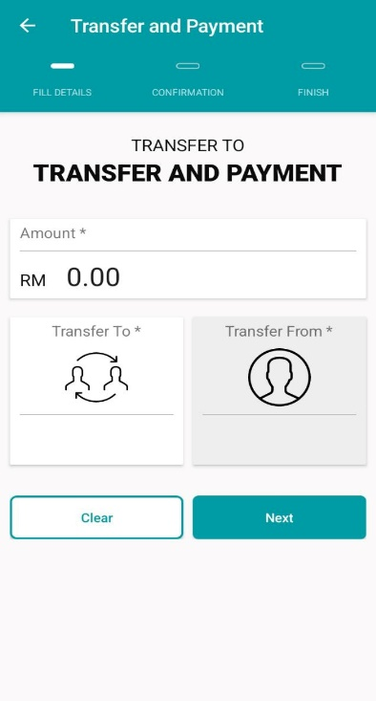
Figure 66 : Transfer & Payment Form screen
Input Specifications:
No | Field | Field Type | Validation Rule | Description | Required
1. | Amount | Text | Max length: 12 Numeric | Contains an action to enter transaction amount | Yes
Table 68 : Transfer and Payment – Input Specification
Display Fields:
No | Field | Format | Description
1. | Title | Text | Transfer and Payment title
2. | Sub Title | Text | TRANSFER TO  TRANSFER AND PAYMENT
3. | Amount | Numeric | Amount to transfer
Table 69 : Transfer and Payment – Display Field
Action:
No | Action | Type | Description
1. | Back | Button | This action will go back to Landing Page
2. | Transfer To | Button | This action will open Transfer To screen
3. | Transfer From | Button | This action will open Transfer From screen
4. | Clear | Button | This action will refresh current Transfer and Payment form
5. | Next | Button | This action will proceed Transfer and Payment form to Transfer and Payment confirmation
Table 70 : Transfer and Payment – Action
Step 2:
            - CDB Mobile User can tap on Transfer To button to perform Own Account Transfer. By default, CDB Mobile will show the Favourite account listing after tap on the Transfer To button. To create a new transaction, User can tap on New Recipient button
            - Select Transaction Type and tap on Transfer To dropdown list to choose available account to receive transaction. Dormant Account will also be available at Transfer To dropdown list.

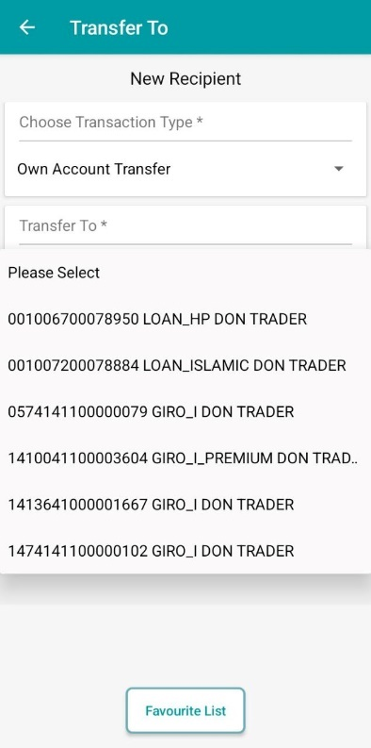
Figure 67 : Transfer To page
Display Fields:
No | Field | Format | Description
1. | Title | Label | Transfer To
2. | Sub Title | Label | New Recipient
3. | Choose Transaction Type | Select Box | Transaction Type Select Box
4. | Transfer To | Select Box | Transfer To Select Box
Table 71 : Transfer To – Display Field
Action:
No | Action | Type | Description
1. | Back | Button | This action will go back to Transfer and Payment page
2. | Favourite List | Button | This action will go back to Favourite Account List
3. | Next | Button | This action will go to Transfer and Payment form and auto populate the transfer detail base on New Recipient form filled data
Table 72 : Transfer To – Action
Step 3:
- CDB Mobile user click on Next button, CDB Mobile will auto populate collected data to the Transfer and Payment form.
- CDB Mobile user is required to choose a Transfer From by tapping on the Transfer From button and a list of available account will be displayed.
- Dormant Account will be excluded in the Transfer From account list.
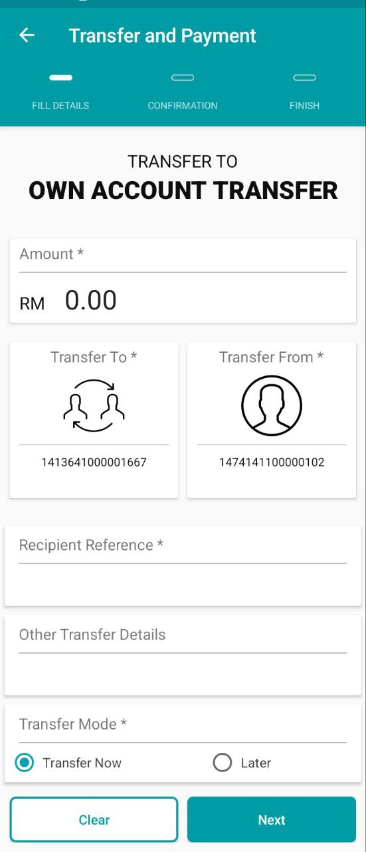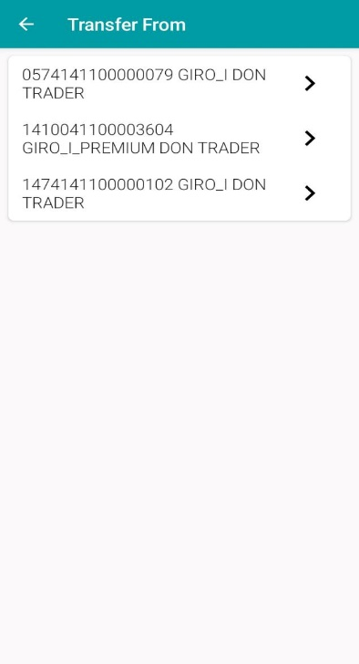
Figure 68 : Own Account Transfer Form and Transfer From page

Input Specifications:
No | Field | Field Type | Validation Rule | Description | Required
1. | Amount | Text | Max length: 12 Numeric | Contains an action to enter transaction amount | Yes
2. | Recipient Reference | Text | Alphanumeric | Contains an action to enter transaction receipt reference | Yes
3. | Other Transfer Details | Text | Alphanumeric | Contains an action to enter other transfer details | No
Table 73 : Own Account Transfer Form and Transfer From – Input Specification
Display Fields:
No | Field | Format | Description
1. | Title | Text | Transfer and Payment title
2. | Sub Title | Text | TRANSFER TO  TRANSFER AND PAYMENT
3. | Amount | Numeric | Amount to transfer
4. | Recipient Reference | Text | Reference information to the Recipient
5. | Transfer Mode | Radio Button | Now - the effective date is today  Later – user select an effective date that is after today
6. | Date | Date Picker | Date Effective Date picker for the Later option.  Will only show when Later option is selected.
Table 74 : Own Account Transfer Form and Transfer From – Display Field
Action:
No | Action | Type | Description
1. | Back | Button | This action will go back to Landing Page
2. | Transfer To | Button | This action will open Transfer To screen
3. | Transfer From | Button | This action will open Transfer From screen
4. | Clear | Button | This action will refresh current Transfer and Payment form
5. | Next | Button | This action will proceed Transfer and Payment form to Transfer and Payment confirmation
Table 75 : Own Account Transfer Form and Transfer From – Action
Step 4:
- After User selected an account on the account listing, the app will auto populate selected account to the Transfer and Payment form. The Effective Date is defaulted to Now. User can change to other date by selecting the Later option and set a future date. After set the Effective Date, User tap on the Next button to go to the confirmation form
Figure 69 : Own Account Transfer page

Input Specifications:
No | Field | Field Type | Validation Rule | Description | Required
1. | Amount | Text | Max length: 12 Numeric | Contains an action to enter transaction amount | Yes
2. | Recipient Reference | Text | Alphanumeric | Contains an action to enter transaction receipt reference | Yes
3. | Other Transfer Details | Text | Alphanumeric | Contains an action to enter other transfer details | No
Table 76 : Own Account Transfer Form– Input Specification

Display Fields:
No | Field | Format | Description
1. | Title | Text | Transfer and Payment title
2. | Sub Title | Text | TRANSFER TO  TRANSFER AND PAYMENT
3. | Amount | Numeric | Amount to transfer
4. | Recipient Reference | Text | Reference information to the Recipient
5. | Transfer Mode | Radio Button | Now - the effective date is today  Later – user select an effective date that is after today
6. | Date | Date Picker | Date Effective Date picker for the Later option.  Will only show when Later option is selected.
Table 77 : Own Account Transfer Form– Display Field

Action:
No | Action | Type | Description
1. | Back | Button | This action will go back to Landing Page
2. | Transfer To | Button | This action will open Transfer To screen
3. | Transfer From | Button | This action will open Transfer From screen
4. | Clear | Button | This action will refresh current Transfer and Payment form
5. | Next | Button | This action will proceed Transfer and Payment form to Transfer and Payment confirmation
Table 78 : Own Account Transfer Form– Action
Step 5:
- After CDB Mobile user filled the form and tap on Next button, Transaction Confirmation form will show.
- Click on Confirm button to proceed to Transfer and Payment Result form.
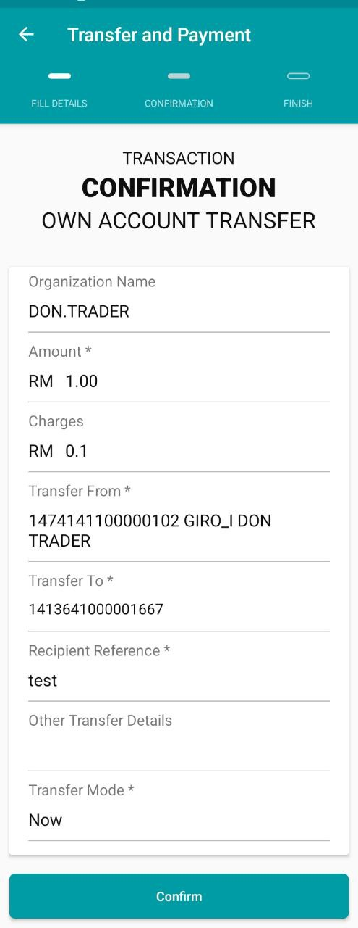
Figure 70 : Transaction Confirmation page

Display Fields:
No | Field | Format | Description
1. | Title | Text | Transfer and Payment
2. | Sub Title | Text | TRANSACTION CONFIRMATION OWN ACCOUNT
3. | Amount | Label | Amount to transfer
4. | Charges | Label | Transactional Charges
5. | Transfer From | Label | Debiting account number
6. | Transfer To | Label | Crediting account number
7. | Recipient Reference | Label | Reference information to the Recipient
8. | Other Payment Details | Text | Other Reference information to the Recipient
9. | Effective Date | Label | The payment value date
Table 79 : Transaction Confirmation - Display Field
Action:
No | Action | Type | Description
1. | Back | Button | This action will go back to Transfer and Payment form
2. | Confirm | Button | This action will proceed payment and transfer Confirm to payment and transfer Result
Table 80 : Transaction Confirmation– Action
Step 6:
- CDB Mobile will show the Transfer and Payment Result form
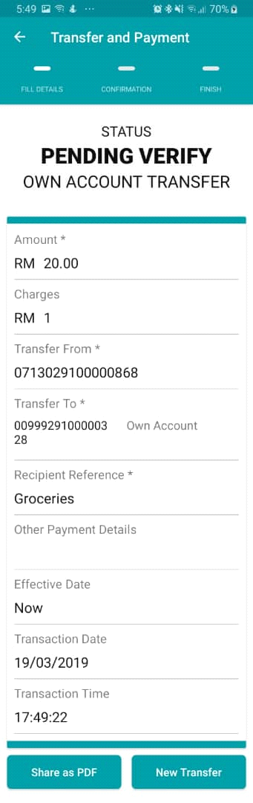
Figure 71 : Transfer and Payment Result page
Display Fields:
No | Field | Format | Description
1. | Title | Text | Transfer and Payment
2. | Status | Text | Pending Verify, Successful, Unsuccessful
3. | Amount | Label | Transaction amount
4. | Charges | Label | Transactional Charges
5. | Transfer To | Label | Crediting account number
6. | Transfer From | Label | Debiting account number
7. | Recipient Reference | Label | Reference information to the Recipient
8. | Other Payment Details | Text | Other Reference information to the Recipient
9. | Effective Date | Label | Value date
Table 81 : Transfer and Payment Result - Display Field
Action:
No | Action | Type | Description
1. | Back | Button | This action will go back to Transfer and Payment form
2. | Make New Transfer | Button | This action will prompt user to make new transfer
3. | Share as PDF | Button | This action will show receipt as PDF
Table 82 : Transfer and Payment Result– Action

