
Corporate Digital Banking
BSNeBiz

(CORPORATE ADMIN)
User Guide
(PENRIL/BSN/BRFD_CDB(SU)006)
Revision: 00

25th April 2024

Prepared By:

Penril Datability (M) Sdn Bhd (816792-X)
Suite A-07-07 Plaza Mon’t Kiara
No. 2, Jalan Kiara, Mon’t Kiara
50480 Kuala Lumpur, Malaysia
Tel: (603) 6201 2622Fax: (603) 6201 7622

Document Amendment Log
Rev. No | Date Update | Description of Change | Update By  <Name, Dept> | Review By  <Name, dept> | Approved By  <Name, Dept>
00 | 17/4/2023s | Initial Release | Nurul Aziana  QA Executive |  | Tan Lee Yong  Project Manager

Table of Content
Document Amendment Log 2
Table of Content 3
1. New Application 4
1.1. Process Flow 4
1.2. Screen Flow 4
2. Receiving Email 11
3.1 First Time Login 11
3.1.1 Process Flow 11
3.1.2 Screen Flow 11
3.2 Login 16
3.2.1 Process Flow 16
3.2.2 Screen Flow 17

New Application
  - Process Flow
Diagram 1: New Application
  - Screen Flow
Step 1:
- User access to the Registration form by clicking on the “New Application” link. CDB system displays the online Registration form.

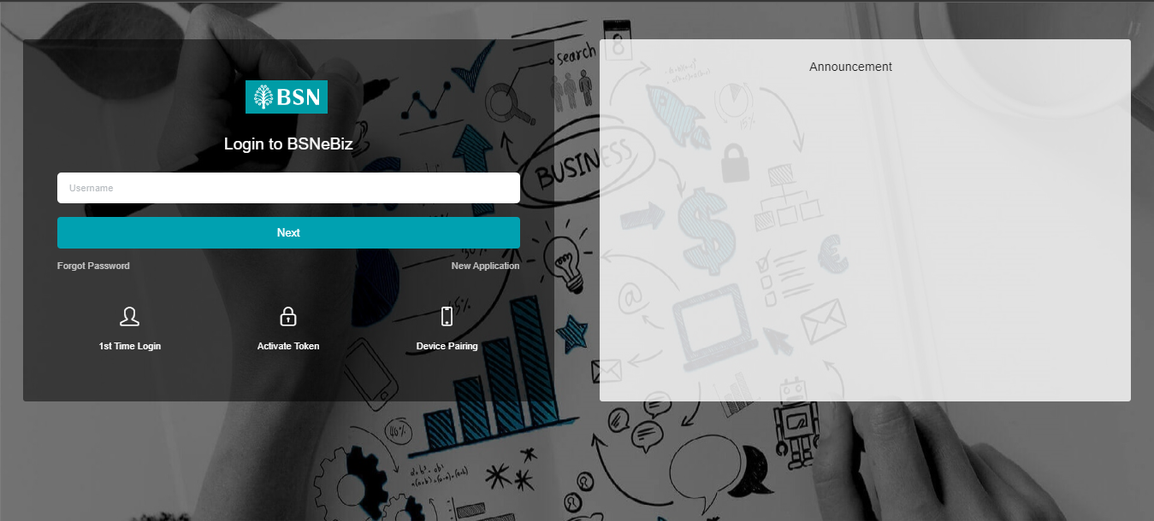
Figure 1: BSNeBiz Login Screen

Step 2:
1. Customer inputs the required organization and information fields, and click “Next” button, or click “Back” button to go previous page.
2. CDB System will save the data input.

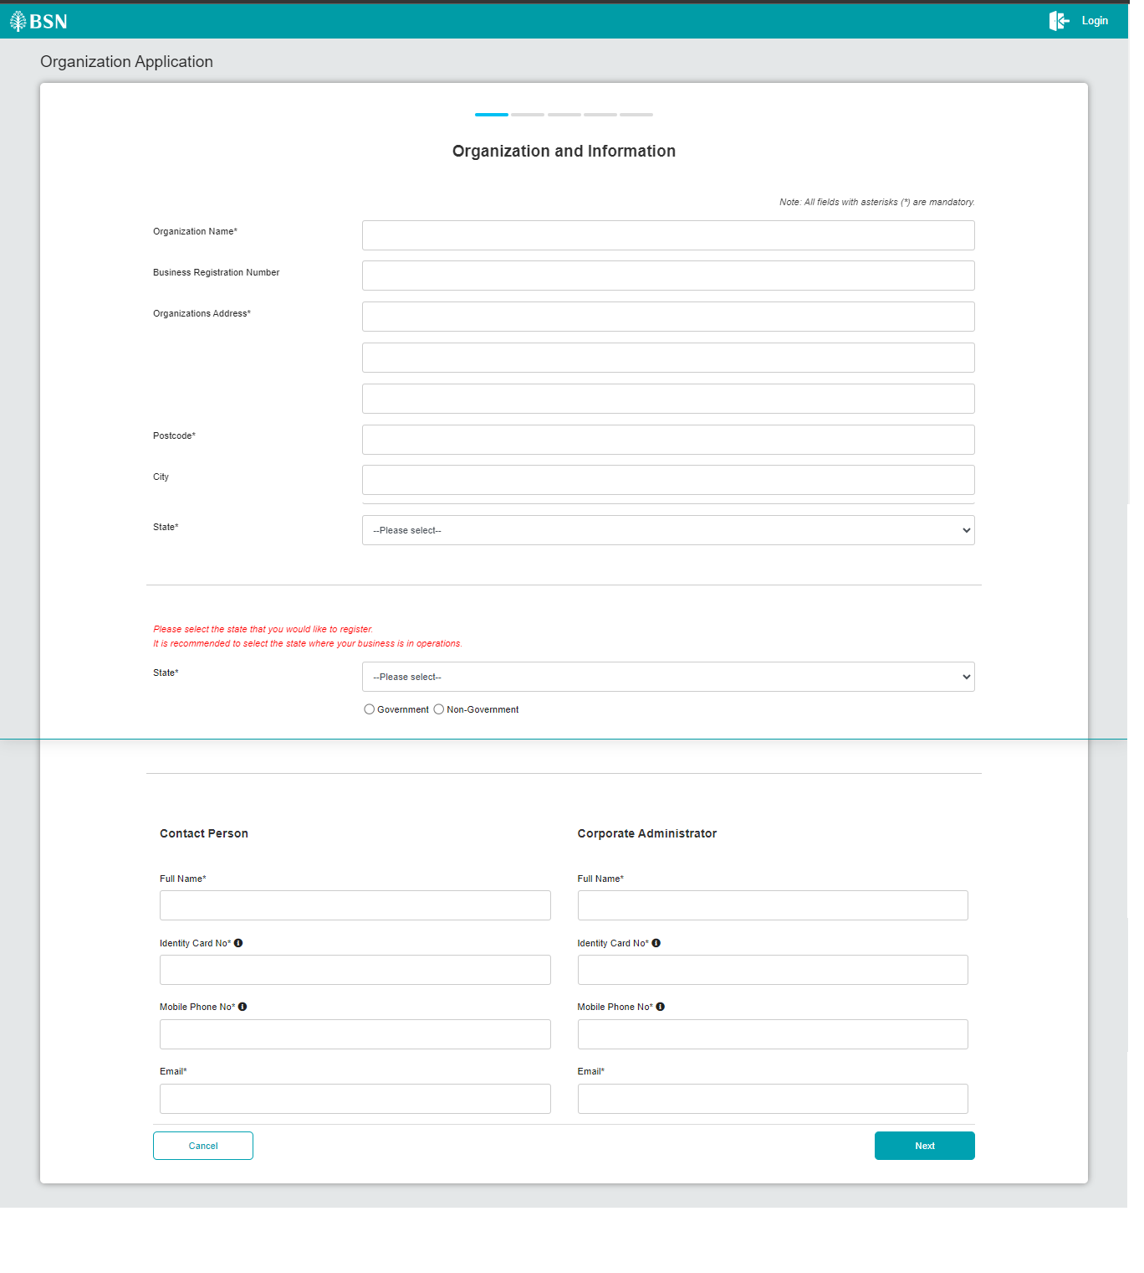
Figure 2: New Application Form – Organization and Information screen

Step 3:
1. User select the subscribing services, input the BSN Corporate Account No fields, select the type of access and clicks the “Next” btton to go to next page, or click the “Back” button to go to the previous page.
2. CDB system will save the data input.

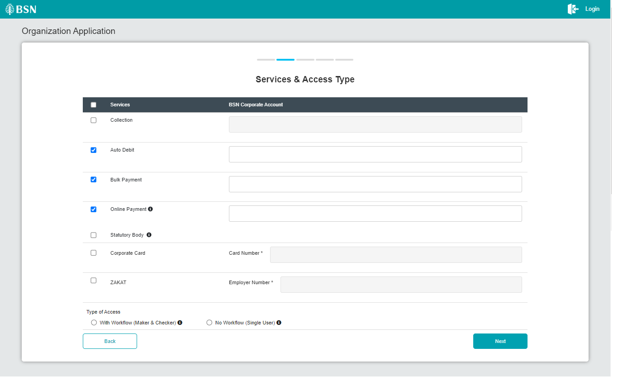
Figure 3: New Application Form – Services & Access Type Screen

Step 4:

1. CDB displays the Application’s summary screen.
2. Customer confirms the registration by clicking on the “Next” button or clicks on the “Back” button to go back to the previous page.
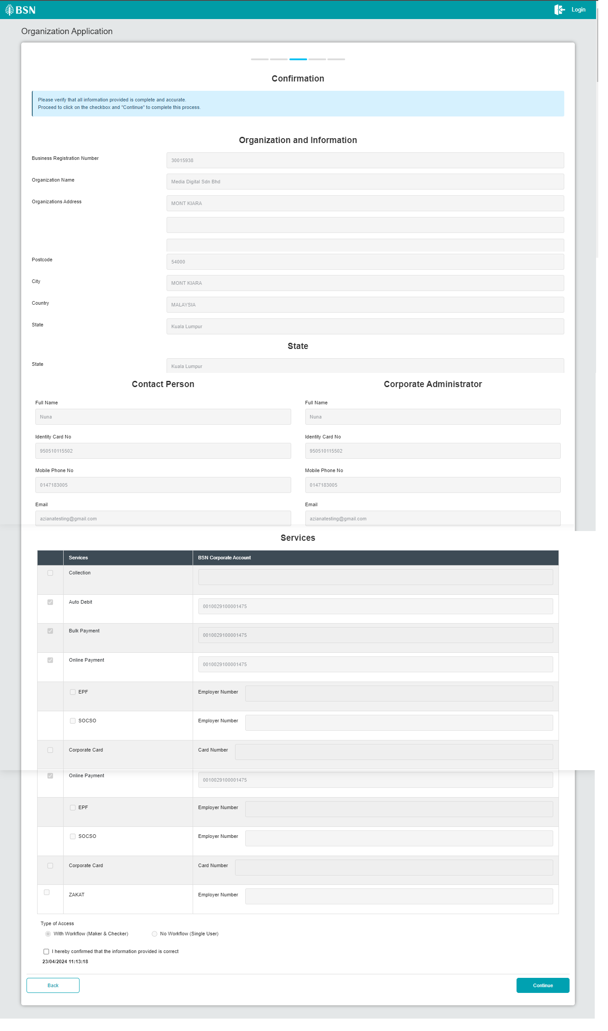
Figure 4: New Application Form – Summary Screen

Step 5:

1. CDB display Terms & Conditions screen.

2. If user tick on “NO, I DO NOT AGREE….”, system will prompt “Thank You!...”.
3. If user tick on “ YES, I agree…” to accept the Terms and Conditions of the usage.
4. CDB display Applicant Declaration form. Customer input the details (Name, IC Number, Email) and click on “Save & Print” button.
5. The system will download the completed registration form as PDF file.
6. Customer clicks on “Submit” button to submit the application for processing.

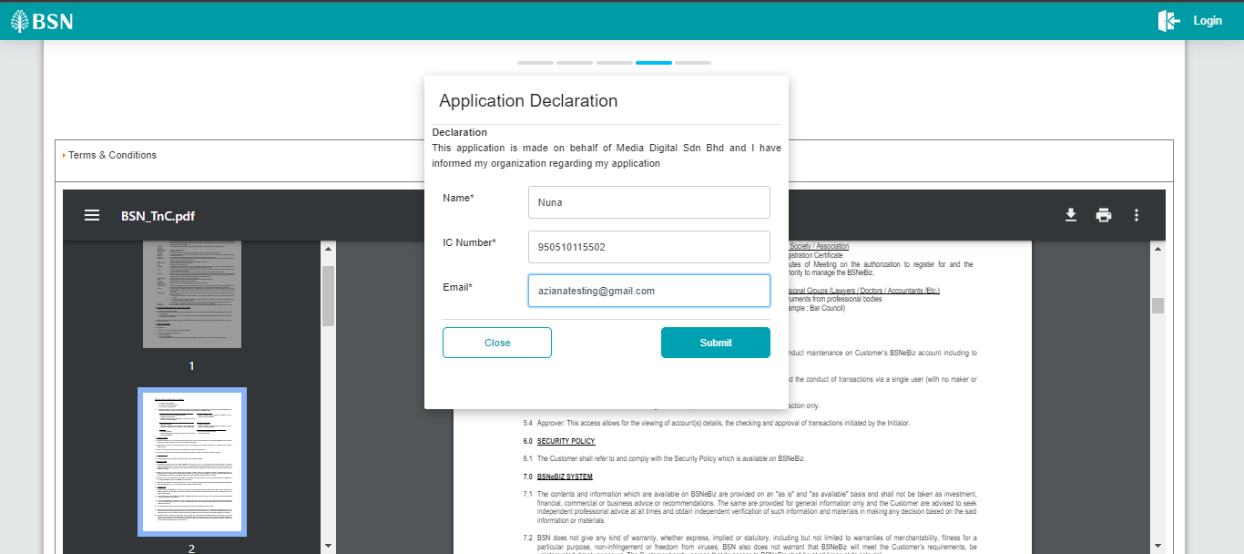
Figure 5: New Application Form – Applicant Declaration Screen

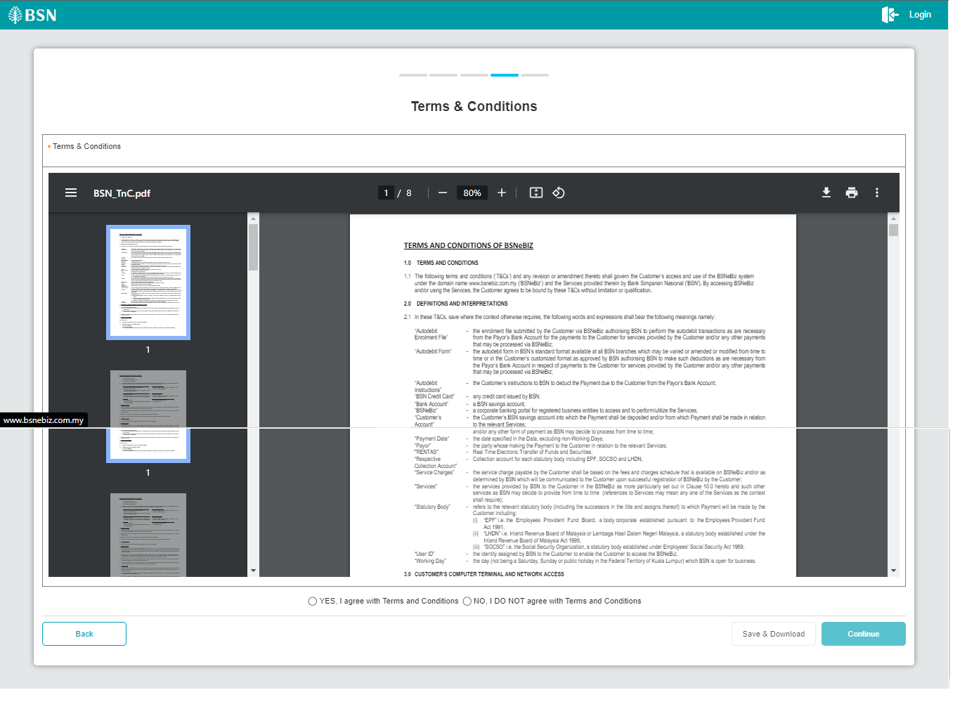

Figure 6: New Application Form - Terms and Conditions

Step 6:

1. CDB system display Result screen.
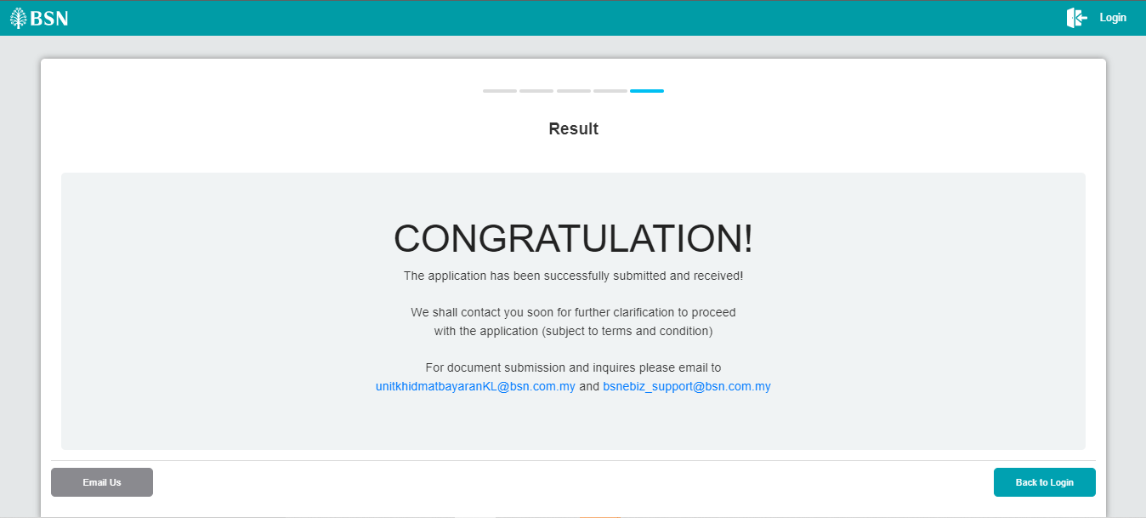
Figure 7: New Application Form – Result Screen

Receiving Email

First Time Login

Process Flow
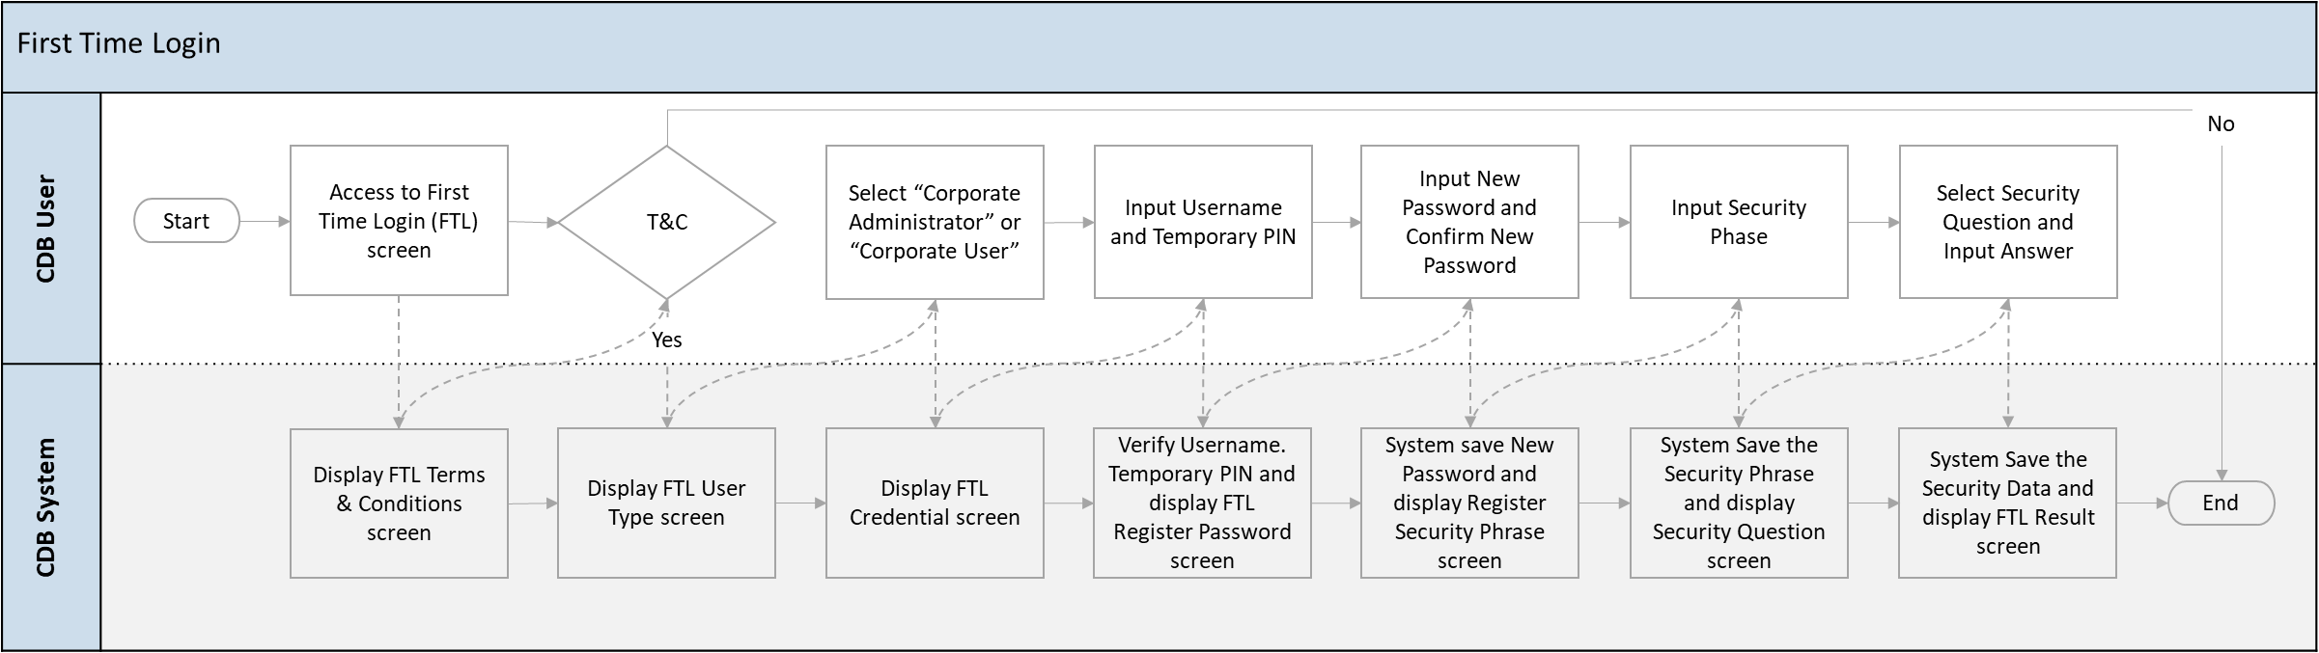
Diagram 2: First Time Login Process Flow

Screen Flow
Step 1:
- User accesses to First Time Login Selection from the Login screen of BSNeBiz System.
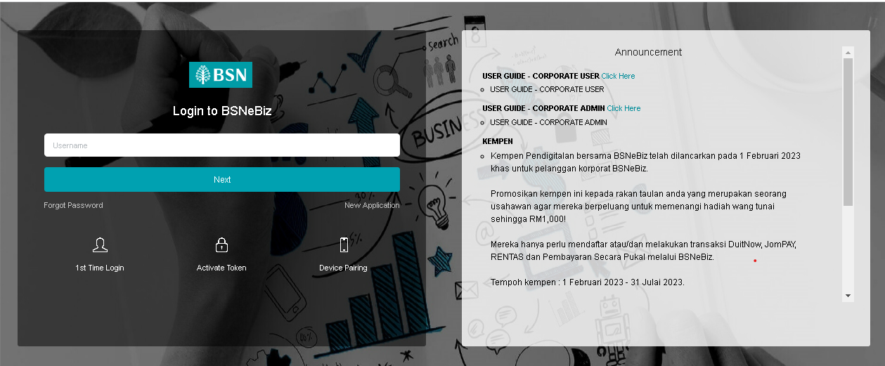
Figure 8: Login screen of BSNeBiz

Step 2:
- User ticks on “YES, I agree...” to accept the Terms and Conditions and click on the “Continue” button.

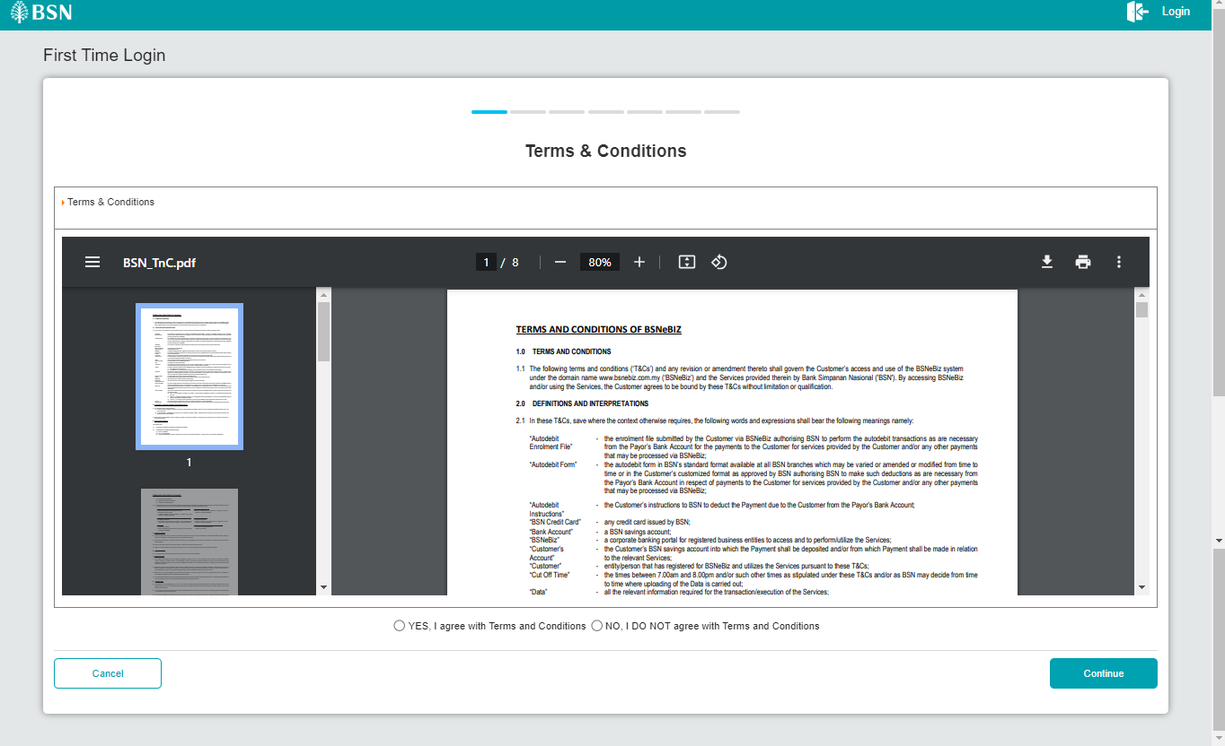
Figure 9: FTL - Terms & Condition’s screen

Step 3:
- User clicks on the ‘Corporate Administrator” or “Corporate User” button and proceeds to the next step.
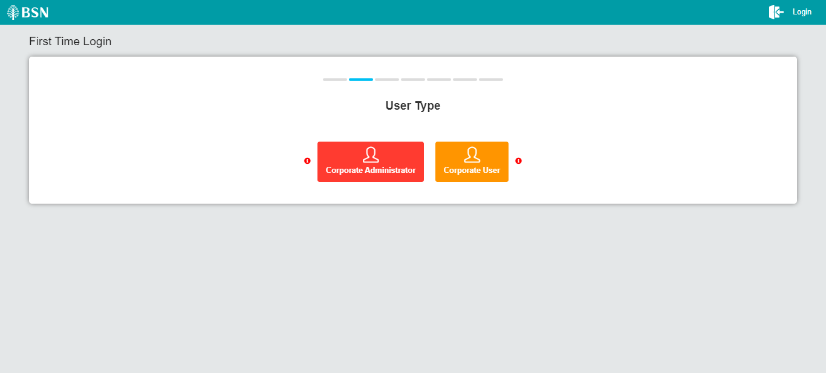
Figure 10: FTL – User Type Selection Screen

Step 4:
- Enter the Username and Temporary Pin received and click on the “Next” button.
- CDB System validates the Username and PIN. After successful validation, CDB System will then prompt the screen for Change Password of First Time Login.

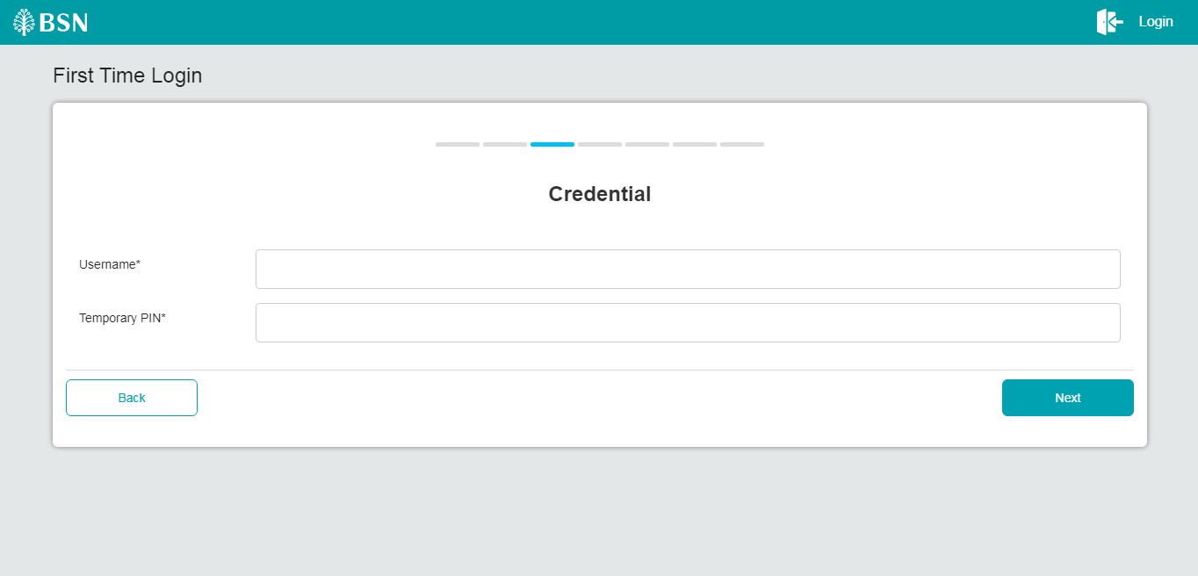
Figure 11: FTL - Credentials for the Corporate Administrator’s screen

Step 5:
- CA inputs the New Password, Confirm Password and click on the “Next” button.

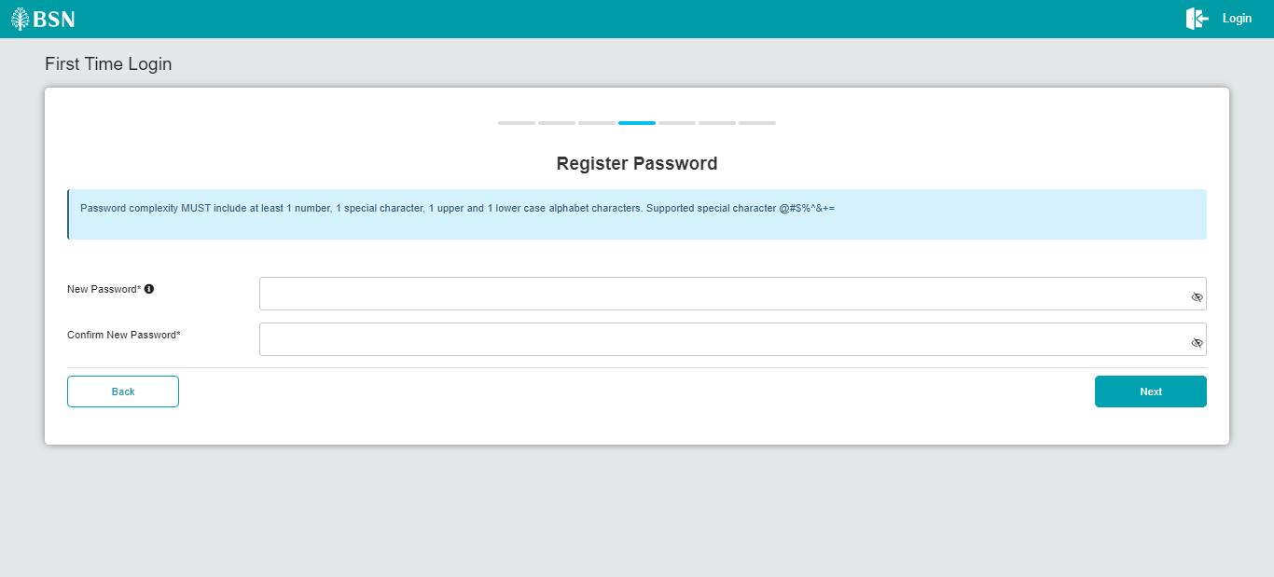
Figure 12: FTL – Register Password Screen
Step 6:
- User inputs a security phrase then click on the “Next” button.
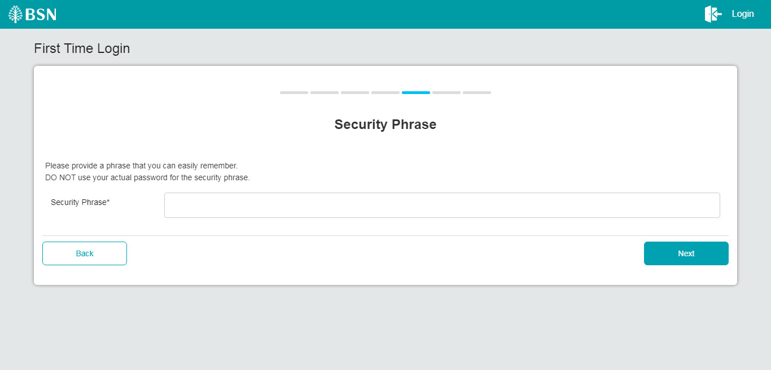

Figure 13: FTL – Security Phrase Screen
Step 7:
- User selects security questions and input the answers then clicks on the “Confirm” button.
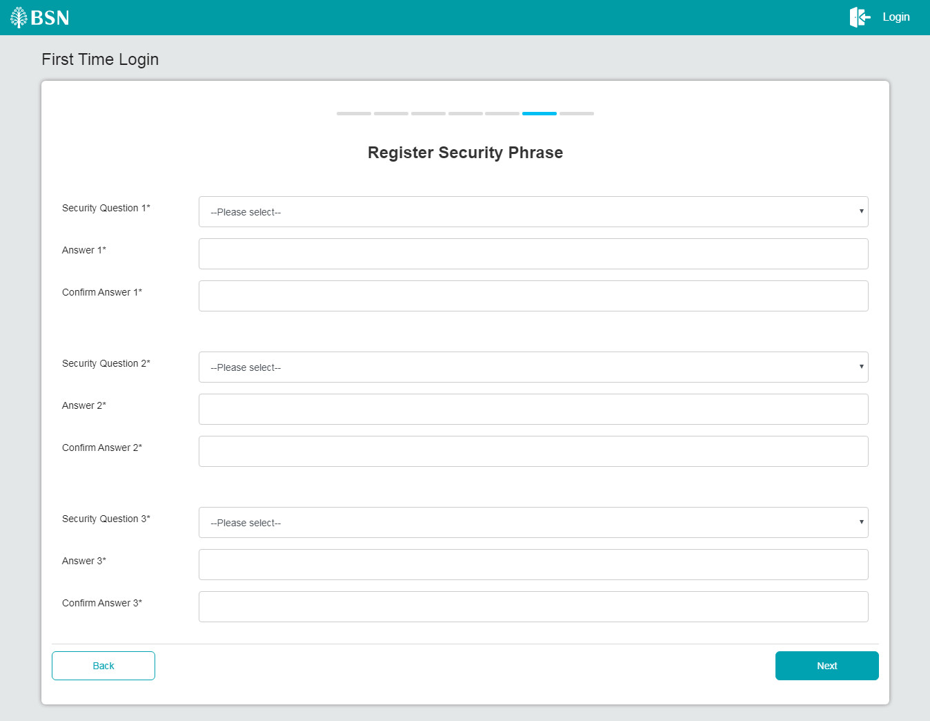
Figure 14: FTL - Security Question Screen

Step 8:
- CDB System displays the FTL result. User may proceed to Login by clicking on the “Proceed to Login” button.
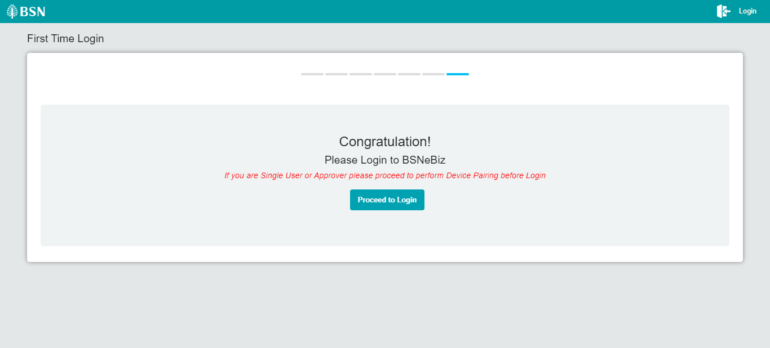
Figure 15: First Time Login Result Screen

- CDB System displays the FTL result. User may proceed to Login by clicking on the “Proceed to Login” button.

3.2 Login

Process Flow
Diagram 3: First Time Login Process Flow

Screen Flow
- (login )
- BSNeBiz user fills in their username and clicks next.

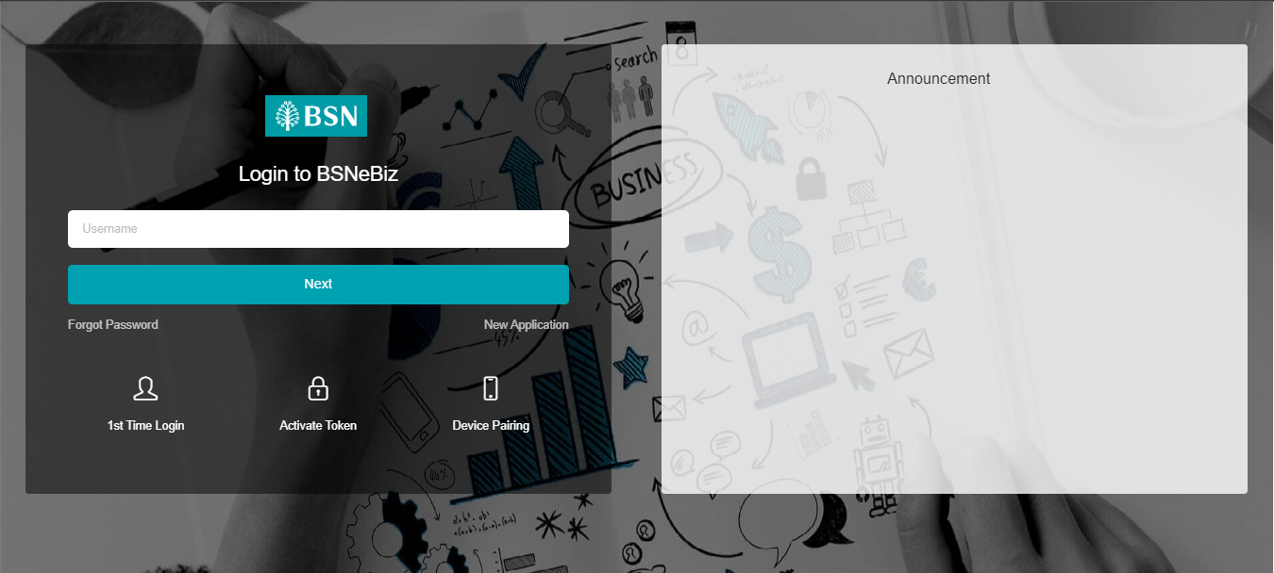
Figure 16: Login Screen

- (insert password)
- BSNeBiz user fills in their password.
- Once the password is entered, click the "Login" button to proceed.
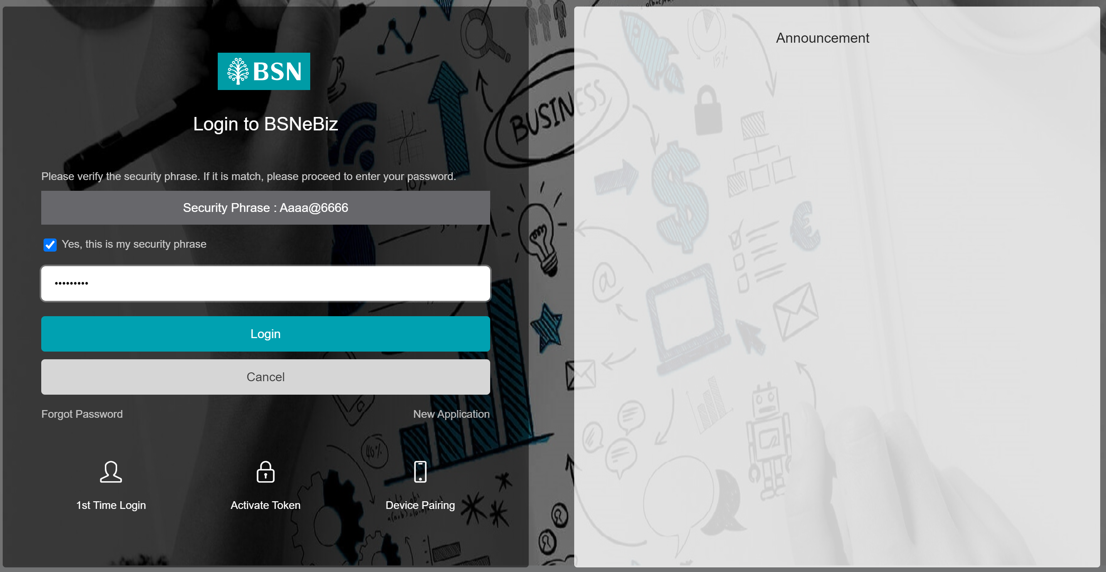
Figure 17: Login screen (insert password)

