Kuwait Finance House (Malaysia) Berhad
Internet Banking System

Functional Requirement and System Specification
for IBSCR2023004 – Panic Button / Kill Switch for KFH Online

^{16th} May 2024
Reference: KFH/FSD/IBSCR2023004
Version: 1.0

Prepared By:

Penril Datability (M) Sdn Bhd (816792-X)
Suite A-07-07 Plaza Mon’t Kiara
No. 2, Jalan Kiara, Mon’t Kiara
50480 Kuala Lumpur, Malaysia
Tel: (603) 6201 2622Fax: (603) 6201 7622

Document Management
Rev. No | Date Update | Description of Change | Update By | Review By
1.0 | 04/12/2023 | Initial release | Amir Hakim Bin Mior Kamarul Bahrain | Lizahwati  Yap Kah Yan

Table of Contents
Section A: Introduction 5
1.1 Objective 5
1.2 Scope of Delivery 6
Section B: Functional Specifications 11
[MOD01] KFH Online 11
[FUNC01] Add new navigation and Panic Button/Kill Switch Activation module 11
[FUNC02] The system block KFHOnline access (including FPX) and auto logs out the user from the active login session once the kill switch activated (both KFH Online & FPX) 16
[FUNC03] During “Kill Switch Activated” mode 17
[MOD02] API Integration 18
[MOD03] SMS Notification on Kill Switch Activation and Deactivation 18
[FUNC04] Kill Switch Activation 18
[FUNC05] Kill Switch Deactivation 18
[MOD04] FPX 20
[MOD04] BVMC 21
[FUNC06] Scenario for Panic Button/Kill Switch Deactivation 21
[FUNC07] Process flow 22
[FUNC08] Screen flow 22
[MOD04] Report 24
[FUNC08] Report 24
[MOD05] Database 25
[MOD05] Additional Requirement 25
Section C: Traceability Matrix 26

Functional Requirement and System Specification Acceptance

I/We hereby verify that this Functional Requirement and System Specification consist of all the requirements requested by Kuwait Finance House (M) Berhad. The implemented system will fulfill ONLY this requirement.

I/We also hereby AGREE that this satisfies our entire requirement for IBSCR2023004 Kill Switch Button.
Any future changes to this agreed scope will be treated as an enhancement to the system. Any future changes to the project timeline will be subjected to the final approval of the project steering committee.

Kuwait Finance House (M) Berhad:

Approved by | Role | Signature | Date

Penril Datability (M) Sdn. Bhd.:

Approved by | Role | Signature | Date
Lizahwati Basirun | Professional Services

Section A: Introduction

This document served as basic/high level business requirement and system specification for KFH Online new enhancement. This new enhancement is to implement “Panic Button” or known as kill switch function in KFH Online system in order to comply with Bank Negara Malaysia (BNM) requirement to curb online fraud/scam, pursuant to YAB PM announcement in Budget 2023.
All screen designs provided in this document are samples and only illustration purpose for easy understanding. The screen designs are not final.

Objective
The base line features description and screen designs will become a reference blueprint for the development team to develop the transactional and administration module. Hence, it is crucial that all stakeholders need to ensure the correctness and adequacy of the requirements captured in this document.
All stakeholders involved are expected to review and sign off this document before the development start. By signing off the document, the stakeholder has endorsed the correctness and accuracy and adequacy of the requirements documented in this document.

Scope of Delivery

Please refer to the linked Section for the details of the proposed solution for the scope of work.
This enhancement is only applicable for KFH Online & FPX module.
Section | Description | Yes – in scope  No – not in scope
Consumer | Add new navigation and Panic Button/Kill Switch Activation module [BRS1.1, BRS1.2, BRS1.3, BRS2.1, BRS2.2, BRS3.1, BRS3.2, BRS3.3, BRS3.4, BRS3.4.1, BRS3.6, BRS3.7, BRS3.8, BRS3.9, BRS3.10]  - Kill switch module accessed from navigation and welcome page  - New Panic Button/Kill Switch Activation module.  - Terms and condition page  - Activation acknowledgement page with Reference No  - Scenario for Panic Button/Kill Switch Activation  - Successful – send “Successful SMS Notification” to customer  - In core banking change account status to restricted  - Unsuccessful  - Send "Unsuccessful SMS Notification” to customer.  - System displayed the unsuccessful screen.  - To ensure no change and impact on customer’s existing access and usage (including FPX)  Panic Button/Kill Switch Deactivation [BRS4.1, BRS4.2, BRS4.3, BRS4.3.1, BRS4.3.2, BRS4.3.5, BRS4.3.6, BRS5.2, BRS5.3  - Customer visit nearest branch for verification and reactivate account  - Customer call Contact Center to reactivate KFHOnline access via BVMC  - Contact Center will update customer status to ‘Panic button deactivated’  - Contact Center able to search the “Activated Kill Switch” customers as BAU in BVMC  - Customer will need to change password after login.  - Successful – change user status to ‘Normal’  *Note: Customer and Contact Center will not receive the SMS notification and email notification during deactivation. Notification will be sent only after customer successful change their password  - The system block KFHOnline access (including FPX) and auto logs out the user from the active login session once the kill switch activated (both KFH Online & FPX) [BRS3.4, BRS3.4.2, BRS3.5. BRS3.5.1]  - Implement new checking to check on kill switch flag, if the kill switch flag is on, then need to log the user out when user clicks on next action.  During “Kill Switch Activated” mode [BRS3.3.1, BRS5.1, BRS6.1, BRS6.2, BRS6.5]  - Customer will not allow to login to KFHOnline  - Enhance login screen to add new friendly error message.  - Allow incoming fund to credited into the customer’s current and saving accounts | Yes
SI | SI transaction flow as BAU | NO
API integration | New Integration (to block account CASA)  - New API - dbo.sp_KFHM_acct_killswc  - call existing service ESBAccountEnquiryServices  SERVICE_ID = 800, TRANCode = 61 - pass in RIM No.  2. get list of Normal Accounts / CASA account type  3. block all account in the list  SP dbo.sp_KFHM_acct_killswc  req: channel, acct number, account type  res success = empty data  res error = "-10003" | Yes
SMS TEMPLATE | SMS Notification on Kill Switch Activation and Deactivation [BRS3.6.1, BRS3.10.1, BRS5.3.1  - Kill Switch Activation  (Successful)  Proposed Message - RM0.00 KFH: Your Kill Switch activation on DDMMMYY 00:00:00 was successful. To deactivate, visit our nearest branch. For queries, call the No. on the card.  (Unsuccessful)  Proposed Message - "RMO KFH: Your Kill Switch activation on 01JUN23 09:31:37 was unsuccessful. Not you? Call the No. on the card.”  - Kill Switch Deactivation  Proposed Message - RM0.00 KFH: You have successfully deactivate Kill Switch on DDMMMYY 00:00:00. For queries, call the No. on the card. | Yes
FPX | Panic Button/Kill Switch Activated [BRS6.2]  - Enhance login screen to add new error message and return error code to PayNet [1C - Buyer choose cancel at Login Page]  Panic Button/Kill Switch Deactivated  - Enhance login screen to add new error message and return error code to PayNet | Yes
BVMC | Customer’s access status flag after activation or deactivation [BRS3.4, BRS4.3.3  - Kill Switch Activated  - Kill Switch Deactivated  New Additional Account status [ BRS3.4.1, BRS4.3.1]  - Kill Switch Activation  - Kill Switch Deactivation | Yes
Report | Add new report for Kill Switch Activation [BRS8.1]  - Daily/Monthly/Yearly "Kill Switch" activation report | Yes
 | Add new report for Kill Switch Activation [BRS8.2]  Daily/Monthly/Yearly "Kill Switch" deactivation report | Yes
Database | Add new table to store Panic Button/Kill Switch request  - Panic button/kill switch table | Yes
Performance Test | Performance test using JMeter | No
VAPT | VAPT Support | No

Section B: Functional Specifications

[MOD01] KFH Online

[FUNC01] Add new navigation and Panic Button/Kill Switch Activation module

[FUNC01.1] Kill switch module accessed from navigation and welcome page.
- User login to KFHOnline.
- User locate and click the “Kill Switch” function which is located at the left side menu of the home page.
- Upon clicking the hyperlink, system will route the customer to the “Kill Switch” Terms and Conditions screen.

[FUNC01.2] New Panic Button/Kill Switch Activation module.
- After user clicks the “Kill Switch” hyperlink, user can click “Cancel” button to be routed back KFHOnline home screen or click “Activation” to send request to activate the Kill Switch and route customer to the Acknowledgement screen.
- System will assign Reference No for all the “Kill Switch” requests.
- Customer’s account status will change from “Active” to “Restricted” and customer’s access status will flag from Active to “Kill Switch Activated”.

[FUNC01.3] Scenario for Panic Button/Kill Switch Activation

[FUNC01.3.1] Kill Switch Activation Successful

- After user click System will display Successful screen
- System will assign Reference No for all Kill Switch requests.
- Core Banking will change the account status from “Activate” to “Restricted”.
- System will flag customer’s KFHOnline access as “Kill Switch Activated” in BVMC.
- System will auto logout the customer when customer clicks on any of the active menu/button available in KFHOnline.
- System will send “Successful SMS Notification” to cutomer’s mobile number to notify “Kill Switch” activation status.
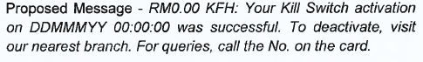

[FUNC01.3.2] Kill Switch Activation Unsuccessful
- System will display Unsuccessful screen.
- System will assign Reference No for all Kill Switch request.
- There will be no change on customer’s existing access and usage (including FPX).
- System will send “Unsuccessful SMS Notification” to customer’s mobile number to notify on “Kill Switch” activation status.
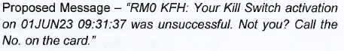

[FUNC01.4] Process flow - Kill Switch Activation
Diagram 1 Kill Switch Activation – Kill Switch

[FUNC01.5] Screen flow – Kill Switch Activation
User access KFHOnline
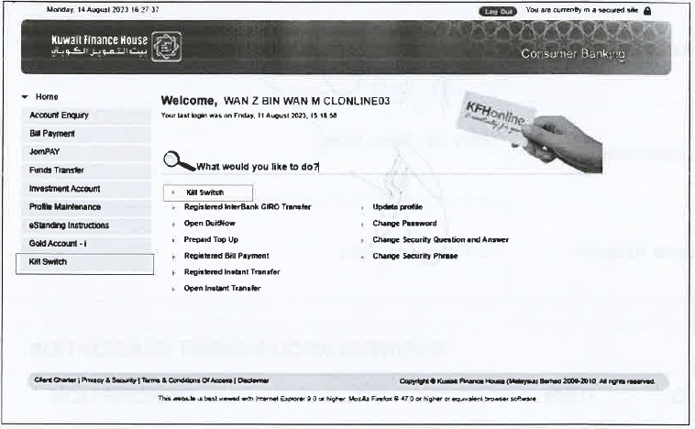
Figure 1 KFHOnline.

User clicks Kill Switch
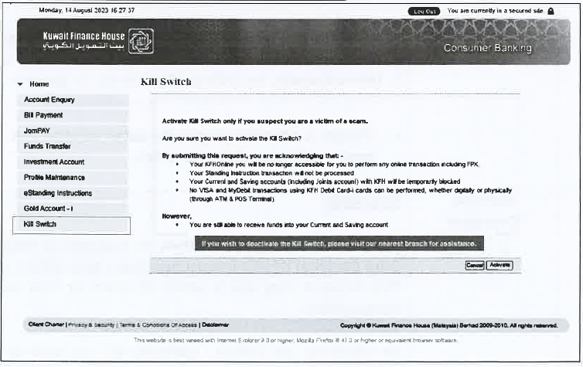
Figure 2 Terms & Conditions – Kill Switch KFHOnline

User successfully perform Kill Switch
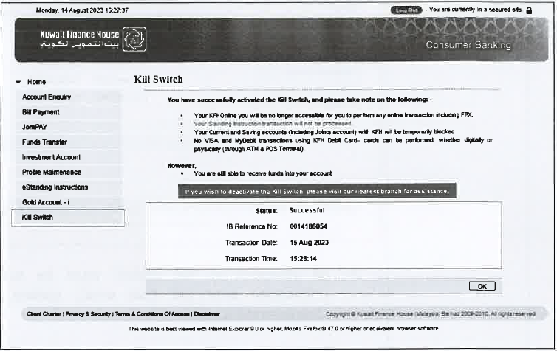
Figure 3 Acknowledgement Successful Screen– Kill Switch KFHOnline

User unsuccessfully perform Kill Switch

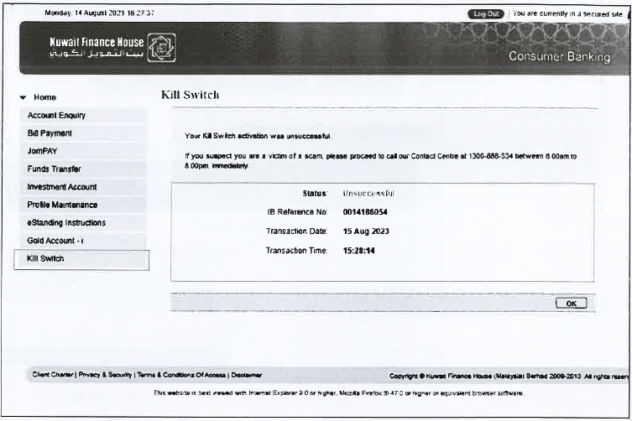
Figure 4 Acknowledgement Unsuccessful Screen– Kill Switch KFHOnline

[FUNC02] The system block KFHOnline access (including FPX) and auto logs out the user from the active login session once the kill switch activated (both KFH Online & FPX)
To Implement a new checking to check on kill switch flag, if the kill switch flag is on, then need to log the user out when user clicks on next action.

[FUNC02.1] Process flow - KFHOnline access block

[FUNC03] During “Kill Switch Activated” mode
This requirement is to lock user account after system detected user clicking the Kill Switch. This change is applicable for KFH Online. Once customer activate the Panic Button, KFH Online instantly blocks customer’s access anytime without calling our Contact Centre if they detected they are a victim of scam, or their login credentials have been compromised.

[FUNC03.1] Customer will not allow to login to KFHOnline.
- For FPX, to block the login and send correct Error Code to PayNet.
- For Standing Instructions, to apply existing rules and handling for “Restricted status”.
- No Debit/ATM cards transactions (physically and digitally) will be allowed, as the accounts have been locked.

[FUNC03.2] Enhance login screen to add new friendly error message.
Login screen will block the KFHOnline access with friendly message.
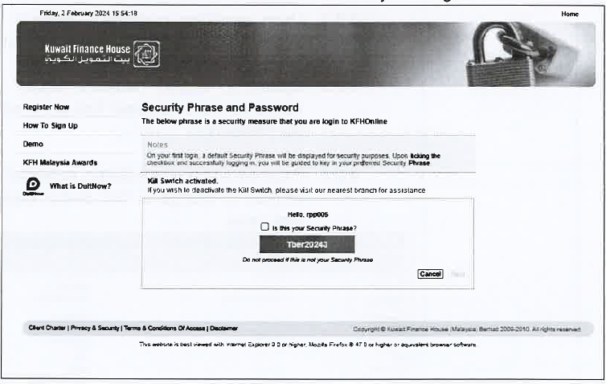
Figure 5 Kill Switch message– Kill Switch KFHOnline

[FUNC03.3] Allow incoming fund to credited into the customer’s current and saving accounts.
- Incoming fund will be credited to customer’s Current and Saving account including other account available in the bank, as per BAU process.
- To allow incoming fund to be credited to the existing customer’s

[MOD02] API Integration
The API block the account number sent in. When the API is called with account number and account type, then the Core Banking will block the account.

- New API - dbo.sp_KFHM_acct_killswc
- call existing service ESBAccountEnquiryServices
SERVICE_ID = 800, TRANCode = 61 - pass in RIM No.
2. get list of Normal Accounts / CASA account type
3. block all account in the list
SP dbo.sp_KFHM_acct_killswc
req: channel, acct number, account type
res success = empty data
res error = "-10003"

[MOD03] SMS Notification on Kill Switch Activation and Deactivation

[FUNC04] Kill Switch Activation
After user activate “Kill Switch”, System will display Successful screen. System will auto logout the customer when customer clicks on any of the active menu/button available in KFHOnline.
System will send a SMS Notification to customer’s mobile number to notify “Kill Switch” activation status.

- (Successful)
Proposed Message - RM0.00 KFH: Your Kill Switch activation on DDMMMYY 00:00:00 was successful. To deactivate, visit our nearest branch. For queries, call the No. on the card.

- (Unsuccessful)
Proposed Message - "RMO KFH: Your Kill Switch activation on 01JUN23 09:31:37 was unsuccessful. Not you? Call the No. on the card.”

[FUNC05] Kill Switch Deactivation
- Customer is required to visit the nearest branch for verification purposes in order to reactivate the account. There is no change on account activation process.
- Once the account has been activated, customer is required to call the Contact Centre to re-activate KFHOnline access via BVMC.
- After successful verification on change of account status done by Contact Centre, customer will not allow to login to KFHOnline until the customer perform password change.
- Once the password has been changed, customer status at BVMC will change to “Normal” and customer is allowed to login to KFHOnline.
- System will send notification to customer’s mobile number to update on the Kill Switch deactivation status.

Proposed Message - RM0.00 KFH: You have successfully deactivate Kill Switch on DDMMMYY 00:00:00. For queries, call the No. on the card.
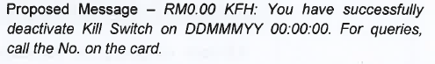

[MOD04] FPX
Panic Button/Kill Switch Activated
- Enhance login screen to add new error message and return error code to PayNet [1C - Buyer choose cancel at Login Page]
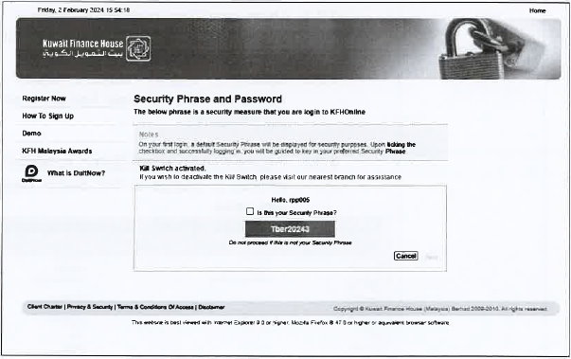

Panic Button/Kill Switch Deactivated
Enhance login screen to add new error message and return error code to PayNet.

[MOD04] BVMC

[FUNC06] Scenario for Panic Button/Kill Switch Deactivation

- Customer is required to visit the nearest branch for verification purposes in order to reactivate the account. There is no change on account activation process.
- Once the account has been activated, customer is required to call the Contact Centre to re-activate KFHOnline access via BVMC.
- Upon searching customer’s name in BVMC “User” screen, system to auto display customer’s details.
- If current status is “Kill Switch Activated”, Contact Centre is only allowed to change to “Kill Switch Deactivated” status only or vice versa.
- Contact Center able to search the “Activated Kill Switch” customers as BAU in BVMC.
- During “Kill Switch Deactivated” status, customer is required to change their password. If changing password is successful system will change user status to ‘Normal’.
- Once the password has been changed, customer status at BVMV will change to “Normal” and customer is allowed to login to KFHOnline.

Customer’s access status flag after activation or deactivation
- BVMC have an additional Account Status – “Kill Switch Activation” and “ Kill Switch Deactivation”.
- To block KFHOnline access (including FPX) once the status flag changed to “Kill Switch Activated”.

New Additional Account status
- Kill Switch Activation
- Kill Switch Deactivation

[FUNC07] Process flow – Kill Switch Deactivation

Diagram 2 Kill Switch Activation – Kill Switch

[FUNC08] Screen flow – Kill Switch Deactivation
BVMC Account Status is set into “Kill Switch Activated” after button activation.
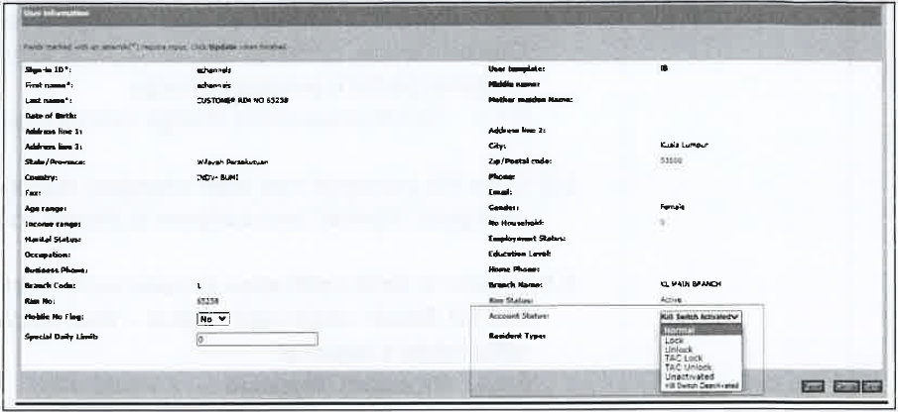
Figure 6 Kill Switch activated– Kill Switch BVMC

Contact Centre change Account Status to “Kill Switch Deactivated” and will manually unblock user’s debit card.
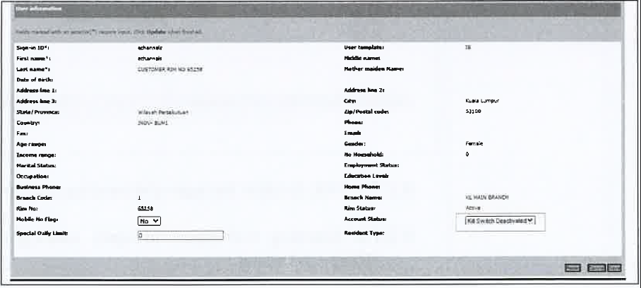
Figure 7 Kill Switch deactivated– Kill Switch BVMC

[MOD04] Report

[FUNC08] Report
To have Daily/Monthly/Yearly “Kill Switch” activation report.
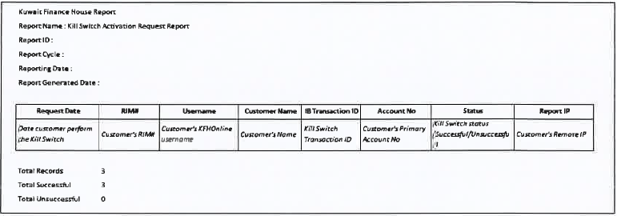
Figure 8 Daily/Monthly/Yearly “Kill Switch” activation report – Kill Switch KFHOnline
To have Daily/Monthly/Yearly “Kill Switch” activation report.
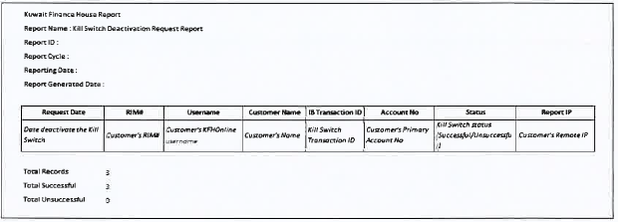
Figure 9 Daily/Monthly/Yearly “Kill Switch” activation report – Kill Switch KFHOnline

[MOD05] Database
Add new table to store Panic Button/Kill Switch request
Panic button/kill switch table

[MOD05] Additional Requirement
- Auto Debit / Standing Iinstruction Transaction
- To run the next SI date as per normal process

- VISA and MyDebit transactions
- Allow for withdrawal and other ATM transactions
- Allow for POS and eCommerce transactions

- Registered / Favourite listing
- Favourite listing will remain the same after deactivate the Kill Switch

Section C: Traceability Matrix
Document Matrix
No | BRS | FSD | SOW
1 | Signed off_Kill Switch_SP | FSD - IBSCR2023004 Panic Button Kill Switch for KFH Online | SOW Kill Switch as at 09052024

No BRS document to map for the requirements
No | BRS | FSD | SOW
 |  |  | SOW Kill Switch v1.2

