SCPID#7013
Test Title: |  | BSNeBiz Registration
Test Description: |  | Finding:  IBAM do not validate INDIVIDUAL or CORPORATE account.  Solution:  No validation was done since phase 1.
Test Functionality: |  | To ensure account number can be validate in IBAM so when Individual account is use during BSNeBiz Registration it will shows error message and only Corporate account is valid for BSNeBiz Registration.
Test Procedure: |  | Test steps:  - Access and submit BSNeBiz > New Application > Account Services. Key in the account number.  - Access IBAM > CBE > Application form and validate account number  - Expected result, page shows error Invalid account type. Please enter corporate account number.  - Access IBAM > CBE > Application form > Create New  - Enter CIS or Account Number and validate  - Expected result, page shows error Invalid account type. Please enter corporate account number
Response Message:
Test Result: | Pass: Fail: |  | Tested by: | Nurin Sabrina (20/05/2024)
Reason for Failure:
Remarks: |  | 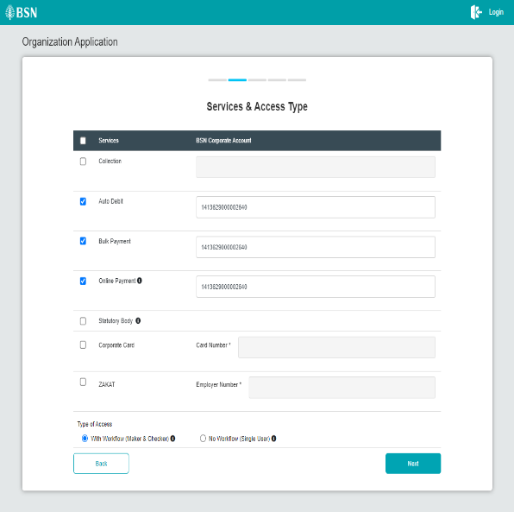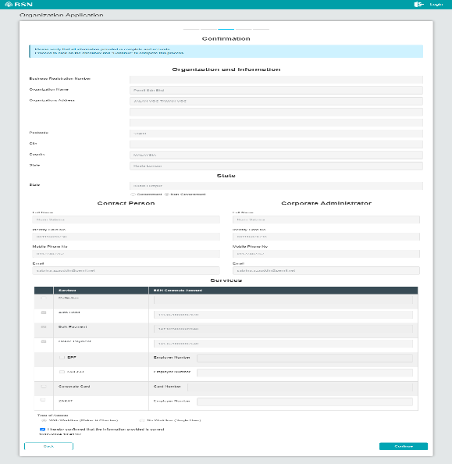  Figure 1: BSNeBiz > New Application > Services & Access Type (Giro Account)
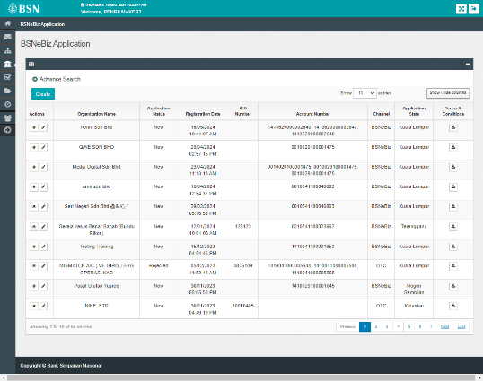
Figure 2: IBAM > BSNeBiz Application (Giro Account)

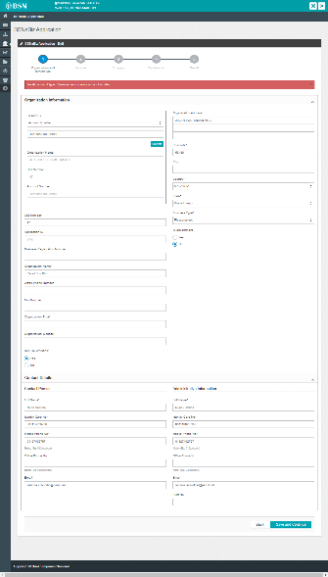
Figure 3: BSNeBiz Application form (Giro Account)

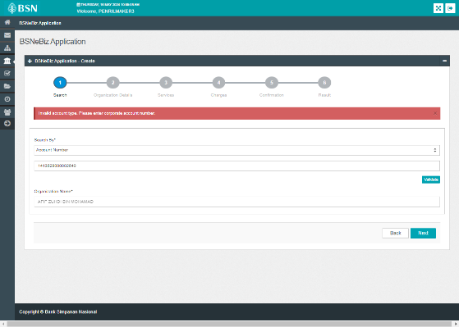
Figure 4: Create new BSNeBiz Application (Giro Account)

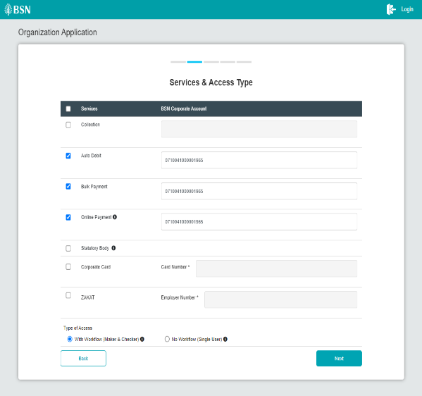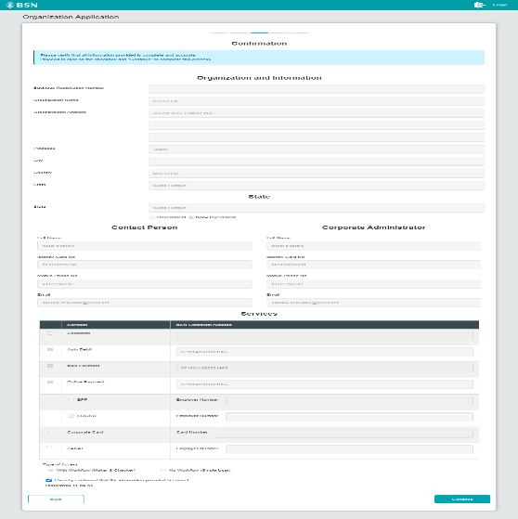
Figure 1: BSNeBiz > New Application > Services & Access Type (Giro-i Account)

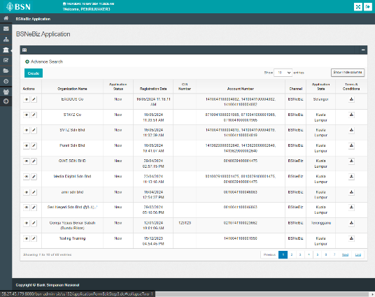
Figure 2: IBAM > BSNeBiz Application (Giro-i Account)

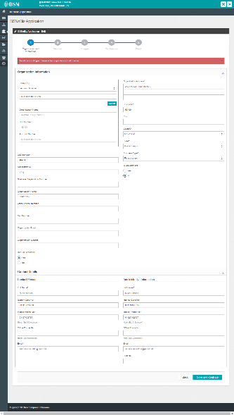
Figure 3: BSNeBiz Application form (Giro-i Account)

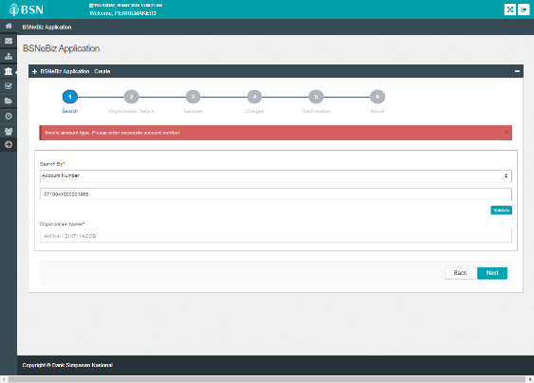
Figure 4: Create new BSNeBiz Application (Giro-i Account)

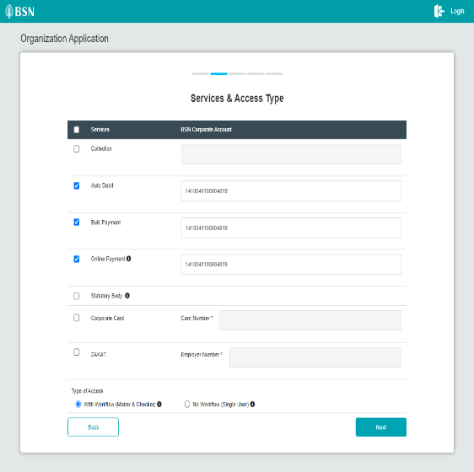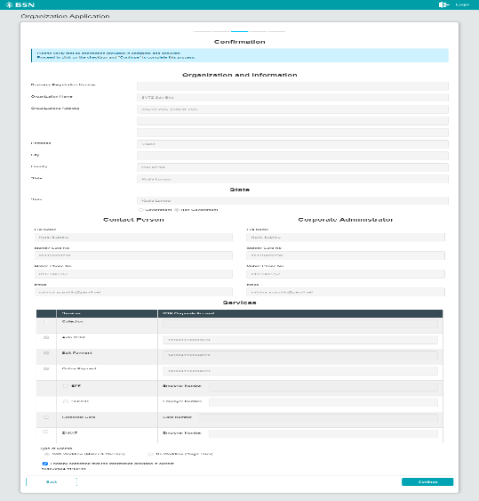
Figure 1: BSNeBiz > New Application > Services & Access Type (Cashline Account)

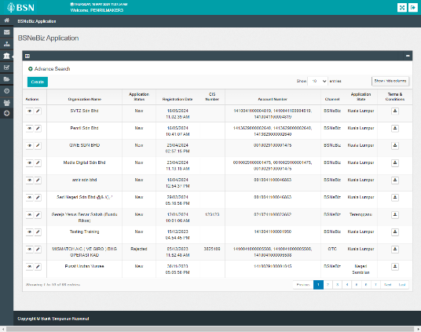
Figure 2: IBAM > BSNeBiz Application (Cashline Account)

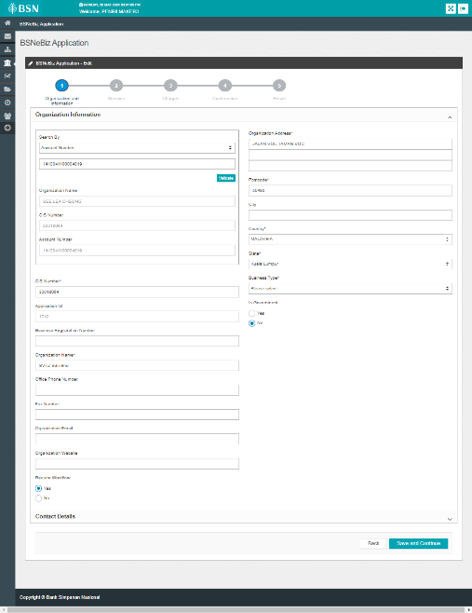
Figure 3: BSNeBiz Application form (Cashline Account)

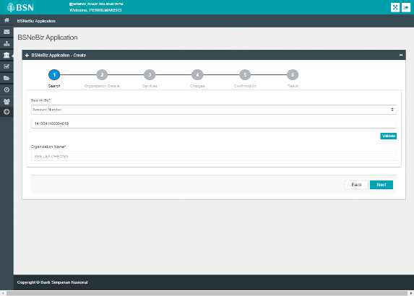
Figure 4: Create new BSNeBiz Application (Cashline Account)

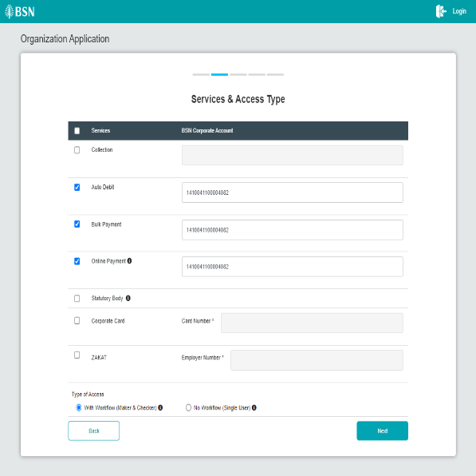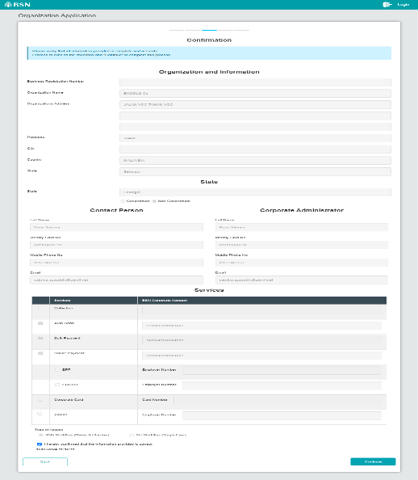
Figure 1: BSNeBiz > New Application > Services & Access Type (Corporate Account)

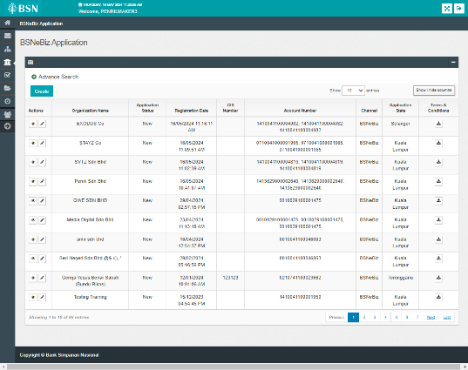
Figure 2: IBAM > BSNeBiz Application (Corporate Account)

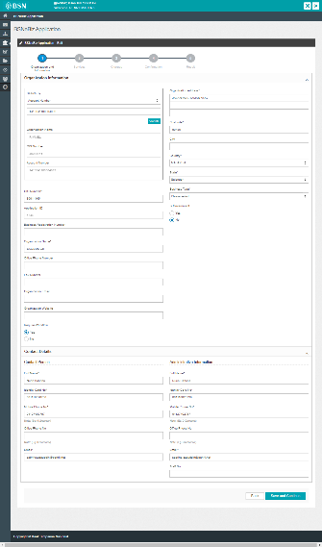
Figure 3: BSNeBiz Application form (Corporate Account)

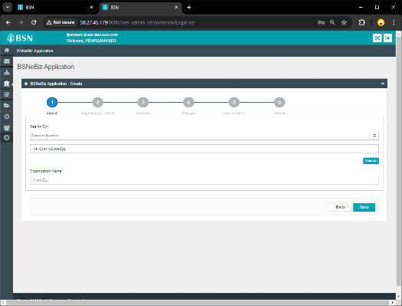
Figure 4: Create new BSNeBiz Application (Corporate Account)

