Test Issue Log |  |  |  | ReqID #14017
Project Name: | CORUS (IBG Scheduler Enhancement )
Test Stage: | Unit Functionality Integration System Interface  Performance Regression Acceptance Pilot
Test Case Number: |  |  | Test Started Date: |  | 27/05/2024
Test Title: | IBG Scheduler Holiday and Weekend
Test Description: | To ensure the system flows without any problem
Test Functionality: | - Job Scheduler
Test Procedure: | - Performing IBG Job Scheduler during  - Holiday  - Weekend
Test Result: | Pass: Fail: Conditional Pass: | Tested by: |  | Amir Hakim Mior
Reason for Failure:
TEST DESCRIPTION

IBG Scheduler on Holiday
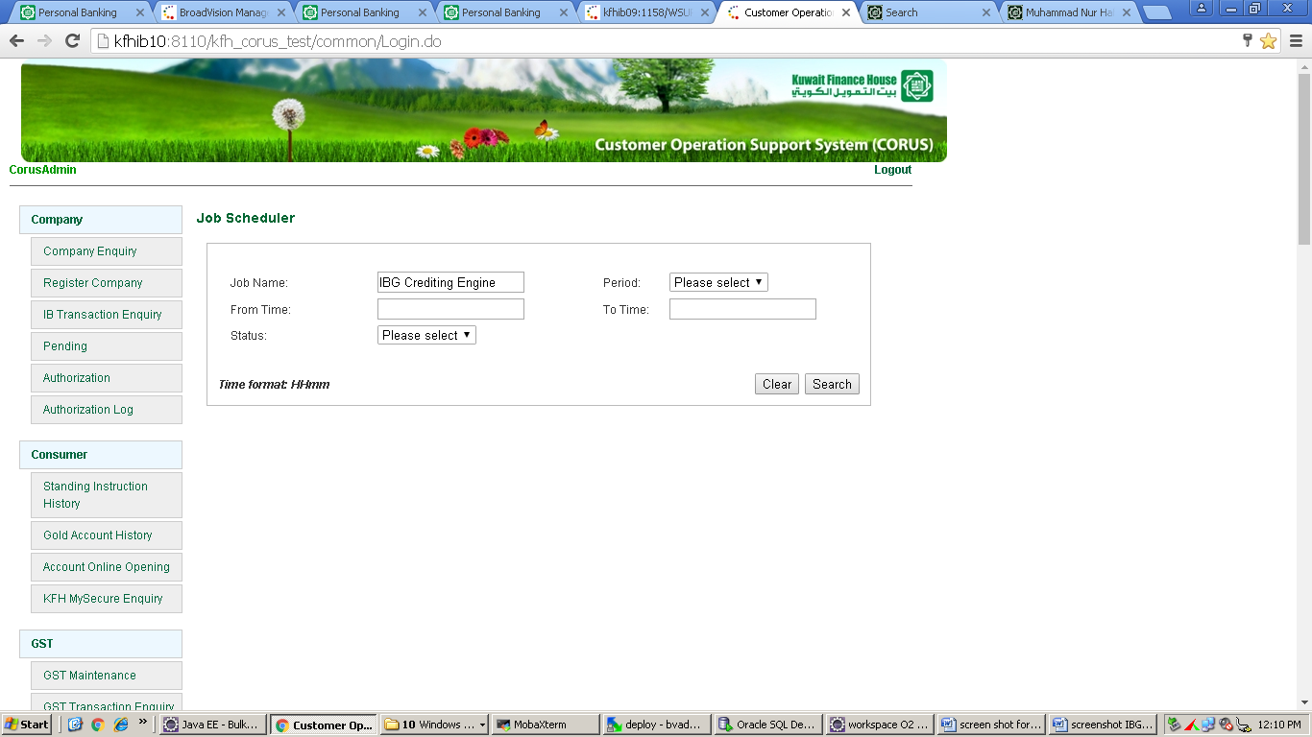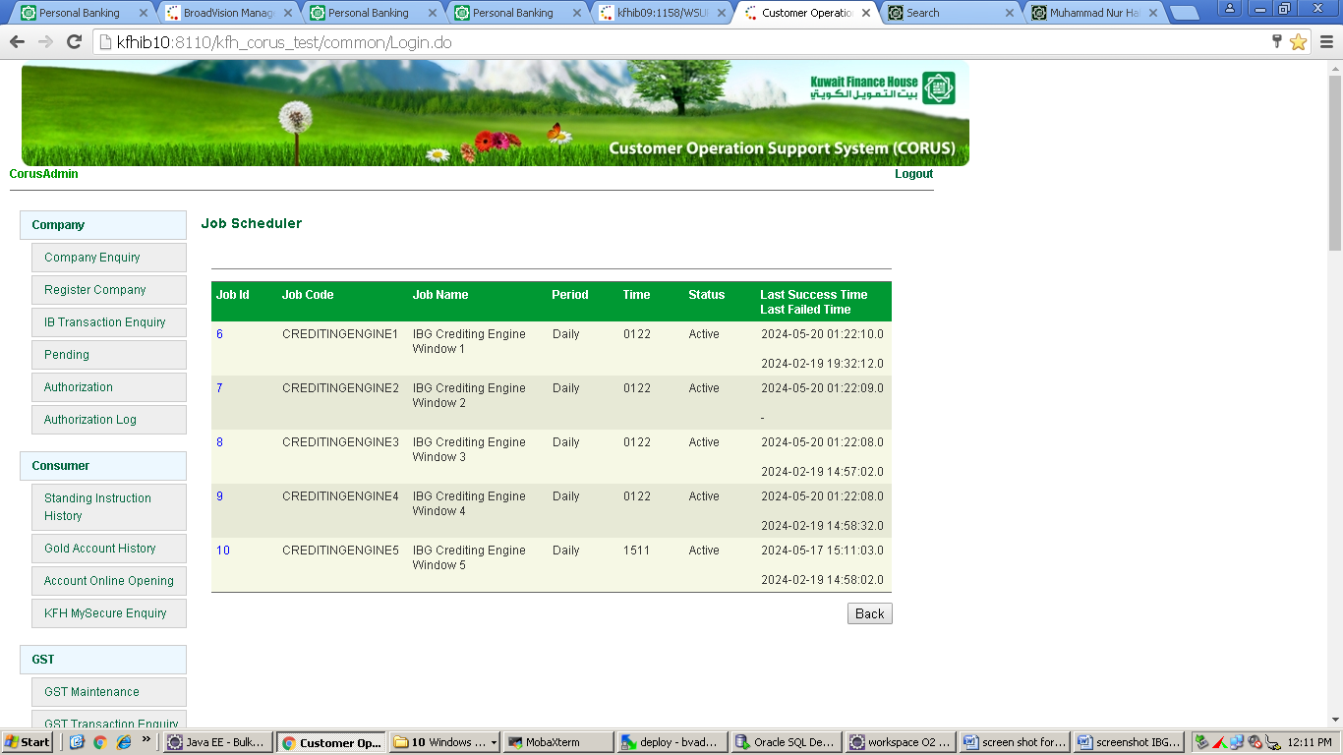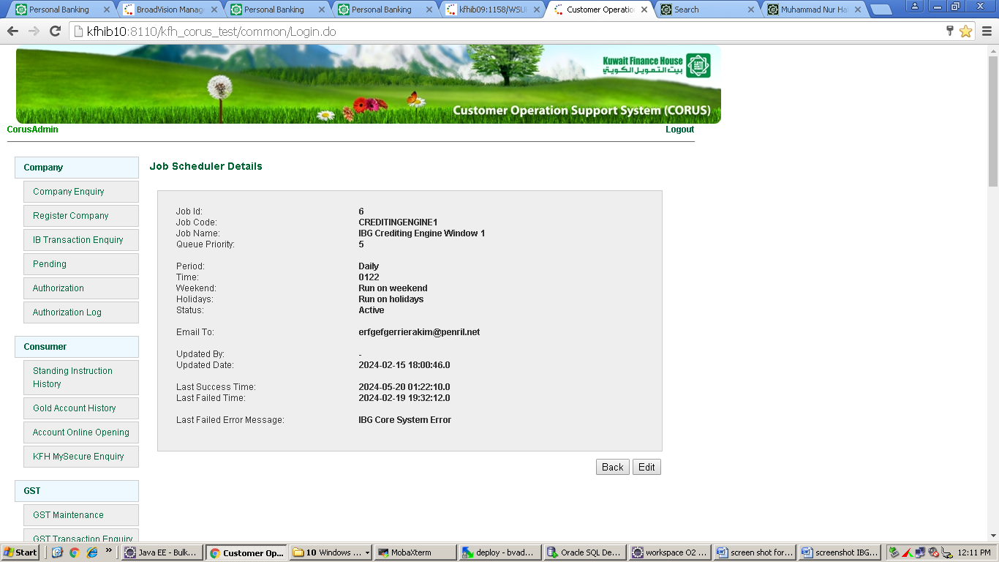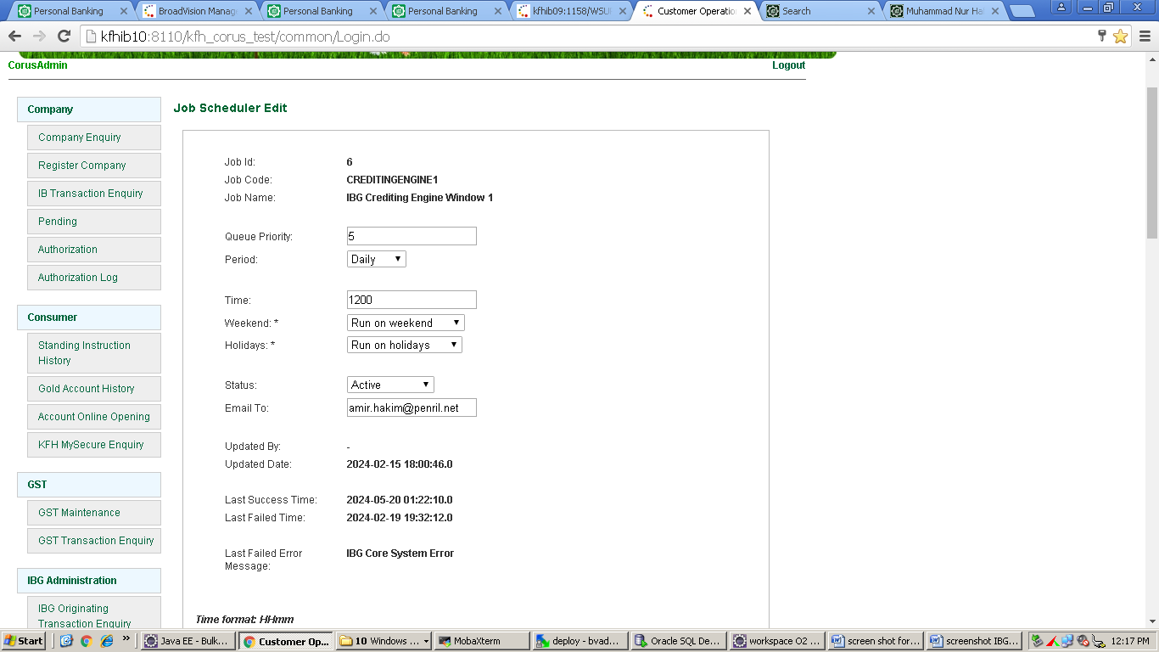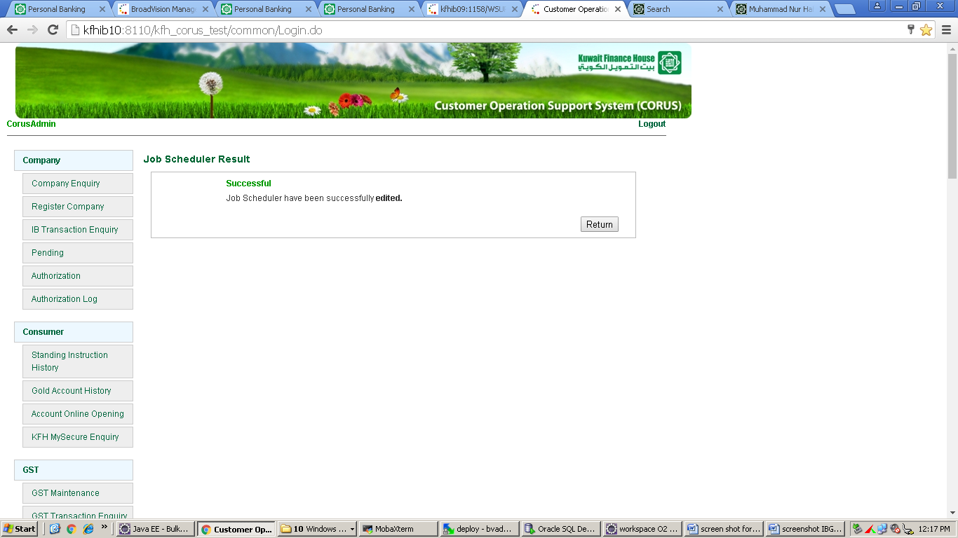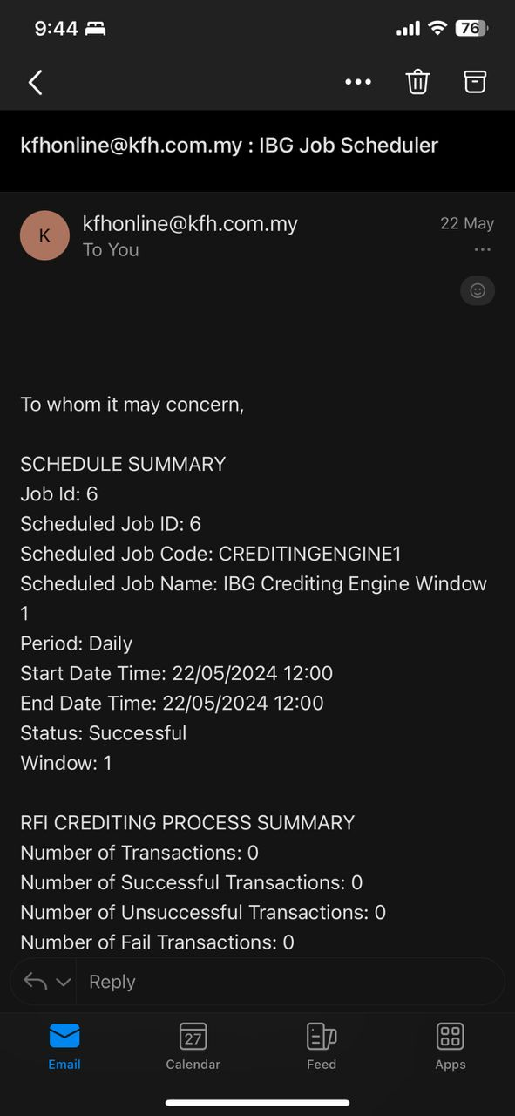

IBG Scheduler on Weekend
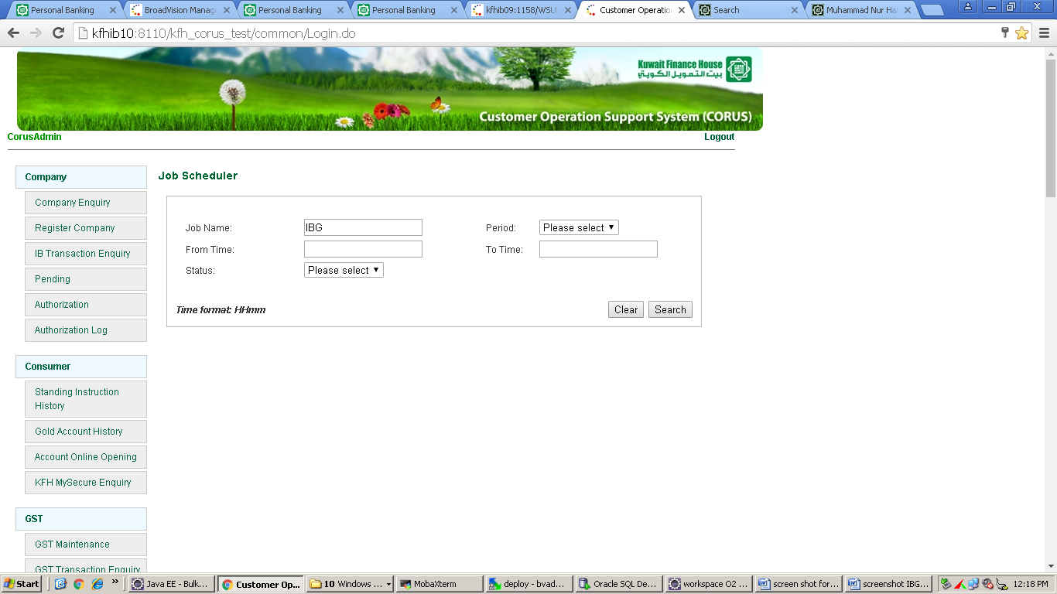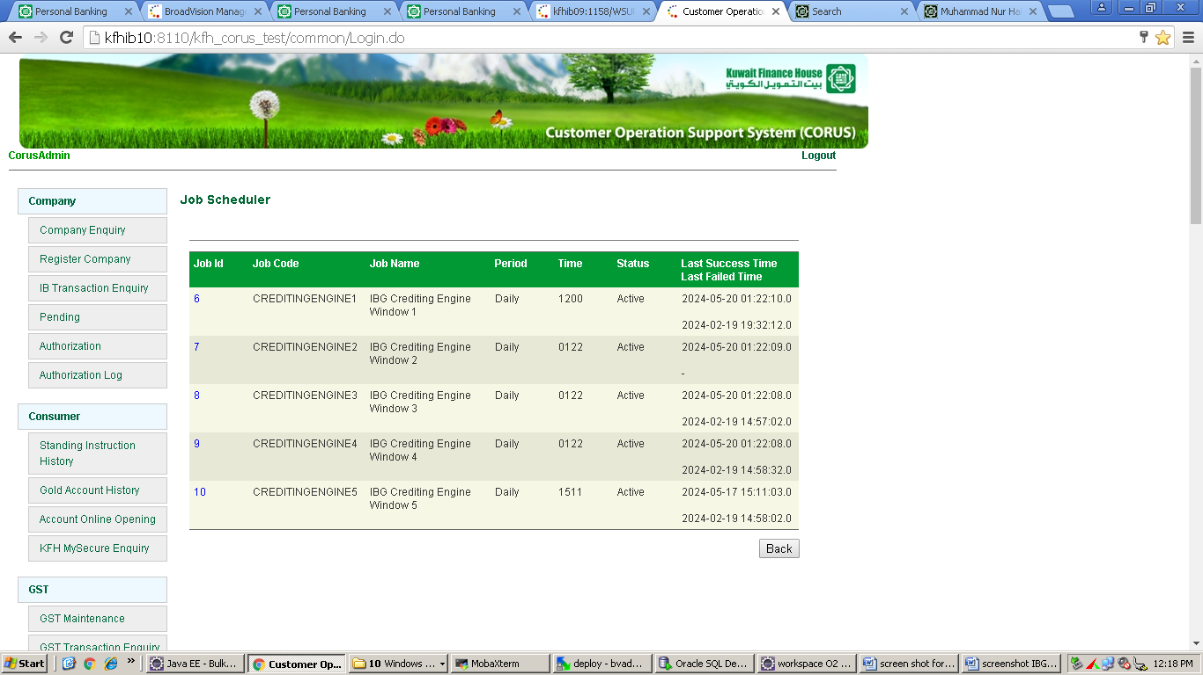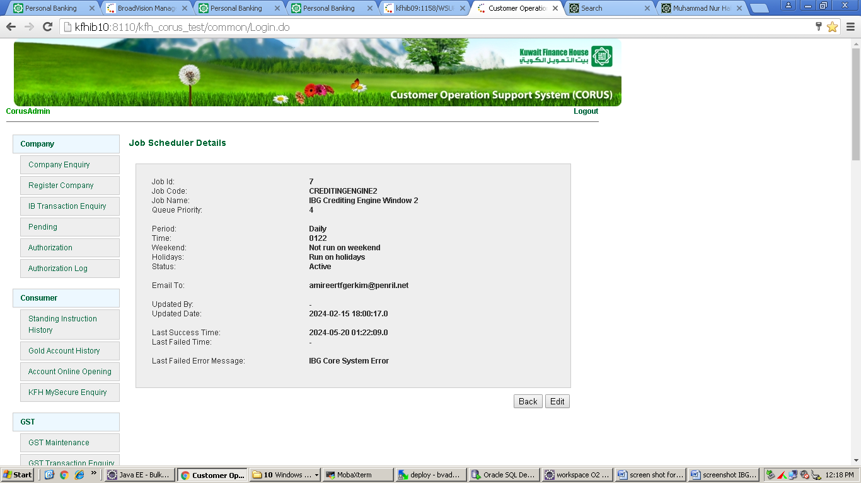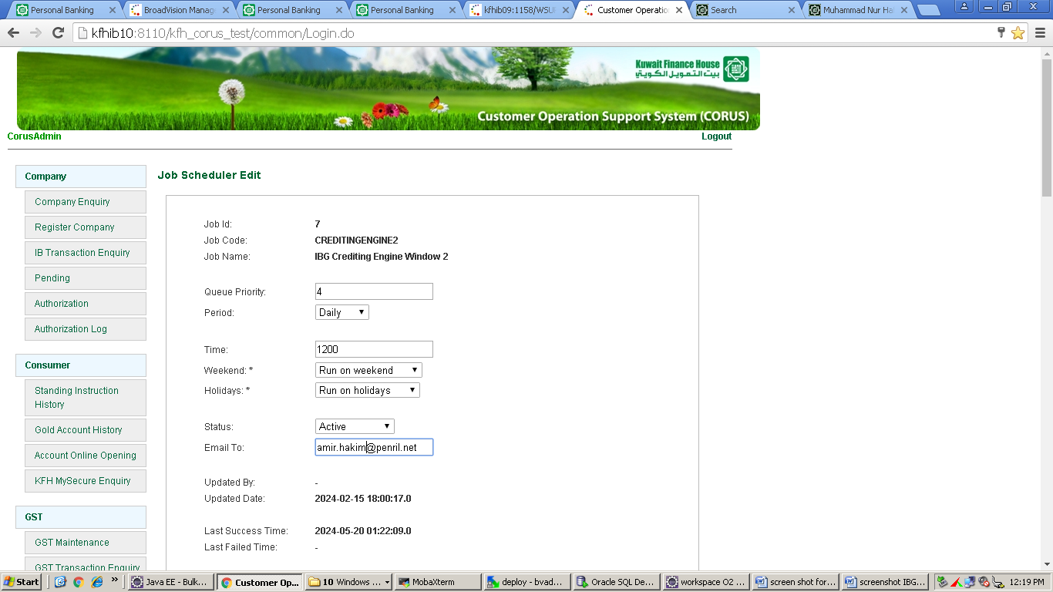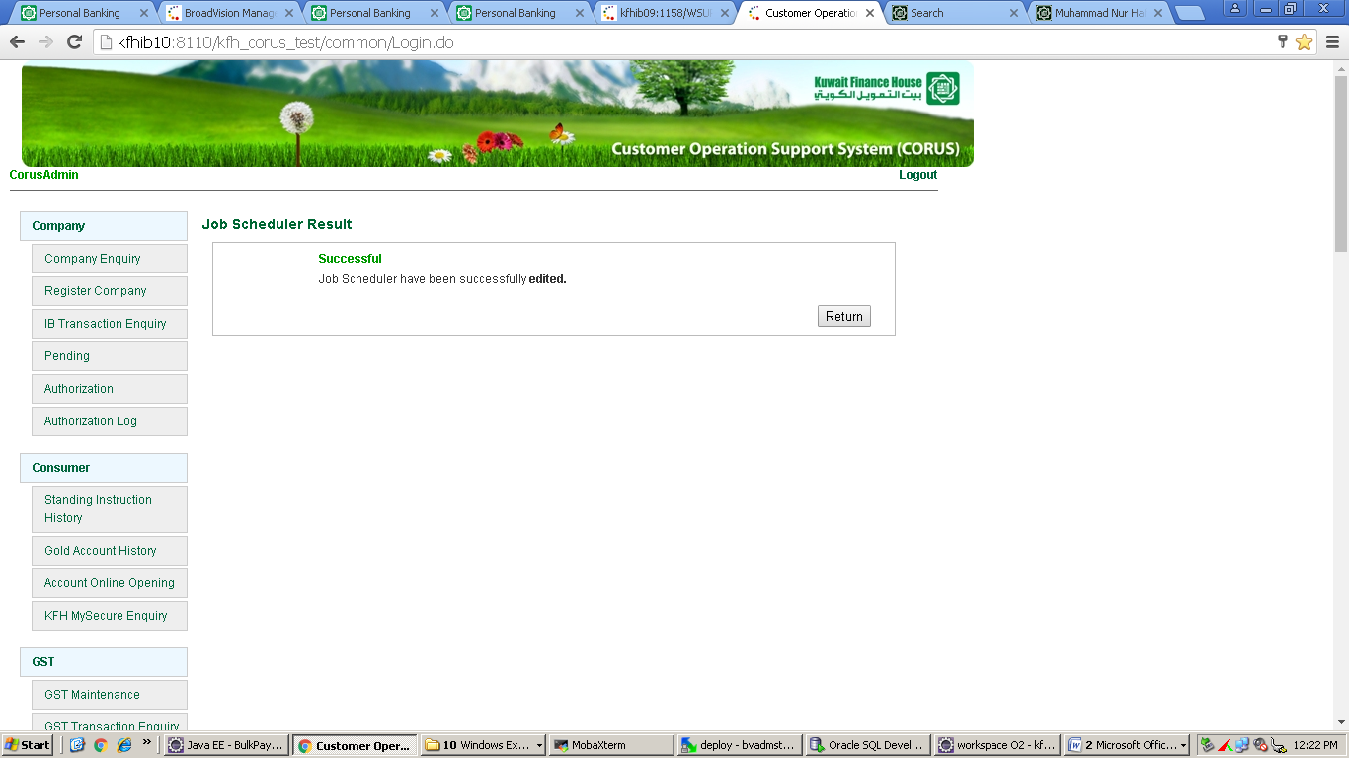

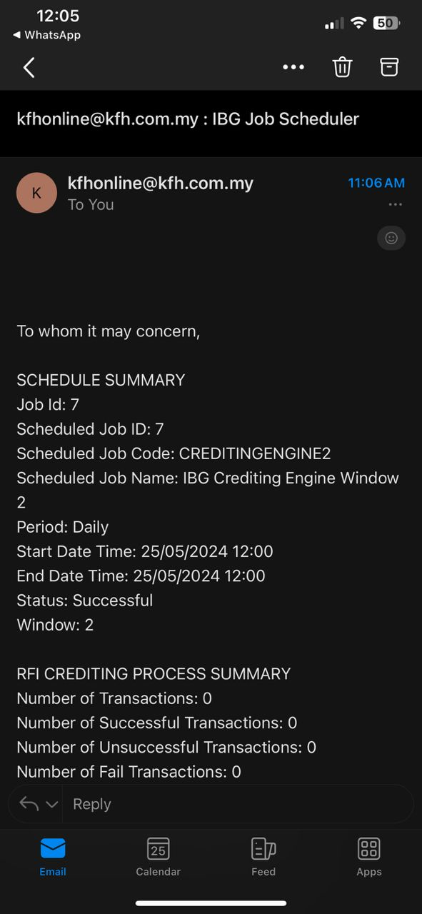

Reviewed By: (PMO)
Lizahwati Basirun | Name/Position: Lizahwati binti Basirun/Project Coordinator  Date :27/05/2024

