SCPID#7028
Test Title: |  | Enable Edit CIS Field for JPD Maker Role
Test Description: |  | Issue: To enable edit function to CIS number field for JPD maker role and ensure the edit will reflected to DB.
Test Functionality: |  | To test on edit CIS field.
Test Procedure: |  | Conditions:  - Administrator cannot edit/approve org details edit CIS number  - Only maker with allowed access “Edit CIS Number” can edit CIS number  - Only checker with allowed access “Edit CIS Number” can approve edit CIS number  Test Steps:  - Allow/Disallow “Edit CIS Number” for maker/checker at IBAM > BBE > Admin User Manager  - IBAM > Organization Setup > Edit Organization Details > CIS Number  Scenario 1  - Maker with allowed access “Edit CIS Number” edit CIS number  - Checker with allowed access Edit CIS Number approve edit CIS number  - Status success. CIS number changes reflected/save in db  Scenario 2  - Maker with allowed access “Edit CIS Number” edit CIS number  - Checker without allowed access Edit CIS Number approve edit cis number  - System throw error message  Scenario 3  - Maker with allowed access “Edit CIS Number” edit CIS number  - Admin approve edit CIS number  - System throw error message  Scenario 4  - Maker without allowed access “Edit CIS Number” edit Organization Details  - System displays disabled CIS number field  - Edit CIS number at DevTools (Right click>Inspect or press F12)  - Checker/Admin approve. CIS number changes not reflected/not save in db  - Edit another field besides CIS number. Data changes reflected/save in db  Scenario 5  - Admin edit Organization Details  - System displays disabled CIS number field  - DevTools (Right click>Inspect or press F12)  - CIS number changes not reflected/not save in db  - Edit another field besides CIS number. Data changes reflected/save in db
Response Message:
Test Result: | Pass: Fail: |  | Tested by: | Nor Athirah Umairah (27/05/2024)
Reason for Failure:
Remarks: |  | Scenario 1:  Maker: penrilmaker3  Checker: penrilchecker3  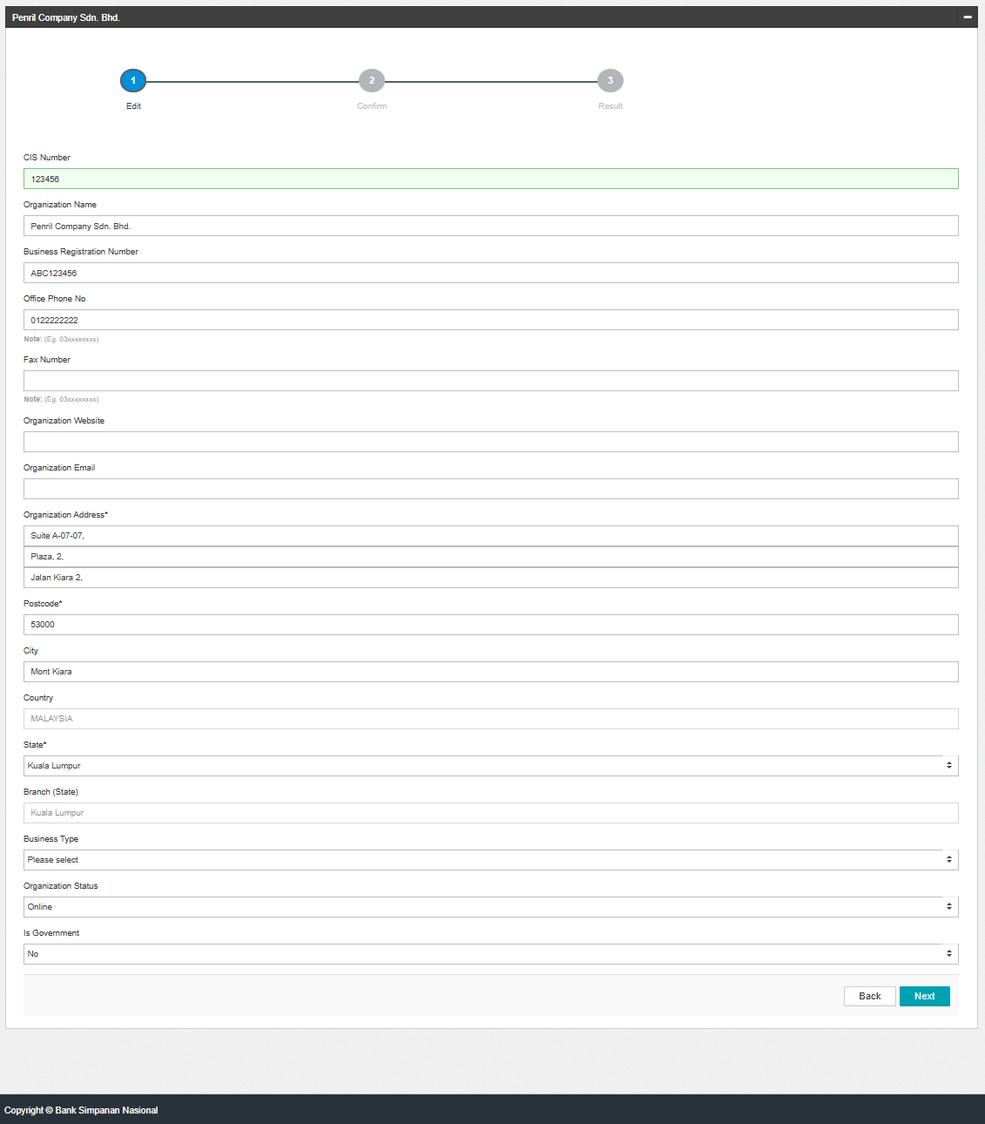  Figure 1: IBAM>Org Setup>Org Details (Edit)  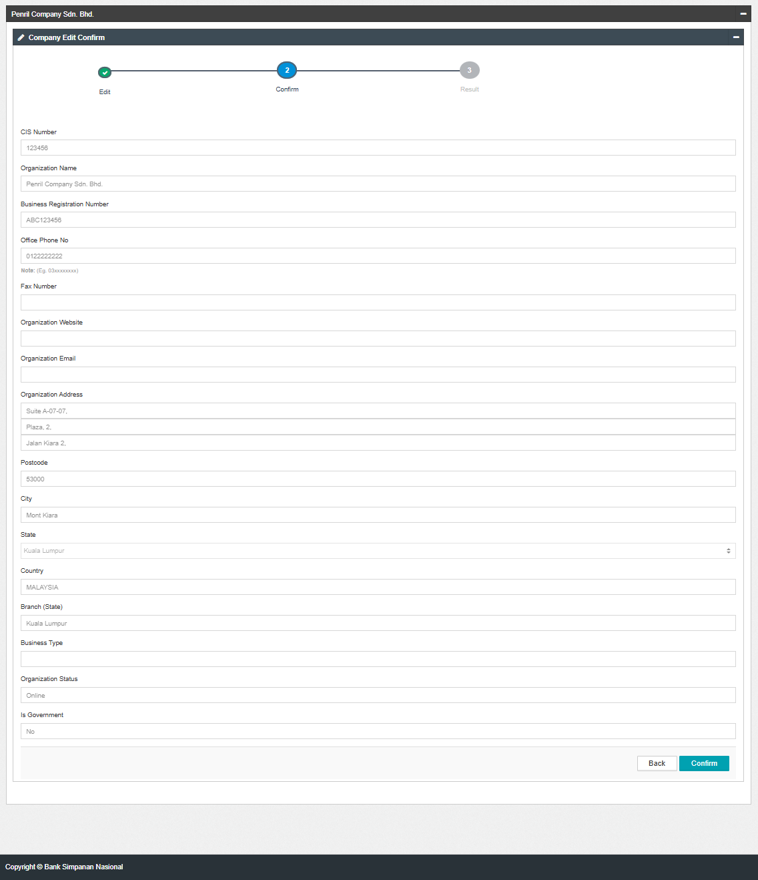  Figure 1: IBAM>Org Setup>Org Details (Confirm)  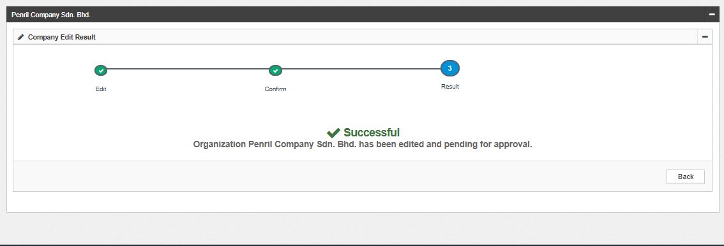  Figure 1: IBAM>Org Setup>Org Details (Result)  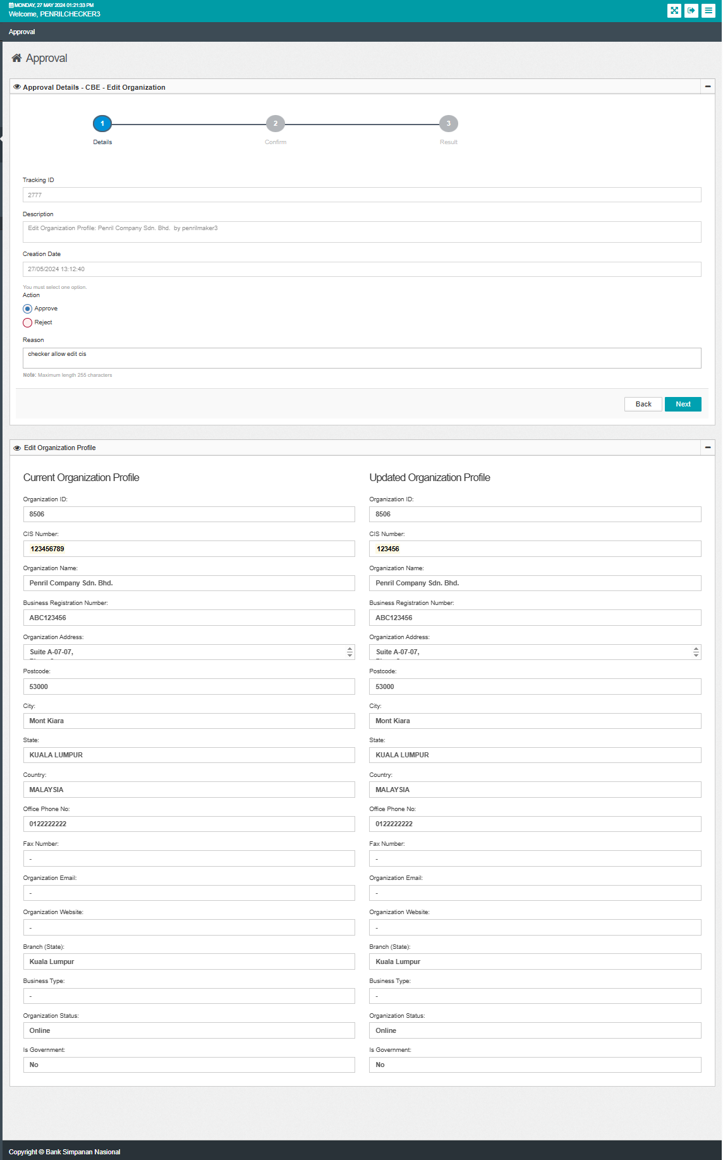  Figure 1: IBAM>Authorization>Approval (Details)  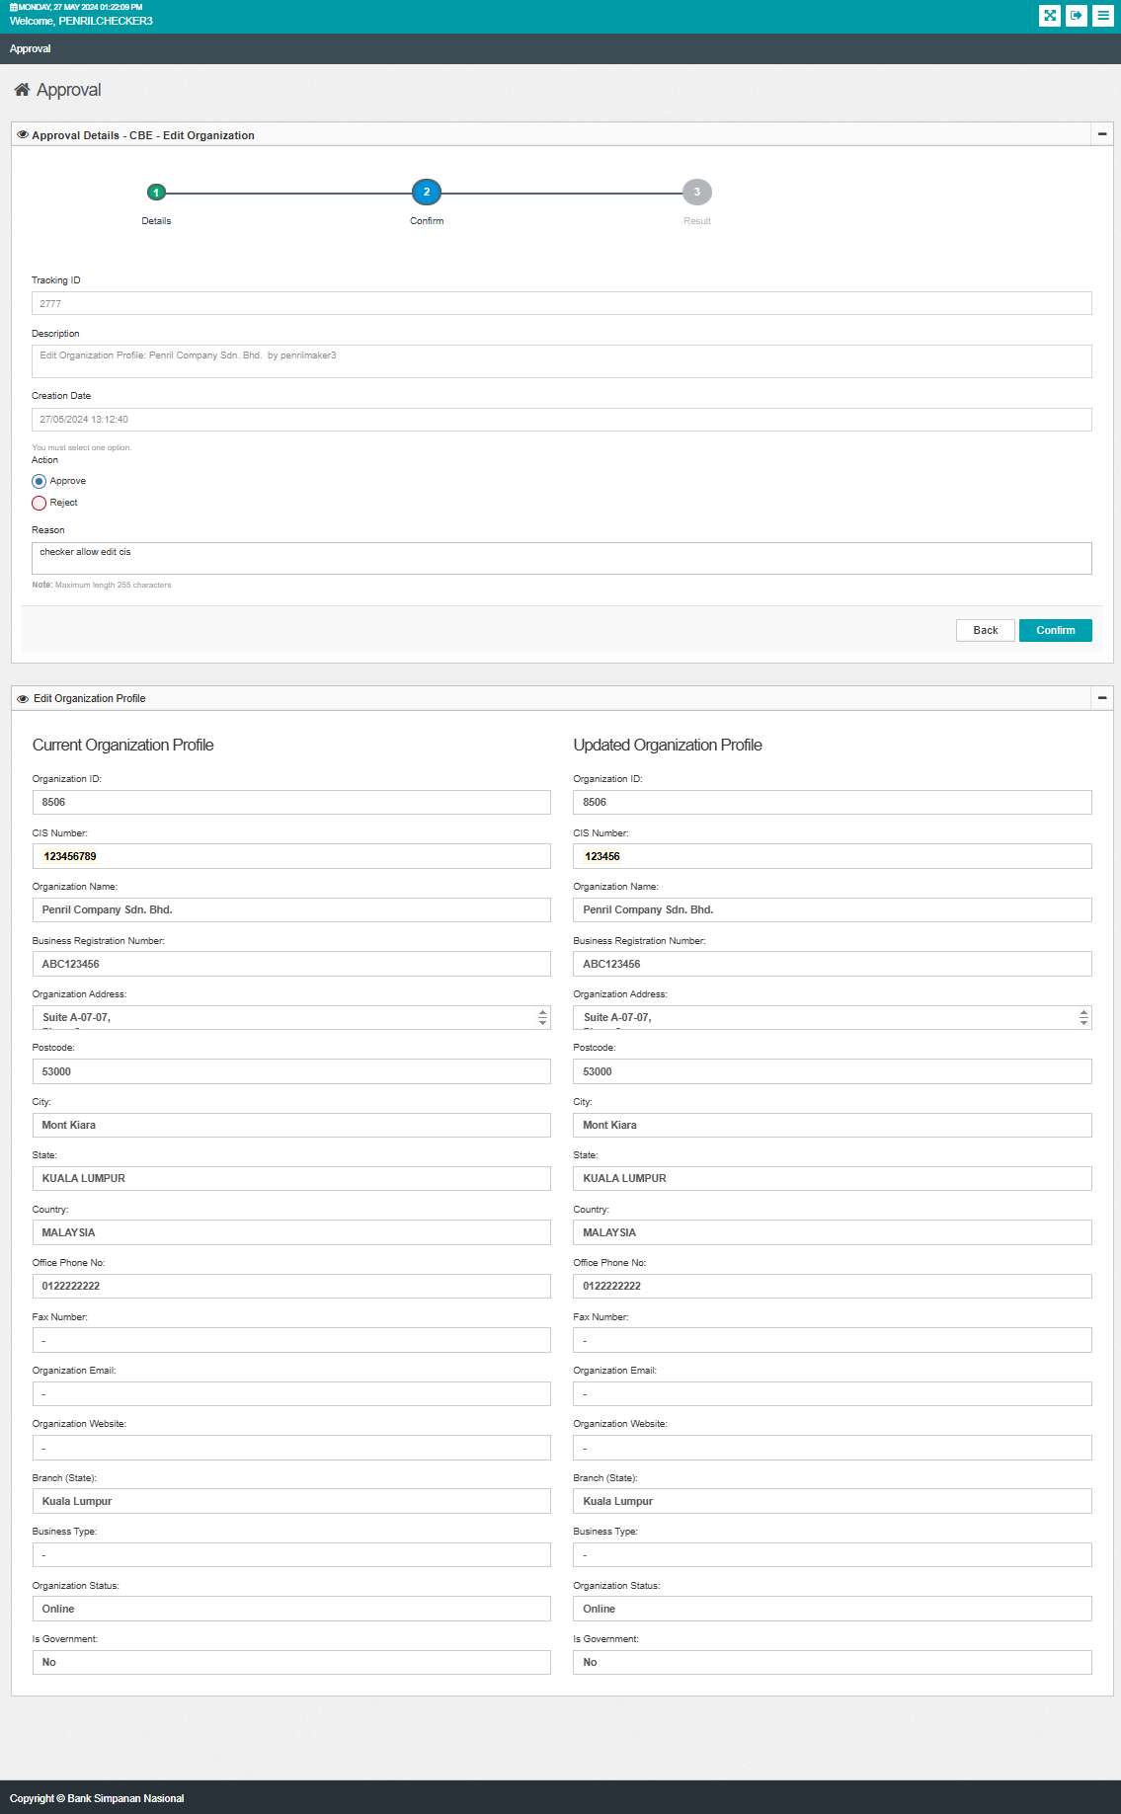  Figure 1: IBAM>Authorization>Approval (Confirm)  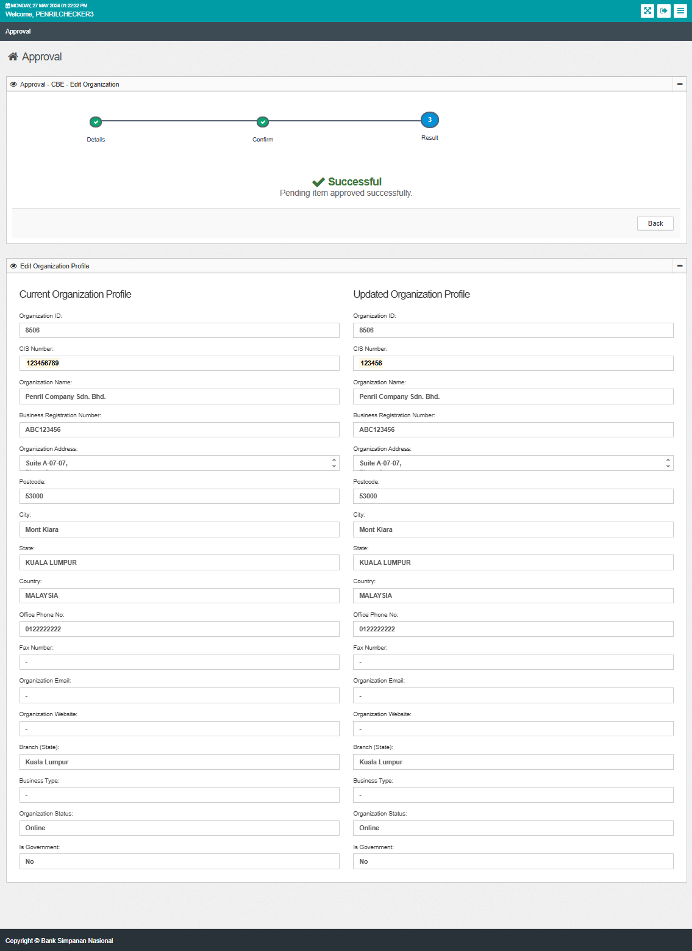  Figure 1: IBAM>Authorization>Approval (Result)  Scenario 2:  Checker: penrilchecker2  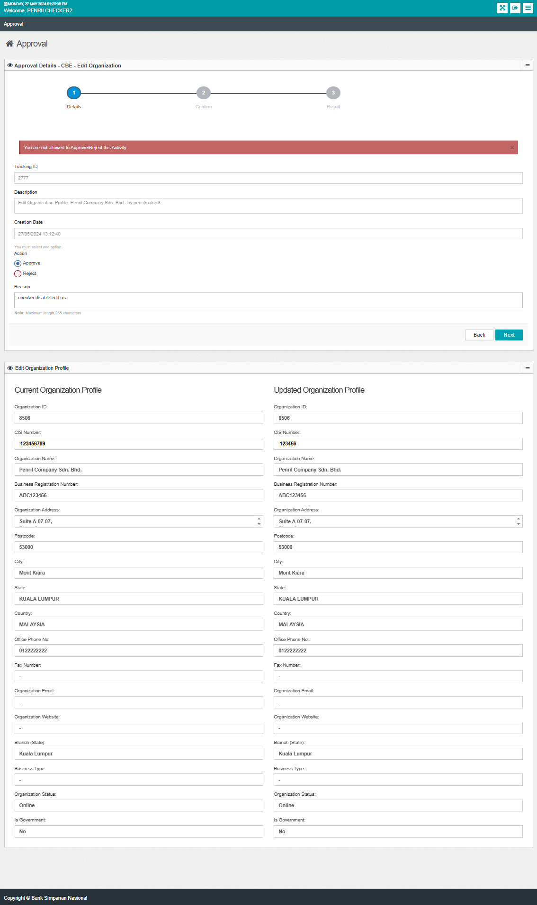  Figure 1: IBAM>Authorization>Approval (Confirm)  Scenario 3:  Administrator  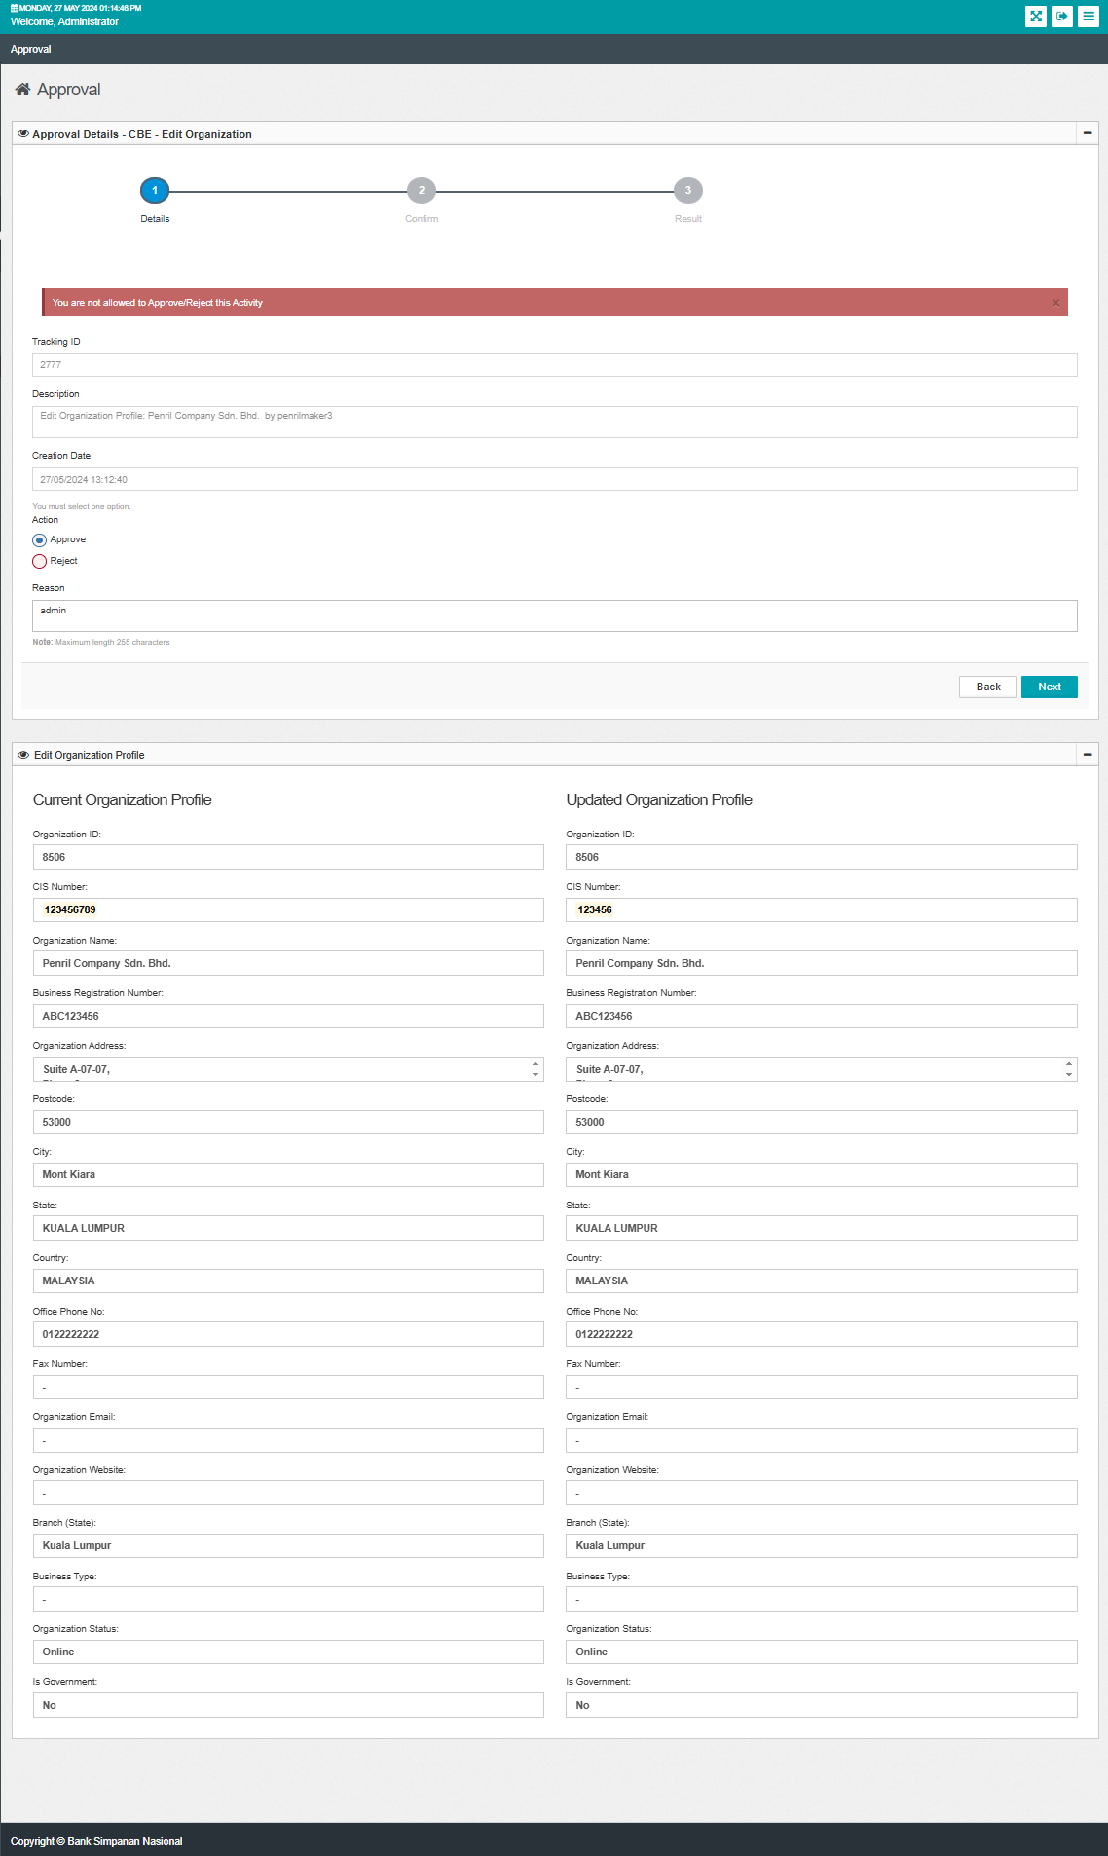  Figure 1: IBAM>Authorization>Approval (Confirm)  Scenario 4:  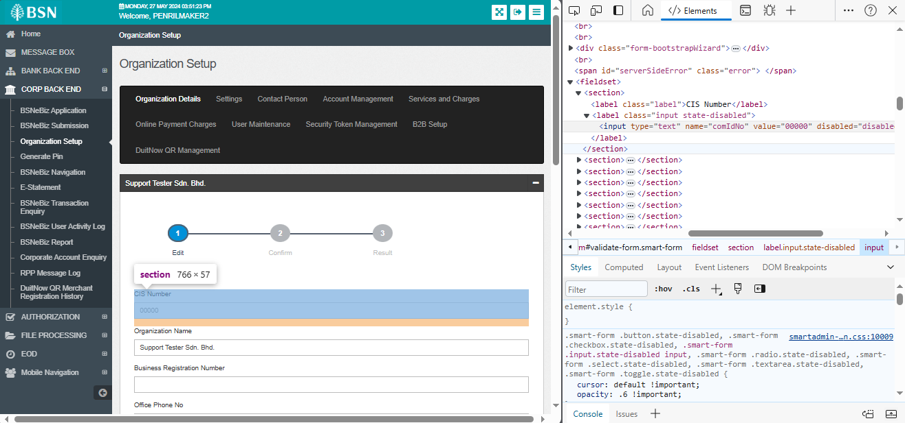  Figure 1: IBAM>Org Setup>Org Details (Edit)  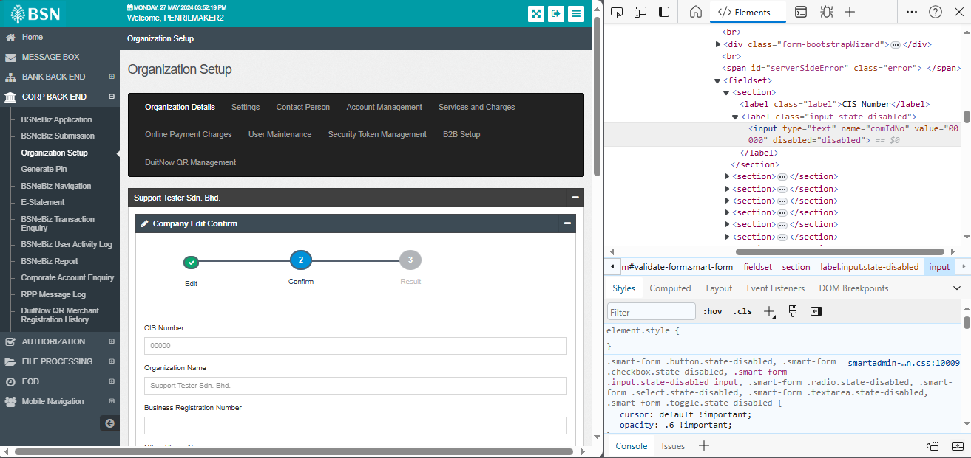  Figure 1: IBAM>Org Setup>Org Details (Confirm)  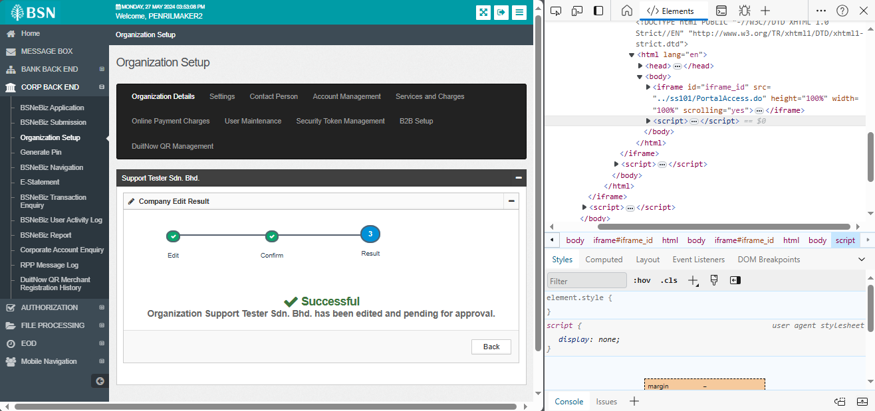  Figure 1: IBAM>Org Setup>Org Details (Result)  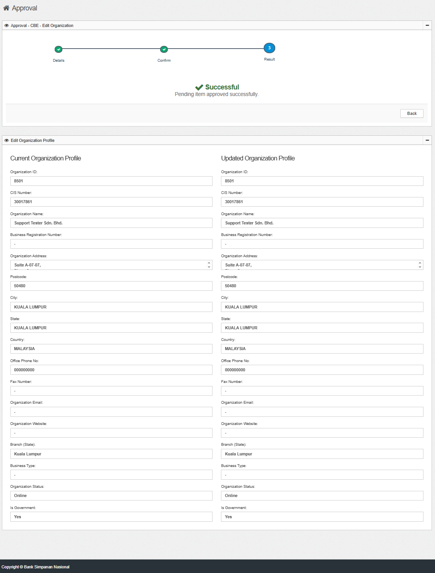  Figure 1: IBAM>Authorization>Approval (Result)  Scenario 5:  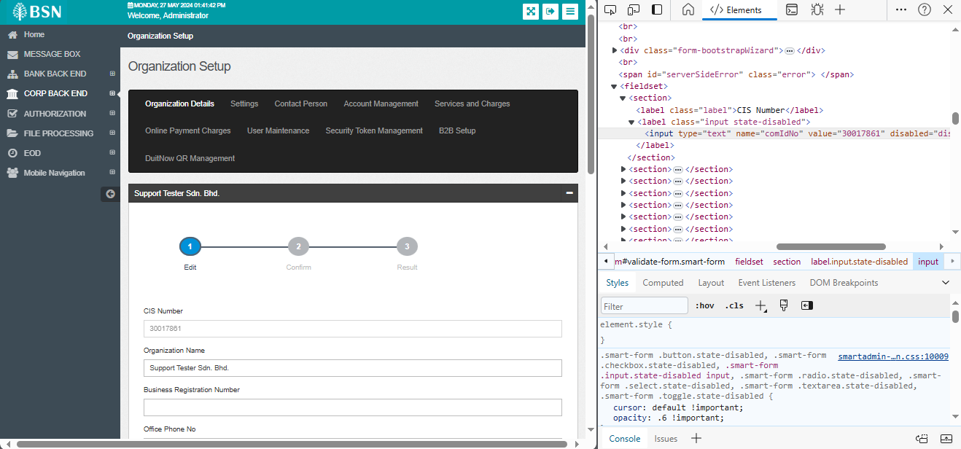  Figure 1: IBAM>Org Setup>Org Details (Edit)  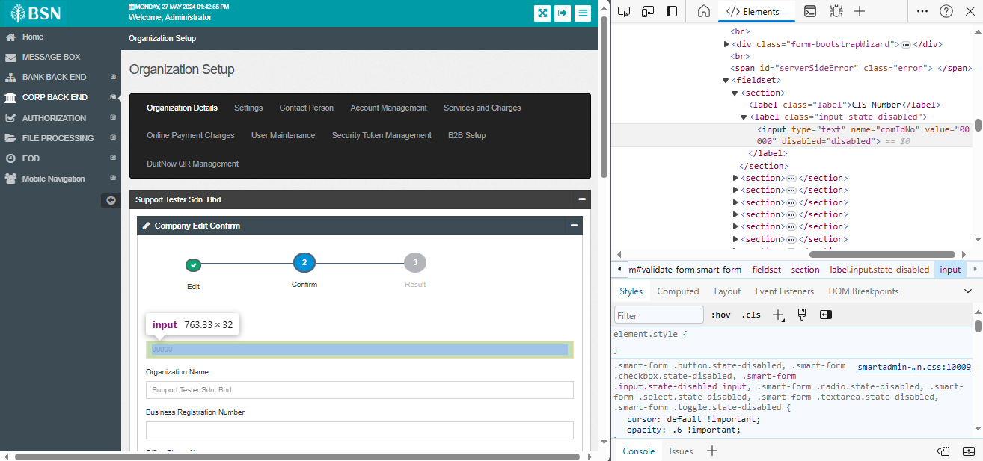  Figure 1: IBAM>Org Setup>Org Details (Confirm)  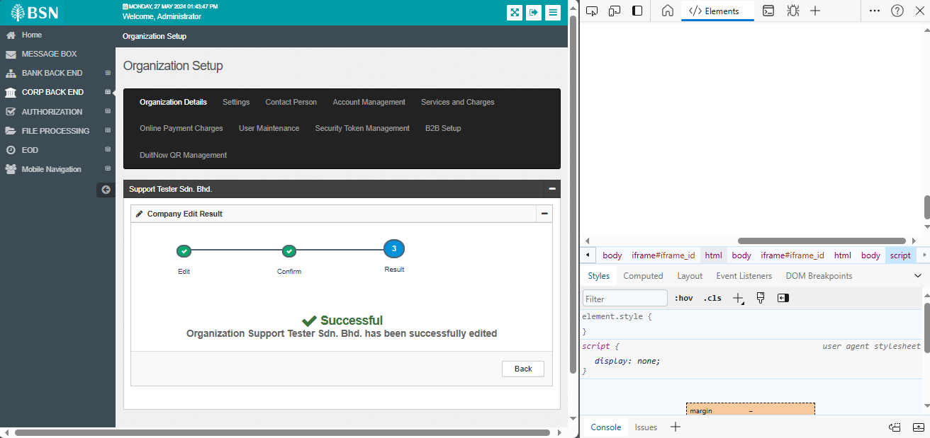  Figure 1: IBAM>Org Setup>Org Details (Result)  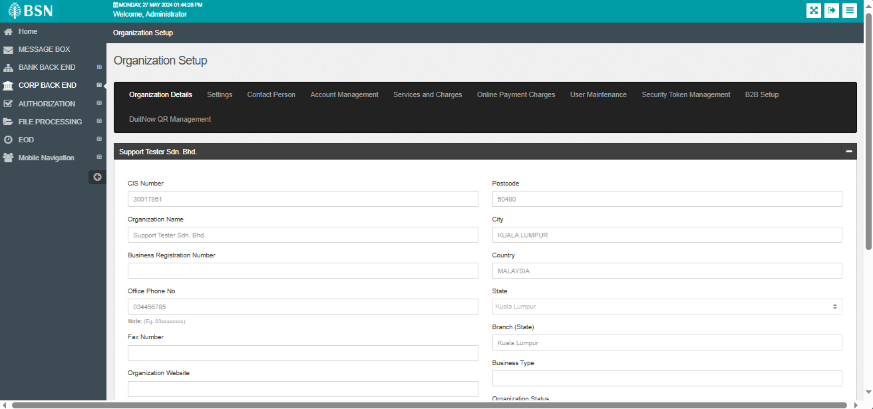  Figure 1: IBAM>Org Setup>Org Details

