SCPID#7031
Test Title: |  | Bugs on Mobile Does Not Read Based on Service Info in Web (Android)
Test Description: |  | Issue: Bugs on mobile that does not read based on service info in Web
Test Functionality: |  | To test transfer mode functionality based on service info for mobile.
Test Procedure: |  | Test case 1:  - Set “Yes” for Future Transaction Flag on selected transaction in IBAM>Content>Service Info  - Expected result, able to make pay later transaction.  Test case 2:  - Set “No” for Future Transaction Flag on selected transaction in IBAM>Content>Service Info  - Expected result, only able to make pay now transaction.
Response Message:
Test Result: | Pass: Fail: |  | Tested by: | Nor Athirah Umairah (04/06/2024)
Reason for Failure:
Remarks: |  | Transaction Future Flag = Yes Future Flag = No  Own Account Pass Pass  New 3rd Party Pass Pass  Fav 3rd Party Pass Pass  New IBG Pass Pass  Fav IBG Fail (no option for ibg in trxn mode) Fail (no option for ibg in trxn mode)  New RENTAS Pass Pass  Fav RENTAS Pass Fail (able to select pay later)  New Bill Payment Fail (Connection Error) Fail (Connection Error)  Fav Bill Payment Fail (Connection Error) Fail (Connection Error)  New JomPay Pass Pass  Fav JomPay Pass Pass  New DuitNow Instant Pass Pass  Fav DuitNow Instant Pass (BE issue) Pass (BE issue)  New DuitNow Proxy Pass Pass  Fav DuitNow Proxy Pass Pass  Table 1: Result  *To check (DuitNow) scenario:  Instant = No, Proxy = Yes  1. select account number, fill in details  2. at fill details screen, transfer mode refer to acc num  3. click back transfer to  3. select proxy (mobile/business reg), transfer mode refer to acc num instead of proxy  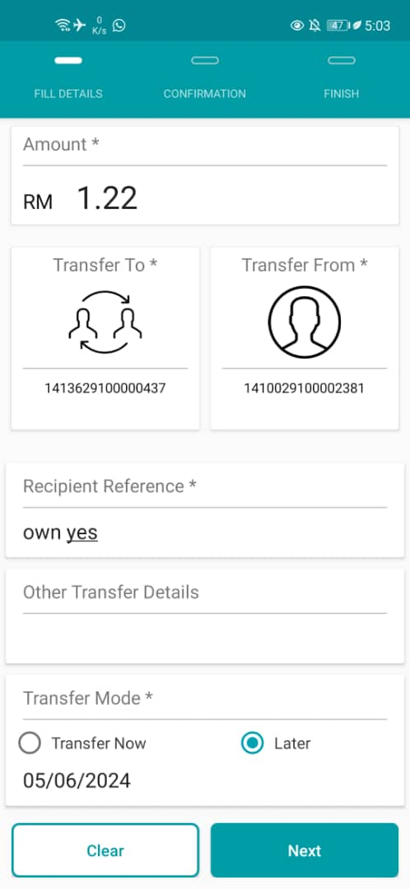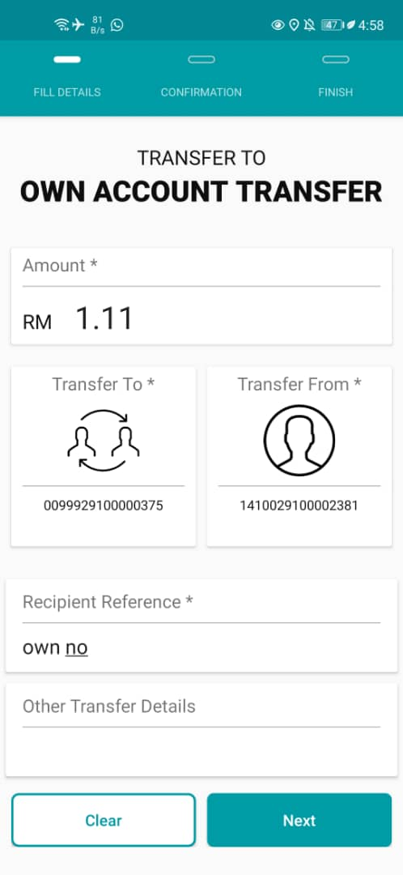  Figure 1: Own Account (Left: Future Flag = Yes; Right: Future Flag = No)  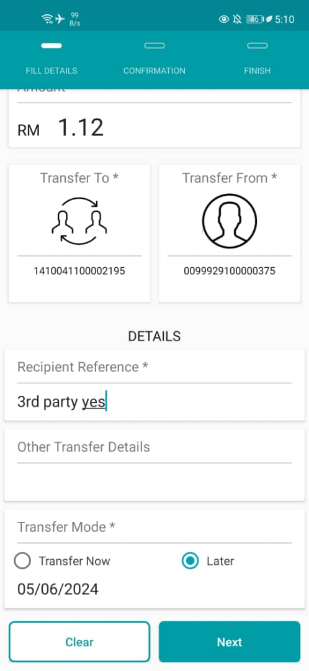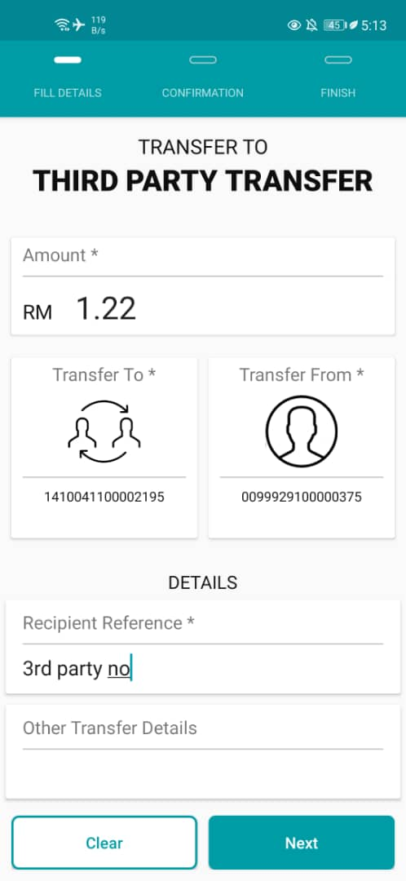  Figure 2: New 3rd Party (Left: Future Flag = Yes; Right: Future Flag = No)  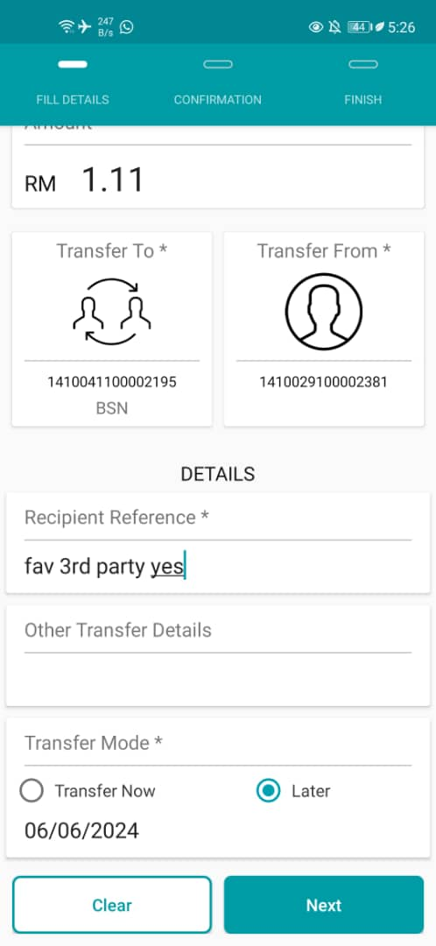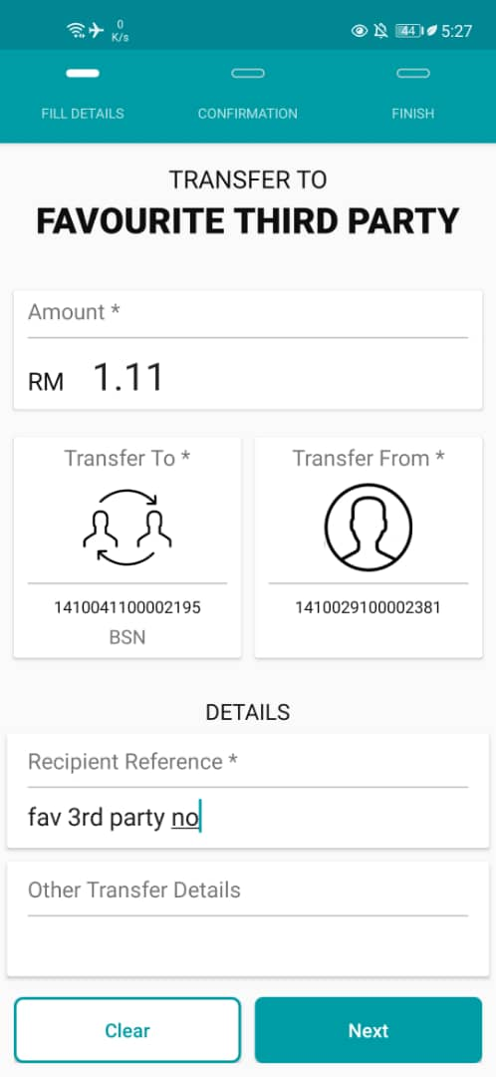  Figure 3: Fav 3rd Party (Left: Future Flag = Yes; Right: Future Flag = No)  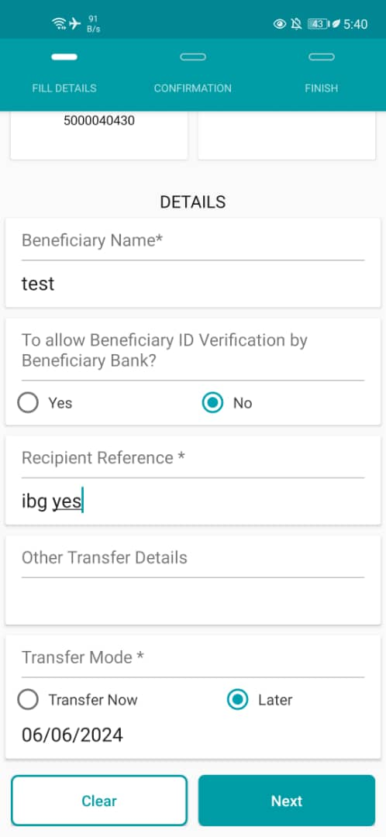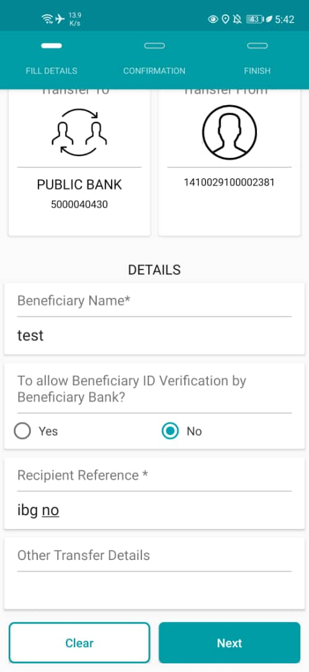  Figure 4: New IBG (Left: Future Flag = Yes; Right: Future Flag = No)  Figure 5: Fav IBG (Left: Future Flag = Yes; Right: Future Flag = No)  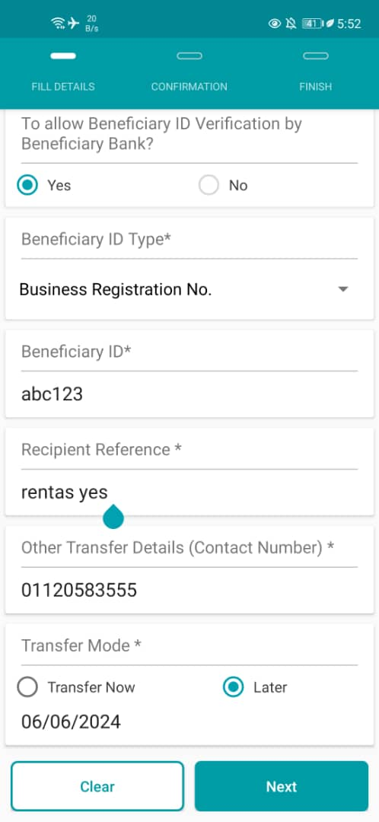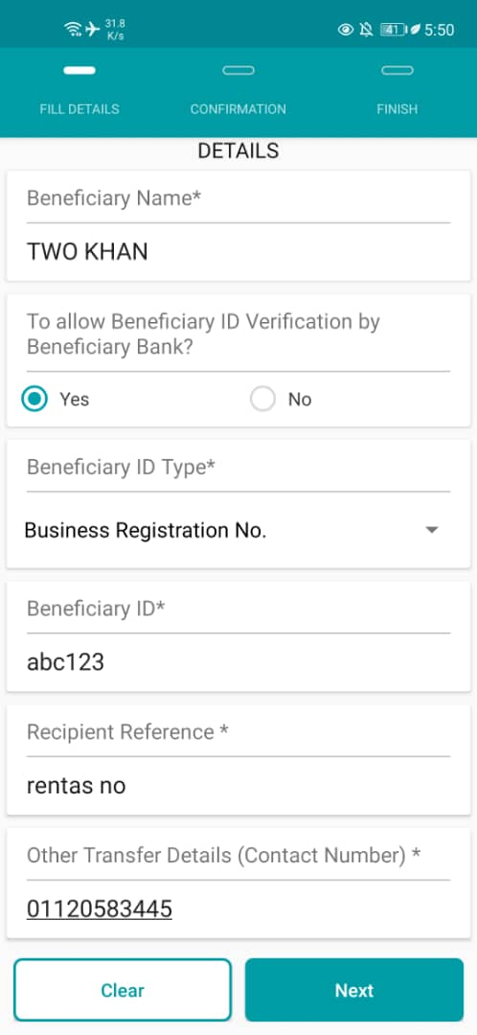  Figure 6: New RENTAS (Left: Future Flag = Yes; Right: Future Flag = No)  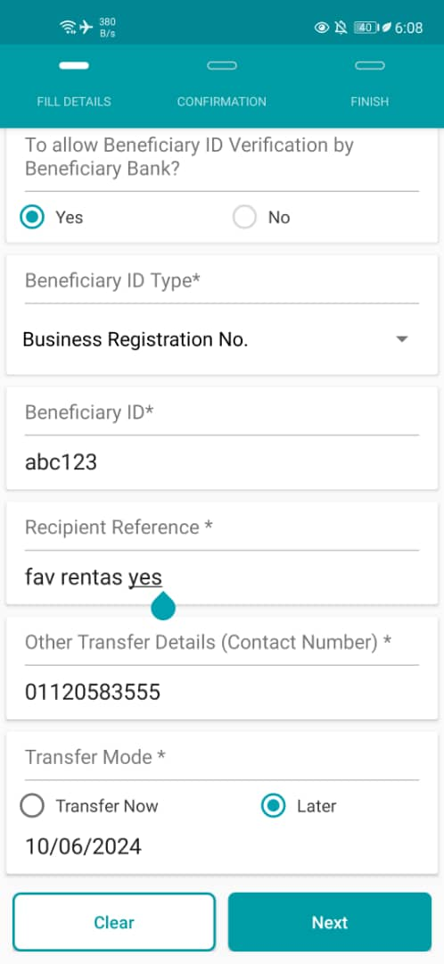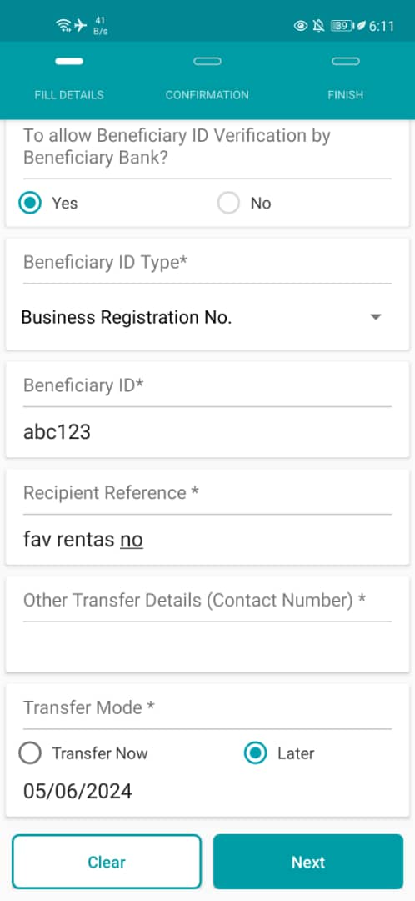  Figure 7: Fav RENTAS (Left: Future Flag = Yes; Right: Future Flag = No)  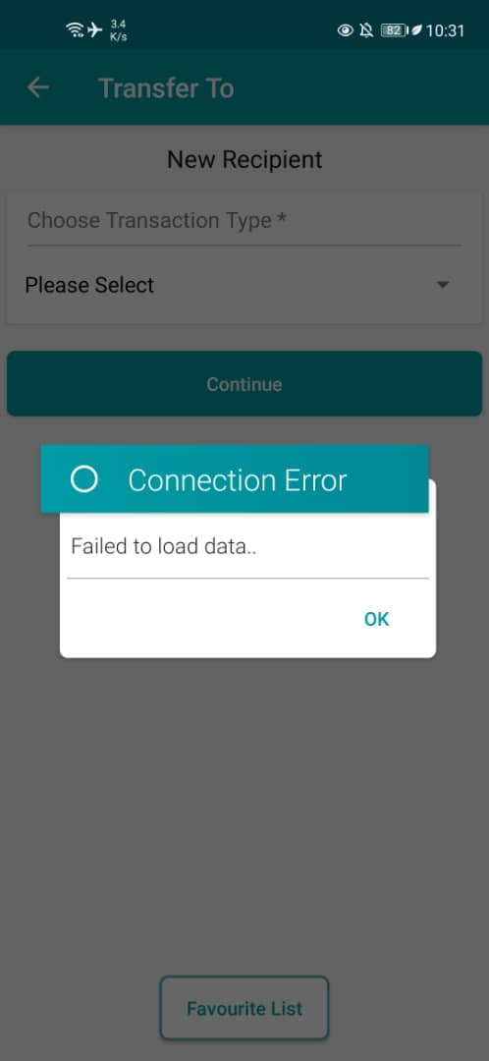  Figure 8: New Bill Payment (Left: Future Flag = Yes; Right: Future Flag = No)  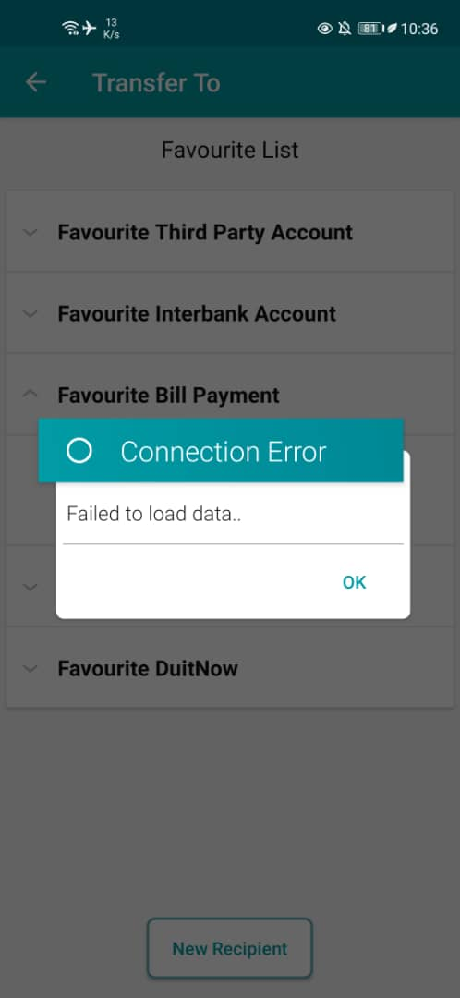  Figure 9: Fav Bill Payment (Left: Future Flag = Yes; Right: Future Flag = No)  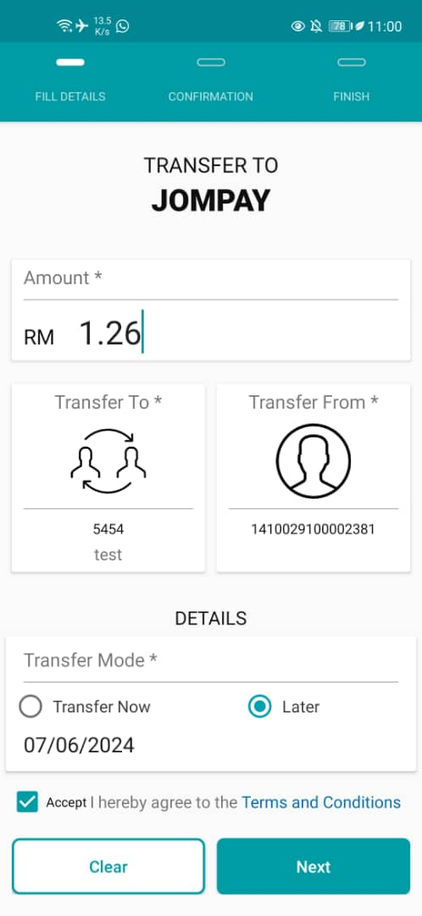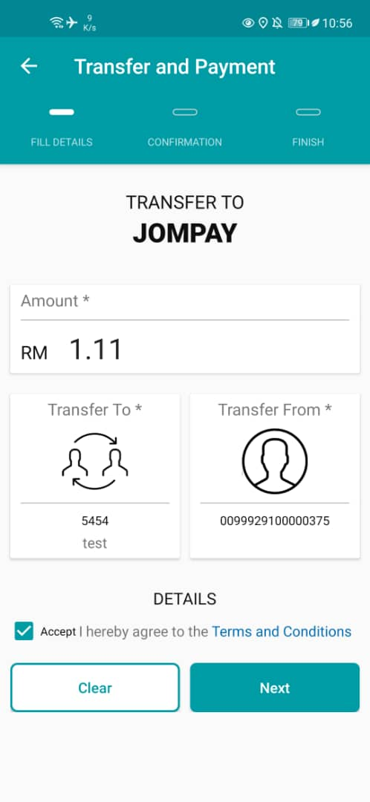  Figure 10: New JomPay (Left: Future Flag = Yes; Right: Future Flag = No)  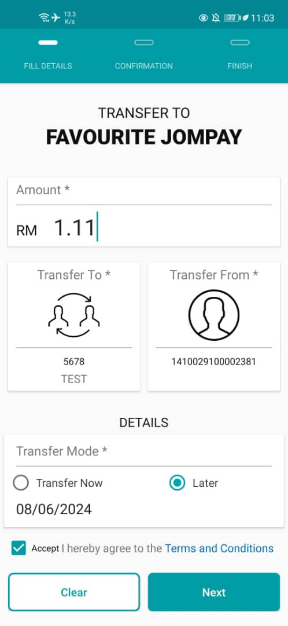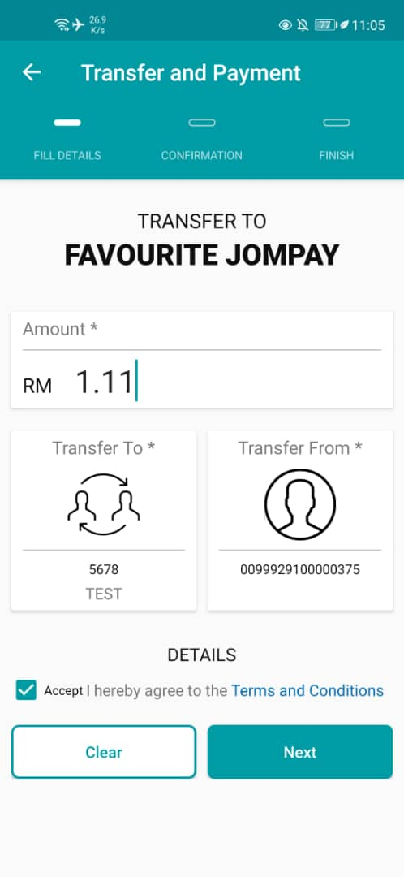  Figure 11: Fav JomPay (Left: Future Flag = Yes; Right: Future Flag = No)  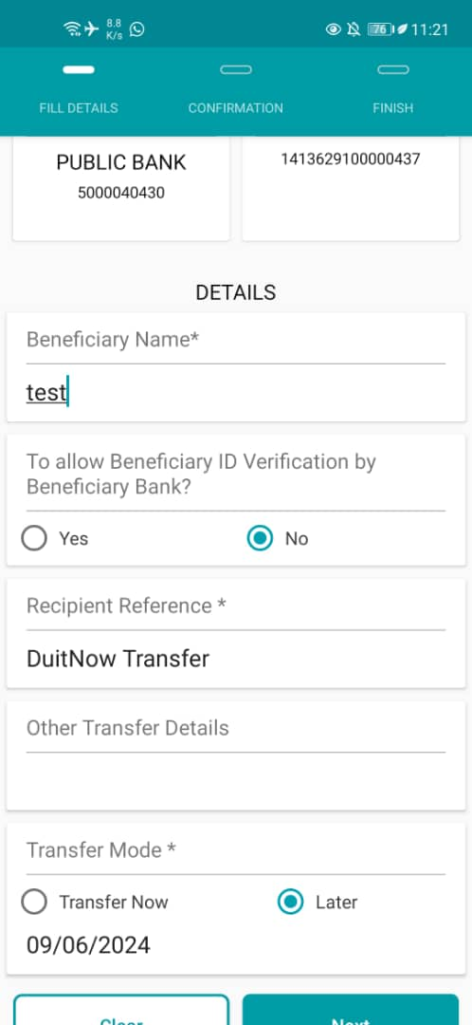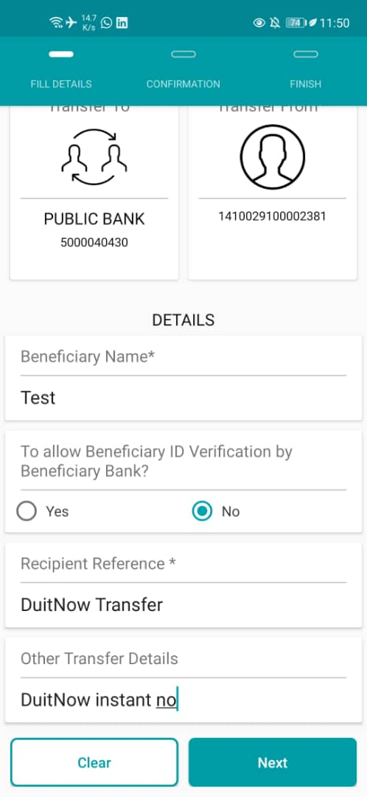  Figure 12: New DuitNow Instant (Left: Future Flag = Yes; Right: Future Flag = No)  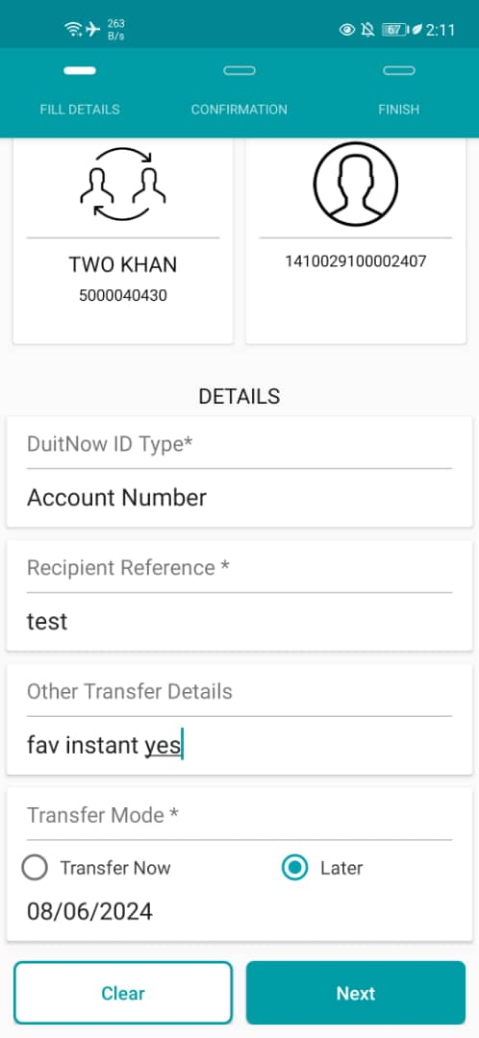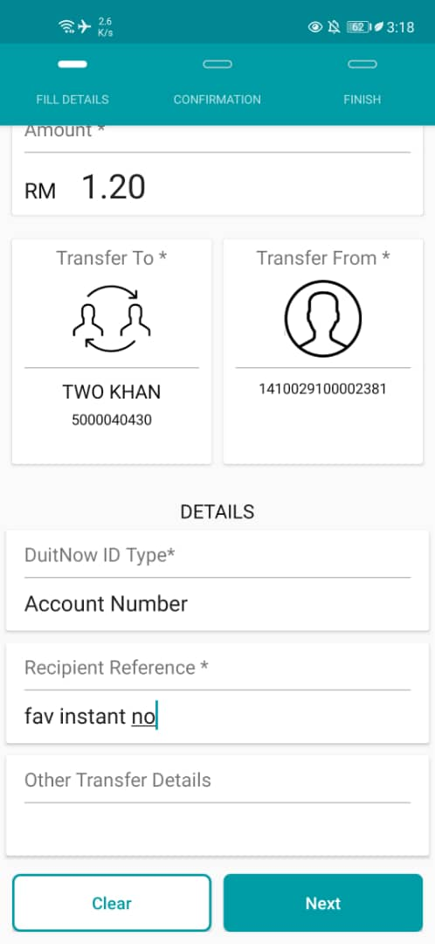  Figure 13: Fav DuitNow Instant (Left: Future Flag = Yes; Right: Future Flag = No)  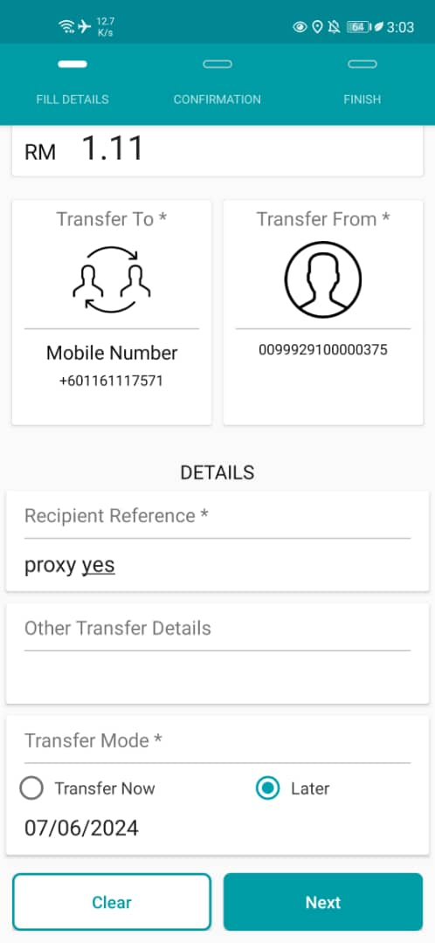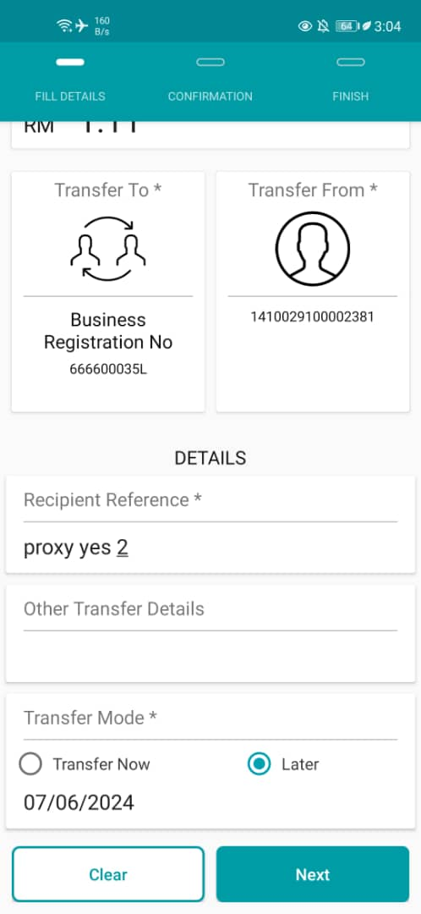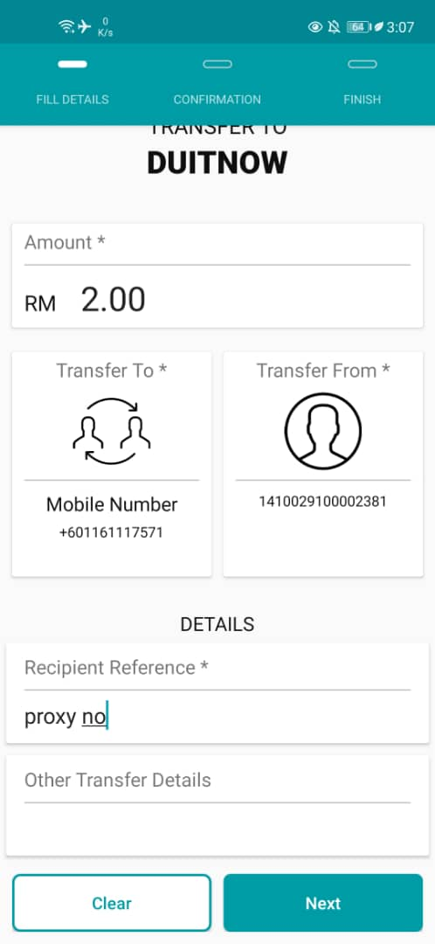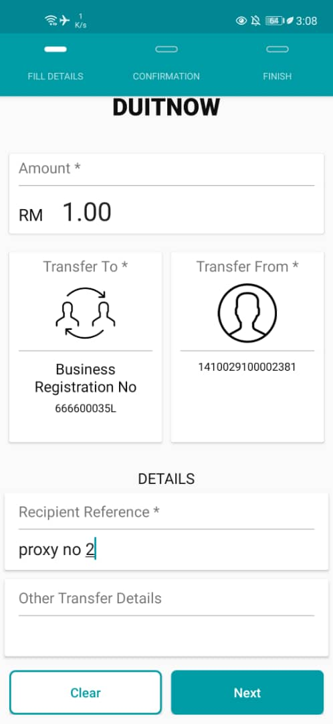  Figure 12: New DuitNow Proxy (Left: Future Flag = Yes; Right: Future Flag = No)  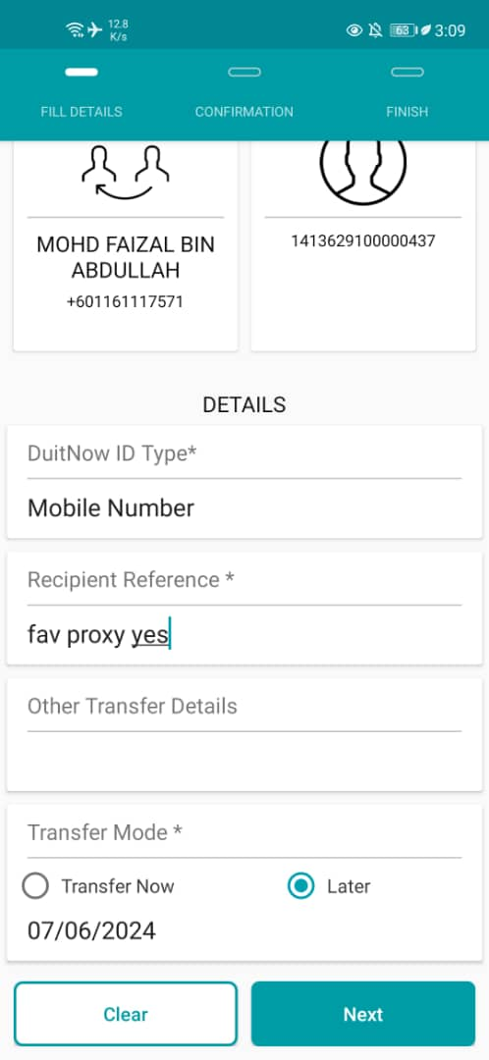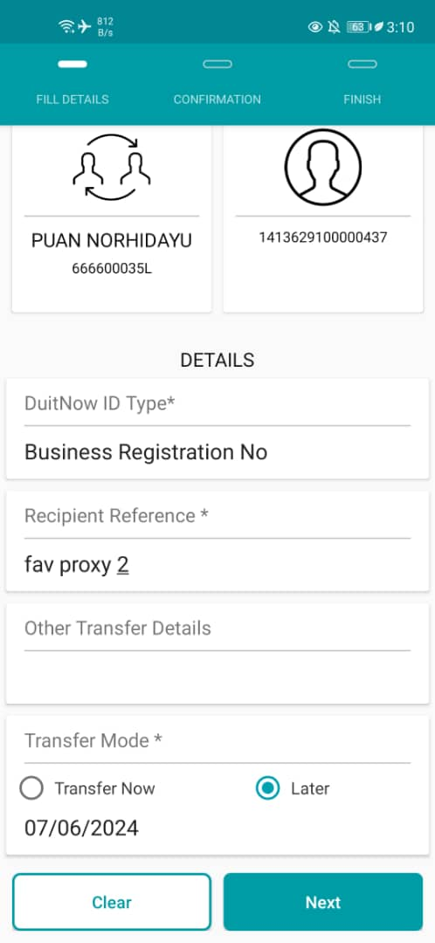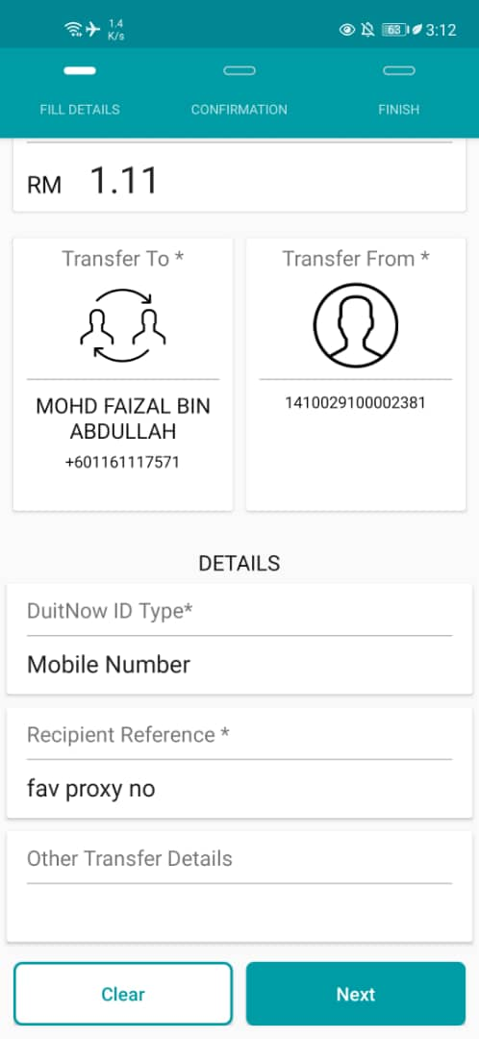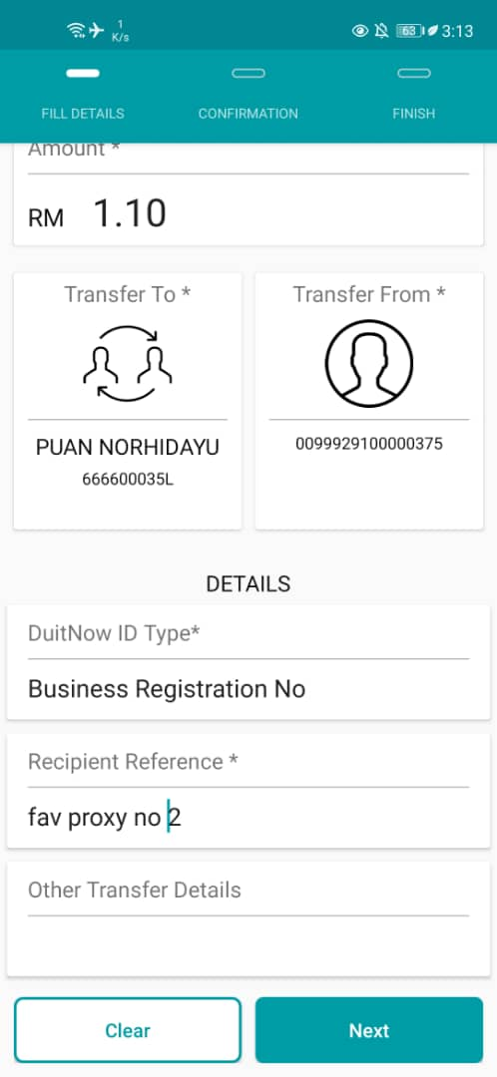  Figure 13: Fav DuitNow Proxy (Left: Future Flag = Yes; Right: Future Flag = No)

