SCPID#7041
Test Title: |  | New Onboarding of Merchantrade Asia on RPP
Test Description: |  | To add Merchantrade Asia in interbank list.
Test Functionality: |  | To test on Duitnow transaction for Merchantrade Asia Sdn Bhd
Test Procedure: |  | Test Steps:  - Access to IBAM>Content>Interbank  - Add Merchantrade Asia Sdn Bhd and allow IBFT  - Perform DuitNow to Merchantrade account  - Expected result, Merchantrade display in Bank List and successful perform transaction
Response Message:
Test Result: | Pass: Fail: |  | Tested by: | Nor Athirah Umairah (06/06/2024)
Reason for Failure:
Remarks: |  | 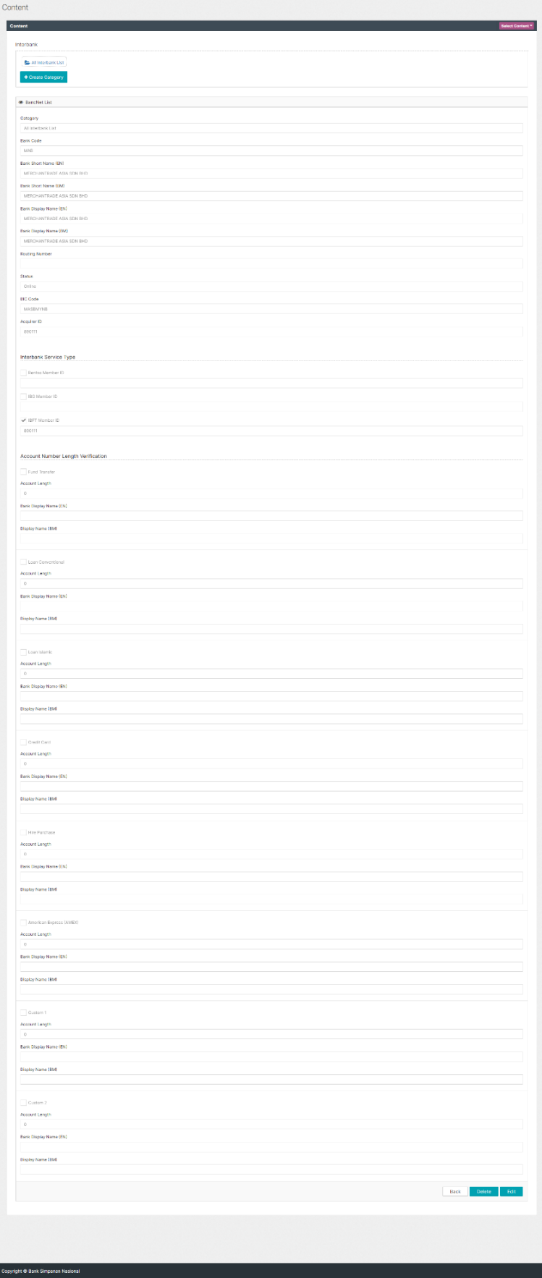  Figure 1: IBAM>Content>Interbank  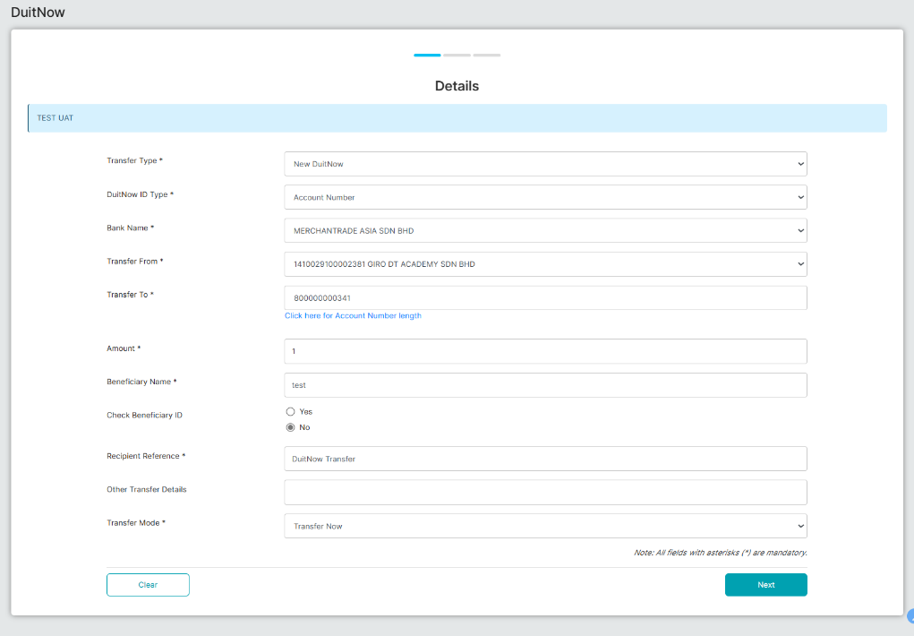  Figure 2: New DuitNow (Details)  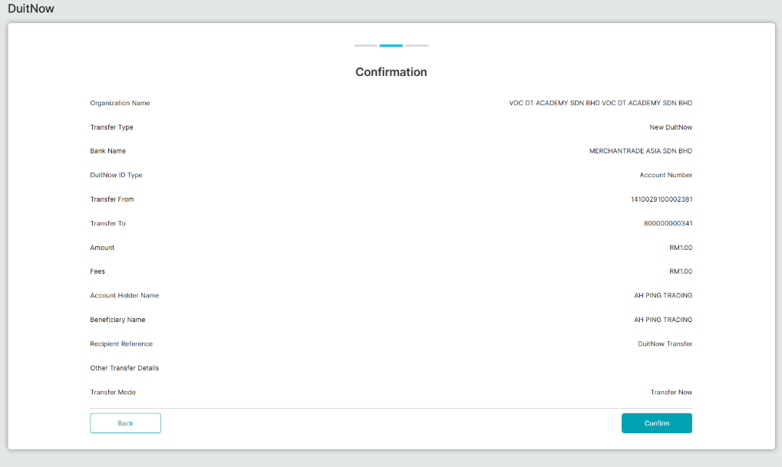  Figure 3: New DuitNow (Confirm)  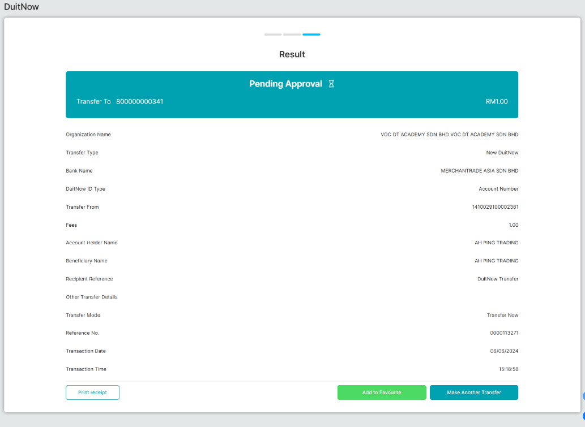  Figure 4: New DuitNow (Result)  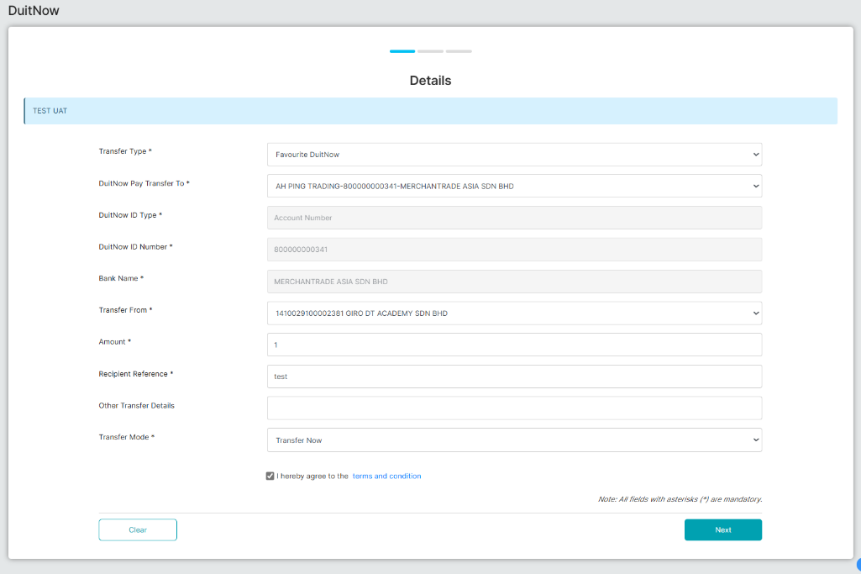  Figure 5: Fav DuitNow (Detail)  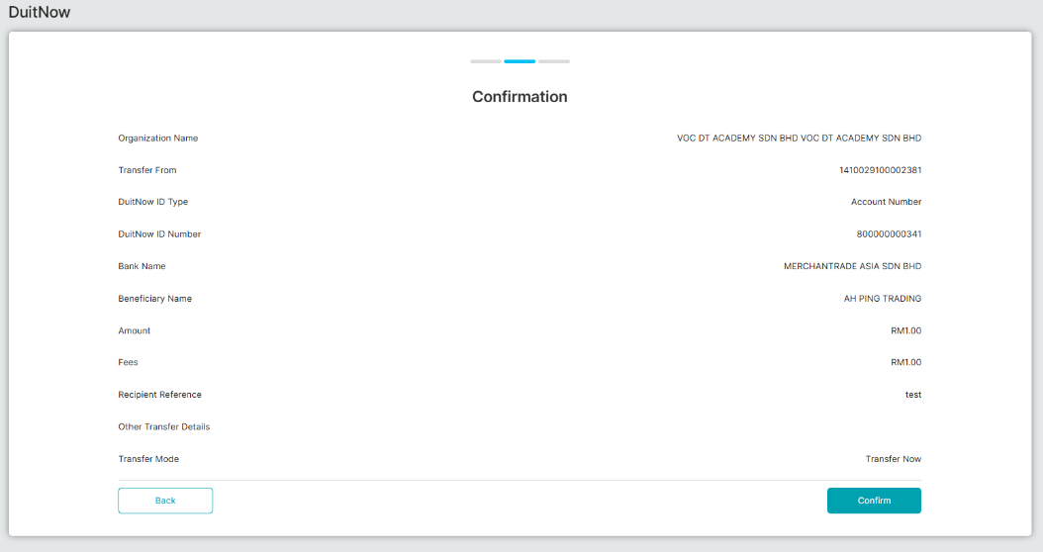  Figure 6: Fav DuitNow (Confirm)  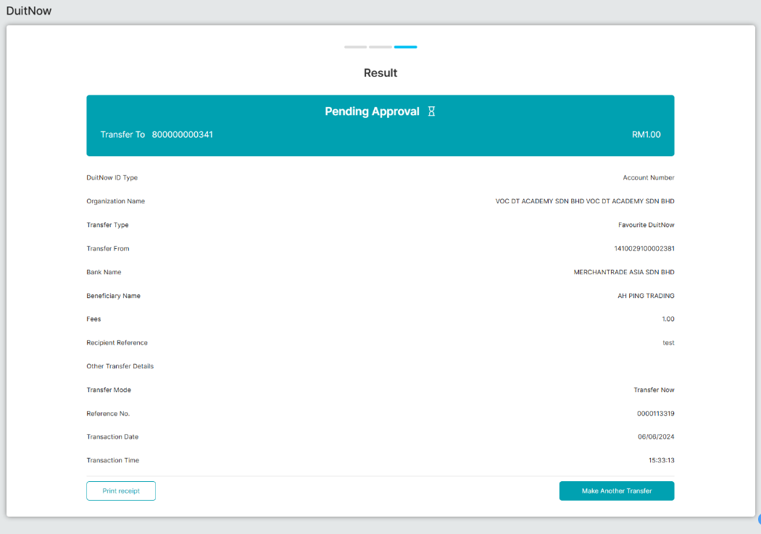  Figure 7: Fav DuitNow (Result)  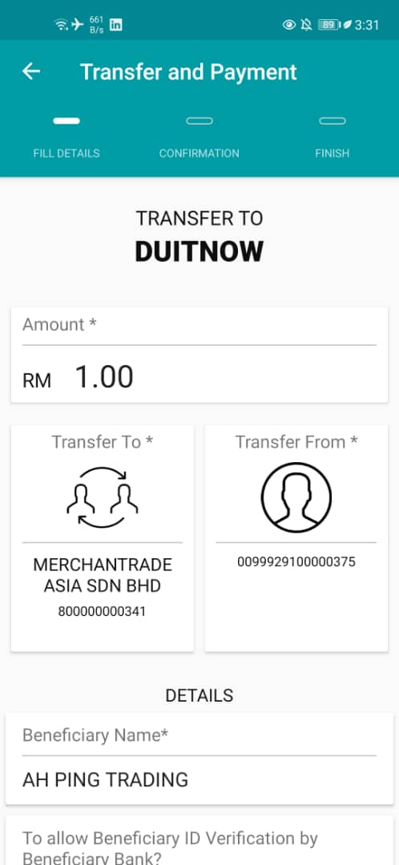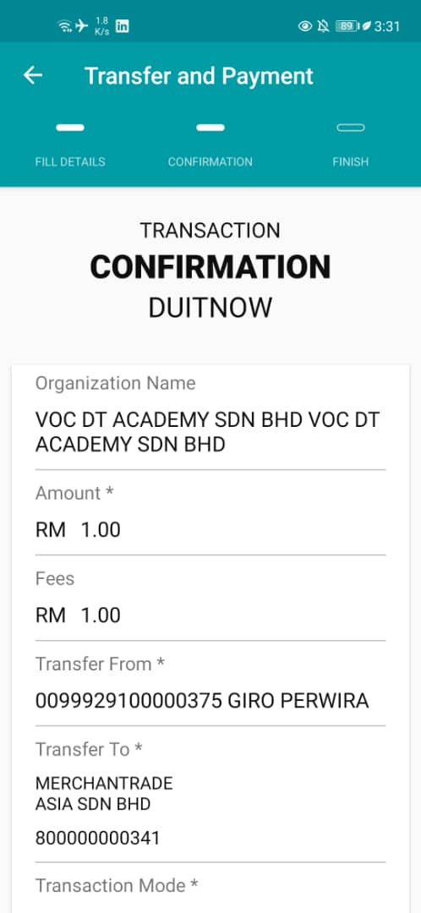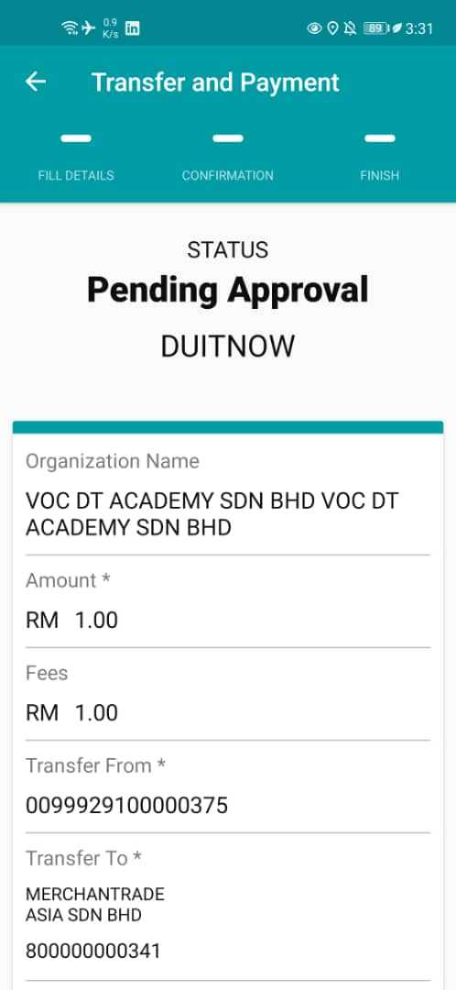  Figure 8: New DuitNow (Android)  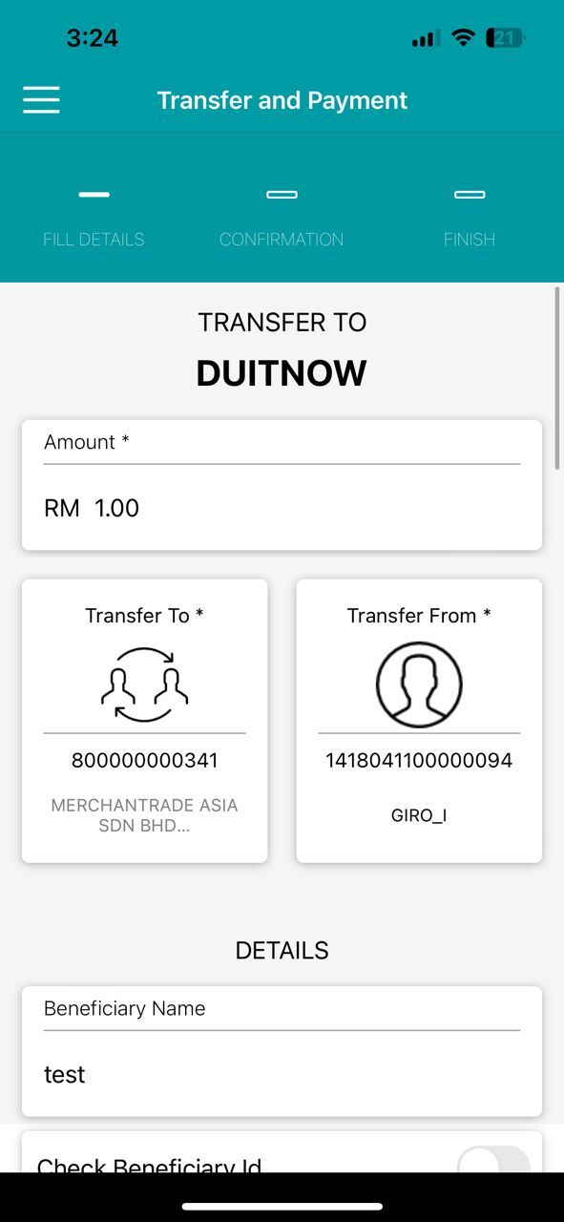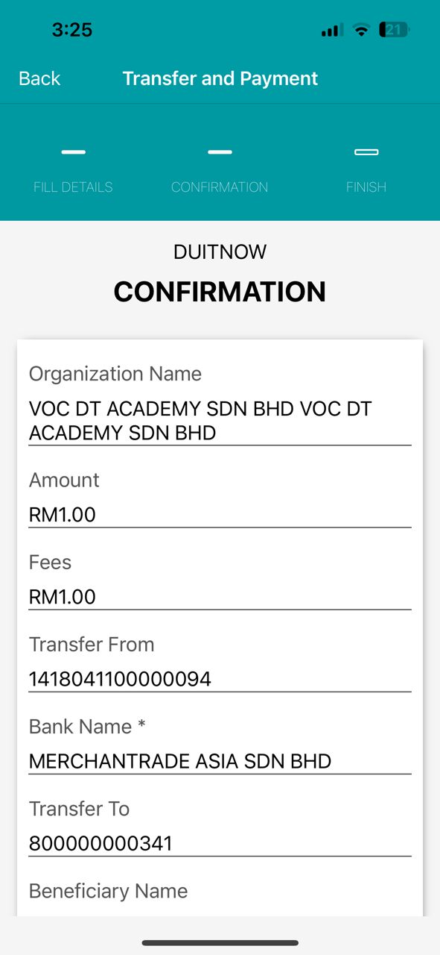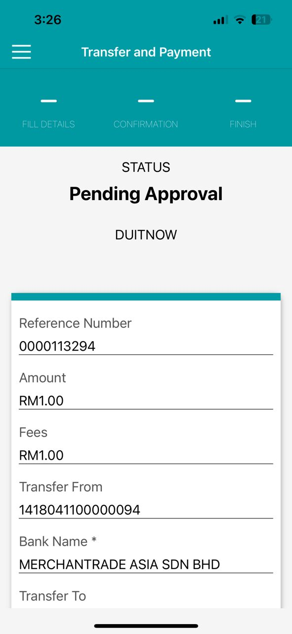  Figure 9: New DuitNow (iOS)  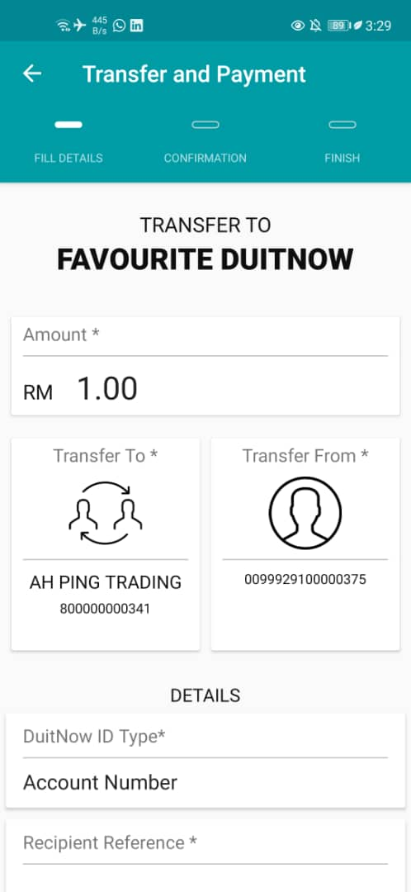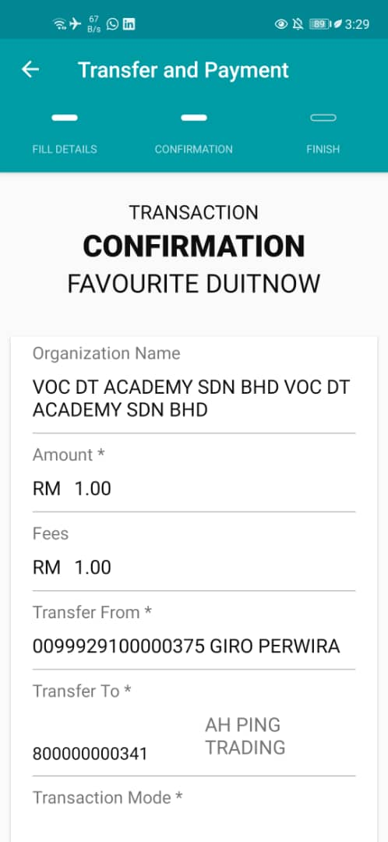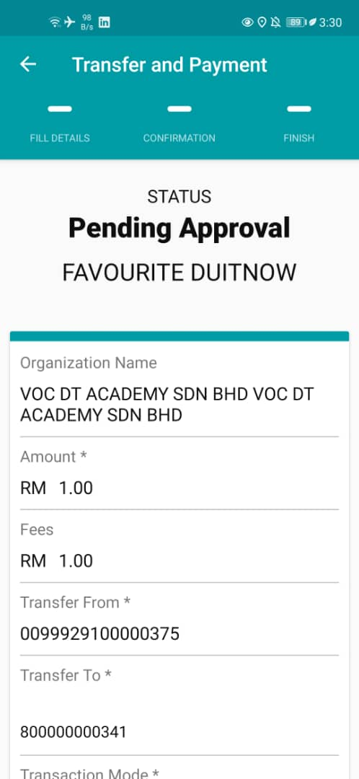  Figure 10: Fav DuitNow (Android)  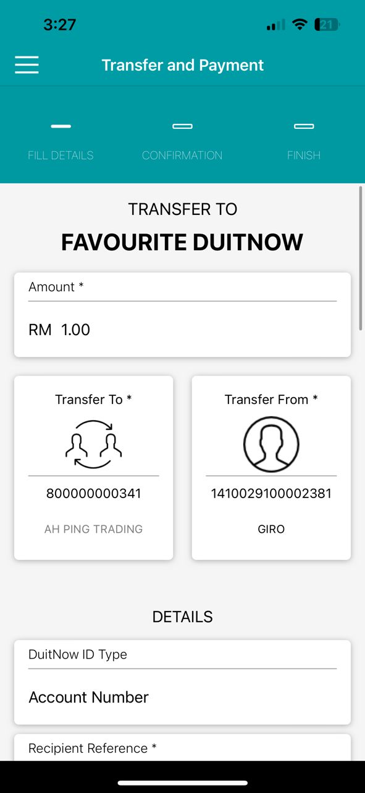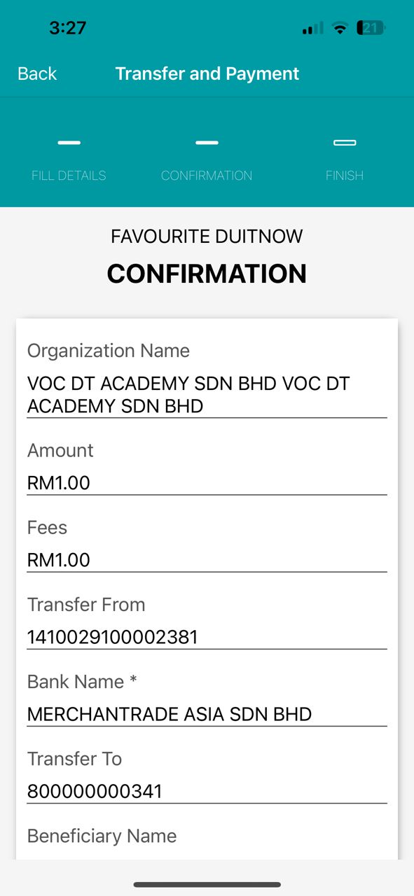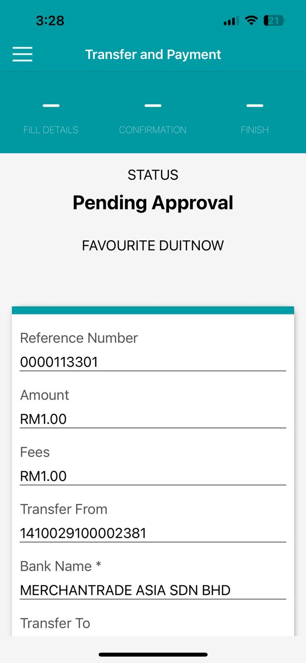  Figure 11: Fav DuitNow (iOS)

