SCPID#7040
Test Title: |  | Message Box Bugs - Cannot Send Message to All User
Test Description: |  | Issue:  Message box cannot send messages to all users even after selected all user.
Test Functionality: |  | To test on send message to all users using Message Box.
Test Procedure: |  | Test steps:  - Access to IBAM > Message Box  - Send New Notification to “All Users”  - Expected result, all users receive the message in CDB > Inbox
Response Message:
Test Result: | Pass: Fail: |  | Tested by: | Nor Athirah Umairah (07/06/2024)
Reason for Failure:
Remarks: |  | Send to All Users  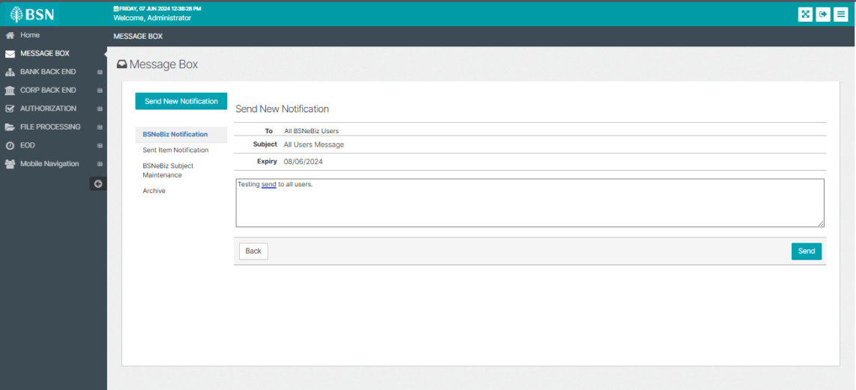  Figure 1: IBAM > Message Box > Send New Notification  Expected result: Message send to all users  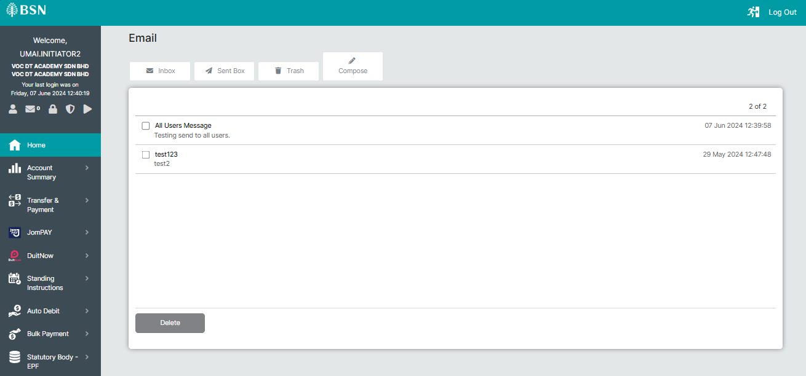  1  New  Figure 2: CDB > Inbox > Inbox (User A)  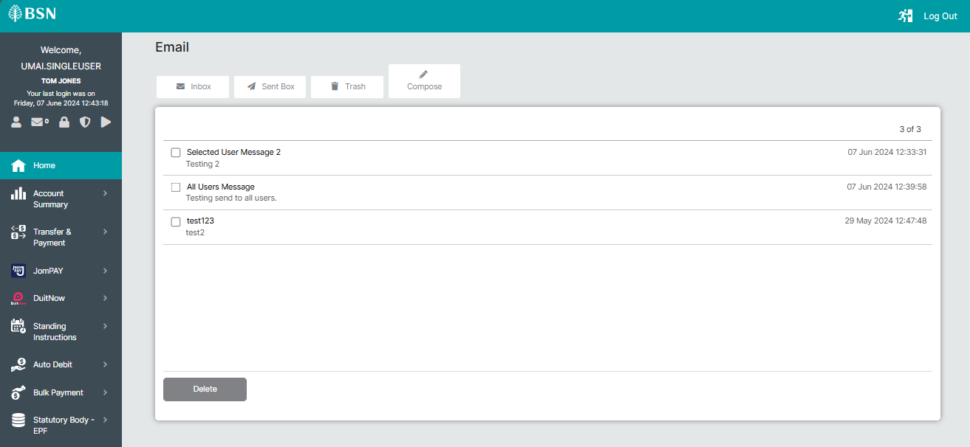  Figure 3: CDB > Inbox > Inbox (User B)  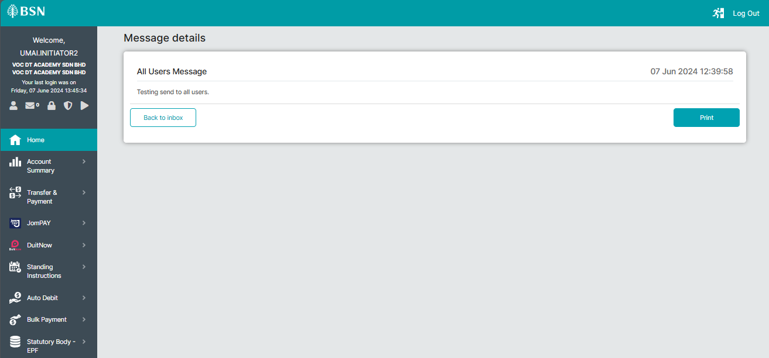  Figure 4: CDB > Inbox > Message Details  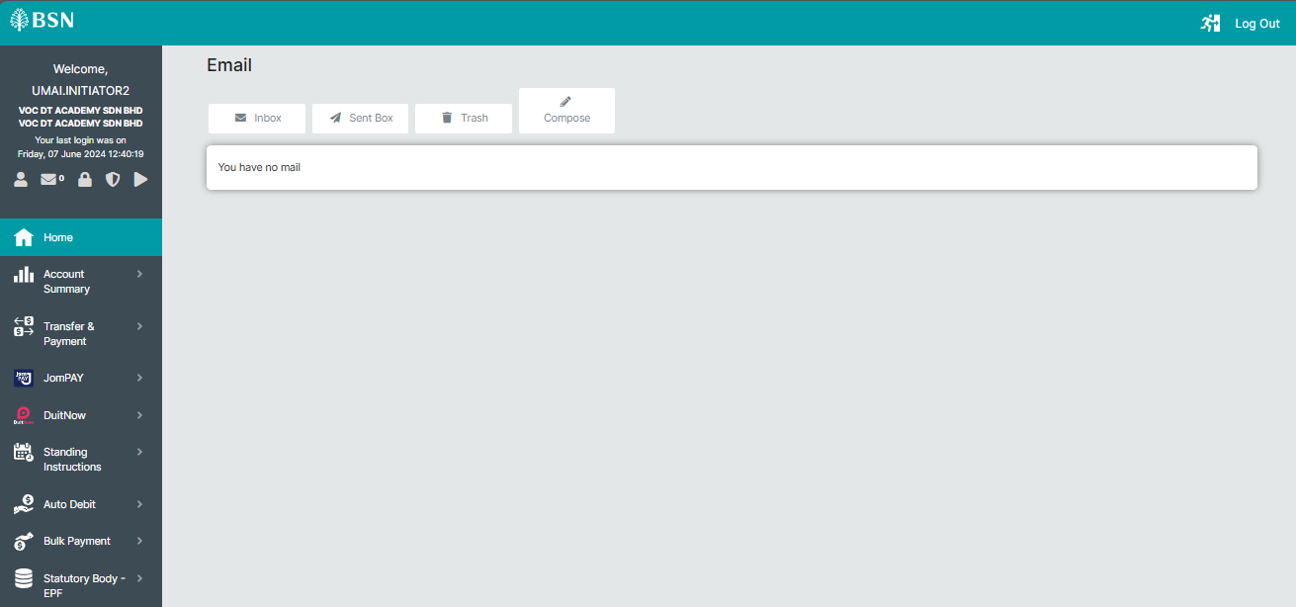  Figure 5: CDB > Inbox > Trash  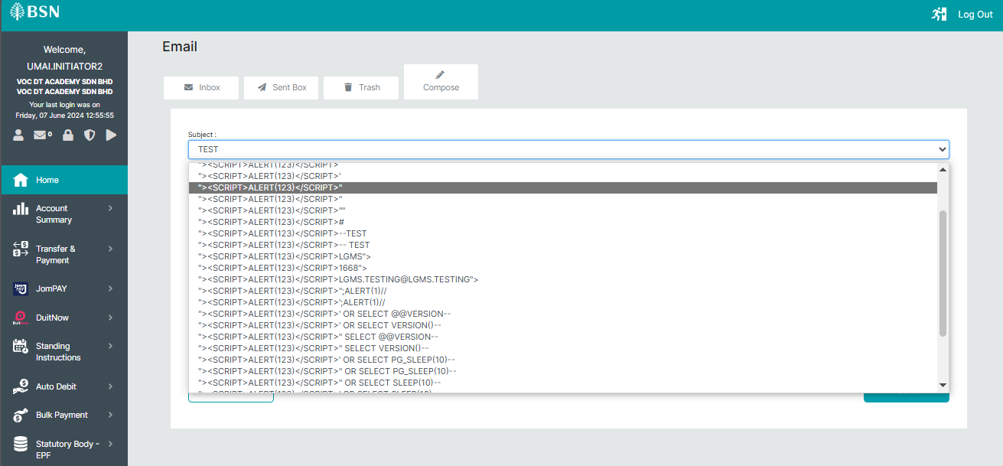  Figure 6: CDB > Inbox > Compose  Send to Selected Users (Extra Test)  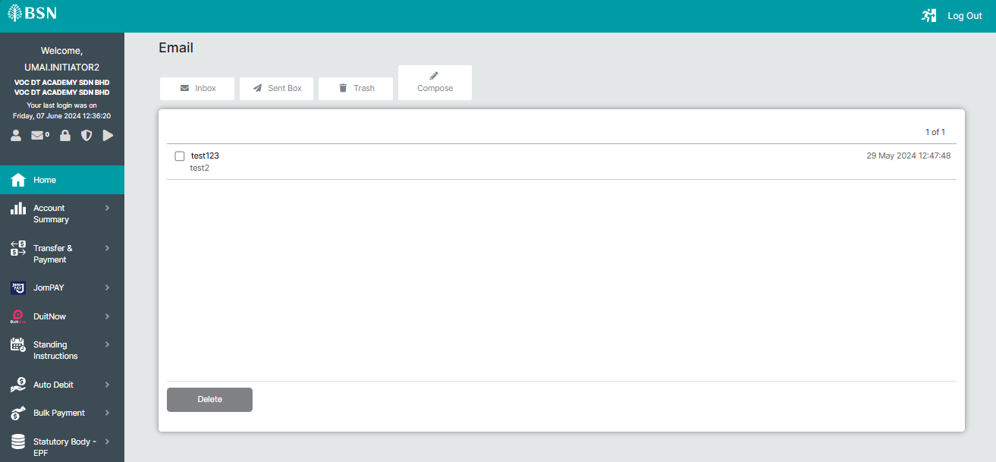  Figure 7: CDB > Inbox > Inbox (User A)  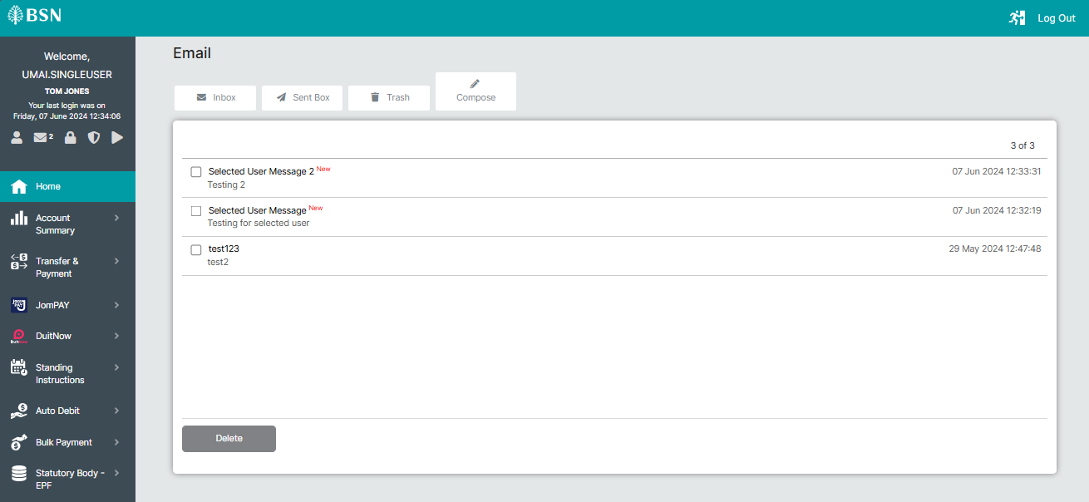  Figure 8: CDB > Inbox > Inbox (User B)  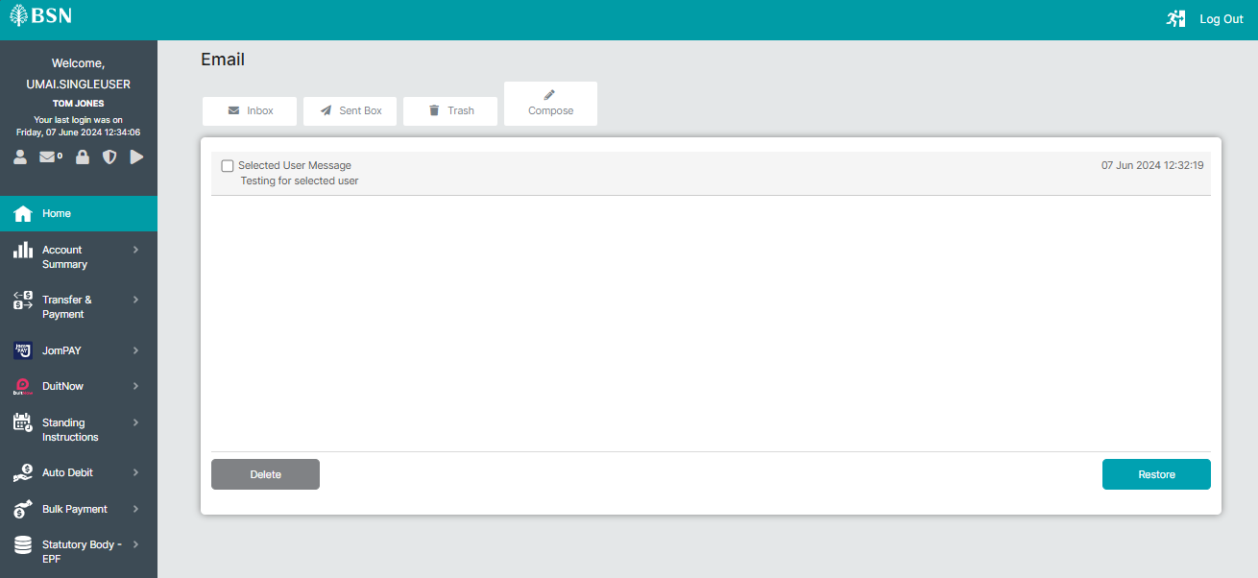  Figure 9: CDB > Inbox > Trash (Successful deleted)

