SCPID#7058
Test Title: |  | BSNeBiz User Management: To set IC Number field as mandatory
Test Description: |  | Issue:  - CDB: No field to key-in the IC number in User Information  - IBAM: IC number not mandatory in User Maintenance  Solution:  - CDB: Add IC Number field and validation(mandatory) - Create and Edit user  - IBAM: Add validation IC Number mandatory Edit user
Test Functionality:
Test Procedure: |  | Test steps:  BSNeBiz  - Access to CDB > User Maintenance  - Create new users. Expected result, required to input IC Number  - Edit existing user. Expected result, required to input IC Number  IBAM  - Access to IBAM > Organization Setup > User Maintenance  - Maker edits existing user. Expected result, required to input IC Number  - Checker approves. Expected result, IC Number successfully updated.  IC Validation: Maximum length=20; required.
Response Message:
Test Result: | Pass: Fail: |  | Tested by: | Nor Athirah Umairah (18/06/2024-19/06/2024)
Reason for Failure:
Remarks: |  | CDB Create User  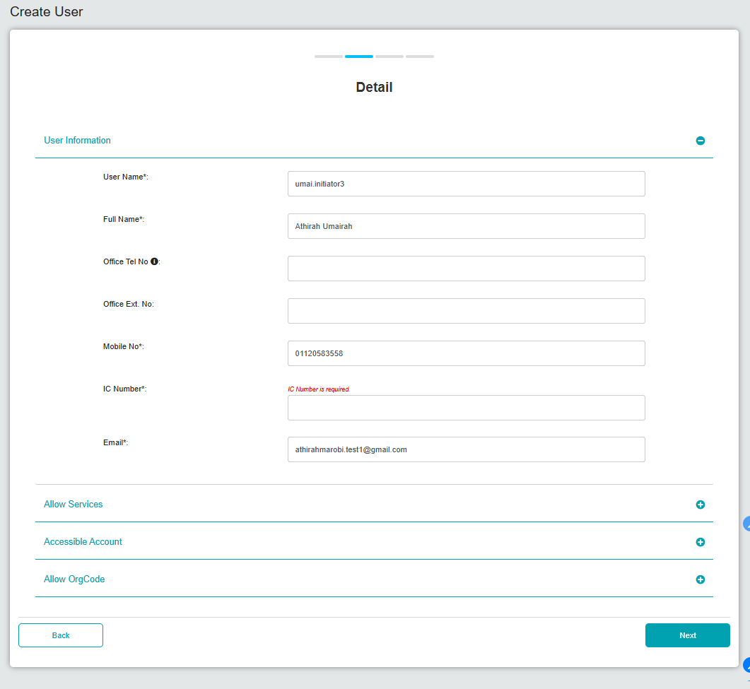  Figure 1: CDB > User Maintenance > Create User (Detail)  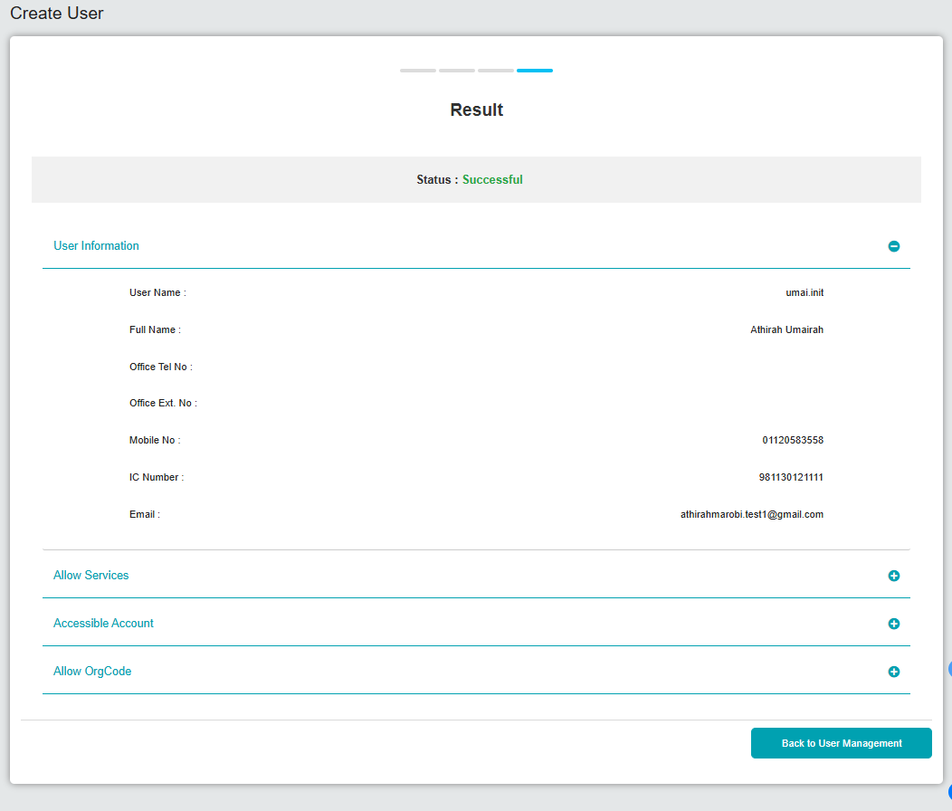  Figure 2: CDB > User Maintenance > Create User (Result)  CDB Edit User  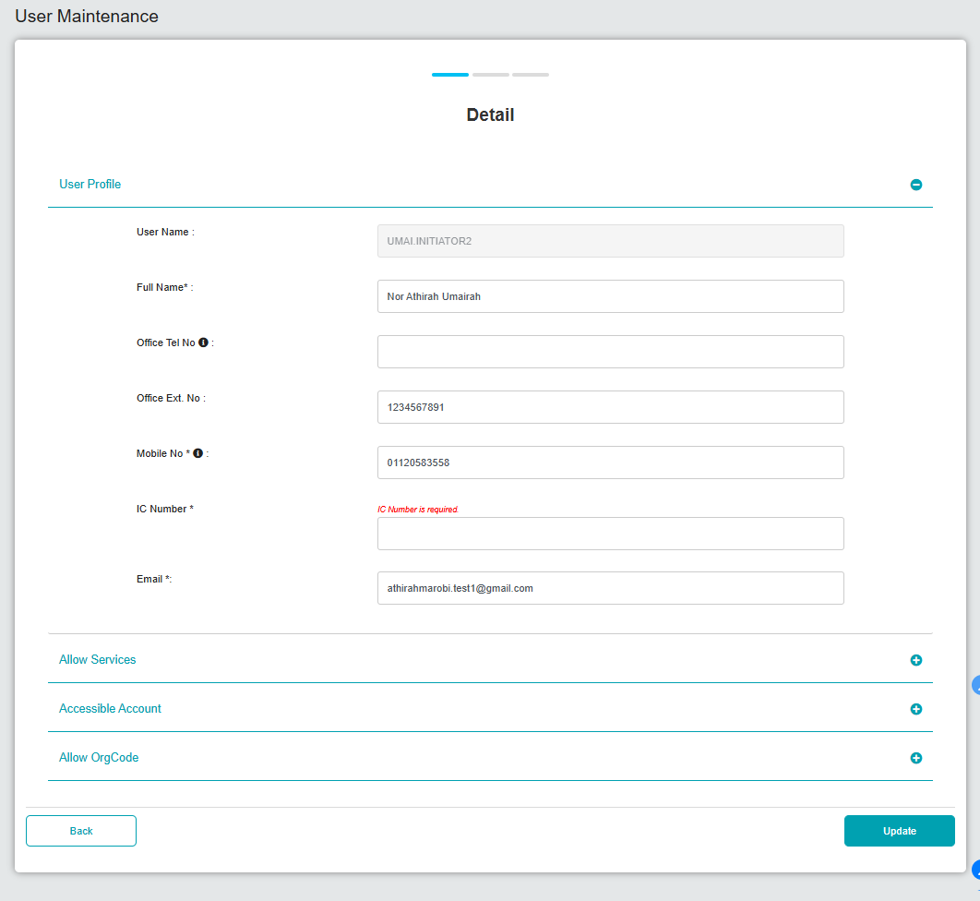  Figure 3: CDB > User Maintenance > Edit User (Detail)  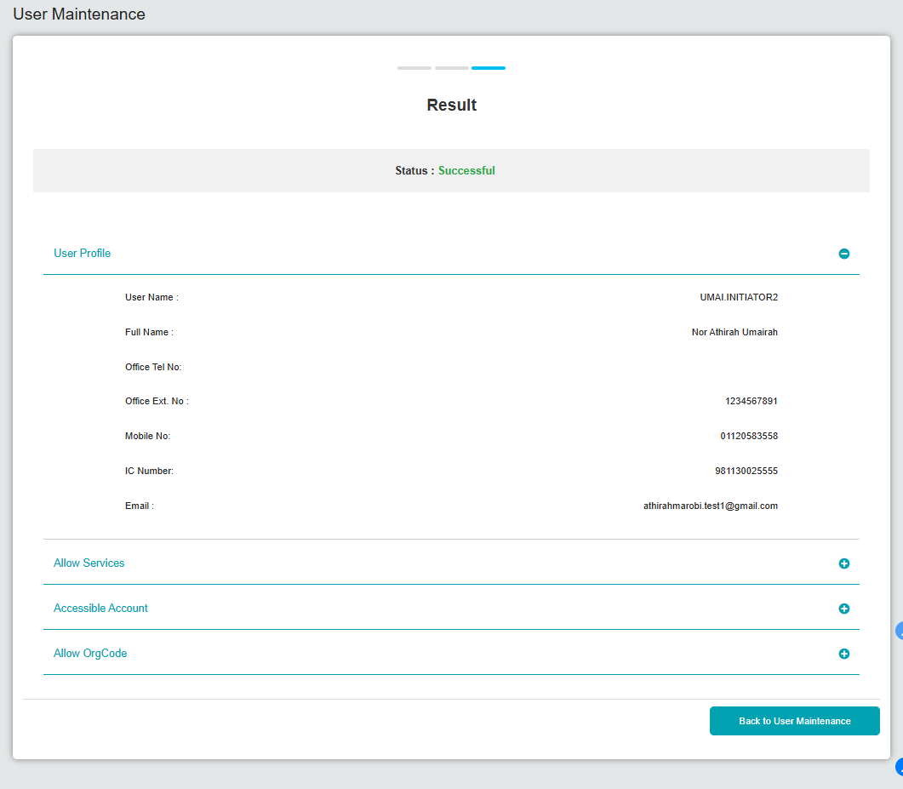  Figure 4: CDB > User Maintenance > Edit User (Result)  IBAM Edit User  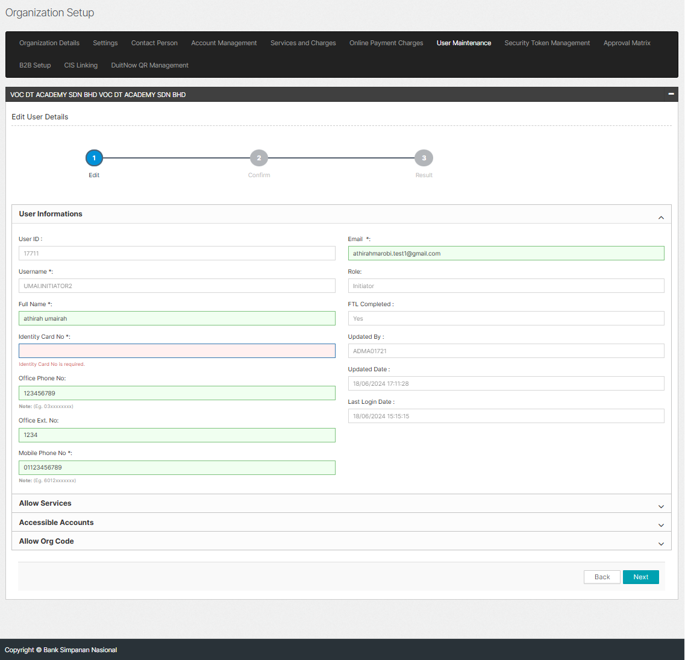  Figure 5: IBAM > User Maintenance > Edit User (Edit)  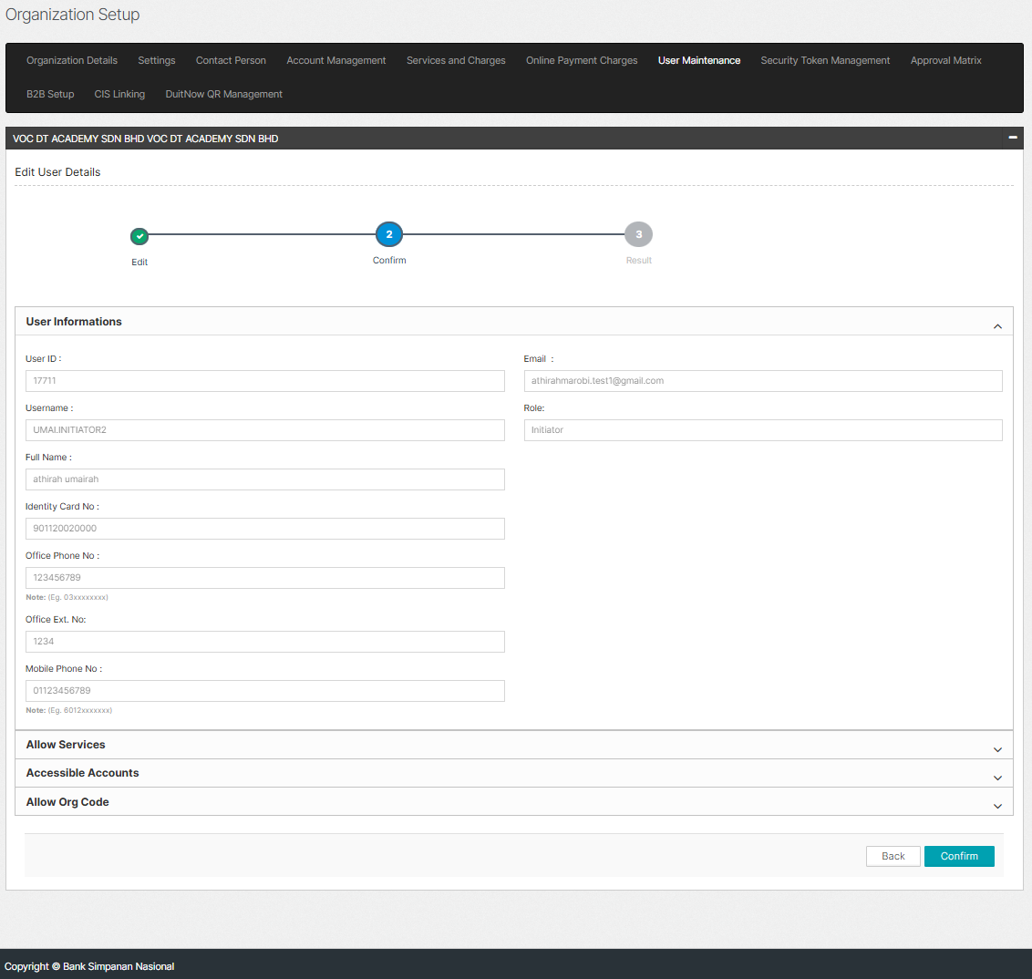  Figure 6: IBAM > User Maintenance > Edit User (Confirm)  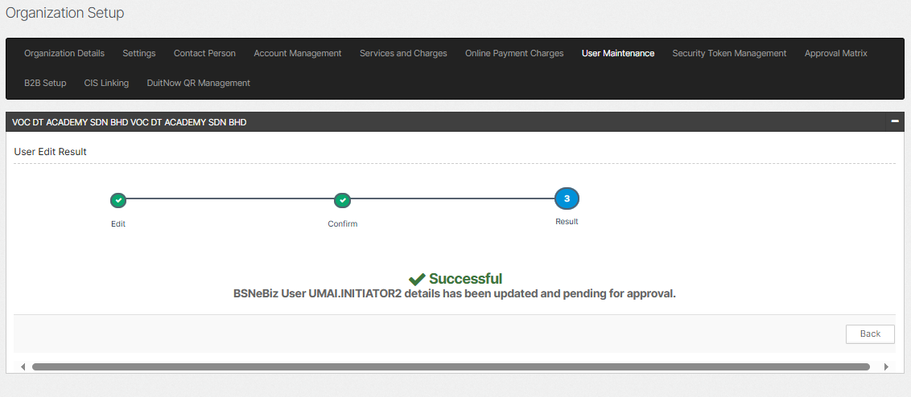  Figure 7: IBAM > User Maintenance > Edit User (Result)  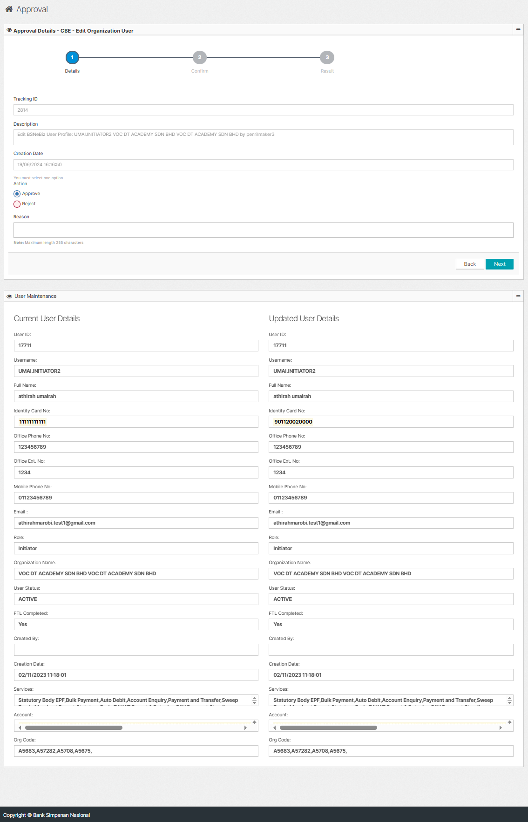  Figure 8: IBAM > Authorization > Approval (Details)  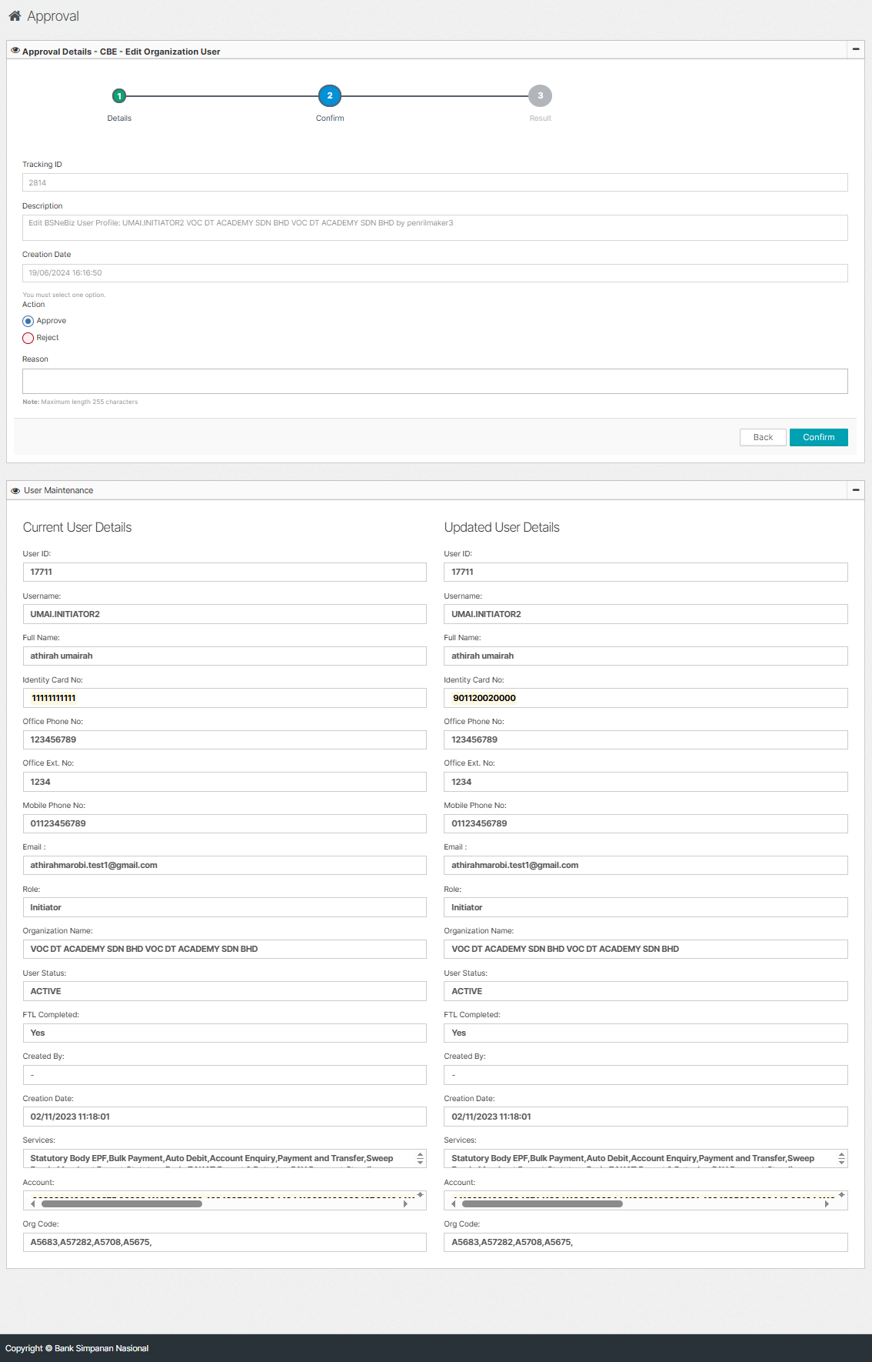  Figure 9: IBAM > Authorization > Approval (Confirm)  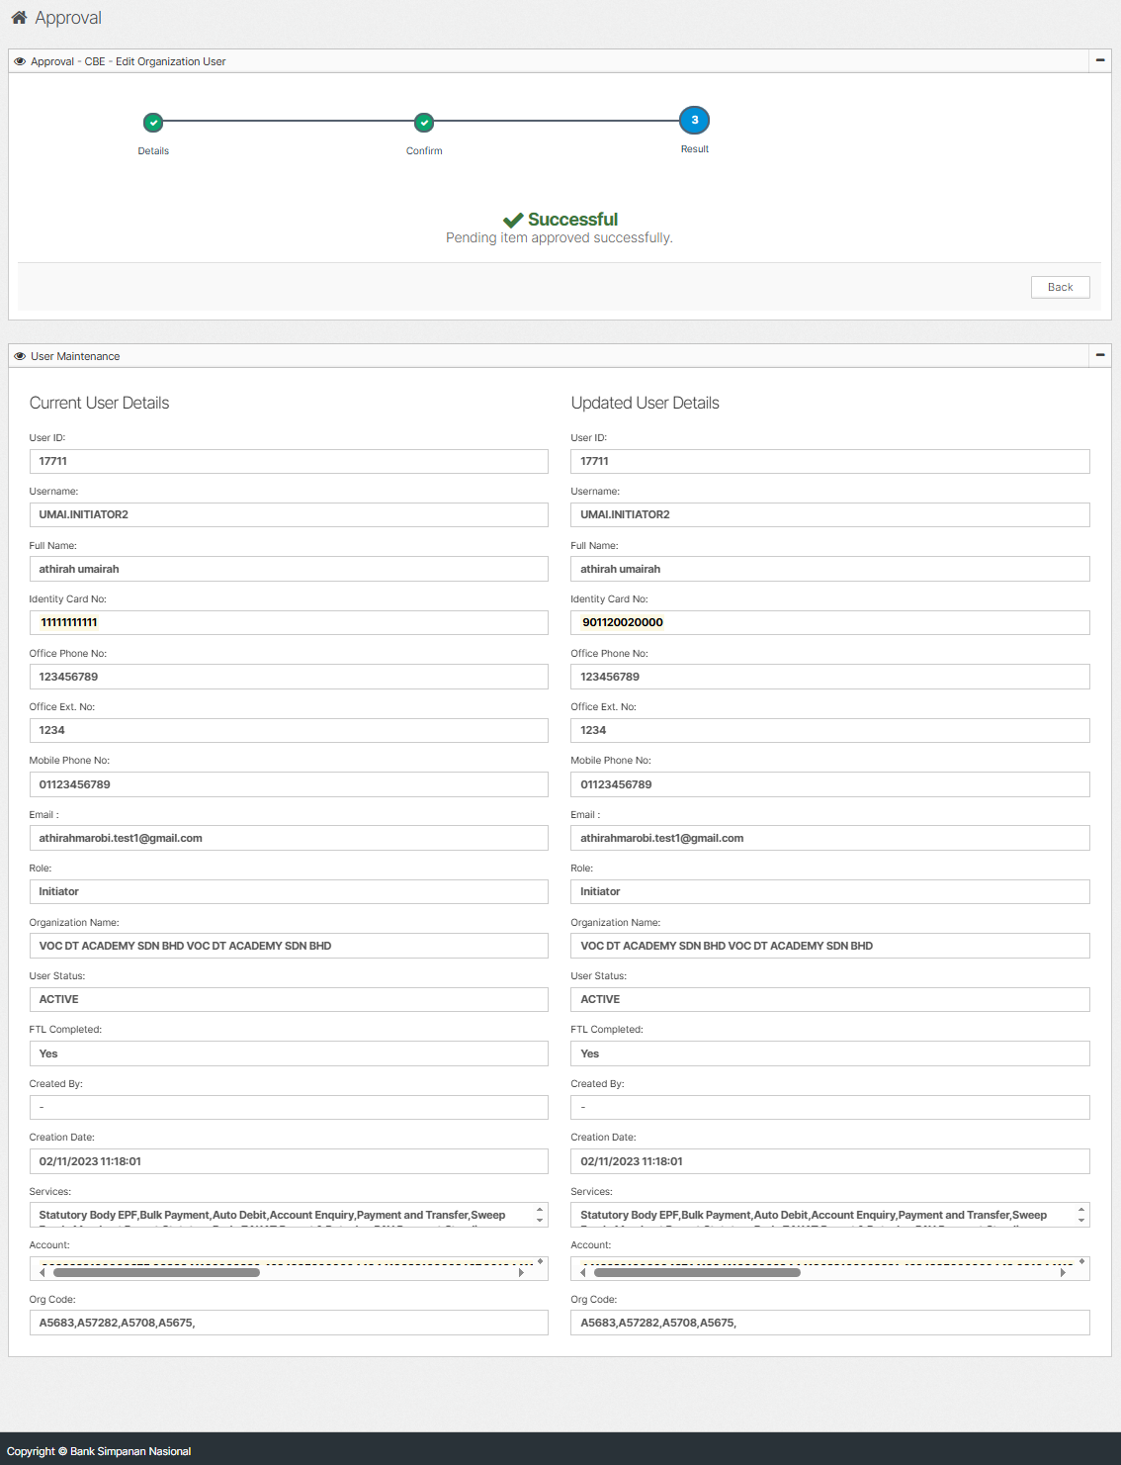  Figure 10: IBAM > Authorization > Approval (Result)  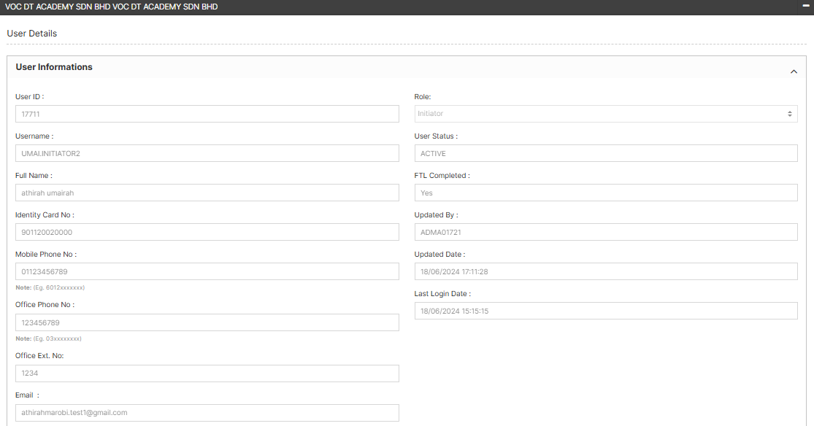  Figure 11: IBAM > User Maintenance > View User

