SCPID#7031
Test Title: |  | Bugs on Mobile Does Not Read Based on Service Info in Web (Android)
Test Description: |  | Issue: Bugs on mobile that does not read based on service info in Web
Test Functionality: |  | To test transfer mode functionality based on service info for mobile.
Test Procedure: |  | Test case 1:  - Set “Yes” for Future Transaction Flag on selected transaction (Ex: IBG) in IBAM>Content>Service Info  - Expected result, able to make pay later transaction  - Repeat for all transactions  Test case 2:  - Set “No” for Future Transaction Flag on selected transaction (Ex: IBG) in IBAM>Content>Service Info  - Expected result, only able to make pay now transaction  - Repeat for all transactions
Response Message:
Test Result: | Pass: Fail: |  | Tested by: | Nor Athirah Umairah (04/06/2024-24/06/2024)
Reason for Failure:
Remarks: |  | Transaction Future Flag = Yes Future Flag = No  Own Account Pass Pass  New 3rd Party Pass Pass  Fav 3rd Party Pass Pass  New IBG Pass Pass  Fav IBG Pass Pass  New RENTAS Pass Pass  Fav RENTAS Pass Pass  New Bill Payment Pass Pass  Fav Bill Payment Pass Pass  New JomPay Pass Pass  Fav JomPay Pass Pass  New DuitNow Instant Pass Pass  Fav DuitNow Instant Pass Pass  New DuitNow Proxy Pass Pass  Fav DuitNow Proxy Pass Pass  Table 1: Result  Android version: v2.1.2 build 10, v2.1.2 build 22  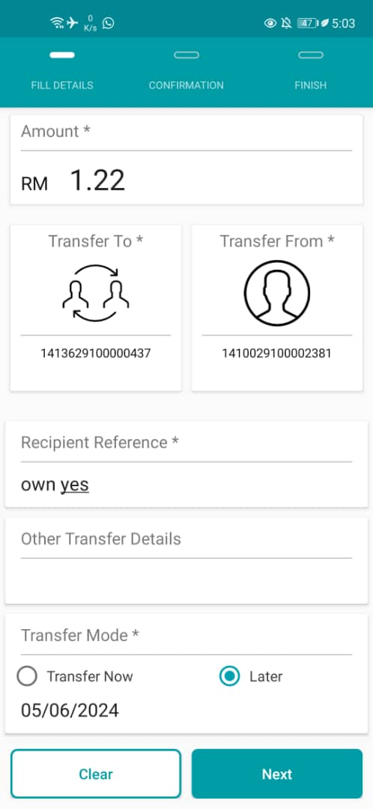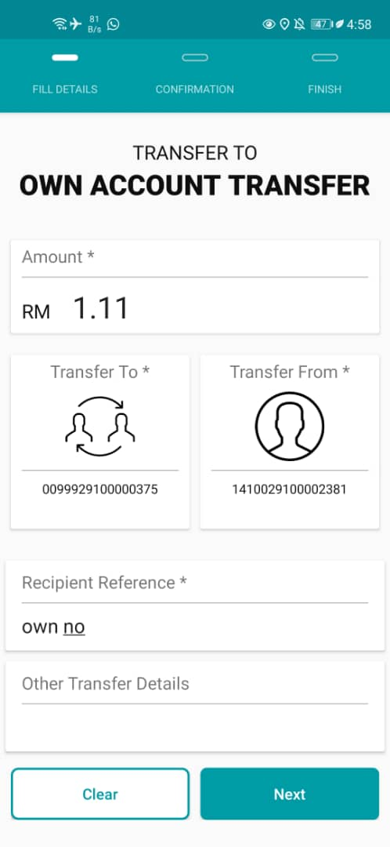  Figure 1: Own Account (Left: Future Flag = Yes; Right: Future Flag = No)  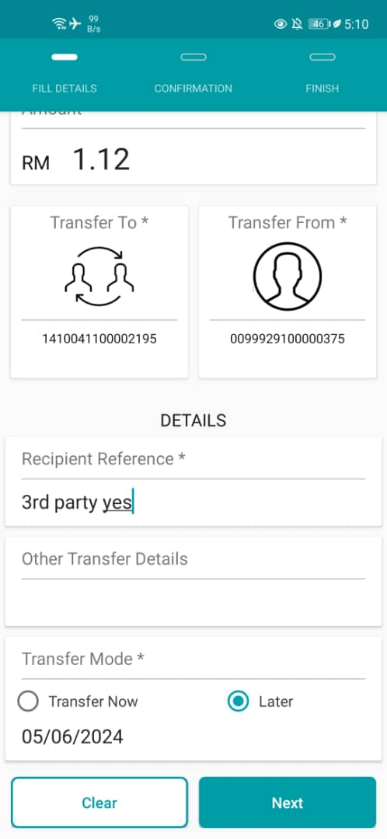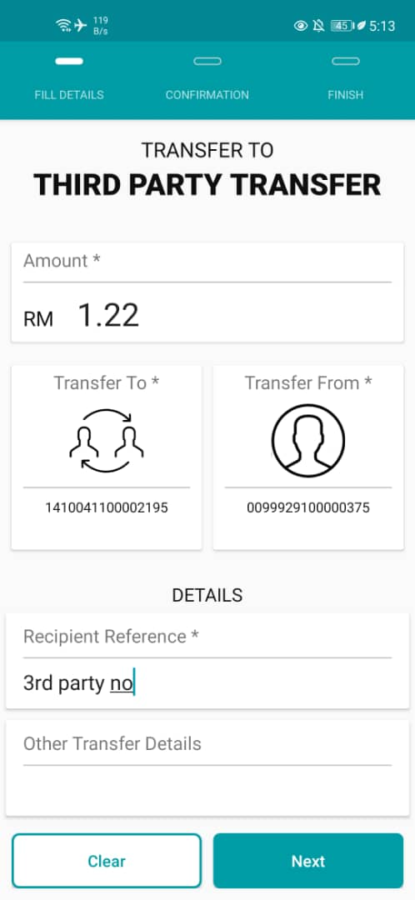  Figure 2: New 3rd Party (Left: Future Flag = Yes; Right: Future Flag = No)  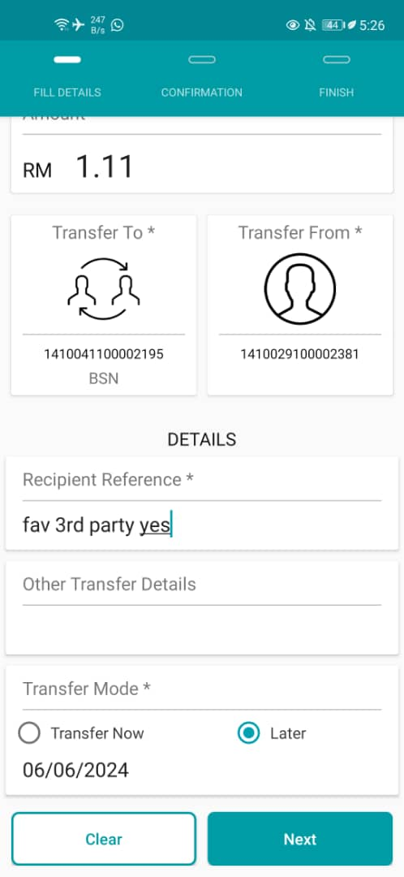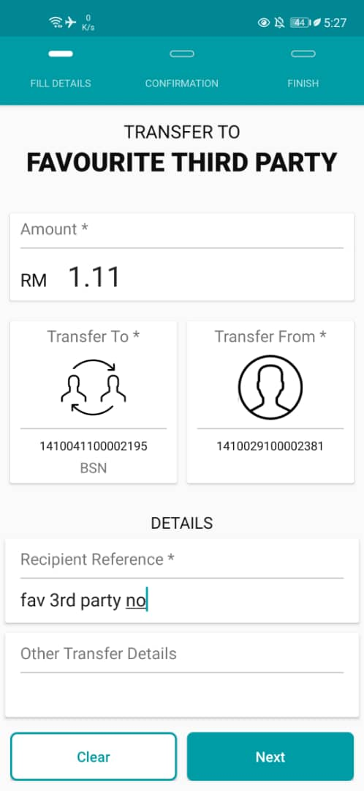  Figure 3: Fav 3rd Party (Left: Future Flag = Yes; Right: Future Flag = No)  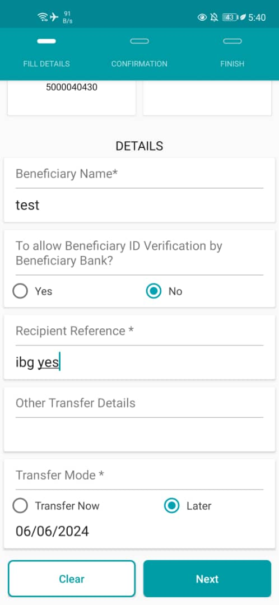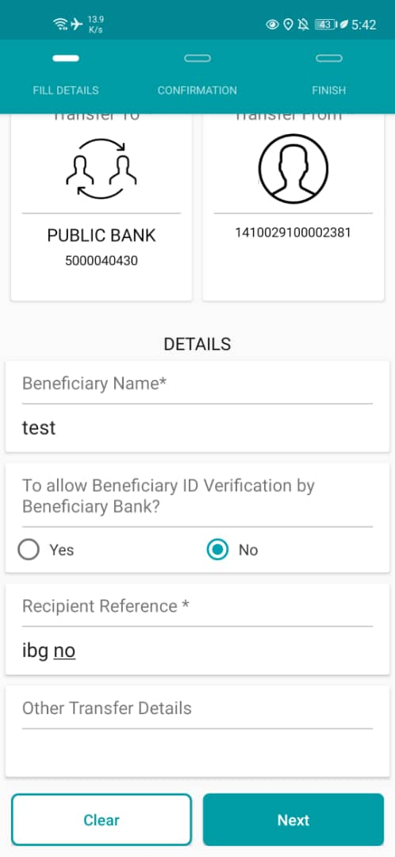  Figure 4: New IBG (Left: Future Flag = Yes; Right: Future Flag = No)  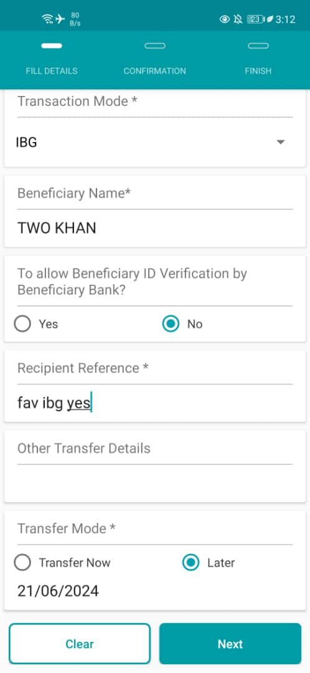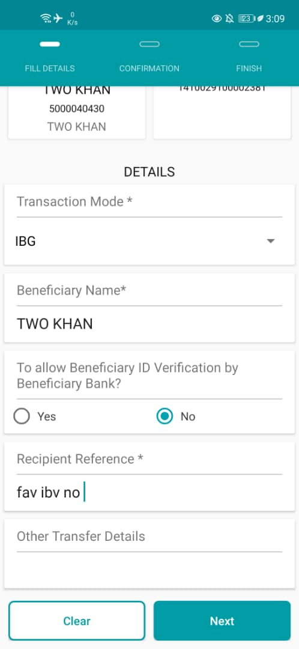  Figure 5: Fav IBG (Left: Future Flag = Yes; Right: Future Flag = No)  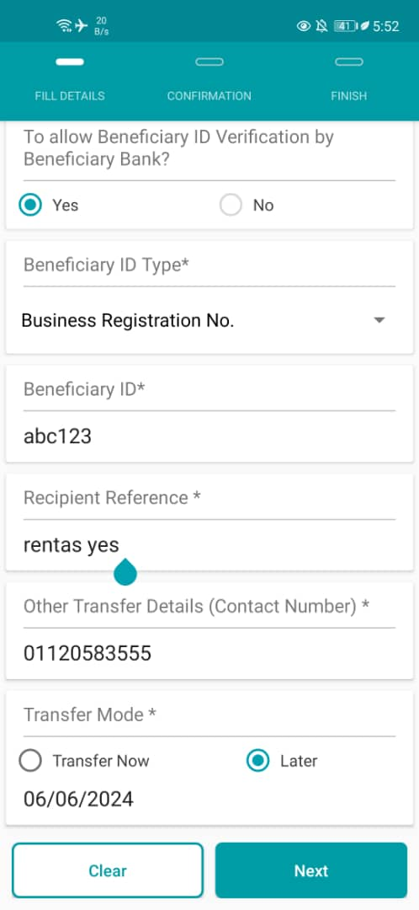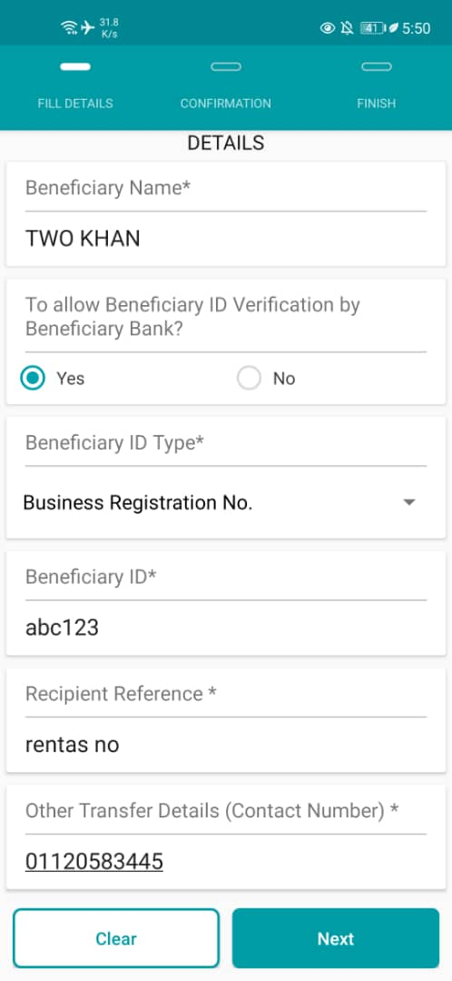  Figure 6: New RENTAS (Left: Future Flag = Yes; Right: Future Flag = No)  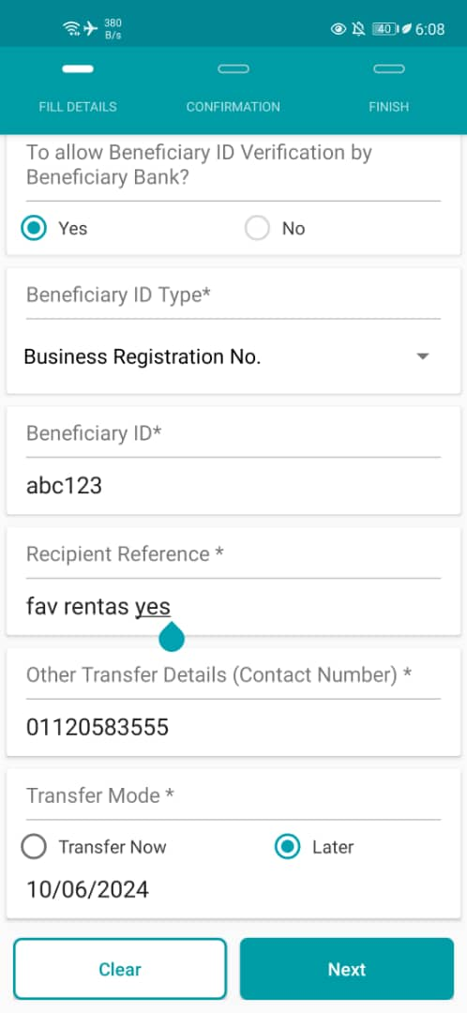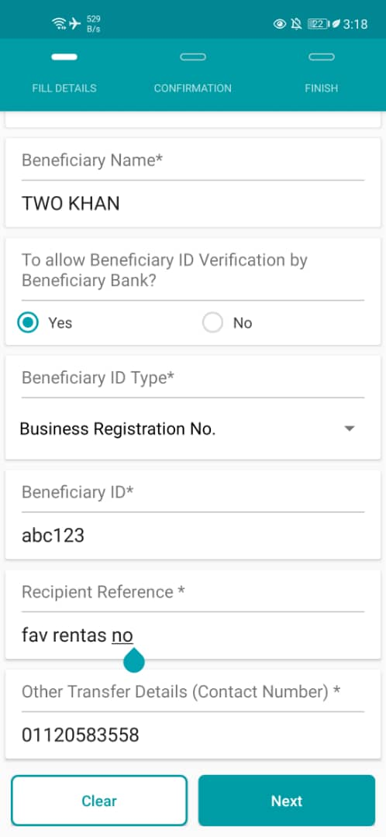  Figure 7: Fav RENTAS (Left: Future Flag = Yes; Right: Future Flag = No)  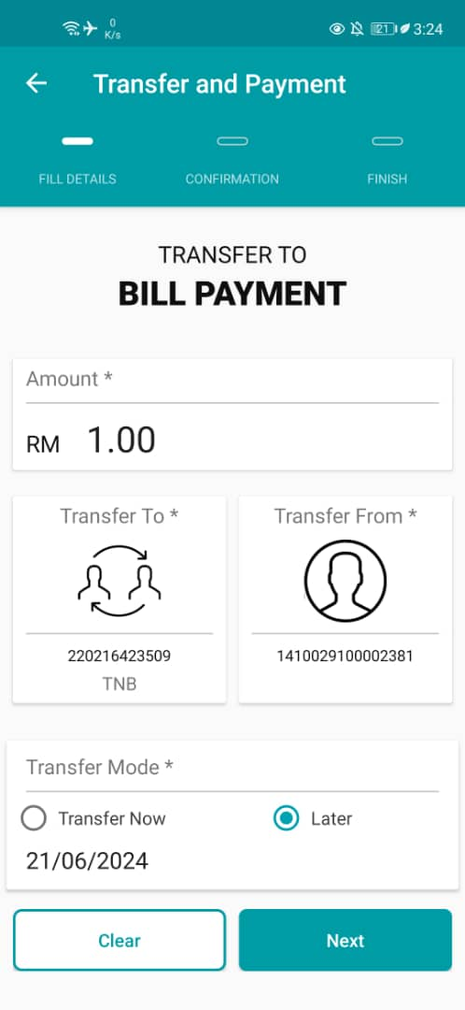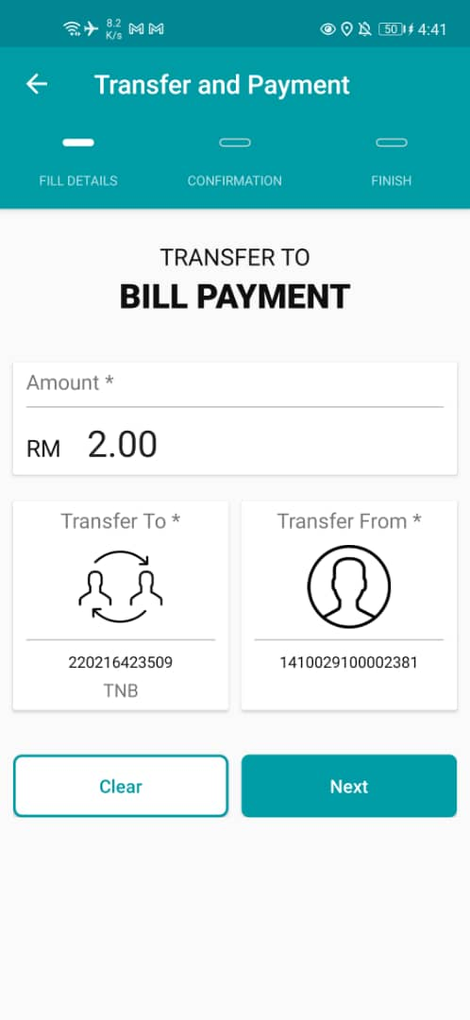  Figure 8: New Bill Payment (Left: Future Flag = Yes; Right: Future Flag = No)  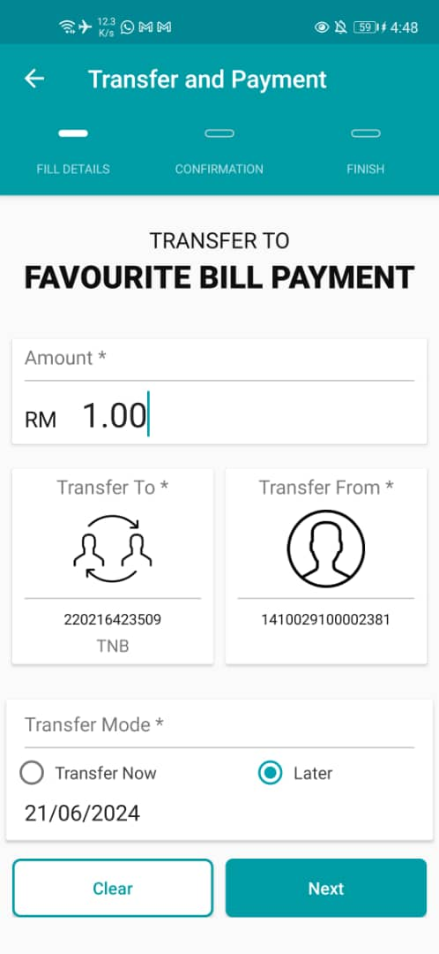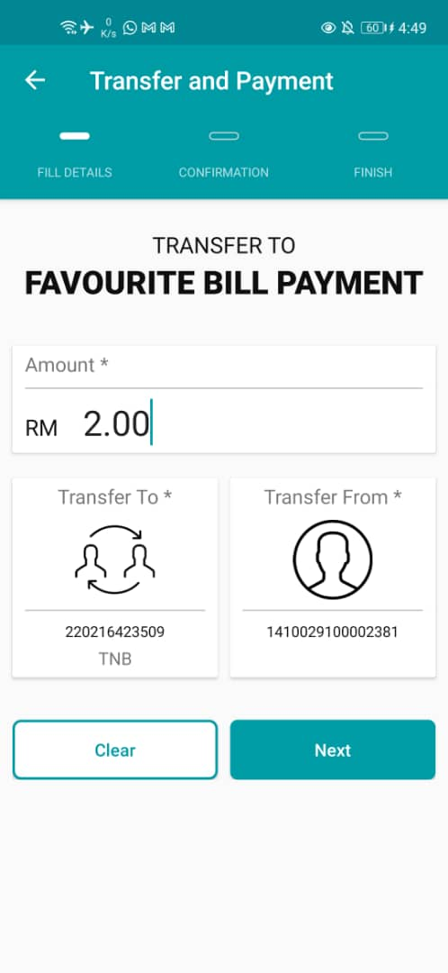  Figure 9: Fav Bill Payment (Left: Future Flag = Yes; Right: Future Flag = No)  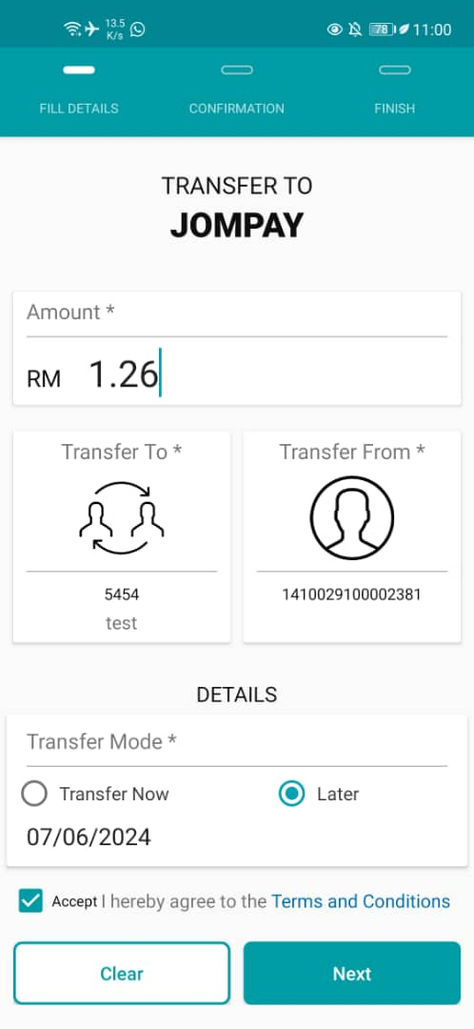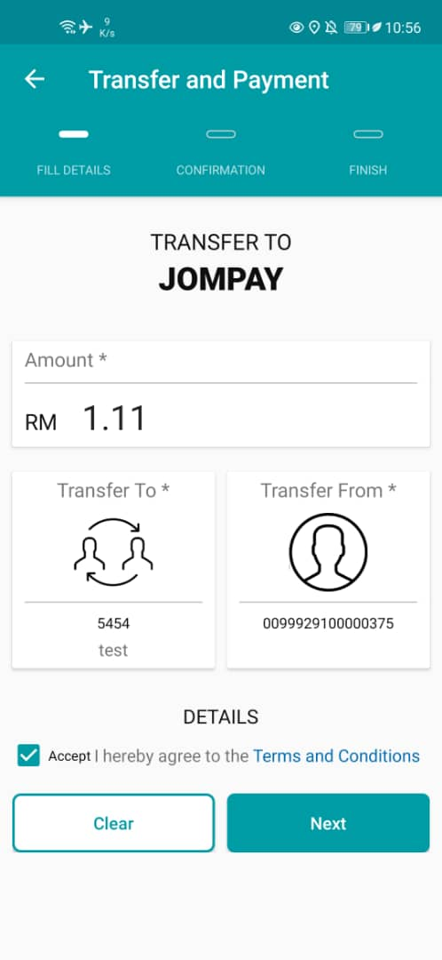  Figure 10: New JomPay (Left: Future Flag = Yes; Right: Future Flag = No)  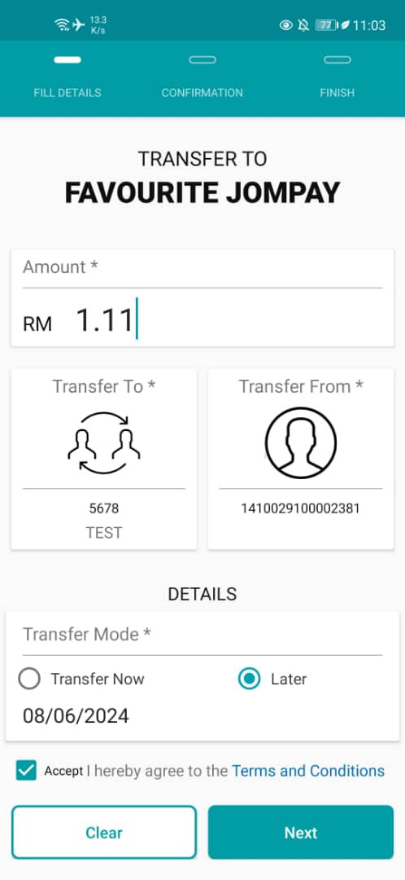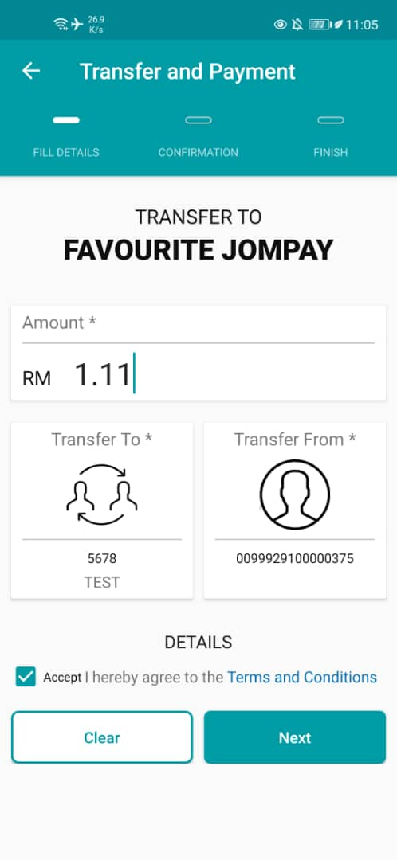  Figure 11: Fav JomPay (Left: Future Flag = Yes; Right: Future Flag = No)  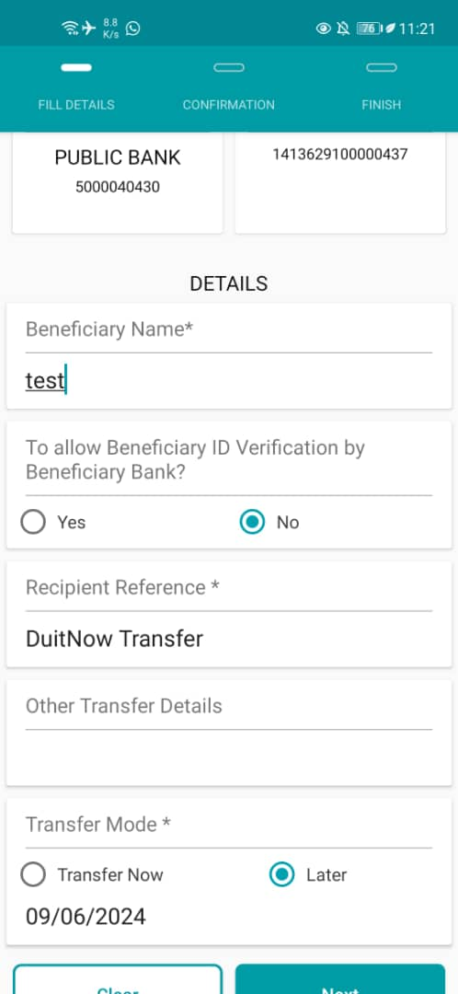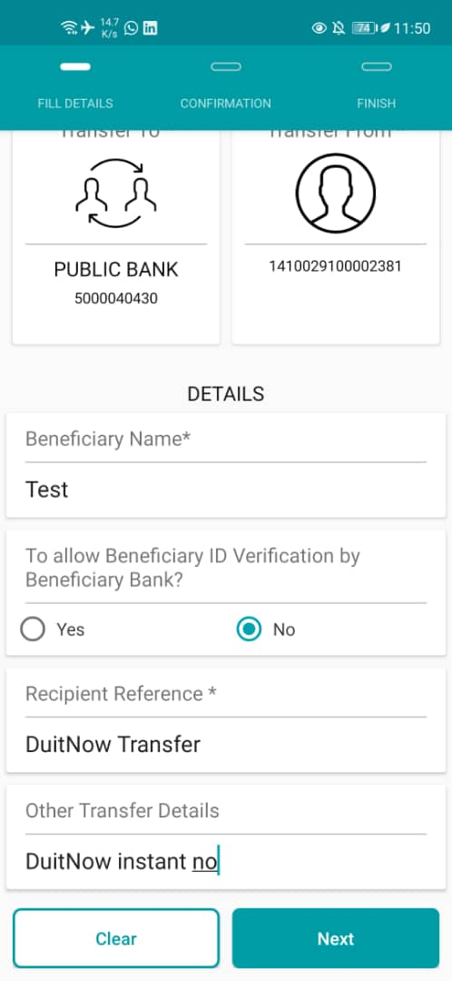  Figure 12: New DuitNow Instant (Left: Future Flag = Yes; Right: Future Flag = No)  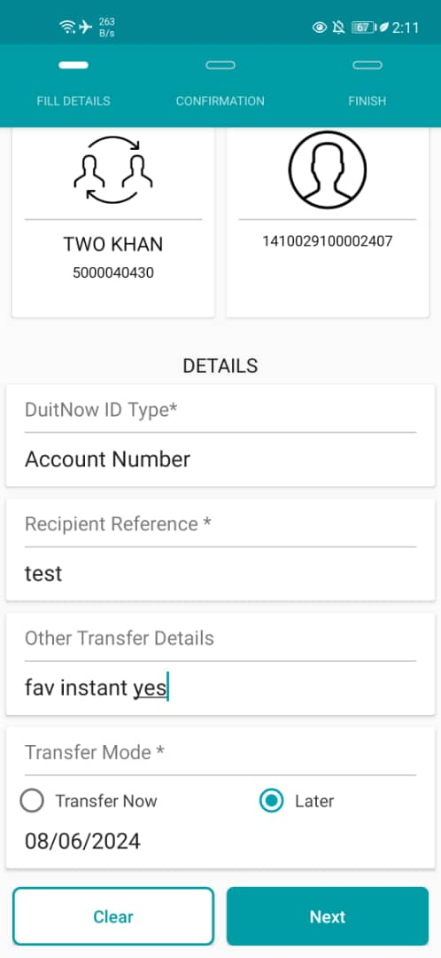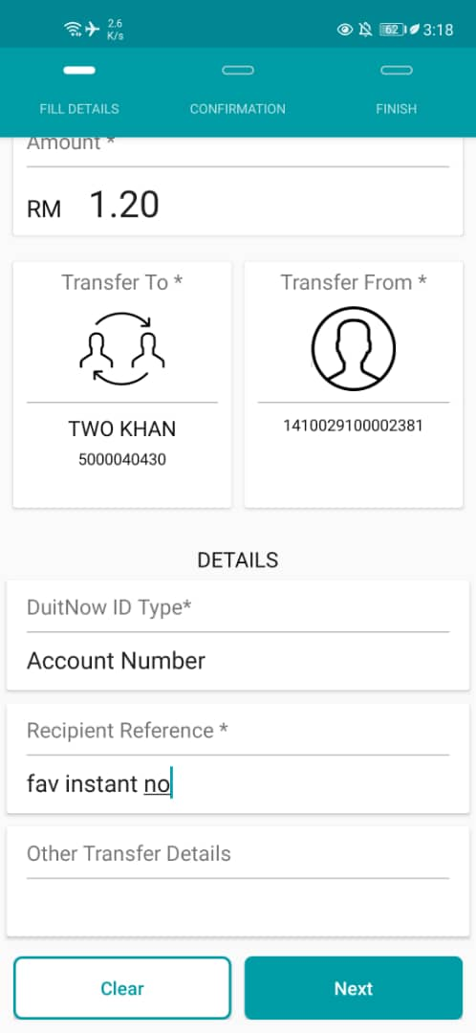  Figure 13: Fav DuitNow Instant (Left: Future Flag = Yes; Right: Future Flag = No)  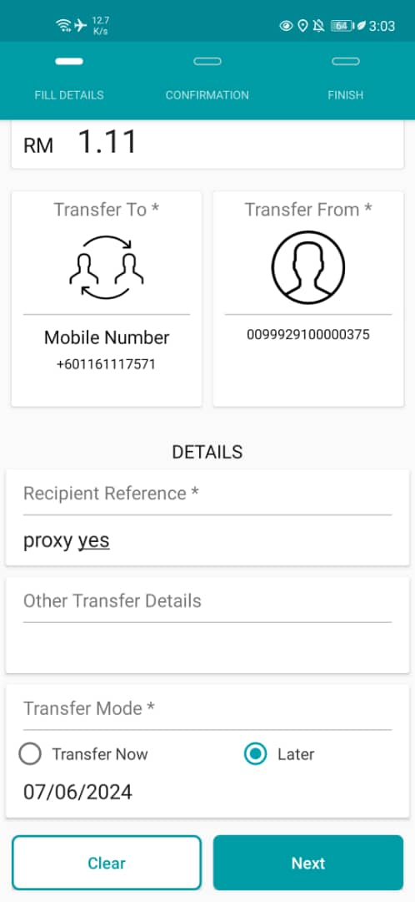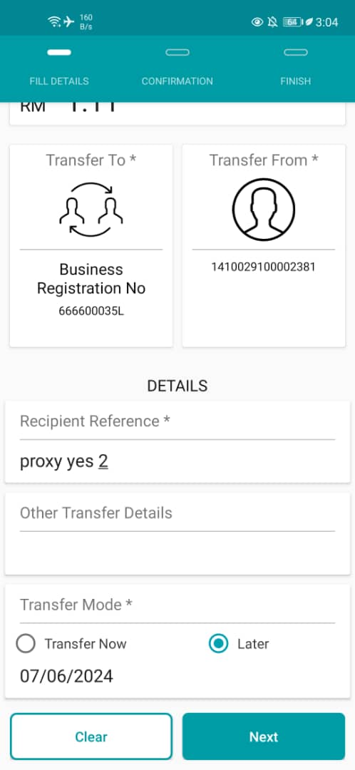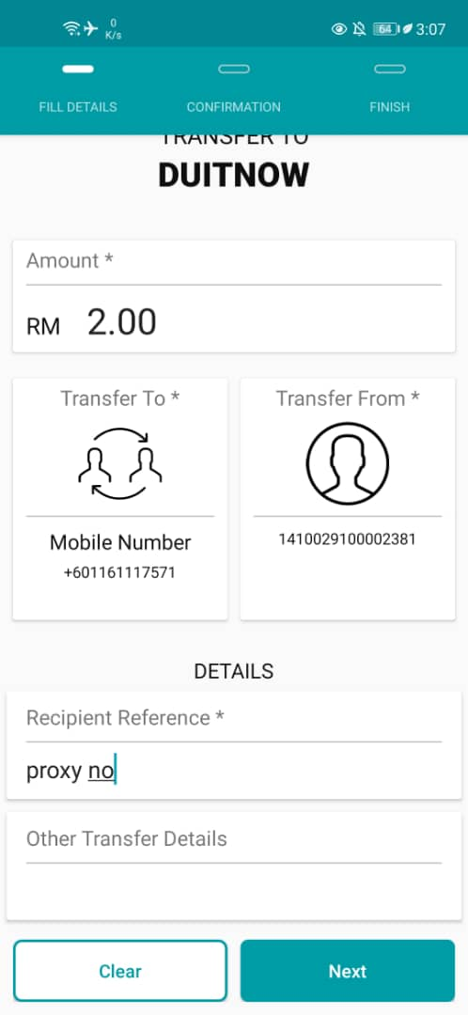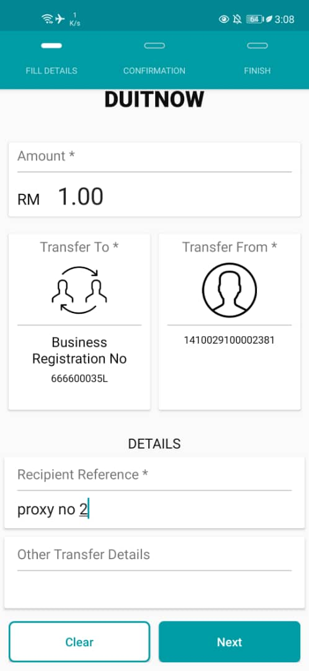  Figure 12: New DuitNow Proxy (Left: Future Flag = Yes; Right: Future Flag = No)  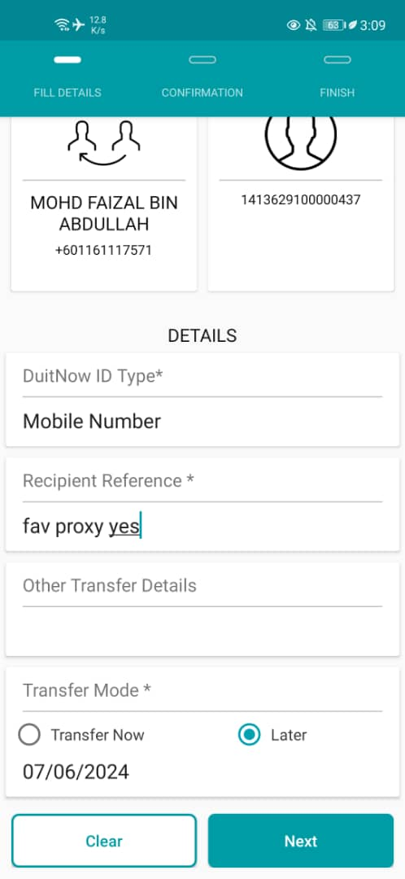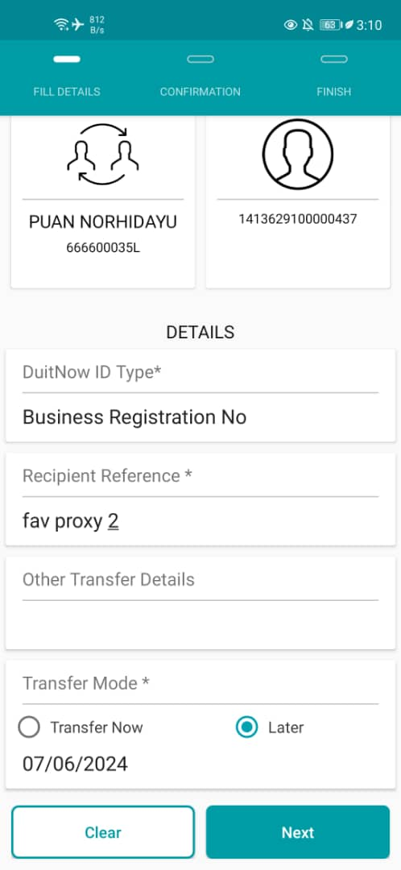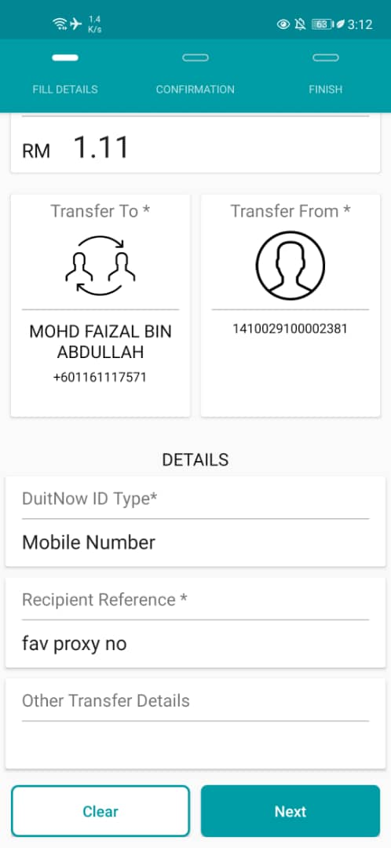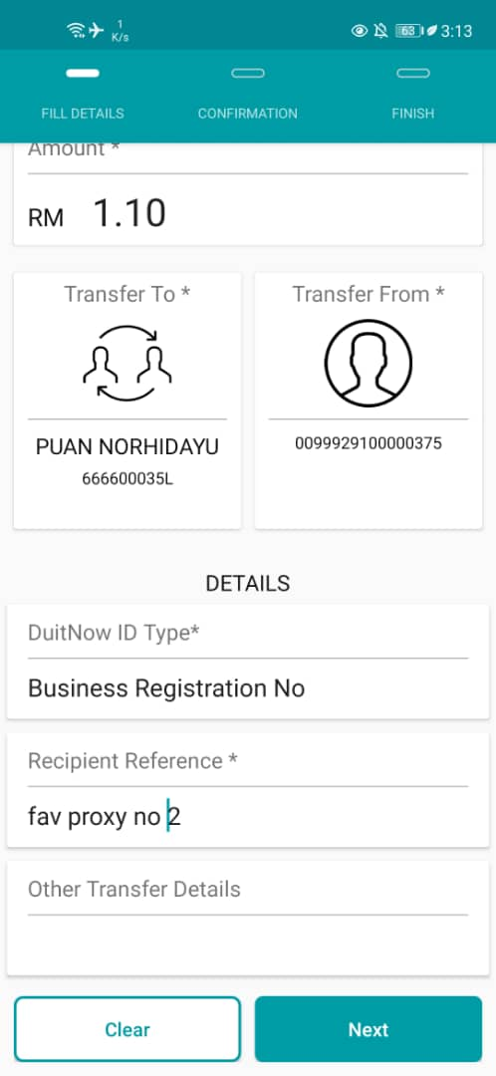  Figure 13: Fav DuitNow Proxy (Left: Future Flag = Yes; Right: Future Flag = No)

