SCPID#7054
Test Title: |  | Update FTL
Test Description: |  | Issue:  - FTL need to call Customer Centre  - FTL and locked email need to update content  Solution:  - Only update error message to include call contact center for locked user  - Email content for temporary password already update on SCPID 6840
Test Functionality:
Test Procedure: |  | Test steps:  - Access to BSNeBiz Web and Mobile  - Login using username with "LOCKED" status.  - Expected result, display error message “Your Account has been locked. Please call your Corporate Admin or BSN Contact Center at 1300 88 1900.”
Response Message:
Test Result: | Pass: Fail: |  | Tested by: | Nor Athirah Umairah (20/06/2024-24/06/2024)
Reason for Failure:
Remarks: |  | Web  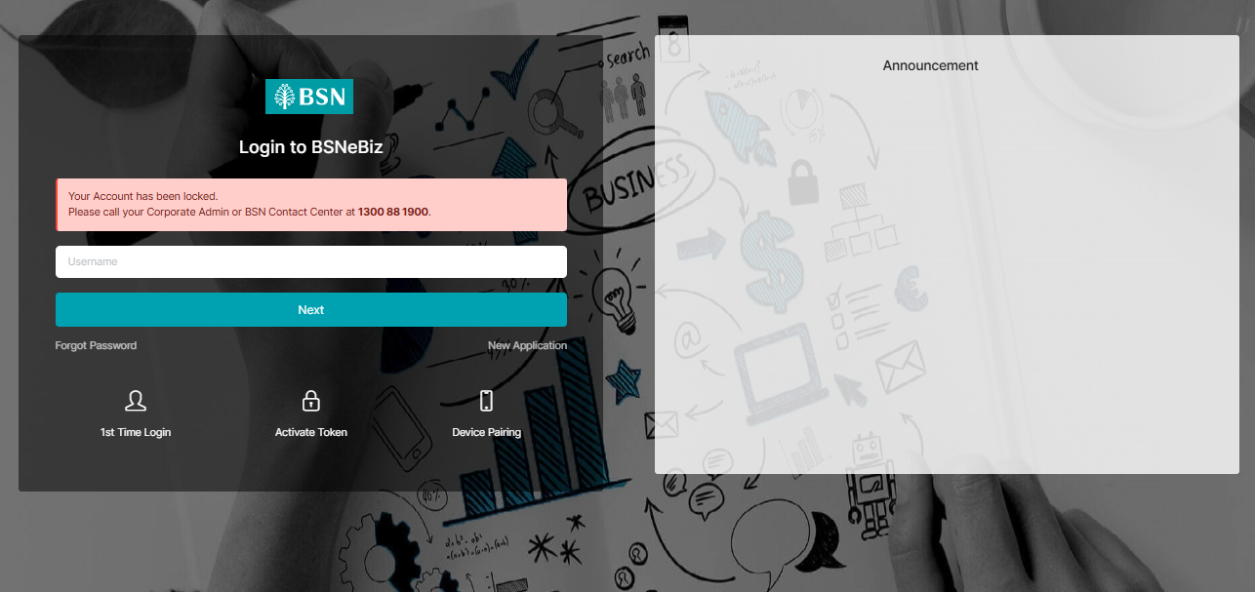  Figure 1: Login  Android  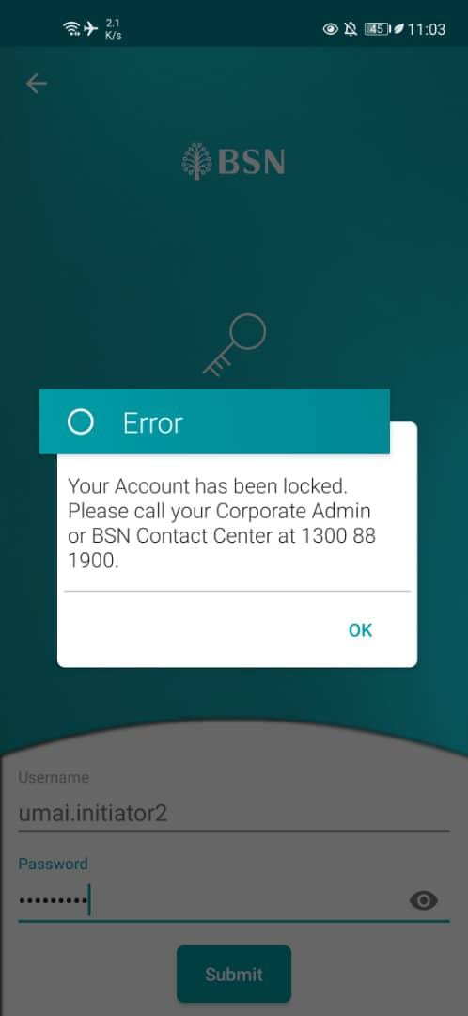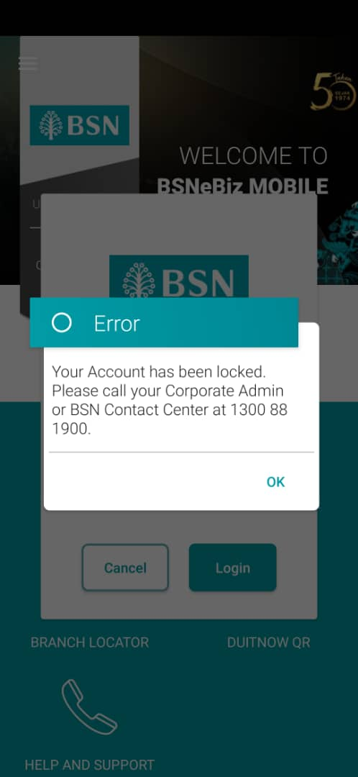  Figure 2: Right: FTL; Left: Login  iOS  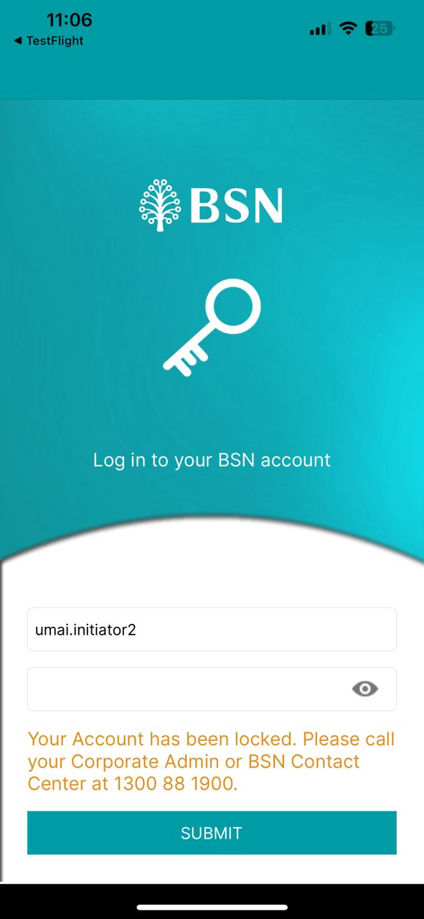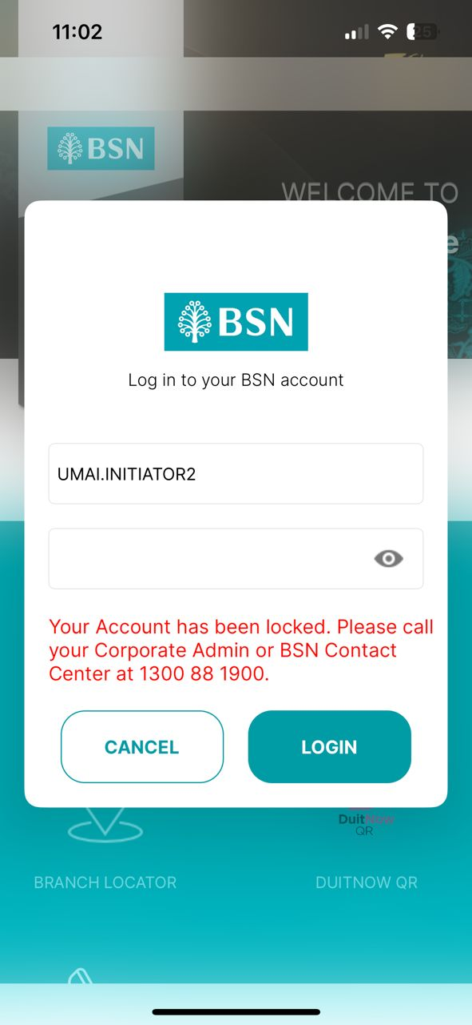  Figure 3: Right: FTL; Left: Login

