|  |
| --- |
|  |
| **Corporate Digital Banking**  **Font Usage**  **[CR24006]**  **for**  **IBAM and BSNeBiz (Web & Mobile)** |
| Performance Testing Report |
|  |
| ***(PENRIL/BSN-PERF-TEST/BSNeBiz/00 – [CR24006])***  ***Revision: 00*** |
| **1st July 2024**  Prepared By:    **Penril Datability (M) Sdn Bhd (816792-X),**  Suite A-07-07 Plaza Mon’t Kiara,  No. 2, Jalan Kiara, Mon’t Kiara,  50480 Kuala Lumpur, Malaysia.  Tel: (603) 6201 2622, Fax: (603) 6201 7622. |

Performance Testing Acceptance

I/We hereby verify that this Performance Testing Acceptance Document consists of all the information requested by Bank Simpanan Nasional.

I/We also hereby AGREE that this satisfies our entire performance test result for DB Tech Refresh (MSSQL 2019) in SIT environment.

Bank Simpanan Nasional:

|  |  |  |  |
| --- | --- | --- | --- |
| Approved by | Role | Signature | Date |
|  |  |  |  |
|  |  |  |  |
|  |  |  |  |
|  |  |  |  |
|  |  |  |  |
|  |  |  |  |
|  |  |  |  |
|  |  |  |  |
|  |  |  |  |
|  |  |  |  |
|  |  |  |  |

Penril Datability (M) Sdn. Bhd.:

|  |  |  |  |
| --- | --- | --- | --- |
| Approved by | Role | Signature | Date |
|  |  |  |  |
|  |  |  |  |
|  |  |  |  |

**Document Management**

|  |  |  |  |  |
| --- | --- | --- | --- | --- |
| Rev. No | Date Update | Description of Change | Updated By | Reviewed By |
| 00 | 1/July/2024 | Initial Release | Nurin Sabrina Binti Azauddin |  |
|  |  |  |  |  |
|  |  |  |  |  |

**Table of Contents**

Chapter 1 - Introduction 5

1. Background 5

2. Purpose 5

Chapter 2 – Content 6

1. Execution Strategy 6

1.1 Type of testing: Performance Testing 6

1.2 Methods of Testing 6

1.3 Process of Testing 6

1.4 Acceptance Criteria 6

1.5 Tools: Apache JMeter 5.1.1 r1855137 6

2. Test Scenarios 7

3. Business Processes Involved 8

4. Performance Test Environment 11

5. Test Results 12

6. Performance Test Result Summary 13

7. Final Conclusion 19

# Chapter 1 - Introduction

## Background

Bank implements the Font Usage for BSN’s Corporate Digital Banking (Web & Mobile) and IBAM system. However, the bank requested Penril to perform a performance report at BSN’s Corporate Digital Banking (Web & Mobile) and IBAM system.

## Purpose

Bank need to ensure that by implementing BSN’s Corporate Digital Banking (Web & Mobile) and IBAM system and integrating IB to this new system will not cause major performance degradation.

Thus, this document describes the Performance Test Result before and after IB integration to BSN’s Corporate Digital Banking (Web & Mobile) and IBAM system in the SIT environment.

# Chapter 2 – Content

## Execution Strategy

### Type of testing: Performance Testing

A performance test is a planned test to perform a specified number of requests to a system in order to test the query to DB under specific levels of simultaneous requests. A performance test ensures that CDB is capable of handling an expected volume of traffic with minimal to acceptable performance degradation.

The goal of this load test is to prove that with new integration to BSN’s Corporate Digital Banking (Web & Mobile) and IBAM system, it can handle the expected volume with minimal to acceptable performance degradation. In this test scenario, we simulated the maximum number of requests with the goal of less than 1% of errors.

### Methods of Testing

Penril conducted performance testing on the 10 most frequently used module. The test cases were designed in such a way that each of these modules is run by 100 threads, respectively to mimic the actual business scenarios such as Initiate Transaction and Create New BSNeBiz Application.

### Process of Testing

Each of the test cases will be run by based on the given module, number of threads. Then, the number of errors, throughput and average response time for each of the test cases were being monitored.

### Acceptance Criteria

The test is considered successful when it meets the expected error rate criteria.

### Tools: Apache JMeter 5.1.1 r1855137

Apache JMeter is pure Java open-source software with the purpose of load test functional behaviour and measuring performance of web applications. This app is chosen because it is platform independent, easy to install and provides better visualization on test results.

|  |
| --- |
| Important Notes:  This performance test case does not reflect the actual performance in the production environment. Bank need to provide the ratio between staging vs. production environment. |

## Test Scenarios

Below is the list of test scenarios of implementing the Font Usage for BSN’s Corporate Digital Banking (Web & Mobile) and IBAM system.

|  |  |  |
| --- | --- | --- |
| Scenario # | Scenario to be Tested | Functionality |
| 1 | IBAM – Create BSNeBiz Application | Create new BSNeBiz application |
| 2 | IBAM – Authorization | Approve new BSNeBiz application |
| 3 | IBAM – Edit Organization Setup | Update organization setup details |
| 4 | IBAM – View Transaction Enquiry | Display BSNeBiz Transaction Enquiry |
| 5 | BSNeBiz – Login | Login to BSNeBiz |
| 6 | BSNeBiz – Transaction | Initiate transaction at BSNeBiz Web |
| 7 | BSNeBiz – Authorization | Authorization approval for any transaction |
| 8 | BSNeBiz Mobile – Login | Login to BSNeBiz Mobile |
| 9 | BSNeBiz Mobile – Transaction | Initiate transaction at BSNeBiz Mobile |
| 10 | BSNeBiz Mobile – Authorization | Authorization approval for any transaction |

Notes:

* Each of the test scenarios above will be executed using **JMeter** tool **version 5.6.2.**

## Business Processes Involved

IBAM – Create BSNeBiz Application

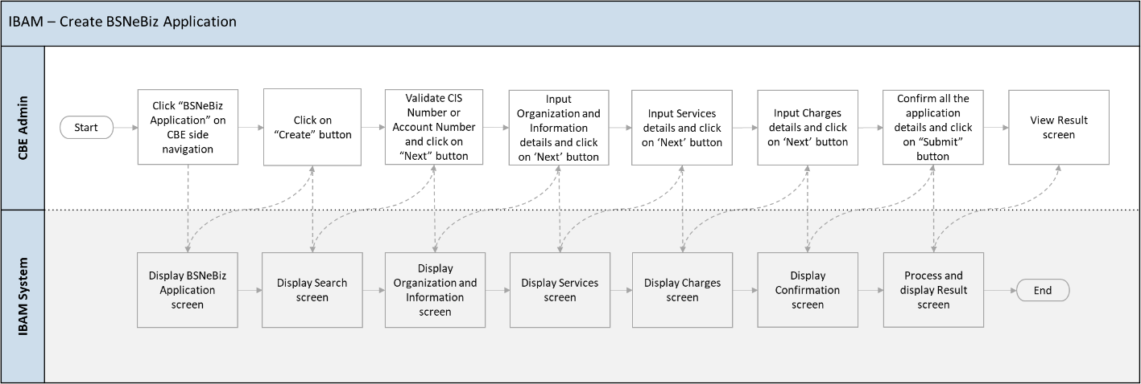

Diagram 1 : Create BSNeBiz Application Flow Diagram

IBAM – Authorization



Diagram 2 : Authorization Flow Diagram

IBAM – Edit Organization Setup



Diagram 3 : Edit Organization Setup Flow Diagram

IBAM – View Transaction Enquiry



Diagram 4 : View Transaction Enquiry Flow Diagram

BSNeBiz – Login



Diagram 5 : BSNeBiz Login Flow Diagram

BSNeBiz – Transaction

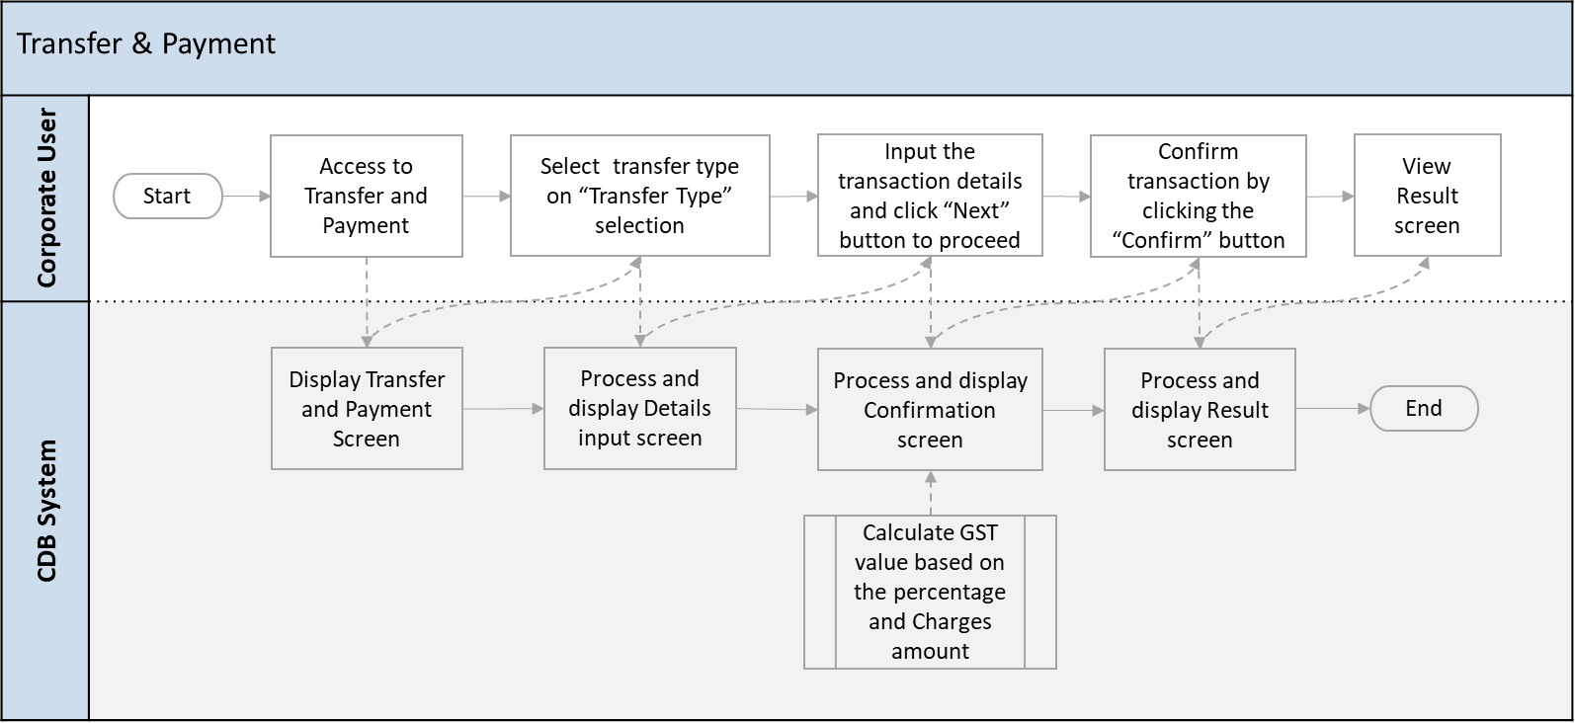

Diagram 6 : BSNeBiz Transaction Flow Diagram

BSNeBiz – Authorization



Diagram 7 : BSNeBiz Authorization Flow Diagram

BSNeBiz Mobile – Login

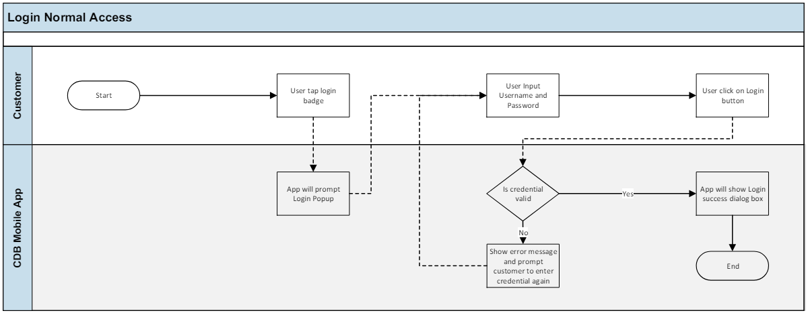

Diagram 8 : BSNeBiz Mobile Login

BSNeBiz Mobile – Transaction

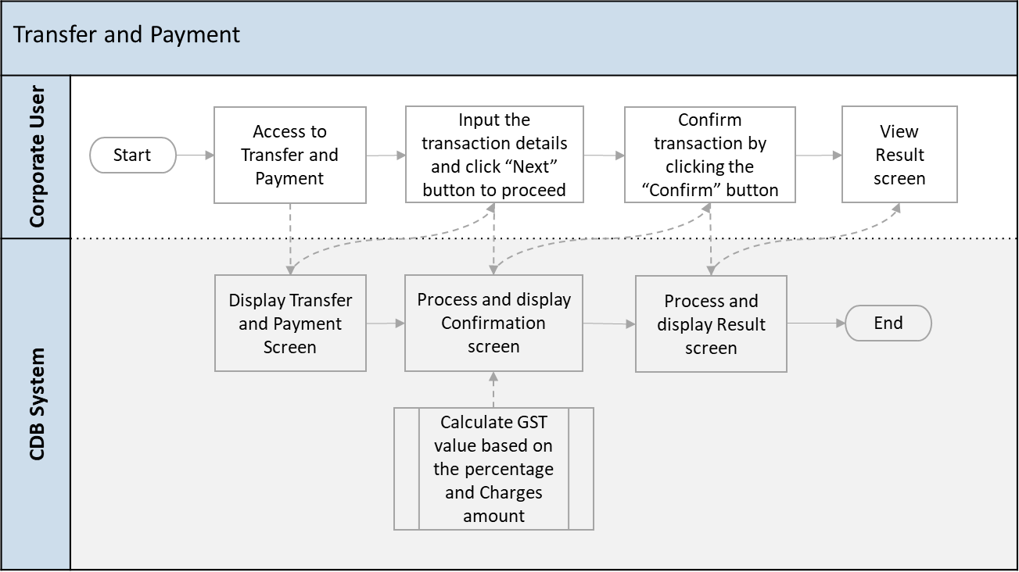

Diagram 9 : BSNeBiz Mobile Transaction Flow Diagram

BSNeBiz Mobile – Authorization

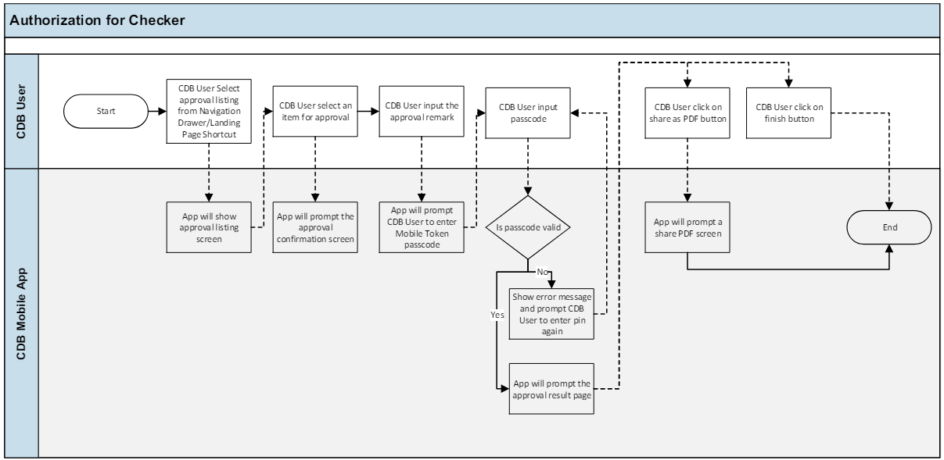

Diagram 10 : BSNeBiz Mobile Authorization Flow Diagram

This is a simplified flow diagram of load test flow scenarios representing Corporate Digital Banking Customers performing Create New BSNeBiz Application process, Authorization process, Edit Organization Setup process, View Transaction Enquiry, BSNeBiz Login process, BSNeBiz Transaction process, BSNeBiz Authorization process, BSNeBiz Mobile Login process, BSNeBiz Mobile Transaction process and BSNeBiz Mobile Authorization process.

## Performance Test Environment

|  |  |  |
| --- | --- | --- |
| Test Region | : | SIT Environment |
| Instance Testing | : | BSNeBIZ – SIT Environment  Web : <http://58.27.45.179:8080/bsn-cdb-sit/commonLogin>  Mobile : Version 2.1.2 Build 21 |
| Apache JMeter | : | Version 5.6.2 |
| Java Version | : | JDK 1.8 |

## Test Results

Testing Objective:

To stimulate the maximum number of requests to perform performance test on 10 modules with goal of:

* Error < 1%

|  |  |  |  |  |  |  |  |  |
| --- | --- | --- | --- | --- | --- | --- | --- | --- |
| Test Group | Test Case | Start Time | End Time | Duration | Error % | Throughput (req/sec) | Average Response Time (ms) | Pass  (Y/N) |
| 100 Thread Users with 10 loops | IBAM – Create BSNeBiz Application | 17:54:07 | 17:56:24 | 00:02:17 | 0.02 | 94.4 | 580 | Y |
| IBAM – Authorization | 18:18:15 | 18:19:42 | 00:01:27 | 0.00 | 92.2 | 351 | Y |
| IBAM – Edit Organization Setup | 18:30:56 | 18:31:19 | 00:01:23 | 0.00 | 96.0 | 338 | Y |
| IBAM – View Transaction Enquiry | 18:41:22 | 18:42:29 | 00:01:06 | 0.00 | 89.6 | 167 | Y |
| BSNeBiz – Login | 18:57:12 | 18:58:12 | 00:01:01 | 0.00 | 49.0 | 51 | Y |
| BSNeBiz – Transaction | 18:49:16 | 18:50:43 | 00:01:27 | 0.00 | 103.4 | 336 | Y |
| BSNeBiz – Authorization | 18:59:58 | 19:01:04 | 00:01:05 | 0.00 | 106.8 | 115 | Y |
| BSNeBiz Mobile – Login | 19:09:46 | 19:10:47 | 00:01:00 | 0.00 | 66.5 | 17 | Y |
| BSNeBiz Mobile – Transaction | 19:05:39 | 19:06:40 | 00:01:00 | 0.00 | 147.6 | 18 | Y |
| BSNeBiz Mobile – Authorization | 19:11:39 | 19:12:40 | 00:01:00 | 0.00 | 115.5 | 19 | Y |

## Performance Test Result Summary

Below show the summary report and response time graph for all the modules when perform performance test. Summary Report in JMeter provides a concise and comprehensive overview of the performance metrics for each sampler in your test plan. It aggregates and displays key statistics that help you analyze and understand the behavior of your application under load. Response Time Graph is an essential tool for performance testing, providing insights into the application's behavior under load and helping identify potential bottlenecks and areas for optimization.

**IBAM – Create BSNeBiz Application**

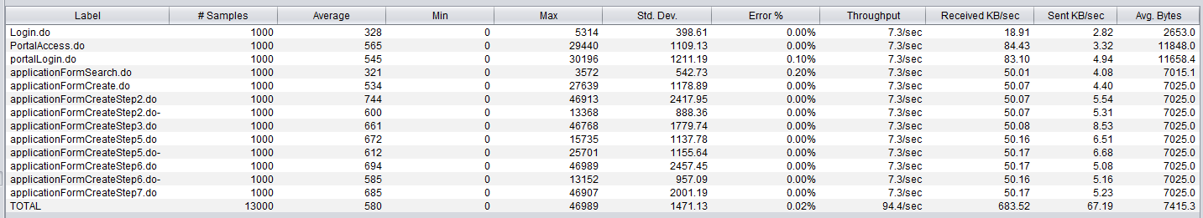

Image 1 : Summary Report for IBAM - Create BSNeBiz Application

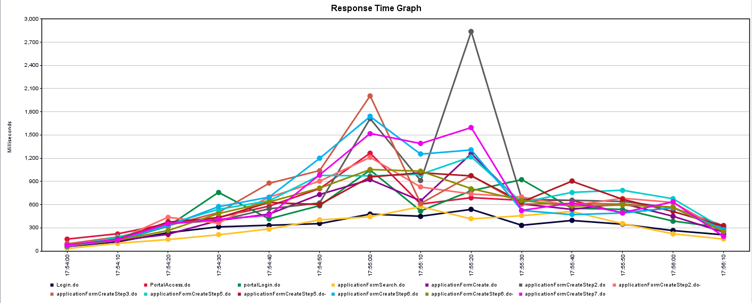

Image 2 : Response Time Graph for IBAM - Create BSNeBiz Application

**IBAM – Authorization**

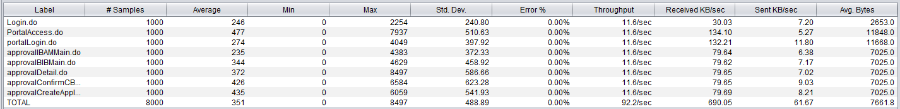

Image 3 : Summary Report for IBAM - Authorization

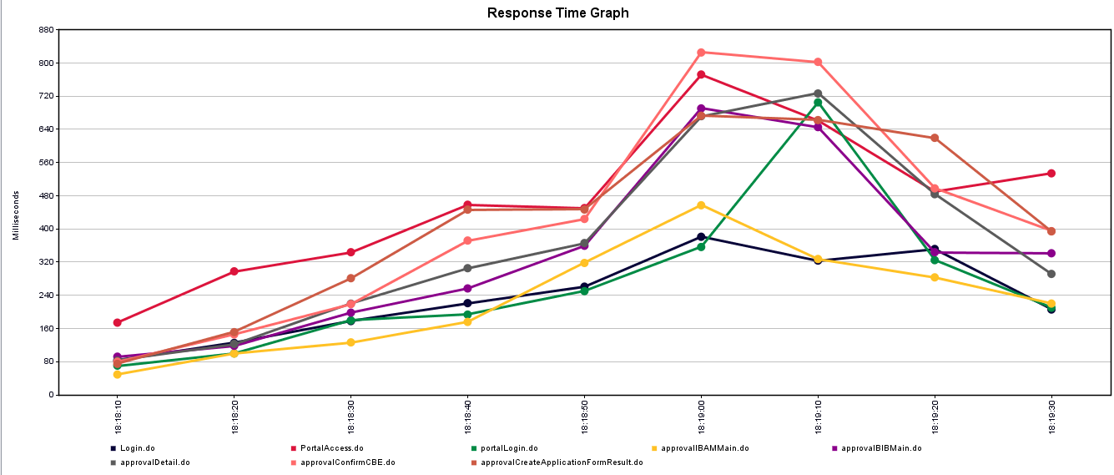

Image 4 : Response Time Graph for IBAM – Authorization

**IBAM – Edit Organization Setup**

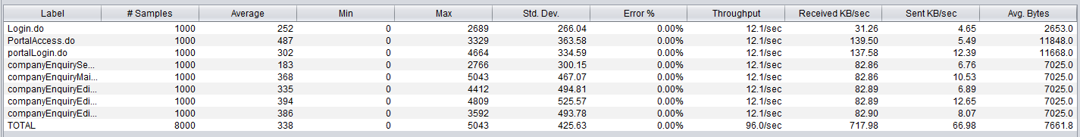

Image 5 : Summary Report for IBAM - Edit Organization Setup

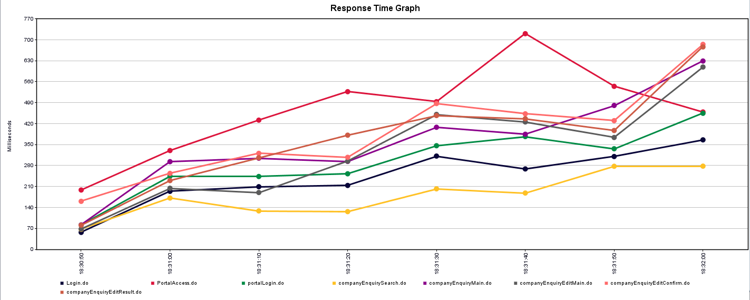

Image 6 : Response Time Graph for IBAM - Edit Organization Setup

**IBAM – View Transaction Enquiry**

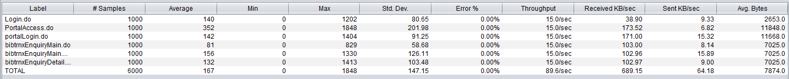

Image 7 : Summary Report for IBAM - View Transaction Enquiry

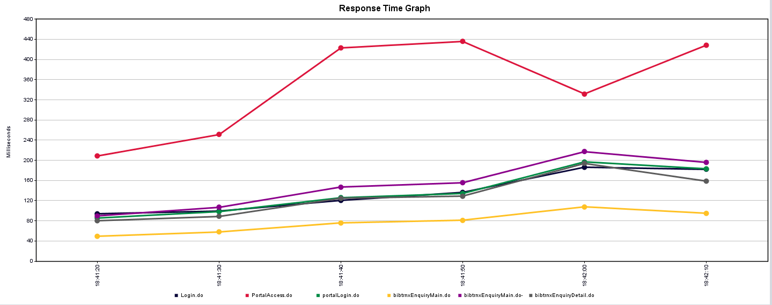

Image 8 : Response Time Graph for IBAM - View Transaction Enquiry

**BSNeBiz – Login**



Image 9 : Summary Result for BSNeBiz - Login

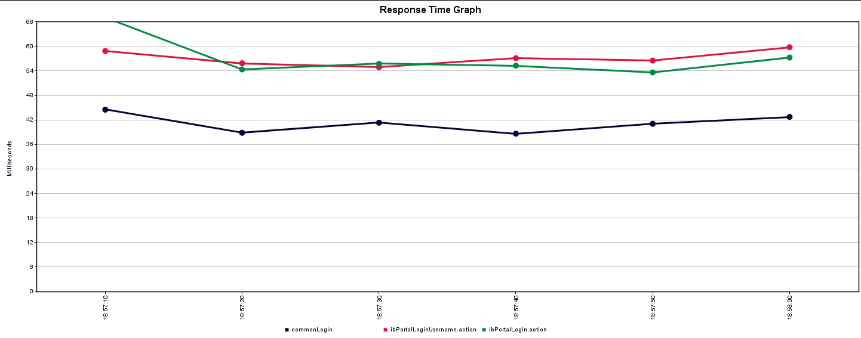

Image 10 : Response Time Graph for BSNeBiz - Login

**BSNeBiz – Transaction**

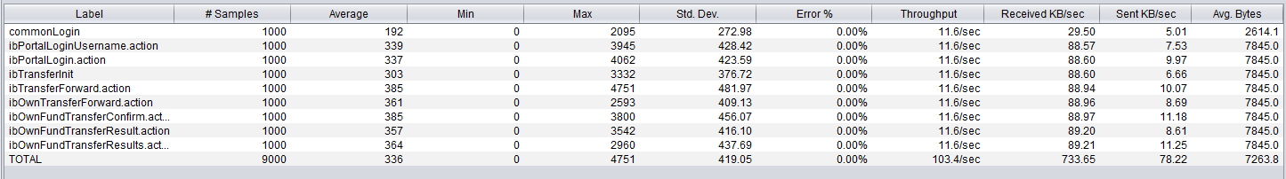

Image 11 : Summary Report for BSNeBiz - Transaction

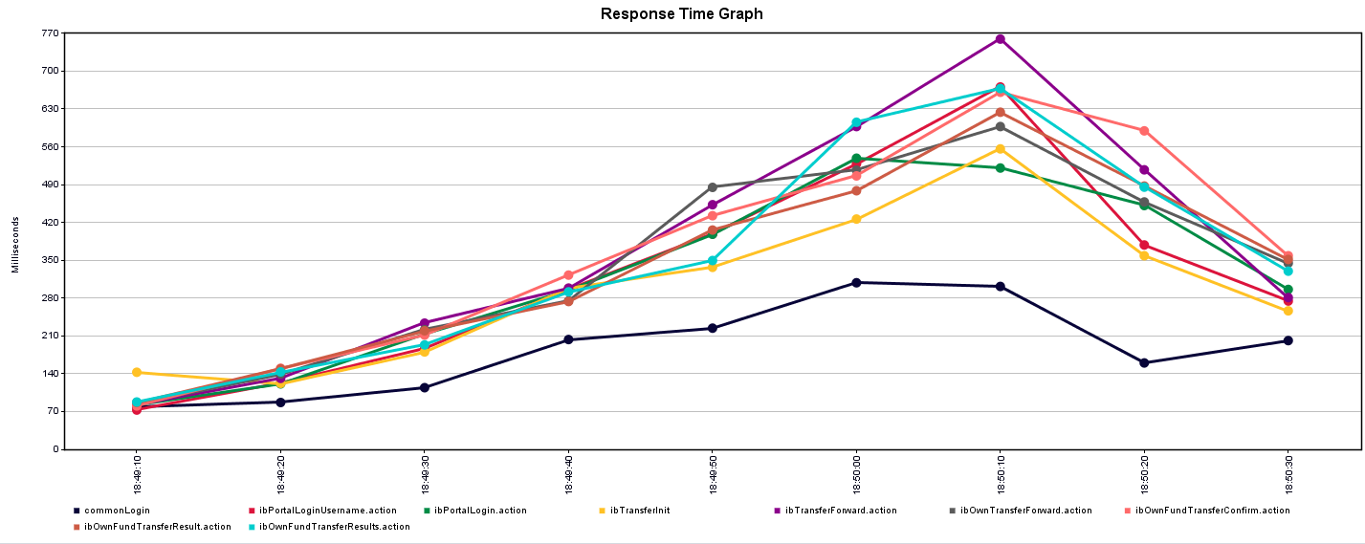

Image 12 : Response Time Graph for BSNeBiz - Transaction

**BSNeBiz – Authorization**

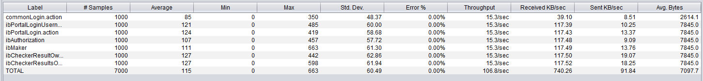

Image 13 : Summary Report for BSNeBiz - Authorization

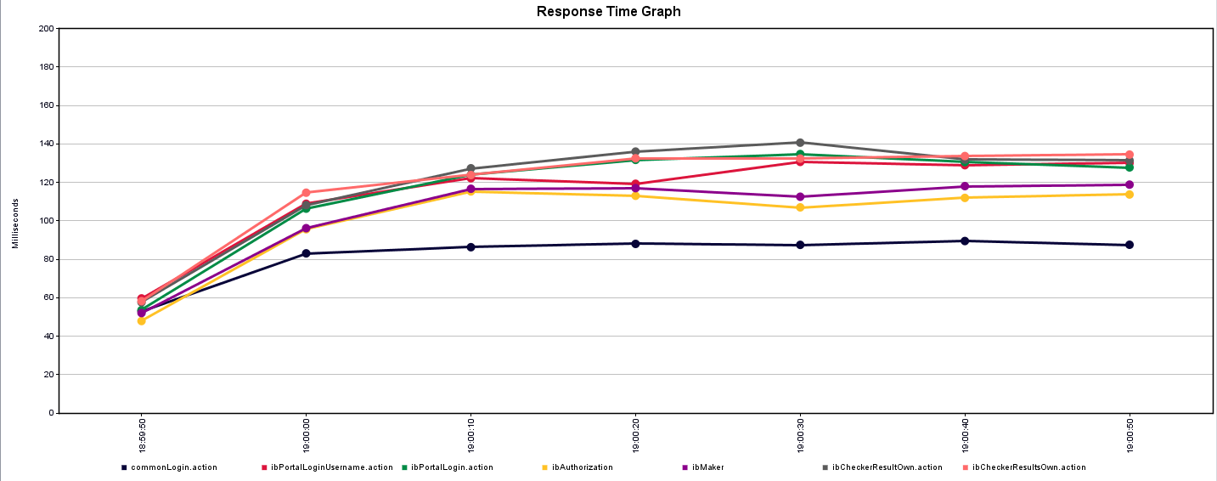

Image 14 : Response Time Graph for BSNeBiz - Authorization

**BSNeBiz Mobile – Login**



Image 15 : Summary Report for BSNeBiz Mobile - Login

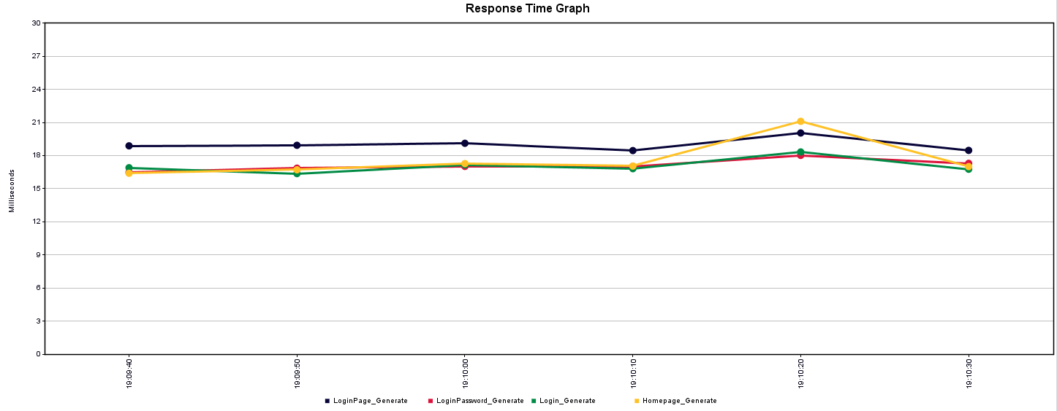

Image 16 : Response Time Graph for BSNeBiz Mobile - Login

**BSNeBiz Mobile – Transaction**

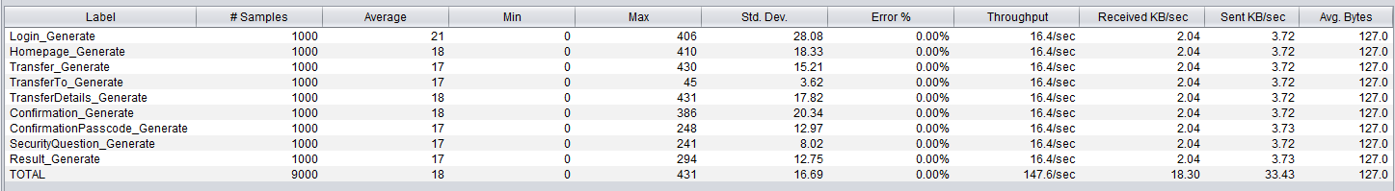

Image 17 : Summary Report for BSNeBiz - Transaction

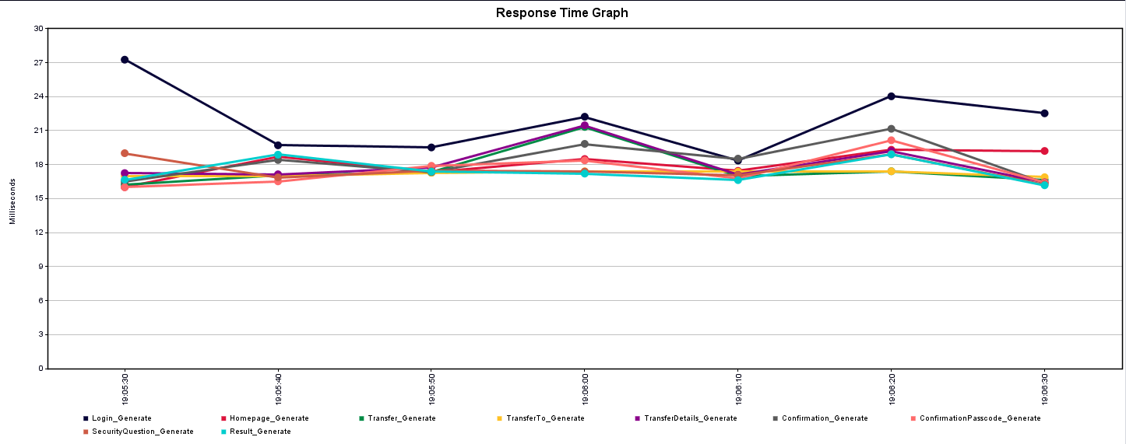

Image 18 : Response Time Graph for BSNeBiz Mobile - Transaction

**BSNeBiz Mobile – Authorization**

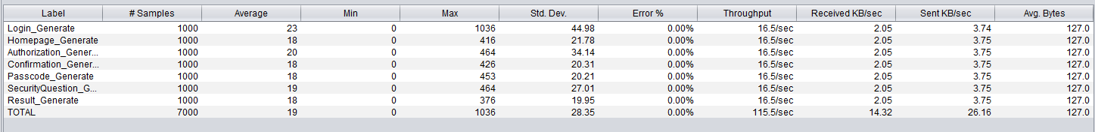

Image 19 : Summary Report for BSNeBiz Mobile - Authorization

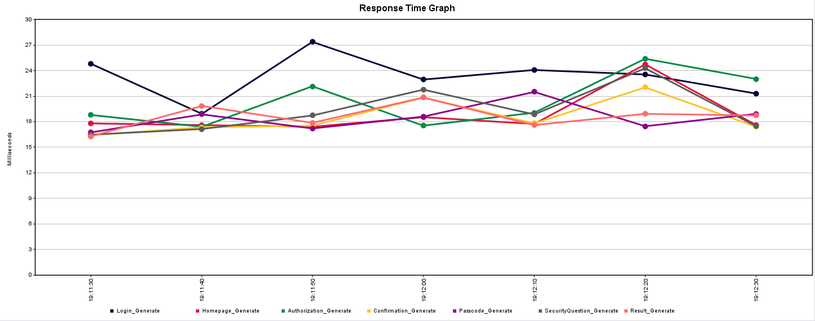

Image 20 : Response Time Graph for BSNeBiz Mobile – Authorization

## Final Conclusion

To conclude, the expected load of 1000 threads for those 9 selected modules able to be sustained by the server. Except for module IBAM - Create BSNeBiz Application, it has the evidence of having 6 errors under 1000 threads test. Even it exists such cases, the error rate is actually still considered within acceptable range as it has error of less than 1 %.