|  |
| --- |
|  |
| **Corporate Digital Banking**  **BSNeBiz - MFA Process and Cooling Period BRFD_CR24007** |
| Business Requirement and Functional Document |
|  |
| ***(PENRIL/BSN/BRFD_BSNEBIZ(P2)037)***  ***Revision: 00*** |
| **26th June 2024**  Prepared By: **Penril Datability (M) Sdn Bhd (816792-X)**  Suite A-07-07 Plaza Mon’t Kiara  No. 2, Jalan Kiara, Mon’t Kiara  50480 Kuala Lumpur, Malaysia  Tel: (603) 6201 2622Fax: (603) 6201 7622 |

# Document Amendment Log

| **Rev. No** | **Date Update** | **Description of Change** | **Update By**  **<Name, Dept>** | **Review By**  **<Name, dept>** | **Approved By**  **<Name, Dept>** |
| --- | --- | --- | --- | --- | --- |
| 00 | 26/06/2024 | Initial Release | Aziana Jaafar  Quality Engineer | Nurul Athirah  Quality Engineer | Norhaidah Dasuki  Senior Manager |
|  |  |  |  |  |  |

# Table of Content

Document Amendment Log 1

Table of Content 3

Business Requirement & Functional Acceptance 4

**Section A: Introduction** 5

1 Introduction 5

1.1 Objective 5

1.2 Assumptions 6

1.3 Impact Modules 7

2 Secure Verification for Monetary Transaction at BSNeBiz 8

2.1 Hardware Token (Vasco) 8

2.1.1 Process Flow 8

2.1.2 Screen Flow 9

2.2 Mobile Token 11

2.2.1 Screen Flow 11

2.2.2 Process Flow 15

**Section B: BSNeBiz - MFA Process and Cooling Period** 15

3 SOW01.0: Cooling Period 15

3.1.1 SOW01.1 BSNeBiz Login for Single User, Approver and CA 16

3.1.2 SOW01.2 IBAM - Approver 19

3.2 SOW02.0 Remove CA for Non-Workflow Company 25

3.2.1 Process Flow 25

3.2.2 Screen Flow 25

# Business Requirement & Functional Acceptance

I/We hereby verify that this Business Requirement & Functional consist of all the requirements requested by BANK SIMPANAN NASIONAL. The implemented system will fulfill ONLY this requirement.

I/We also hereby AGREE that this satisfies our entire requirement for **MFA Process and Cooling Period** Any future changes to this agreed scope would be treated as an enhancement to the system. Any future changes to the project timeline will be subjected to the final approval of the project steering committee.

**BANK SIMPANAN NASIONAL:**

|  |  |  |  |
| --- | --- | --- | --- |
| **Approved by** | **Role** | **Signature** | **Date** |
|  |  |  |  |
|  |  |  |  |
|  |  |  |  |
|  |  |  |  |
|  |  |  |  |
|  |  |  |  |
|  |  |  |  |

**Penril Datability (M) Sdn. Bhd.:**

|  |  |  |  |
| --- | --- | --- | --- |
| **Approved by** | **Role** | **Signature** | **Date** |
| Norhaidah Bt Md Dasuki | Senior Manager, Profesional Service |  |  |
|  |  |  |  |
|  |  |  |  |

**Section A: Introduction**

# Introduction

This document served as the business requirement and system specification of implementing **BSNeBiz - MFA Process and Cooling Period.**

This document shall explain all the features and functionalities, which is elaborating with screen captures, process flow, descriptions, input fields specifications and error messages. All screen designs provided in this document are samples and only illustration purpose for easy understanding. The screen designs are not final.

## Objective

The objective of this document is to capture user requirements of transactional and administration modules of implementing **BSNeBiz - MFA Process and Cooling Period.** This document will facilitate development and implementation of the mentioned modules of Internet Banking System for BSNeBiz.

The base line features description and screen designs will become a reference blueprint for the development team to develop the transactional and administration module. Hence, it is crucial that all stakeholders need to ensure the correctness and adequacy of the requirements captured in this document.

All stakeholders involved are expected to review and sign off this document before the development starts. By signing off the document, the stakeholder has endorsed the correctness and accuracy and adequacy of the requirements documented in this document.

## Assumptions

**BSNeBiz - MFA Process and Cooling Period**

This module will enhance the MFA Process and Cooling Period.

1. **Cooling Period**

To remove the current web device pairing process, once a customer logs in, the device will be considered paired, and the status will be pending approval (Single User, Approver, and CA). The bank admin (IBAM) needs to approve the device pairing request. Within the cooling-off period, the user will only be able to log in and access the account balance and will not be allowed to proceed with any monetary transactions.

1. **Remove CA for BSNeBiz (Applicable for Non-Workflow)**

* Allowing single user to access CA navigations.
* To update the New Application form

## Impact Modules

To update impact module section



|  |  |  |  |
| --- | --- | --- | --- |
| System | Modules | Features | Description |
| BSNeBiz | Cooling Period | Field |  |
| Remove CA | Field |  |
|  |  |  |
|  |  |  |  |
|  |  |  |  |

Table 1: BSNeBiz - MFA Process and Cooling Period.

# Secure Verification for Monetary Transaction at BSNeBiz

PIN is required as the second level security authentication for BSNeBiz Role’s Single User and Approver when perform any monetary transactions via online. PIN is a six random digits temporary security code, which is generated and verified by the authentication server.

**There are two types of Secure Verification assign to the user by Corporate Admin:**

1. Hardware Token (Vasco)
2. Mobile Token

## Hardware Token (Vasco)

Hardware token from VASCO is physical device that will be used by Single User and Approver to authorize a monetary transaction using the “Transaction Singing” function; also known as Challenge Response (CR).

### Process Flow



Diagram 1: Hardware Token Flow Diagram

### Screen Flow

***Step 1:***

1. When user in Transaction Confirmation page, BSNeBiz system will required Challenge Response code to proceed the transaction
2. User needs to use Hardware Token to generate the Challenge Response code.

Figure 1: Hardware Token

***Step 2:***

1. Users press OK button for 2 seconds to turn on the Token.
2. User key in the 6 digits login PIN (User Password) and press OK.
3. BSN logo will be displayed on the token screen.

Figure 2: Turn on Token Flow

***Step 3:***

1. User press button 2 to change to Challenge Response program.
2. User key in the last 8 digits of recipient account number for Challenge Response.
3. Press OK and Challenge Response code will be displayed.

Figure 3: Get Challenge Response Code Flow

***Step 4:***

1. User use generated Challenge Response from the Token and input to the Challenge Response field in BSNeBiz – Transaction Confirmation pages.

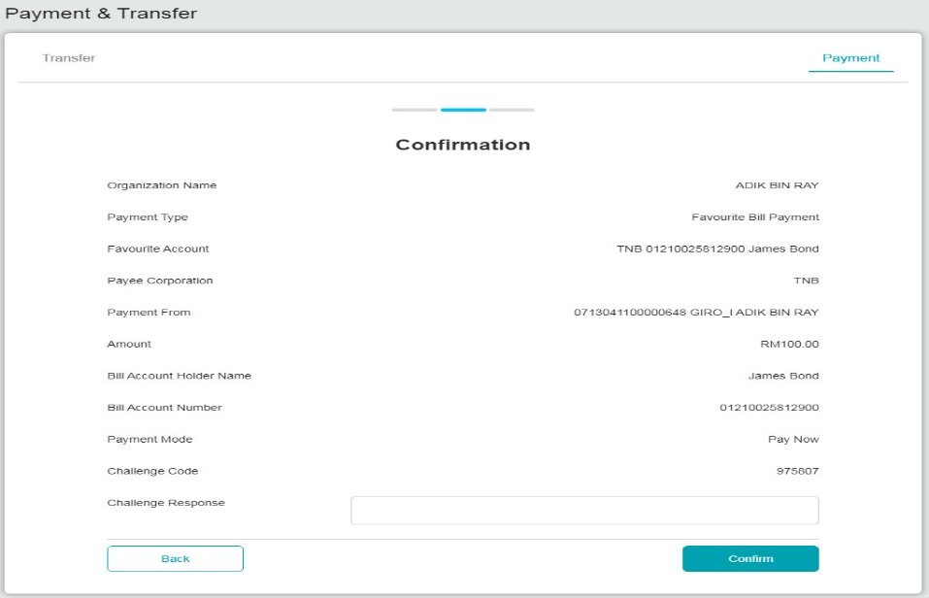

Figure 4: Confirmation page for Hardware Token verification

## Mobile Token

Mobile Token is a mobile application that has the same functionalities as the VASCO Hardware Token using mobile phone features and serves the same usage purpose.

### Screen Flow

***Step 1:***

1. When user in Transaction Confirmation page with QR code.
2. User needs to use Mobile Apps to scan the QR code to generate the Challenge Response code.

Figure 5: Mobile Apps screen

***Step 2:***

1. User Login to the Mobile apps and Click on Challenge Respond icon.
2. User scans the QR code generated at IBS confirmation screen.

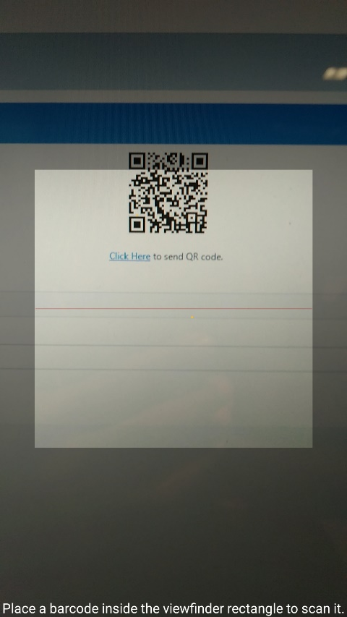

Figure 6: Mobile Apps QR Scan screen

***Step 3:***

1. BSN Application generate and display the Challenge Response code to be used.

Figure 7: Challenge Response Code display Screen

***Step 4:***

1. User use generated Challenge Response from the Mobile Token App and input to the Challenge Response field in BSNeBiz – Transaction Confirmation pages.

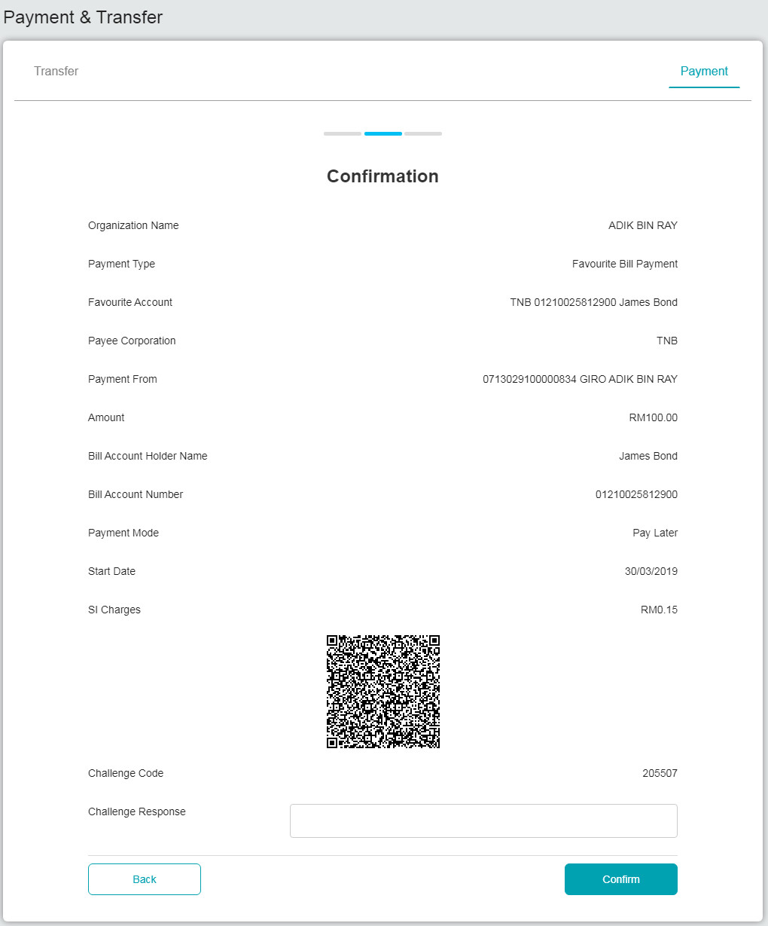

Figure 8: Confirmation page for Mobile Token verification

### Process Flow



Diagram 2: Mobile Token Flow Diagram

**Section B:** **BSNeBiz - MFA Process and Cooling Period**

# 3 SOW01.0: Cooling Period

| Function ID | SOW01.0 | | |
| --- | --- | --- | --- |
| Module Name | Cooling Period | Path | BSNeBiz > 1st Time Login |
| Description | This function removes the current web device pairing process.  The enhancement on First Time Login user: -   1. Remove Device Pairing | | |



### SOW01.1 BSNeBiz Login for Single User, Approver and CA

#### Process Flow



Diagram 3: User Login

#### Screen Flow

***Step 1:***

1. Users click Login from screen of BSNeBiz system.
2. User insert username and password

Figure 9: Login

Figure 10: Login

**Action:**

| **No** | **Action** | **Type** | **Description** |
| --- | --- | --- | --- |
|  | Login | Button | This action will direct user to homescreen page |
|  | Cancel | Button | This action will cancel the process |

Table 2: Login

***Step 2:***

1. Display BSNeBiz Home screen
2. User will not allow to proceed to do monetary transaction.
3. Bank Admin (IBAM) need to approve the request.

Figure 11: BSNeBiz Home screen

**Action:**

**Action:**

| **No** | **Action** | **Type** | **Description** |
| --- | --- | --- | --- |
|  | Account Summary | Navigation pane | Contain the action to view the account balance |

Table 3: BSNeBiz Homescreen

### SOW01.2 IBAM - Approver

#### Process Flow



#### Screen Flow

***Step 1:***

1. Admin access to Approval by clicking on the “Authorization” menu at the left navigation followed by clicking the “Approval” navigation.

Figure 12: IBAM Home Screen

**Action:**

|  |  |  |  |
| --- | --- | --- | --- |
| No | Action | Type | Description |
|  |  | Button | Contains an action to the NAD Maintenance - Listing screen |
|  | Confirm | Button | Contains an action to NAD Maintenance - Result screen |

Table 4: NAD Maintenance – Deactivate Confirmation Action

**List of available messages for the screen:**

| **No.** | **Event** | **Error Description in English** |
| --- | --- | --- |
|  | Did not fill in the challenge response code | Challenge Response is required. |
|  | Fill in alphanumeric challenge response code | Challenge Response must be numeric. |
|  | Fill in less than 6 digits of challenge response code | OTP is invalid. |
|  | Fill in invalid 6 digits of challenge response code | Transaction Signing is invalid. |

Table 5: NAD Maintenance – Deactivate Confirmation Available Error Message

Step 2:

1. Administrators click the eye icon to review the device pairing transaction.

Figure 13: IBAM – CBE Authorization

Display Fields:

| **No** | **Field** | **Format** | **Description** |
| --- | --- | --- | --- |
|  | Tracking ID | Numeric | To display tracking ID. |
|  | Description | Text | To display the description of each transaction. |
|  | Creation Date | DD/MM/YYYY  HH:MM:SS | To display the creation date. |

Table 6: Authorization – Approval ListDisplay Fields (Step 3)

**Action:**

|  |  |  |  |
| --- | --- | --- | --- |
| **No** | **Action** | **Type** | **Description** |
|  | Eye | Icon | Contains an action to display approval details screen. |

Table 7: Authorization –Approval List of Action (Step 2)

Figure 14: IBAM Home Screen

Display Fields:

| **No** | **Field** | **Format** | **Description** |
| --- | --- | --- | --- |
|  | Tracking ID | Numeric | To display tracking ID. |
|  | Description | Text | To display the description of each transaction. |
|  | Creation Date | DD/MM/YYYY  HH:MM:SS | To display the creation date. |

Table 8: Authorization – Approval Details Display Fields

**Input Specification:**

| **No** | **Field** | **Field Type** | **Rule** | **Description** | **Required** |
| --- | --- | --- | --- | --- | --- |
|  | Action | Radio Button | Must select one radio button | The Action ID | Yes |
|  | Reason | Text | Alphanumeric  Max length: 255 | The reason for each approval or reject action | No |

Table 9: Authorization –Approval Details Input Specification

**Action:**

|  |  |  |  |
| --- | --- | --- | --- |
| **No** | **Action** | **Type** | **Description** |
|  | Next | Button | Contains an action to Approval Details Confirm screen. |
|  | Back | Button | Contains an action to Approval Advance Search screen. |

Table 10: Authorization –Approval Details List of Action

**List of available messages for the screen:**

|  |  |  |
| --- | --- | --- |
| **No.** | **Event** | **Error Description in English** |
|  | Action is not selected | Please select an action to proceed |

Table 11: Login Error message list

Step 3:

1. Admin selects either to approve or reject the device pairing transaction.
2. Admin clicks "Next" to navigate to the confirmation page.
3. Admin clicks "Confirm." To proceed the transaction.

Figure 15: IBAM - Device Pairing

Display Fields:

| **No** | **Field** | **Format** | **Description** |
| --- | --- | --- | --- |
|  | Tracking ID | Numeric | To display tracking ID. |
|  | Description | Text | To display the description of each transaction. |
|  | Creation Date | DD/MM/YYYY  HH:MM:SS | To display the creation date. |

Table 12: Authorization – Approval Details Display Fields

**Input Specification:**

| **No** | **Field** | **Field Type** | **Rule** | **Description** | **Required** |
| --- | --- | --- | --- | --- | --- |
|  | Action | Radio Button | Must select one radio button | The Action ID | Yes |
|  | Reason | Text | Alphanumeric  Max length: 255 | The reason for each approval or reject action | No |

Table 13: Authorization –Approval Details Input Specification

**Action:**

|  |  |  |  |
| --- | --- | --- | --- |
| **No** | **Action** | **Type** | **Description** |
|  | Next | Button | Contains an action to Approval Details Confirm screen. |
|  | Back | Button | Contains an action to Approval Advance Search screen. |

Table 14: Authorization –Approval Details List of Action

**List of available messages for the screen:**

|  |  |  |
| --- | --- | --- |
| **No.** | **Event** | **Error Description in English** |
|  | Action is not selected | Please select an action to proceed |

Table 15: Login Error message list

Figure 16: IBAM - Device Pairing Approval

Display Fields:

| **No** | **Field** | **Format** | **Description** |
| --- | --- | --- | --- |
|  | Tracking ID | Numeric | To display tracking ID. |
|  | Description | Text | To display the description of each transaction. |
|  | Creation Date | DD/MM/YYYY  HH:MM: SS | To display the creation date. |

Table 16: Authorization – Approval Details Display Fields

**Input Specification:**

| **No** | **Field** | **Field Type** | **Rule** | **Description** | **Required** |
| --- | --- | --- | --- | --- | --- |
|  | Action | Radio Button | Must select one radio button | The Action ID | Yes |
|  | Reason | Text | Alphanumeric  Max length: 255 | The reason for each approval or reject action | No |

Table 17: Authorization –Approval Details Input Specification

**Action:**

|  |  |  |  |
| --- | --- | --- | --- |
| **No** | **Action** | **Type** | **Description** |
|  | Confirm | Button | Contains an action to Confirm Details screen. |
|  | Back | Button | Contains an action to Approval Advance Search screen. |

Table 18: Authorization –Approval Details List of Action

**List of available messages for the screen:**

|  |  |  |
| --- | --- | --- |
| **No.** | **Event** | **Error Description in English** |
|  | Action is not selected | Please select an action to proceed |

Table 19: Login Error message list

Figure 17: Result Screen – Device Pairing

**Display Fields:**

| **No** | **Field** | **Format** | **Description** |
| --- | --- | --- | --- |
|  | Status | Text, symbol | To display result status. |
|  | Result Message | Alphanumeric | To display result message. |

Table 20: Authorization – CDB Approval Result Display Field

**Action:**

|  |  |  |  |
| --- | --- | --- | --- |
| **No** | **Action** | **Type** | **Description** |
|  | Back | Button | Contains an action to Approval Advance Search screen |

Table 21: Authorization –Approval Result List of Actions

## SOW02.0 Remove CA for Non-Workflow Company

### Process Flow

### Screen Flow