|  |
| --- |
|  |
| **Corporate Digital Banking**  **BSNeBIZ – New API to OCMS Project Server**  **CR24003** |
| Business Requirement and Functional Document |
|  |
| ***(PENRIL/BSN/BRFD_BSNEBIZ(P2)037)***  ***Revision: 00*** |
| **11th July 2024**  Prepared By: **Penril Datability (M) Sdn Bhd (816792-X)**  Suite A-07-07 Plaza Mon’t Kiara  No. 2, Jalan Kiara, Mon’t Kiara  50480 Kuala Lumpur, Malaysia  Tel: (603) 6201 2622Fax: (603) 6201 7622 |

# Document Amendment Log

| **Rev. No** | **Date Update** | **Description of Change** | **Update By**  **<Name, Dept>** | **Review By**  **<Name, dept>** | **Approved By**  **<Name, Dept>** |
| --- | --- | --- | --- | --- | --- |
| 00 | 14/04/2024 | Initial Release | Aziana Jaafar  Quality Engineer | Nurul Athirah  Quality Engineer | Norhaidah Dasuki  Senior Manager |
| 00 | 01/08/2024 | Initial Release | Amir Hakim Mior  Quality Engineer | Nurul Athirah  Quality Engineer | Norhaidah Dasuki  Senior Manager |

# Table of Content

Document Amendment Log 2

Table of Content 3

Business Requirement & Functional Acceptance 4

**Section A: Introduction** 5

1 Introduction 5

1.1 Objective 5

1.2 Assumptions 6

1.3 Impact Modules 7

**Section B: BSNeBiz – New API to OCMS Project Server** 8

2 SOW01 - Integration with OCMS Project Server 8

2.1 SOW1.1 New Registration via API 8

2.1.1 Flowchart 8

2.2 SOW1.2 First Time Login 9

2.2.1 Flowchart 9

2.2.2 Process Flow 11

2.2.3 Screen Flow 11

2.3 SOW1.3 Login For Forgot Password 20

2.3.1 Flowchart 21

2.3.2 Process Flow 22

2.3.3 Screen Flow 22

2.4 SOW1.4 BSNeBiz Login via API 28

2.4.1 Flowchart 28

3 SOW02 - Enhancement at iBAM 29

3.1 SOW2.1 BSNeBiz Application 29

3.1.1 Process Flow 29

3.1.2 Screen Flow 29

3.2 SOW2.2 BSNeBiz User Activity Log 37

3.2.1 Process Flow 37

3.2.2 Screen Flow 37

**Section D: Appendix** 42

D1: Traceability Matrix 42

D2: Related Item for Development 42

# Business Requirement & Functional Acceptance

I/We hereby verify that this Business Requirement & Functional consist of all the requirements requested by BANK SIMPANAN NASIONAL. The implemented system will fulfill ONLY this requirement.

I/We also hereby AGREE that this satisfies our entire requirement for **BSNeBiz – New API to OCMS Project Server.** Any future changes to this agreed scope would be treated as an enhancement to the system. Any future changes to the project timeline will be subjected to the final approval of the project steering committee.

**BANK SIMPANAN NASIONAL:**

|  |  |  |  |
| --- | --- | --- | --- |
| **Approved by** | **Role** | **Signature** | **Date** |
|  |  |  |  |
|  |  |  |  |
|  |  |  |  |
|  |  |  |  |
|  |  |  |  |
|  |  |  |  |
|  |  |  |  |

**Penril Datability (M) Sdn. Bhd.:**

|  |  |  |  |
| --- | --- | --- | --- |
| **Approved by** | **Role** | **Signature** | **Date** |
| Norhaidah Bt Md Dasuki | Senior Manager, Profesional Service |  |  |
|  |  |  |  |
|  |  |  |  |

**Section A: Introduction**

# Introduction

This document served as the business requirement and system specification of implementing **BSNeBiz - New API to OCMS Project Server.**

This document shall explain all the features and functionalities, which is elaborating with screen captures, process flow, descriptions, input fields specifications and error messages. All screen designs provided in this document are samples and only illustration purpose for easy understanding. The screen designs are not final.

## Objective

The objective of this document is to capture user requirements of transactional and administration modules of implementing **BSNeBiz - New API to OCMS Project Server.** This document will facilitate development and implementation of the mentioned modules of Internet Banking System for BSNeBiz.

The base line features description and screen designs will become a reference blueprint for the development team to develop the transactional and administration module. Hence, it is crucial that all stakeholders need to ensure the correctness and adequacy of the requirements captured in this document.

All stakeholders involved are expected to review and sign off this document before the development starts. By signing off the document, the stakeholder has endorsed the correctness and accuracy and adequacy of the requirements documented in this document.

## Assumptions

**BSNeBiz - New API to OCMS Project Server**

This module will enhance the New Registration with or without CIS.

1. **New Registration with or without CIS**

New Registration with CIS (Customer Information System): Assuming that the OCMS Project Server may need to integrate with an external system for user registration, such as a CRM or customer database.

New Registration without CIS: Assuming that there's an option for users to register directly within the OCMS Project Server without needing integration with an external system.

1. **Authentication**

Username and Passphrase Authentication: Assuming that users may have the option to log in using a combination of a username and passphrase, where the passphrase could be a more secure form of authentication such as a one-time password or a token generated through another system.

Usernames and Password Authentication: Assuming that users can also log in using the username and password.

## Impact Modules

To update impact module section



|  |  |  |  |
| --- | --- | --- | --- |
| System | Modules | Features | Description |
| OCMS | New Registration via API | API | To add an Integration (API) for New Registration |
| First Time Login | Link | To add a link that would link OCMS portal to BSNeBiz portal to perform First Time Login. |
| Login for Forgot Password | Link | To add a link that would link OCMS portal to BSNeBiz portal to perform Forgot Password. |
| BSNeBiz Login Via API | API | To add an Integration (API) for BSNeBiz Login |
| IBAM | BSNeBiz Application | Field | To add OCMS channel in BSNeBiz Application |
| User Activity Log | Field | To add OCMS channel in User Activity Log |

Table 1: BSNeBiz - Impact Module

**Section B:** **BSNeBiz – New API to OCMS Project Server**

# 2 SOW01 - Integration with OCMS Project Server



## SOW1.1 New Registration via API

New registrations in OCMS page and BSNeBiz verified the application.

| Function ID | SOW01.1 | | |
| --- | --- | --- | --- |
| Module Name | New Registration | Path | OCMS > New Registration |
| Description | The function required a person to apply OCMS New Registration via New Application form in BSNeBiz Portal through OCMS. | | |

### Flowchart



Diagram 1: BSNeBiz New Application flowchart

***Step:***

1. The customer clicks on OCMS "New Application," prompting a new application page to appear.
2. Customer fill and submit new application.
3. The customer fills out and submits the new application.
4. BSNeBiz verifies that the new application has been received from OCMS.
5. OCMS user will receive a successful message

## SOW1.2 First Time Login

First time login using BSNeBiz portal.

| Function ID | SOW01.2 | | |
| --- | --- | --- | --- |
| Module Name | First Time Login | Path | OCMS > First Time Login |
| Description | The function allows new users to perform First Time Login (FTL) to activate their account to login to Corporate Digital Banking (CDB) Portal through OCMS. | | |

### Flowchart



Diagram 2: BSNeBiz First Time Login flowchart

***Step:***

1. Customers access the BSNeBiz Portal by clicking on the "First Time Login" link in OCMS.
2. The BSNeBiz Portal link is opened.
3. The BSNeBiz Portal Login Page is displayed.
4. Customers select "First Time Login," prompting the appearance of the first-time login page.
5. Customers enter their credentials, including the temporary password received via email, and set a new password.
6. Customers enter the security phrase.
7. Customers answer the security questions.
8. The first-time login process is completed successfully.

### Process Flow



Diagram 3: New Application Process Flow

### Screen Flow

***Step 1:***

1. Customers access the BSNeBiz Portal by clicking on the "First Time Login" link in OCMS.
2. The BSNeBiz Portal link is opened.
3. The BSNeBiz Portal Login Page is displayed.
4. User accesses to First Time Login Selection from the Login screen of BSNeBiz System.

Figure 1: Login screen of BSNeBiz

***Step 2:***

1. User ticks on “YES, I agree...” to accept the Terms and Conditions and click on the “Continue” button.

Figure 2: FTL - Terms & Condition’s screen

**Action:**

|  |  |  |  |
| --- | --- | --- | --- |
| No | Action | Type | Description |
|  | No, I DO NOT Agree with the Terms and Conditions | Radio Button | Select this option if you do not agree with the Terms and Conditions. |
|  | YES I Agree with the Terms and Conditions | Radio Button | Select this option if you agree with the Terms and Conditions. |
|  | Continue | Button | IF Do Not Agree – Clicking this button exits the system.  IF Agree - System will continue to FTL. |

Table 2: FTL – Terms &Condition - Action

***Step 3:***

1. User clicks on the ‘Corporate Administrator” or “Corporate User” button and proceeds to the next step.

Figure 3: FTL – User Type Selection Screen

**Action:**

| **No** | **Action** | **Type** | **Description** |
| --- | --- | --- | --- |
|  | Corporate Administrator | Button | This action prompts the First Time Login screen together with username and pin for a Corporate Administrator. |
|  | Corporate User | Button | This action prompts the First Time Login screen together with username and password for Single User, Initiator, Viewer or Approver. |

Table 3: FTL –User Type Selection - Action

**First Time Login step as per BAU**

***Step 4:***

1. Enter the Username and Temporary Pin received and click on the “Next” button.
2. CDB System validates the Username and PIN. After successful validation, CDB System will then prompt the screen for Change Password of First Time Login.

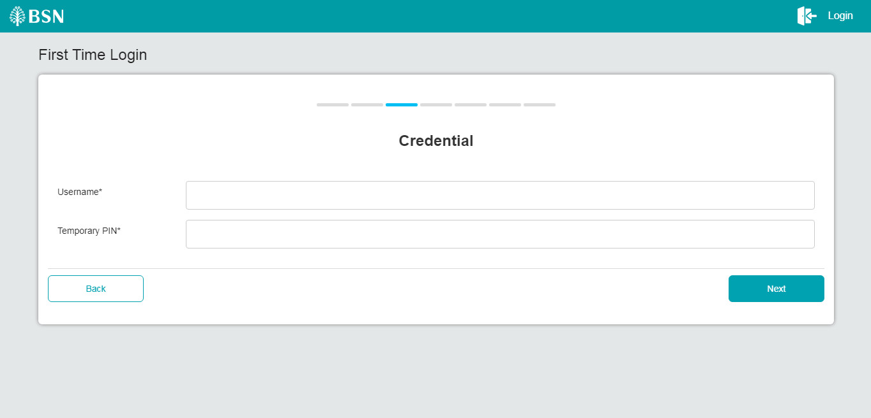

Figure 4: FTL - Credentials for the Corporate Administrator’s screen

**Input Specification:**

| **No** | **Field** | **Field Type** | **Rule** | **Description** | **Required** |
| --- | --- | --- | --- | --- | --- |
| 1. | Username | Text Box | Min Length: 8  Max Length: 16  Alphanumeric | The unique personal identifier for the user. Username is unique in CDB.  Notes:  ADM/ StateCode/ SequenceNo | Yes |
| 2. | PIN | Text Box Masked | Match Length: 6  Numeric | The system generates and sends one-time use unique number to the user via SMS services. This number is used to authenticate the user for First Time Login | Yes |

Table 4: FTL Credential - Input Specification

**Action:**

| **No** | **Action** | **Type** | **Description** |
| --- | --- | --- | --- |
|  | Next | Button | Validates the Username and Password > If correct > Prompts the screen for Reset Password. |
|  | Cancel | Button | Cancels the transaction. |

Table 5: FTL – Credential’s Action

**List of available messages for the screen:**

|  |  |  |
| --- | --- | --- |
| No | Event | Error Description in English |
|  | Username not input | Username is required |
|  | PIN not input | PIN is required |
|  | Invalid username | Invalid username or PIN |
|  | Invalid PIN | Invalid username or PIN |

Table 6: FTL – Credential’s - Error Messages

***Step 5:***

1. CA inputs the New Password, Confirm Password and click on the “Next” button.

Figure 5: FTL – Register Password Screen

**Input Specification:**

| **No** | **Field** | **Field Type** | **Rule** | **Description** | **Required** |
| --- | --- | --- | --- | --- | --- |
| 1. | New Password | Text Box | Min Length: 8  Max Length: 12  Password must consist a mixture of at least 1 Uppercase Alphabet, 1 Lowercase Alphabet, 1 Numeric and 1 Special Character except *[“<>’;&+].> | Inputs the new password to replace the existing password | Yes |
| 2. | Confirm New Password | Text Box | Confirm New Password must be the same input as New Password. | Confirms the new password | Yes |

Table 7: FTL - Register Password - Input Specification

**Action:**

| **No** | **Action** | **Type** | **Description** |
| --- | --- | --- | --- |
|  | Next | Button | Saves the New Password into the database. |
|  | Cancel | Button | Returns the user back to the previous page. |

Table 8: FTL - Register Password - Action

**List of available messages for the screen:**

|  |  |  |
| --- | --- | --- |
| No | Event | Error Description in English |
|  | Password is not inserted. | Password is required |
|  | No Confirm Password input | Confirm Password is required |
|  | Fill in password contains with one of the criteria below:   1. Special characters ["<>'%;&+].> 2. Digits only 3. Alphabets only | Password must contain alphanumeric characters and must not include these special characters [“<>‘%;&+].> |
|  | Invalid Confirm Password | Confirm Password must be the same as the Password. |
|  | Password has been previously used. | For a minimum of **12** cycles, the same password must not be reused. |

Table 9: FTL – Register Password – Error Message

***Step 6:***

1. User inputs a security phrase then click on the “Next” button.

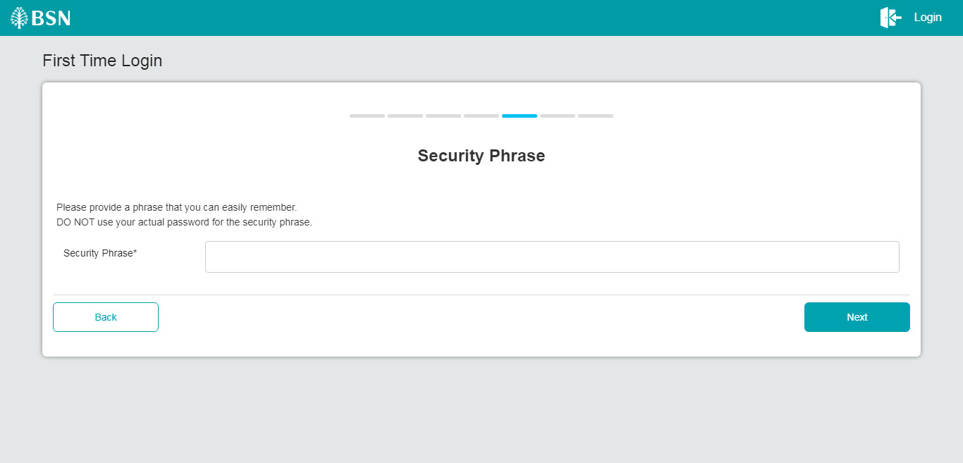

Figure 6: FTL – Security Phrase Screen

**Input Specification:**

| **No** | **Field** | **Field Type** | **Rule** | **Description** | **Required** |
| --- | --- | --- | --- | --- | --- |
| 1. | Security Phrase | Text Box | Max Length: 64  Alphanumeric | Input phrase to enhance security | Yes |

Table 10: FTL - Security Phrase – Input Specification

**Action:**

| **No** | **Action** | **Type** | **Description** |
| --- | --- | --- | --- |
|  | Next | Button | Saves the security image and phrase into the database. |
|  | Back | Back | Returns the user back to the previous page. |

Table 11: FTL – Security Phrase - Action

**List of available messages for the screen:**

|  |  |  |
| --- | --- | --- |
| No | Event | Error Description in English |
|  | Security phrase not inserted | Security Phrase is required. |
|  | Input for Security Phrase is shorter than 8 letters | A minimum of 8 letters is needed for the Security Phrase. |

Table 12: FTL - Security Phrase – Error Message

***Step 7:***

1. User selects security questions and input the answers then clicks on the “Confirm” button.

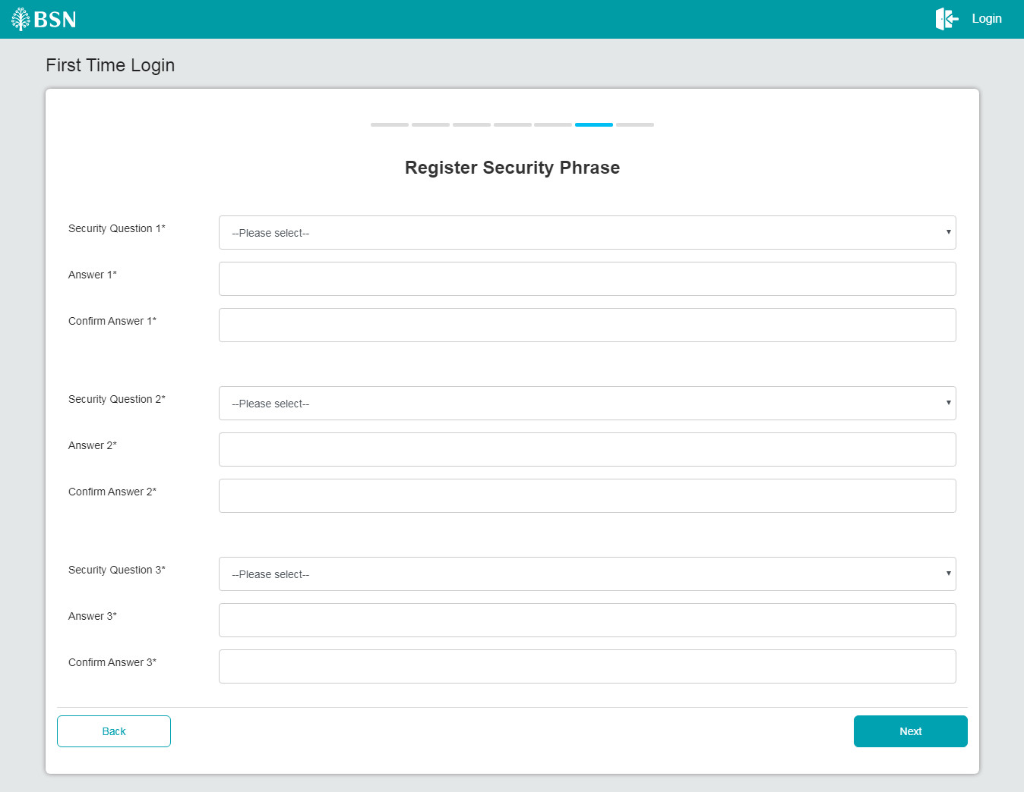

Figure 7: FTL - Security Question Screen

**Action:**

| **No** | **Action** | **Type** | **Description** |
| --- | --- | --- | --- |
|  | Confirm | Button | Saves the Security Questions and Passwords into the database. |
|  | Clear | Button | Clears all fields in the page. |
|  | Back | Button | Brings the user back to the previous page. |

Table 13: FTL – Security Question - Action

**List of available messages for the screen:**

|  |  |  |
| --- | --- | --- |
| No | Event | Error Description in English |
|  | Security Questions are not selected | Please select Security Question |
|  | Answer is not inserted | Answer is required |
|  | Confirm Answer does not match with Answer | Confirm Answer does not match with Answer |

Table 14: FTL - Security Question – Error Message

***Step 8:***

1. CDB System displays the FTL result. User may proceed to Login by clicking on the “Proceed to Login” button.

Figure 8: First Time Login Result Screen

**Display Fields:**

| **No** | **Field** | **Format** | **Description** |
| --- | --- | --- | --- |
| 1. | Status | Text | Notification that shows password was successfully reset. |
| 2. | Status Note | Text | Shows message for FTL status. |

Table 15: First Time Login Result - Display Field

**Action:**

| **No** | **Action** | **Type** | **Description** |
| --- | --- | --- | --- |
|  | Proceed to Login | Button | Brings the user back to the login page. |

Table 16: First Time Login Result - Action

## SOW1.3 Login For Forgot Password

OCMS will be sent in username and password and BSNeBiz will validate the password.

| Function ID | SOW01.3 | | |
| --- | --- | --- | --- |
| Module Name | Forgot Password | Path | OCMS > Forgot Password |
| Description | The function required an authorized person(s) of a company to do Forgot Password on BSN Corporate Digital Banking Portal through OCMS. | | |

### Flowchart



Diagram 4: BSNeBiz Forgot Password flowchart

***Step:***

1. The customer clicks on "Forgot Password" on the OCMS portal.
2. Customer clicks on link and the link redirects to the BSNeBiz Login Page.
3. The customer clicks on "Forgot Password," and the Forgot Password page appears.
4. The customer enters their username and answers the security question.
5. If the security answer is correct, the customer can enter a new password.
6. The password reset is successful.

### Process Flow



Diagram 5: Login For Forgot Password Process Flow

### Screen Flow

***Step 1:***

1. Users access the BSNeBiz Portal by clicking on the "Login for Forgot Password" link in OCMS.
2. The BSNeBiz Portal link is opened.
3. The BSNeBiz Portal Login Page is displayed.
4. User clicks Forgot Password hyperlink.

Figure 9: Login screen

***Step 2:***

1. BSNeBiz prompts the screen for Forgot Password Credential.
2. BSNeBiz User inputs Username and click Next button.

Figure 10: Forgot Password credential screen

***Step 3:***

1. System validates Username and display Security Question screen. The Security Question will be randomly picked from the list registered by User during FTL.
2. User inputs the Security Question answer and clicks on the “Next” button.

Figure 11: Forgot Password Security Question screen

***Step 4:***

1. BSNeBiz displays the screen for Change Password.
2. User inputs New Password and Confirm New Password and clicks on the “Confirm” button.
3. BSNeBiz will call FHP and Predator to perform Risk Analysis process with require information.
4. BSNeBiz perform checking on action code from FHP and Predator analysis response:
   * 1. IF risk analysis response action code **REJECT**, BSNeBiz will throws error message "Error - FMeBIZ001. You are not allowed to perform this action. Please contact BSN Contact Centre at 1300 88 1900 for assistance." and will redirect user to logout page.
     2. IF risk analysis response action code is **OK** and user status is **APPROVE/UNLOCK**, a user is allows to skip the step-up authentication and the BSNeBiz will redirect user to result screen at step 6.
     3. IF risk analysis response action code **STEPUP**, the BSNeBiz will pop up Security question screen for user to answer security question at next step 5.

Figure 12: Change Password screen

**Error messages for the screen:**

|  |  |  |
| --- | --- | --- |
| No | Action Code | Error Description in English |
|  | REJECT | Return error message "Error - FMeBIZ001. You are not allowed to perform this action. Please contact BSN Contact Centre at 1300 88 1900 for assistance." |

Table 17: Fraud Alert - Return Error Message

***Step 3:***

1. Retrieve the Security question from FHP and Predator and display to user.
2. Customer Answer the question and click submit button.
3. BSNeBiz request FHP and Predator to validate the submitted answer.
   1. IF the response return “YES”, indicate the answer is correct, BSNeBiz will redirect customer to step 4.
   2. IF the response return “NO”, indicate the answer is incorrect. BSNeBiz perform checking on FHP and Predator user status:
      1. Unlocked – BSNeBiz request FHP and Predator to return next Security question.
      2. Locked – BSNeBiz throws error message “Error - FMeBIZ002. Access has been locked. Please contact BSN Contact Centre at 1300 88 1900 for assistance.” and will redirect user to logout page.

Figure 13: Security Question screen

**Display Specification:**

| **No** | **Field** | **Field Type** | **Description** |
| --- | --- | --- | --- |
|  | Security Question | Text | Details of security question |

Table 18: Fraud Alert – Security Question Display Specification

**Input Specification:**

| **No** | **Field** | **Field Type** | **Rule** | **Description** | **Required** |
| --- | --- | --- | --- | --- | --- |
|  | Answer | Text Box | Alphanumeric | Input answer for security question | Yes |

Table 19: Fraud Alert – Security Question Input Specification

**Action:**

| **No** | **Action** | **Type** | **Description** |
| --- | --- | --- | --- |
|  | Submit | Button | Contains an action to submit the security question to FHP and Predator to process response. |
|  | Close | Button | Contains an action to close the security question |

Table 20: Fraud Alert - Security Question Action

**List of available messages for the screen:**

|  |  |  |
| --- | --- | --- |
| No | Event | Error Description in English |
|  | Submit empty field | Security Question answer is required |
|  | FHP and Predator return error incorrect answer | Security Question answer is incorrect |
|  | FHP and Predator return user status locked | Error - FMeBIZ002. Access has been locked. Please contact BSN Contact Centre at 1300 88 1900 for assistance |

Table 21: Fraud Alert - Security Question Error Message

***Step 4:***

1. BSNeBiz System saves the New Password to IB Database and display the result screen. User can go back to Login screen by click the “Proceed to Login” button.

Figure 14: Forgot Password result screen

## SOW1.4 BSNeBiz Login via API

| Function ID | SOW01.4 | | |
| --- | --- | --- | --- |
| Module Name | Login | Path | OCMS > Login |
| Description | The function required an authorized person(s) of a company to Login through OCMS. | | |

### Flowchart



Diagram 6: Login via API flowchart

***Step:***

1. Customer enters their BSNeBiz username and submits.
2. BSNeBiz validates the username and returns the security phrase.
3. The OCMS portal displays the security phrase, and the customer enters their BSNeBiz password and OTP, then submits.
4. BSNeBiz validates the password and OTP, and if they are valid, returns the CIS and Business Number.
5. The process proceeds to the OCMS portal.

# 3 SOW02 - Enhancement at iBAM



## SOW2.1 BSNeBiz Application

| Function ID | SOW02.1 | | |
| --- | --- | --- | --- |
| Module Name | BSNeBiz Application | Path | IBAM > CBE > BSNeBiz Application |
| Description | The function required an authorized person(s) of a company to view OCMS BSNeBiz Application though IBAM. | | |

### Process Flow

Diagram 7: BSNeBiz Application (View) Process Flow

### Screen Flow

***Step 1:***

1. CBE Admin accesses IBAM – Corporate Back End module and click on BSNeBiz Application Side Navigation.
2. IBAM system displays the BSNeBiz Application Advance Search Function screen.

Figure 15: BSNeBiz Application – Advanced Search Function Screen

**Input Specification:**

| **No** | **Field** | **Field Type** | **Rule** | **Description** | **Required** |
| --- | --- | --- | --- | --- | --- |
|  | CIS Number | Text Box | Numeric | Search based on CIS Number | No |
|  | Organization Name | Text Box | Alphanumeric | Search based on Organization Name | No |
|  | Business Registration Number | Text Box | Alphanumeric | Search based on Business Registration Number | No |
|  | Application Status | Dropdown | List of Status  Select one only | Search application based on the Application Status.   * New * Pending Approval * Resubmit | No |
|  | Registration Date From | Date Picker | DD/MM/YYYY | Search application based on Registration Date from | No |
|  | Registered Date To | Date Picker | DD/MM/YYYY | Search application based on Registration Date to | No |
| 7. | Channel | Dropdown | List of Channel  Select one only | Search application based on Channel:   * CDB * OTC * OCMS | No |
|  | Application State | Dropdown | List of application state | Search based on Application State.  Application State are not available for Branches | No |

Table 22: BSNeBiz Application – Advanced Search Function Input Specification

**Action:**

| **No** | **Action** | **Field Type** | **Description** |
| --- | --- | --- | --- |
|  | Search | Button | Contains an action to display the search result screen. |
|  | Clear | Button | Contains an action to clear up the entered fields. |

Table 23: BSNeBiz Application – Advanced Search Function Action

***Step 2:***

1. CBE Admin click on Search button to view the list of customer applications or using the Advance Search function based on criteria of CIS No, Organization Name, Business Registration No, Application Status, Registration Date From/To, Channel and/or any combination of filters.
2. IBAM System list out the search result in the table format below the Advance Search function.
3. CBE Admin clicks on “Eye” icon on the view the Application form details.

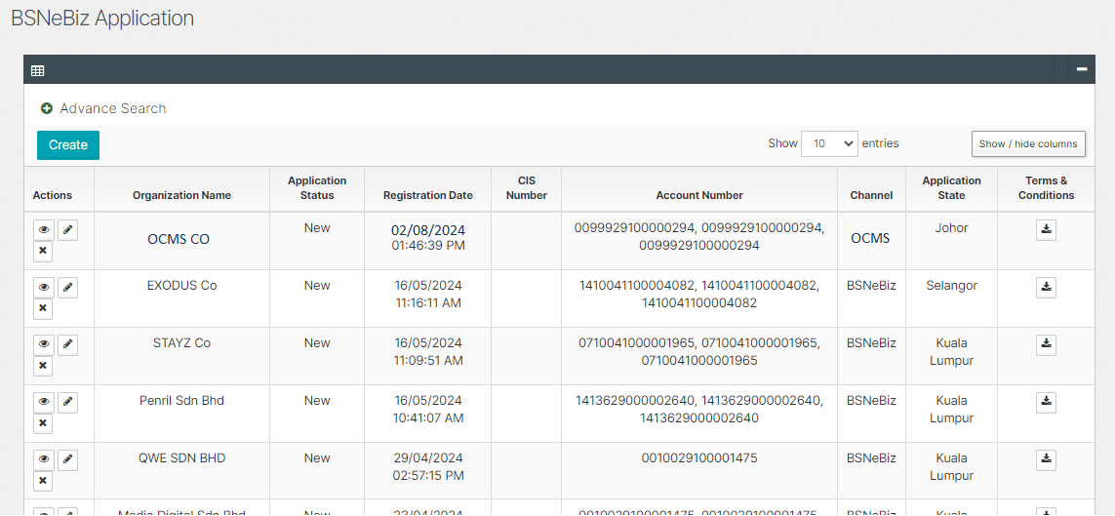

Figure 16: BSNeBiz Application – Search Result Screen

**Display Specification:**

| **No** | **Field** | **Field Type** | **Description** |
| --- | --- | --- | --- |
|  | Organization Name | Text | The name of the organization. |
|  | Application Status | Text | Define the status of the application.  Status: New, Pending Approval, Resubmit |
|  | Registration Date | DD/MM/YYYY HH:MM: SS | Shows the date and time when an application was registered. |
|  | CIS Number | Text | The organization CIS Number |
|  | Account Number | Text | The organization Account Number |
|  | Channel | Text | Show the type of application channel |
|  | Application State | Text | Show the state of the organization |

Table 24: BSNeBiz Application – Search Result Display Field

*Note: Search Result Display column will be show based on the selection of field by user using “Hide and Show” feature.*

**Action:**

| **No** | **Action** | **Field Type** | **Description** |
| --- | --- | --- | --- |
|  | Eye icon | Button | Contains an action to display the details of the company. |
|  | Download icon | Button | Contains an action to download T&C document in PDF file. |
|  | Next/Previous | Button | Contains an action to display the next or previous page. |
|  | Show or Hide column | Button | Contains an action to show or hide any related column to be displayed by default in the Search result List |

Table 25: BSNeBiz Application – Search Result Action

***Step 3:***

1. IBAM system shows the selected Application details.

Figure 17: BSNeBiz Application (Details) Screen

**Display Specification:**

| **No** | **Field** | **Field Type** | **Description** |
| --- | --- | --- | --- |
| **State** | | | |
|  | State | Text | Customer application that segregate by state |
| **Organization Information** | | | |
|  | CIS No | Text | Display the Organization CIS No |
|  | Organization ID | Text | Display the generated Organization ID |
|  | Application ID | Numeric | The organization reference Application ID. |
|  | Application Status | Text | The organization application status. |
|  | Organization Name | Text | The name of the organization |
|  | Business Registration No. | Text | The organization registration No. |
|  | Office Phone Number | Numeric | The organization office No. |
|  | Fax No. | Numeric | The organization fax No. |
|  | Organization Website | Text | The organization website. |
|  | Organization Email | Text | The organization email address. |
|  | Organization Address | Text | The organization address. |
|  | Postcode | Numeric | Display the postcode of the organization city located. |
|  | City | Text | Display the city of the organization located. |
|  | Country | Text | Display the country code of the organization located |
|  | State | Text | Display the state of the organization located |
|  | Require Workflow | Yes/No | Display the workflow set for the organization.  By default = “Yes” |
| **Contact Details – Contact Person** | | | |
|  | Full Name | Text | Organization Contact Person’s 1 name |
|  | ID No. | Numeric | Organization Contact Person’s 1 ID no. |
|  | Mobile Phone No. | Numeric | Organization Contact Person’s 1 Mobile phone no. |
|  | Office Phone No. | Numeric | Organization Contact Person’s 1 Office phone no. |
|  | Email | Text | Organization Contact Person’s 1 email |
| **Contact Details - Administrative Information** | | | |
|  | Full Name | Text | Customer Admin’s name |
|  | ID No. | Numeric | Customer Admin’s ID no. |
|  | Mobile Phone No. | Numeric | Customer Admin’s Mobile phone no. |
|  | Office Phone No. | Numeric | Customer Admin’s Office phone no. |
|  | Email | Text | Customer Admin’s email |
|  | Staff No. | Numeric | Customer Admin’s staff no. |
| **Services** | | | |
|  | Services subscribe | Text | List of BSN Services subscribe by organization:   * 1. Online Payment   2. Bulk Payment   3. Auto Debit   4. Bill Payment   5. EPF |
| **Charges** | | | |
|  | Charges Package | Text | BSN Services charges |
|  | Package Details | Text | BSN Services charges details |

Table 26: BSNeBiz Application (Details) Display Field

**Action:**

| **No** | **Action** | **Field Type** | **Description** |
| --- | --- | --- | --- |
|  | Back | Button | Contains an action to go to the previous page. |

Table 27: BSNeBiz Application (Details) Action

## SOW2.2 BSNeBiz User Activity Log

| Function ID | SOW02.2 | | |
| --- | --- | --- | --- |
| Module Name | User Activity Log | Path | IBAM > CBE > BSNeBiz User Activity Log |
| Description | The function required an authorized person(s) of a company to view OCMS BSNeBiz User Activity Log though IBAM. | | |

### Process Flow



Diagram 8: BSNeBiz User Activity Log Process Flow

### Screen Flow

***Step 1:***

1. CBE Admin accesses IBAM – Corporate Back End module and click on BSNeBiz User Activity Log Side Navigation.
2. IBAM system displays the BSNeBiz User Activity Log Advance Search Function screen.

Figure 18: BSNeBiz User Activity Log – Advanced Search Function Screen

**Input Specification:**

| **No** | **Field** | **Field Type** | **Rule** | **Description** | **Required** |
| --- | --- | --- | --- | --- | --- |
|  | User Name | Text Box | Alphanumeric | Search based on User Names | No |
|  | Channel | Dropdown | List of Channel  Select one only | Search Activity based on Channel:   * Mobile * OTC * Web | No |
|  | Date From | Date Picker | DD/MM/YYYY | Search application based on Activity Date from | No |
|  | Date To | Date Picker | DD/MM/YYYY | Search application based on Activity Date to | No |
|  | Activity ID | Text Box | Alpha, numeric, or alphanumeric | Search log based on activity ID | No |
|  | Activity Name | Drop Down | Alpha, numeric, or alphanumeric | Search log based on activity type | No |
|  | Org Code | Text Box | Alpha, numeric, or alphanumeric | Search log based on Org Code | No |

Table 28: BSNeBiz User Activity Log – Advanced Search Function Input Specification

**Action:**

| **No** | **Action** | **Field Type** | **Description** |
| --- | --- | --- | --- |
|  | Search | Button | Contains an action to display the search result screen. |
|  | Clear | Button | Contains an action to clear up the entered fields. |

Table 29: BSNeBiz User Activity Log – Advanced Search Function Action

***Step 2:***

1. CBE Admin click on Search button to view the list of customer applications or using the Advance Search function based on criteria of User Name, Channel, Date From, Date To, Activity ID, Activity Name, Org Code and/or any combination of filters.
2. IBAM System list out the search result in the table format below the Advance Search function.
3. CBE Admin clicks on “Eye” icon on the view the User Activity Log form details.

Figure 19: BSNeBiz User Activity Log – Search Result Screen

**Display Specification:**

| **No** | **Field** | **Field Type** | **Description** |
| --- | --- | --- | --- |
|  | Activity ID | Text | The organization Account Number |
|  | User Name | Text | The user’s username. |
|  | Activity Date | DD/MM/YYYY HH:MM: SS | Shows the date and time when an activity was done. |
|  | Activity Type | Text | Shows the type of activity done. |
|  | Channel | Text | Shows the channel that the activity was done |
|  | Status | Text | Show the status of the action. |

Table 30: BSNeBiz User Activity Log – Search Result Display Field

*Note: Search Result Display column will be show based on the selection of field by user using “Hide and Show” feature.*

**Action:**

| **No** | **Action** | **Field Type** | **Description** |
| --- | --- | --- | --- |
|  | Eye icon | Button | Contains an action to display the details of the action. |
|  | Download icon | Button | Contains an action to download T&C document in PDF file. |
|  | Next/Previous | Button | Contains an action to display the next or previous page. |
|  | Show or Hide column | Button | Contains an action to show or hide any related column to be displayed by default in the Search result List |

Table 31: BSNeBiz User Activity Log – Search Result Action

***Step 3:***

1. IBAM system shows the selected User Activity Log details.

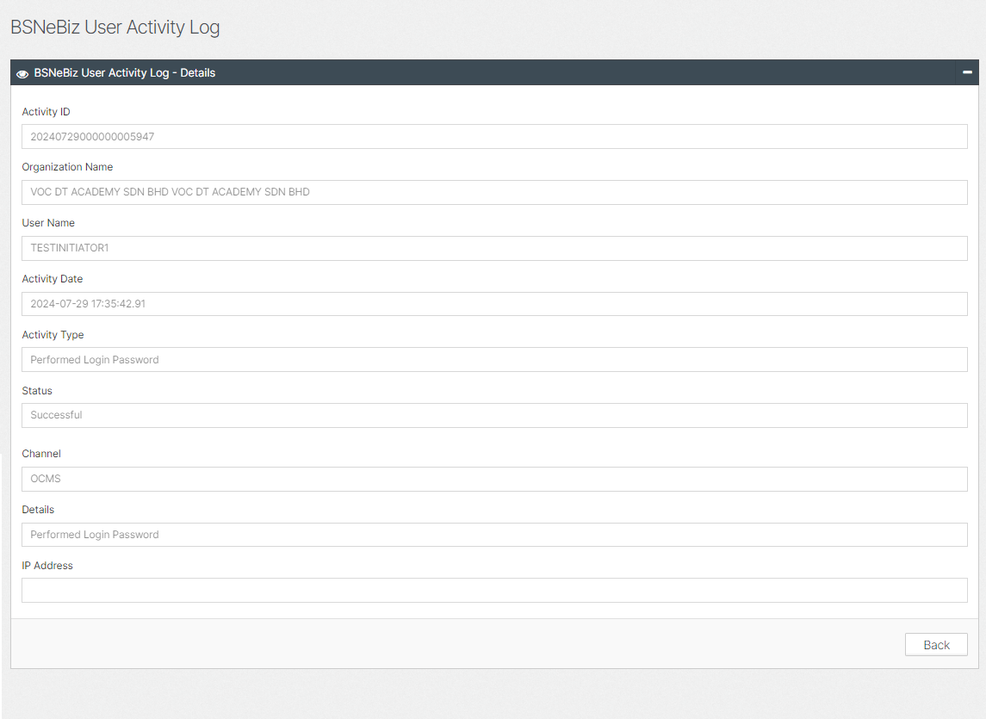

Figure 20: BSNeBiz User Activity Log (Details) Screen

**Display Specification:**

| **No** | **Field** | **Field Type** | **Description** |
| --- | --- | --- | --- |
|  | Activity ID | Numeric | The organization reference Activity ID. |
|  | Organization Name | Text | The name of the organization |
|  | User Name | Text | Display the username of the selected audit trail. |
|  | Activity Date | Date (DD/MM/YY)  Time (HH:MM:SS) | Display the action date of the selected User Activity Log. |
|  | Activity Type | Text | Shows the type of activity done |
|  | Status | Text | Show the status of the action. |
|  | Channel | Text | Shows the channel that the activity was done |
|  | Details | Test | Shows the details of the action done. |
|  | Fax No. | Numeric | The organization fax No. |
|  | Organization Website | Text | The organization website. |
|  | IP Address | Text | The IP address for the activity log. |

Table 32: BSNeBiz User Activity Log (Details) Display Field

**Action:**

| **No** | **Action** | **Field Type** | **Description** |
| --- | --- | --- | --- |
|  | Back | Button | Contains an action to go to the previous page. |

Table 33: BSNeBiz User Activity Log (Details) Action

**Section D: Appendix**

# D1: Traceability Matrix

**Version Control**

|  |  |  |  |
| --- | --- | --- | --- |
| No | **BRFD Version** | **CR Version** | **CR Date** |
| 1 | ver.00 | CR-24003 | 22/03/2024 |

**CR vs BRFD**

|  |  |  |
| --- | --- | --- |
| No | **CR SOW ID** | **BRFD ID** |
|  | SOW01 (I) | 2.1 |
|  | SOW01 (II) | 2.2 |
|  | SOW01 (III) | 2.3 |
|  | SOW01(IV) | 2.4 |
|  | SOW02 (I) | 3.1 |
|  | SOW02 (II) | 3.2 |

# D2: Related Item for Development

|  |  |
| --- | --- |
| **CR SOW ID** | **Item** |
| SOW02 | Add new table at DB   1. New Application channel    * OCMS 2. User Activity Log channel    * OCMS |