CAS showing active

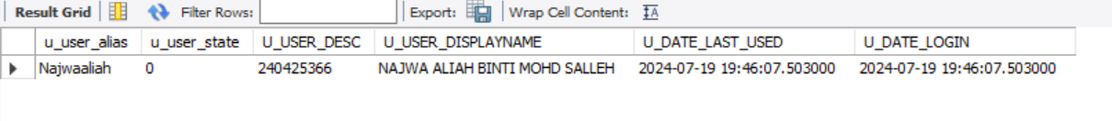

Login History

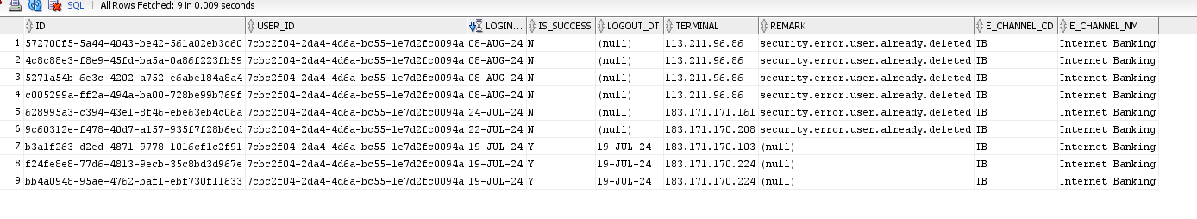

Customer Profile

