SCPID#7105
Test Title: |  | IBAM - CDB User deletion
Test Description: |  | IBAM > CBE > Org Setup > User Maintenance  Finding: Delete User Confirm page display Allow Services list get from setting frontend values.  Solution: Update Delete User Confirm page display Allow Services list based on user details page.
Test Functionality: |  | To ensure allow services lists are based on user details when delete BSNeBiz user in IBAM
Test Procedure: |  | Test steps: (Admin and Maker Checker)  - Access IBAM > CBE > Org Setup > User Maintenance > Delete (X icon)  - Select delete icon. View Delete confirm page and ensure display as Details page (eye icon)  - Successfully deleted user.  p/s: Verifier and Approver cannot be deleted if there are Pending Verify and Pending Approval transaction list.
Response Message:
Test Result: | Pass: Fail: |  | Tested by: | Nor Athirah Umairah (20/08/2024)
Reason for Failure:
Remarks: |  | Admin  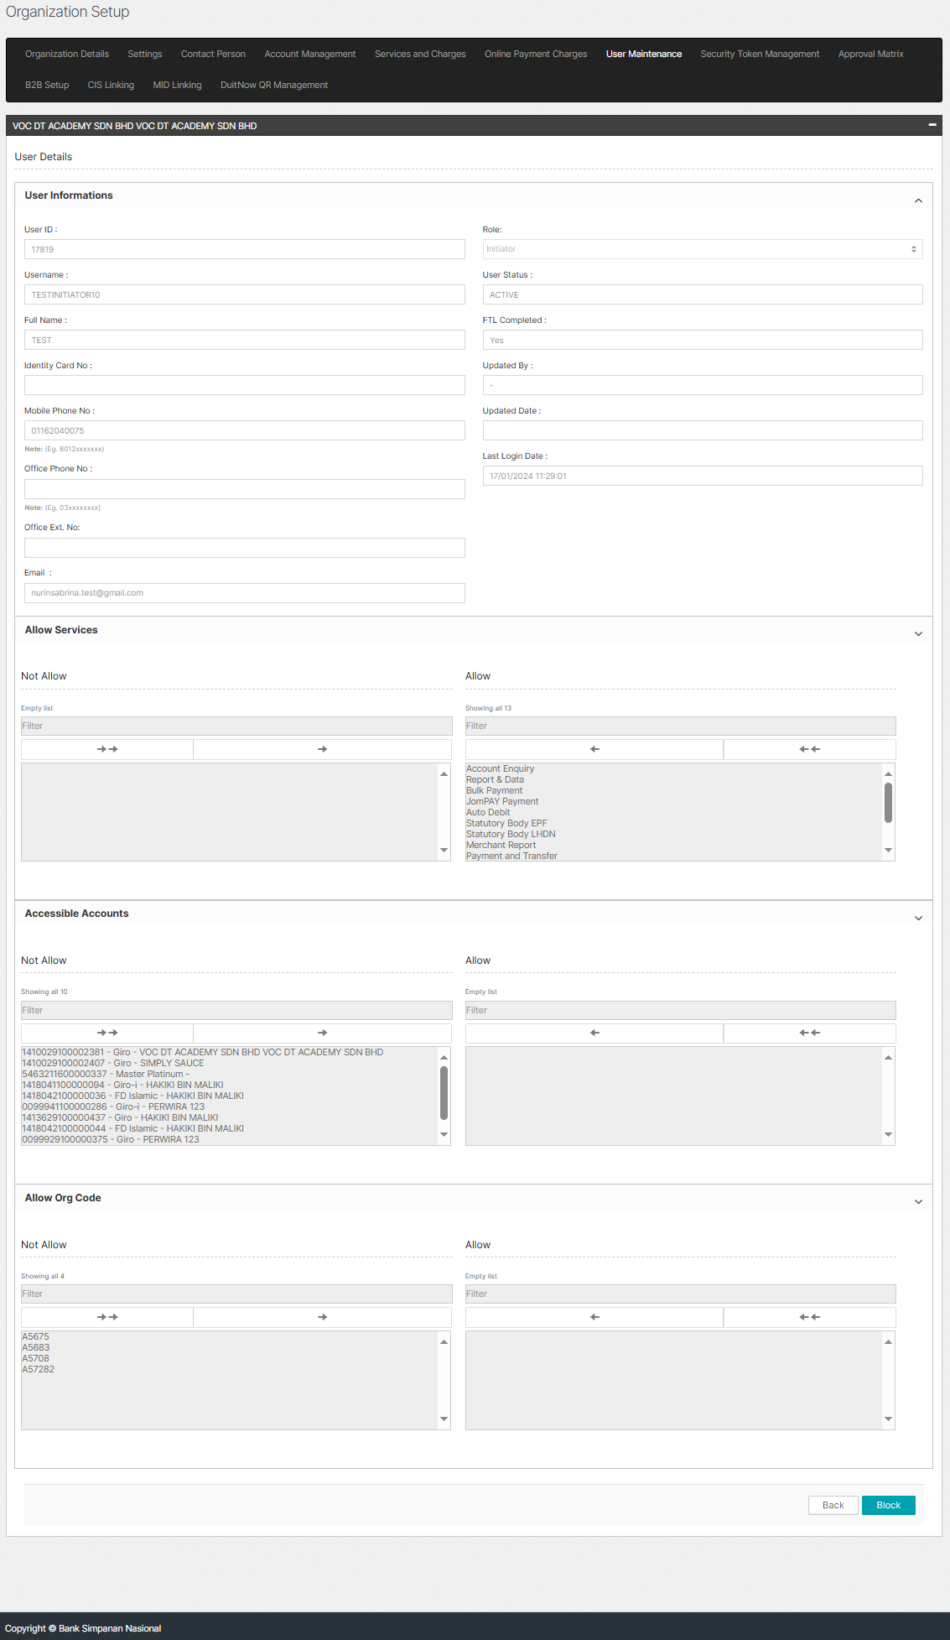  Figure 1: Organization Setup > User Maintenance > View  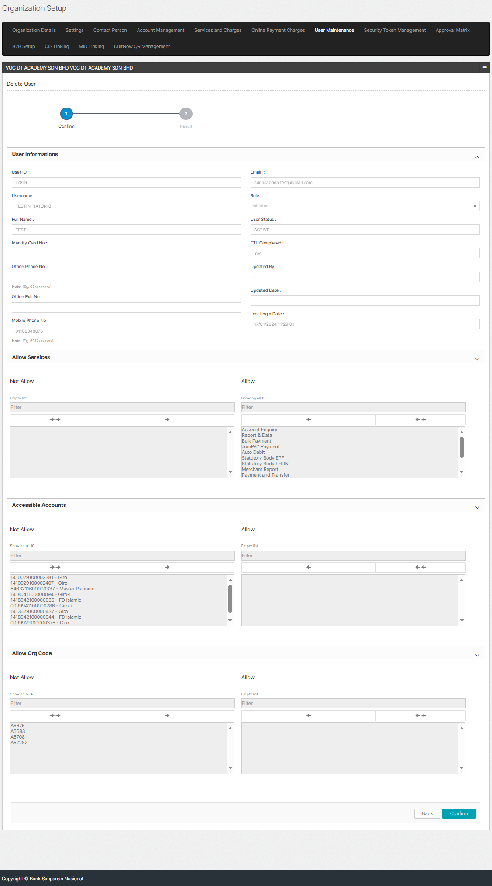  Figure 2: Organization Setup > User Maintenance > Delete (Confirm)  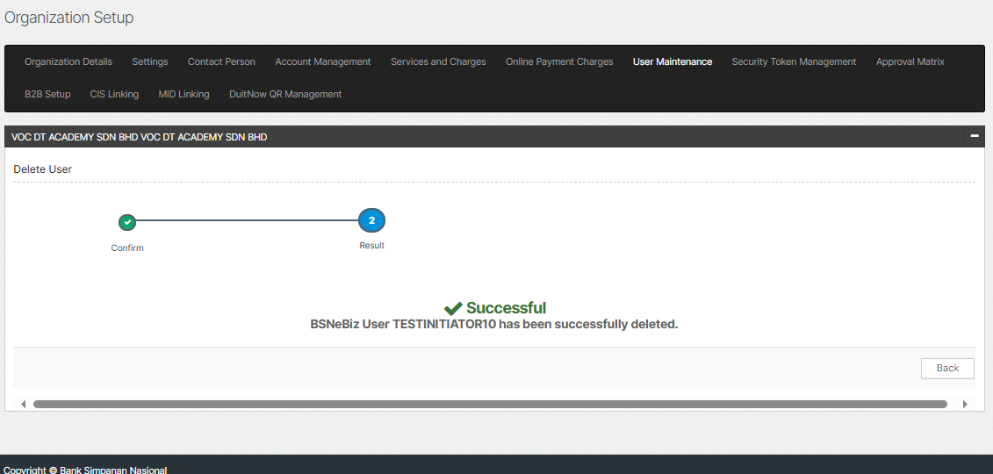  Figure 3: Organization Setup > User Maintenance > Delete (Result)  Maker Checker  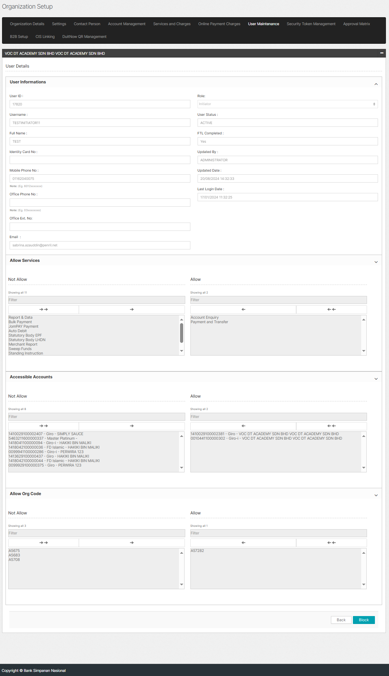  Figure 4: Organization Setup > User Maintenance > View  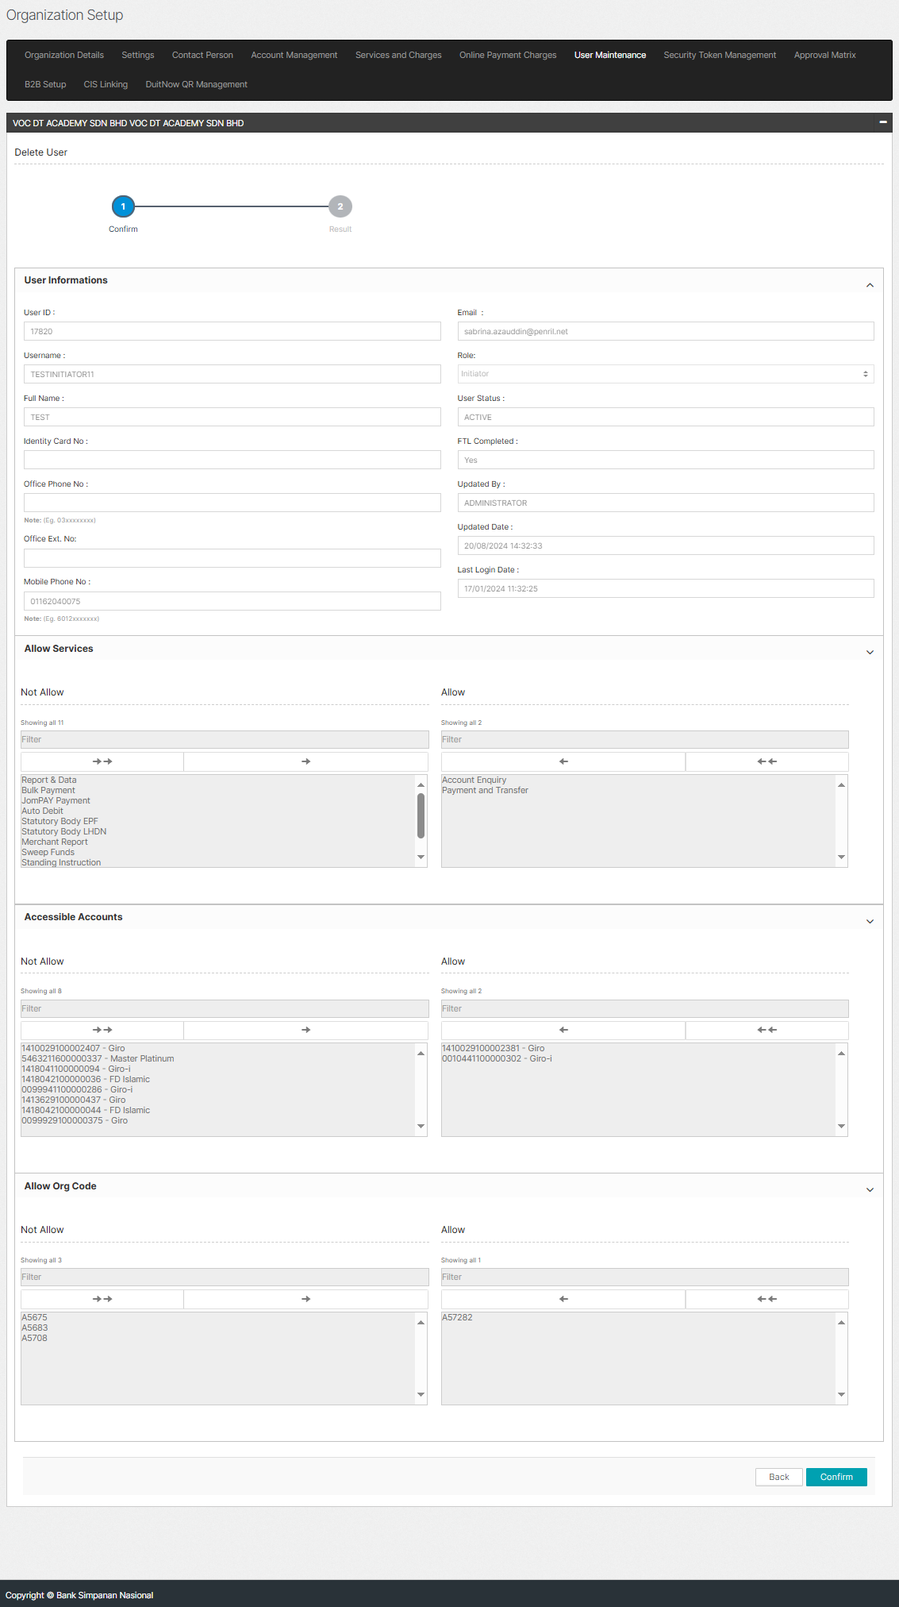  Figure 5: Organization Setup > User Maintenance > Delete (Confirm)  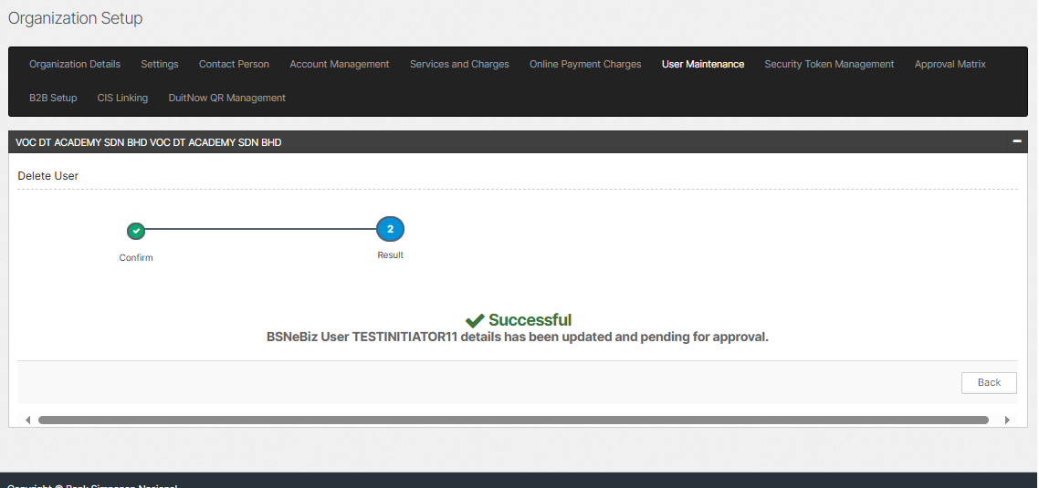  Figure 6: Organization Setup > User Maintenance > Delete (Result)  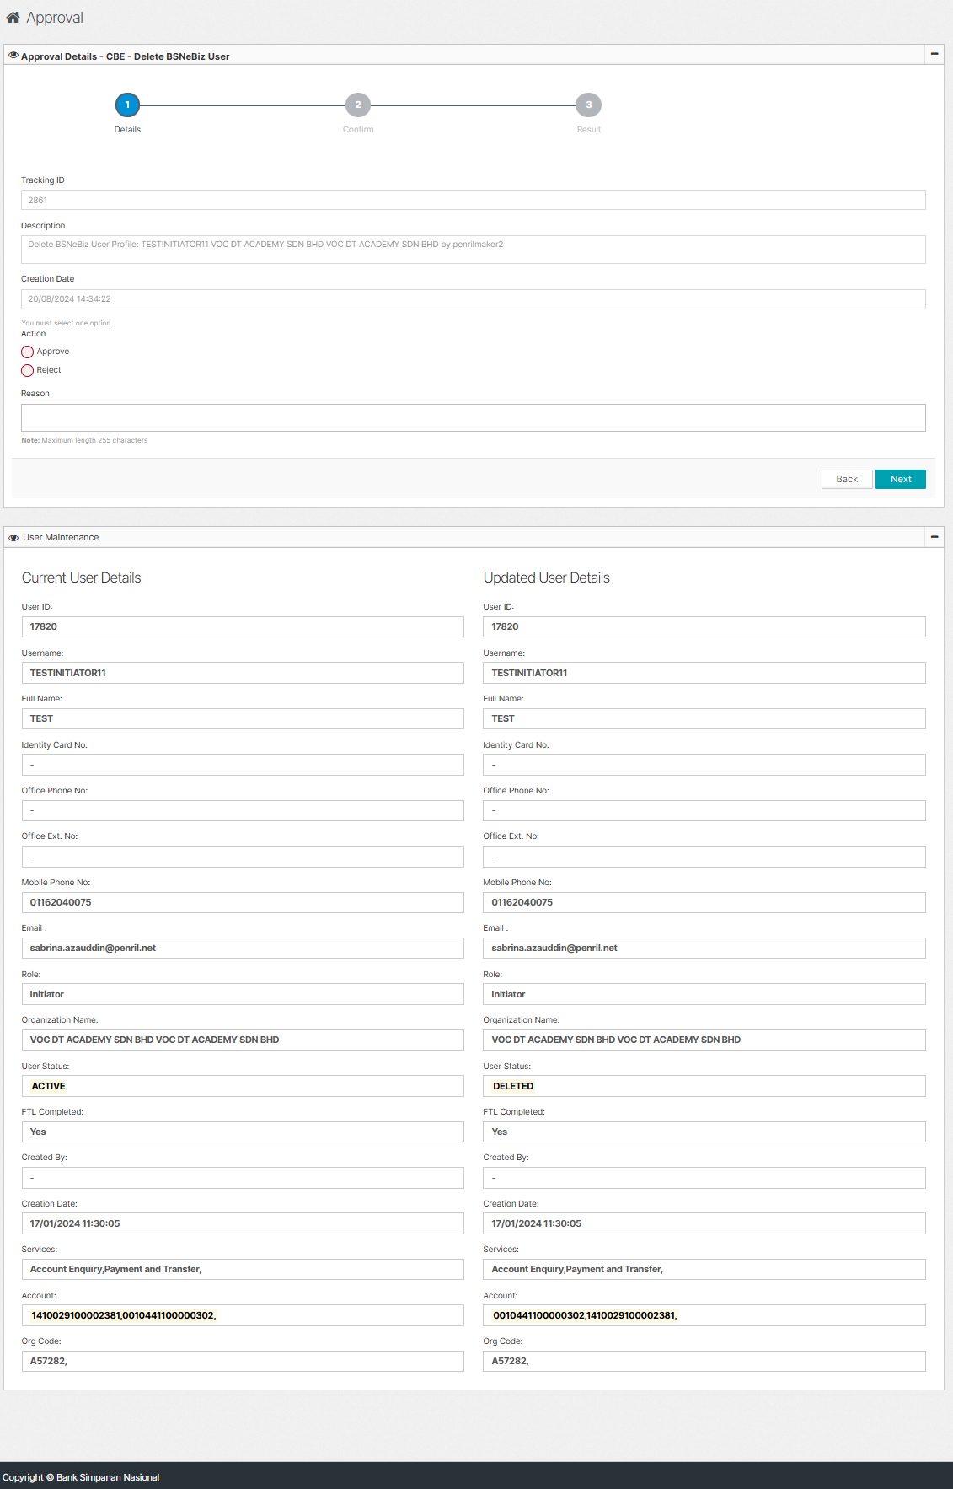  Figure 7: Approval > CBE Authorization > Delete BSNeBiz User (Details)  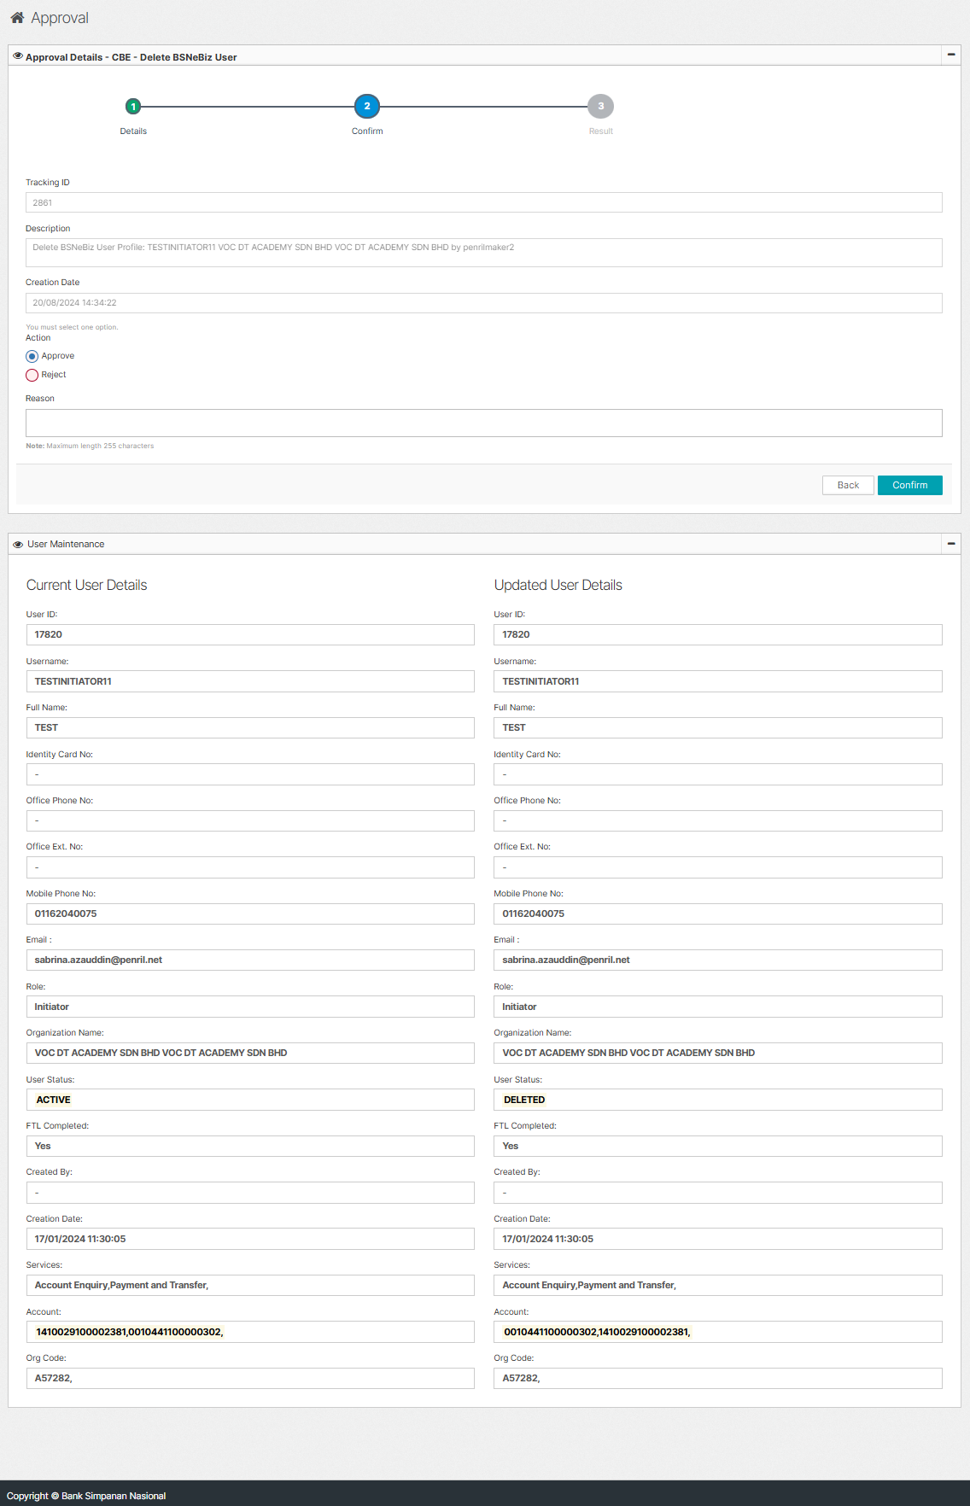  Figure 8: Approval > CBE Authorization > Delete BSNeBiz User (Confirm)  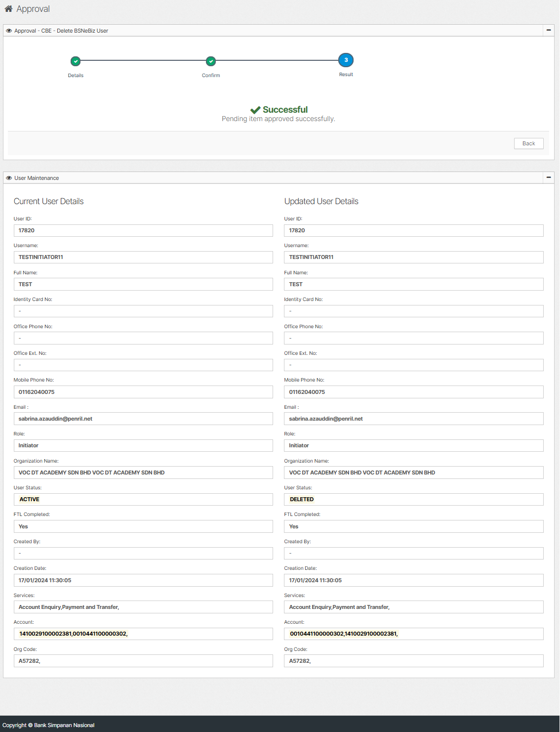  Figure 9: Approval > CBE Authorization > Delete BSNeBiz User (Result)  p/s: Verifier and Approver cannot be deleted if there are Pending Verify and Pending Approval transaction list.  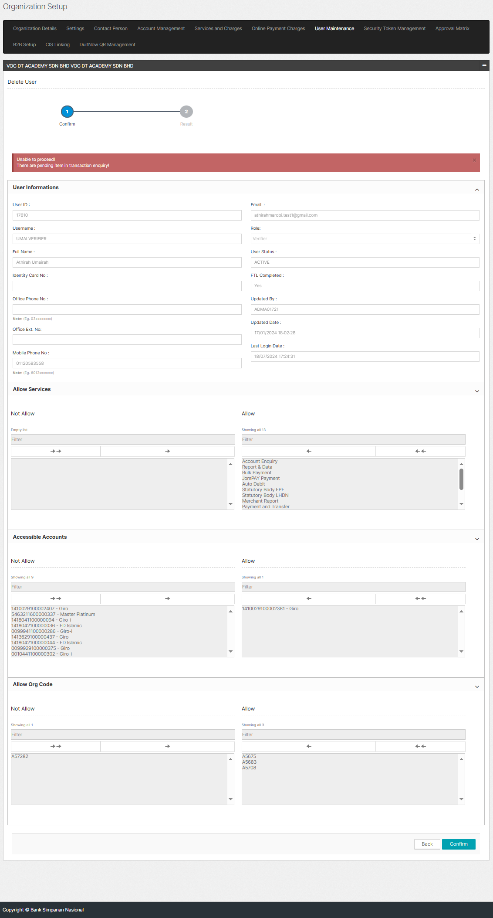  Figure 10: Verifier  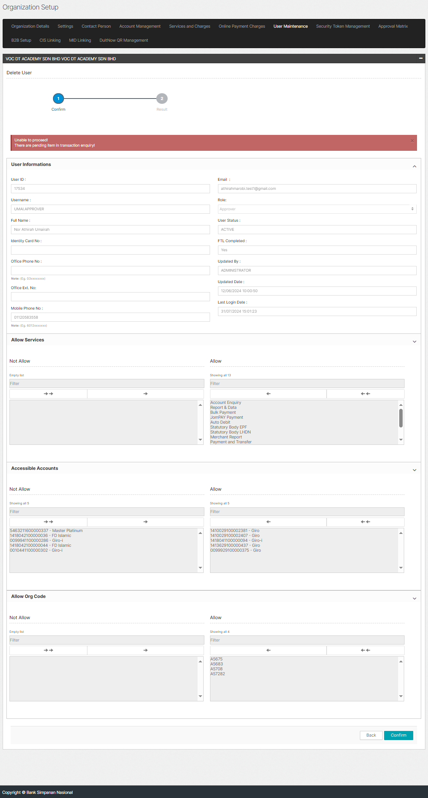  Figure 11: Approver

