SCPID#7106
Test Title: |  | Ios General setting label
Test Description: |  | Expected Result:  If the user has Face ID, supposed the label use "Face ID"  Actual Result:  In all iPhone devices, the label is "Fingerprint" whether it only has Face ID or Fingerprint  Solution:  Dynamically change the label based on the biometric availability on each device.  Finding:  The literal string for that label only statically type as:  "Fingerprint Access" - preferences_fingerprint_title  "Enable Fingerprint to Access Quick Balance" - preferences_fingerprint_sum
Test Functionality: |  | To test on Face ID and Touch ID for BSNeBiz Mobile (iOS)
Test Procedure: |  | Test steps:  - Login to BSNeBiz Mobile (iOS)  - Access to “Settings” on side menu  - Allow Face ID/Touch ID (based device’s biometric availability)  - Success access Quick Balance using Face ID/Touch ID
Response Message:
Test Result: | Pass: Fail: |  | Tested by: | Nor Athirah Umairah (21/08/2024)
Reason for Failure:
Remarks: |  | SIT version 3.4.0 build 28  Face ID  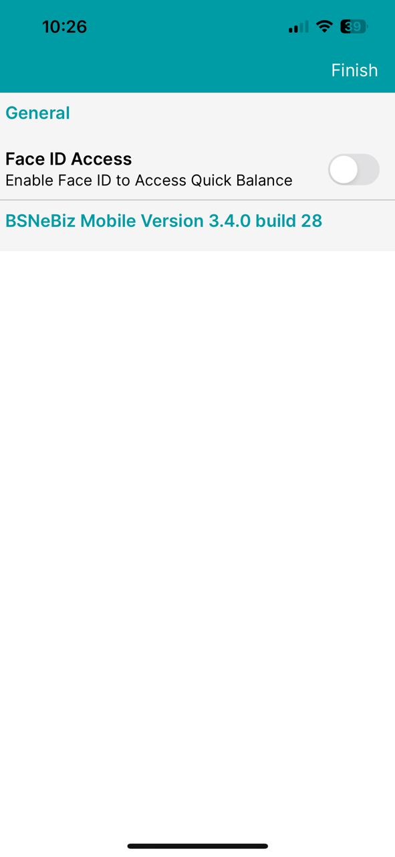  Figure 1: FTL  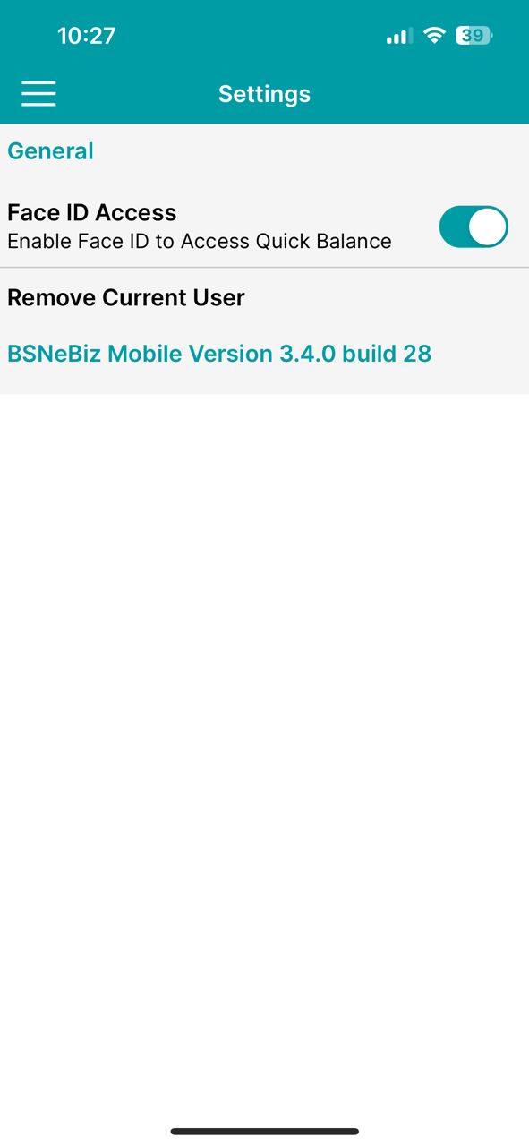  Figure 2: Settings  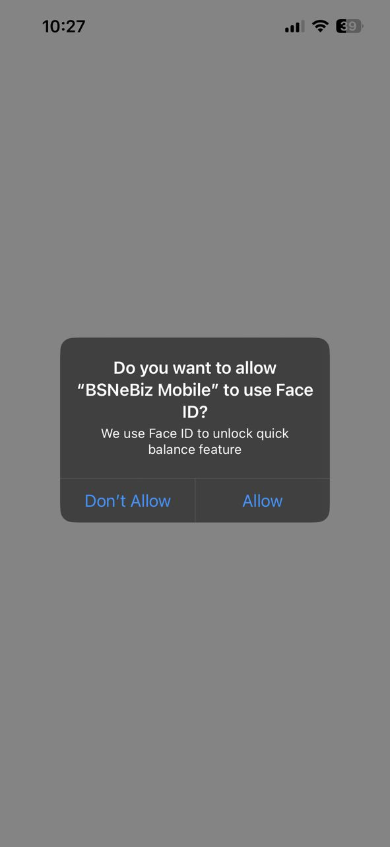  Figure 3: Allow device’s Face ID access  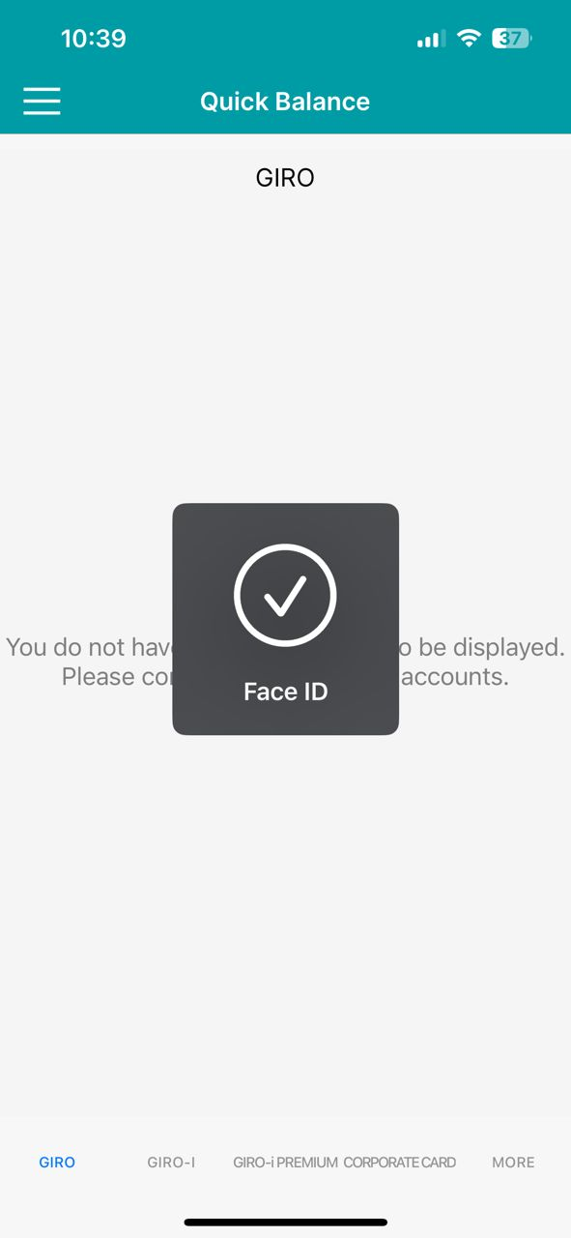  Figure 4: Access to quick balance  Touch ID    Figure 5: Access to quick balance    Figure 6: Settings

