SCPID#7112
Test Title: |  | CDB - Error service unavailable
Test Description: |  | Finding:  Checking fraud code is placed before the validation of valid user. When getting the user data (fraud request), the data is null and Service Unavailable error is being thrown as user does not exist in DB.  Solution:  Validate user null first before checking fraud.
Test Functionality:
Test Procedure: |  | Test steps 1 (Activate Token):  - IBAM > BBE > Fraud Management > Turn on fraud  - CDB > Login Page > Activate Token. Insert random username and password. Username or Password is invalid error message will be displayed.  - Create or use existing single user/approver with Secure Pass Type VASCO.  - Perform First Time Login (For New User).  - CDB > Login Page > Activate Token. Activate token using valid username and password. Successfully activate token.  Test steps 2 (Device Pairing):  - IBAM > BBE > Fraud Management > Turn on fraud  - CDB > Login Page > Device Pairing. Insert random username and password. Username or Password is invalid error message will be displayed.  - Create or use existing single user/approver with Secure Pass Type Mobile UPASS.  - Perform First Time Login (For New User).  - CDB > Login Page > Device Pairing. Pair device using valid username and password. Successfully pairing device.
Response Message:
Test Result: | Pass: Fail: |  | Tested by: | Nor Athirah Umairah (21/08/2024)
Reason for Failure:
Remarks: |  | 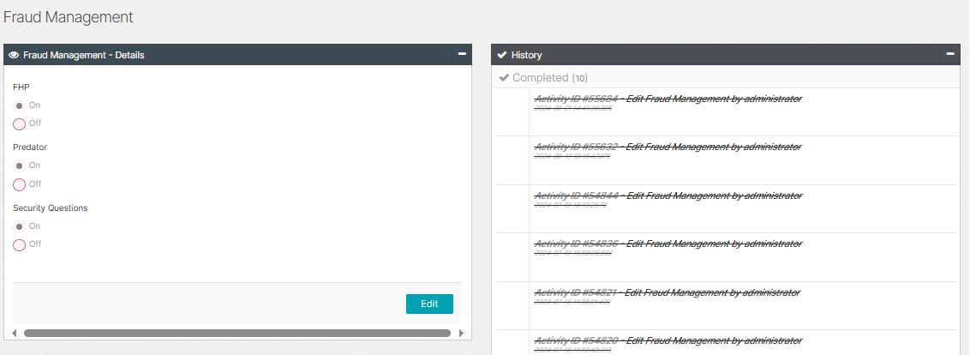  Figure 1: IBAM > BBE > Fraud Management (On)  Activate Token  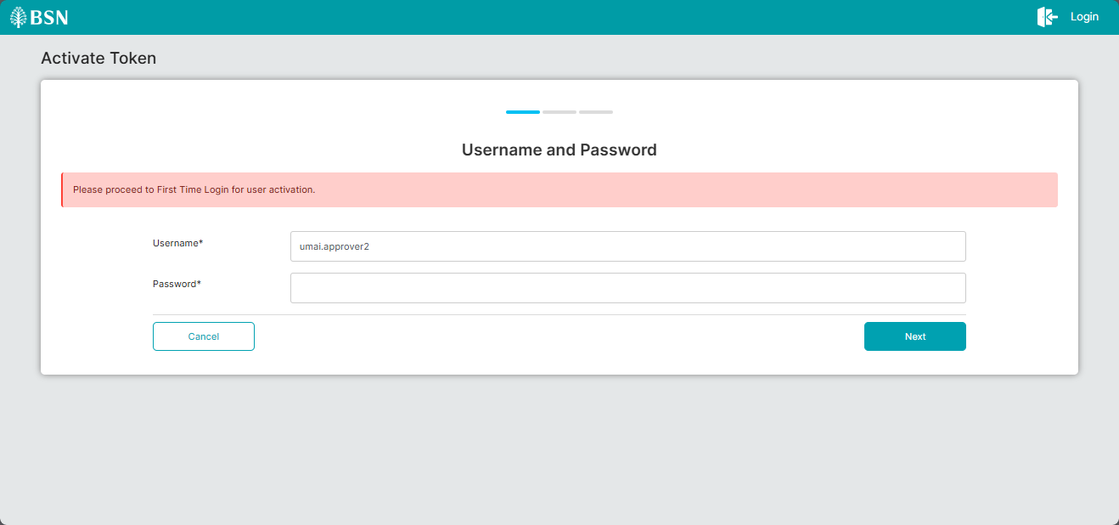  Figure 2: Activate Token (FTL = No)  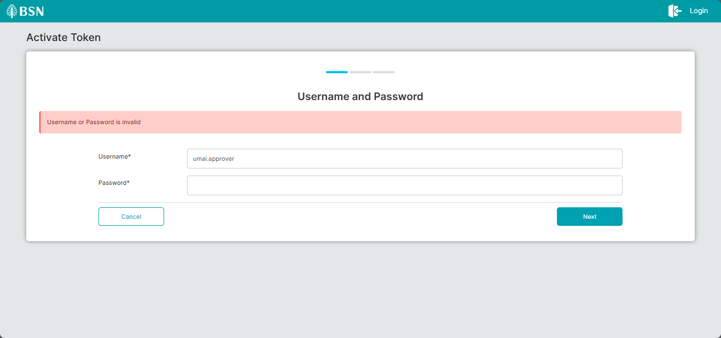  Figure 3: Activate Token (Invalid Username and Password)  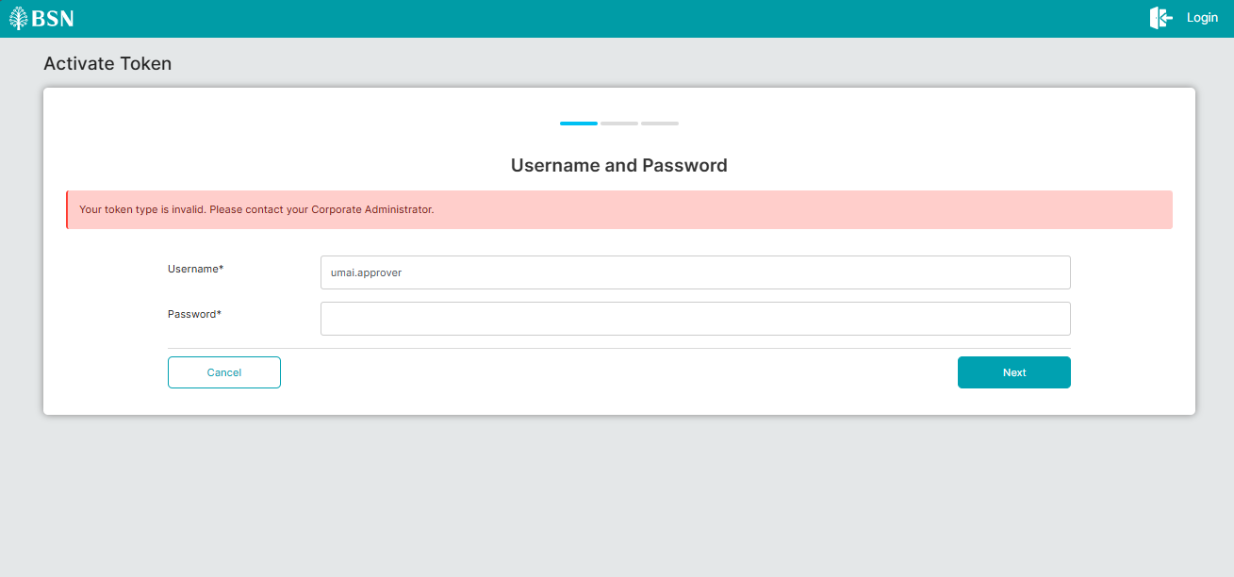  Figure 4: Activate Token (Invalid Token Type)  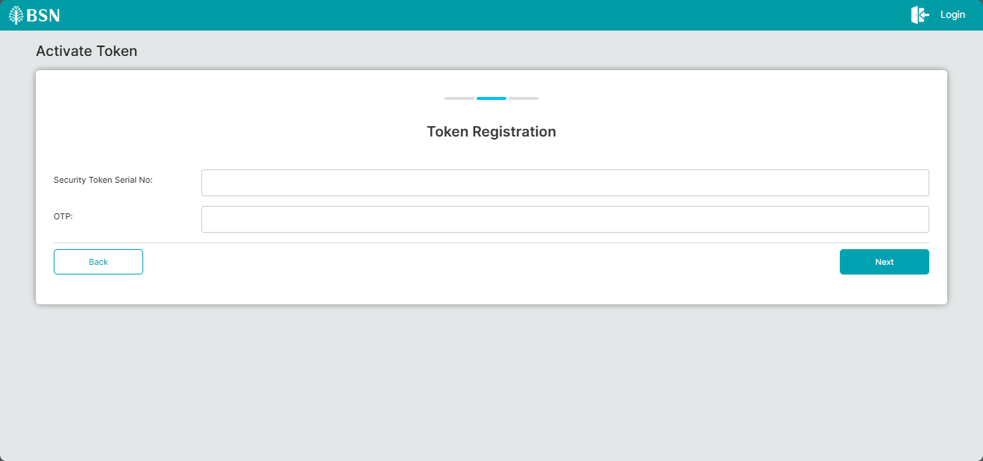  Figure 5: Activate Token (Valid Username and Password)  **don’t have device to proceed activate token  Device Pairing  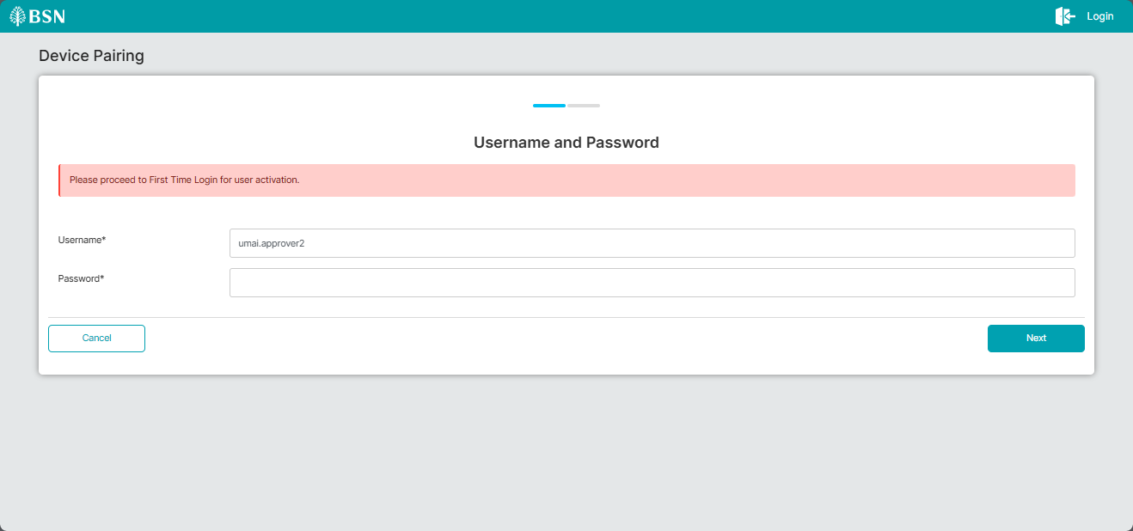  Figure 6: Device Pairing (FTL = No)  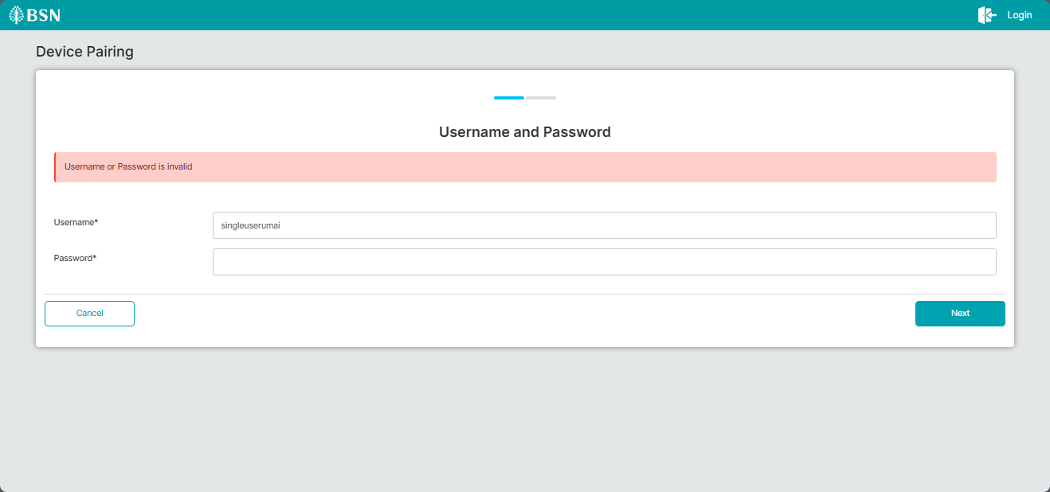  Figure 7: Device Pairing (Invalid Username and Password)  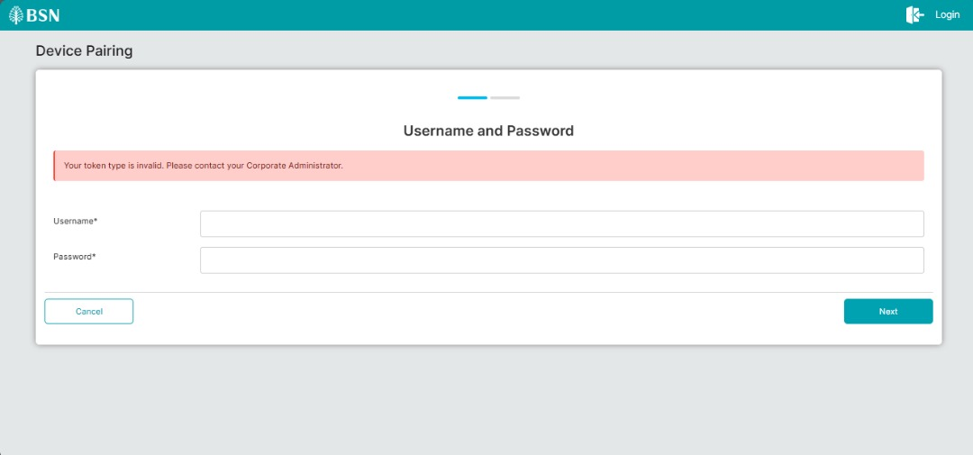  Figure 8: Device Pairing (Invalid Token Type)  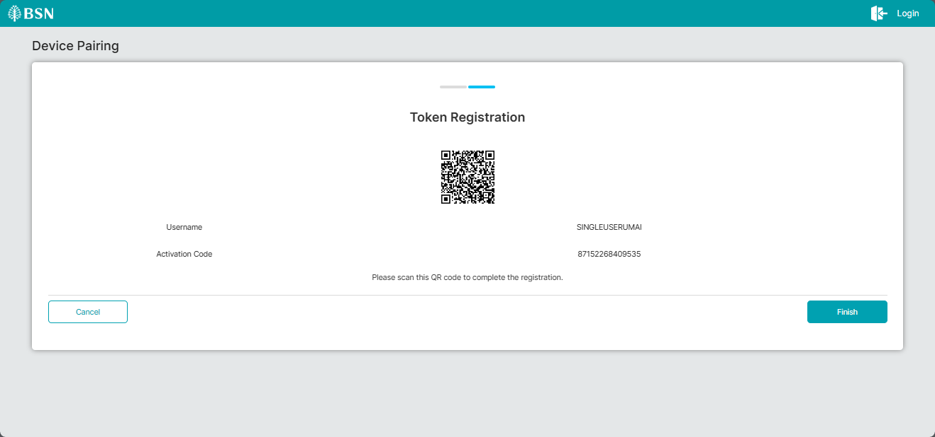  Figure 9: Device Pairing (Valid Username and Password)

