**There is no title for the Export to Text:**

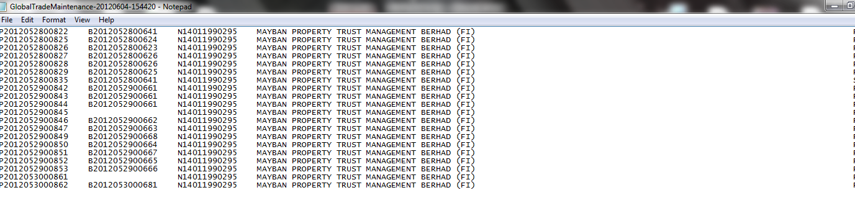

**There is no title for Export to CSV:**

