REQUEST TITLE: SI Charges for Each Modules
REQUESTOR DETAIL
System : BVMC

Requested by : Chooi So Fun Signature: …………………………………

Reviewed by : Malarvili Muniandy Signature: …………………………………

Department : PDM

Date Request : 22 July 2010

REQUEST DESCRIPTION

No | Item | Description
1 | OBJECTIVE of the Project / Enhancement | - SI charges to be configurable for each module in BVMC (Consumer & Business)  - Special SI charges for Business to be maintained in CORUS (Business)
2 | General Overview | In BVMC, currently there is only 1 SI charge field to be maintained for all SI modules. However as per existing bank practice there will be no SI charges for Own Account Transfer therefore enhancement needs to be done to the system in order to cater for SI charges to be parameterized for each module.
3 | Proposed Process Flow | NA
4 | Charges | NA
5 | Features / Functions | - Common SI charges to be maintained for each module for Consumer and Business in BVMC.  - Allow special SI charges for Business to be maintained in CORUS.
6 | Screen and Design (Include Notes / Messages) | CORUS:  For Business, under the “Charges” tab to include section for Special SI Charges to be maintained for each module:  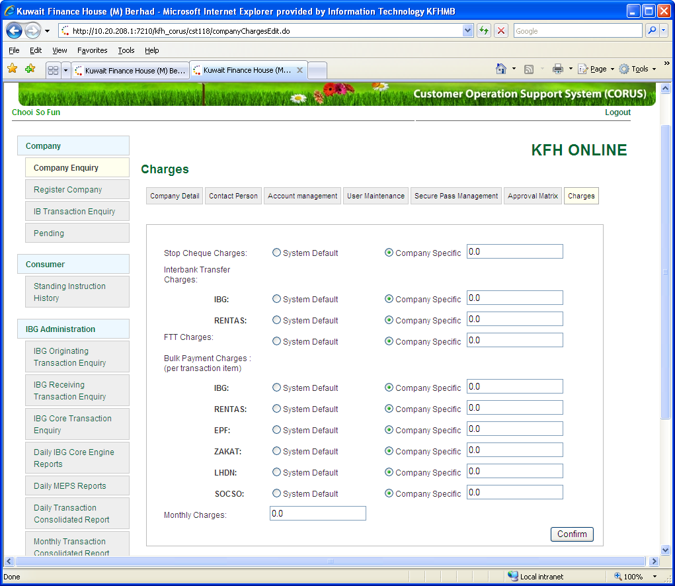  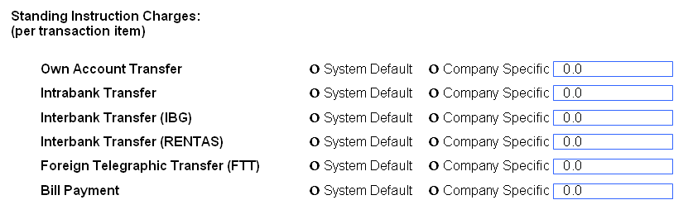  BVMC - An example for maintaining SI Charges for Registered Interbank Transfer:  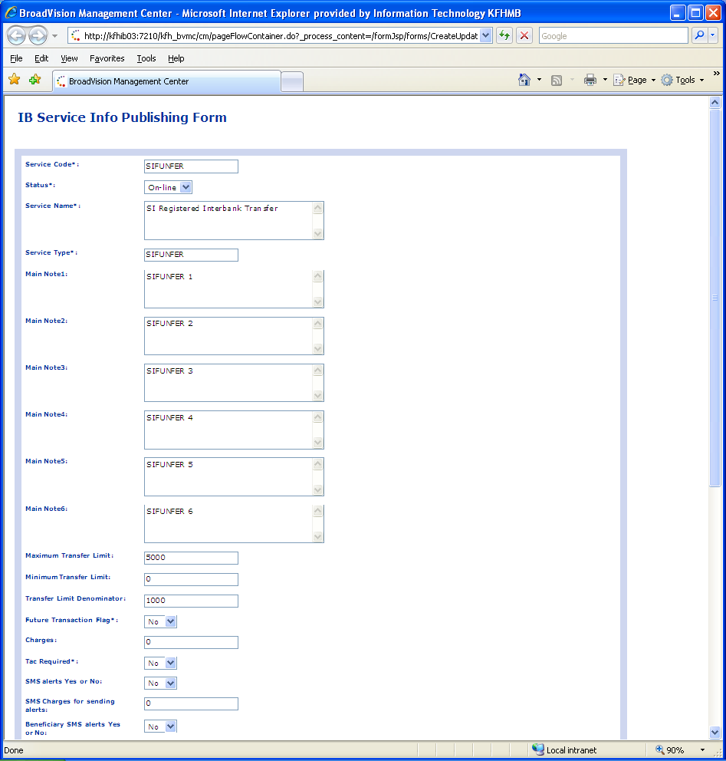  May use this existing “Charges” field for maintaining the SI Charges.
7 | Reports (new / enhancement) and samples | For Business and Consumer:  - To reflect the SI transactions (text in blue) into the respective individual transaction type report:  - Bill Payment Report  - FTT Report  - Interbank Funds Transfer Report (IBG, RENTAS)  - Intrabank Funds Transfer Report  - Own Account Transfer Report)  - Additional fields (as highlighted in blue) need to be included:  - Payment Mode (i.e Pay Now, Pay Later, and Recurring)  - Payment Frequency (i.e. Weekly, Monthly, Quarterly, Half Yearly, and Yearly)  - SI Ref. No.  - SI Charges (i.e. RM2.00 or RM0.00)  Please refer to sample attached for further details:
8 | Audit Trails | Provide audit trails for changes in parameter
9 | BVMC Changes / Enhancements | - Allow to set up the common SI charges for each module.  - Allow special SI charges for Business
10 | Back-end processes / enhancements | NA
11 | ATM / OTC | NA
12 | Timeline | ASAP
13 | Exceptional Handling | NA

