Kuwait Finance House
IBG Technical Documentation

Prepared By



Kuwait Finance House, Malaysia

&



VERSION: 1.2

Revision

Revision | Amendment | Ref In Doc | Updated By | Date
1.0 | New Document | All | Vincent | 23/04/2010
1.1 | Web Service Entry | All | Vincent | 27/04/2010
1.2 | IBG via Branch | All | Vincent | 29/07/2010

Table of Contents

1.0 Document Purpose 5
2.0 Corus 6
2.1 Hibernate 6
2.2 Scheduler 7
2.2.1 Scheduler for Consumer Internet Banking (CIB) 7
2.2.2 Scheduler for Business Internet Banking (BIB) 7
2.2.3 Scheduler for IBG Core Process 8
2.3 Beneficiary Bank Name 8
2.4 Report 9
3.0 IBG 10
3.1 Database 10
3.1.1 Hibernate 10
3.1.2 Properties 11
3.2 IBG Entry Validation 11
3.2.1 Beneficiary Account No & Length 12
3.2.2 Transfer Limit 12
3.2.3 Black list 13
3.3 Debiting & Crediting 14
3.4 IBG Crediting Validation 14
3.4.1 Account Verification 14
3.4.2 KFH Route No 15
3.5 NACHA & Report 16
3.6 System Logging 17
3.7 Back up & Cleaning 17
4.0 Web Service Message Components 19
4.1 Web Service Parameters for Internet Banking 19
(A) Transaction Entry Parameters 19
(B) Transaction Enquiry Parameters 24
(C) Transaction Cancellation Parameters 26
4.2 Web Service Parameter for Other Channels 27
(A) Transaction Entry Parameters 27
4.3 Web Service Validation Code 31
4.4 IBG Web Service ID 31
5.0 Appendix 32
5.1 IBG Hibernate configuration XML file 32
hibernateIBG.cfg.xml 32
5.2 Scheduler configuration properties file 33
5.2.1 Scheduler Consumer Setting 33
5.2.2 Scheduler BIB Setting 33
5.2.3 Scheduler IBG Setting 34
5.3 Beneficiary Bank Name configuration properties file 34
5.3.1 Display in jsp page 34
5.3.2 Used in Application 35
5.4 CORUS report directory configuration properties file 35
5.5 IBG Server configuration file 36
5.5.1 Hibernate XML file 36
5.5.2 Properties file: Setting.properties 36
5.5.3 Properties file:SettingScheduler.properties 37
5.6 IBG Entry validation Configuration properties file 37
5.6.1 Properties file: BankAccountNoLength.properties 37
5.6.2 Properties file: rc.properties 38
5.6.3 Properties file: Setting.properties 38
5.7 Debiting & Crediting Configuration properties file 39
5.8 IBG Crediting validation configuration properties file 39
5.8.1 Properties file: Setting.properties 39
5.8.2 Properties file: Setting.properties 40
5.9 NACHA & Report path configuration properties file 40
5.10 Log4j XML configuration file 41
5.11 IBG XML Format 42
5.11.1 Request XML Format 42
5.11.2 Response XML Format 43

Document Purpose

This document serves as a reference for KFH Technical personnel to do any enhancement to CORUS in future by modifying the configurations. It provides a brief description of the configurations and configuration files.
There are two common configuration files used in CORUS, .xml and .properties. This configuration files like change once and effect all. Means, only one configuration file will be changed and any other files that sharing the configuration file will get affected.
Finally, an example configuration file is given to guide the Technical personnel on how to make the changes.
Apart from the configuration of the application, parameter setting for IBG via Internet Banking and Branch has been included.

Corus
CORUS required setting & configuration as below for IBG modules:

Hibernate

Hibernate is driven by XML configuration files to configure data connectivity and map classes to database tables with which it needs to interact. These XML files contain database connection specifics, connection pooling details, transaction factory settings, as well as references to other XML files that describe tables in the database.
This Hibernate XML file contains properties that to configure Database connection settings. Five (5) properties to be configured;

Property name | Description
hibernate.connection.driver_class | Database driver to connect to database
hibernate.connection.url | URL path (IP Address & Port)
hibernate.connection.username | UserName to access database
hibernate.connection.password | Password to access database
dialect | Dialect is depends on which database to connect.

The Hibernate XML is named as hibernateIBG.cfg.xml and located at:

kfh_corus.war/WEB-INF/classes/my/com/cst/hibernate/configuraion/hibernateIBG.cfg.xml

in four instances:

- /opt/BV1TO1/Jboss/server/bv_framework0/deploy
- /opt/BV1TO1/Jboss/server/bv_framework1/deploy
- /opt/BV1TO1/Jboss/server/bv_framework2/deploy
- /opt/BV1TO1/Jboss/server/bv_framework3/deploy

Refer to Appendix 5.1 for the example hibernateIBG.cfg.xml file and the properties.

Scheduler
Scheduler is similar to an engine that executes job on the specific date and time. It can be single job or a recurrence job for a number of days. The execution of the jo b is based on the information given by the user. Information such as, when to execute, what to execute and include other conditions. This information is stored into a database so that it can be maintained in CORUS.

There are Schedulers for three (3) different applications and the data maintained in three (3) separate databases. A Properties file is used to configure the database connectivity. Four (4) properties to change and the database connectivity settings as follow;

Property name | Description
org.quartz.dataSource.qzDS.driver | Database driver to connect to database
org.quartz.dataSource.qzDS.URL | URL path (IP Address & Port)
org.quartz.dataSource.qzDS.user | UserName to access database
org.quartz.dataSource.qzDS.password | Password to access database
All Three (3) properties files carrying the same properties.

Scheduler for Consumer Internet Banking (CIB)
- Executes future and recurrent payment.

The properties file is named as quartzConsumer.properties and located at:

kfh_corus.war/WEB-INF/classes/my/com/cst/resources/parameter/quartzConsumer.properties

Refer to Appendix 5.2.1 for example of scheduler properties file.

Scheduler for Business Internet Banking (BIB)
- Executes future and recurrent payment.

The properties file is named as quartzBib.properties and located at:

kfh_corus.war/WEB-INF/classes/my/com/cst/resources/parameter/quartzBib.properties

Refer to Appendix 5.2.2 for example of scheduler properties file.

Scheduler for IBG Core Process
- Executes IBG Engine Processes

The properties file is named as quartzIBG.properties and located at:

kfh_corus.war/WEB-INF/classes/my/com/cst/resources/parameter/quartzIBG.properties

Refer to Appendix 5.2.3 for example of scheduler properties file.

Modification of these XML files should apply to all four (4) instances:

- /opt/BV1TO1/Jboss/server/bv_framework0/deploy
- /opt/BV1TO1/Jboss/server/bv_framework1/deploy
- /opt/BV1TO1/Jboss/server/bv_framework2/deploy
- /opt/BV1TO1/Jboss/server/bv_framework3/deploy

Beneficiary Bank Name
Beneficiary Bank Name with Route No is maintained in a properties file that to be used while file processing or to display. Two separate lists are used in two (2) areas:
- In Enquiry screen where the Beneficiary Bank Name is to be selected from the dropdown selection. Two (2) Enquiries in CORUS:
    - IBG Originating Transaction Enquiry
    - IBG Receiving Transaction Enquiry
- In CORUS IBG reports where the Beneficiary Bank Name is to get and display in report for respective Route No.
The properties file is named as IBBusinessOptionsResources.properties and located at:
/kfh_corus/src/my/com/cst/resources/message/IBBusinessOptionsResources.properties

Modification of this properties file should apply to all four (4) instances:
- /opt/BV1TO1/Jboss/server/bv_framework0/deploy
- /opt/BV1TO1/Jboss/server/bv_framework1/deploy
- /opt/BV1TO1/Jboss/server/bv_framework2/deploy
- /opt/BV1TO1/Jboss/server/bv_framework3/deploy
Refer to Appendix 5.3.1 and 5.3.2 for example of properties file.

Report
There are two (2) modules in CORUS to view or save IBG Process Report and MEPS reports. Since the directories were mounted, the directory path in production server should be same IBG Server.

Properties to change:
Property name | Description
ibg.core.process.report | IBG Core Process Report directory
ibg.meps.proces.report | MEPS Process Report directory
ibg.meps.settlement.report | MEPS Settlment Report directory

The directory paths stored in a properties file named reportFile.properties located at:

/kfh_corus/src/my/com/cst/resources/parameter/reportFile.properties

Modification of this properties file should apply to all four (4) instances:

- /opt/BV1TO1/Jboss/server/bv_framework0/deploy
- /opt/BV1TO1/Jboss/server/bv_framework1/deploy
- /opt/BV1TO1/Jboss/server/bv_framework2/deploy
- /opt/BV1TO1/Jboss/server/bv_framework3/deploy

Refer to Appendix 5.4 for example of properties file.

IBG

Database
Three (3) configuration files required in IBG and all serves for different purpose.
- 1 Hibernate XML and
- 2 Properties file.

Hibernate
Hibernate is driven by XML configuration files to configure data connectivity and map classes to database tables with which it needs to interact. These XML files contain database connection specifics, connection pooling details, transaction factory settings, as well as references to other XML files that describe tables in the database.
This Hibernate XML file contains properties that to configure Database connection settings. Five (5) properties to be configured;

Property name | Description
hibernate.connection.driver_class | Database driver to connect to database
hibernate.connection.url | URL path (IP Address & Port)
hibernate.connection.username | UserName to access database
hibernate.connection.password | Password to access database
dialect | Dialect is depends on which database to connect.

The Hibernate XML is named as hibernate.cfg.xml:

The modification should apply to 3 hibernate XML files located at:
- /home/jbadmin/IBGCore/bin/net/penril/hibernate/conf/hibernate.cfg.xml
- /opt/jboss501/server/default/deploy/scheduler.war/WEB-INF/classes/net/penril/hibernate/conf/hibernate.cfg.xml
- /opt/jboss501/server/default/deploy/IBGWS.war/WEB-INF/classes/net/penril/hibernate/conf/hibernate.cfg.xml

Refer to Appendix 5.5.1 for example Hibernate XML file.

Properties
Apart from the Hibernate XML database connectivity, the IBG Core required database connection in application level. Four (4) properties to be configured;

Property name | Description
db.driver | Database driver to connect to database
db.url | URL path (IP Address & Port)
db.userid | UserName to access database
db.password | Password to access database

There are two (2) properties to be configurated:
- Setting.properties located at:
- /home/jbadmin/IBGCore/bin/i18n/ Setting.properties
- /opt/jboss501/server/default/deploy/scheduler.war/WEB-INF/classes/i18n/ Setting.properties
- /opt/jboss501/server/default/deploy/IBGWS.war/WEB-INF/classes/i18n/ Setting.properties

Refer to Appendix 5.5.2 for example properties file.

- SettingScheduler.properties located at:
- /home/jbadmin/IBGCore/bin/i18n/ SettingScheduler.properties
- /opt/jboss501/server/default/deploy/scheduler.war/WEB-INF/classes/i18n/ SettingScheduler.properties
- /opt/jboss501/server/default/deploy/IBGWS.war/WEB-INF/classes/i18n/ SettingScheduler.properties

Refer to Appendix 5.5.3 for example properties file.

IBG Entry Validation

Every IBG OFI Transaction required to go through a validation process to ensure that the transaction contains all required and valid information. There are several fields to be taken to validate such as;
- Beneficiary Name
- Beneficiary Account No.
- Amount

The information given by the user is to validate against the value in the properties or configuration file. Below are the validation processes perform upon IBG OFI Transaction.

Beneficiary Account No & Length

Beneficiary Account No should be a valid Account No. and the Length is to validate as well. A list of Beneficiary Account No & Route No maintained in a properties file so that users can add or delete IBG member bank in future.

Property to configure:
Property name | Description
bank.account.length.<Bank Route No> | Beneficiary Bank Account No. Length

The properties file is named as BankAccountNoLength.properties and is located at:
- /opt/jboss501/server/default/deploy/IBGWS.war/WEB-INF/classes/i18n/BankAccountNoLength.properties

Refer to Appendix 5.6.1 for example properties file.

Transfer Limit

The Amount to be transferred is to validate for maximum value which means that the amount should not be exceeds the maximum value. Amount is to checked against the value in properties file for two (2) different type of account holder:
- External Account holder – maximum (5000)
- Normal Account holder – maximum (100000)

Properties to configure:
Property name | Description
ibg.entry.transfer.limit.1 | External Account holder fund transfer limit
ibg.entry.transfer.limit.0 | Normal Account holder fund transfer limit

The properties is named as rc.properties and located at:

- /opt/jboss501/server/default/deploy/IBGWS.war/WEB-INF/classes/i18n/rc.properties

Refer to Appendix 5.6.2 for example properties file.

Black list

The Beneficiary Name is to check against the list of Names maintained in SQL server. The Configuration of the Database connectivity is stored in a properties file.

Four (4) fields to configure:
Property name | Description
kfhaml02.db.drive | Database driver to connect to database
kfhaml02.db.url | URL path (IP Address & Port)
kfhaml02.db.userid | UserName to access database
kfhaml02.db.password | Password to access database

The properties is named as settring.properties and located at:

- /opt/jboss501/server/default/deploy/IBGWS.war/WEB-INF/classes/i18n/setting.properties

Refer to Appendix 5.6.3 for example properties file.

Debiting & Crediting
For debiting and crediting process different GL Account been used. The GL Account Numbers stored in a properties file.

Properties to configure:
Property name | Description
forward.to.GL.ofi | OFI GL Account No.
forward.to.GL.rfi | RFI GL Account No.

The properties is named as rc.properties and located at:

- /opt/jboss501/server/default/deploy/IBGWS.war/WEB-INF/classes/i18n/rc.properties
- /home/jbadmin/IBGCore/bin/i18n/ rc.properties

Refer to Appendix 5.7 for example properties file.

IBG Crediting Validation
Before crediting process of IBG RFI Transaction, validation is to be done to ensure that the transaction contains all required and valid information. The information received will be checked against local bank account holder information (KFH). There are several fields that to be taken to validate;
- Receiver Account No.
- Receiver Bank Route No.

Account Verification

Two (2) verifications involve:

- Account No length
The receiver’s account no to validate for length where as it should be 12 digit character (as in the configuration file).
- Account type
The crediting of fund is set to only to current, saving and loan accounts.
The configuration of these two verifications is stored in a properties file.
The properties to configure:
Property name | Description
cdt.account.length | Receiver Account No Length
cdt.account.type | Receiver Account No Type

The properties is named as setting.properties and located at:

- /opt/jboss501/server/default/deploy/IBGWS.war/WEB-INF/classes/i18n/ setting.properties
- /home/jbadmin/IBGCore/bin/i18n/ setting.properties

Refer to Appendix 5.8.1 for example properties file.

KFH Route No

The receiving Bank Route No is to check against the local bank (KFH) route no whether the transaction reached the right destination.

The local bank route no is stored in a properties file

Property to configure if the local bank (KFH) route no to be changed in future.

Property name | Description
ofi.route.no | Local Bank Route No. (KFH)
ofi.name | Local Bank Name

The properties is named as setting.properties and located at:

- /home/jbadmin/IBGCore/bin/i18n/ setting.properties

Refer to Appendix 5.8.2 for example properties file.

NACHA & Report

All IBG Engine processes will generate a file that to be stored in a directory so that it can be retrieved at the later time. It can be a NACHA that needs to send to MEPS or a report file. The files were categorized into 4 and each specified a directory:
- OFI NACHA
- RFI NACHA
- MEPS Report
- Process Report

The file directory setting is stored in a properties file.

Properties to configure:
Property name | Description
ofi.nacha.path | Directory to drop OFI NACHA
rfi.nacha.path | Directory to read RFI NACHA
ibg.recon.read.path | Directory to read OFI & RFI Recon file
ibg.report.path | Directory to drop IBG Core Process Report

The properties is named as setting.properties and located at:

- /home/jbadmin/IBGCore/bin/i18n/ setting.properties

Refer to Appendix 5.9 for example properties file.

System Logging

Log4j logging is used to log the IBG Core system. All the activities within the system were monitored by the logging and logged into a file. It is a daily rolling file that will store in a directory. The file directory can be changed for users convenient:

Properties to change:

Property name | Description
<param name="File" value="/opt/jboss501/logs/IBGSystem.log" /> | Logging file directory

The properties is named as log4j.xml and located at:

- /home/jbadmin/IBGCore/bin/log4j.xml

Refer to Appendix 5.10 for example XML file.

Back up & Cleaning

The report files and NACHA are highly confidential and need backup for future references. These files can be overridden in the future due to the structure of the file name (name+MMDDW.txt). So, it is recommended to backup the files frequently. Below is the backup plan;

There are 4 directories specified in IBG Core:
Name |  | Directory | Description
OFI NACHA |  | /home/jbadmin/IBGCore/MEPS/OFI | OFI NACHA Directory
RFI NACHA |  | /home/jbadmin/IBGCore/MEPS/RFI | RFI NACHA Directory
MEPS Report |  | /home/jbadmin/IBGCore/MEPS/MEPSRpt | MEPS Report Directory
IBG Process Report |  | /home/jbadmin/IBGCore/ProcessRpt | IBG CORE Process Report Directory
No | Activity |  |  | Description
1 | Login to IBG Server  userName:******  Password:*******  Note: Users should have userName and Password.
2 | Go to directory:  - /home/jbadmin/IBGCore/MEPS/OFI  - /home/jbadmin/IBGCore/MEPS/RFI  - /home/jbadmin/IBGCore/MEPS/MEPSRpt  Copy the content of the folder and save it into the local directory.  Remove the content after finished copying them. |  |  | Backup every 3 – 6 months
3 | Go to directory:  - /home/jbadmin/IBGCore/ProcessRpt  Copy the content of the folder and save it into the local directory.  Remove the content after finished copying them. |  |  | Backup once a year.

Web Service Message Components

Web Service Parameters for Internet Banking

Transaction Entry Parameters

Input
FIELD | PARAMETER NAME |  | CONTENTS | LENGTH =< | EXAMPLE / REMARK
 | channel | M | Numeric | 2 | 01
 | subChannel | M | Numeric | 8 | 00000001
 | toBankRouteNo | M | Numeric | 8 | 10000233
 | fromAccountNo | M | Numeric | 17 | 1234567891012
 | toAccountNo | M | Numeric | 17 | 98765432109876
 | amount | M | ######.00 | 10 | 100.00
 | chargeAmount | M | ####.00 | 6 | 2.00
 | beneID | O | Alphanumeric | 15 | M336475
 | toName | M | Alphanumeric | 16 | Julie Andrews
 | beneBankName | M | Alphanumeric | 64 | Public Bank
 | segmentCode | M | Numeric | 1 | 1
 | elementCode | M | Numeric | 1 | 0
 | fromName | M | Alphanumeric | 80 | Sharon Wee
 | rimNo | M | Alphanumeric | 5 | 968
 | paymentRefNo | M | Alphanumeric | 20 | 12345677
 | paymentDescription | M | Alphanumeric | 20 | Loan Payment
 | newICNo | O | Numeric | 12 | 751215105978
 | oldICNo | O | Alphanumeric | 8 | A2342024
 | businessRegNo | O | Alphanumeric | 20 | 43456-K
 | otherIDNo | O | Numeric | 4 | R980003
 | epfMemberId | O | Numeric | 8 | 12345678
 | batchDate | O | YYYYMMDD | 8 | 20091211
 | eftNumber | O | Numeric | 20 | 1234567890
 | description | O | Alphanumeric | 256 | Not in used
 | creationDate | O | Date Time | - | Not in used
 | effectiveDate | M | YYMMDD | 6 | 091118
 | dateOfDeath | O | YYMMDD | - | Not in used
 | isTransferCharges | O | Alphabet | 1 | Not in used
 | isTransferAmount | O | Alphabet | 1 | Not in used
 | phnxChargesDesc | M | Alphanumeric | 64 | IBG Charges Transfer
 | phnxPrincipleDesc | M | Alphanumeric | 64 | IBG Fund Transfer
 | ibTrnxId | M | Numeric | 18 | 200912110000000001
 | paymentType | M | Numeric | 2 | 01
 | forwardCharges | M | Numeric | 3 | 001
 | oid | O | Numeric | 32 | Not in used
 | transactionCode | O | Numeric | 20 | Not in used
 | returnCode | O | Alphanumeric | 3 | Not in used
 | status | O | Alphabet | 16 | Not in used
 | traceNo | O | Numeric | 15 | Not in used

Field 1: channel Mandatory
This defines the code assigned to each input channel.

CHANNEL | CHANNEL CODE
Branch | 01
Internet Banking | 02

Field 2: subChannel Mandatory
This defines the code assigned to each sub channel. A Channel by default has to assign a Sub Channel Code in order to be related. E.g. Internet Banking will have a Channel Code of ‘02’ where ‘00000001’ will be Consumer Internet Banking and ‘00000002’ will be Business Internet Banking. For Branch which belongs to Channel Code of ‘01’, ‘00000001’ will be the first dedicated branch of the respective bank and so forth.

Field 3: toBankRouteNo Mandatory
A standard Routing Number as assigned by MEPS is used to identify a RFI.

Field 4: fromAccountNo Mandatory
This field defines the Originator’s account number for the IBG transaction.

Field 5: toAccountNo Mandatory
This field defines the Beneficiary’s bank customer identification (account number).

Field 6: amount Mandatory
This field defines the amount of the IBG transaction.

Field 7: chargeAmount Mandatory
This field defines the charges amount applied to the IBG transaction.

Field 8: BeneID Optional
This field contains the accounting number by which the Receiver is known to the Originator. It is included for further identification and for descriptive purposes only.

Field 9: toName Mandatory
The Receiving Company Name / Beneficiary Name field contains the name of the Receiver.

Field 10: beneBankName Mandatory
This field defines the beneficiary bank name of the Receiver.

Discretionary Data
Discretionary data is used to enable special handling of the IBG transaction.
This field used 2 alphanumeric characters. The first position will identify the segment code while the second character is used to determine the residential status of the Originator (External Account).

- Field 11: segmentCode Mandatory
- Government - (0)
- Private - (1)
- OTC - (2)
- EPF- (3)
- Accountant General - (4)
- Second Validation - (5)

- Field 12: elementCode Mandatory
- Resident - (0)
- Non-Resident - (1)

Field 13: fromName Mandatory
As a Web Service Entry, it is mandatory to incorporate the Applicant / Remitter Name (in full name) in IBG Transaction.

Field 14: rimNo Mandatory
Field for idenfication of Originator. (RIM NO for case of KFHMB)

Field 15: paymentRefNo Mandatory
It is a field for payment reference number such as invoice number.

Field 16: paymentDescription Mandatory
It is a field to provide information on the type of payment.

Field 17: newICNo Required
It is a field for beneficiary New IC No. where applicable for Discretionary Data Segment Code “3” and “5”.

Field 18: oldICNo Required
It is a field for beneficiary Old IC No. where applicable for Discretionary Data Segment Code “3” and “5”.

Field 19: businessRegNo Required
It is a field for beneficiary Business Registration No. where applicable for Discretionary Data Segment Code “5”.

Field 20: otherIDNo Required
It is a field for Police/Army ID/Passport No. where applicable for Discretionary Data Segment Code “3” and “5”.

Note: OFI must indicate at minimum one of the fields as stated from field 17 to field 19 if Segment Code of “3” and “5” is used.

Field 21: epfMemberId Required
It is a field for EPF Member ID for EPF Direct Crediting where applicable for Discretionary Data Segment Code “3”.

Field 22: batchDate Required
It is a field for Batch Date for EPF Direct Crediting where applicable for Discretionary Data Segment Code “3”.

Field 23: eftNumber Required
It is a field for EFT Number for Accountant General EFT payments where applicable for Discretionary Data Segment Code “4”.

Field 24: description Not in Used
The field defines the description of rejected IBG transactions during enquiry process. Description is as per Web Service Validation Code. It is not in used and the parameter can be treated as an empty field.

Field 25: creationDate Not in Used
The field defines the timestamp where the entry is sent to IBG Core Engine for processing. It is not in used and the parameter can be treated as an empty field.

Field 26: Effective Date Mandatory
The Effective Date identifies the payment date of an entry. Future payments must not have payment date as of current date.

Field 27: dateOfDeath Not in Used
The field is not in used and the parameter can be treated as an empty field.

Field 28: isTransferCharges Not in Used
The field defines the indicator to enable charges transfer for the entry. ‘Y’ denotes yes while ‘N’ denotes no. It is not in used and the parameter can be treated as an empty field.

Field 29: isTransferAmount Not in Used
The field defines the indicator to enable charges transfer for the entry. ‘Y’ denotes yes while ‘N’ denotes no. It is not in used and the parameter can be treated as an empty field.

Field 30: phnxChargesDesc Mandatory
This field defines the message needed to be parsed into charges transfer when the entry is processed.

Field 31: phnxPrincipleDesc Mandatory
This field defines the message needed to be parsed into fund transfer when the entry is processed.

Field 32: ibTrnxId Mandatory
The ibTrnxId defines the unique reference number that identifies the entry through specified channel.

Field 33: paymentType Mandatory
This field is to be used by IBG CORE to filter the entries being enquired by payment type. “01” denotes Immediate Payment Entries while “02” denotes Future Payment Entries.

Field 34: forwardCharges Mandatory
This field is to be used by IBG CORE to determine the branch that placed the charges on the entry and to warehouse the record of the collection account. Branch code of 3 characters will be used to determine the specific collection account for the charges to be forwarded to.

Field 35: oid Not in Used
The oid is the unique reference number of the transaction being warehoused in IBG Core Engine. It is not in used and the parameter can be treated as an empty field.

Field 36: transactionCode Not in Used
The field is not in used and the parameter can be treated as an empty field.

Field 37: returnCode Not in Used
The field is not in used and the parameter can be treated as an empty field.

Field 38: status Not in Used
This field defines the status of the transaction. It is not in used and the parameter can be treated as an empty field.

STATUS INDICATOR | DESCRIPTION
N | New Transaction
P | Accepted Transaction
F | Failed Transaction

Field 39: traceNo Not in Used
The field is not in used and the parameter can be treated as an empty field.

Output
FIELD | PARAMETER NAME |  | CONTENTS | LENGTH | EXAMPLE
1 | chargeReferenceNo | O | Numeric | >0 | 123456
2 | chargeRespCode | O | Numeric | >0 | 0000
3 | fundReferenceNo | O | Numeric | >0 | 234567
4 | fundRespCode | O | Numeric | >0 | 0000
5 | oid | M | Numeric | 14 | 20100309000096
6 | respCode | M | Numeric | 4 | 5000
7 | respMsg | M | Alphanumeric | >0 | Successful

Field 1: chargeReferenceNo Optional
The chargeReferenceNo is the unique reference number of the transaction where a charge is deducted or reverted.

Field 2: chargeRespCode Optional
The chargeRespCode is the return code that defines the status of the specified charge being transferred.

Field 3: fundReferenceNo Optional
The fundReferenceNo is the unique reference number of the transaction where a fund is deducted or reverted.

Field 4: fundRespCode Optional
The fundRespCode is the return code that defines the status of the specified fund being transferred.

Field 5: oid Mandatory
The oid is the unique reference number of the transaction being warehoused in IBG Core Engine.

Field 6: respCode Mandatory
The respCode defines the code returned by IBG Core. Refer Web Service Validation Code for details.

Field 7: respMsg Mandatory
The respMsg further elaborates the denotation of Return Code. Refer Web Service Validation Code for details.

Transaction Enquiry Parameters

Input
FIELD | PARAMETER NAME |  | CONTENTS | LENGTH | EXAMPLE
1 | p_sRimNo | M | Numeric | >0 | 010

Field 1: p_sRimNo Mandatory
RIM No Number of CASA Account Holder.

Output
FIELD | PARAMETER NAME |  | CONTENTS | LENGTH | EXAMPLE
 | IBGEntryBeanArray | M | IBGEntryBean | >0 | -
 | respCode | M | Alphanumeric | 4 | 5000
 | respMsg | O | Alphanumeric | >0 | Successful

Field 1: IBGEntryBeanArray Mandatory
The IBGEntryBeanArray contains a list of records returned by IBG Core Engine. The parameters available in each record of the IBGEntryBeanArray are IBGEntryBean. Details as per below section named “IBGEntryBean Parameters”

Field 2: respCode Mandatory
The respCode defines the code returned by IBG Core. Refer Web Service Validation Code for details.

Field 3: respMsg Optional
The respMsg further elaborates the denotation of respCode. Refer Web Service Validation Code for details.

IBGEntryBean Parameters:
FIELD | PARAMETER NAME |  | CONTENTS | LENGTH =< | EXAMPLE / REMARK
 | channel | M | Numeric | 2 | 01
 | subChannel | M | Numeric | 8 | 00000001
 | toBankRouteNo | M | Numeric | 8 | 10000233
 | fromAccountNo | M | Numeric | 17 | 1234567891012
 | toAccountNo | M | Numeric | 17 | 98765432109876
 | amount | M | 00000000.00 | 10 | 0000010000
 | chargeAmount | M | 00000000.00 | 10 | 0000000200
 | beneID | O | Alphanumeric | 15 | Not in used
 | toName | M | Alphanumeric | 16 | Julie Andrews
 | beneBankName | M | Alphanumeric | 64 | Public Bank
 | segmentCode | M | Numeric | 1 | 1
 | elementCode | M | Numeric | 1 | 0
 | fromName | M | Alphanumeric | 80 | Sharon Wee
 | rimNo | M | Alphanumeric | 5 | 968
 | paymentRefNo | M | Alphanumeric | 20 | 12345677
 | paymentDescription | M | Alphanumeric | 20 | Loan Payment
 | newICNo | O | Numeric | 12 | 751215105978
 | oldICNo | O | Alphanumeric | 8 | A2342024
 | businessRegNo | O | Alphanumeric | 20 | 43456-K
 | otherIDNo | O | Numeric | 4 | R980003
 | epfMemberId | O | Numeric | 8 | 12345678
 | batchDate | O | YYYYMMDD | 8 | 20091211
 | eftNumber | O | Numeric | 20 | 1234567890
 | description | O | Alphanumeric | 256 | Not in used
 | creationDate | M | Date Time | - | Not in used
 | effectiveDate | M | YYMMDD | 6 | 091118
 | dateOfDeath | O | YYMMDD | - | Not in used
 | isTransferCharges | M | Alphabet | 1 | Y
 | isTransferAmount | M | Alphabet | 1 | Y
 | phnxChargesDesc | O | Alphanumeric | 64 | Not in used
 | phnxPrincipleDesc | O | Alphanumeric | 64 | Not in used
 | ibTrnxId | M | Numeric | 18 | 200912110000000001
 | paymentType | M | Numeric | 2 | 01
 | forwardCharges | M | Numeric | 3 | 001
 | oid | M | Numeric | 14 | 20091211000001
 | transactionCode | O | Numeric | 20 | Not in used
 | returnCode | O | Alphanumeric | 3 | Not in used
 | status | M | Alphabet | 16 | P
 | traceNo | O | Numeric | 15 | Not in used

Transaction Cancellation Parameters

Input
FIELD | PARAMETER NAME |  | CONTENTS | LENGTH | EXAMPLE
1 | p_sOID | M | Numeric | 14 | 20100309000096

Field 1: p_sOID Mandatory
The p_sOID is a unique reference number of the transaction being warehoused in IBG Core Engine.

Output
FIELD | PARAMETER NAME |  | CONTENTS | LENGTH | EXAMPLE
1 | chargeReferenceNo | O | Numeric | >0 | 123456
2 | chargeRespCode | O | Numeric | >0 | 0000
3 | fundReferenceNo | O | Numeric | >0 | 234567
4 | fundRespCode | O | Numeric | >0 | 0000
5 | oid | M | Numeric | 14 | 20100309000096
6 | respCode | M | Numeric | 4 | 5000
7 | respMsg | M | Alphanumeric | >0 | Successful

Field 1: chargeReferenceNo Optional
The chargeReferenceNo is the unique reference number of the transaction where a charge is deducted or reverted.

Field 2: chargeRespCode Optional
The chargeRespCode is the return code that denotes the status of the specified charge being transferred.

Field 3: fundReferenceNo Optional
The fundReferenceNo is the unique reference number of the transaction where a fund is deducted or reverted.

Field 4: fundRespCode Optional
The fundRespCode is the return code that denotes the status of the specified fund being transferred.

Field 5: oid Mandatory
The oid is the unique reference number of the transaction being warehoused in IBG Core Engine.

Field 6: respCode Mandatory
The respCode defines the code returned by IBG Core. Refer Web Service Validation Code for details.

Field 7: respMsg Mandatory
The respMsg further elaborates the denotation of Return Code. Refer Web Service Validation Code for details.

Web Service Parameter for Other Channels

Transaction Entry Parameters

Input XML
FIELD | PARAMETER NAME |  | CONTENTS | LENGTH =< | EXAMPLE / REMARK
 | IBG Entry | M | XML String | -

Content of the input XML
FIELD | ELEMENT NAME |  | CONTENTS | LENGTH =< | EXAMPLE / REMARK
 | ServiceID | M | String | 3 | 1001
 | channel | M | String | 2 | 01
 | subChannel | M | String | 8 | 00000001
 | toBankRouteNo | M | String | 8 | 10000233
 | fromAccountNo | M | String | 17 | 1234567891012
 | toAccountNo | M | String | 17 | 98765432109876
 | amount | M | String | 10 | 100.00
 | chargeAmount | M | String | 6 | 2.00
 | beneID | O | String | 15 | M336475
 | toName | M | String | 16 | Julie Andrews
 | segmentCode | M | String | 1 | 1
 | elementCode | M | String | 1 | 0
 | fromName | M | String | 80 | Sharon Wee
 | rimNo | M | String | 5 | 968
 | paymentRefNo | M | String | 20 | 12345677
 | paymentDescription | M | String | 20 | Loan Payment
 | newICNo | O | String | 12 | 751215105978
 | oldICNo | O | String | 8 | A2342024
 | businessRegNo | O | String | 20 | 43456-K
 | otherIDNo | O | String | 4 | R980003
 | epfMemberId | O | String | 8 | 12345678
 | batchDate | O | String | 8 | 20091211
 | eftNumber | O | String | 20 | 1234567890
 | effectiveDate | M | String | 6 | 091118
 | phnxChargesDesc | M | String | 64 | IBG Charges Transfer
 | phnxPrincipleDesc | M | String | 64 | IBG Fund Transfer
 | ibTrnxId | M | String | 18 | 200912110000000001
 | paymentType | M | String | 2 | 01
 | forwardCharges | M | String | 3 | 001

Refer to Appendix 5.11.1 for example input XML Format

Field 1: channel Mandatory
This defines the code assigned to each input channel.

CHANNEL | CHANNEL CODE
Branch | 01
Internet Banking | 02

Field 2: subChannel Mandatory
This defines a eight (8) digit code assigned to each sub channel. A Channel by default has to assign a Sub Channel Code in order to be related. E.g. Internet Banking will have a Channel Code of ‘02’ where ‘00000001’ will be Consumer Internet Banking and ‘00000002’ will be Business Internet Banking. For Branch which belongs to Channel Code of ‘01’, ‘00000001’ will be the first dedicated branch of the respective bank and so forth.

Field 3: toBankRouteNo Mandatory
A standard Routing Number as assigned by MEPS is used to identify a RFI.

Field 4: fromAccountNo Mandatory
This field defines the Originator’s account number for the IBG transaction.

Field 5: toAccountNo Mandatory
This field defines the Beneficiary’s bank customer identification (account number).

Field 6: amount Mandatory
This field defines the amount of the IBG transaction.

Field 7: chargeAmount Mandatory
This field defines the charges amount applied to the IBG transaction.

Field 8: BeneID Optional
This field contains the accounting number by which the Receiver is known to the Originator. It is included for further identification and for descriptive purposes only.

Field 9: toName Mandatory
The Receiving Company Name / Beneficiary Name field contains the name of the Receiver.

Discretionary Data
Discretionary data is used to enable special handling of the IBG transaction. This field used 2 characters. The first position will identify the segment code while the second character is used to determine the residential status of the Originator (External Account).

- Field 10: segmentCode Mandatory
- Government - (0)
- Private - (1)
- OTC - (2)
- EPF- (3)
- Accountant General - (4)
- Second Validation - (5)

- Field 11: elementCode Mandatory
- Resident - (0)
- Non-Resident - (1)

Field 12: fromName Mandatory
As a Web Service Entry, it is mandatory to incorporate the Applicant / Remitter Name (in full name) in IBG Transaction.
Field 13: rimNo Mandatory
Field for idenfication of Originator. (RIM NO for case of KFHMB)

Field 14: paymentRefNo Mandatory
It is a field for payment reference number such as invoice number.

Field 15: paymentDescription Mandatory
It is a field to provide information on the type of payment.

Field 16: newICNo Required
It is a field for beneficiary New IC No. where applicable for Discretionary Data Segment Code “3” and “5”.

Field 17: oldICNo Required
It is a field for beneficiary Old IC No. where applicable for Discretionary Data Segment Code “3” and “5”.

Field 18: businessRegNo Required
It is a field for beneficiary Business Registration No. where applicable for Discretionary Data Segment Code “5”.

Field 19: otherIDNo Required
It is a field for Police/Army ID/Passport No. where applicable for Discretionary Data Segment Code “3” and “5”.

Note: OFI must indicate at minimum one of the fields as stated from field 16 to field 18 if Segment Code of “3” and “5” is used.

Field 20: epfMemberId Required
It is a field for EPF Member ID for EPF Direct Crediting where applicable for Discretionary Data Segment Code “3”.

Field 21: batchDate Required
It is a field for Batch Date for EPF Direct Crediting where applicable for Discretionary Data Segment Code “3”.

Field 22: eftNumber Required
It is a field for EFT Number for Accountant General EFT payments where applicable for Discretionary Data Segment Code “4”.

Field 23: Effective Date Mandatory
The Effective Date identifies the payment date of an entry. Future payments must not have payment date as of current date.
Field 24: phnxChargesDesc Mandatory
This field defines the message needed to be parsed into charges transfer when the entry is processed.

Field 25: phnxPrincipleDesc Mandatory
This field defines the message needed to be parsed into fund transfer when the entry is processed.

Field 26: ibTrnxId Mandatory
The ibTrnxId defines the unique reference number that identifies the entry through specified channel.

Field 27: paymentType Mandatory
This field is to be used by IBG CORE to filter the entries being enquired by payment type. “01” denotes Immediate Payment Entries while “02” denotes Future Payment Entries.

Field 28: forwardCharges Mandatory
This field is to be used by IBG CORE to determine the branch that placed the charges on the entry and to warehouse the record of the collection account. Branch code of 3 characters will be used to determine the specific collection account for the charges to be forwarded to.

Output XML

FIELD | ELEMENT NAME |  | CONTENTS | LENGTH | EXAMPLE
1 | SerciveID | M | String | 3 | 1001
2 | chargeReferenceNo | O | String | >0 | 123456
3 | chargeRespCode | O | String | >0 | 0000
4 | fundReferenceNo | O | String | >0 | 234567
5 | fundRespCode | O | String | >0 | 0000
6 | oid | M | String | 14 | 20100309000096
7 | respCode | M | String | 4 | 5000
8 | respMsg | M | String | >0 | Successful
Refer to example output XML format in Appendix 5.11.2

Field 1: chargeReferenceNo Optional
The chargeReferenceNo is the unique reference number of the transaction where a charge is deducted or reverted.

Field 2: chargeRespCode Optional
The chargeRespCode is the return code that defines the status of the specified charge being transferred.

Field 3: fundReferenceNo Optional
The fundReferenceNo is the unique reference number of the transaction where a fund is deducted or reverted.
Field 4: fundRespCode Optional
The fundRespCode is the return code that defines the status of the specified fund being transferred.

Field 5: oid Mandatory
The oid is the unique reference number of the transaction being warehoused in IBG Core Engine.

Field 6: respCode Mandatory
The respCode defines the code returned by IBG Core. Refer Web Service Validation Code for details.

Field 7: respMsg Mandatory
The respMsg further elaborates the denotation of Return Code. Refer Web Service Validation Code for details.

Web Service Validation Code
The Validation Code is returned after each web service is being called. Validation code as per below:

RETURN | RETURN CODE | CODE DESCRIPTION
1 | 5000 | SUCCESSFUL
2 | 5001 | ACCEPTED
3 | 5003 | NO RECORD FOUND
4 | 5555 | INVALID EFFECTIVE DATE
5 | 5555 | INVALID BENEFICIARY ACCOUNT NO
6 | 5555 | TRANSFER LIMIT EXCEEDED {AMOUNT}
7 | 5555 | IB TRANSACTION ID IS NULL
8 | 5555 | IB TRANSACTION ID IS NOT VALID

IBG Web Service ID
Service ID is to indicate which IBG web service is being called.

No | ServiceID | DESCRIPTION
1 | 101 | IBG Entry

Appendix

IBG Hibernate configuration XML file

hibernateIBG.cfg.xml

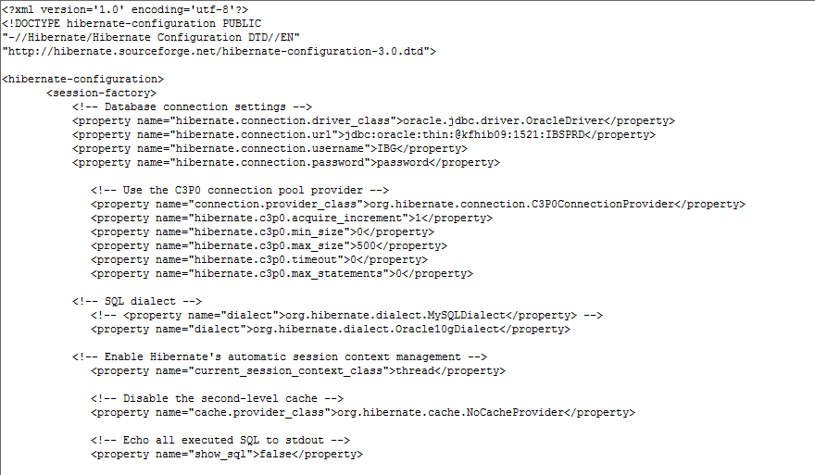

Scheduler configuration properties file

Scheduler Consumer Setting
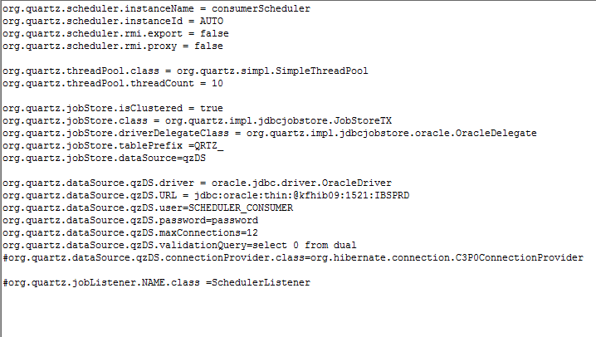

Scheduler BIB Setting
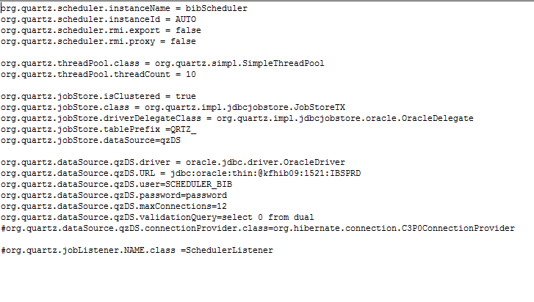

Scheduler IBG Setting
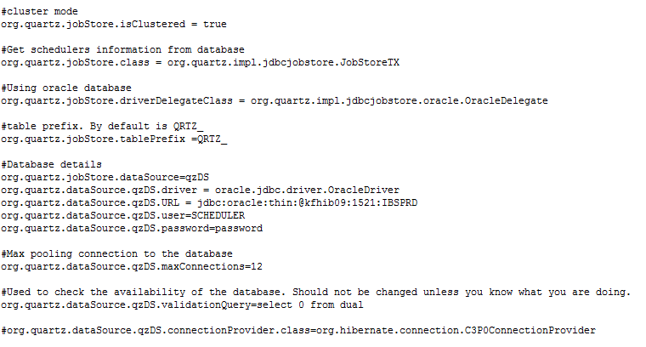

Beneficiary Bank Name configuration properties file

Display in jsp page
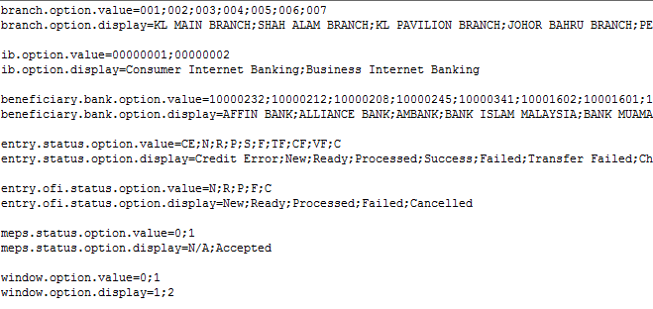

Used in Application
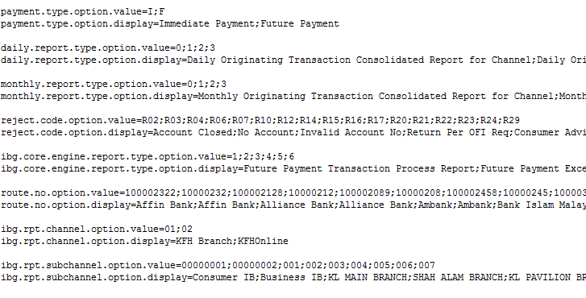

CORUS report directory configuration properties file

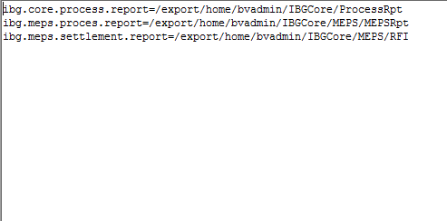

IBG Server configuration file

Hibernate XML file
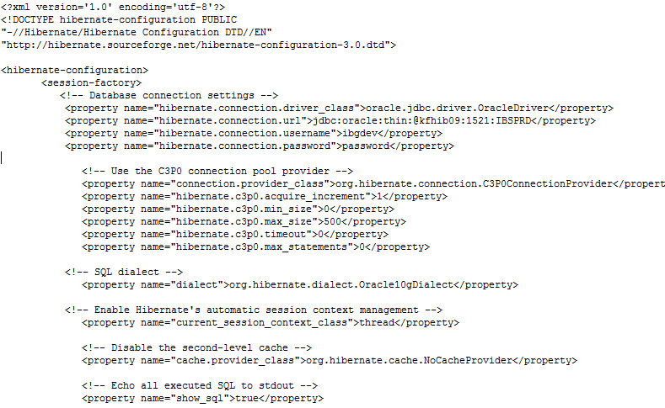

Properties file: Setting.properties
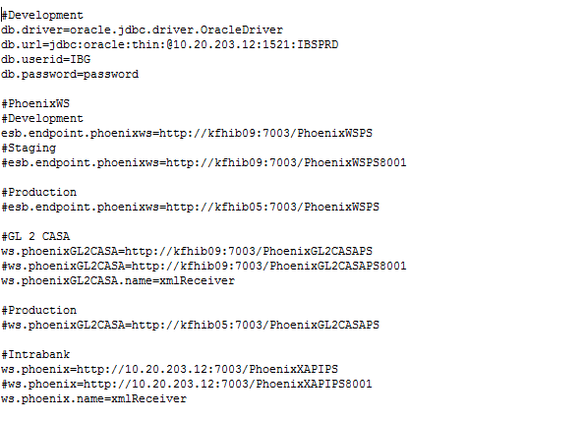

Properties file:SettingScheduler.properties
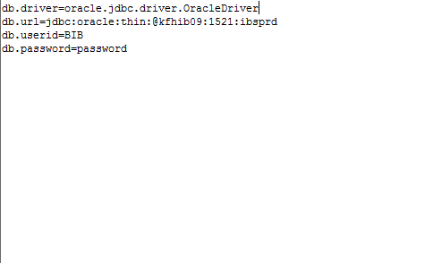

IBG Entry validation Configuration properties file

Properties file: BankAccountNoLength.properties

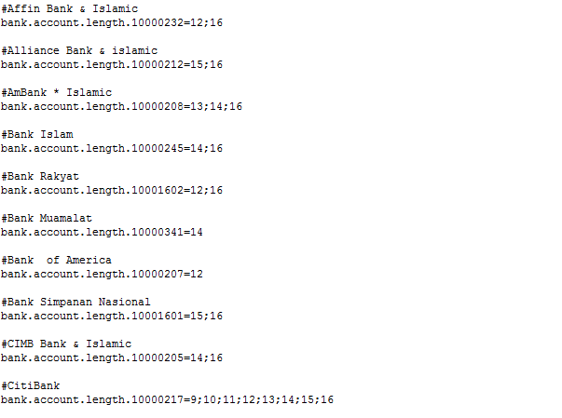

Properties file: rc.properties
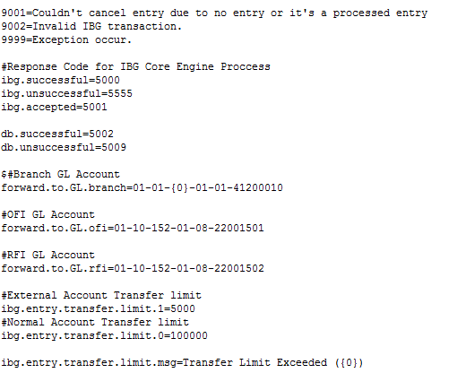

Properties file: Setting.properties
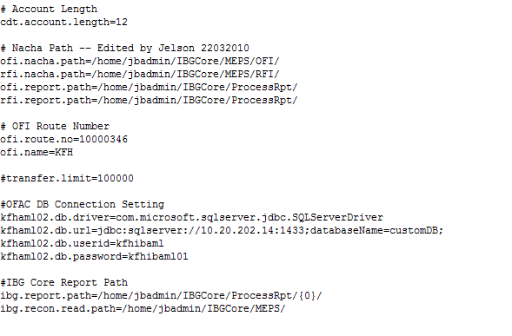

Debiting & Crediting Configuration properties file
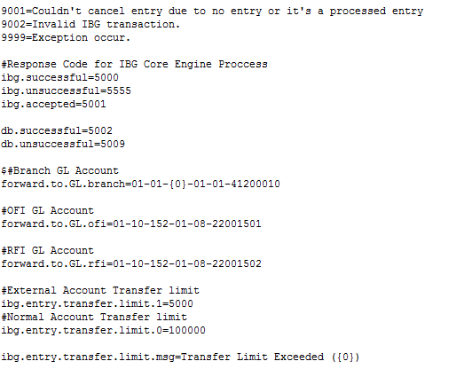

IBG Crediting validation configuration properties file

Properties file: Setting.properties
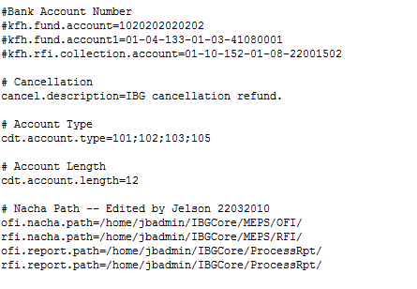

Properties file: Setting.properties
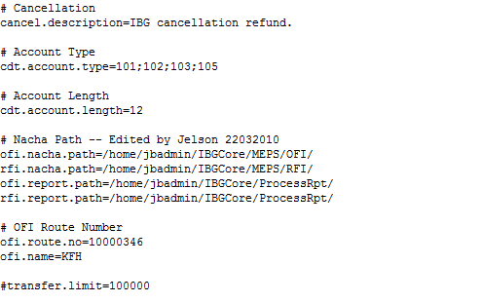

NACHA & Report path configuration properties file
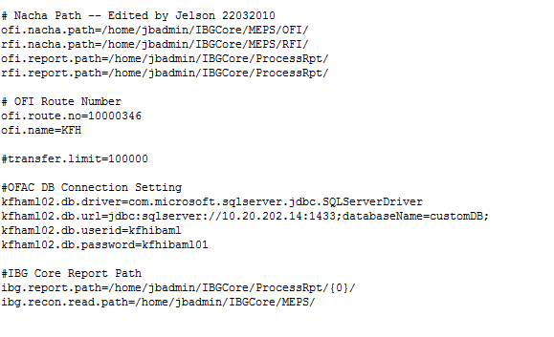

Log4j XML configuration file
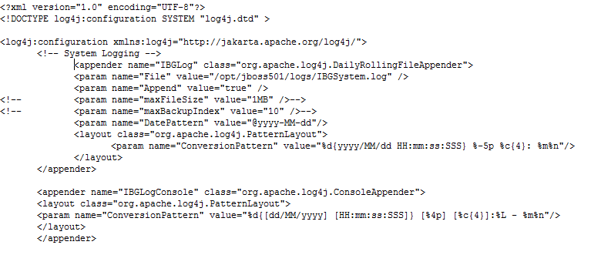

IBG XML Format

Request XML Format

<Msg>
<MsgHeader>
<ServiceID>101</ServiceID>
<channel>01</channel>
<subChannel>00000001</subChannel>
</MsgHeader>
<MsgBody>
<toBankRouteNo>10000233</toBankRouteNo>
<fromAccountNo>1234567891012</fromAccountNo>
..
..
..
..
..
..
<forwardCharges>001</forwardCharges>
</MsgBody>
</Msg>

Response XML Format

<Msg>
<MsgHeader>
<ServicesID>101</ServicesID>
<respCode>5000</respCode>
<respMsg>Successful</respMsg>
</MsgHeader>
<MsgBody>
<Records>
<Record>
<chargeRespCode>0000</chargeRespCode>
<chargeReferenceNo>123456</chargeReferenceNo>
<fundRespCode>0000</fundRespCode>
<fundReferenceNo>123457</ fundReferenceNo>
<oid>20100729001234</oid>
</Record>
</Records>
</MsgBody>
</Msg>

