Tested in RIB UAT on 31.07.2012 – OK

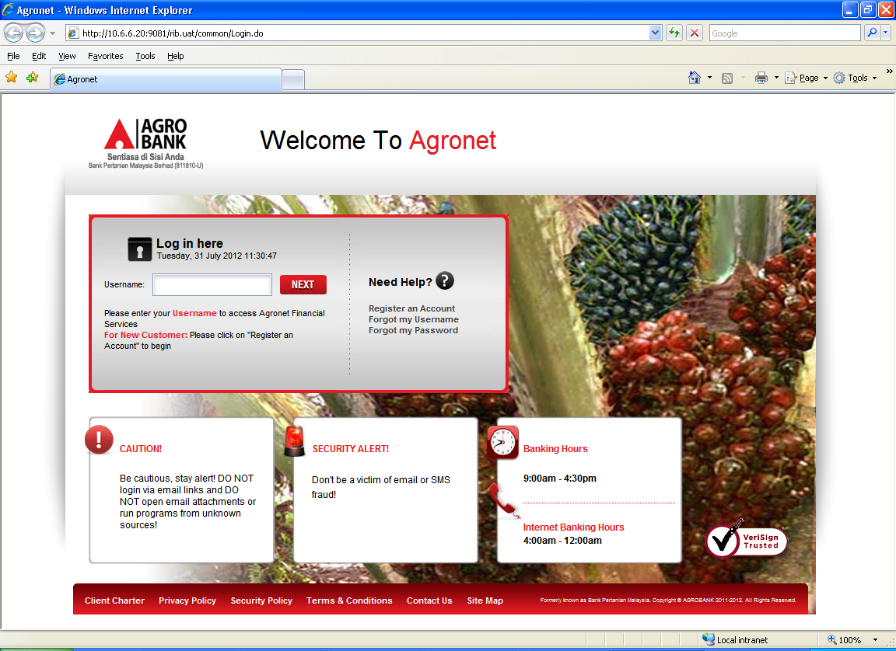
Click here



After click the Agrobank’s logo, it will go to Agrobank Home Page.

