Agrobank

REVERSE PROXY SETUP

USING

IBM PLUGIN

Contents

Plugin Installation step 3

Plugin-cfg file 11

Apache Web server 11

## Plugin Installation step

1. Run the installer and click **Launch the installation wizard for Web Server plug-ins**

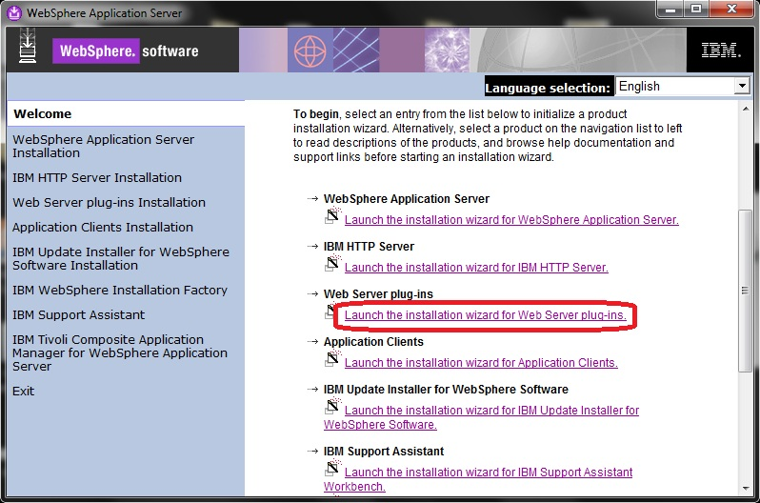

1. Click **Next**

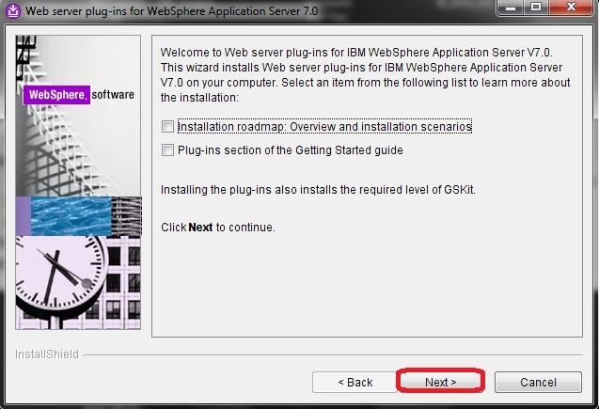

1. Accept the terms and click **Next**

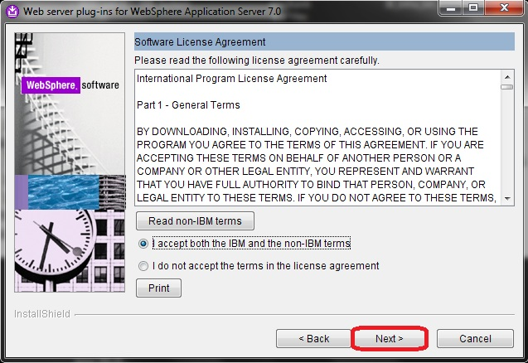

1. Click **Next**

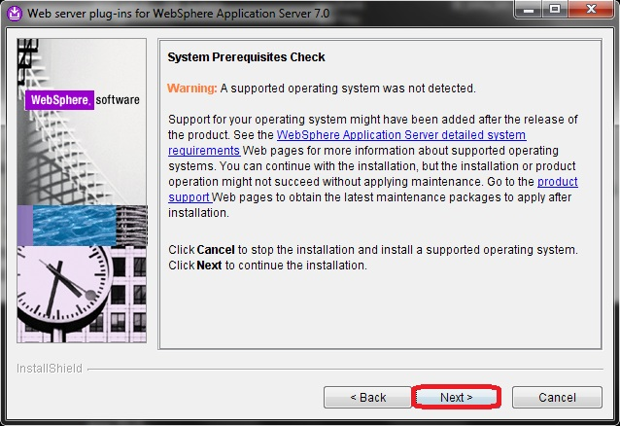

1. Choose **Apache Web Server V2.2** and click **Next**

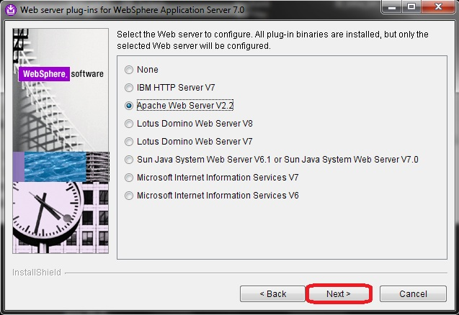

1. Choose **remote** option and click **Next**

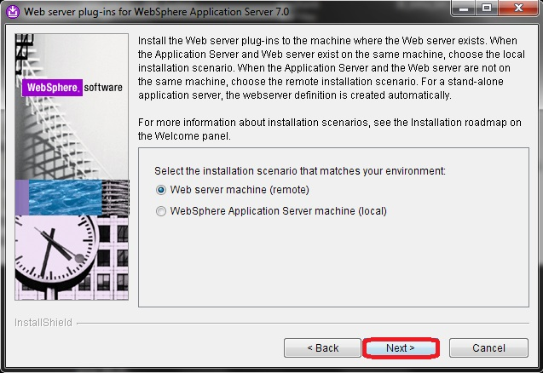

1. Specify the plugin installation directory and click **Next**

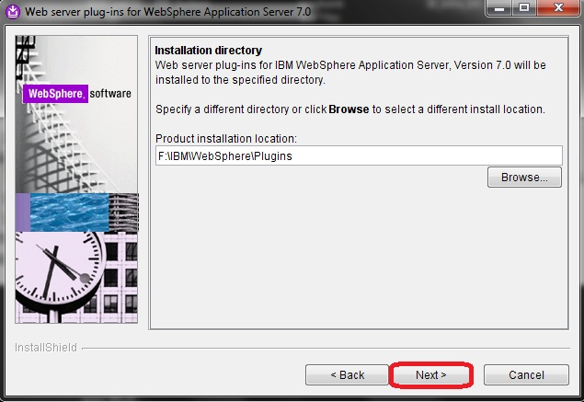

1. Select the httpd.conf file from the local machine(Apache).

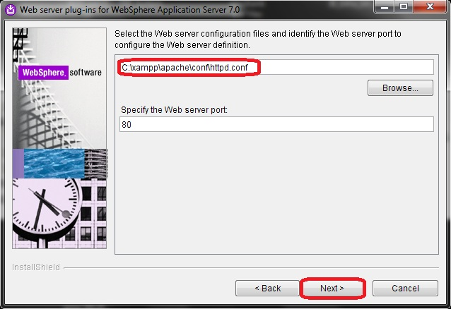

1. Specify the Web server name or proceed with default name.

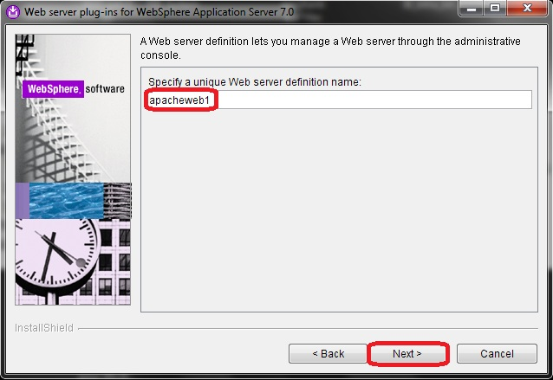

1. Click **Next** to proceed.

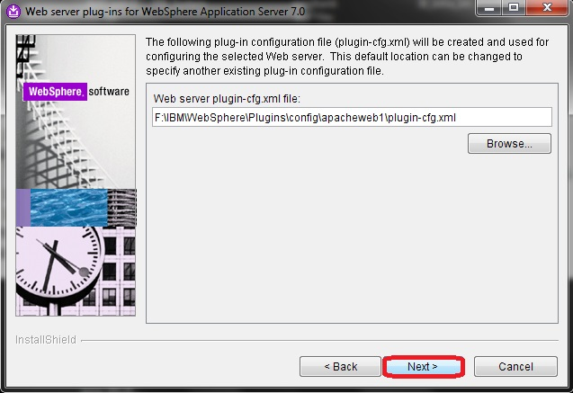

1. Enter the Info Site(CMS) server IP(either one)

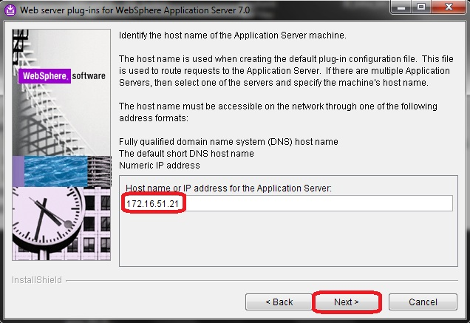

1. Click **Next** to proceed.

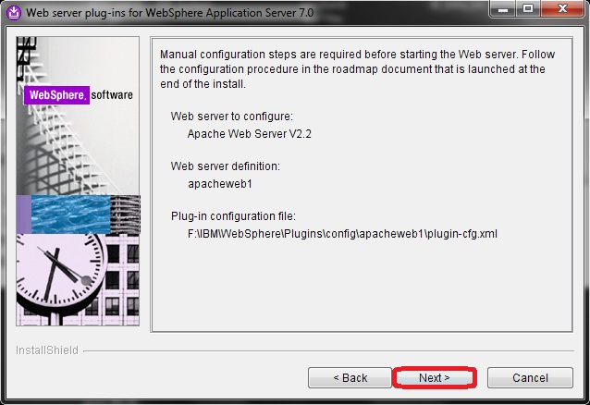

1. Click **Next** to proceed.

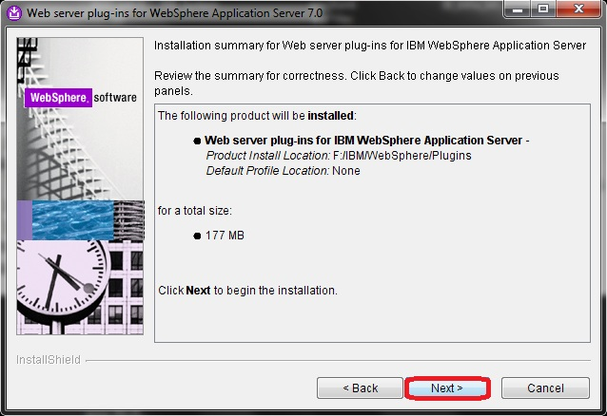

1. Installation progress.

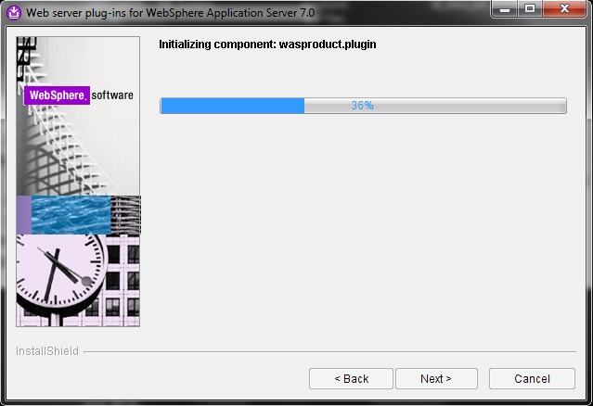

1. Click Next to proceed.

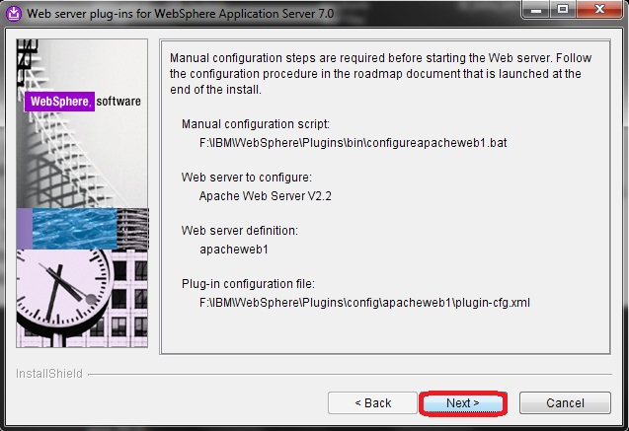

1. Click **Finish** to complete the plugin installation.

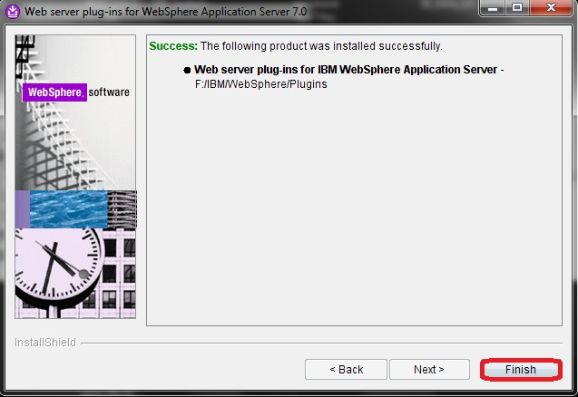

## Plugin-cfg file

1. To support redirection for multiple products, the configuration files must be merged to a single plugin-cfg.xml file.
2. Copy plugin.xml file in CMS1 and CMS2 server from **D:\IBM\WebSphere\AppServer\profiles\AppSrv01\config\cells\ibcmssvr1Node01Cell\nodes\ibcmssvr1Node01\servers\server1** to **C:\IBM\Websphere\AppServer\bin** and rename it using different name. Eg:- *plugin1xml* and *plugin2.xml*.
3. Open CMD as administrator. Point to **C:\IBM\Websphere\AppServer\bin** and run this command:

pluginMerge.bat plugin1.xml plugin2.xml output.xml

Notes: output.xml is the file after merged.

1. After the merges are complete, rename output.xml to plugin-cfg.xml and copy or move it to plugin installation directory (Apache server).

**C:\IBM\WebSphere\Plugins\config\apacheweb1**

1. Copy *configureapacheweb1.bat* in Apache server from this directory :

**C:\IBM\WebSphere\Plugins\bin** to **C:\IBM\WebSphere\AppServer\bin** in CMS1 and CMS2

1. In CMS1 and CMS2 server open CMD as administrator and point to:

**C:\IBM\WebSphere\AppServer\bin** and run this command:

configureapacheweb1.bat

# Apache Web server

1. Stop the Apache server
2. In httpd.conf file make sure **mod_jk.so** and **mod_jk.conf** disabled.

#LoadModule jk_modules/mod_jk.so

#Include “C:/xampp/apache/conf/mod_jk.conf

1. After save the httpd.conf, start the Apache server