
Issue Form (PROD)
Originator's Name: Chooi So Fun  Project: Internet Banking  Project Manager: Malarvili / Chris Gunn  Module : IB  Date Raised: 02.08.10  Phase : Consumer Internet Banking  Functional Area : BVMC (CIB) | Issue ID Number: C005  Related Issue ID Number:  Classification:  Priority: Critical/High/Medium/Low  Assigned to: Vendor / IT / PMO SA / UPA  Actual Closed Date:
Status: Open/Assigned/Investigated/Resolved/Approved/Deferred/No Action (Circle one)
Description :  For CIB, the following reports dated 31.07.10 are not available for retrieval at BVMC:  - Monthly Consolidated Transaction IB  - Statistical Report  - SI Maintenance Rpt  (Refer to below attachment for details) |  | Impact:
Findings/Root Caused (Description): |  | Resolution:
Estimated Impact :

Recommendation:

Accepted :  (Vendor / IT / PMO SA / UPA)  Date: | Accepted (KFHMB Tester):  Date:

Monthly Consolidated Transaction IB Report
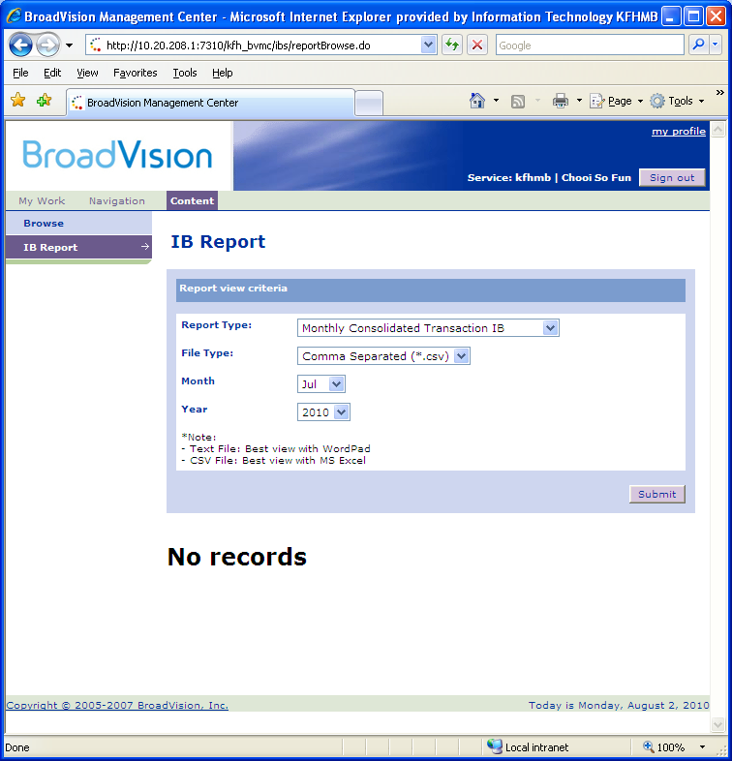

Statistical Report:
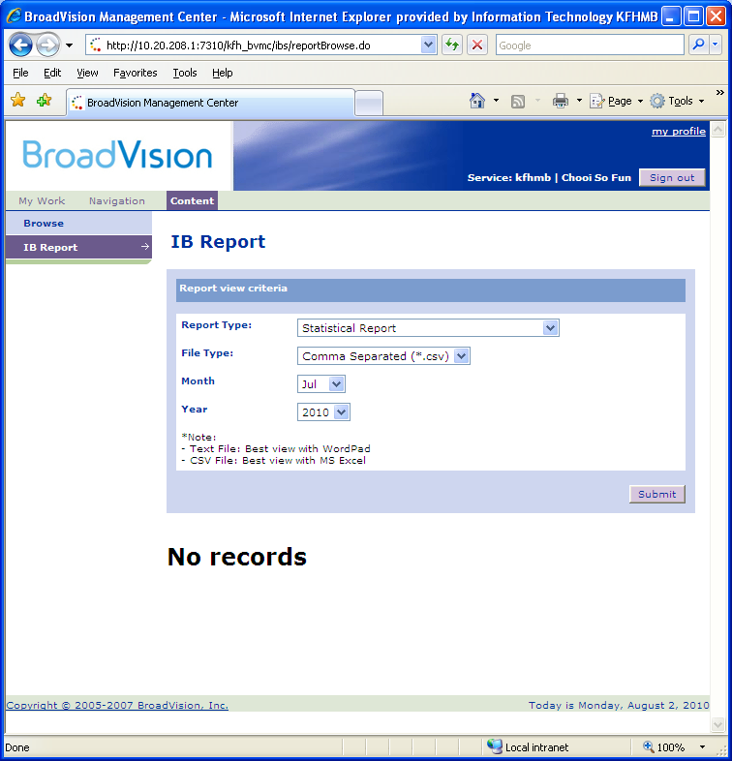

SI Maintenance Report
