1. Firefox – alignment out

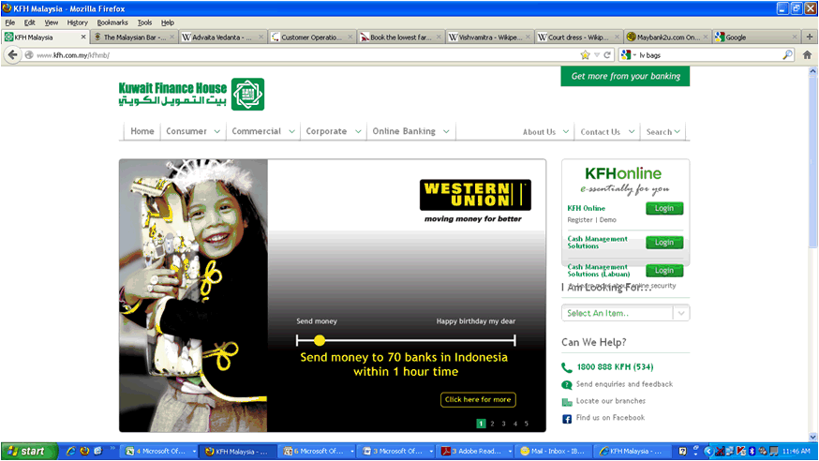

1. Learn more about online security > Page deleted

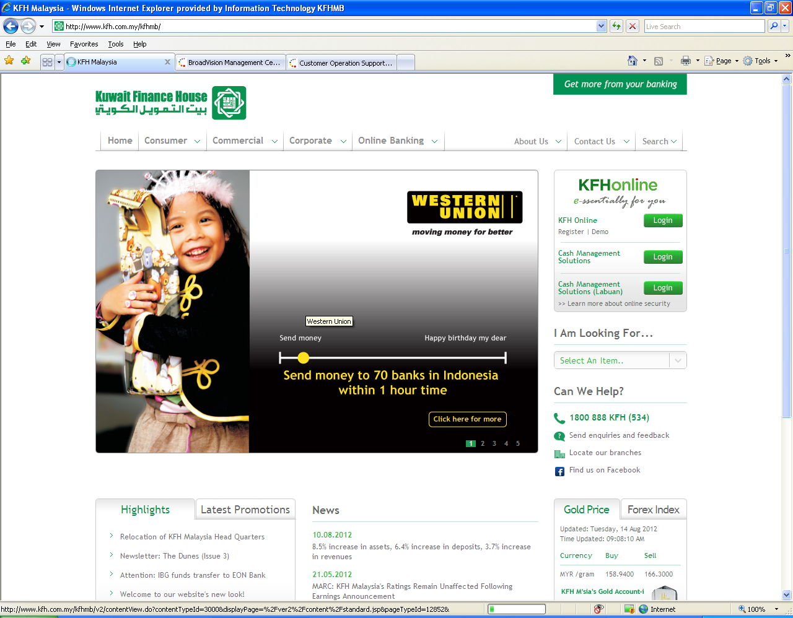

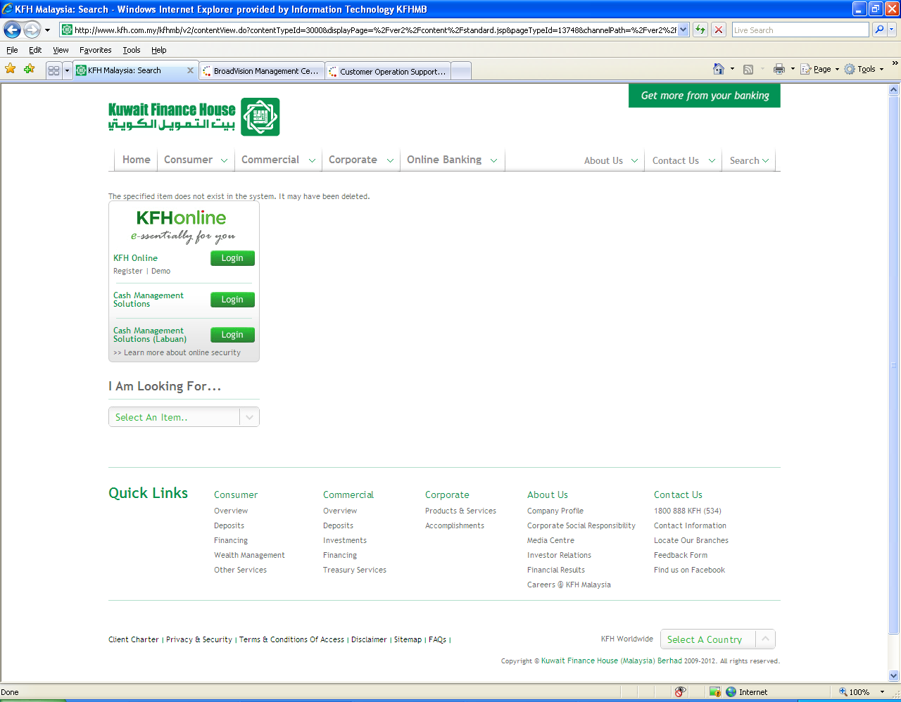

1. Pls delete Alert

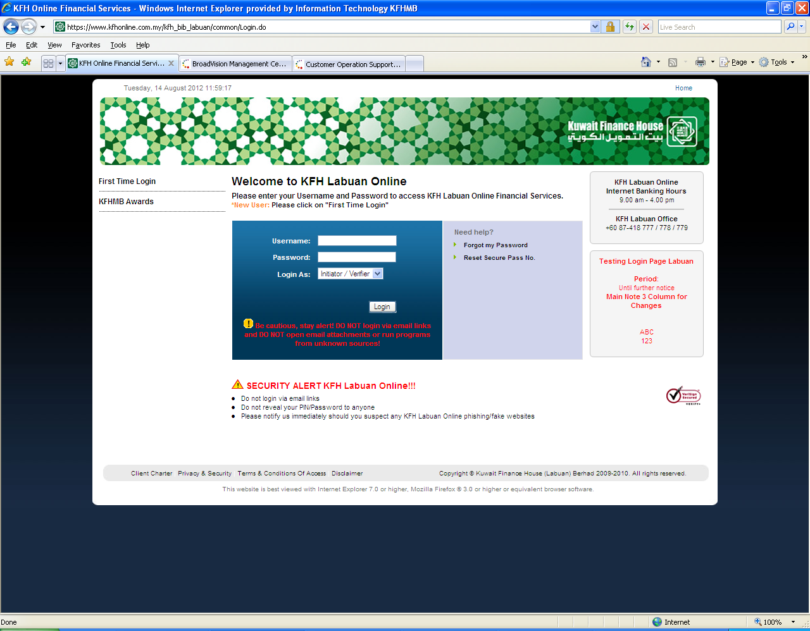

1. Security Alert > Error page

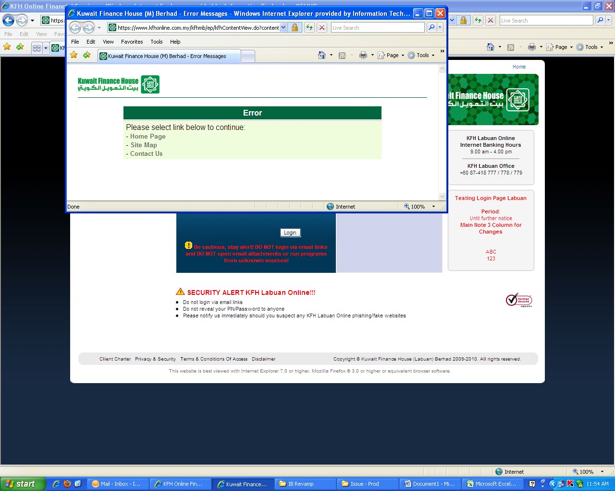

1. On Chrome: Spacing too big between banner and highlight (comments from Corp Comm)

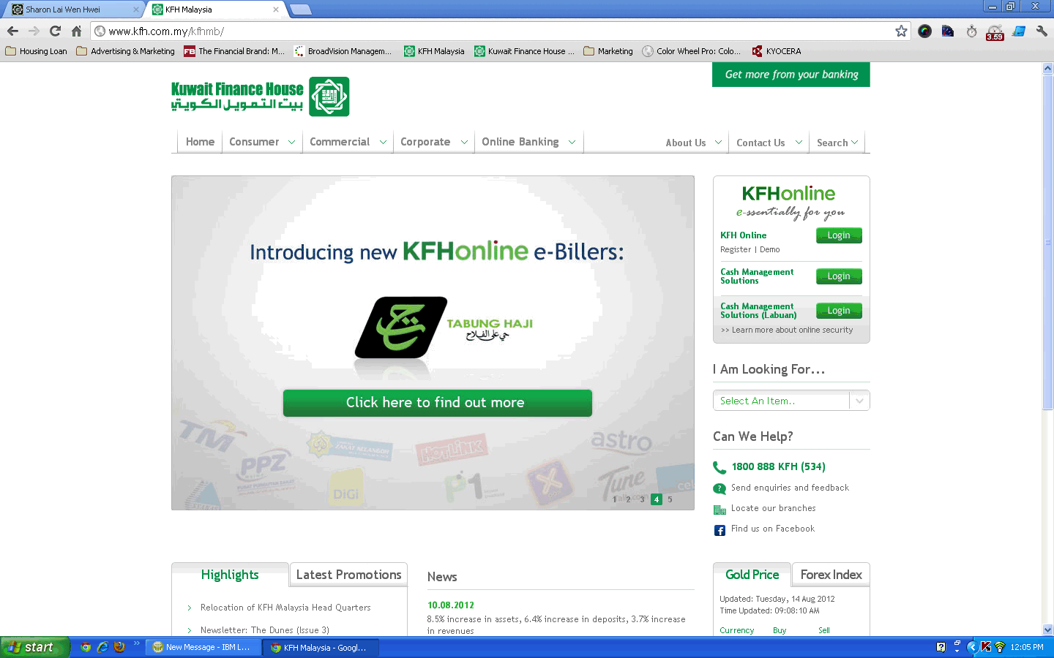

1. Login box – separate between KFH Online and Labuan (we encountered 1 confused CMS customer today)
2. ‘Learn more about online security’ to be below CMS KL

