TRANSFER LIMIT
RIB PRODUCTION ON 07.09.2012
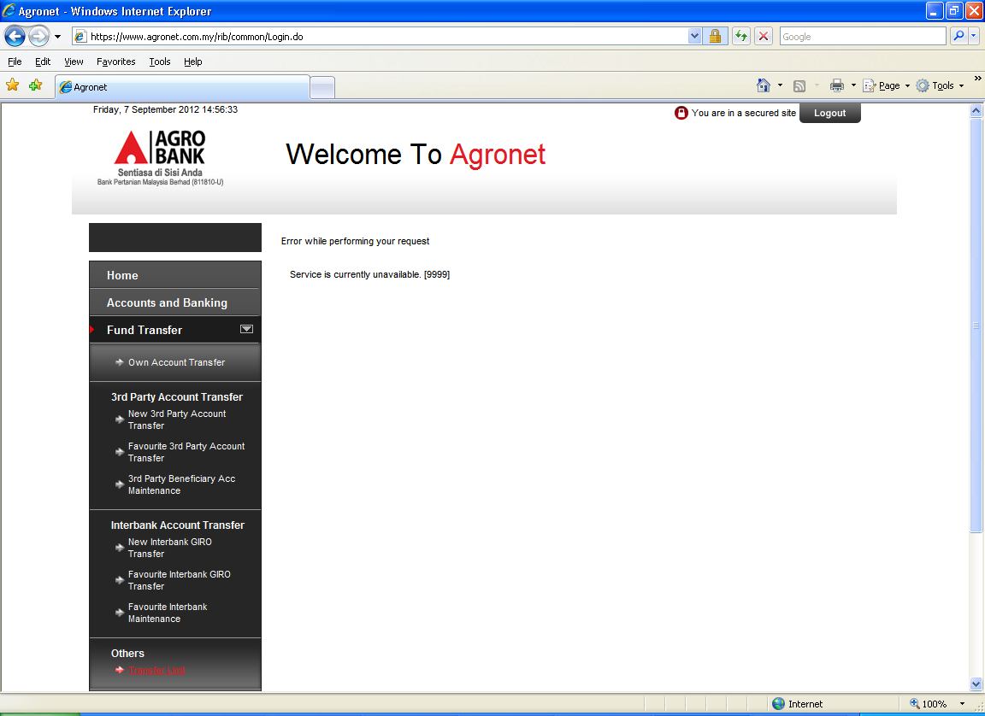
Issue: successful change the limit but when click back the Transfer limit menu, this error page appear.

