RIB REPORT IN IBAM

BILL PAYMENTS REPORT DAILY

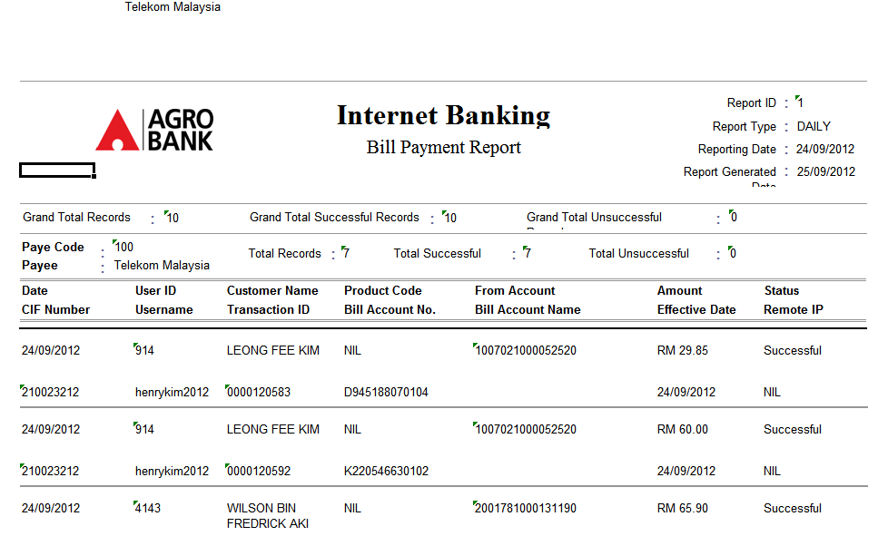
- Add total amount (RM) by payee
- Add grand total amount (RM) for all payees

INTERBANK FUND TRANSFERS REPORT DAILY

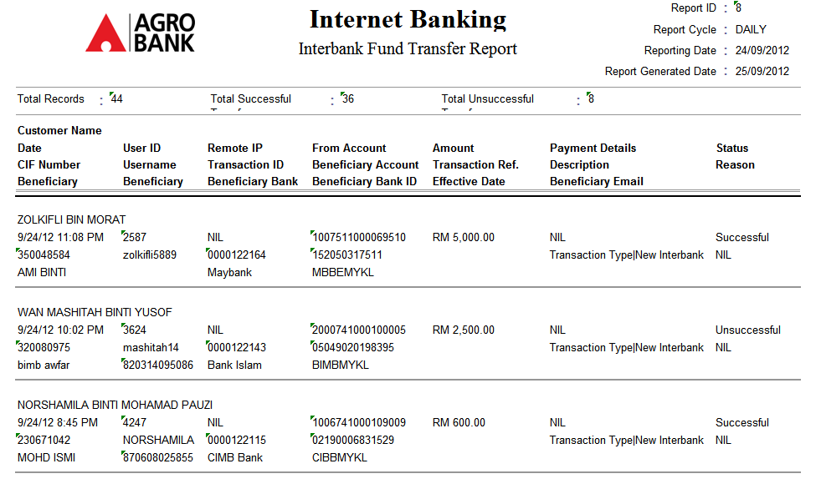
Add grand total amount (RM) for Interbank Fund Transfer similar like Own Account Transfer and 3rd Party Transfer.

