BILL PAYMENT

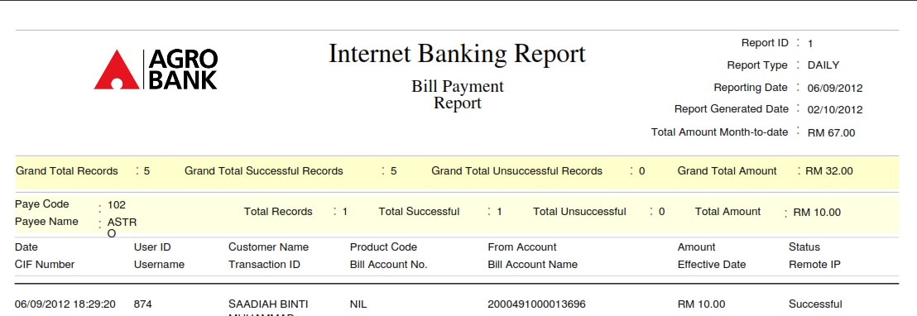

Grand Total Amount and Total Amount per Payee added as per requested.

The Total Amount Month-to-Date will be accumulate and shows in the report even though there is no transaction activity report.

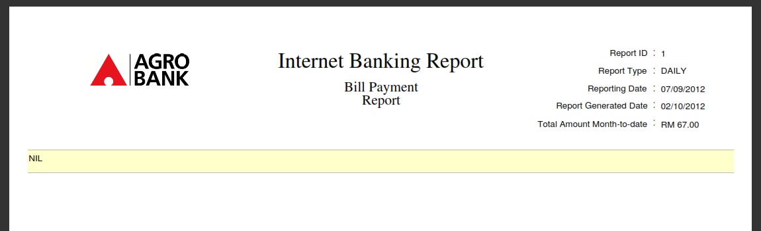

**OWN ACCOUNT TRANSFER**

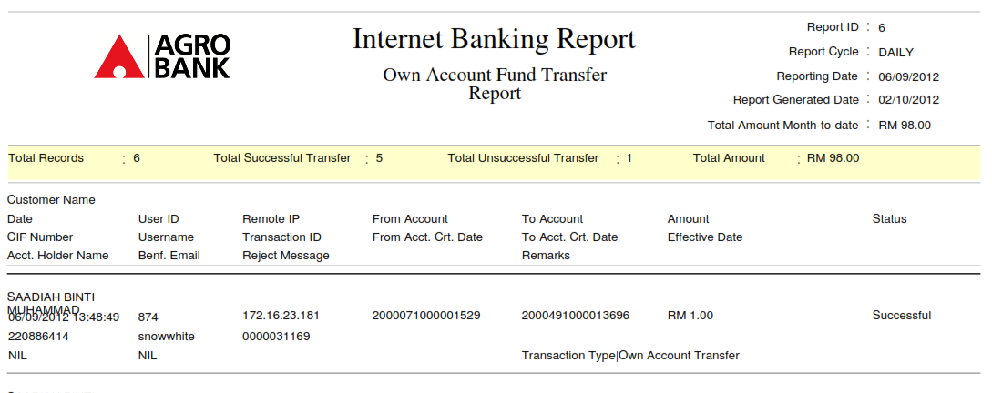

**3RD PARTY ACCOUNT TRANSFER**

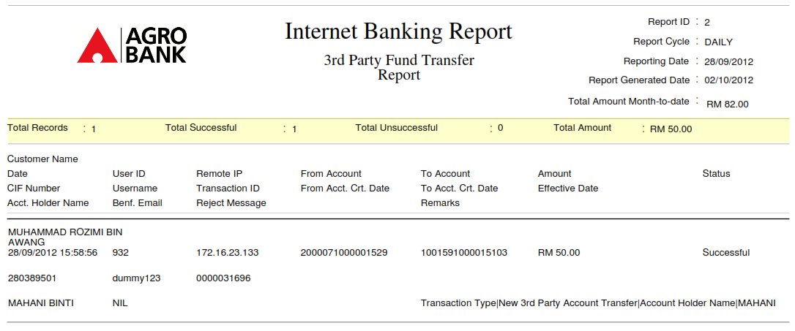

**INTERBANK GIRO TRANSFER**

