RIB PRODUCTION 03.10.2012
Favourite Payee Maintenance – Syarikat Air Terengganu
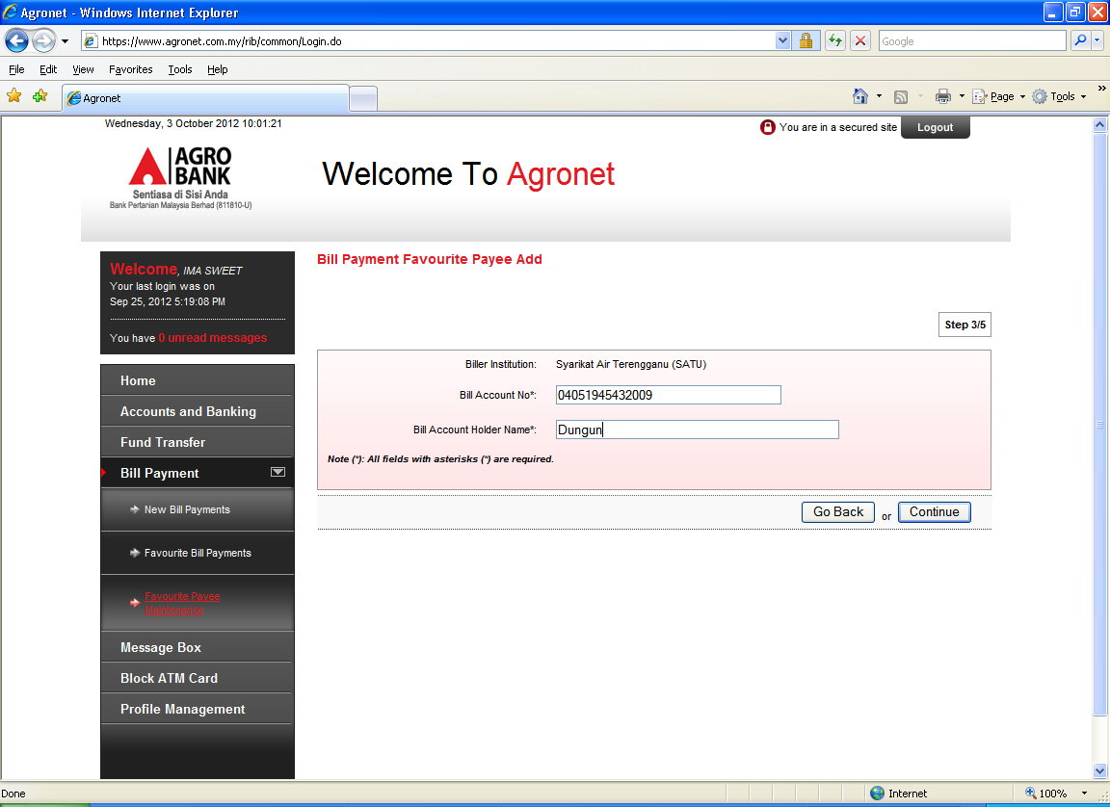
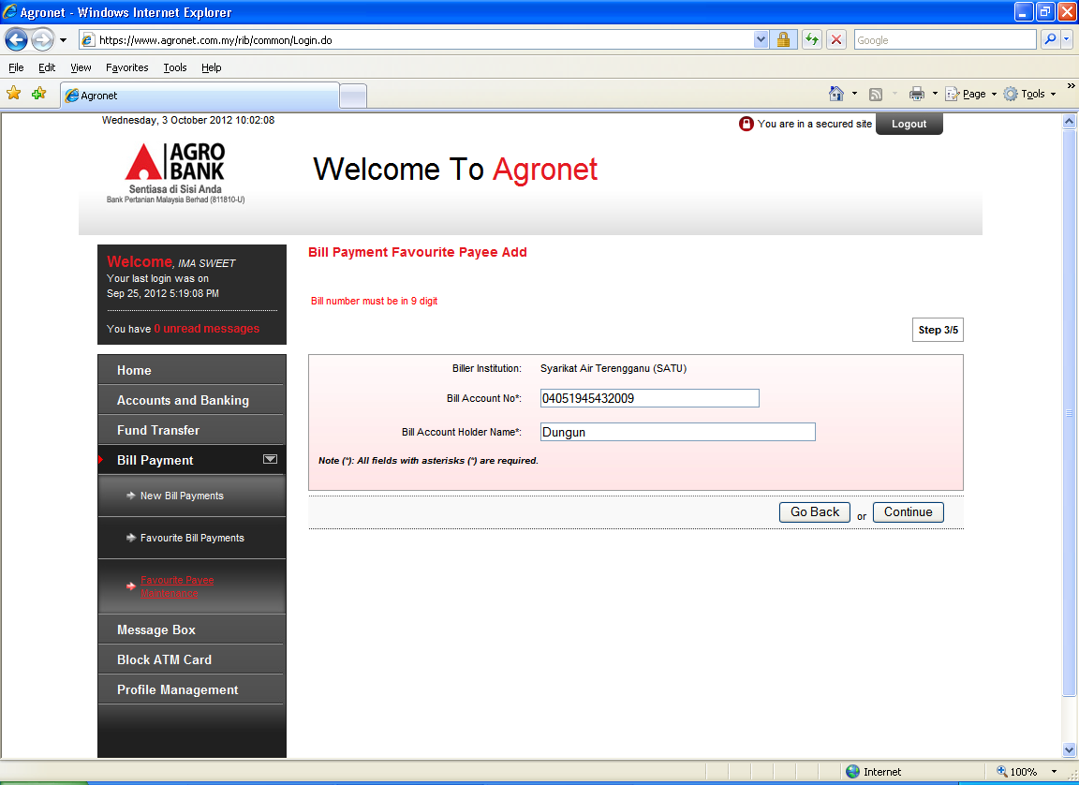
ISSUE:
Add the payee and keyin the account number but this error message appear “Bill number must be in 9 digit”

