AGRONet Production on 03.10.2012
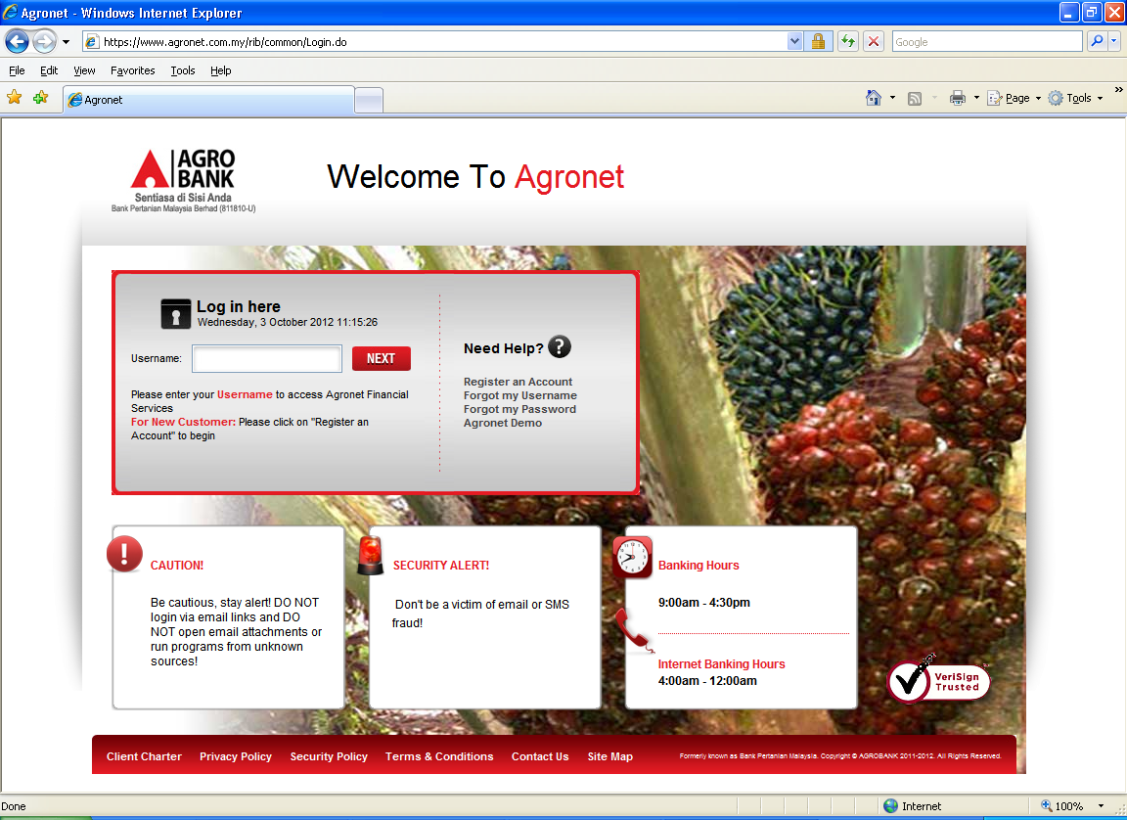

To add Agrobank Contact Centre Number 1 300 88 2476 in this box

