FUND TRANSFER MODULE
- Own Account Transfer > Step 2/3
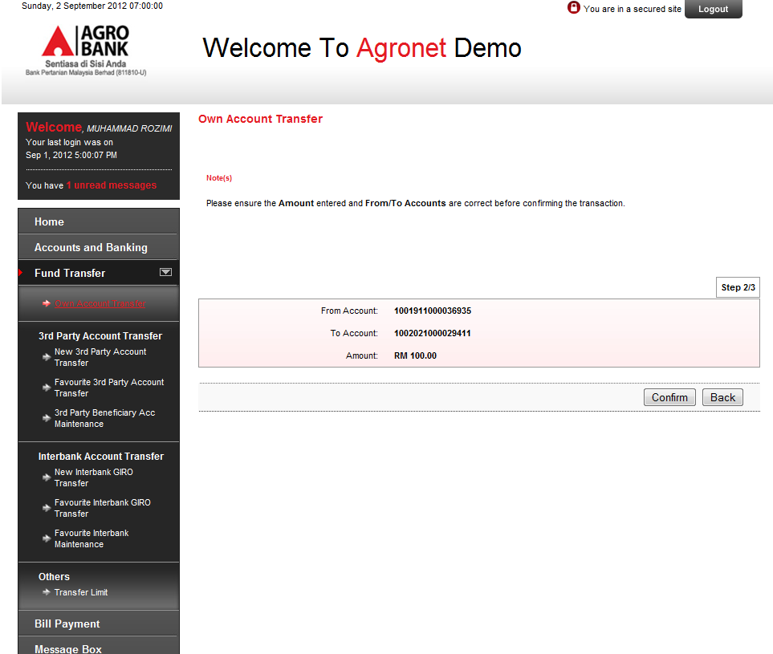
Change location to
Back
Confirm

- 3rd Party Account Transfer > New 3rd Party Account Transfer > Step 1/3
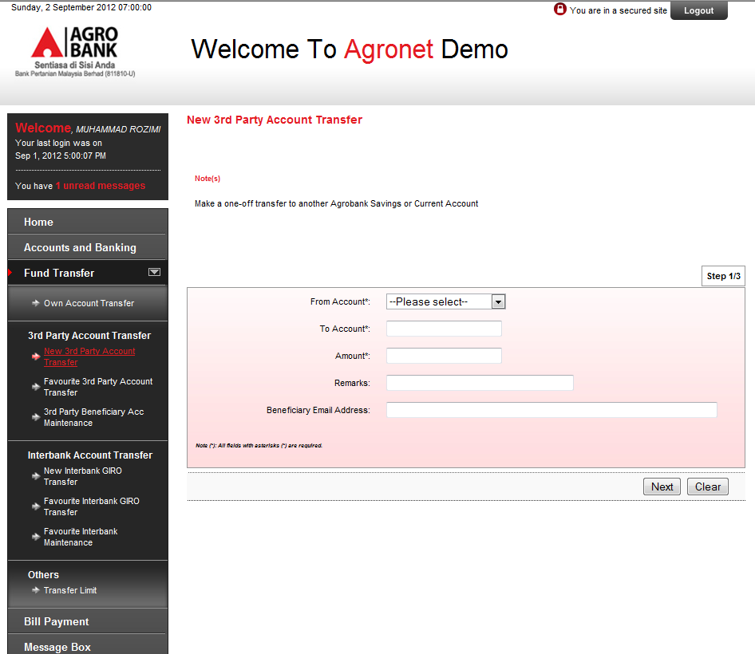
Change location to
Clear
Next

- 3rd Party Account Transfer > New 3rd Party Account Transfer > Step 2/3
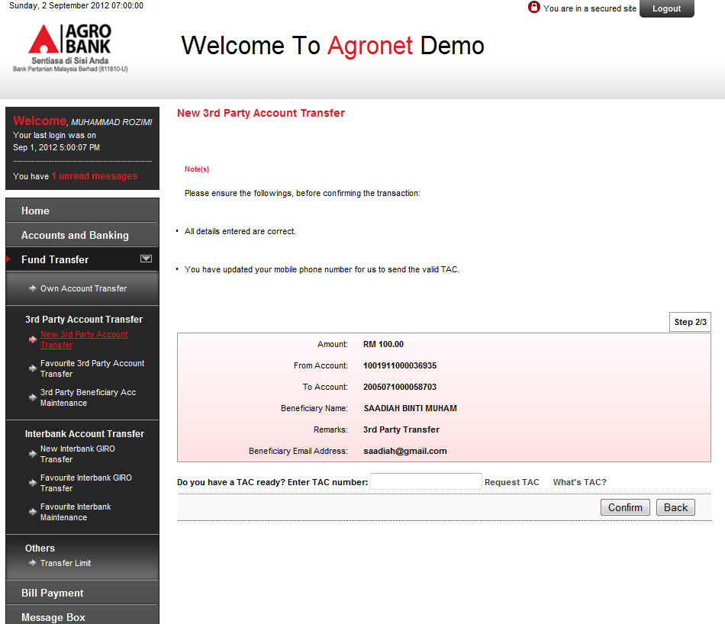
Change location to
Back
Confirm

- 3rd Party Account Transfer > New 3rd Party Account Transfer > Step 3/3
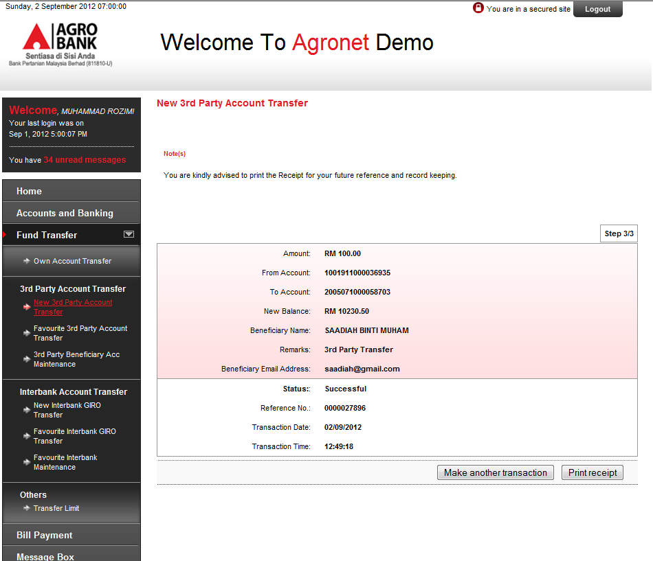
Change location to
Print Receipt
Make another transaction

- 3rd Party Account Transfer > Favourite 3rd Party Account Transfer > Step 1/3
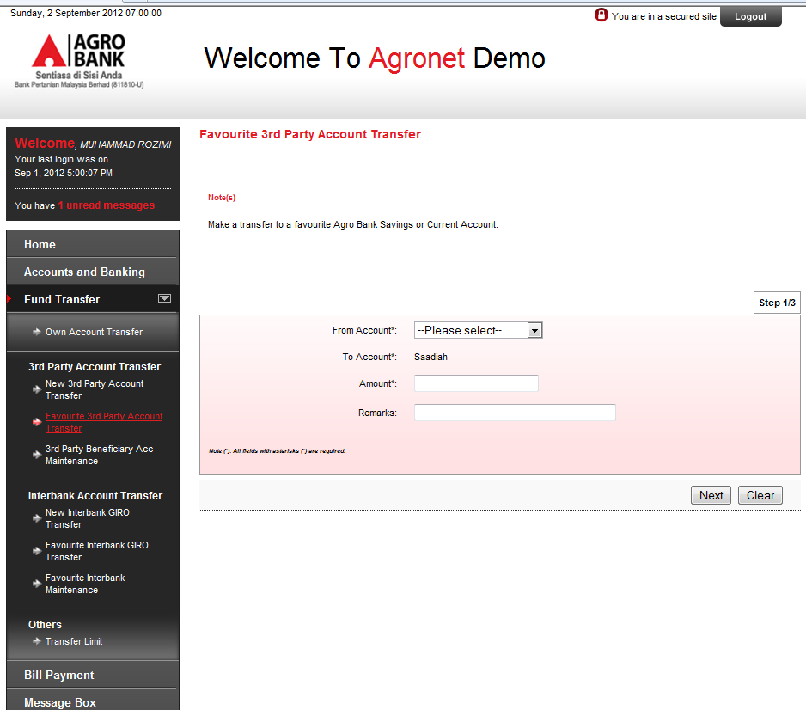
Change location to
Clear
Next

- 3rd Party Account Transfer > Favourite 3rd Party Account Transfer > Step 2/3
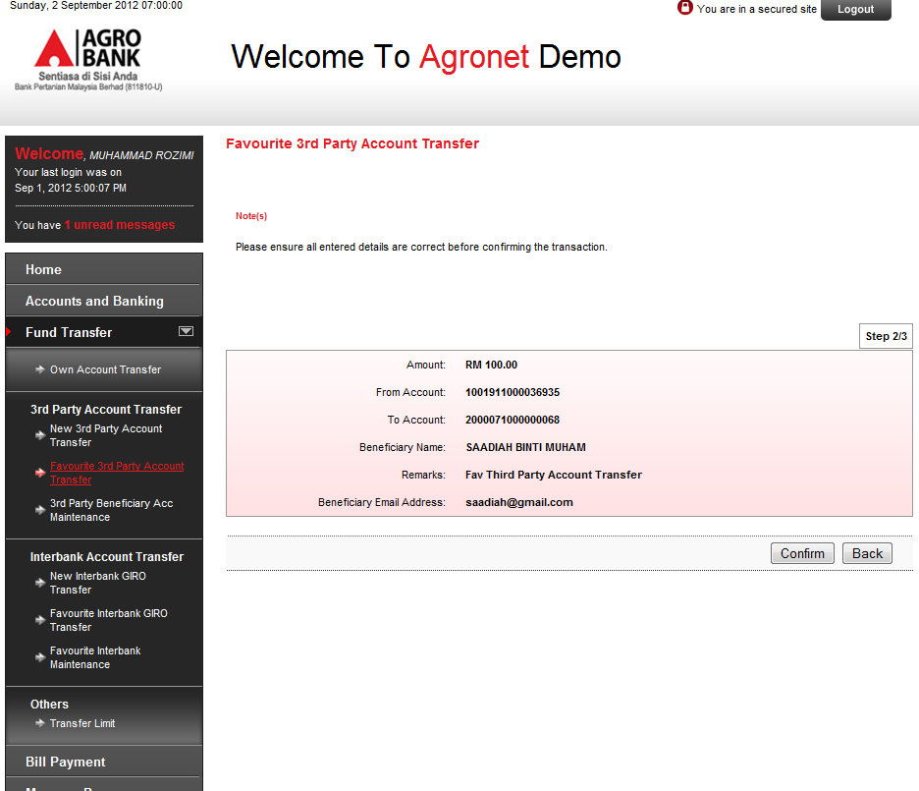
Change location to
Back
Confirm

- 3rd Party Account Transfer > Favourite 3rd Party Account Transfer > Step 3/3
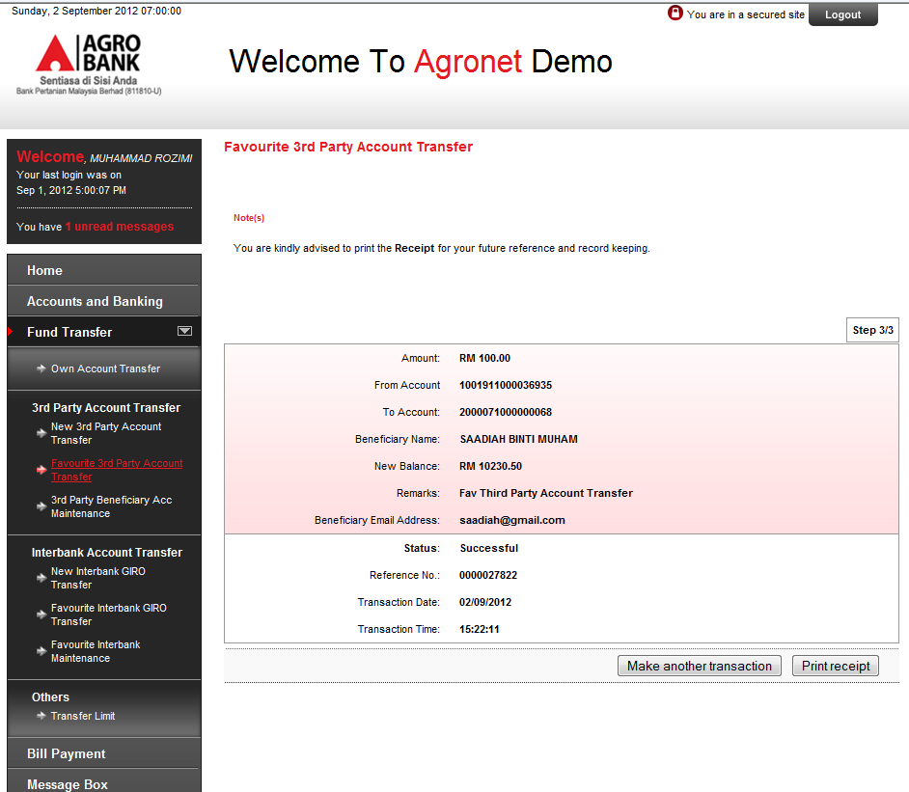
Change location to
Print Receipt
Make another transaction

- 3rd Party Account Transfer > 3rd Party Beneficiary Acc Maintenance > Add > Step 1/3
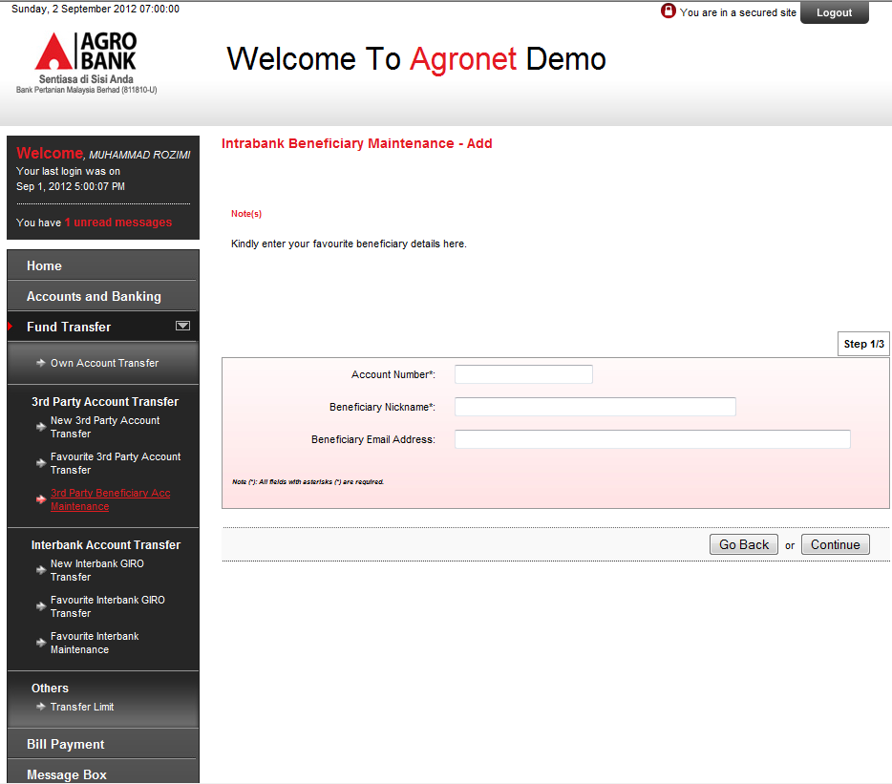
Change Go Back to Back
Change Continue to Next

- 3rd Party Account Transfer 3rd Party Beneficiary Acc Maintenance > Add > Step 2/3
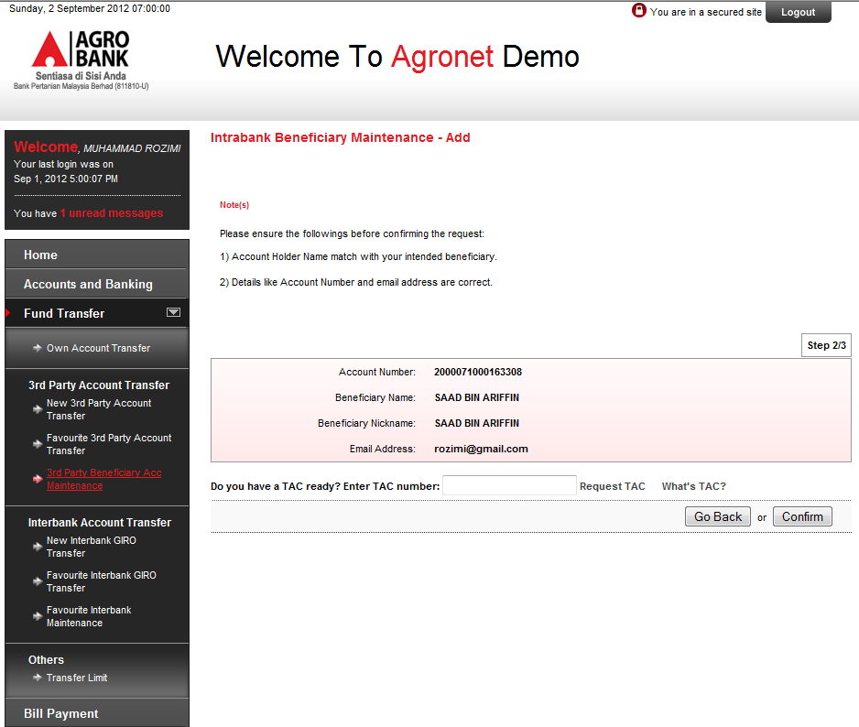
Change Go Back to Back

- 3rd Party Account Transfer > 3rd Party Beneficiary Acc Maintenance > Delete > Step 1/2
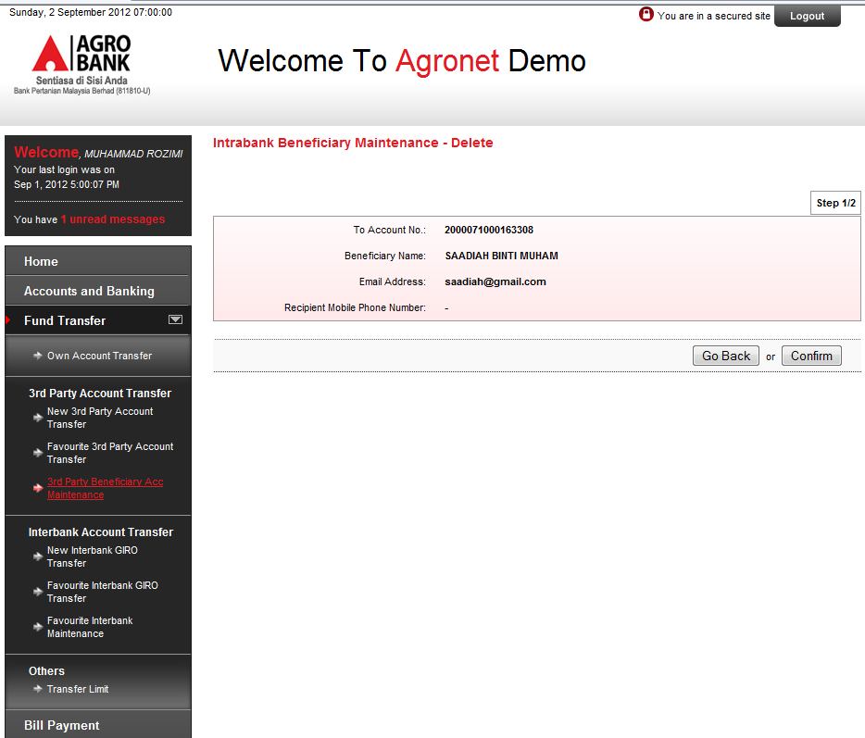
Change Go Back to Back

- Interbank Account Transfer > New Interbank GIRO Transfer > Step 2/3
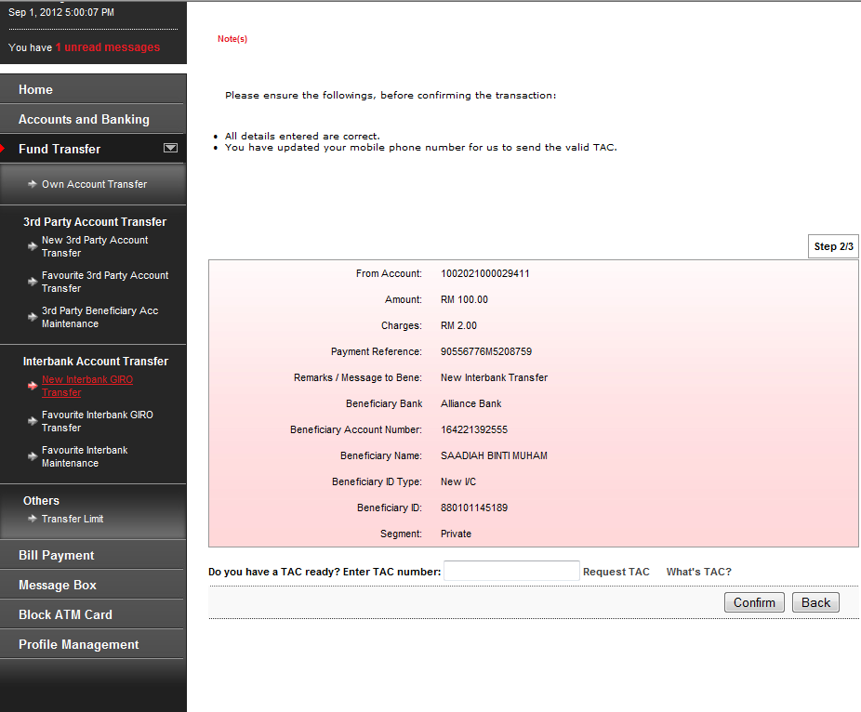
Change location to
Back
Confirm

- Interbank Account Transfer > New Interbank GIRO Transfer > Step 3/3
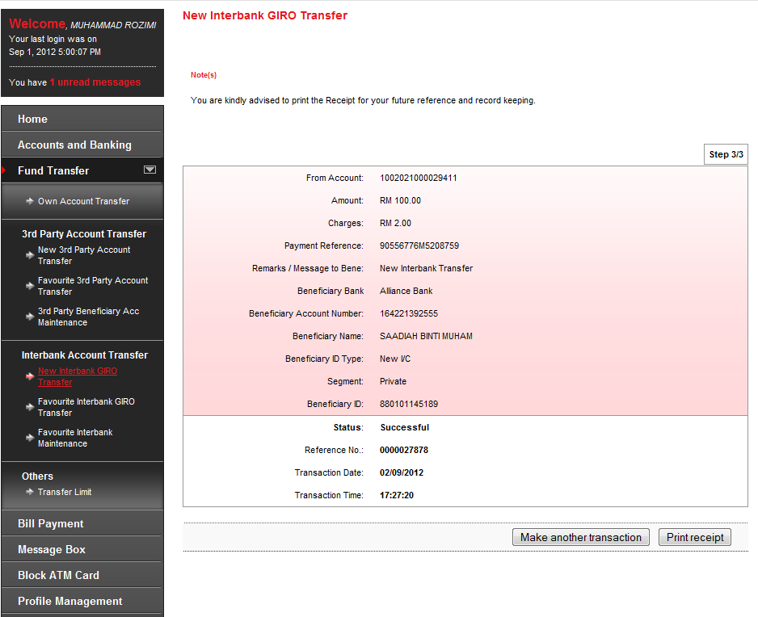
Change location to
Print Receipt
Make another transaction

- Interbank Account Transfer > Favourite Interbank GIRO Transfer > Step 1/3
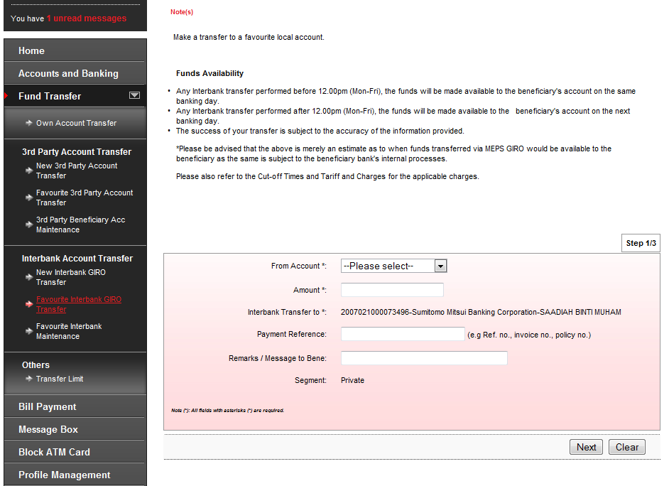
Change location to
Clear
Next

- Interbank Account Transfer > Favourite Interbank GIRO Transfer > Step 2/3
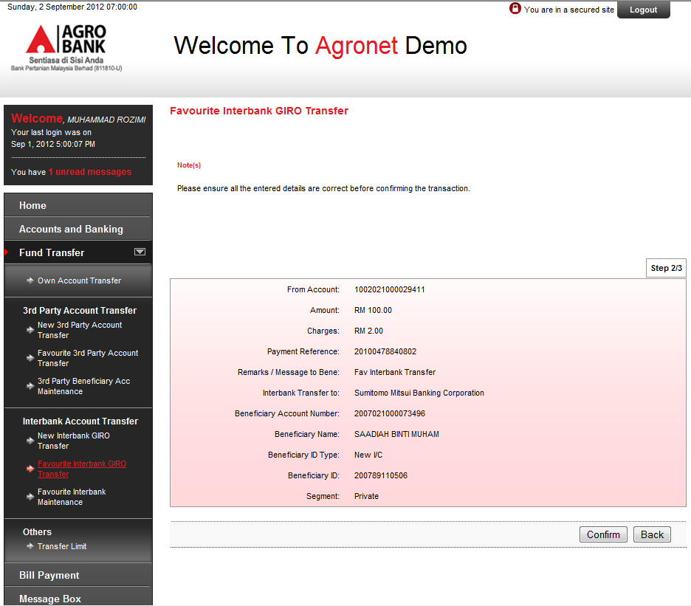
Change location to
Back
Confirm

- Interbank Account Transfer > Favourite Interbank GIRO Transfer > Step 3/3
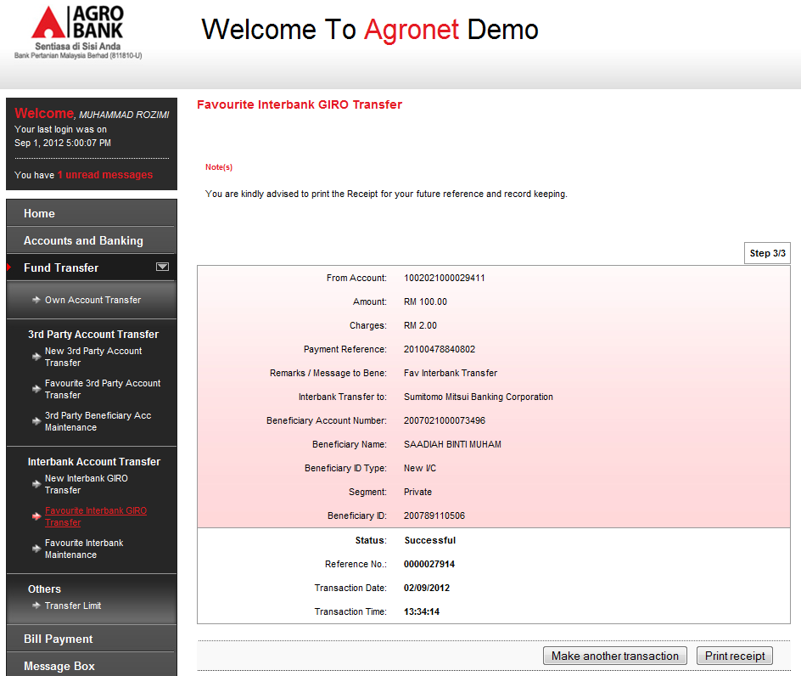
Change location to
Print Receipt
Make another transaction

- Favourite Interbank Maintenance > Add > Step 2/3
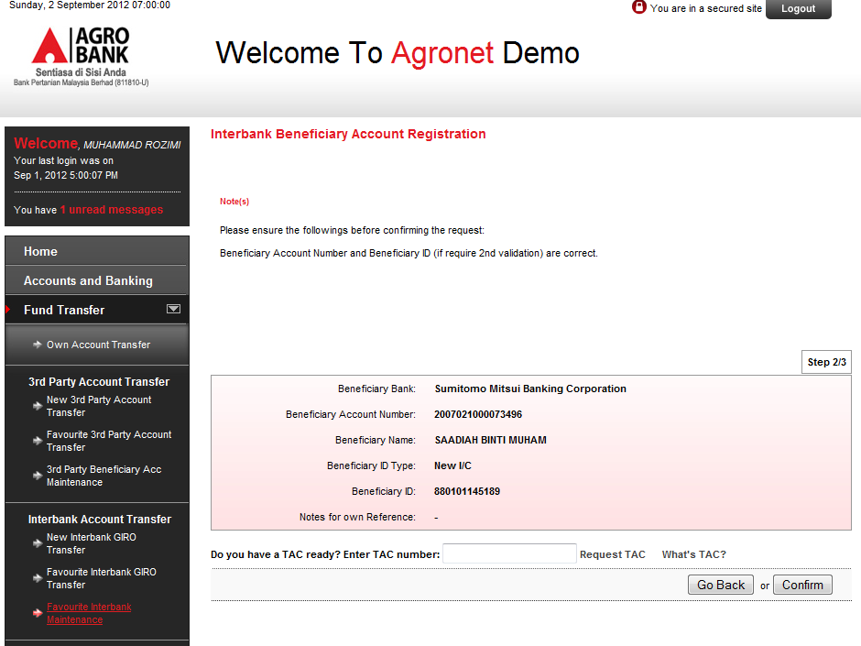
Change Go Back to Back

- Favourite Interbank Maintenance > Delete > Step 1/2
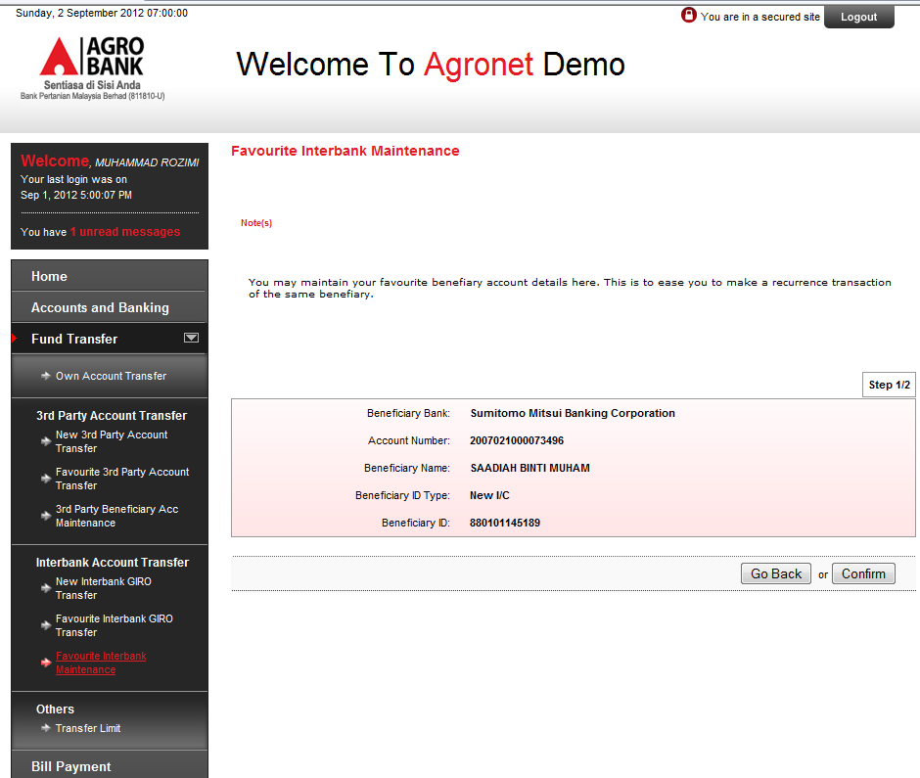
Change Go Back to Back

BILL PAYMENT MODULE
- Favourite Payee Maintenance > Bill Payment Favourite Payee Add > Step 3/5
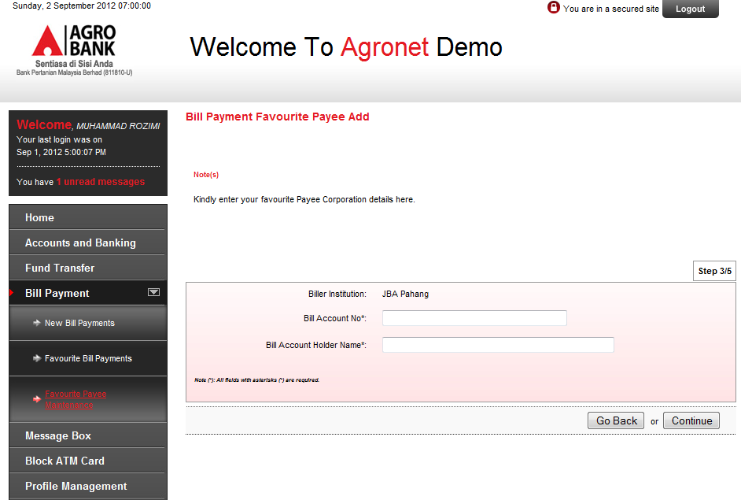
Change Go Back to Back
Change Continue to Next

- Favourite Payee Maintenance > Bill Payment Favourite Payee Add > Step 4/5
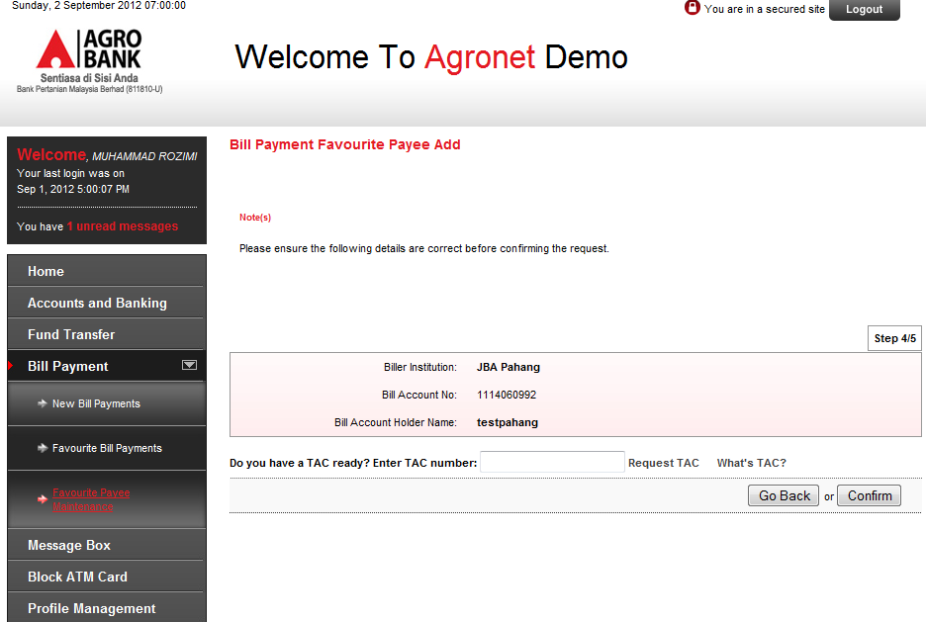
Change Go Back to Back

- Favourite Payee Maintenance > Bill Payment Favourite Add > Step 5/5
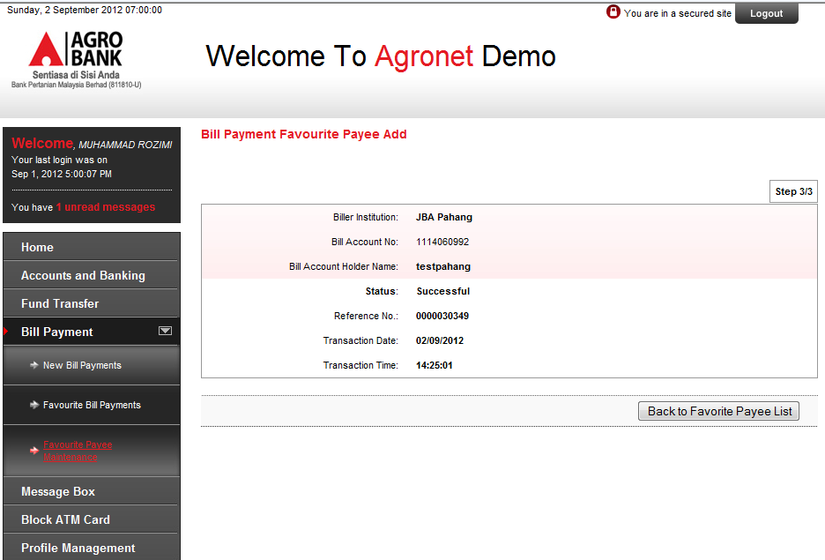
Change Step 3/3 to Step 5/5
only this screen needs to change in Demo page.

- Favourite Payee Maintenance > Bill Payment Favourite Delete > Step 1/2
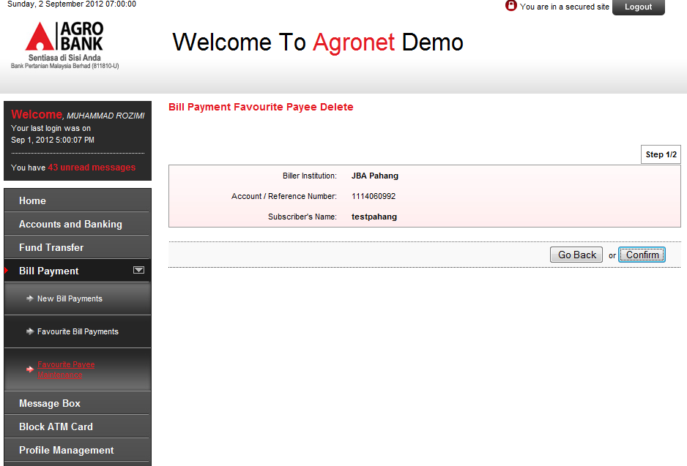
Change Go Back to Back

BLOCK ATM CARD MODULE
- Block ATM Card > Step 2/3
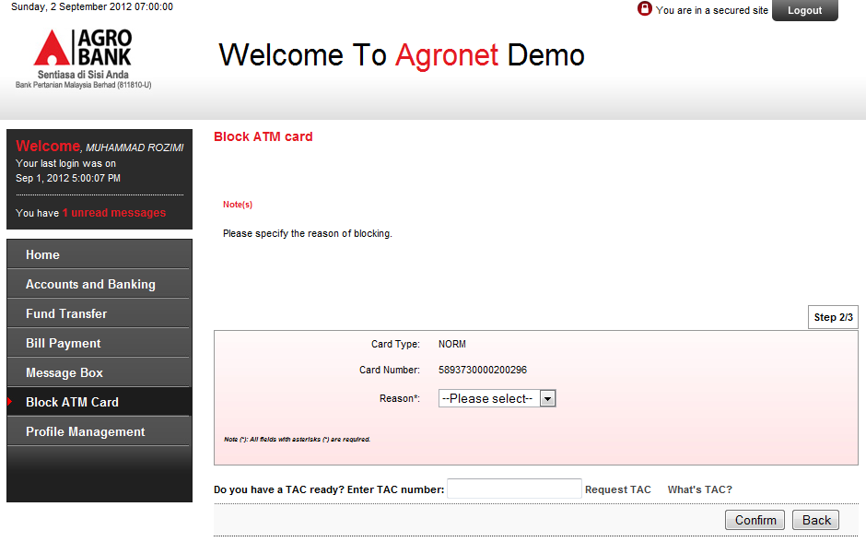
Change location to
Back
Confirm

