RIB UAT 12.10.2012
FROM THIS SCREEN CHANGE TO:
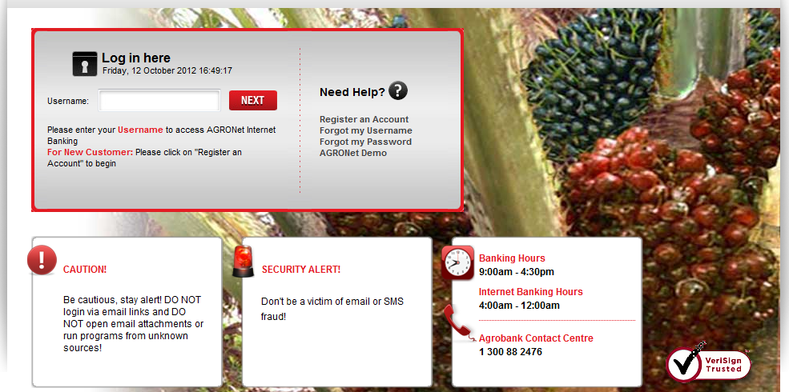

THIS SCREEN:
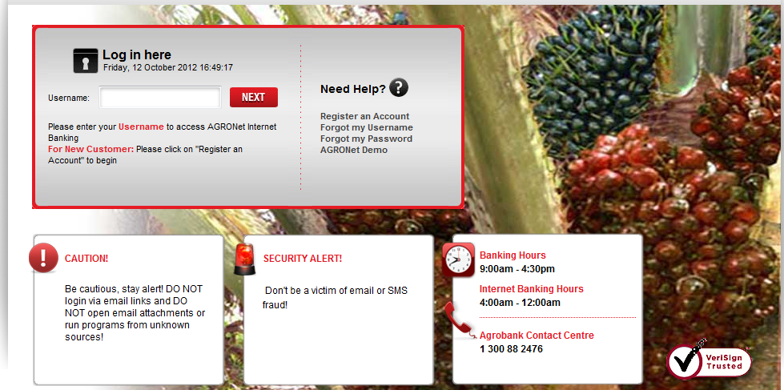
All this 3 topics and sentences shall be align as per above

Please ensure to standardize the font type, size and spacing

Change to capital Letter:

BANKING HOURS
INTERNET BANKING HOURS
AGROBANK CONTACT CENTRE

