**PRINT RECEIPT (LIVE)**

1. **Bill Payment**

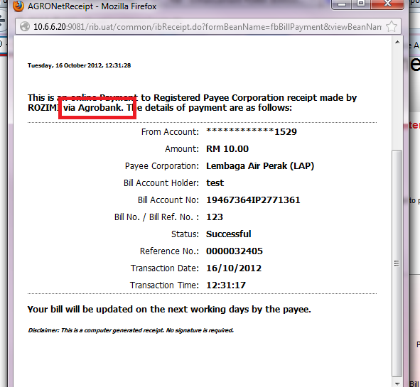

1. **Fund Transfer**

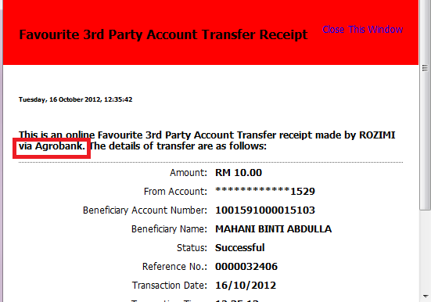

* To change “via Agrobank” to **“via AGRONet”** as per customer **File** [IE000105SP_15_oct_-1.docx](http://hub.penril.net/redmine/attachments/1423/IE000105SP_15_oct_-1.docx) added

**LOGOUT PAGE**

1. **Live**

