Test Case#1: Create Payee Category Content in IBAM

Issue: Field Maximum Payment shows 3 times.

**FIXED & TEST SUCCESSFULLY**

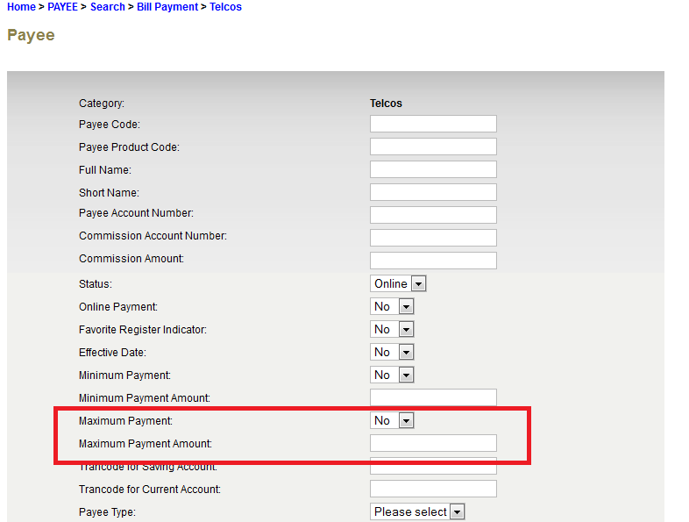

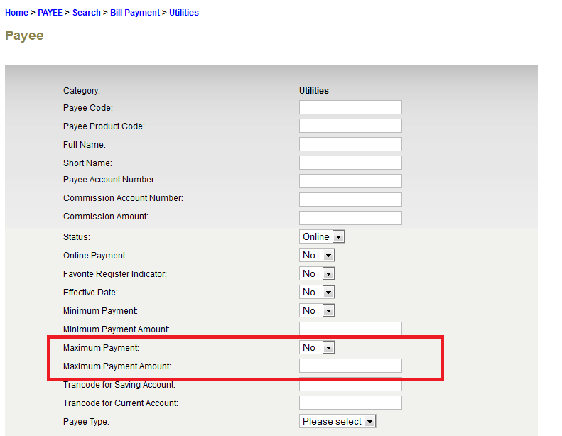

Test Case#5: Running Invalid Check Digit in RIB

Issue: Successful go to Confirm Page even though enter Invalid Bill No. in RIB.

**FIXED & TEST SUCCESSFULLY –** This issue occurred due to the user key-in in wrong check digit, it should be key in in check digit 1 instead of check digit 2 in prerequisite check digit screen,

