# CR#48: To validate account number upon registration

1. Add CapChar function to the registration form for DOS attack prevention/auto-bot form submission.

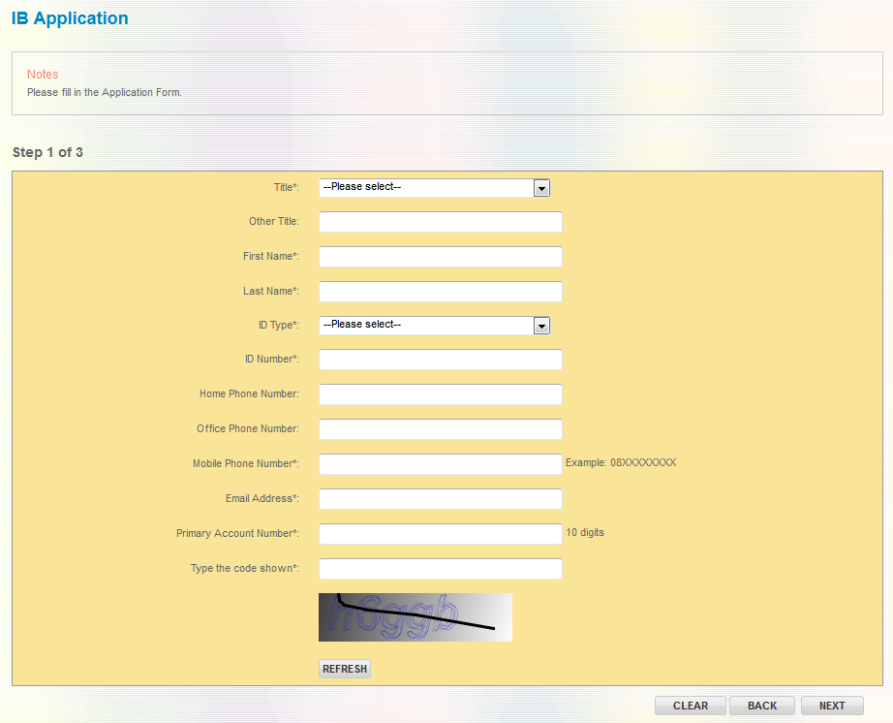

1. To validate Primary Account Number’s check digit as the first level account validation. Do not need to validate account at HOST

|  |  |
| --- | --- |
| Effort(man-days) | 2 |
| Affected Area | RIB  User Manual – RIB  Demo – RIB |