# CR#45: To change the TAC request flow

To change the Request TAC link layout from using a HTML link to button.

All modules that require 2-FA (TAC Authentication) will be affected. Re-test on these modules are required.



Figure 1: Request TAC with Link (As-Is)

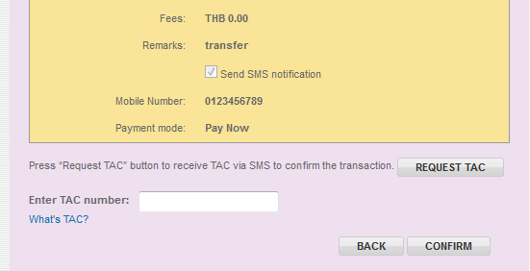

Figure 2: Request TAC with Button (To-Be)

|  |  |
| --- | --- |
| Effort(man-days) | 5 |
| Affected Area | RIB  User Manual – RIB  Demo – RIB |