**RIB REPORTS IN IBAM**

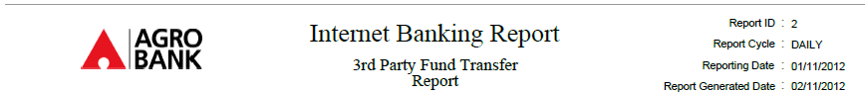

**Add this**

**Report GeneratedTime :**

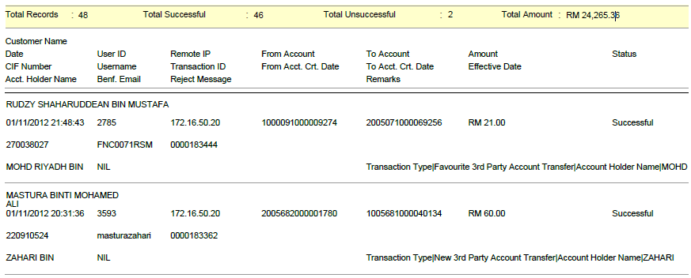

To add **“Report Generated Time”** below the “Report Generated Date” at the header report for **ALL** RIB reports in IBAM