BEFORE
RIB UAT ON 30.11.2012

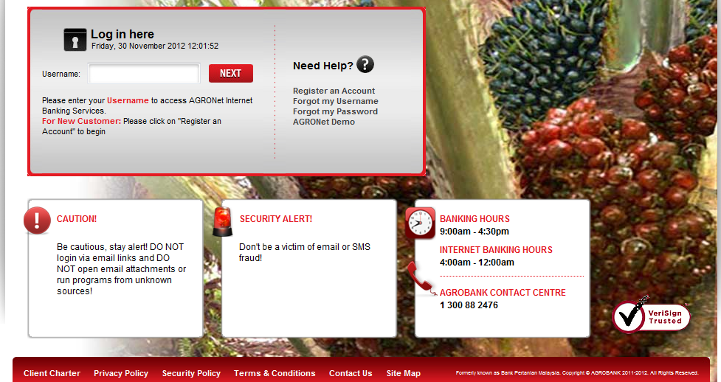
Insert this below the BANKING HOURS



