Hi,

Kindly need your assistant on this issue. (Development environment)

IE0000016C
TO ADD IN AGRONet LANDING PAGE

PROMOTION
20/12/2012-20/03/2013 Get your own "BACK TO SCHOOL' merchandise for every NEW ACCOUNT or ADDITIONAL DEPOSIT of your AgroMuda-i account!*
* subject to terms & conditions

ANNOUNCEMENT
SSPN-i:
Open SSPN-i Account at any of your nearest Agrobank branches today for a FREE insurance coverage and death benefits!*
* subject to terms and conditions

P/S:
1. Bagi Promotion tempoh perlu ada di AGRONet adalah sepertimana dinyatakan.
2. Bagi announcement perlu berada di AGRONet sehingga 31.12.2013

1) Promotion/Announcement title cannot include special character or symbol except space.
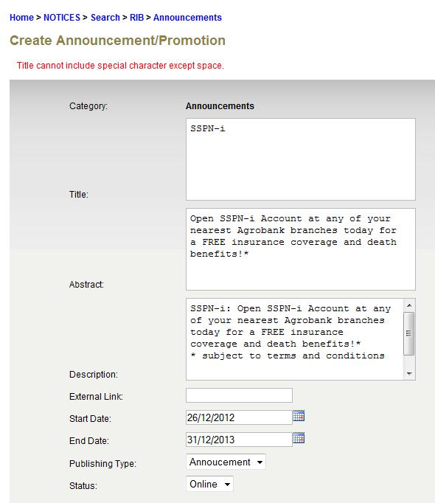

2) Promotion/Announcement description field cannot be in new line.

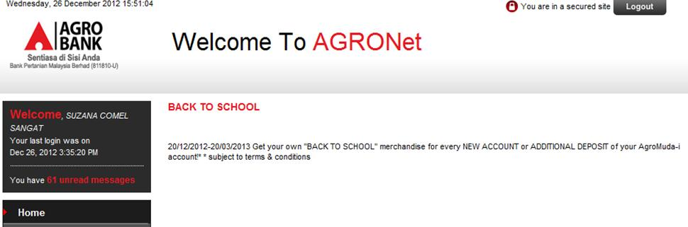

Does there are any solution on this issues? Please kindly advise.
Your cooperation is highly appreciated.

Thank You.

