**User Group Maintenance – Create**

1. To add Max Length to “Group Name” & “Group Description” fields.

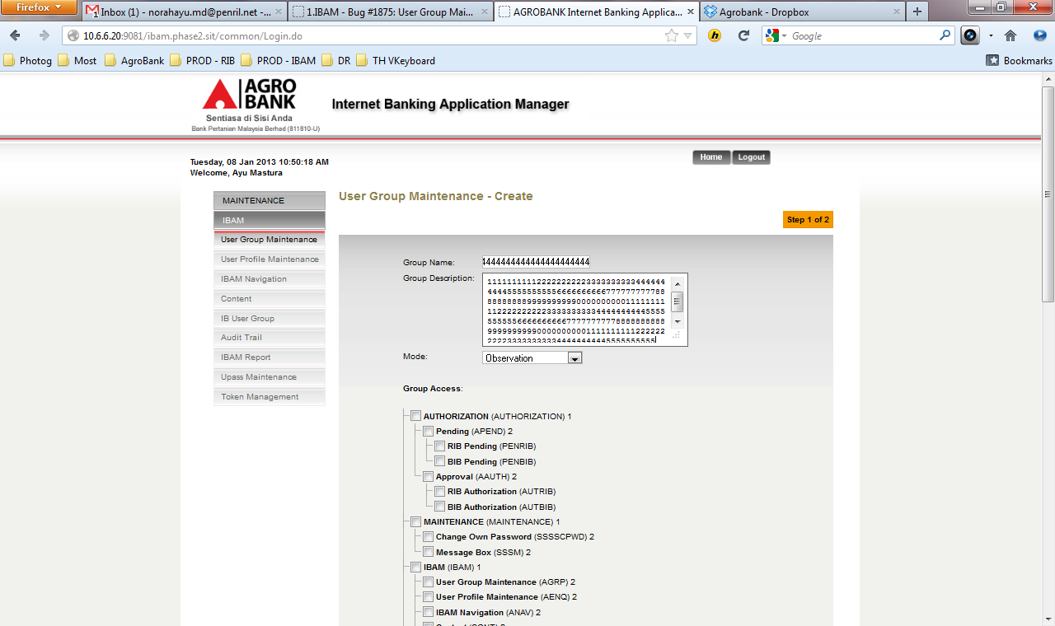

| **No** | **Field** | **Rule** | **Required** |
| --- | --- | --- | --- |
|  | Group Name | 30 Alpha, Numeric, or alphanumeric | Yes |
|  | Group Description | 255 Alpha Numeric | No |

1. To check checkbox is not empty before proceed to create the group

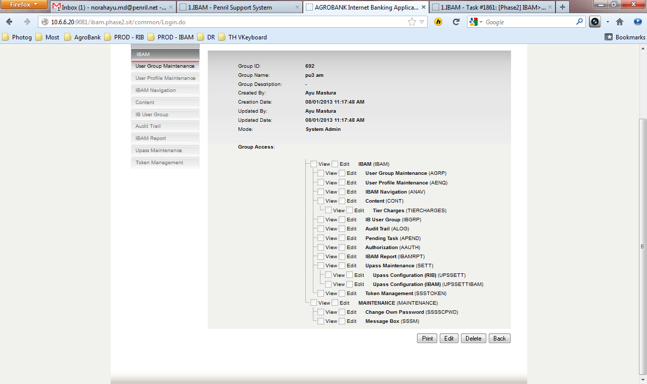

**User Group Maintenance – Print**

1. Prints Receipt – Group Access label is not needed.
2. Content of Navigation table is empty.

